**PROJECT REPORT**  
**PRACTICE MODULE (Project) FOR CERTIFICATE IN: INTELLIGENT REASONING SYSTEMS (IRS)**



|  |
| --- |
| PERSONAL FINANCE BUTLER |

**TEAM MEMBERS**  
RICHARD CHAI   
KOH HONG WEI

**Contents**

|  |  |
| --- | --- |
| 1.) Executive Summary | 3 |
| 2.) Problem Statement / Business Opportunity | 4 |
| 2.1) Assumptions | 5 |
| 2.2) Project Scope | 5 |
| 2.3) Project Objectives | 5 |
| 3.) Solution | 7 |
| 3.1) First function (Portfolio Allocation - CRISP Rules Engine) | 8 |
| 3.2) Second function (Bond Fund Recommendation, Collaborative Filtering: Mode 1) | 11 |
| 3.3) Third function (Bond Fund Recommendation, Collaborative Filtering: Mode 2) | 12 |
| 3.4) Fourth function (Bond Fund Recommendation, Collaborative Filtering: Mode 3) | 13 |
| 3.5) Fifth function (Bond Fund Recommendation, Collaborative Filtering: Mode 1) | 14 |
| 3.6) Sixth function (Portfolio Optimisation Engine – Genetic Algorithm – future enhancement) | 15 |
| 3.7) Seventh function (Portfolio Allocation - Fuzzy Inference System) | 15 |
| 4.) System Architecture | 16 |
| 5.) Limitation | 17 |
| 6.) Conclusion | 18 |
| 7.) Improvements | 18 |
| 8.) Bibliography & Appendix | 20 |

**1.0 EXECUTIVE SUMMARY**

Our project team sees the business potential to develop a PERSONAL FINANCE BUTLER (PFB) to help time-strapped Singaporeans better manage their financial health. This is especially important because of 2 factors: 1) Singaporeans are expected to run out of money in the last 14 years of their lives (based on AIA 2021 survey) and 2) the world is undergoing huge inflationary pressures (due to Covid and Russia-Ukraine military conflict). The PFB will provide users with a convenient platform to get their personalized Investment Portfolio Allocation swiftly. Moreover, the time-to-market for the PFB is relatively quick and can be used by many users. Thus, it will benefit a large group of users with a relatively short development effort (~ 1 - 2 months).

The PFB offers many solutions and much convenience to users. Stock and Bond portfolio allocation and recommendation is customised based on user’s Risk Profile and Investment Objectives, and it is delivered in an intuitive user interface that is accessible on desktop, laptops, tablets and mobile phones that have access to the internet.

For technical details, please refer to the following github repo:

<https://github.com/atsui888/Intelligent-Reasoning-Systems>  
  
For testing the live system/demonstration, please refer to following url:

<https://bit.ly/3jQ0Df0>

**2.0 PROBLEM STATEMENT / BUSINESS OPPORTUNITY**

A 2021 study by AIA shows that more than half of Singaporeans will run out of money in the last 14 years of their lives. The fact that Singaporeans have one of the longest life expectancies in the world at 84.8 years made the findings even more concerning. Singaporeans are running out of money when they are unlikely to have any salary income and will be hit by higher healthcare expenses. The AIA survey also highlights that 92% of Singaporeans over-rely on bank savings.

The on-going Covid virus situation which started in end 2019 has created supply chain bottlenecks and huge supply-demand imbalance around the world. This in turn has generated huge inflationary pressures in many countries. CNBC reported 10 February 2022 that U.S January 2022 inflation surges 7.5% on an annual basis, higher than market expectations and is the highest since 1982. Closer to home, Business Times reported 23 February 2022 that Singapore’s core inflation rose to its highest level in nearly 10 years in January 2022 to 2.4 per cent year on year, on the back of rising food and energy prices.

The Russia-Ukraine military conflict (which started on 24 February 2022) has also pushed prices of commodity like Oil, Natural Gas and Wheat to either near all-time high or record high. France President Emmanuel Macron has commented that “this war will last”, suggesting that it will be a multi-month event.

Against this backdrop, it is imperative for Singaporeans to be more proactive in their financial management now.

Assume a middle-class Singaporean married with kids. They are likely to be time-strapped and bogged down by parenting duties and busy chasing the corporate rat race. Thus, it will be ideal if there is a PERSONAL FINANCE BUTLER (PFB) to help the busy Singaporean better manage their financial health.

**2.1 ASSUMPTIONS**

The project makes a few assumptions about the users' computer proficiency and financial knowledge. First, the project assumed that the users are able to handle the use of a computer. Second, the users are assumed to have a basic financial knowledge to understand the risk profiling questionnaire and, if not, can do simple research on Google to learn more about the subject.

**2.2 PROJECT SCOPE**

Generally, stock investors will invest in their domestic markets, given their familiarity with the local market. Hence, the PERSONAL FINANCE BUTLER (PFB) will be focused on Singapore market primarily and does not take into account the differing available investment choices / instruments or tax rules outside Singapore market.

**2.3 PROJECT OBJECTIVE**  
  
The team envisions developing a PERSONAL FINANCE BUTLER (PFB) to :

1) empower people with Personal Finance Advice by recommending a personalized Investment Portfolio Allocation

2) bring convenience and time-savings to people

The PFB will be equipped with the following functions and features. *Table 1: PFB Features*

|  |  |
| --- | --- |
| **Functions** | **Features** |
| Portfolio Allocation -  CRISP Rules Engine | A Forward chaining (or forward reasoning) engine that starts with the available data and uses inference rules until a goal is reached, i.e., recommending the appropriate level (%) of stocks and bond funds in the portfolio for a specific end-user.  This is data-driven method where the data determines which rules are selected and triggered. |
| Bond Fund Recommendation  Collaborative Filtering: Mode 1 | Mode 1: Given a User, recommend one or more funds.  Based on user similarity in risk aversion, investment objectives, stock and bond allocation levels. |
| Bond Fund Recommendation  Collaborative Filtering: Mode 2 | Mode 2: Given a fund, recommend one or more suitable users.  Based on user similarity in risk aversion, investment objectives, stock and bond allocation levels. |
| Bond Fund Recommendation  Collaborative Filtering: Mode 3 | Mode 3: Given a fund, recommend one or more funds.  Based on funds similarity which are based on surveys where user indicate their satisfaction for a fund based on investment returns and volatility. |
| Stock Selection Engine - ARIMA | From a set of stocks, the engine uses ARIMA algorithm to forecast the future price of each stock 5 years out. It then selects the best stock by investment returns to recommend to the end-user. |
| Portfolio Optimisation Engine – Genetic Algorithm | This function is KIV for future Enhancement (due to time constraint). |
| Portfolio Allocation -  Fuzzy Inference System | This function is KIV for future Enhancement (due to time constraint). |

**3.0 SOLUTION**

The PFB is designed with the end-user in mind, and the dialogue/workflow is intended to be as user-friendly and intuitive as possible. The following diagram shows how users can initiate a session with it. An overview of all the available functions / features of the PFB is also displayed.

*Table 2 :*

|  |  |
| --- | --- |
| Investor Questionnaire Screen | An intuitive user interface for the user to input their risk profile and investment objectives |
| Portfolio Recommendation Screen | The screen where the app displays the stock and bond recommendations tailored to the users’ specific risk profile and investment objectives. |

In-depth screen shots and steps can be found in the user guide at:

* <https://github.com/atsui888/Intelligent-Reasoning-Systems/tree/main/System_Code>

Next, the report will discuss in-depth and zoom into each function and explain related design background.

**3.1 First function (Portfolio Allocation - CRISP Rules Engine)**

A Forward chaining (or forward reasoning) engine that starts with the available data and uses inference rules until a goal is reached, i.e., recommending the appropriate level (%) of stocks and bond funds in the portfolio for a specific end-user. This is a data-driven method where the data determines which rules are selected and triggered. The reception of new data can trigger new inferences, which makes this engine suitable for dynamic situations.

From Human Heuristics to CRISP Rules

We obtained the human heuristics from subject matter experts.

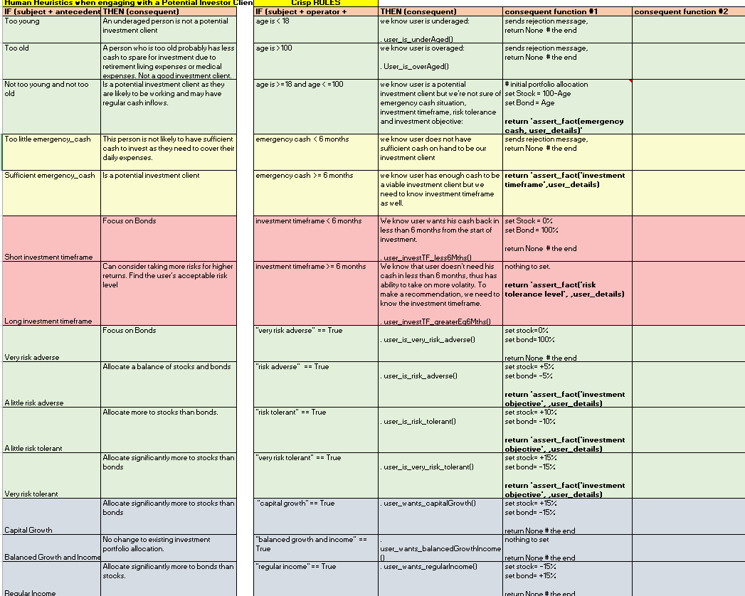

*Figure: From human heuristics to CRISP Rules*

And translate them into a format (CRISP Rules) that is suitable for a computer program to utilise.

CRISP Rules in Flow Chart format

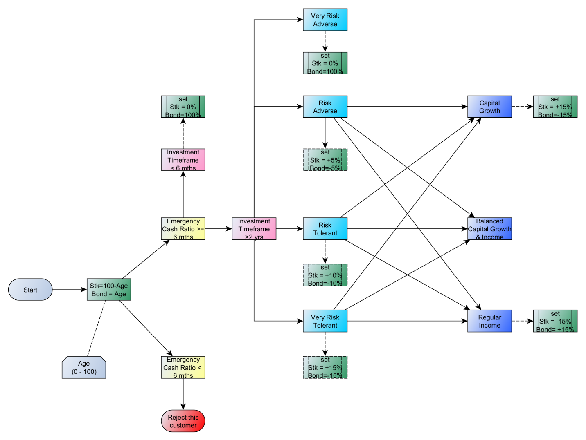

*Figure: From human heuristics to CRISP Rules (flow chart format)*

Finally, we implement the CRISP Rules in the custom coded CRISP Rules Engine where the rules are expressed in a format that the Python program can execute based on the input data.

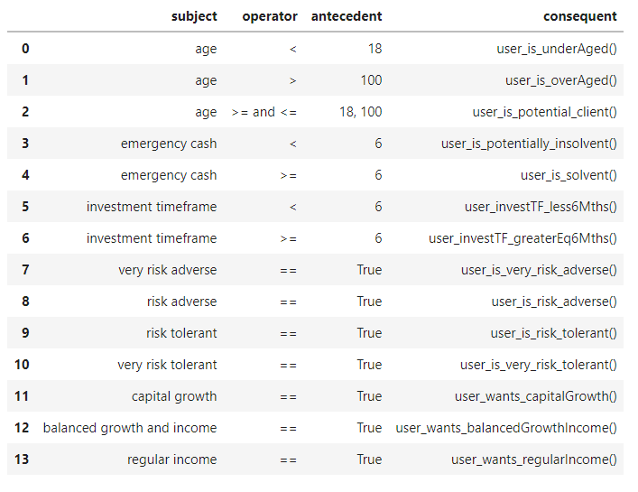

*Figure: CRISP Rules in Python Program format (Pandas Dataframe)*

The CRISP Rules to compute the appropriate allocation of Stocks vs Bonds is determined by the data provided by the user of the PFB app which are based on human expert heuristics on the appropriate levels to recommend according to their years of experience.

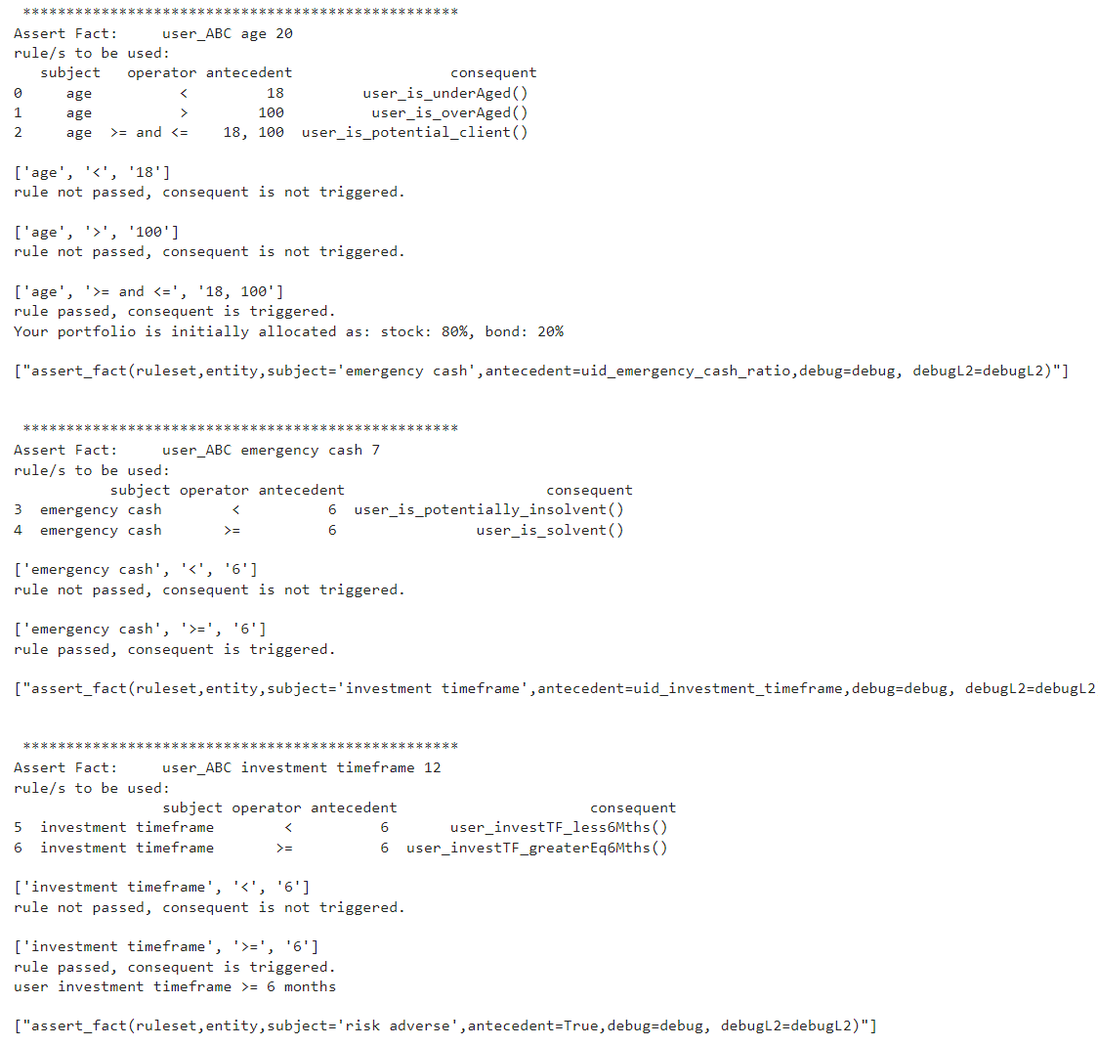

*Figure: CRISP Rules in action: debug output @ server*

**3.2) Second function ( Bond Fund Recommendation Collaborative Filtering)**

Mode 1: Given a User, recommend one or more funds.

In both mode 1 and 2, “user-based”, first take 4 features (risk aversion, investment objectives, stock and bond allocation levels),

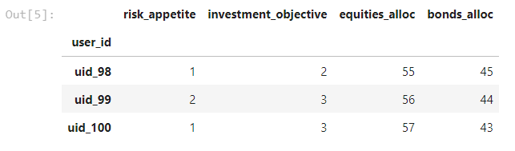

And calculate the pair-wise similarity of each user.

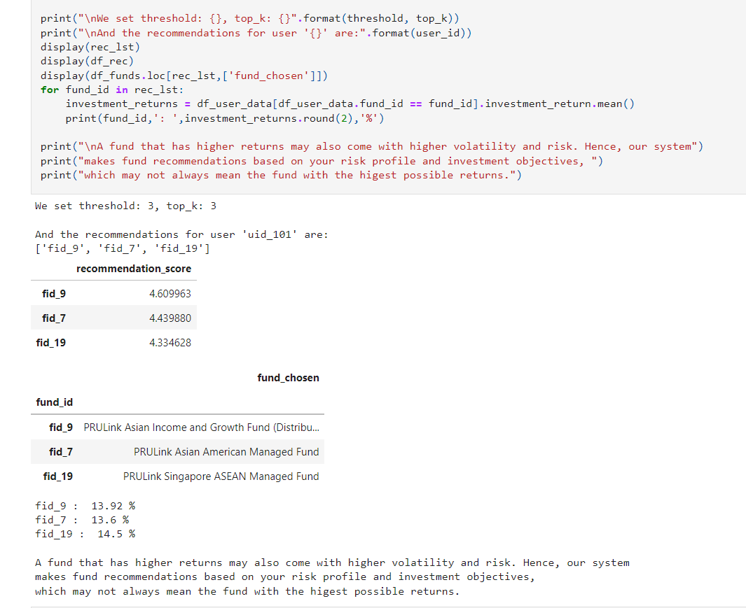

After we know the similarity that each user has relative to other users, we can link each user to the stocks and bonds they have in their portfolio. We can then leverage this information to make stock and bond recommendations to other users who are similar.

**3.3) Third function (Bond Fund Recommendation Collaborative Filtering:)**

Mode 2: Given a fund, recommend one or more suitable users.

This mode is very similar to mode 1 but in reverse.

We know which users are similar to other users (based on risk aversion, investment objects, portfolio allocations). We also know the bond fund that each user has in their portfolio.

Instead of recommending one or more funds to a user (based on user similarity), we flip it around and recommend one or more users (based also on user similarity) that are appropriate for a specific fund.

This function is already implemented in python code, but not yet implemented in online App**.** A demo is available, and you can see the output of that demo in the chart below.

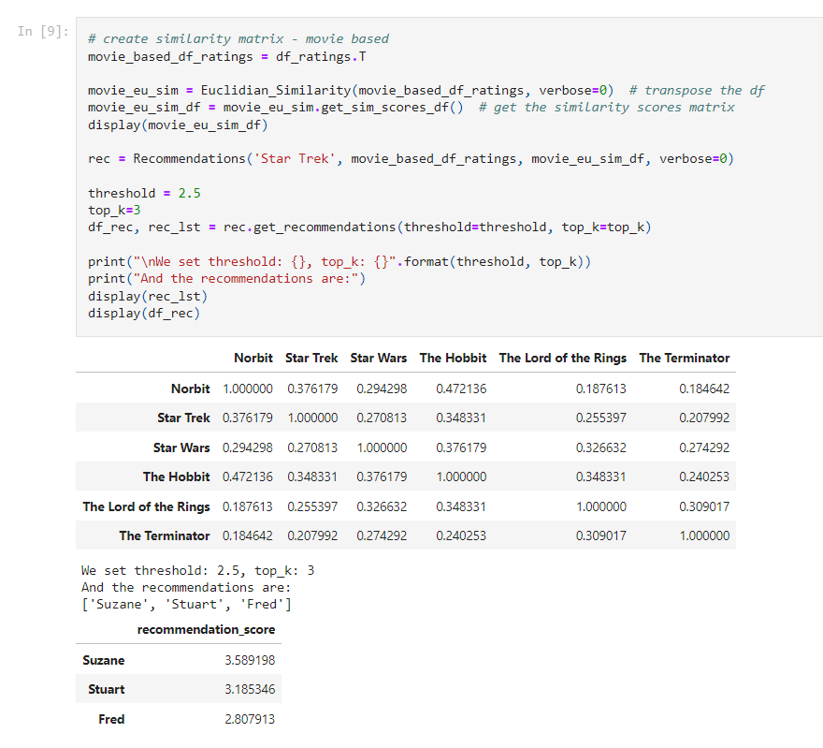

The screen shot above is a demo done on a sample movie dataset to test the code.

In this scenario, we have a user (whom we do not know much about), and this user either puts the movie ‘Star Trek’ in the shopping basket or clicks on ‘Star Trek’ to view more information. We then find other movies that are similar to ‘Star Trek’ and recommend one or more such movies to the user for movie rental or purchase.

Similarly, if a user of our Personal Financial Butler app whom we do not know much about, clicks on a stock or bond fund, or puts it in the “shopping basket” to invest in, we can use that to search for similar stocks or bonds to recommend to the user.

**3.4) Fourth function (Bond Fund Recommendation Collaborative Filtering)**

Mode 3: Given a fund, recommend one or more funds.

Unlike mode 1 and 2, mode 3 is “item-based” and not “user-based”

Based on surveys done or internal data, we know which funds tend to be associated with other funds based on fund characteristics e.g., investment returns and volatility.

This function is already implemented in python code, but not yet implemented in online App. A demo is available, and you can see the output of that demo in the chart below.

In the demo, we simulate a user who we do not have any information about but who has indicated an interest in a particular fund by clicking on it to view more information. Because we know the pair-wise similarity scores of all funds in our database, we are able to perform ‘item-based’ collaborative filtering and recommend funds that are similar.

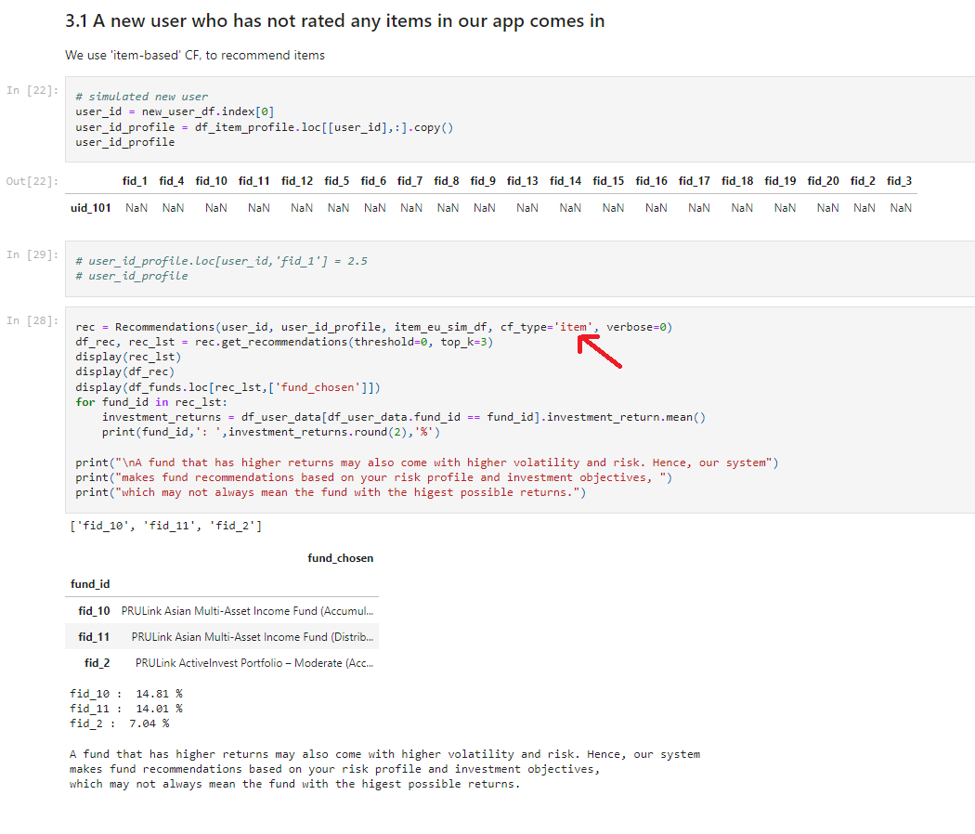

*Figure: “item-based” collaborative filtering recommendation*

**3.5) Fifth function (Stock Selection Engine – ARIMA)**

The engine uses ARIMA algorithm to forecast the future price of each stock in our database 5 years from today. It then selects the stock with the highest investment returns to recommend to the end-user.

For future enhancements, we intend to link this to the collaborative filtering recommendation engine to take into account user similarity of risk adverseness and investment objectives.

**3.6) 6th function (Portfolio Optimisation Engine – Genetic Algorithm)**

Currently the recommendations are based on the investor risk profile, investment objectives and satisfaction ratings, but they do not consider the end-users’ dollar budget. If we add a Portfolio Optimisation Engine which utilize Genetic Algorithm to optimise the end-user’s investment objectives subject to constraints, we can help the end-user not only with stock and bond recommendations but also with the appropriate dollar amounts to invest in each investment vehicle.

Due to time constraint to complete this project, this function is KIV for future enhancement.

**3.7) 7th function (Portfolio Allocation - Fuzzy Inference System)**

While the inferencing rules are triggered by data (data driven), the decision boundaries for the CRISP Rule Engine are rigid. Hence, adding a Fuzzy Inference System can improve the effectiveness of the portfolio allocation recommendations for the end-user.

Due to time constraint to complete this project, this function is KIV for future enhancement.

**4 SYSTEM ARCHITECTURE**

The PERSONAL FINANCE BUTLER (PFB) is built using Python, Anvil server, Postgres database and uses custom coded intelligence reasoning components as well as open-source libraries.

Machine Reasoning and Inferencing

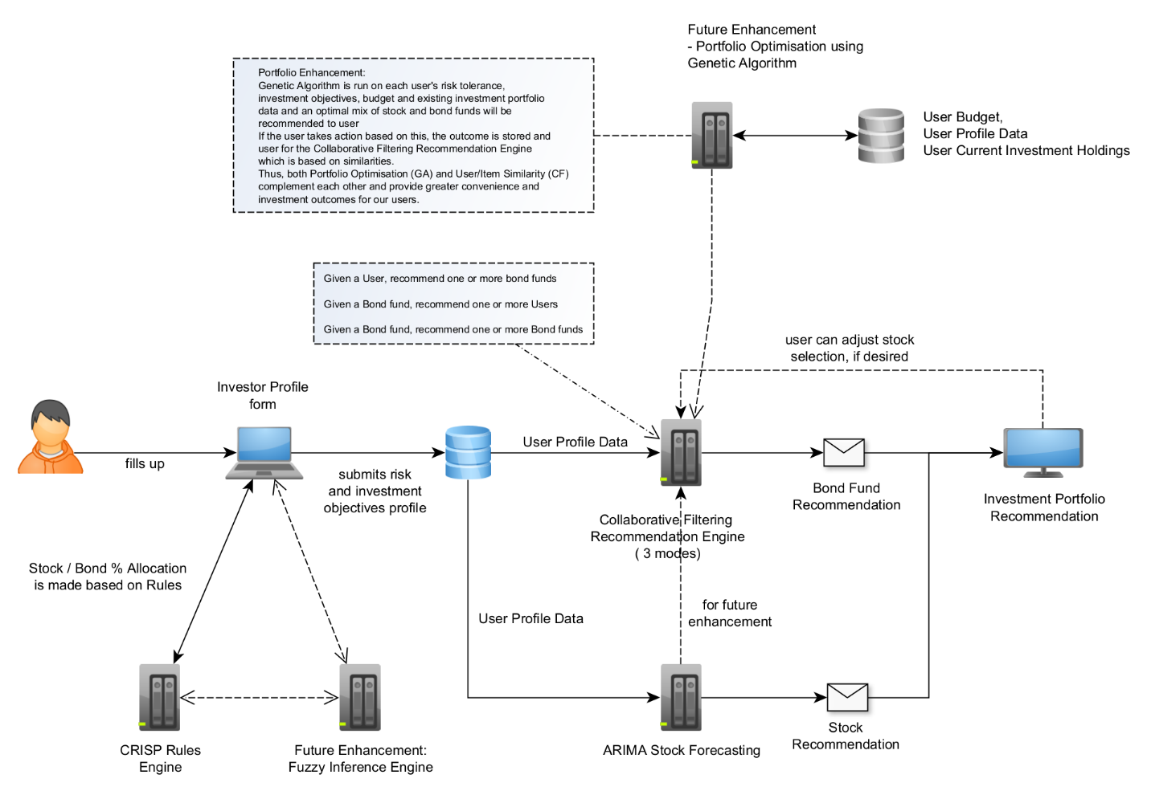

*Figure: Personal Financial Butler: Machine Reasoning and Inferencing System*

System Infrastructure

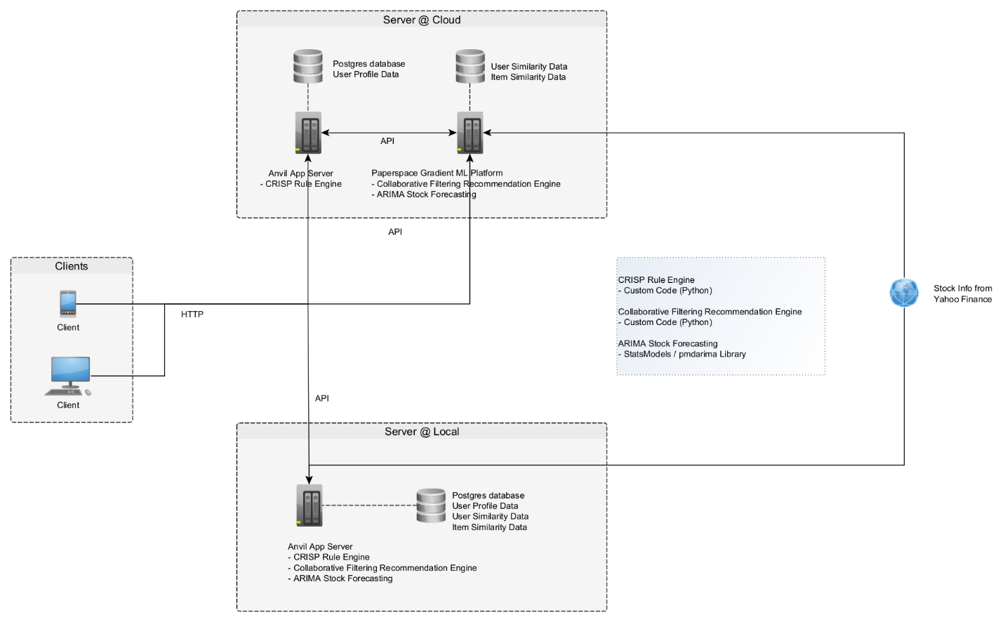

*Figure: Personal Financial Butler: System Architecture*

**5 LIMITATIONS**

Users with limited stock market / financial knowledge may not be able to understand / appreciate the information provided by PERSONAL FINANCE BUTLER (PFB). However, this group of users can still benefit by using it as a reference point when they use the information to discuss their investment / portfolio allocation with their personal financial advisors / relationship managers.

A user’s risk tolerance/profile could change with time or after going through certain life events, so the PFB’s recommendation should not be used as a cast in stone recommendation and to be followed blindly.

Given time constraints in completing the project, there are certain areas of improvements which cannot be accomplished; these are detailed in the following “IMPROVEMENTS” section.

**6.0 CONCLUSION**

In conclusion, the team has observed a business opportunity to develop a PERSONAL FINANCE BUTLER (PFB) to provide consumers with helpful portfolio allocation information swiftly.

The team has leveraged what they have learnt in their NUS-ISS AI program: reasoning systems, knowledge representation and machine learning technologies to build this PFB, and in doing so, provides its end-users precious time-savings and convenience.

**7.0 IMPROVEMENTS**

The PERSONAL FINANCE BUTLER (PFB) can be improved in the following areas: additional scope, additional functions and platform delivery.

As the PFB is focused on the Singapore market, there is an opportunity to expand the scope to cover other geographical audience.

The PFB can also be enhanced with more functions. For instance, an early warning indicator system can be set up to alert the user to idiosyncratic risk (if certain stock price sees some unusual stock volume level) or general market risk (if the stock-related peers rise or fall beyond a certain level); a historical correlation matrix can also be created to let the user know the correlation of securities as specified by the user.

Other future enhancements could come in the form of a portfolio optimisation module that uses genetic algorithm and a fuzzy inferencing system that combines with the CRISP Rule Engine to improve portfolio allocation accuracy and the corresponding stock and fund recommendations.

In additional, for this proof-of-concept, the stock and bond dataset is restricted to a sub-set of all available stocks and bonds in the market and some data is algorithm-generated, subsequently we could explore adding more stocks and funds from the market.

The PFB is currently available only on one delivery platform. Thus, it can be enhanced to be made available on other platforms (TELEGRAM, Whatsapp, Wechat etc.).

**8.0 BIBLIOGRAPHY & APPENDIX**

<https://www.straitstimes.com/business/invest/plan-early-to-have-enough-money-for-life>

<https://www.cnbc.com/2022/02/10/january-2022-cpi-inflation-rises-7point5percent-over-the-past-year-even-more-than-expected.html>

<https://www.businesstimes.com.sg/government-economy/singapore-core-inflation-rises-further-to-24-in-january-headline-inflation-flat#:~:text=SINGAPORE'S%20core%20inflation%20rose%20to,on%20Wednesday%20(Feb%2023)>.

<https://www.straitstimes.com/world/europe/this-war-will-last-warns-frances-macron-on-ukraine>

# APPENDIX 1 - Mapped System Functionalities

# Please refer to excel attachment

# APPENDIX 2 – Project Proposal

* <https://github.com/atsui888/Intelligent-Reasoning-Systems/tree/main/Project_Report>

# APPENDIX 3 – Installation and User Guide, System Code

* <https://github.com/atsui888/Intelligent-Reasoning-Systems/tree/main/System_Code>

# APPENDIX 4 – Individual Project Reports

* <https://github.com/atsui888/Intelligent-Reasoning-Systems/tree/main/Miscellaneous>