*Figure* *1.*  Stimuli. (A)Articulation. The curved line (slur) indicates legato and the dots indicate staccato. In multiple regression analysis, (1) corresponds to Legato model and (2) corresponds to Staccato model. (B)Dynamics. The symbol ‘f’ denotes forte and the symbol ‘p’ denotes piano. In multiple regression analysis, (3) corresponds to Forte model and (4) corresponds to Piano model. Only the parts composed of 16th notes (i.e., (1), (2), (3), (4)) were used for data analysis.

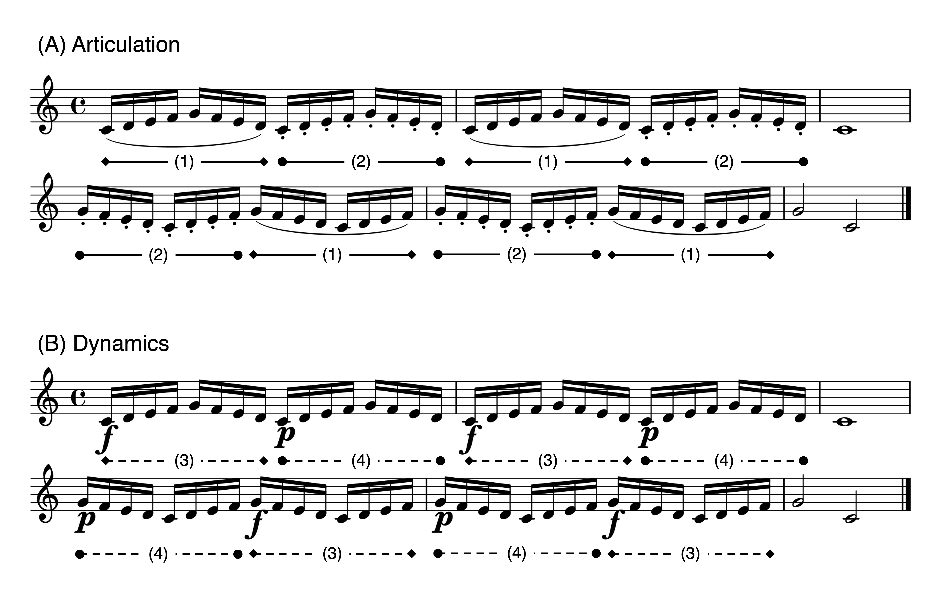

*Figure* *2.*  Procedure. Participants listened to a recording via headphones while corresponding sheet music was displayed on a monitor. They were required to respond by pressing the left-arrow (yes) or right-arrow (no) key for each judgment. Headphone image from Flaticon.com.

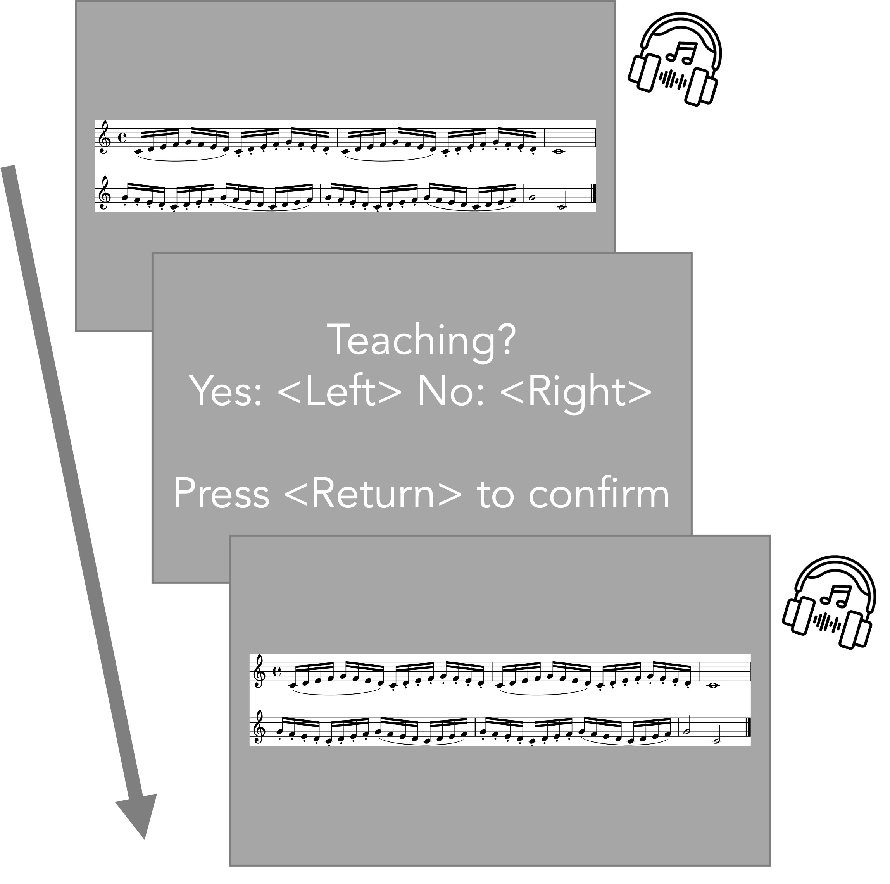

*Figure* *3.*  Experiment 1: Scatter plot showing the correlation between tempo feature (IOIs) and average participants’ judgments as teaching for each recording. Therefore, each dot represents each stimulus. The gray bands display the 95 percent confidence intervals.

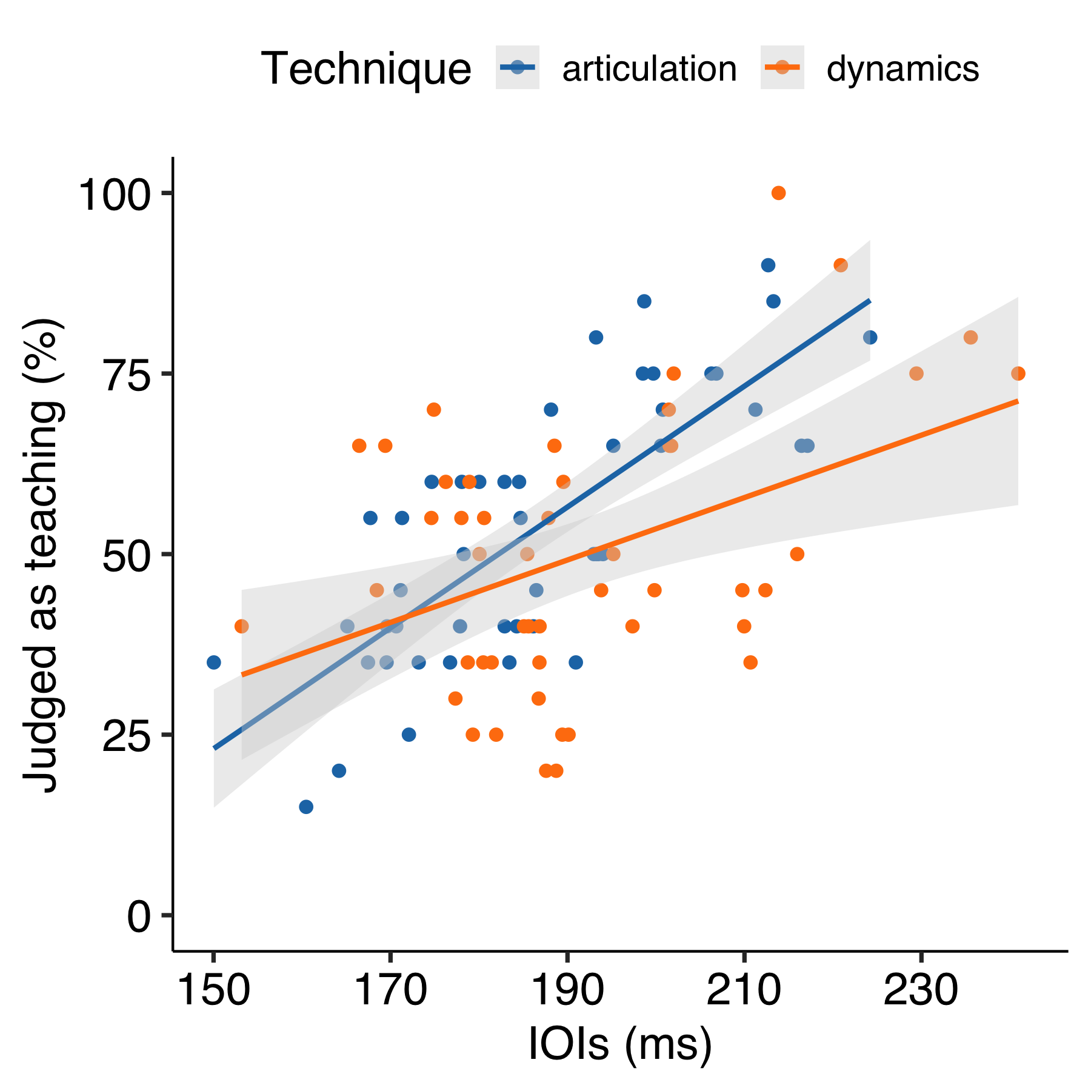

*Figure* *4.*  Experiment 1: Scatter plot showing the correlation between articulation feature (KOT) and average participants’ judgments as teaching for each recording. Therefore, each dot represents each stimulus. The gray bands display the 95 percent confidence intervals.

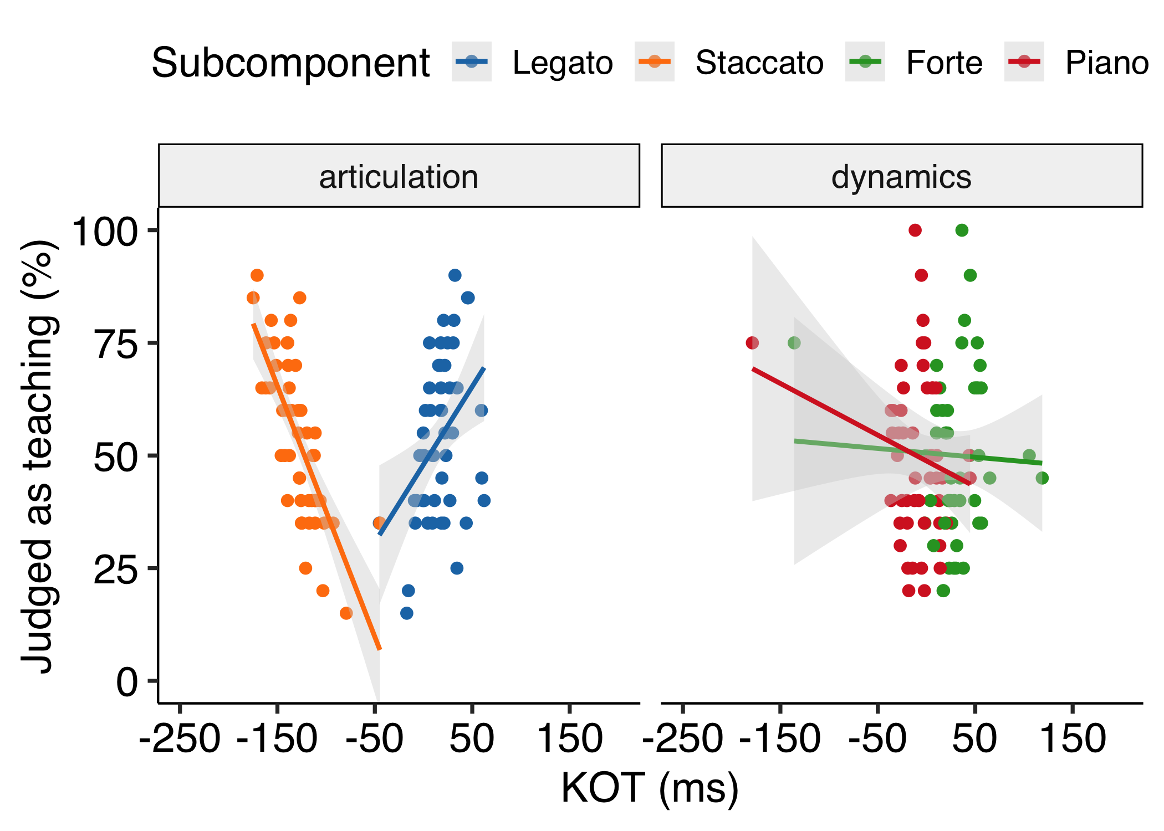

*Figure* *5.*  Experiment 1: Scatter plot showing the correlation between dynamics feature (KV) and average participants’ judgments as teaching for each recording. Therefore, each dot represents each stimulus. The gray bands display the 95 percent confidence intervals.

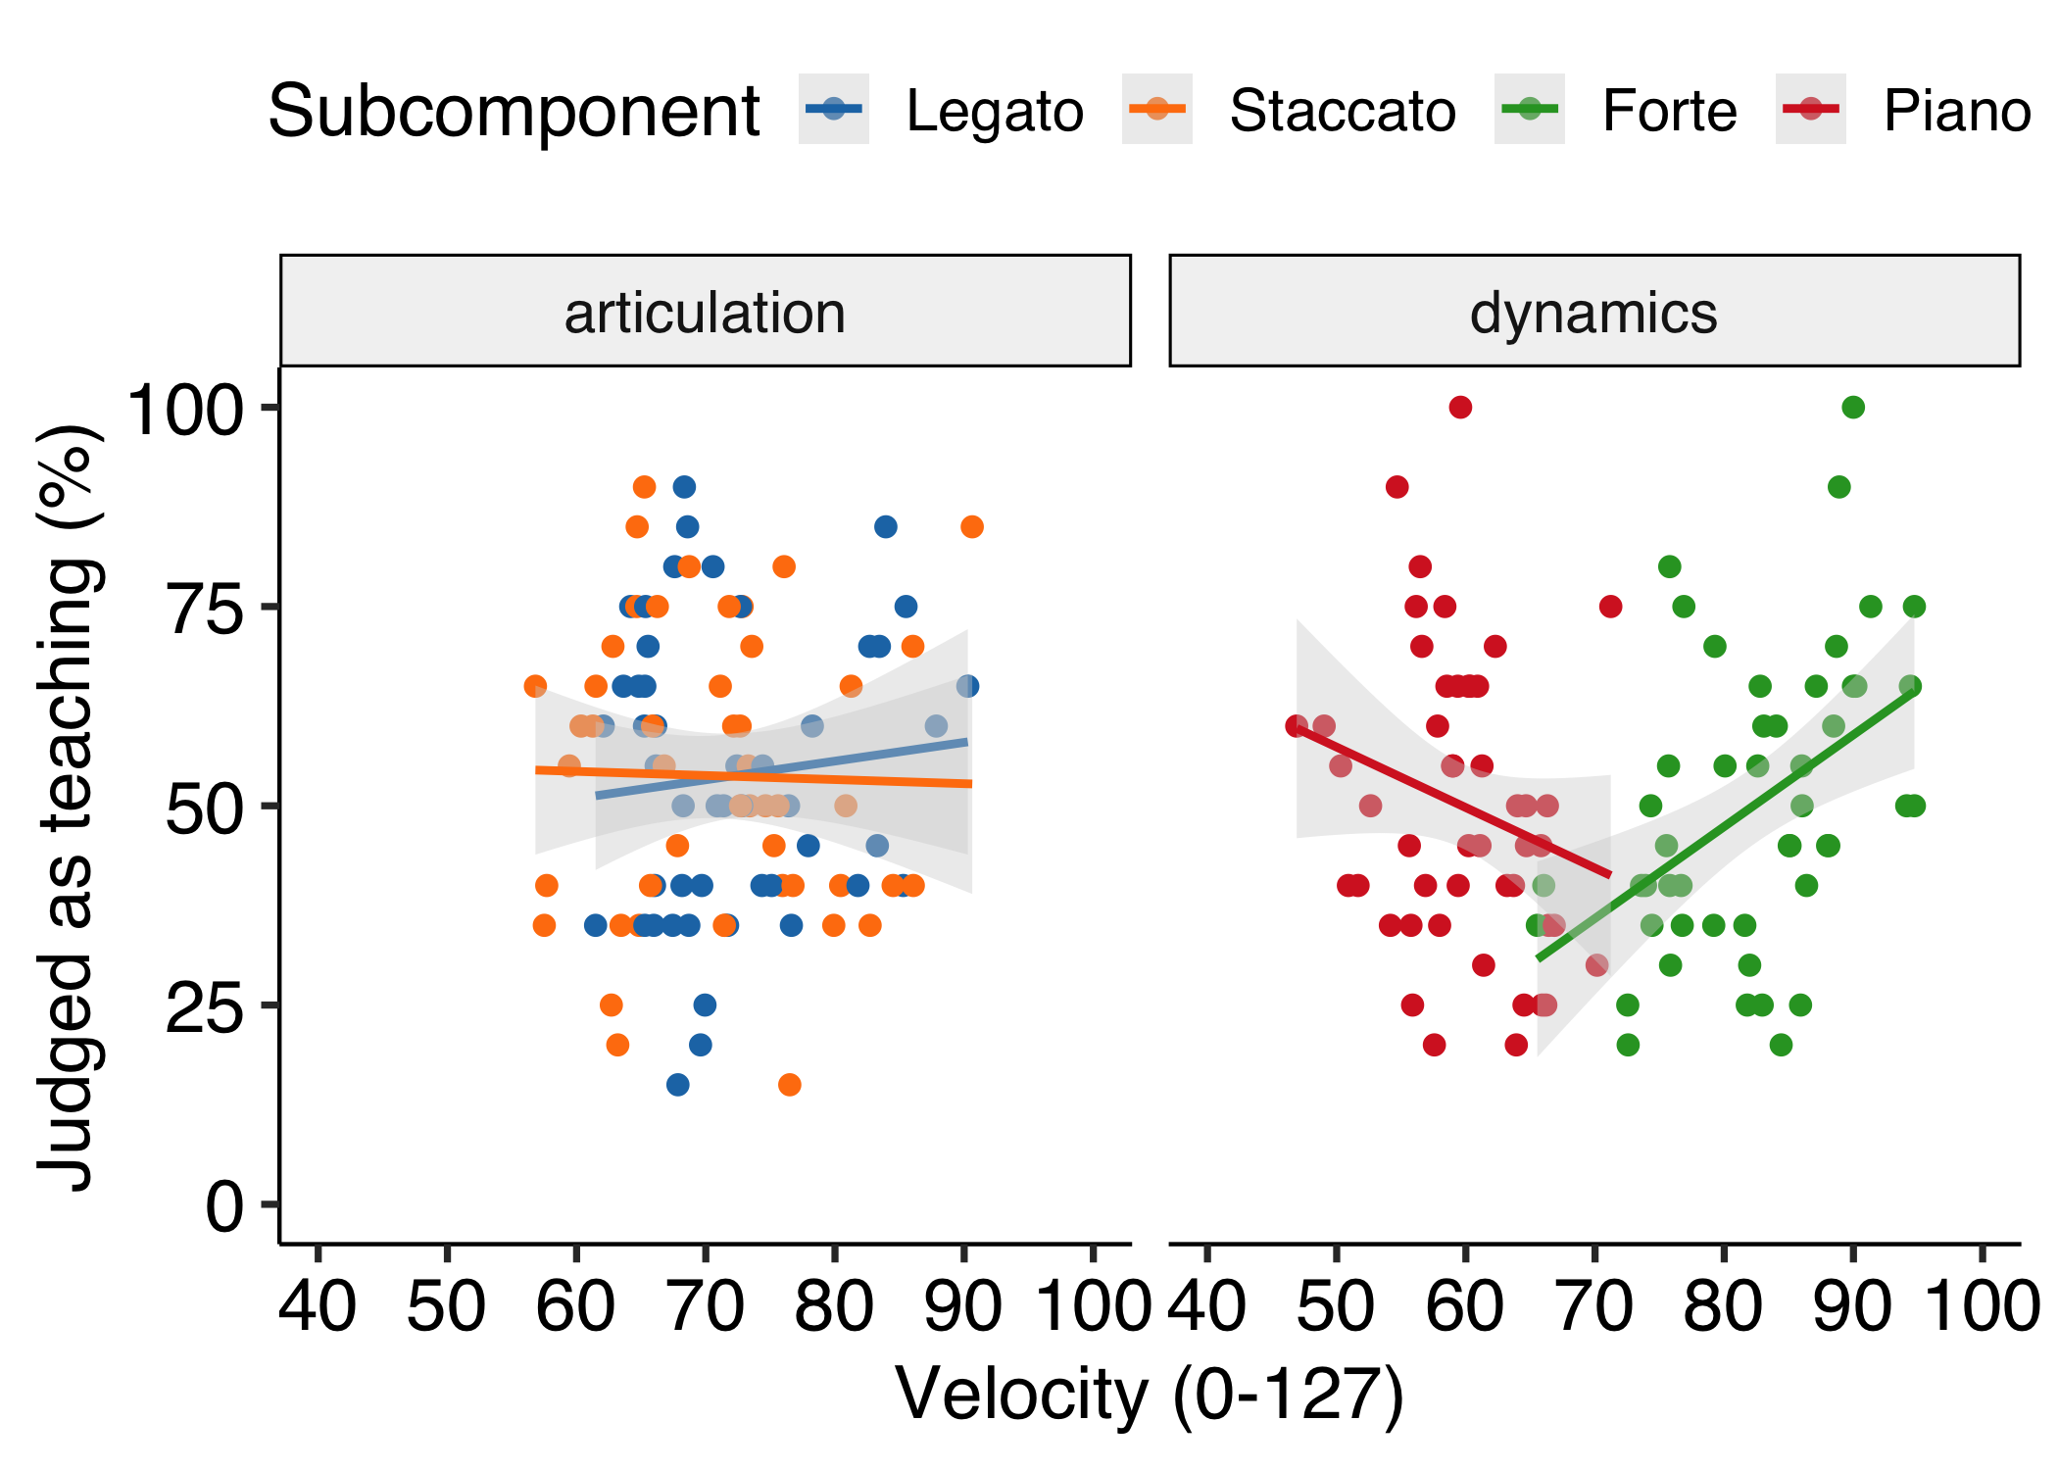

*Figure* *6.*  Experiment 1: Scatter plot showing the correlation between dynamics contrast feature (KV-Diff) and average participants’ judgments as teaching for each recording. Therefore, each dot represents each stimulus. The gray bands display the 95 percent confidence intervals. LtoS; Legato to Staccato, StoL; Staccato to Legato, FtoP; Forte to Piano, PtoF; Piano to Forte.

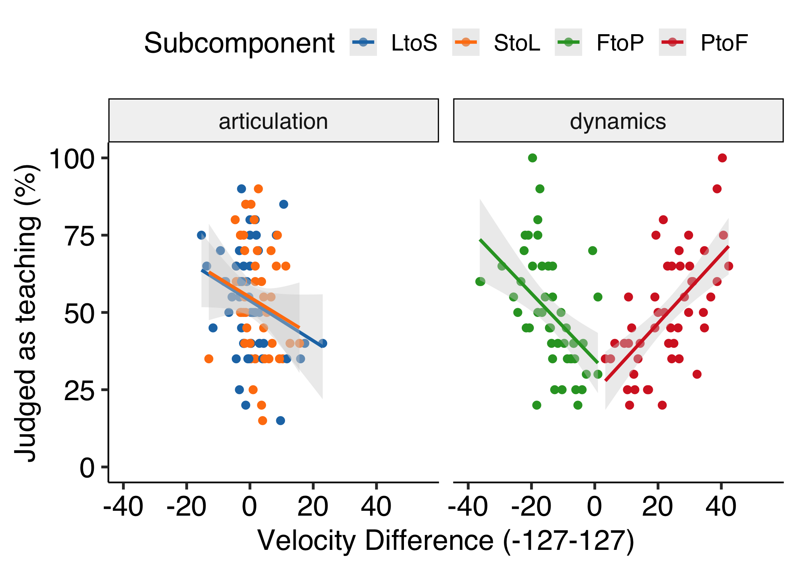

*Figure* *7.*  Stimuli. (A)Articulation. The curved line (slur) indicates legato and the dots indicate staccato. In multiple regression analysis, (1) corresponds to Legato model and (2) corresponds to Staccato model. (B)Dynamics. The symbol ‘f’ denotes forte and the symbol ‘p’ denotes piano. In multiple regression analysis, (3) corresponds to Forte model and (4) corresponds to Piano model. Only the 8th notes with expressive notations (i.e., (1), (2), (3), (4)) were used for data analysis.

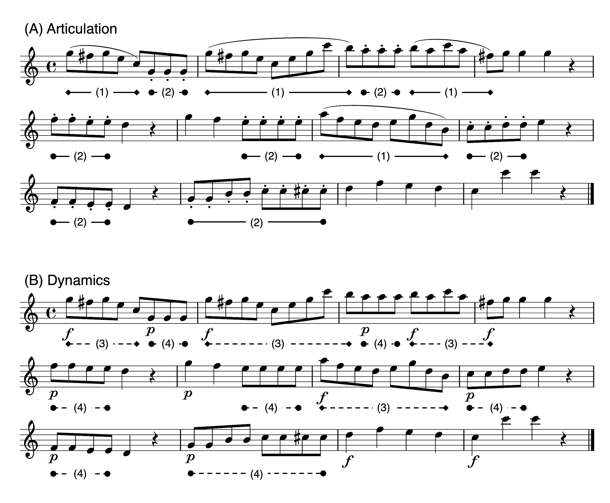

*Figure* *8.*  Experiment 2: Scatter plot showing the correlation between tempo feature (IOIs) and average participants’ judgments as teaching for each recording. Therefore, each dot represents each stimulus. The gray bands display the 95 percent confidence intervals.

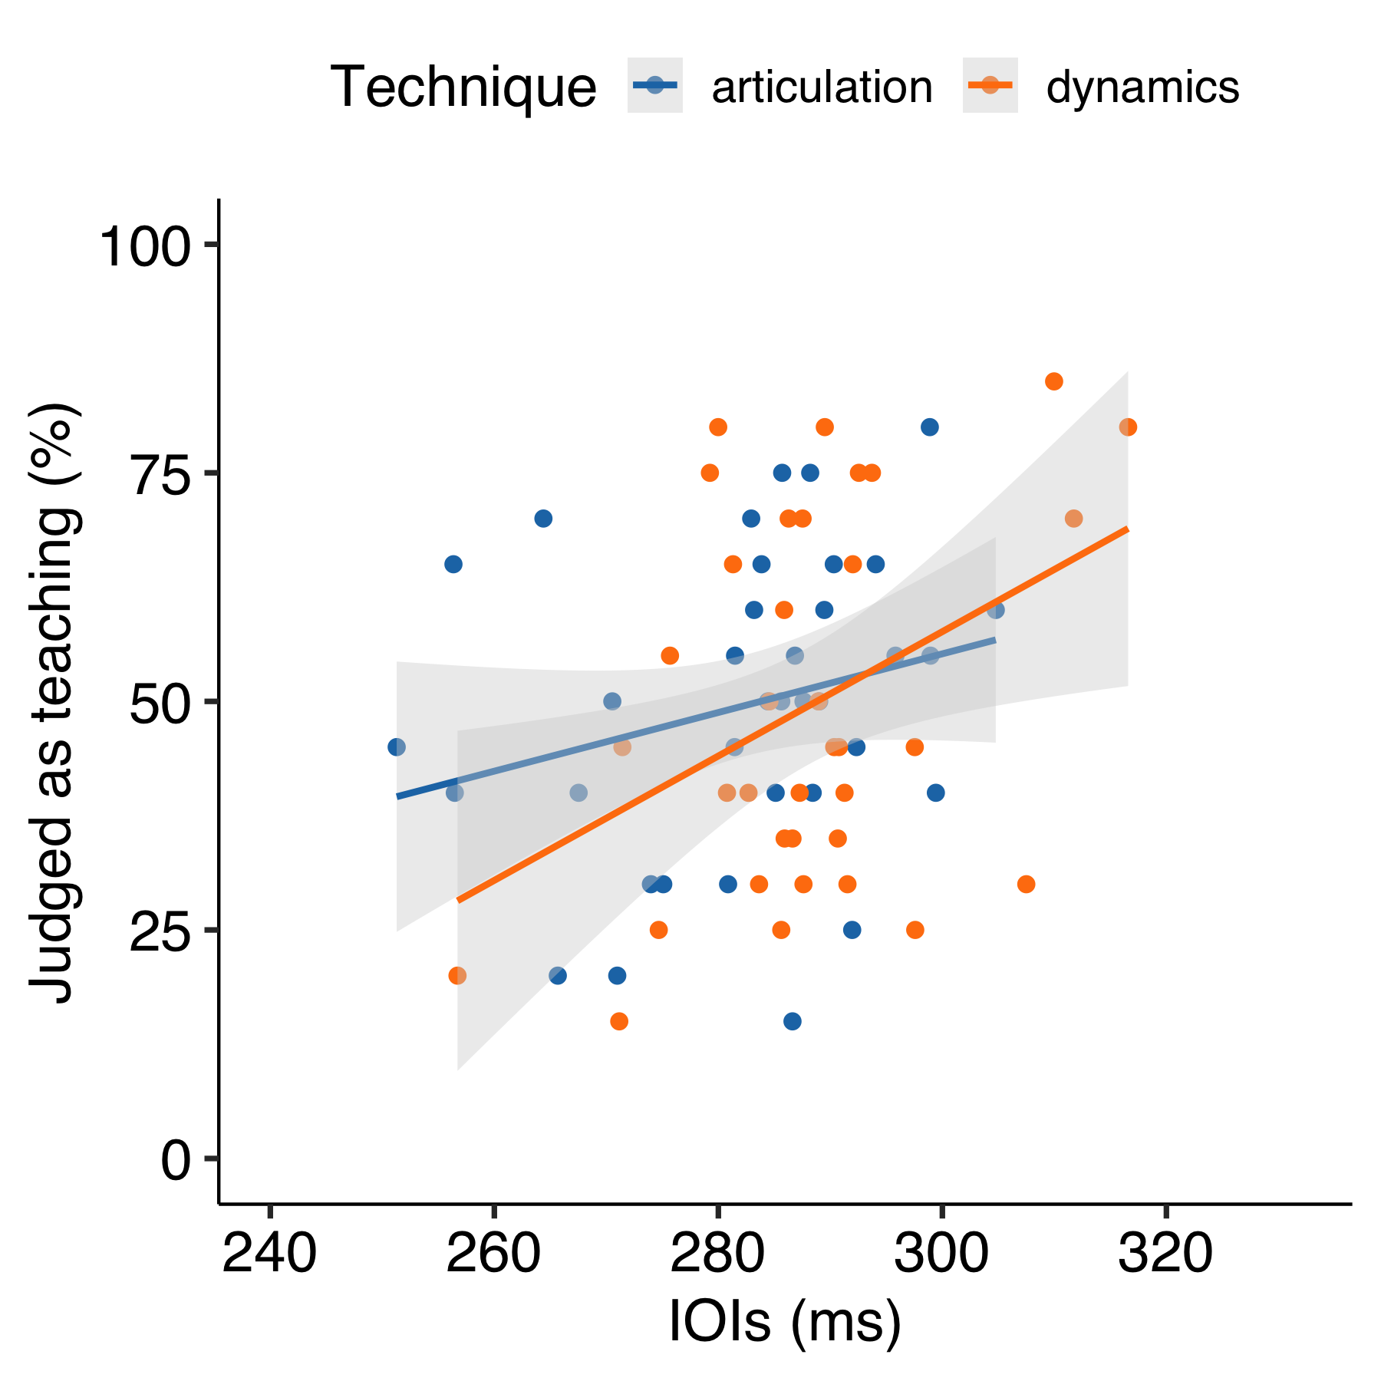

*Figure* *9.*  Experiment 2: Scatter plot showing the correlation between articulation features (KOT) and average participants’ judgments as teaching for each recording. Therefore, each dot represents each stimulus. The gray bands display the 95 percent confidence intervals.

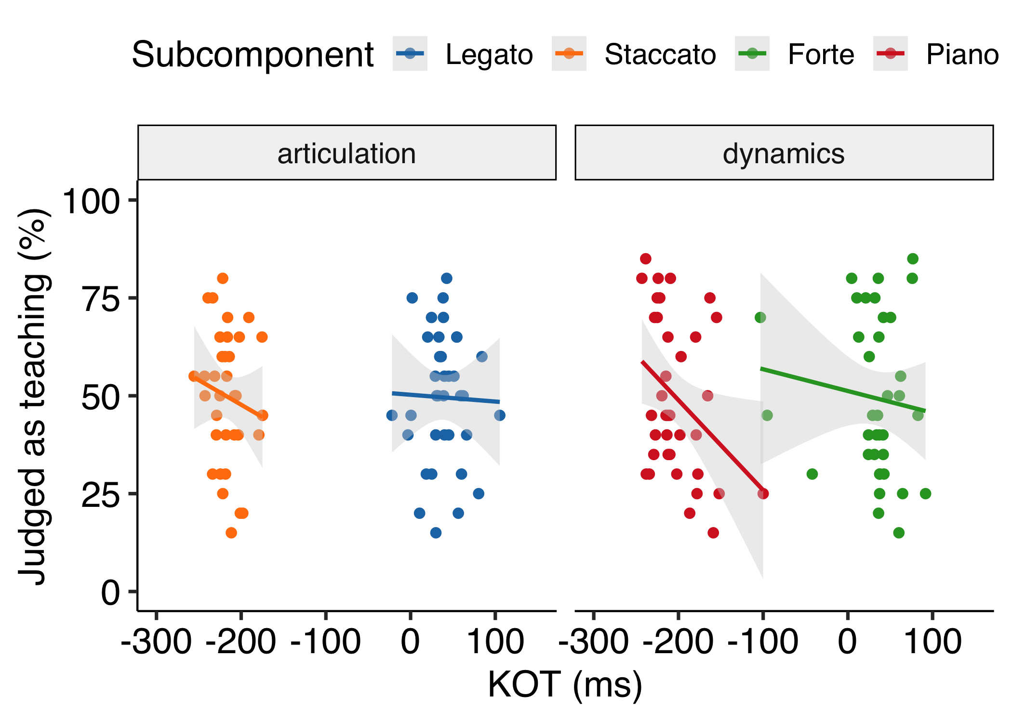

*Figure* *10.*  Experiment 2: Scatter plot showing the correlation between dynamics features (KV) and average participants’ judgments as teaching for each recording. Therefore, each dot represents each stimulus. The gray bands display the 95 percent confidence intervals.

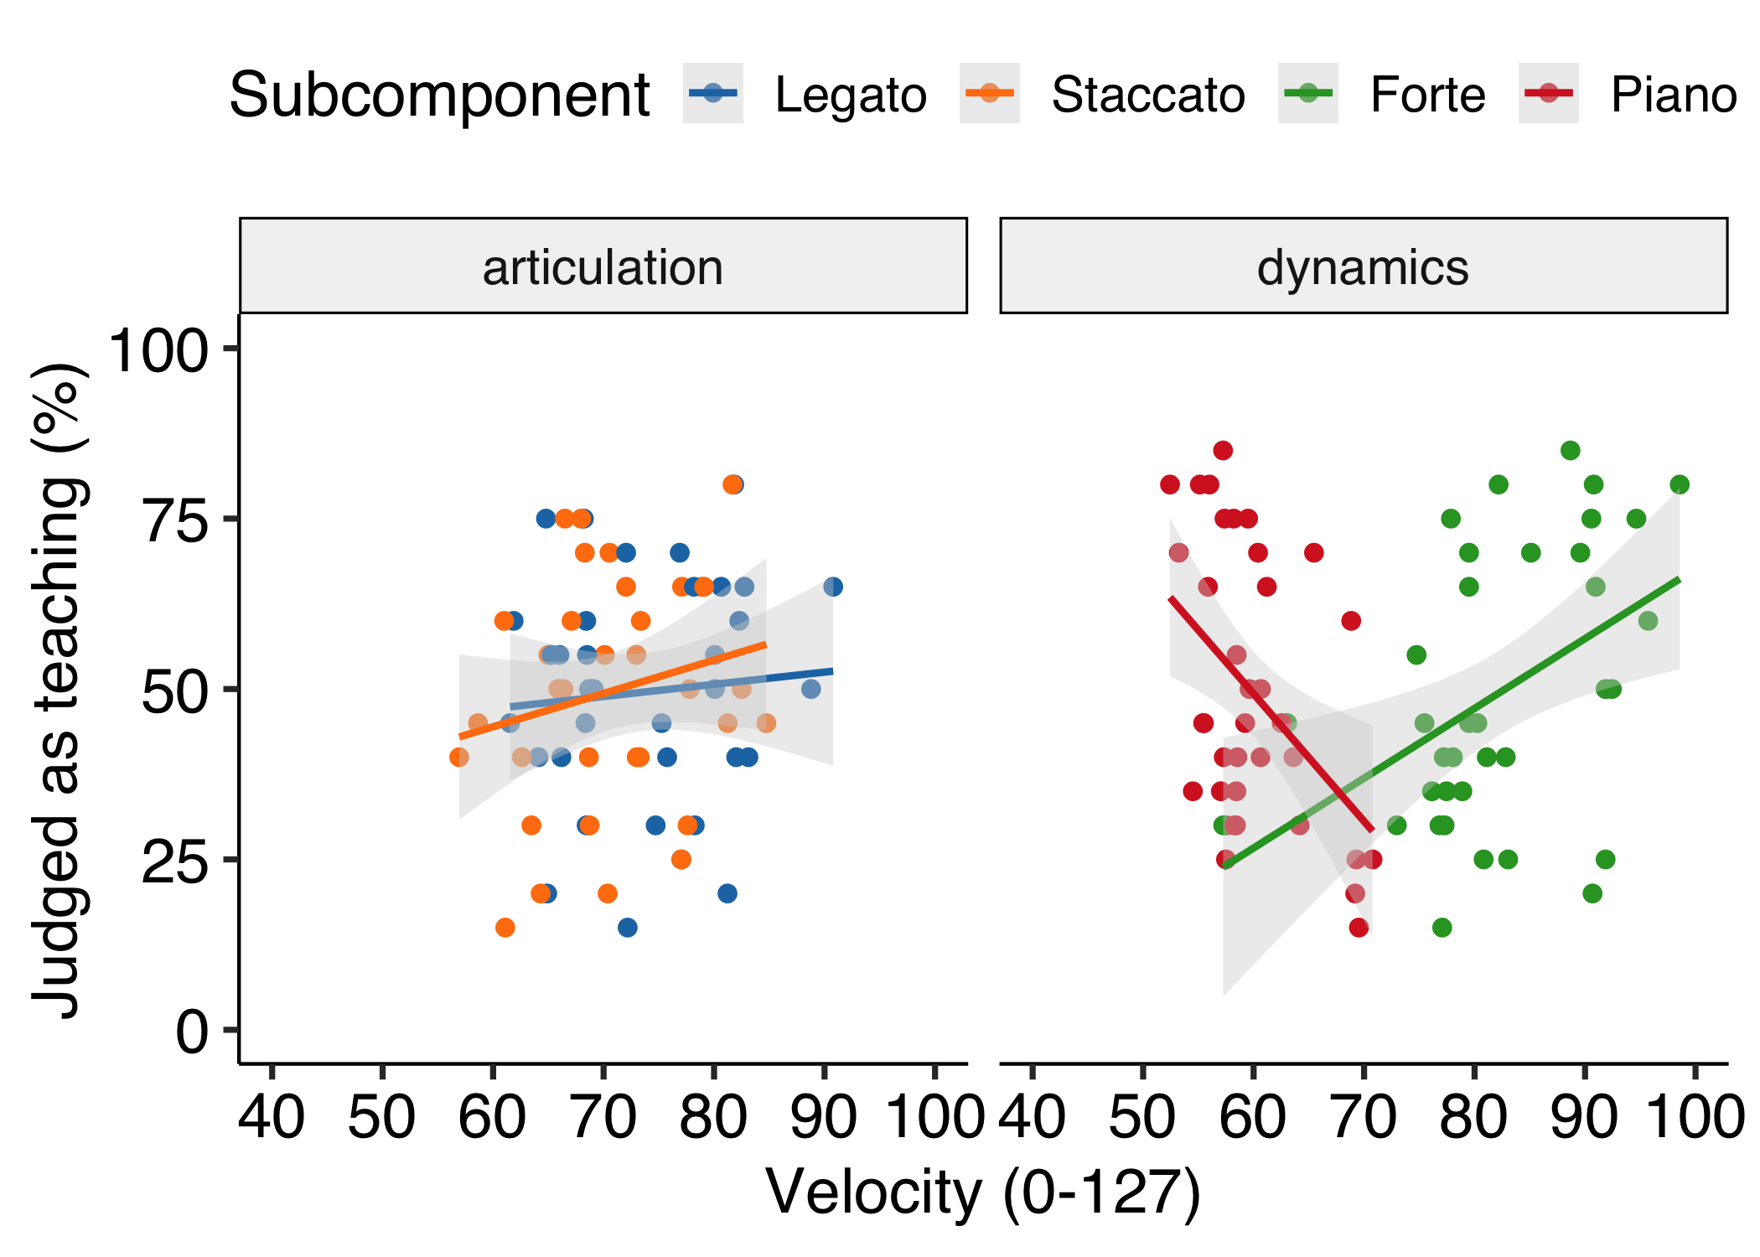

*Figure* *11.*  Experiment 2: Scatter plot showing the correlation between dynamics contrast features (KV-Diff) and average participants’ judgment as teaching for each stimulus. The gray bands display the 95 percent confidence intervals. LtoS; Legato to Staccato, StoL; Staccato to Legato, FtoP; Forte to Piano, PtoF; Piano to Forte.

