Andrew Sullivan

12/6/13

CMSI 370

Assignment 1206

Dream Design

My dream design will be based around the GPS system. The major changes to the system will be the screen size, voice command, and integration with the user’s phone. I have used several models and versions of GPS systems for navigation specifically while driving. The largest problem that I have found with them is efficiency and satisfaction, often due to lack of ease to operate. The current line of GPS’s that I have used seems to have been designed to be either operated by a passenger or by the driver before beginning the trip. This is due to safety measures and California driving laws that prohibit using hands on interfaces while driving. While these systems work perfectly fine when being operated by a passenger or before the driving begins, I have found myself in multiple scenarios in which I have needed to use my GPS to either change my location or select a new one. This is often very difficult to do in the middle of trip with the current user interfaces. My dream design aims at improving on these features. During my report I will be using several GPS’s to compare including several different versions of the Garmin GPS and several apps for the iPhone including Waze, Google Maps, and Apple Maps.

A problem I have seen while using GPS apps on my phone is that it is very difficult to display the screen so that I can view it while driving. The advantage of having a stand-alone GPS device is that it can either be mounted in the car or installed into the car. This way the screen is mounted in a place that the user can easily glance at it without being too distracted from the road. For this reason my dream design of a GPS interface, will be on a stand-alone device whose purpose is to navigate only.

*Voice Control*

Every GPS that I have used has used a touch-screen interface. All of them have been very similar, displaying a map with the current location and a basic menu interface for selecting a destination. For my design I will hope to minimalize the menu system as much as possible in favor of a voice command interface. I would still have a physical touch-screen menu on the device if the user would prefer to use that. The voice command system would work very similarly to Siri and the XBOX Kinect. If the user wants to set in a location for the GPS they would say, “GPS, go to location”. This way if the user is driving alone and wants to put in a destination while driving they can simply speak the instructions to the GPS while keeping both eyes on the road.

*Phone Integration*

The next feature is the GPS’s ability to integrate with the user’s phone. For the sake of simplicity in this paper I will narrow it down to just the iPhone. By doing this all of the contacts on the driver’s iPhone will be able to be used through the GPS. Instead of having the user manually enter in each contact from their phone into the GPS, which is how the current line of Garmin GPSs are designed, they will be able to be accessed directly from the system. Also, if the user wants to be reminded of certain things, such as them being low on gas, they can have them sent directly to their phone.

The GPS will be receiving information from the car as well, such as the amount of gas in the tank. This will allow the GPS to verbally warn the driver when they are low on gas. This combined with the knowledge of that particular car’s miles per gallon (mpg), the system will be able to reasonably predict whether the driver will have enough gas to reach their destination or not.

*Scenarios*

With these few new features integrated into a GPS there are many scenarios in which it would aid the user. The first scenario is a driver is going on a business trip to another city. On the way there they see that they are running low on gas. A warning message pops up onto the GPS warning them of this. While still driving and keeping both eyes on the road the driver says, “GPS, goto the nearest gas station.” The GPS then finds the gas station closest to the driver’s current position and reroutes them there. Once they have reached the gas station their original destination is still on the GPS.

Another scenario is if you are take a short trip to a friends house and the GPS verbally informs the driver that they are low on gas, but that they have enough to reach their destination first. It then asks if they would like to visit a gas station. The user responds yes. The GPS then asks if they would like to do it before they reach their destination or be directed after they leave. The user says after. Once they leave their friends house and turn on their GPS in the car it will automatically direct them to the nearest gas station. If the driver does not want to be automatically directed to a gas station upon return they could ask the GPS to give them a reminder of the low gas either the next time they start their car or via a reminder on their phone.

*Physical Display*

Alongside the voice command interface, there is a standard menu system on the device if the user would rather use that. I often find it easier to use the physical touch-screen menu when looking for a location if I am doing this before driving. On the Garmin GPS models when the device is turned on it defaults to a menu screen seen in Figure 1. It has several options to view the map, navigate, or change the settings.

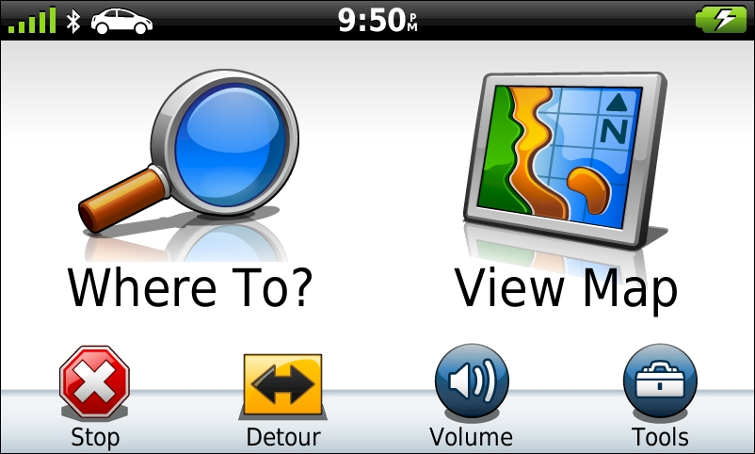

**Figure 1**

For my design, once the system is powered on, it will by default display the map so that the user can just turn it on and go without having to press any buttons. This setting is utilized in Waze and I have found it to be much more efficient, rather than having to click several buttons before getting to the map.

Figure 2 shows the standard display of a Garmin GPS while it is navigating. With my dream design I am aiming at cutting down the clutter on the screen and minimizing all of the displays that are not the actual map. Having so many displays and buttons on the screen at once can be very distracting while driving.

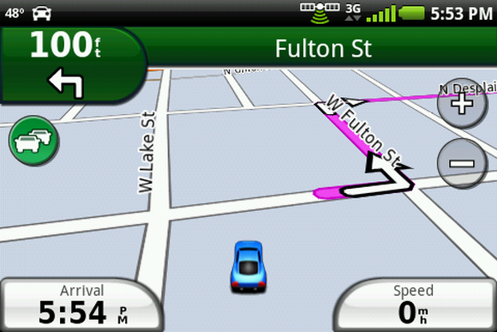

**Figure 2**

For my design the screen will display only the map and a home button, which will be on one of the corners of the screen. The user will be able to choose the position of this button depending on where the GPS is installed in their car (Example, my GPS is in front of the left corner of my windshield so I would set my home button to be at the bottom right corner so that it is closer to my hand).

*Usability Metric “Forecast”*

If this design were to be tested and measured I believe that it’s strong metrics would be efficiency and satisfaction. As a whole, using voice command interfaces, such as Siri, are more efficient than the traditional physical menu system to users that are familiar with the commands. Once the commands are learned it would be much faster and also easier to just say “GPS, go to ______” instead of going through a menu system and a list of locations.

I believe that this would also raise a higher level of user satisfaction than the traditional GPS interface. Because it has both a menu system and a voice command system, the user can chose to use which ever they are more comfortable with. I think that when using the voice command interface while driving, it would be much more satisfying to the user simply because they can do any of the features by just telling the GPS to do it for them instead of having to navigate a physical menu while driving.

Although I feel that this is a strong design that will ultimately increase the efficiency and overall user satisfaction of the device, there are some usability metrics that may suffer. The two usability metrics that I see suffering the most from my design are learnability and errors. Although voice command interfaces, such as Siri, are designed to be intuitive by using common phrases to command, it can still be hard to learn and frustrating at times. At the technologies current level the user can only say certain phrases to accomplish a particular goal. Until voice command technology increases substantially, their will always only be specific commands that must be used. Because of this, it requires the user to learn what these commands are. This can often also lead to frustration when a user cannot remember the exact command for a certain task. This can also lead to a greater number of errors if the user cannot remember the proper vocal commands. Even with this, I have found that through using Siri, the commands are quite intuitive and are often what my first guess would be to ask it, and when it isn’t, Siri can usually deduce what I am trying to do and ask me to confirm it’s guess. Because of this I believe that the system as a whole will have a larger efficiency rating, if at the cost of a higher learnability level and more initial errors.