Supplementary 2

An imputation of the missing values of the mean annual suspended sediment discharge (SSD) were done with the linear models. We used several meteorological parameters calculated on the basis of *in-situ* measurements at 7 meteostations: Kluhorskij pereval, Gudermes, Vladikavkaz, Kazbek mountain (Georgia), Nalcik, Shadzhatmaz and Oni (Georgia). Since there were also some gaps in air temperature and precipitation, we used the TerraClimate dataset to fill them. Data analysis was carried out in R using the ‘easystats’ collection of packages.

We estimated five annual meteorological parameters for every meteostation and used them as predictors:

1. P — annual sum of liquid precipitation, mm
2. n_rain — number of wet days in a year, days
3. SDII — simple precipitation intensity index, calculated as the daily precipitation amount on wet days (≥ 1 mm) in a certain time period divided by the number of wet days in that period.
4. Tav — mean annual air temperature, °C
5. Tsum — number of warm days (with average daily air temperature above 5°C) in a year, days

We fitted nine linear models for nine gauging stations:

ardta_lm — r.Ardon - s.Tamisk; belko_lm — r.Belaya - s.Kora-Ursdon; cheba_lm — r.Cherek Balkarskiy - pos.Babugent; chegnc_lm — r.Chegem - s.Nizhniy Chegem; kamol_lm — r.Kambileyevka - s.Olʹginskoye; malka_lm — r.Malka - s.Kamennomostskoye; sunbr_lm — r.Sunzha - s.Braguny; urukh_lm — r.Urukh - s.Khaznidon; fiata_lm — r.Fiagdon - s.Tagardon

Models performance indices are compared in the Table 1 below. All models explain a significant and substantial proportion of variance (mean R2 is 0.69).

**Table 1.** Comparison of performance indicies

|  |  |  |  |  |  |  |
| --- | --- | --- | --- | --- | --- | --- |
| Names | Model | R2 | RMSE | NRMSE | NSE | KGE |
| ardta_lm | Linear model | 0.66 | 0.45 | 57.30 | 0.66 | 0.74 |
| belko_lm | Linear model | 0.60 | 0.09 | 62.70 | 0.60 | 0.68 |
| cheba_lm | Linear model | 0.65 | 0.03 | 58.00 | 0.65 | 0.73 |
| chegnc_lm | Linear model | 0.61 | 0.05 | 61.70 | 0.61 | 0.69 |
| kamol_lm | Linear model | 0.64 | 0.05 | 59.00 | 0.64 | 0.72 |
| malka_lm | Linear model | 0.65 | 0.02 | 58.70 | 0.65 | 0.72 |
| sunbr_lm | Linear model | 0.84 | 1.28 | 39.20 | 0.84 | 0.88 |
| urukh_lm | Linear model | 0.72 | 0.11 | 52.50 | 0.72 | 0.78 |
| fiata_lm | Linear model | 0.82 | 0.02 | 42.40 | 0.82 | 0.86 |

## Ard-Ta

For Ardon-Tamisk we fit a linear model (estimated using OLS) to predict SSD with year, Tsum (Vladikavkaz), n_rain (Nalcik), Tav (Kazbek mountain), n_rain (Kazbek mountain) and P (Kazbek mountain) (formula: SSD ~ year + Tsum (Vladikavkaz) + n_rain (Nalcik) + Tav (Kazbek mountain) + n_rain (Kazbek mountain) + P (Kazbek mountain)) . The model explains a statistically significant and substantial proportion of variance (R2 = 0.66, F(6, 26) = 8.47, p < .001, adj. R2 = 0.58)

**Table 2.** Model parameters of the Ard-Ta linear model

|  |  |  |  |  |  |
| --- | --- | --- | --- | --- | --- |
| Parameter | Coefficient | SE | 95% CI | t(26) | p |
| (Intercept) | 69.87 | 15.10 | (38.84, 100.91) | 4.63 | < .001 |
| year | -0.04 | 7.63e-03 | (-0.05, -0.02) | -4.60 | < .001 |
| Tsum (Vladikavkaz) | 3.89e-03 | 2.80e-03 | (-1.88e-03, 9.65e-03) | 1.39 | 0.178 |
| n rain (Nalcik) | 0.02 | 8.03e-03 | (5.03e-04, 0.03) | 2.12 | 0.044 |
| Tav (Kazbek mountain) | -0.07 | 0.03 | (-0.12, -0.01) | -2.57 | 0.016 |
| n rain (Kazbek mountain) | -0.01 | 5.47e-03 | (-0.02, 5.51e-05) | -2.05 | 0.051 |
| P (Kazbek mountain) | 9.15e-04 | 4.76e-04 | (-6.27e-05, 1.89e-03) | 1.92 | 0.065 |

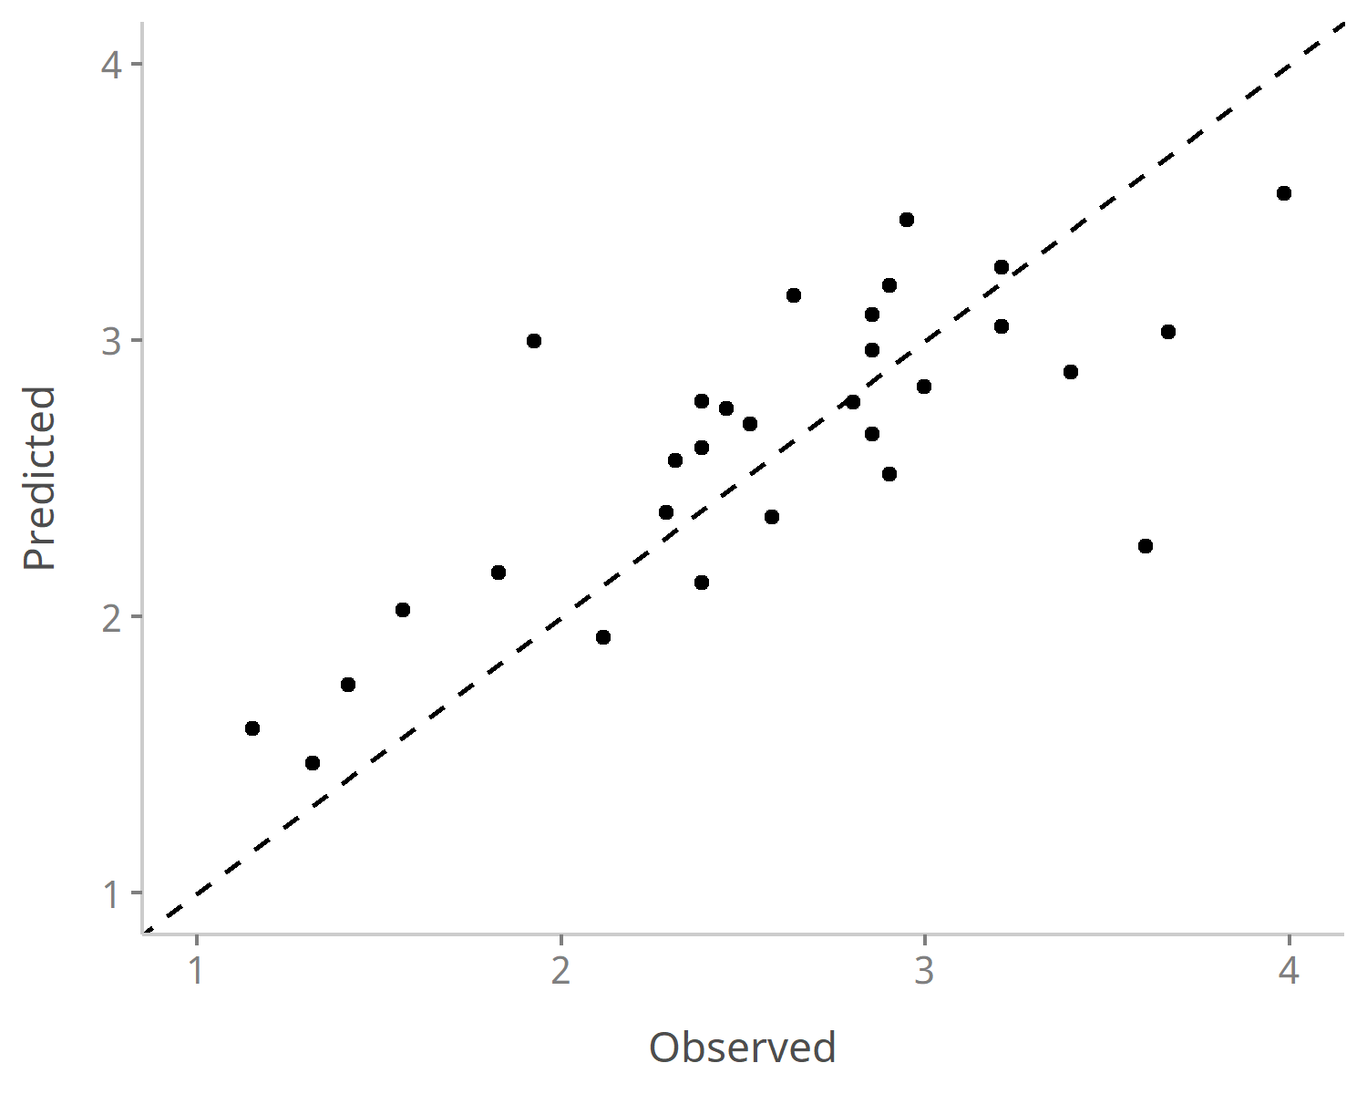

Figure 1. Observed suspended sediment discharge versus their predicted values for Ardon-Tamisk gauging station. Values after Box-Cox transformation

## Bel-Ko

For Belaya - Korsa-Urdon we fit a linear model (estimated using OLS) to predict SSD with Tsum (Nalcik), n_rain (Nalcik), SDII (Nalcik), n_rain (Kazbek mountain), P (Kazbek mountain), SDII (Kazbek mountain), Tav (Shadzhatmaz), n_rain (Shadzhatmaz), P (Shadzhatmaz), SDII (Shadzhatmaz), n_rain (Kluhorskij pereval), P (Kluhorskij pereval) and SDII (Kluhorskij pereval) (formula: SSD ~ Tsum (Nalcik) + n_rain (Nalcik) + SDII (Nalcik) + n_rain (Kazbek mountain) + P (Kazbek mountain) + SDII (Kazbek mountain) + Tav (Shadzhatmaz) + n_rain (Shadzhatmaz) + P (Shadzhatmaz) + SDII (Shadzhatmaz) + n_rain (Kluhorskij pereval) + P (Kluhorskij pereval) + SDII (Kluhorskij pereval)) . The model explains a statistically significant and substantial proportion of variance (R2 = 0.60, F(13, 36) = 4.13, p < .001, adj. R2 = 0.45)

**Table 3.** Model parameters of the Bel-Ko linear model

|  |  |  |  |  |  |
| --- | --- | --- | --- | --- | --- |
| Parameter | Coefficient | SE | 95% CI | t(36) | p |
| (Intercept) | 3.56 | 1.24 | (1.05, 6.07) | 2.88 | 0.007 |
| Tsum (Nalcik) | 4.93e-04 | 2.42e-04 | (3.02e-06, 9.83e-04) | 2.04 | 0.049 |
| n rain (Nalcik) | 3.53e-03 | 8.01e-04 | (1.90e-03, 5.15e-03) | 4.40 | < .001 |
| SDII (Nalcik) | -0.03 | 0.01 | (-0.06, -4.38e-03) | -2.34 | 0.025 |
| n rain (Kazbek mountain) | 4.04e-03 | 1.63e-03 | (7.29e-04, 7.35e-03) | 2.47 | 0.018 |
| P (Kazbek mountain) | -3.79e-04 | 2.20e-04 | (-8.26e-04, 6.81e-05) | -1.72 | 0.094 |
| SDII (Kazbek mountain) | 0.04 | 0.03 | (-0.02, 0.09) | 1.43 | 0.160 |
| Tav (Shadzhatmaz) | 0.02 | 0.01 | (-1.13e-03, 0.04) | 1.92 | 0.062 |
| n rain (Shadzhatmaz) | -0.01 | 4.76e-03 | (-0.02, -2.48e-03) | -2.55 | 0.015 |
| P (Shadzhatmaz) | 2.21e-03 | 8.37e-04 | (5.13e-04, 3.91e-03) | 2.64 | 0.012 |
| SDII (Shadzhatmaz) | -0.24 | 0.09 | (-0.43, -0.05) | -2.53 | 0.016 |
| n rain (Kluhorskij pereval) | -0.01 | 8.05e-03 | (-0.03, 2.09e-03) | -1.77 | 0.085 |
| P (Kluhorskij pereval) | 1.31e-03 | 7.18e-04 | (-1.48e-04, 2.76e-03) | 1.82 | 0.077 |
| SDII (Kluhorskij pereval) | -0.17 | 0.10 | (-0.38, 0.04) | -1.68 | 0.101 |

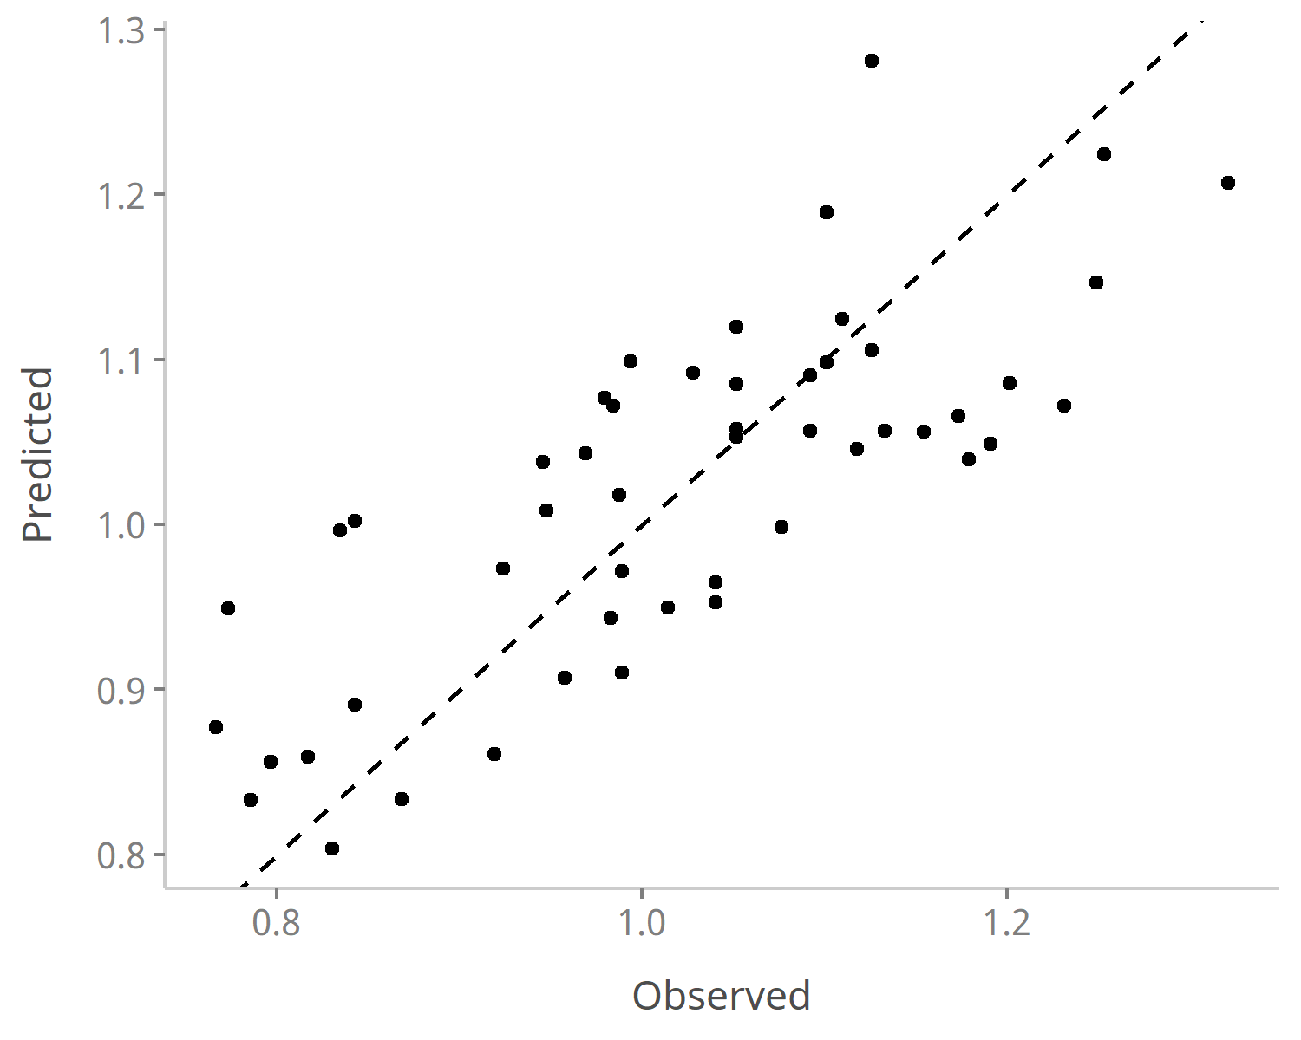

Figure 2. Observed suspended sediment discharge versus their predicted values for r.Belaya - s.Kora-Ursdon gauging station. Values after Box-Cox transformation.

## Che-Ba

For Cherek-Balkarsky - Babugent we fit a linear model (estimated using OLS) to predict SSD with year, n_rain (Vladikavkaz), P (Vladikavkaz), P (Nalcik), SDII (Nalcik), P (Gudermes), Tav (Shadzhatmaz), Tsum (Shadzhatmaz), P (Shadzhatmaz) and SDII (Shadzhatmaz) (formula: SSD ~ year + n_rain (Vladikavkaz) + P (Vladikavkaz) + P (Nalcik) + SDII (Nalcik) + P (Gudermes) + Tav (Shadzhatmaz) + Tsum (Shadzhatmaz) + P (Shadzhatmaz) + SDII (Shadzhatmaz)) . The model explains a statistically significant and substantial proportion of variance (R2 = 0.65, F(10, 26) = 4.91, p < .001, adj. R2 = 0.52)

**Table 4.** Model parameters of the Che-Ba linear model

|  |  |  |  |  |  |
| --- | --- | --- | --- | --- | --- |
| Parameter | Coefficient | SE | 95% CI | t(26) | p |
| (Intercept) | -3.42 | 0.86 | (-5.20, -1.65) | -3.96 | < .001 |
| year | 2.08e-03 | 4.35e-04 | (1.18e-03, 2.97e-03) | 4.77 | < .001 |
| n rain (Vladikavkaz) | -1.82e-03 | 5.05e-04 | (-2.86e-03, -7.83e-04) | -3.61 | 0.001 |
| P (Vladikavkaz) | 1.26e-04 | 5.55e-05 | (1.18e-05, 2.40e-04) | 2.27 | 0.032 |
| P (Nalcik) | 9.07e-05 | 4.59e-05 | (-3.54e-06, 1.85e-04) | 1.98 | 0.059 |
| SDII (Nalcik) | -0.02 | 6.14e-03 | (-0.03, -2.90e-03) | -2.53 | 0.018 |
| P (Gudermes) | 1.74e-04 | 7.33e-05 | (2.38e-05, 3.25e-04) | 2.38 | 0.025 |
| Tav (Shadzhatmaz) | -0.01 | 5.77e-03 | (-0.02, -1.25e-03) | -2.27 | 0.032 |
| Tsum (Shadzhatmaz) | 5.58e-04 | 2.19e-04 | (1.07e-04, 1.01e-03) | 2.54 | 0.017 |
| P (Shadzhatmaz) | -1.26e-04 | 7.03e-05 | (-2.71e-04, 1.82e-05) | -1.80 | 0.084 |
| SDII (Shadzhatmaz) | 0.02 | 0.01 | (1.59e-03, 0.05) | 2.20 | 0.037 |

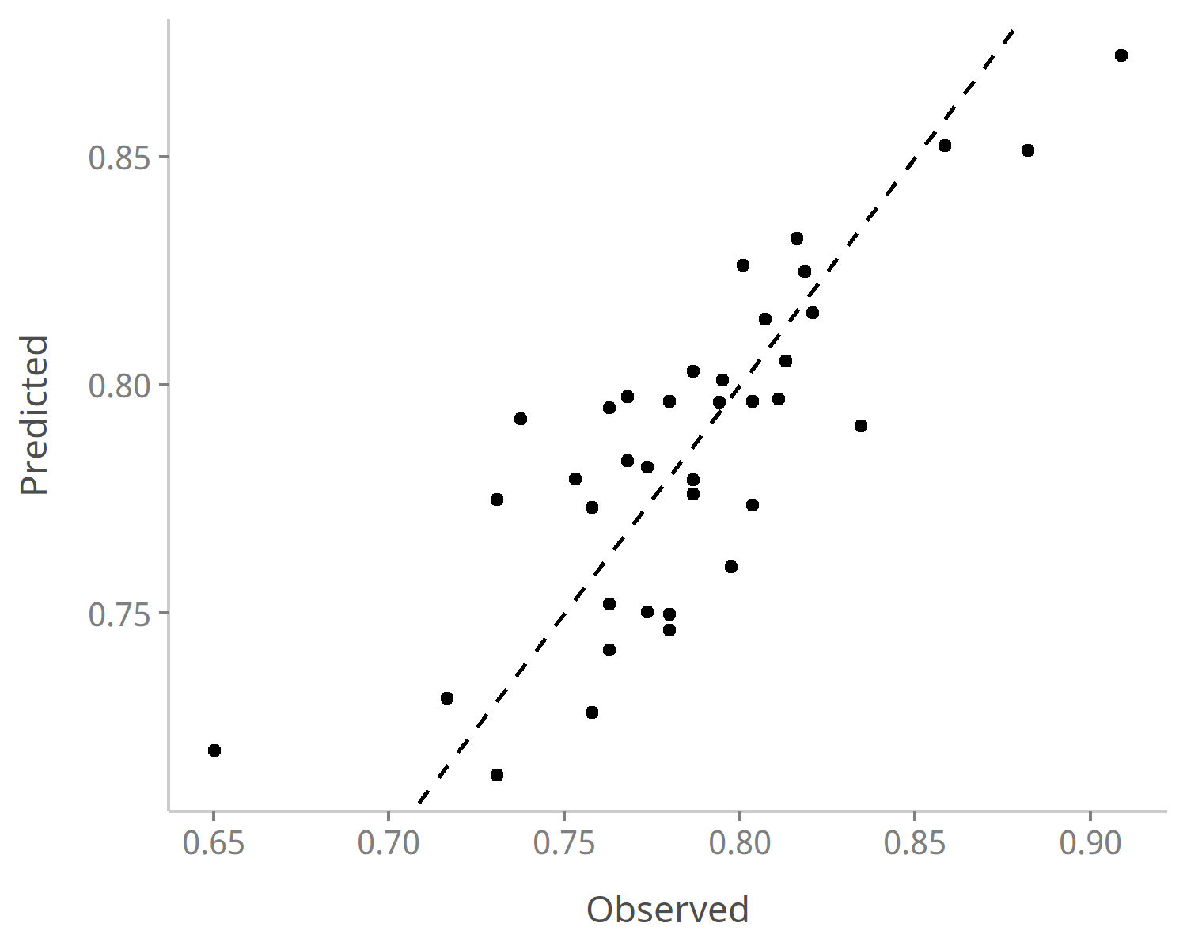

Figure 3. Observed suspended sediment discharge versus their predicted values for r.Cherek Balkarskiy - pos.Babugent gauging station. Values after Box-Cox transformation

## Cheg-Nc

For r.Chegem - s.Nizhniy Chegem we fit a linear model (estimated using OLS) to predict SSD with Tav (Vladikavkaz), Tsum (Vladikavkaz), n_rain (Vladikavkaz), P (Gudermes), Tav (Shadzhatmaz), Tsum (Shadzhatmaz), n_rain (Shadzhatmaz), Tav (Kluhorskij pereval), n_rain (Kluhorskij pereval) and SDII (Kluhorskij pereval) (formula: SSD ~ Tav (Vladikavkaz) + Tsum (Vladikavkaz) + n_rain (Vladikavkaz) + P (Gudermes) + Tav (Shadzhatmaz) + Tsum (Shadzhatmaz) + n_rain (Shadzhatmaz) + Tav (Kluhorskij pereval) + n_rain (Kluhorskij pereval) + SDII (Kluhorskij pereval)) . The model explains a statistically significant and substantial proportion of variance (R2 = 0.61, F(10, 40) = 6.30, p < .001, adj. R2 = 0.51)

**Table 5.** Model parameters of the Cheg-Nc linear model

|  |  |  |  |  |  |
| --- | --- | --- | --- | --- | --- |
| Parameter | Coefficient | SE | 95% CI | t(40) | p |
| (Intercept) | 1.07 | 0.11 | (0.86, 1.28) | 10.15 | < .001 |
| Tav (Vladikavkaz) | -0.05 | 0.01 | (-0.07, -0.02) | -3.18 | 0.003 |
| Tsum (Vladikavkaz) | 2.20e-03 | 4.56e-04 | (1.28e-03, 3.12e-03) | 4.83 | < .001 |
| n rain (Vladikavkaz) | -8.74e-04 | 4.21e-04 | (-1.72e-03, -2.39e-05) | -2.08 | 0.044 |
| P (Gudermes) | -1.67e-04 | 9.02e-05 | (-3.50e-04, 1.47e-05) | -1.86 | 0.071 |
| Tav (Shadzhatmaz) | 0.03 | 9.65e-03 | (0.01, 0.05) | 3.27 | 0.002 |
| Tsum (Shadzhatmaz) | -1.67e-03 | 4.39e-04 | (-2.56e-03, -7.80e-04) | -3.80 | < .001 |
| n rain (Shadzhatmaz) | 2.13e-03 | 6.58e-04 | (8.05e-04, 3.46e-03) | 3.24 | 0.002 |
| Tav (Kluhorskij pereval) | 0.02 | 0.01 | (-2.16e-03, 0.05) | 1.85 | 0.072 |
| n rain (Kluhorskij pereval) | 1.38e-03 | 5.65e-04 | (2.38e-04, 2.52e-03) | 2.44 | 0.019 |
| SDII (Kluhorskij pereval) | -0.01 | 5.34e-03 | (-0.03, -3.91e-03) | -2.75 | 0.009 |



Figure 4. Observed suspended sediment discharge versus their predicted values for r.Chegem - s.Nizhniy Chegem gauging station. Values after Box-Cox transformation

## Kam-Ol

For r.Kambileyevka - s.Ol<U+02B9>ginskoye we fit a linear model (estimated using OLS) to predict SSD with year, Tav (Vladikavkaz), Tsum (Vladikavkaz), P (Vladikavkaz), Tav (Kazbek mountain), P (Kazbek mountain), SDII (Kazbek mountain), Tav (Gudermes), Tav (Shadzhatmaz), P (Shadzhatmaz) and SDII (Shadzhatmaz) (formula: SSD ~ year + Tav (Vladikavkaz) + Tsum (Vladikavkaz) + P (Vladikavkaz) + Tav (Kazbek mountain) + P (Kazbek mountain) + SDII (Kazbek mountain) + Tav (Gudermes) + Tav (Shadzhatmaz) + P (Shadzhatmaz) + SDII (Shadzhatmaz)) . The model explains a statistically significant and substantial proportion of variance (R2 = 0.64, F(11, 34) = 5.60, p < .001, adj. R2 = 0.53)

**Table 6.** Model parameters of the Kam-Ol linear model

|  |  |  |  |  |  |
| --- | --- | --- | --- | --- | --- |
| Parameter | Coefficient | SE | 95% CI | t(34) | p |
| (Intercept) | -1.98 | 1.93 | (-5.90, 1.94) | -1.03 | 0.311 |
| year | 1.47e-03 | 1.02e-03 | (-6.00e-04, 3.54e-03) | 1.44 | 0.158 |
| Tav (Vladikavkaz) | 0.02 | 0.02 | (-0.01, 0.06) | 1.35 | 0.187 |
| Tsum (Vladikavkaz) | -1.43e-03 | 6.15e-04 | (-2.68e-03, -1.79e-04) | -2.32 | 0.026 |
| P (Vladikavkaz) | -1.55e-04 | 5.98e-05 | (-2.77e-04, -3.37e-05) | -2.60 | 0.014 |
| Tav (Kazbek mountain) | 5.55e-03 | 2.71e-03 | (5.01e-05, 0.01) | 2.05 | 0.048 |
| P (Kazbek mountain) | 1.84e-04 | 6.35e-05 | (5.48e-05, 3.13e-04) | 2.90 | 0.007 |
| SDII (Kazbek mountain) | -0.04 | 0.01 | (-0.06, -0.01) | -3.15 | 0.003 |
| Tav (Gudermes) | 0.03 | 7.55e-03 | (0.02, 0.05) | 4.11 | < .001 |
| Tav (Shadzhatmaz) | -0.03 | 0.01 | (-0.05, -4.96e-03) | -2.47 | 0.018 |
| P (Shadzhatmaz) | -3.24e-04 | 1.20e-04 | (-5.67e-04, -8.07e-05) | -2.71 | 0.011 |
| SDII (Shadzhatmaz) | 0.06 | 0.02 | (0.02, 0.10) | 3.10 | 0.004 |

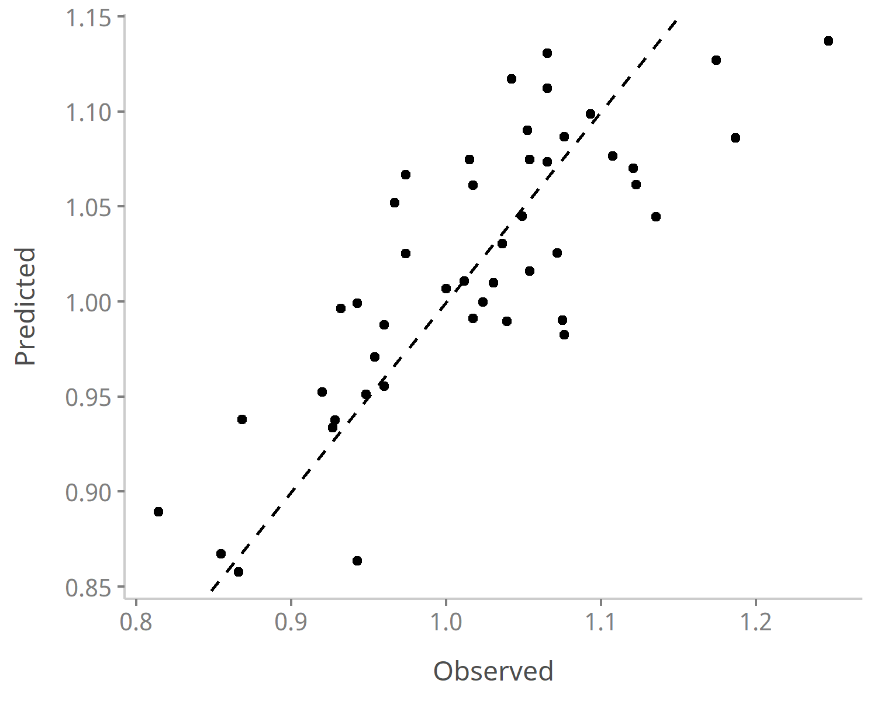

Figure 5. Observed suspended sediment discharge versus their predicted values for r.Kambileyevka - s.Ol<U+02B9>ginskoye gauging station. Values after Box-Cox transformation

## Mal-Ka

For r.Malka - s.Kamennomostskoye we fit a linear model (estimated using OLS) to predict SSD with Tav (Vladikavkaz), P (Vladikavkaz), n_rain (Nalcik), Tav (Kazbek mountain), Tsum (Kazbek mountain), Tav (Gudermes), Tsum (Gudermes), n_rain (Gudermes), SDII (Gudermes), n_rain (Shadzhatmaz), P (Shadzhatmaz), Tav (Kluhorskij pereval), Tsum (Kluhorskij pereval), n_rain (Kluhorskij pereval), P (Kazbek mountain) and P (Kluhorskij pereval) (formula: SSD ~ Tav (Vladikavkaz) + P (Vladikavkaz) + n_rain (Nalcik) + Tav (Kazbek mountain) + Tsum (Kazbek mountain) + Tav (Gudermes) + Tsum (Gudermes) + n_rain (Gudermes) + SDII (Gudermes) + n_rain (Shadzhatmaz) + P (Shadzhatmaz) + Tav (Kluhorskij pereval) + Tsum (Kluhorskij pereval) + n_rain (Kluhorskij pereval) + P (Kazbek mountain) + P (Kluhorskij pereval)) . The model explains a statistically significant and substantial proportion of variance (R2 = 0.65, F(16, 33) = 3.80, p < .001, adj. R2 = 0.48)

**Table 7.** Model parameters of the Mal-Ka linear model

|  |  |  |  |  |  |
| --- | --- | --- | --- | --- | --- |
| Parameter | Coefficient | SE | 95% CI | t(33) | p |
| (Intercept) | 1.10 | 0.06 | (0.97, 1.22) | 18.00 | < .001 |
| Tav (Vladikavkaz) | -7.37e-03 | 4.02e-03 | (-0.02, 7.99e-04) | -1.84 | 0.075 |
| P (Vladikavkaz) | 3.75e-05 | 2.58e-05 | (-1.51e-05, 9.00e-05) | 1.45 | 0.156 |
| n rain (Nalcik) | 4.95e-04 | 2.46e-04 | (-6.19e-06, 9.96e-04) | 2.01 | 0.053 |
| Tav (Kazbek mountain) | 2.51e-03 | 1.52e-03 | (-5.81e-04, 5.60e-03) | 1.65 | 0.108 |
| Tsum (Kazbek mountain) | -3.96e-04 | 1.52e-04 | (-7.06e-04, -8.64e-05) | -2.60 | 0.014 |
| Tav (Gudermes) | -0.01 | 4.59e-03 | (-0.02, -4.62e-03) | -3.04 | 0.005 |
| Tsum (Gudermes) | 5.13e-04 | 2.09e-04 | (8.90e-05, 9.37e-04) | 2.46 | 0.019 |
| n rain (Gudermes) | -1.75e-03 | 7.40e-04 | (-3.25e-03, -2.39e-04) | -2.36 | 0.024 |
| SDII (Gudermes) | -9.25e-03 | 4.20e-03 | (-0.02, -7.07e-04) | -2.20 | 0.035 |
| n rain (Shadzhatmaz) | -5.73e-04 | 4.25e-04 | (-1.44e-03, 2.92e-04) | -1.35 | 0.187 |
| P (Shadzhatmaz) | 1.07e-04 | 3.70e-05 | (3.16e-05, 1.82e-04) | 2.89 | 0.007 |
| Tav (Kluhorskij pereval) | 0.01 | 5.37e-03 | (2.18e-03, 0.02) | 2.44 | 0.020 |
| Tsum (Kluhorskij pereval) | 3.26e-04 | 1.78e-04 | (-3.53e-05, 6.88e-04) | 1.84 | 0.075 |
| n rain (Kluhorskij pereval) | 8.40e-04 | 3.50e-04 | (1.29e-04, 1.55e-03) | 2.40 | 0.022 |
| P (Kazbek mountain) | 1.93e-05 | 1.24e-05 | (-5.89e-06, 4.45e-05) | 1.56 | 0.129 |
| P (Kluhorskij pereval) | -2.25e-05 | 1.79e-05 | (-5.89e-05, 1.40e-05) | -1.26 | 0.218 |

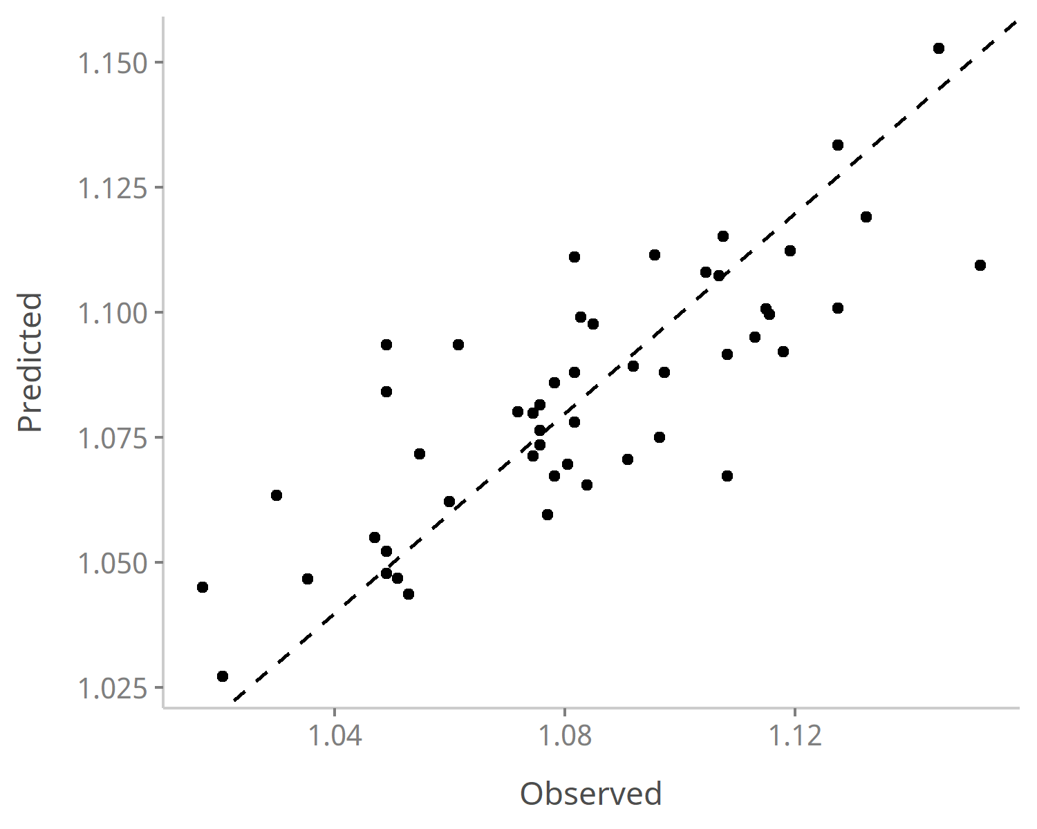

Figure 6. Observed suspended sediment discharge versus their predicted values for r.Malka - s.Kamennomostskoye gauging station. Values after Box-Cox transformation

## Sun-Br

For r.Sunzha - s.Braguny we fit a linear model (estimated using OLS) to predict SSD with year, P (Vladikavkaz), SDII (Vladikavkaz), Tsum (Kazbek mountain), P (Kazbek mountain), SDII (Kazbek mountain), Tsum (Gudermes) and P (Gudermes) (formula: SSD ~ year + P (Vladikavkaz) + SDII (Vladikavkaz) + Tsum (Kazbek mountain) + P (Kazbek mountain) + SDII (Kazbek mountain) + Tsum (Gudermes) + P (Gudermes)) . The model explains a statistically significant and substantial proportion of variance (R2 = 0.84, F(8, 19) = 12.50, p < .001, adj. R2 = 0.77)

**Table 8.** Model parameters of the Sun-Br linear model

|  |  |  |  |  |  |
| --- | --- | --- | --- | --- | --- |
| Parameter | Coefficient | SE | 95% CI | t(19) | p |
| (Intercept) | 177.10 | 89.26 | (-9.73, 363.93) | 1.98 | 0.062 |
| year | -0.09 | 0.04 | (-0.18, 5.30e-03) | -1.98 | 0.063 |
| P (Vladikavkaz) | 4.26e-03 | 1.93e-03 | (2.10e-04, 8.31e-03) | 2.20 | 0.040 |
| SDII (Vladikavkaz) | 0.73 | 0.24 | (0.22, 1.24) | 2.98 | 0.008 |
| Tsum (Kazbek mountain) | -0.06 | 0.02 | (-0.09, -0.02) | -3.05 | 0.007 |
| P (Kazbek mountain) | 3.45e-03 | 1.79e-03 | (-3.06e-04, 7.20e-03) | 1.92 | 0.070 |
| SDII (Kazbek mountain) | -0.54 | 0.27 | (-1.11, 0.04) | -1.96 | 0.065 |
| Tsum (Gudermes) | -0.03 | 0.02 | (-0.07, 0.01) | -1.48 | 0.154 |
| P (Gudermes) | 0.02 | 3.83e-03 | (9.76e-03, 0.03) | 4.64 | < .001 |

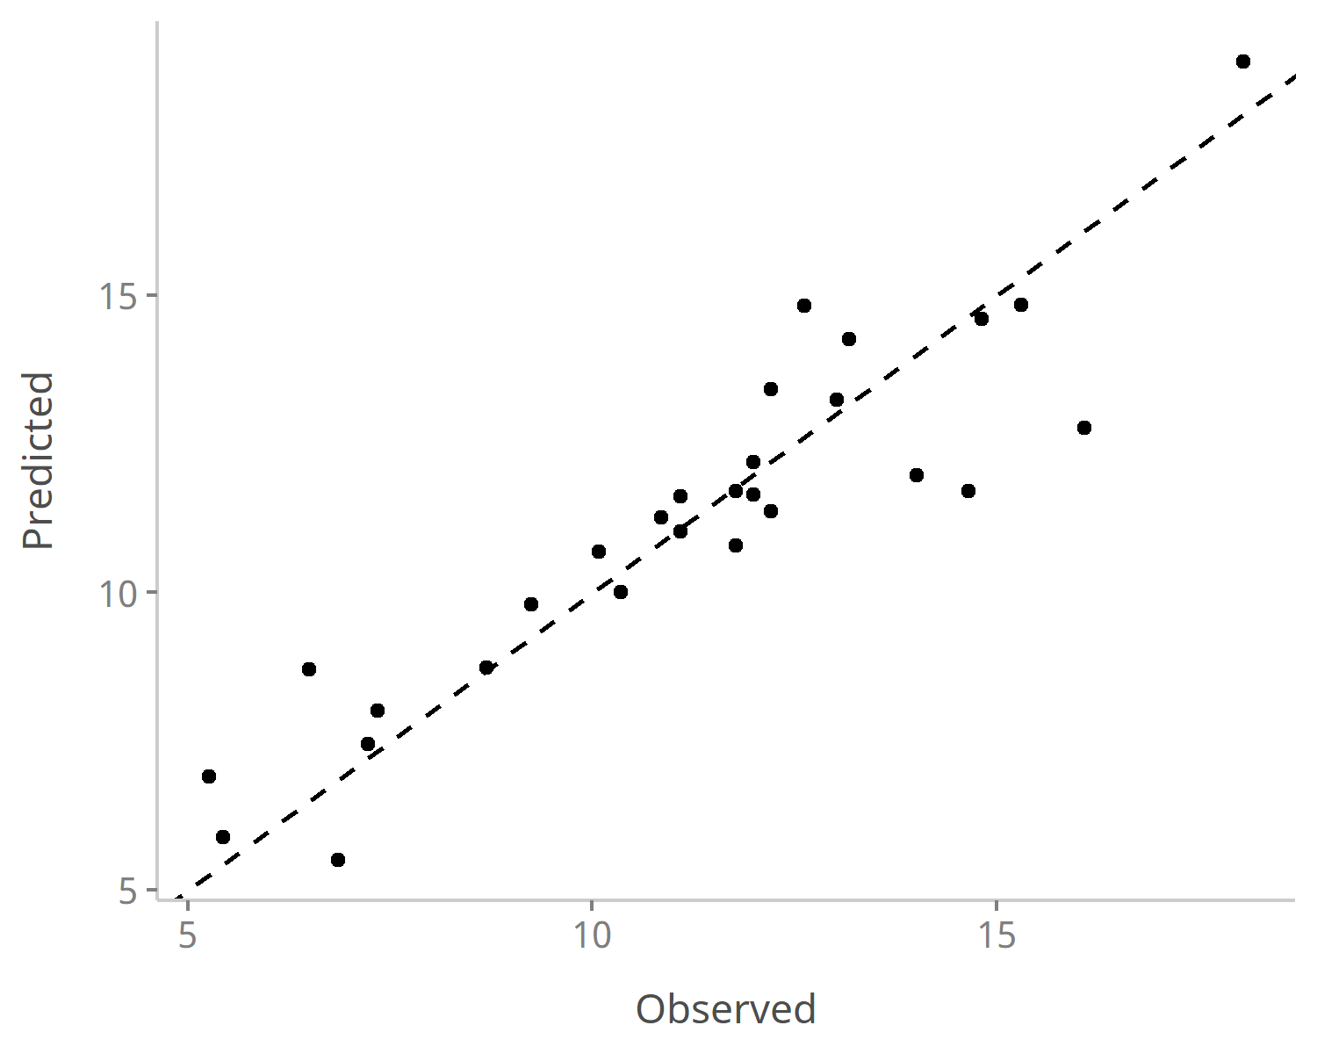

Figure 7. Observed suspended sediment discharge versus their predicted values for r.Sunzha - s.Braguny gauging station. Values after Box-Cox transformation

## Uru-Kh

For r.Urukh - s.Khaznidon we fit a linear model (estimated using OLS) to predict SSD with year, Tav (Vladikavkaz), Tsum (Vladikavkaz), P (Vladikavkaz), Tsum (Nalcik), n_rain (Nalcik), P (Nalcik), Tav (Kazbek mountain), Tsum (Kazbek mountain), n_rain (Kazbek mountain), P (Kazbek mountain), SDII (Kazbek mountain), Tav (Oni), Tsum (Oni) and n_rain (Shadzhatmaz) (formula: SSD ~ year + Tav (Vladikavkaz) + Tsum (Vladikavkaz) + P (Vladikavkaz) + Tsum (Nalcik) + n_rain (Nalcik) + P (Nalcik) + Tav (Kazbek mountain) + Tsum (Kazbek mountain) + n_rain (Kazbek mountain) + P (Kazbek mountain) + SDII (Kazbek mountain) + Tav (Oni) + Tsum (Oni) + n_rain (Shadzhatmaz)) . The model explains a statistically significant and substantial proportion of variance (R2 = 0.72, F(15, 22) = 3.72, p = 0.003, adj. R2 = 0.52)

**Table 9.** Model parameters of the Uru-Kh linear model

|  |  |  |  |  |  |
| --- | --- | --- | --- | --- | --- |
| Parameter | Coefficient | SE | 95% CI | t(22) | p |
| (Intercept) | -12.81 | 6.30 | (-25.89, 0.26) | -2.03 | 0.054 |
| year | 8.52e-03 | 3.31e-03 | (1.66e-03, 0.02) | 2.57 | 0.017 |
| Tav (Vladikavkaz) | -0.08 | 0.05 | (-0.19, 0.03) | -1.48 | 0.153 |
| Tsum (Vladikavkaz) | 5.81e-03 | 1.80e-03 | (2.08e-03, 9.54e-03) | 3.23 | 0.004 |
| P (Vladikavkaz) | -6.22e-04 | 2.65e-04 | (-1.17e-03, -7.30e-05) | -2.35 | 0.028 |
| Tsum (Nalcik) | -9.66e-04 | 5.70e-04 | (-2.15e-03, 2.17e-04) | -1.69 | 0.104 |
| n rain (Nalcik) | -5.09e-03 | 3.07e-03 | (-0.01, 1.27e-03) | -1.66 | 0.111 |
| P (Nalcik) | 7.43e-04 | 2.84e-04 | (1.54e-04, 1.33e-03) | 2.61 | 0.016 |
| Tav (Kazbek mountain) | -0.02 | 0.02 | (-0.05, 0.01) | -1.32 | 0.202 |
| Tsum (Kazbek mountain) | 1.85e-03 | 1.16e-03 | (-5.67e-04, 4.26e-03) | 1.59 | 0.127 |
| n rain (Kazbek mountain) | -7.65e-03 | 2.81e-03 | (-0.01, -1.81e-03) | -2.72 | 0.013 |
| P (Kazbek mountain) | 1.06e-03 | 4.04e-04 | (2.24e-04, 1.90e-03) | 2.63 | 0.015 |
| SDII (Kazbek mountain) | -0.14 | 0.05 | (-0.24, -0.03) | -2.70 | 0.013 |
| Tav (Oni) | -0.05 | 0.02 | (-0.10, -9.77e-03) | -2.55 | 0.018 |
| Tsum (Oni) | -1.79e-03 | 5.71e-04 | (-2.98e-03, -6.08e-04) | -3.14 | 0.005 |
| n rain (Shadzhatmaz) | -8.41e-03 | 2.30e-03 | (-0.01, -3.65e-03) | -3.66 | 0.001 |

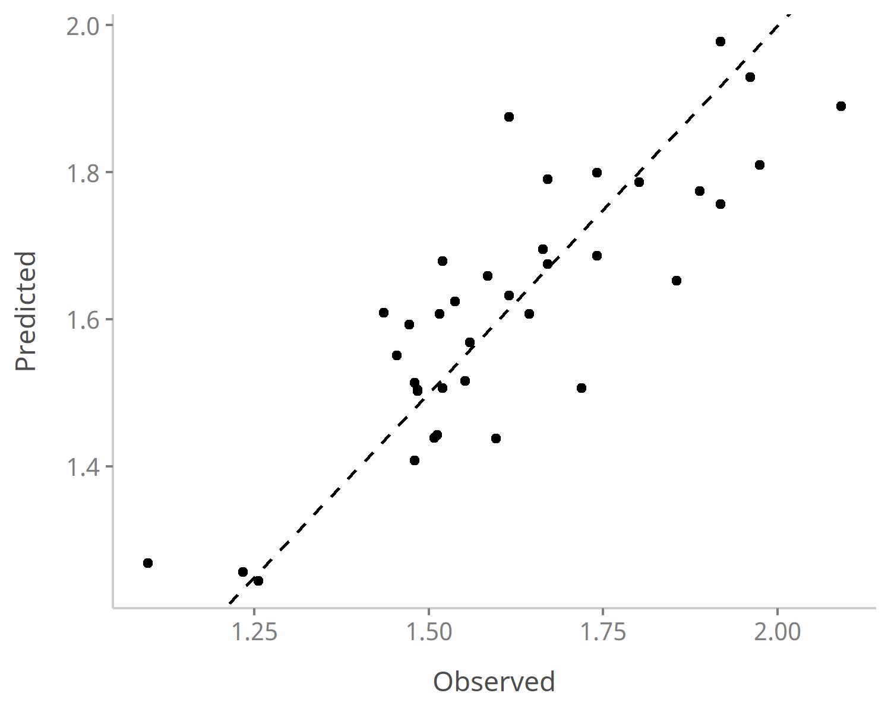

Figure 8. Observed suspended sediment discharge versus their predicted values for r.Urukh - s.Khaznidon gauging station. Values after Box-Cox transformation

## Fia-Ta

For r.Fiagdon - s.Tagardon we fit a linear model (estimated using OLS) to predict SSD with year, Tav (Vladikavkaz), Tsum (Vladikavkaz), P (Vladikavkaz), Tav (Nalcik), n_rain (Nalcik), Tav (Kazbek mountain), Tsum (Kazbek mountain), P (Kazbek mountain), SDII (Kazbek mountain), Tav (Oni), Tsum (Oni), Tsum (Shadzhatmaz) and n_rain (Shadzhatmaz) (formula: SSD ~ year + Tav (Vladikavkaz) + Tsum (Vladikavkaz) + P (Vladikavkaz) + Tav (Nalcik) + n_rain (Nalcik) + Tav (Kazbek mountain) + Tsum (Kazbek mountain) + P (Kazbek mountain) + SDII (Kazbek mountain) + Tav (Oni) + Tsum (Oni) + Tsum (Shadzhatmaz) + n_rain (Shadzhatmaz)) . The model explains a statistically significant and substantial proportion of variance (R2 = 0.82, F(14, 28) = 8.85, p < .001, adj. R2 = 0.72)

**Table 10.** Model parameters of the Fia-Ta linear model

|  |  |  |  |  |  |
| --- | --- | --- | --- | --- | --- |
| Parameter | Coefficient | SE | 95% CI | t(28) | p |
| (Intercept) | 3.68 | 0.96 | (1.71, 5.65) | 3.82 | < .001 |
| year | -1.27e-03 | 5.09e-04 | (-2.31e-03, -2.30e-04) | -2.50 | 0.019 |
| Tav (Vladikavkaz) | -0.02 | 8.50e-03 | (-0.03, 1.92e-03) | -1.82 | 0.079 |
| Tsum (Vladikavkaz) | 4.88e-04 | 2.57e-04 | (-3.93e-05, 1.01e-03) | 1.90 | 0.068 |
| P (Vladikavkaz) | -3.53e-05 | 2.78e-05 | (-9.23e-05, 2.17e-05) | -1.27 | 0.215 |
| Tav (Nalcik) | -3.96e-03 | 2.98e-03 | (-0.01, 2.14e-03) | -1.33 | 0.194 |
| n rain (Nalcik) | -5.13e-04 | 2.99e-04 | (-1.13e-03, 9.97e-05) | -1.72 | 0.097 |
| Tav (Kazbek mountain) | -2.48e-03 | 2.05e-03 | (-6.68e-03, 1.72e-03) | -1.21 | 0.236 |
| Tsum (Kazbek mountain) | 4.59e-04 | 1.89e-04 | (7.19e-05, 8.46e-04) | 2.43 | 0.022 |
| P (Kazbek mountain) | 5.40e-05 | 2.81e-05 | (-3.64e-06, 1.12e-04) | 1.92 | 0.065 |
| SDII (Kazbek mountain) | -9.44e-03 | 5.34e-03 | (-0.02, 1.49e-03) | -1.77 | 0.088 |
| Tav (Oni) | -7.41e-03 | 3.01e-03 | (-0.01, -1.24e-03) | -2.46 | 0.020 |
| Tsum (Oni) | -1.28e-04 | 8.00e-05 | (-2.92e-04, 3.62e-05) | -1.60 | 0.122 |
| Tsum (Shadzhatmaz) | -3.17e-04 | 1.36e-04 | (-5.96e-04, -3.79e-05) | -2.33 | 0.027 |
| n rain (Shadzhatmaz) | 1.39e-03 | 3.20e-04 | (7.31e-04, 2.04e-03) | 4.33 | < .001 |

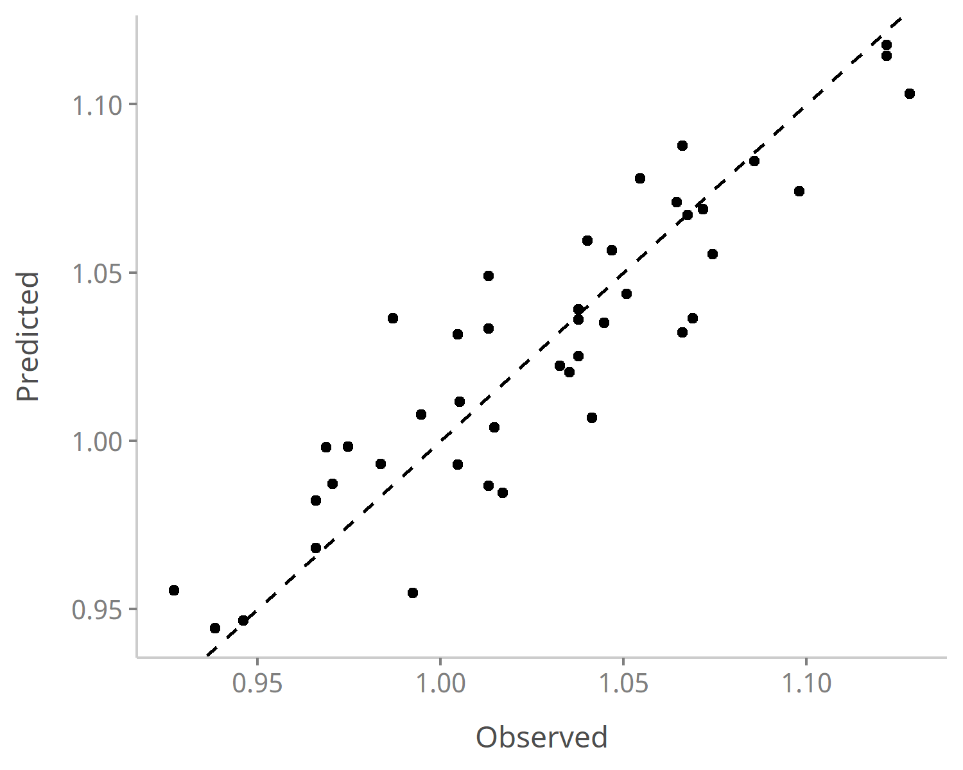

Figure 9. Observed suspended sediment discharge versus their predicted values for r.Fiagdon - s.Tagardon gauging station. Values after Box-Cox transformation