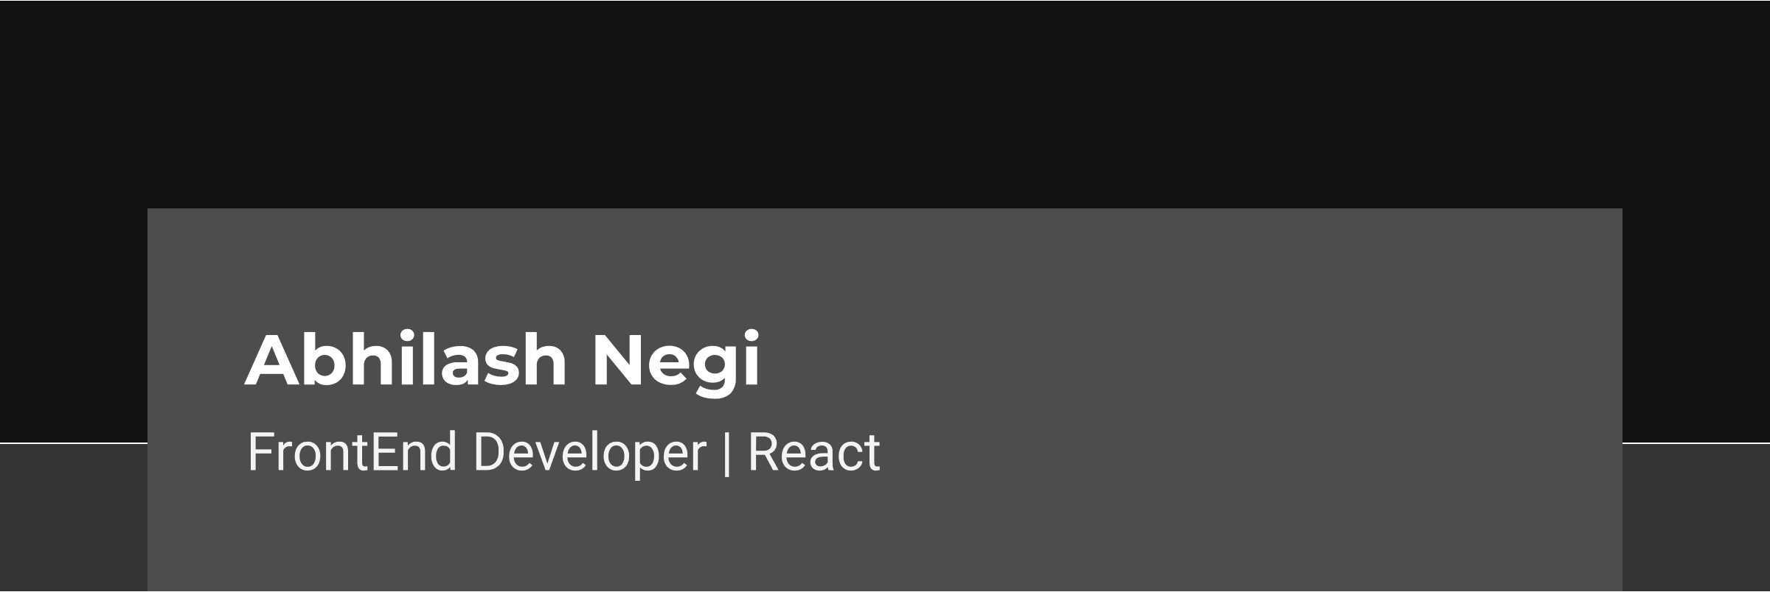

**Contact Information**

* Phone No: +91 – 8374115396
* Email ID: [abhilash.negi@infosys.com](mailto:abhilash.negi@infosys.com) | [abhi.negi.3609@gmail.com](mailto:abhi.negi.3609@gmail.com)
* GitHub: <https://githhub.com/attaboyabhilash>
* LinkedIn: <https://linkedin.com/in/abhilash-negi-247644180/>

**Skill Details**

* Vector Designing with Adobe Illustrator
* UI Design with Adobe Xd and Figma
* HTML5 and CSS3
* Modern Javascript | ES6 and ES7
* ReactJS
* Redux
* React Router
* Context API
* REST and RESTful API
* Jest and React Testing Library
* Firebase and Firestore
* MongoDB and MySQL

**Projects**

* Bubbles Application | Social Media App with React and Firebase. App Link: <https://bubbles-ee7dc.web.app/>
* Netflix Clone Application with React and Firebase. App Link: <https://netflix-clone-3609.web.app/>
* Movie Search App with React and TMDb API App Link: <https://attaboyabhilash.github.io/movieSearchApp/>
* Pomodoro Clock with React, hosted on Github Pages. App Link: <https://attaboyabhilash.github.io/movieSearchApp/>

**Education Details**

* **St. Joseph’s Degree and PG College - April 2018**

BSc in Computer Science – 94.1%

* **Rashtriya Military School, Chail - April 2015**

12th Standard – 69.6%

* **Rashtriya Military School, Chail - April 2013**

10th Standard – 9.0 GPA

**Trainings**

* Modern Javascript ES6 and ES7 training by Udemy
* Front End Libraries training by FreeCodeCamp
* Front End Developer with ReactJS training by Scrimba

**Certifications**

* Modern Javascript ES6 and ES7 Certificate by Udemy.

Certificate Link: <https://www.udemy.com/certificate/UC-45f68f9e-1dd3-4172-8abd-69390bd62241/>

* Front End Libraries Certificate by FreeCodeCamp.

Certificate Link: <https://www.freecodecamp.org/certification/attaboyabhilash/front-end-libraries>

* Front End Developer with ReactJS Certificate by Scrimba.

Certificate Link: <https://scrimba.com/certificate/ug9EvyC7/gfrontend>