AirByte Info

AirByte is an open-source data integration platform used to consolidate data from various sources. This guide will provide general information about the AirByte instance and instructions on how to connect.

Prerequisites
- Your network credentials (username and password)
- Important: AirByte is not currently able to be accessed via the SSO dashboard, SSO integration will be taking place soon.

Instructions
- Open a Web Browser: Use a modern and updated web browser such as Google Chrome, Mozilla Firefox, Microsoft Edge, or Safari.
- Navigate to the AirByte dashboard at the following URL: http://rookery.kingslanding.net
- Enter your credentials in the designated fields.
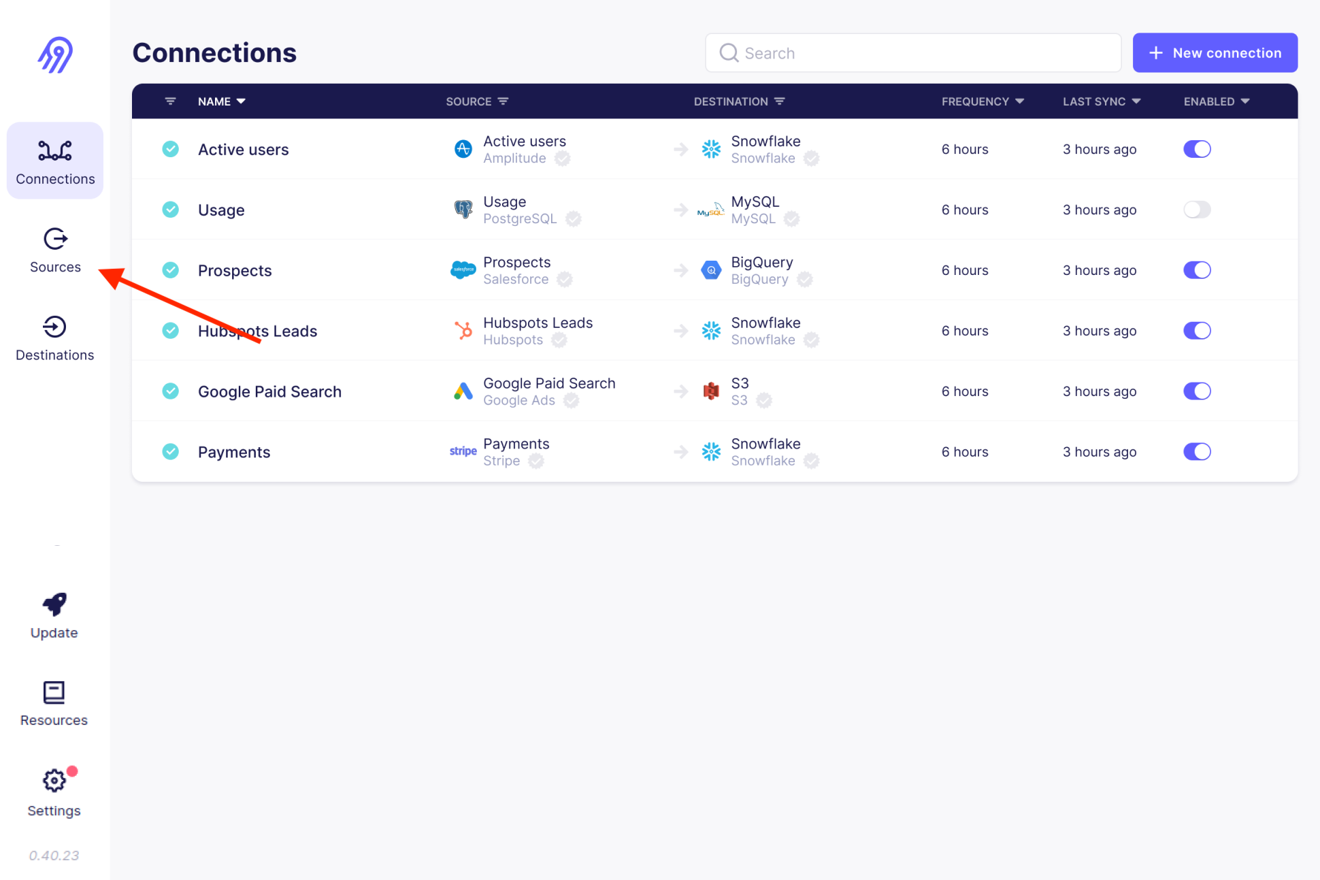
- You are now connected to the AirByte server. In the left-hand menu, browse to Sources to view the data sources backed up by AirByte (Wekan, GitLab, & more). To view where the data is loaded, navigate to the Destinations tab from the left-hand menu.

