Remote Desktop Guide

This guide provides step-by-step instructions and important information for securely connecting to the remote desktop system via Apache Guacamole.

Prerequisites
Before you begin, ensure you have the following:
- A stable internet connection
- Your company-issued device or a personal device that meets security standards
- Your network credentials (username and password)

Instructions
Step 1: Access the SSO dashboard
- Open a Web Browser: Use a modern and updated web browser such as Google Chrome, Mozilla Firefox, Microsoft Edge, or Safari.
- Navigate to the SSO URL: https://sso.kingslanding.net

Step 2: Enter Your Credentials
- Username and Password: Enter your network username and password in the designated fields.
- Enter your MFA token when prompted.

Step 3: Access the Guacamole home screen
- Open Guacamole: Once logged in, you will see a dashboard displaying all the applications you have access to. Select the Guacamole application.

Step 4: Establish the Connection
- From the Guacamole dashboard, select and connect to your host from the list of connections to initiate your remote desktop session.
- Once connected, you will see your work computer's desktop and can begin working remotely.
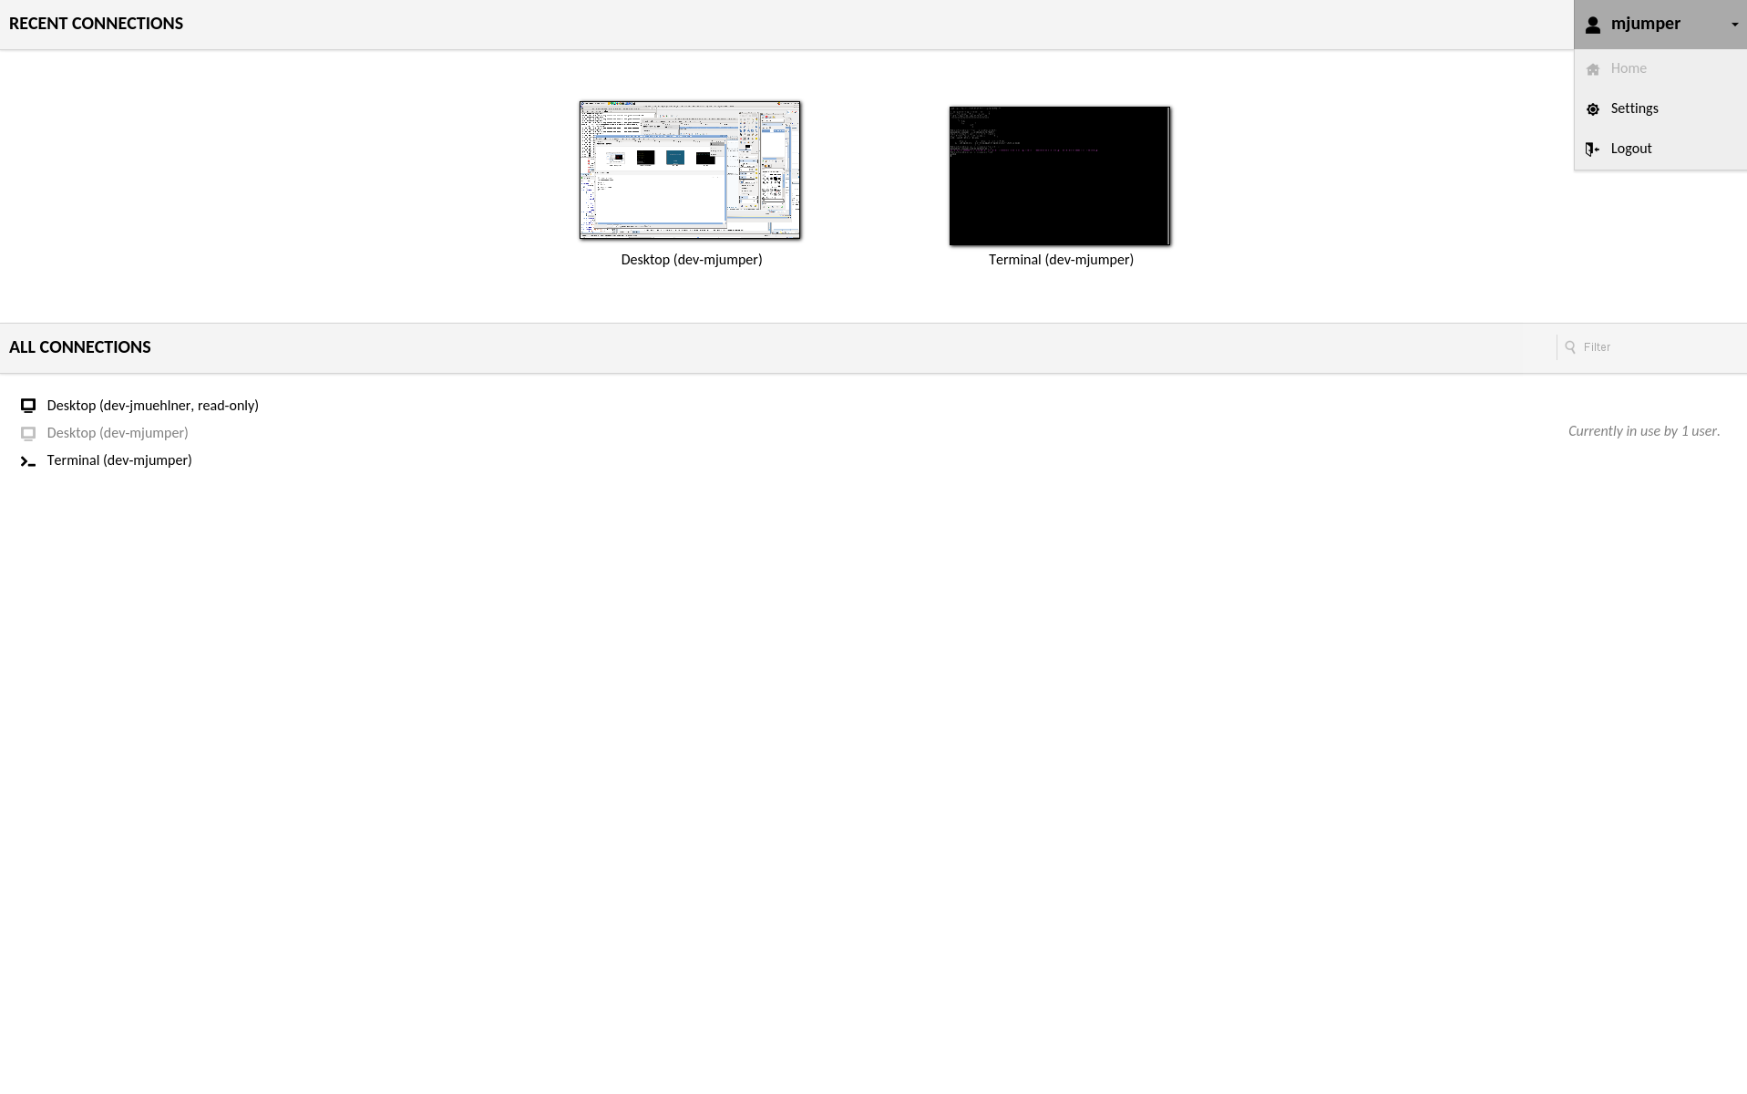

Security Best Practices
- Use Strong Passwords: Ensure your network and remote desktop passwords are strong and unique.
- Keep Software Updated: Regularly update your remote desktop software and operating system to protect against vulnerabilities.
- Log Out When Finished: Always log out of your remote desktop session when you are done working to prevent unauthorized access.

Troubleshooting Tips
- Connection Issues: Ensure your internet connection is stable.
- Authentication Errors: Double-check your username and password, and ensure your account is not locked.
- Software Problems: Restart your remote desktop software or device if you encounter technical issues.

For further assistance, contact the IT support team.

