**BlogginBow – Online blogging website**

Blogginbow is a fully-fledged blogging website with various features to ease the work of bloggers in showcasing their pieces of art. In technical terms, blogging is referred to as content marketing. In fact, content is called ‘King of Digital Marketing’, it is the foundation for successful online marketing.  Hence, it is extremely essential to blog about almost anything in today’s world, and what could be better than an easy-to-use and secure blogging platform that can help users effectively summarising their knowledge in words and pictures.

# **What all features are included in BlogginBow?**

* **User Signup** – Blogginbow uses a detailed signup form where it takes your Full name, email, gender, phone number and password.

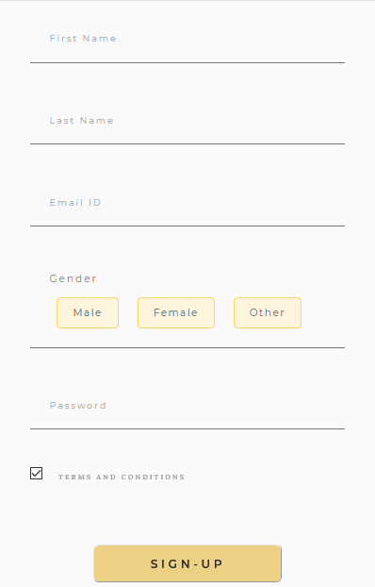

* **User Login** – The login section in pretty easy to use and it also has an admin checkbox that will give you admin access if you are a genuine admin, it restricts you if you are try to open admin section without necessary access.

` 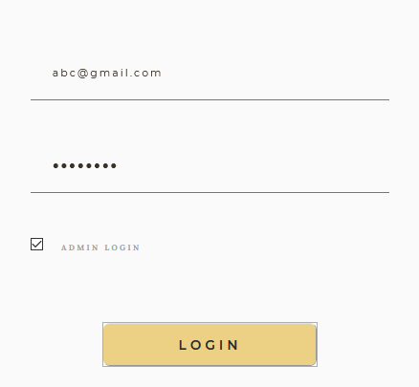

* **User home page** – After a successful signup and login, the page will redirect to the user page, where a user is welcomed and gets access to his profile, read/write blogs, update profile, upload a display picture, edit/delete blogs if exists, and the logout button.
* **Profile Page** – The profile page is a portfolio of the user where he can enter all his/her details like Phone number, Address, DP, About Social media links etc.

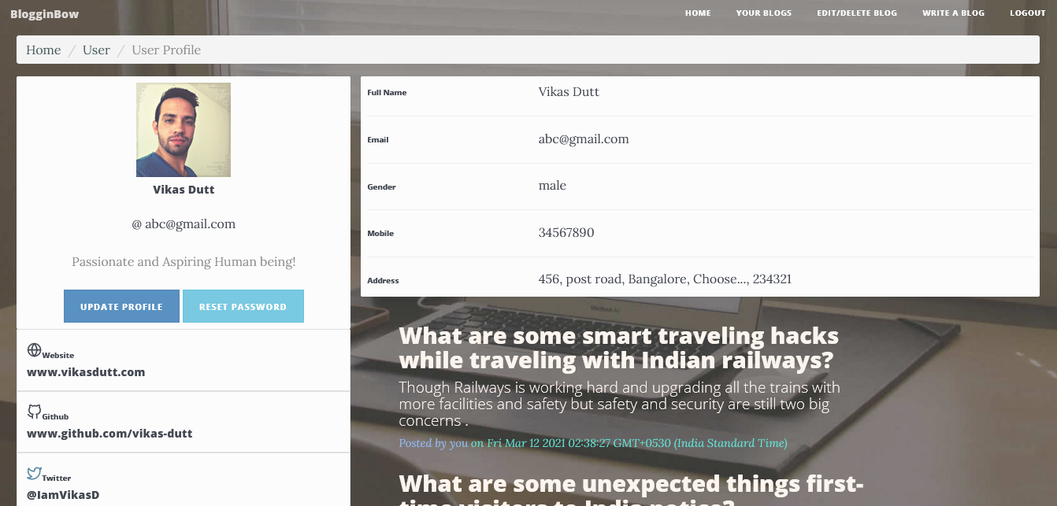

* **Update Profile** – The profile page will be initially empty and only name will be populated. User can go to update profile section and enter his/her details to complete his profile in the field shown below.

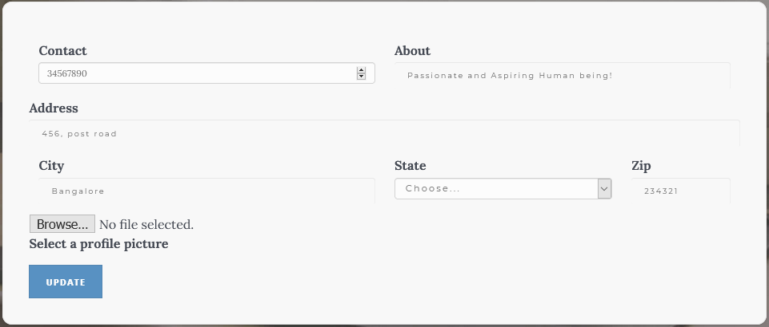

* **Password reset** – There is an option to reset the password inside profile page. It is very easy to use. User can simply enter the old password and then the new password in the respective input fields. Upon submission, the password will be changed and you will be asked to log back in with new password, provided you have entered all the details correctly. It will throw you an error if the old password doesn’t match or both of the new password fields contain different values.

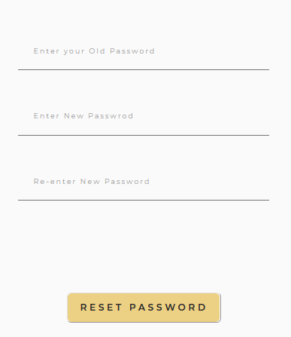

* **Write-blog section** – Here, user can write a well-structured blogpost with the help of editor provided by us. The text are for content detects the markdown text symbols and converts the plain text to a markdown content upon submission.

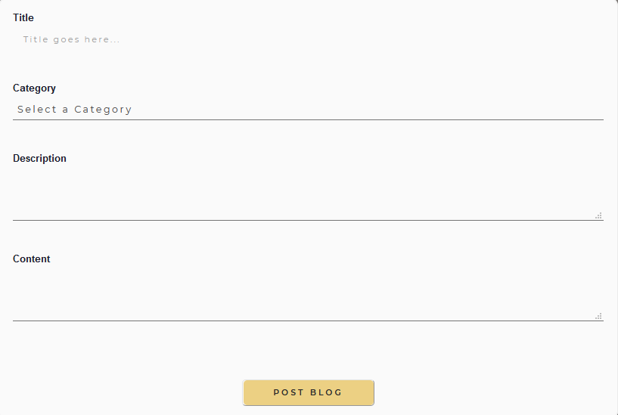

* **Read-blogs** – Users can check all their blogs listed in user page right below the header section. To read a particular blog, user can simply click on the desired blog and it will open up in a new tab with all its contents.

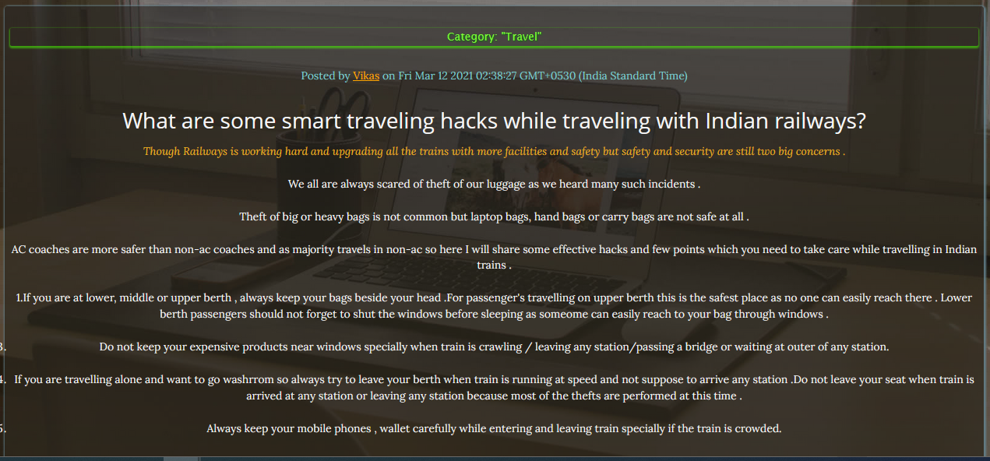

* **Edit blog** – There is a tab named Edit/Delete blog in the navbar of both the user and the profile page. Upon clicking, it will open all the all the blogs written by the user along with Edit and Delete buttons inside each blog listing. User can simply click on the Edit button to edit that particular blog contents and then repost the same.
* **Delete blog** – Under the same tab, there is also a Delete button. Upon clicking the delete button, the target blog gets deleted and removed from the user’s account as well the database.

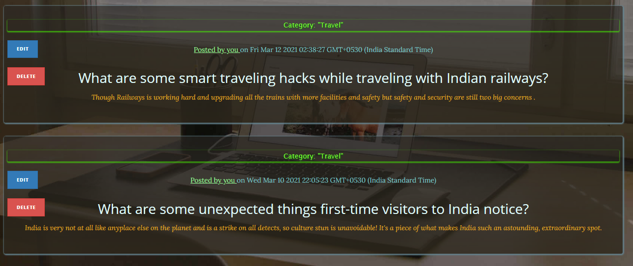

* **Comment section** – Whenever someone opens a particular blog by clicking on it, it will open in a new tab along with a comment section at the bottom of the page which will contains all the comments posted by the readers along with their name and content of the comment.

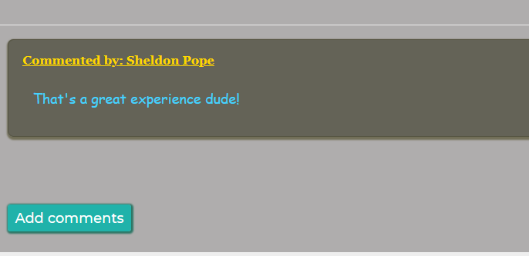

* **Comment button** – The comment section has a comment button which will open a modal upon clicking. The reader or the user can enter their name and the comments then click on post comment button to submit the comment for that particular blog. Comments without name or body will not be accepted.

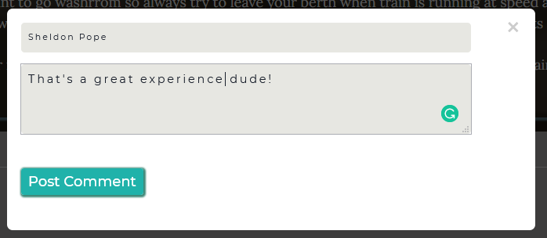

* **BlogginBow Home** – The home page of our website is accessible to both the registered and non-registered users, it consists of a Navigation bar, Header and Blogs section. The navigation panel can be used for signup, login, reading about Blogginbow and to contact us.

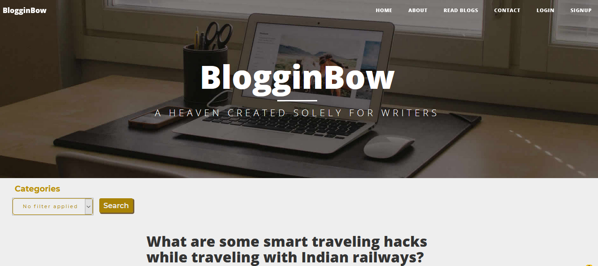

* **General reading section** – As mentioned above the homepage will have all the blogs listed in the order of *latest blog first*. Any reader, registered or non-registered user can scroll through the blogs and read it by clicking on it. They can also comment on any blogs.
* **Category filter** – A categories filter is provided on the left side of the blog listing section through which the reader can filter out the blogs as per the category of their choice and continue browsing the blog section.

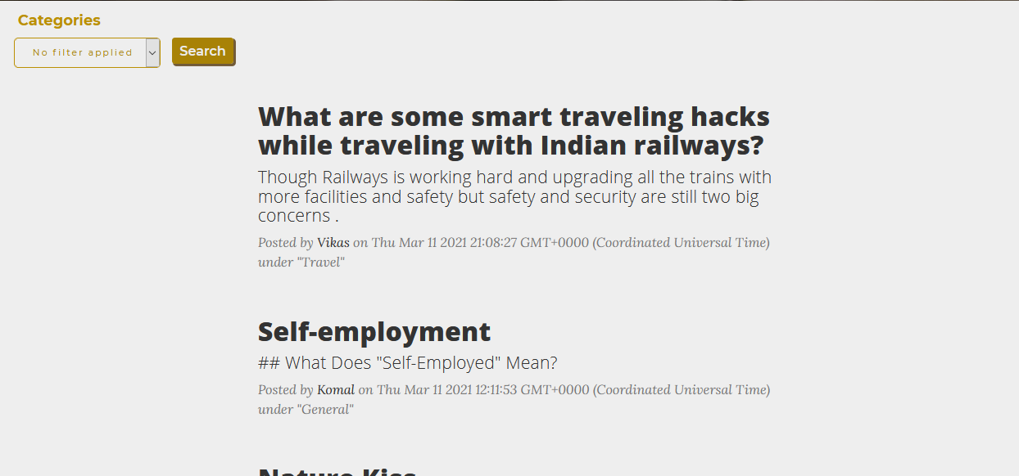

* **Admin mode** – As mentioned above, the login form also contains a checkbox for admin access. IF any admin wants to login, they have to enter their credentials and also check the admin checkbox. It will open up the Admin dashboard for them.
* **Check all Logged users** – The Admin dashboard contains the list of all those users who are currently logged in to the website. The list contains user’s first name and the email.

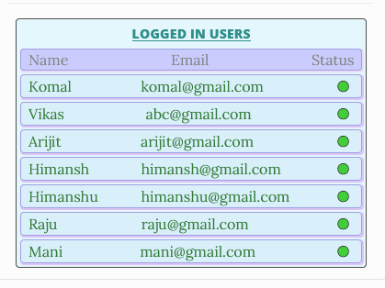

* **All registered users** – Admin also has access to see the list of all the registered users along with their name and email
* **Activate/Deactivate users** – In the Admin dashboard, the admin has access to Activate or Deactivate one or more users if he finds their blogs as inappropriate. Upon deactivation the user won’t be able to login to his profile unless activated back by the admin. It will through an error message stating “Your account is temporarily suspended”.

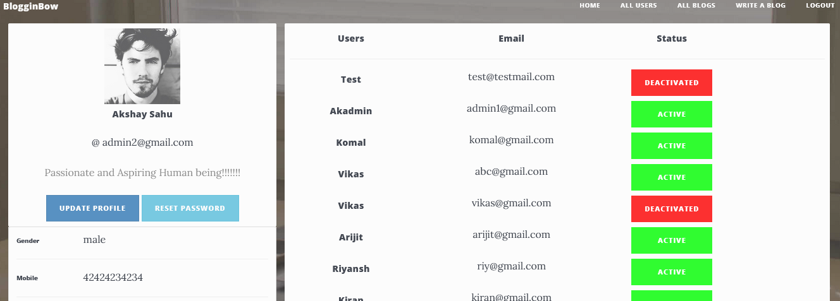

* **Check Author profile** – A normal reader can also check out the profile of the authors by clicking on the author’s name under the *posted by* section. Author profile is a read-only page along with a contact button through which a reader can contact the author via email.

Apart from all the above features, Blogginbow also has the errors and general messages section which comes into picture whenever there is any error from user or server side. It gets displayed in its respective places whenever needed.

# **Tech stacks used:**

* **JavaScript** for performing various array operations and making functions etc.
* **Node.js** as a backend language for the project
* **Express.js**, a node js framework to create a server and make API’s
* **MongoDB** to store the user data, blog data, and other comments(if any)
* **Mongoose**, a MongoDB framework to get more functionalities to retrieve and manipulate data.
* **JWT** library for user authentication
* **HTML/CSS** for designing the front end part
* **Bootstrap** to add some styles to our existing front end section
* **Handlebars** template engine for rendering views from the backend
* **Bcryptjs** library for password encryption
* **Multer** library for uploading pictures
* **Marked** library for converting plain text to markdown text

**Future Scope:**

* There is always some room for improvement, we can make the website mobile friendly and also implement responsive web design
* O-auth like Google auth or Facebook auth can be implemented
* Reputed writers can write blogs for any business or an individual, thereby implementing a business model for creative writers to earn extra bucks from our website using their skills
* For the above-mentioned point, a safe and secure payment gateway can be implemented as well