**Snakes And Ladders**

Name: ​Abhik Dey

Batch: ​C V Raman

A mini python project on a text-based Snakes and Ladders game using Python

**Table of contents**

o Technologies

o Setup

o Usage

o Output

**Technologies**

Project is created with:

• Python: 3.8.5

**Setup**

To run this project:

1. Clone this repo.

2. Install Python

3.

o goto root directory where main.py file is present.

o Run python -m flake8 command and check for any errors:

o output of the program is executed in the terminal window, pressing enter will make the move for each player

**Usage**

Note: - please make sure you follow the commands properly

* Format to be followed
* To play the game press “enter” on the keyboard to make a move (throwing a dice) to start the game.
* After player A makes the move press “enter” again to make for player B.
* To make each move of the player the user has to press enter till the player wins the game.
* After each turn of a player the number “turn” is displayed.
* Followed by an alert, if the player (either A or B) encounters a “snake” i.e. the head of a snake, it is moved back to its tail position
* Similarly, if a player encounters a “ladder” it is moved to its tail position.
* After each successful move, the position of the player is displayed along with the number of turns used.
* After reaching an “outbound” limit i.e. reaching a number higher than 100, the player stays on the same position as it was before making the move.
* After a player reaches the final position of the board i.e. 100, a display alert is shown to show which player has won the game.
* After a player wins the game the program stops.

**Output**

Output for a regular turn:

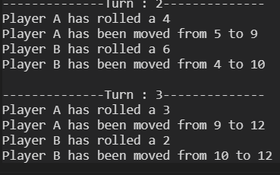

Output for a Ladder encounter:

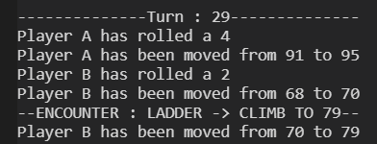

Output for out of bounds:

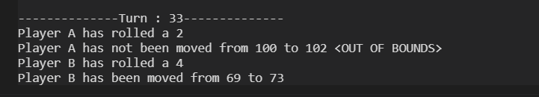

Output for Winner :

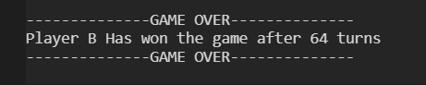

Output for Snake encounter:

