**SWIGGY(ONLINE FOOD ODDERING APP):**

**ABSTRACT:**

An Online Food Ordering System is proposed here which simplifies the food ordering process. The proposed system shows an user interface through terminal and update the menu with all available options so that it eases the customer work. Customer can choose more than one item to make an order and can view order details.

**INTRODUCTION:**

This is a Swiggy food ordering app which is built using python program which works on terminal/command prompt. In this project we will be ordering food online or altering the content of the already avaliable restaurants and its menu. It will work on admin point of view as well as user point of view. The admin will have access to alter the contents like restauarant menu details. For now it is only done through console, in updated versions it can be modified using UI part and database.

We have 3 modules:

**Order Food:**

To place the orders customer visits the restaurant, checks the menu items available in the restaurant, and chooses the items required, then places the order and then do the payment. This method demands manual work and time on the part of the customer. As restaurants have the limitations in taking the order, here have applied the processing capacity of particular restaurant to 3 orders by using the threading function.

**Join Services:**

Provides the registration for new users to join Swiggy services and provide options for updating details of existing clients.

We have two modules in other services:

**New user:** A new user can register by giving user name and password. He can add his restaurant details and add his menu by using this module

**Existing user:** Existing user has the access to add items, update price of the items in that particular restaurant.

**Exit:**

This module is used to exit from the application

**LINKS:**

**https://drive.google.com/drive/folders/168YjHchq-LAbUabnUT89La4P4IbRyuRG?usp=sharing**

**PYTHON PACKAGES:**

Time

Thread

**TECHNOLOGIES USED:**

Python 3.8, VS code

**SCREENSHOTS:**

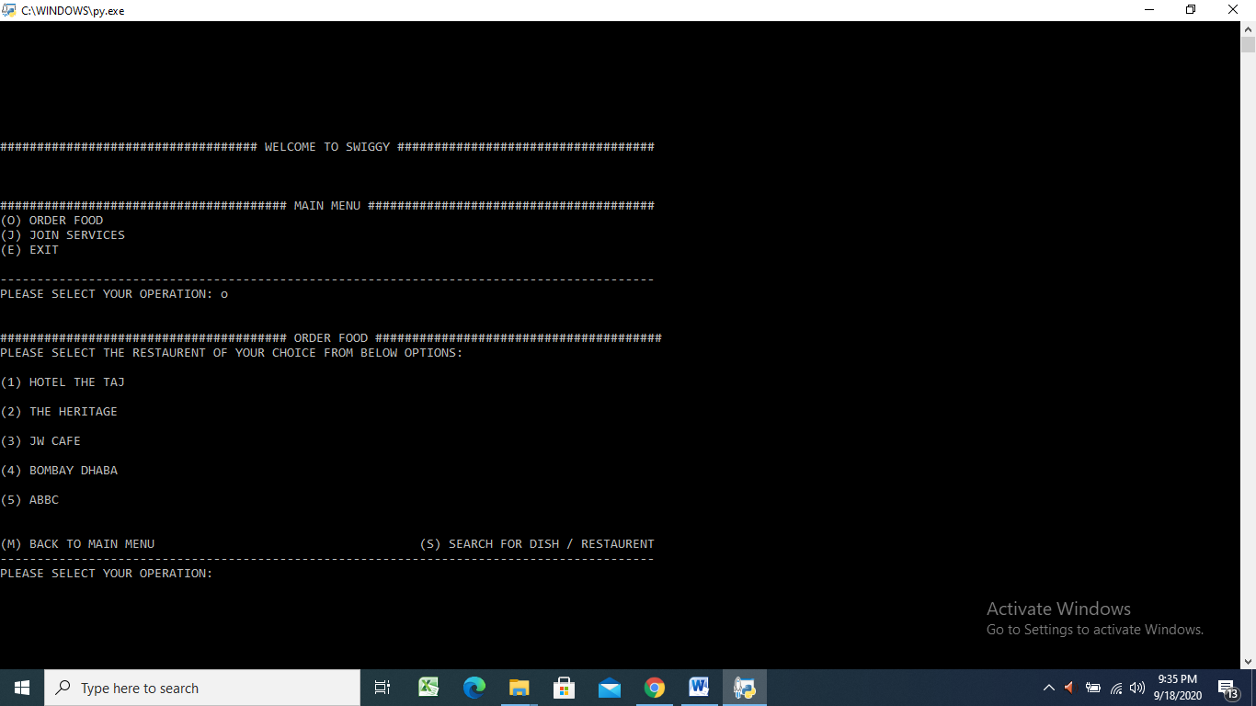

**Fig 1: Shows the Menu Page and In Order Food it will show the list of Restaurant Names**

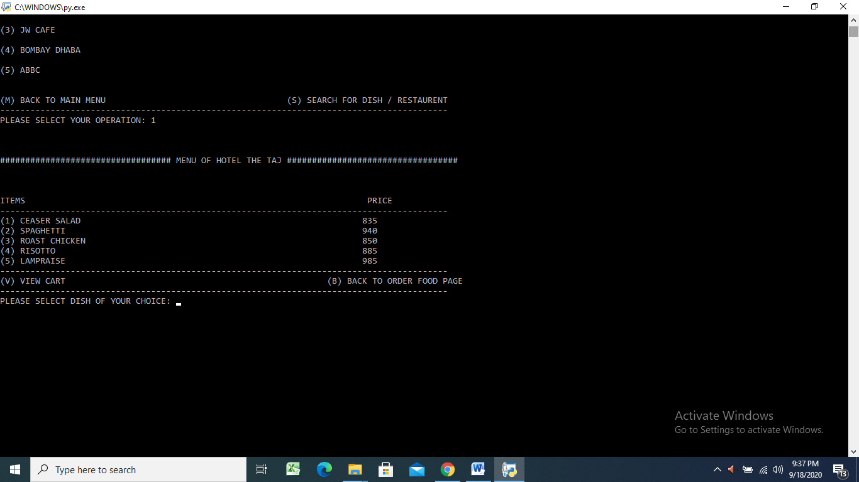

**Fig 2: We can select the particular restaurant and order the items with quantity**

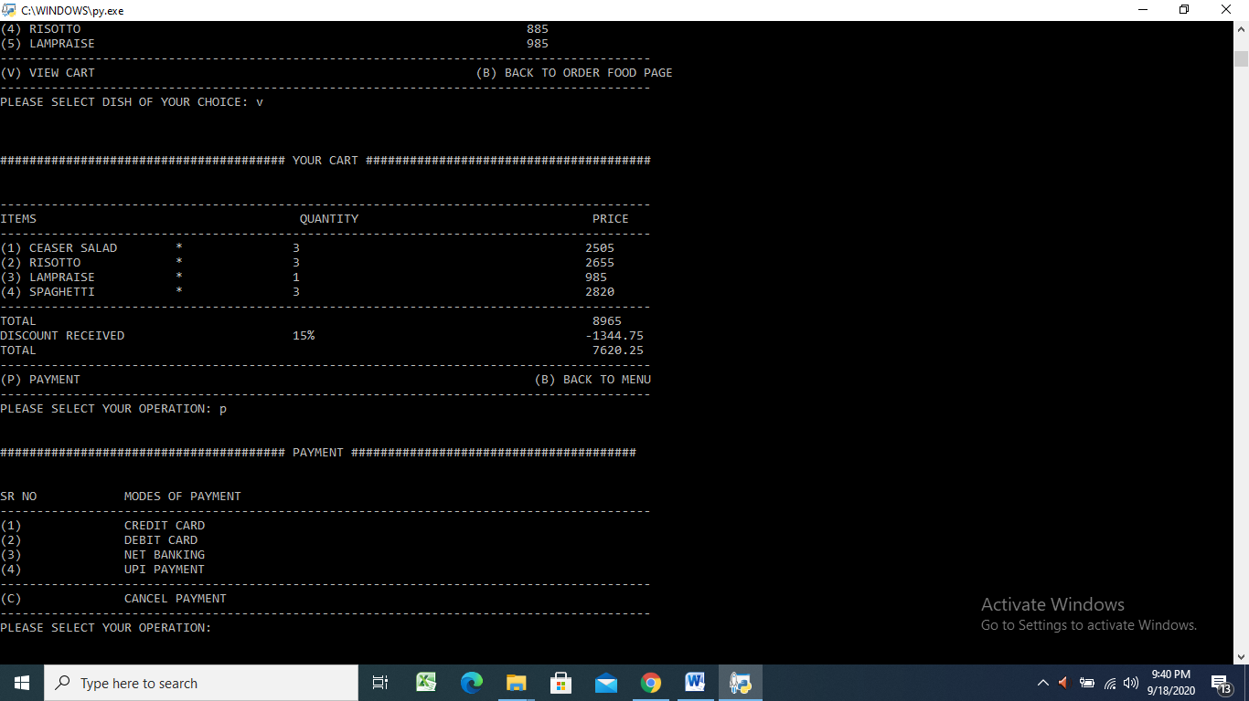

**Fig 3: We can go to cart and see the items and can do different modes of payment**

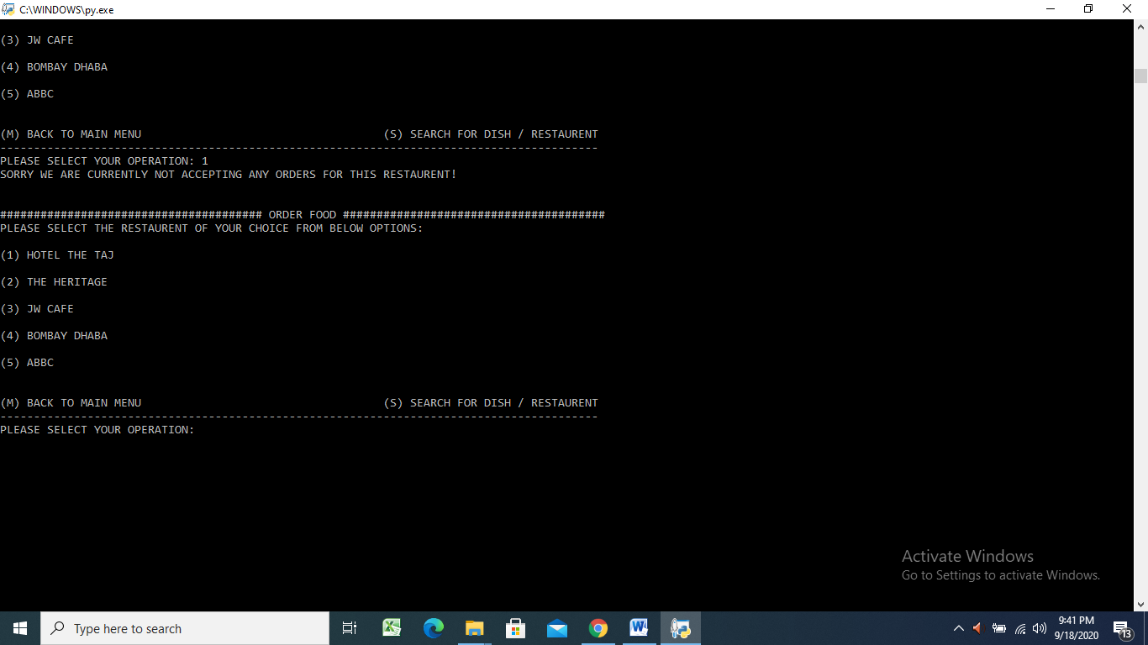

**Fig 4:When the restaurants exceeds the limit of taking orders it won’t accept further**