***Name : V Mokshith Sharma***

***Project Snake and Ladder game***

***Project Progress:***

***About:***

***How is Snake and Ladder Played?***

Rules:

1. Initally all the players are at starting position 0. Take turns according to the order to roll the dice. Move forward the number of spaces shown on the dice.

2. If you reach the bottom of a ladder at a position, move up to the head of the ladder and continue

3. If you land on the head of a snake, you must slide down to the bottom of the snake.

4. The first player to get to reach 100th position Wins .

5. Hit enter to roll the dice.

**Avoid:**

1. Press enter and wait for minimum of 0.5 milli sec for the game to exceute

2. Avoid entering number as player names

3. Make sure to enter input when starting a game

**Snake and Ladder Dice Rules:**

When a User throws a six, he is again prompted for a second chance

2. If a User throws six repeatedly three times in a row,his/her chance will be void.

Snake and Ladder PROJECT:

This project consists mainly of three components:

1. An Automated Approach

2. A Manual Approach

3. A Customizable Approach

1. Automated Approach: In The automated game the user just needs to select how many players are playing the game and the system automatically calculates the player’s position and showcases which player has won the game.

2. Manual Approach: In the manual game the user needs to enter the number of players playing the game and the name of the player. In this each action is executed on pressing the ENTER button. So if player wants to roll a dice he needs to press ENTER for the action to be performed.

3. Customizable Approach:

Features Added are:

Features Added:

        1. Increase the Board Size

        2. Adjust the Number of players that can play

        3. Update the snake and Ladder position according to your choice

4. Add the choice of your dice either 1 dice or two

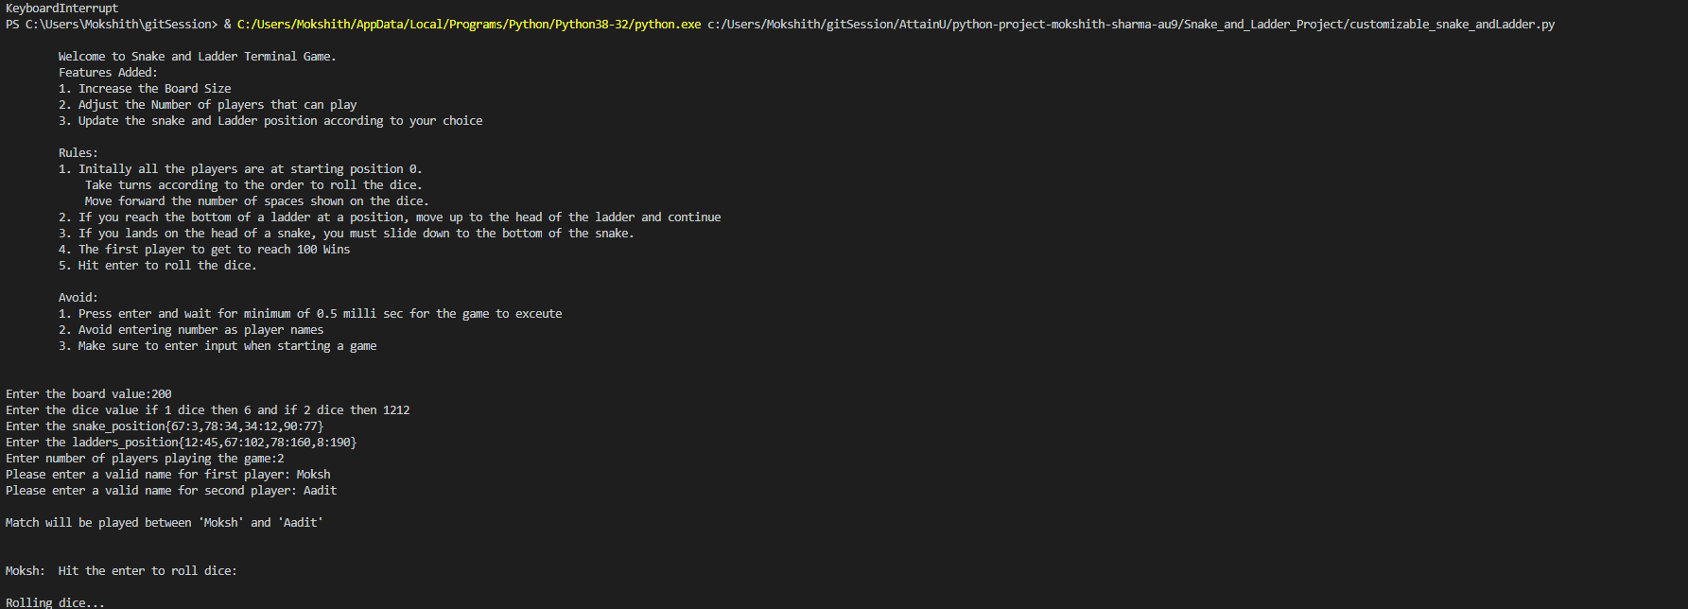

***Difference between Automated and Manual:***

|  |  |
| --- | --- |
| Automated | Manual |
| 1. Minimum number of players to play the game should be 2 | 1. Minimum number of players to play the game should be 2 |
| 2. No limit on maximum number of players that can play the game | 2. Limit on maximum players, only 4 players can play at a time. |
|  |  |
| Scenario-If 4 players are playing |  |
| 1. In Automated if 4 players are playing the maximum time taken for the game to finish is 5 to 6 sec | 1. The same cannot be said for manual game as time complexity increases with addition of each player |
| 2. Easy to implement | 2. Bit tricky to implement |

1. Automated Approach:

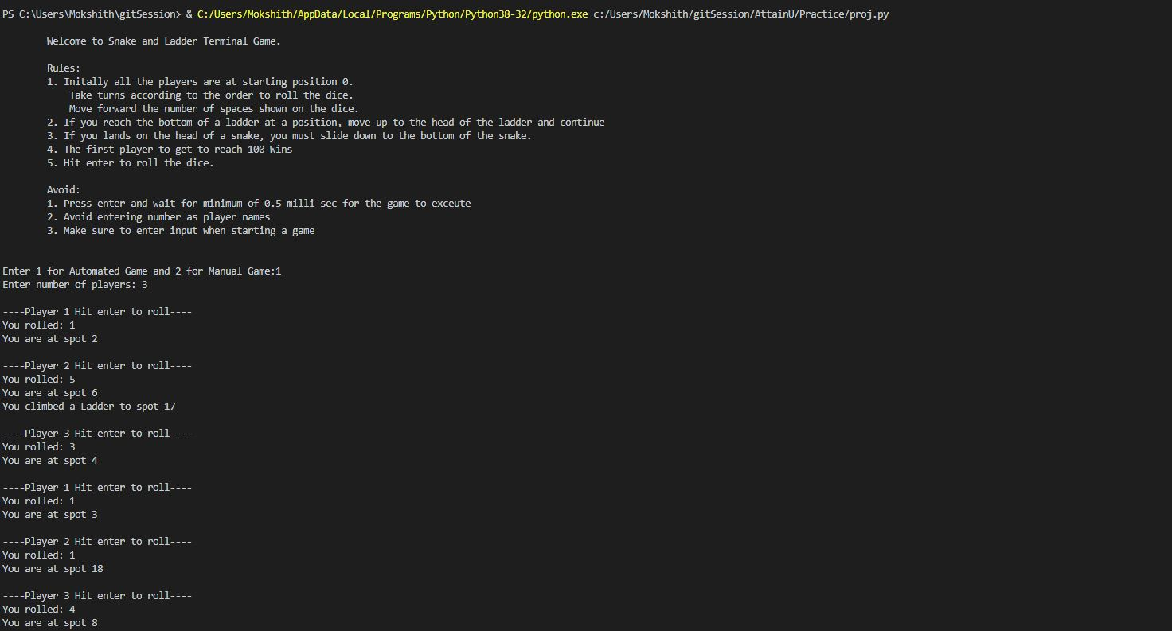

2. Manual Approach:

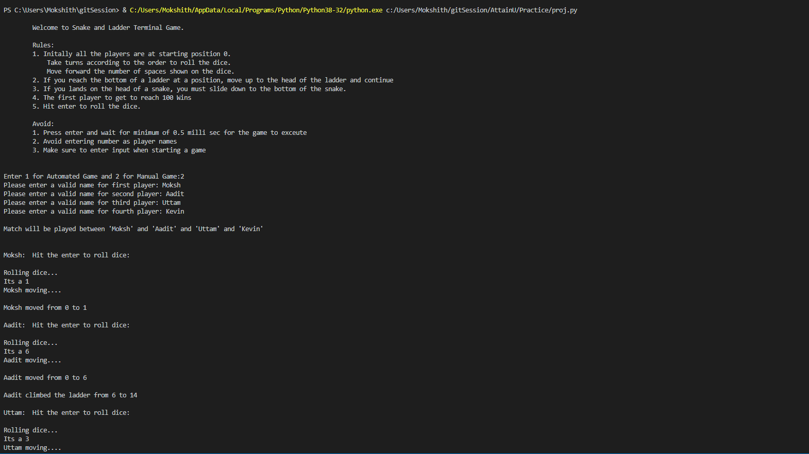

***Python Packages & Libraries Used***

1. time

2. random

3. sys

***Technologies Used:***

Python 3.8

***Future Scope:***

1. Build a GUI for this project

2. Enable animation in dice roll

3. Include sounds when the player moves, climbs ladder, or when he is hit by a snake.

4. Create a score card and give option to user to play the game 1v1,vsCpu,group match etc.

***Day 1 Progress:***

***Requirements:***

1. Username: choose number of players playing the game

2. Define the set of rules to be followed.

3. Define the ladder climb at which positions.

3: 20,

6: 14,

11: 28,

15: 34,

17: 74,

22: 37,

38: 59,

49: 67,

57: 76,

61: 78,

73: 86,

81: 98,

88: 91

4. Define the snake at which positions:

8: 4,

18: 1,

26: 10,

39: 5,

51: 6,

54: 36,

56: 1,

60: 23,

75: 28,

83: 45,

85: 59,

90: 48,

92: 25,

97: 11,

99: 63

***Day 2 Progress:***

***Process Flow:***

***Aim: Calculate Updated Position***

Answer=Updated Position

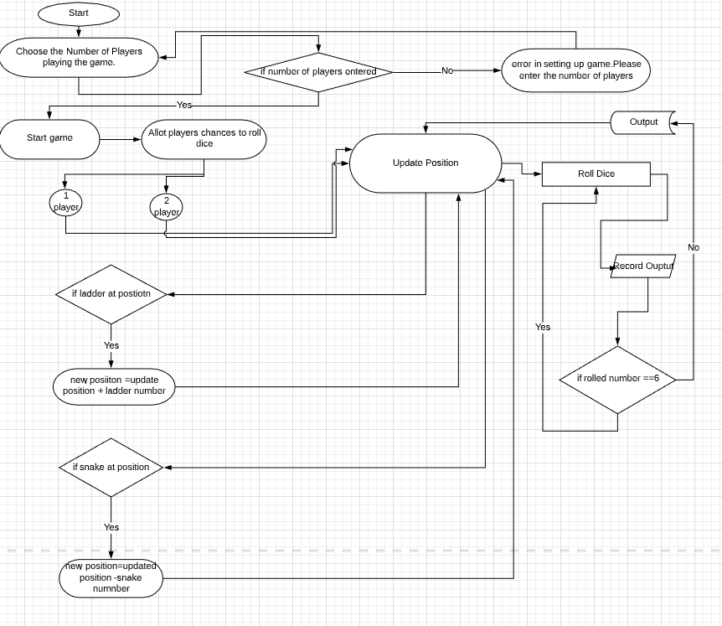

1. Start Game

2. Choose the Number of players playing the game

3, if number of players not selected, error in setting up game, choose the number of players again displayed

4. Start game

5. Allot chance to players selected/entered

***Initial Position assigned:***

6. Update their current position==0

***To move out of the 0th position***

7. If roll dice ==6 move out, updated position =1 and roll again

8. if roll dice not equal to 6 , updated position =0 and next player chance

***Check if rolled number is 6 , give another chance till chance is equal to 3***

9.res=0, if rolled dice is equal to 6

Updated position=res+6

Roll again till chances ==3

if 6 occurs 3 times continuously , updated position =updated position

***Check if Ladder Present***

10. if updated position contains ladder, new position = updated position + ladder number

Updated position =new position

11. if updated position does not contains ladder, updated position=updated position

***Check if Snake Present:***

12 if updated position contains snake:

New position = Updated position – snake Number

Updated position = new position

13. If updated position does not contain snake, then updated position = updated position

***Aim: To Calculate if any player reached 100 points***

***Check if player position ==100:***

if updated position of player ==100, player wins

end game

else continue

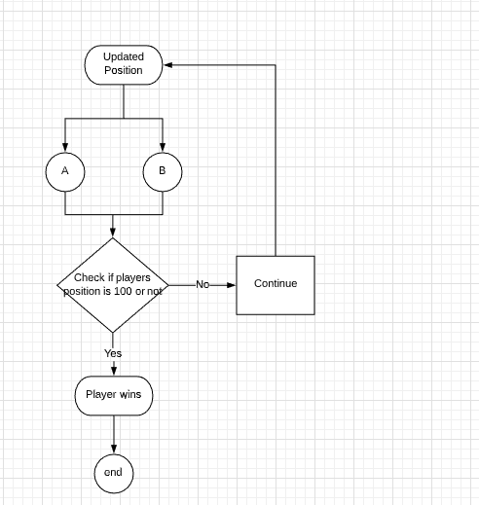

Optional Features added to this project:

1. The game is played with two dice instead of 1 and so the total dice value could be between 2 to 12 in a single move.

2. The board size can be customizable and can be taken as input before other input (snakes, ladders, players).

***Python Packages & Libraries Used***

- time: To implement the command after a certain duration

- random: To randomly select a number

- sys: For System specific parameter and functions

- ast: For converting values to dictionary values

***Conclusion:***

For the above following snake and Ladder project Three implementation have been showcased:

1. Automated Approach

2. Manual Approach

3. Customizable Approach

Future Scope that can follow in the customizable approach are:

1. Build a GUI for this project

2. Enable animation in dice roll

3. Include sounds when the player moves, climbs ladder, or when he is hit by a snake.

4. Create a score card and give option to user to play the game 1v1,vsCpu,group match etc.