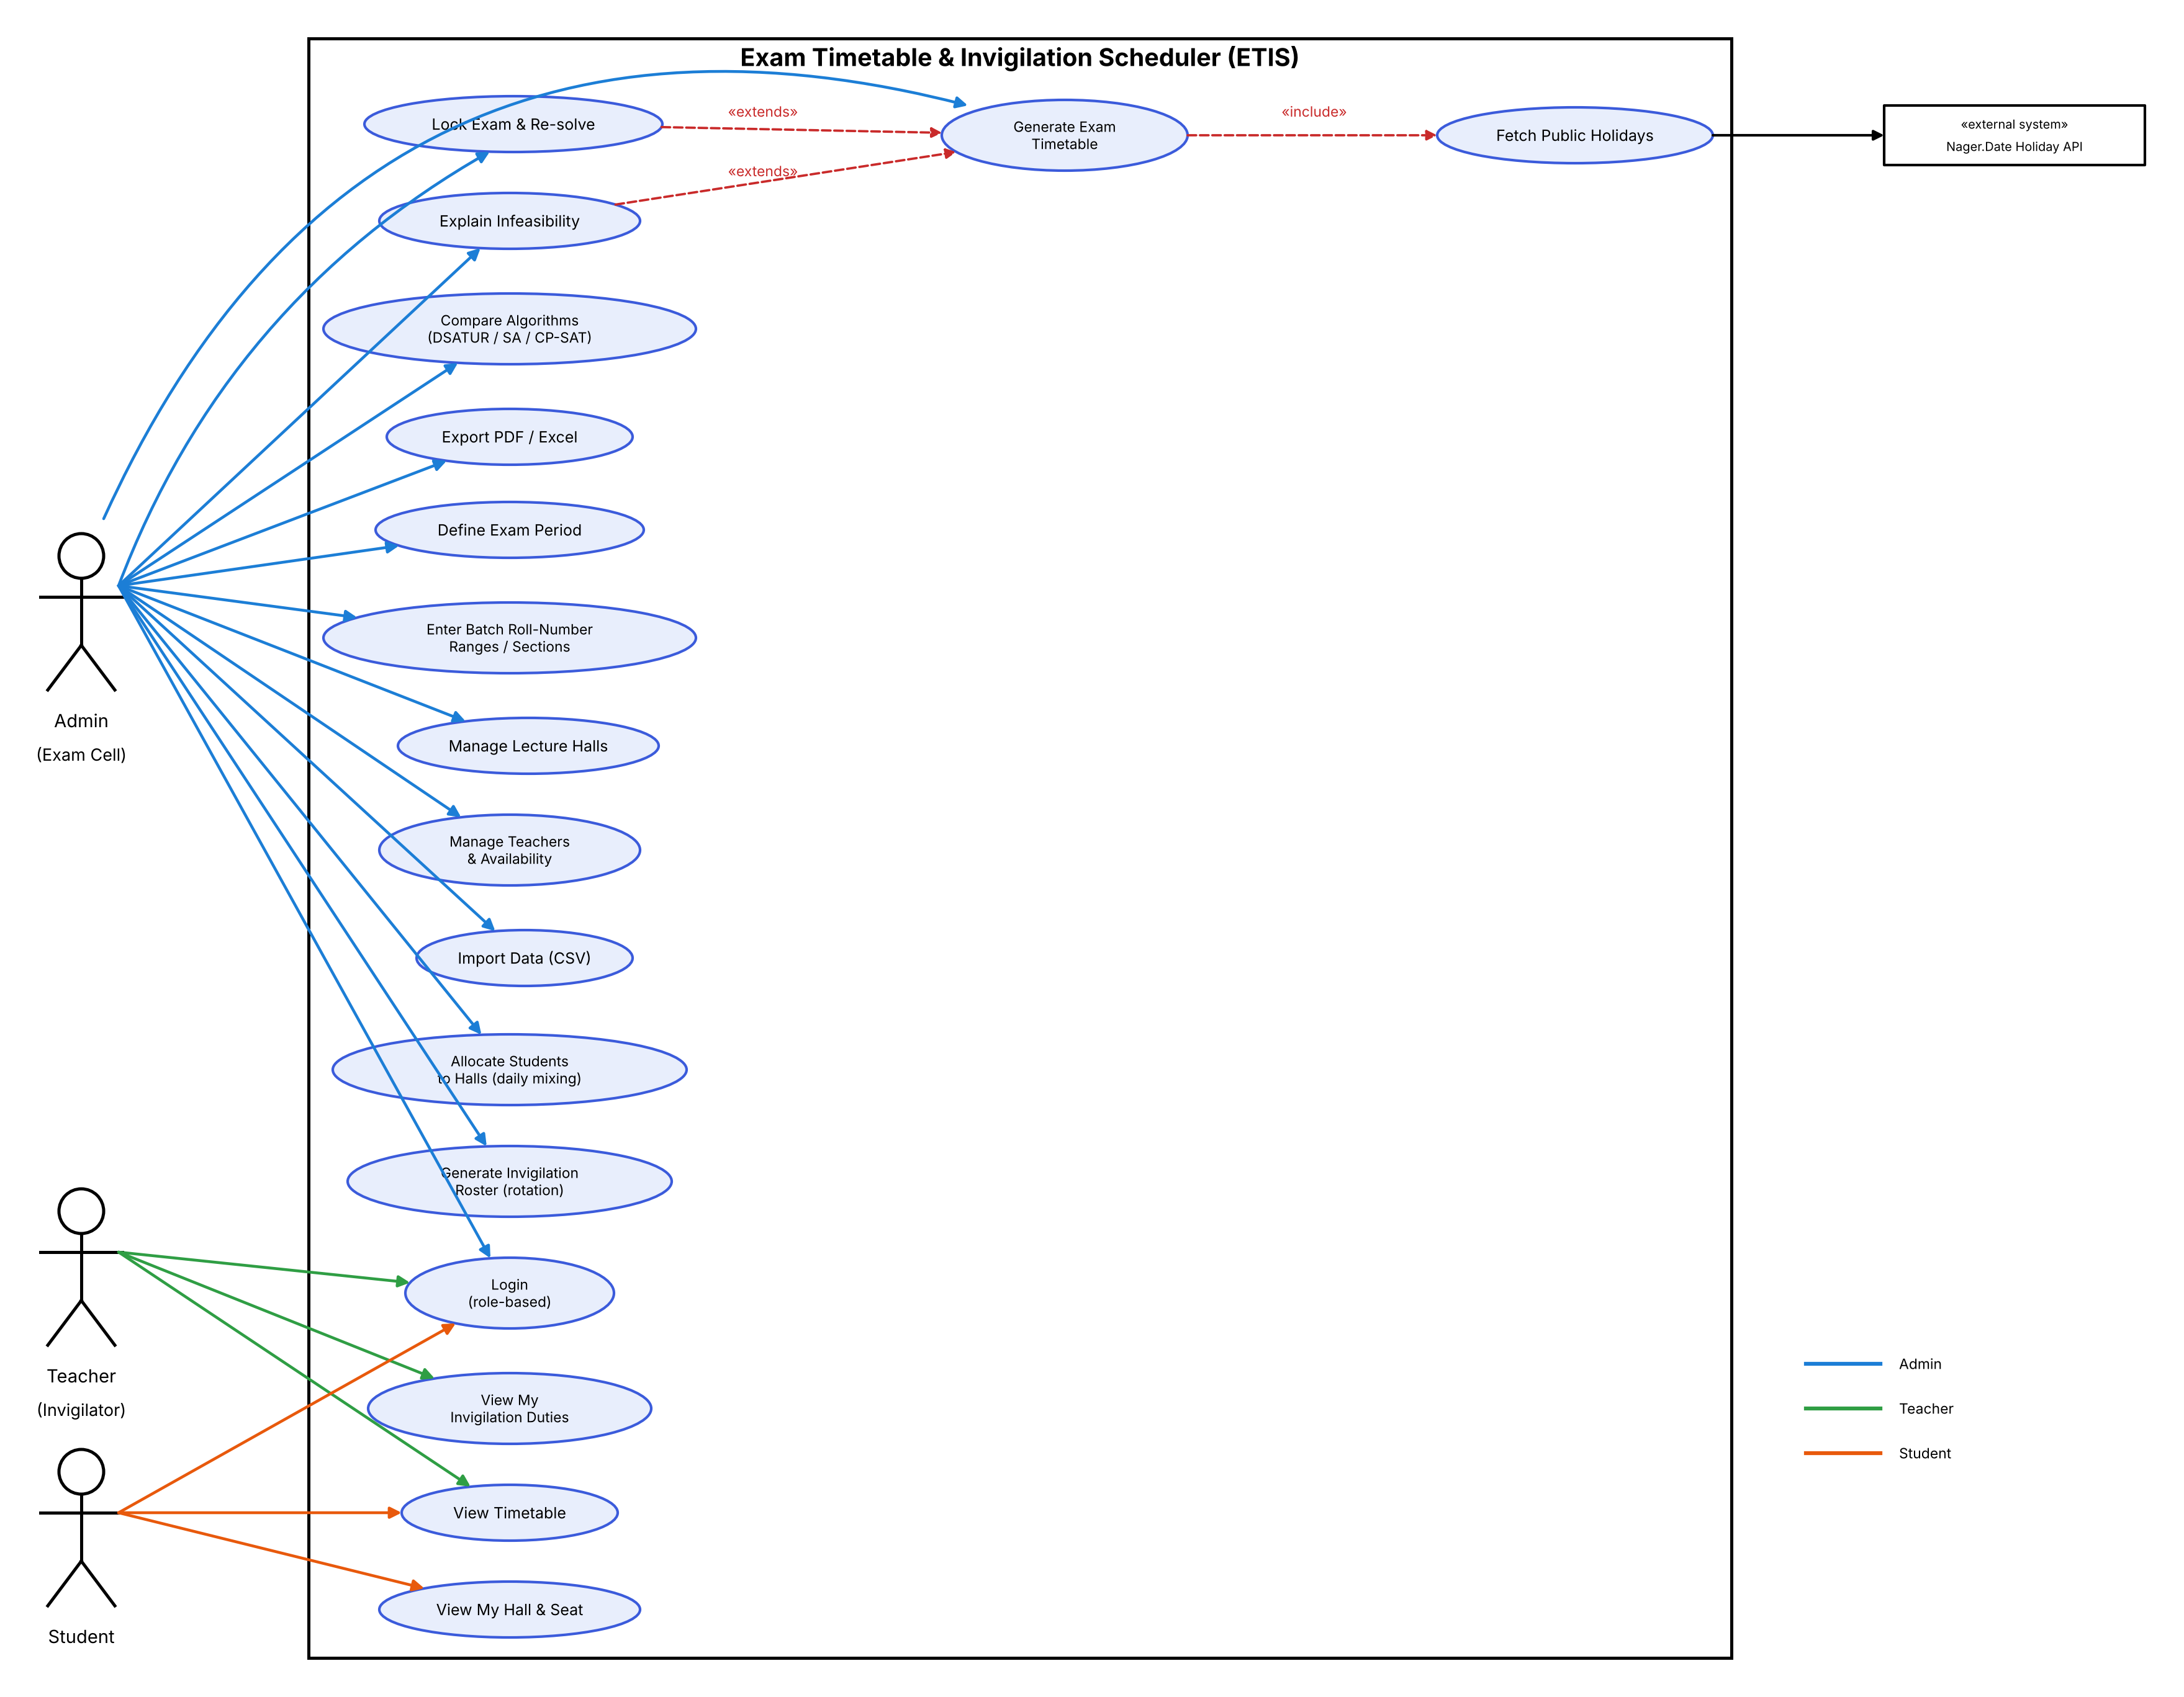
Figure 1: ETIS use case diagram

