Task related to ECS.
1. Setup a highly available ecs cluster with load balancer and dynamic port mapping.
NOTE:
Your cluster should maintain atleast 6 tasks at any point of time and should be highly availble across multiple AZ's.
Use the below image from deployment:
sabair0509/hiring-app:works
Task: Setup a Highly Available ECS Cluster (EC2 Self-Managed) with Load Balancer and Dynamic Port Mapping
Objective
Deploy a highly available Amazon ECS cluster using the EC2 launch type that:
- Maintains at least 6 running tasks at all times
- Is deployed across multiple Availability Zones
- Uses a manually created Application Load Balancer
- Implements dynamic port mapping
- Uses Docker image:
sabair0509/hiring-app:works
- Uses EC2 self-managed instances
1. Network Architecture Setup (Multi-AZ)
Create VPC
- Create a new VPC with CIDR block 10.0.0.0/16.
- Create at least:
  - 2 Public Subnets (in different AZs)
  - 2 Private Subnets (in different AZs)
- Attach an Internet Gateway to the VPC.
- Configure route tables:
  - Public Subnets → Route to Internet Gateway
  - Private Subnets → Route to NAT Gateway (if required)
This ensures high availability across multiple Availability Zones.

2. Security Groups Configuration
ALB Security Group
- Allow inbound HTTP (Port 80) from 0.0.0.0/0
- Allow outbound traffic to ECS instances
ECS EC2 Instance Security Group
- Allow inbound traffic from ALB Security Group
- Allow ephemeral port range (32768–65535) from ALB
- Allow all outbound traffic
Ephemeral ports are required for dynamic port mapping.

3. Create Application Load Balancer (Manually)
- Go to EC2 → Load Balancers → Create Load Balancer.
- Select Application Load Balancer.
- Choose:
  - Internet-facing
  - IPv4
- Select at least 2 Availability Zones.
- Attach ALB Security Group.
Create Target Group
- Target Type: IP (required for dynamic port mapping)
- Protocol: HTTP
- Port: 80
- Health Check Path: /
Attach the target group to the ALB listener (HTTP:80).

4. Create ECS Cluster (EC2 Launch Type)
- Go to ECS Console → Create Cluster.
- Choose EC2 Linux + Networking.
- Provide cluster name (e.g., ha-ecs-cluster).
- Create cluster.
Create Task Definition
- Go to ECS → Task Definitions → Create Task Definition.
- Select EC2 launch type.
- Configure container:
Container Configuration
- Image: sabair0509/hiring-app:works
- CPU: 256
- Memory: 512 MB (or as required)
- Container Port: 80
- Host Port: 0 (Important – enables dynamic port mapping)
Network Mode
- Select bridge (required for dynamic port mapping in EC2)
Save the task definition.

7. Create ECS Service (Minimum 6 Tasks)
- Go to ECS → Cluster → Create Service.
- Launch Type: EC2
- Select task definition.
- Service Name: ha-hiring-app-service
- Desired Count: 6
- Deployment Type: Rolling Update.
Load Balancer Configuration
- Select existing Application Load Balancer.
- Choose target group created earlier.
- Map container port 80.
This ensures the service always maintains 6 running tasks.

8. Enable Service Auto Scaling (Recommended)
- Go to ECS Service → Auto Scaling.
- Set:
  - Minimum tasks: 6
  - Maximum tasks: 12
- Add scaling policies:
  - Scale out when CPU > 70%
  - Scale in when CPU < 30%
This guarantees a minimum of 6 running tasks at all times.

9. Configure EC2 Auto Scaling Group
To ensure high availability at infrastructure level:
- Create a Launch Template:
  - ECS-Optimized AMI
  - Instance type: t3.medium
  - Add ECS cluster user data.
- Create Auto Scaling Group:
  - Deploy across multiple AZs.
  - Minimum instances: 3
  - Desired capacity: 3
  - Maximum capacity: 6
This ensures container instances are automatically replaced if one fails.

10. High Availability Validation
Verify the following:
- 6 tasks are always running.
- Tasks are distributed across multiple AZs.
- ALB health checks are passing.
- If one EC2 instance stops, tasks are rescheduled automatically.
- If one task fails, ECS recreates it automatically.

Final Architecture Flow
Internet
→ Application Load Balancer (Multi-AZ)
→ Target Group (IP Mode)
→ ECS Service (Minimum 6 Tasks)
→ ECS Cluster (EC2 Instances across multiple AZs)

Key Concepts Used
High Availability:
- Multi-AZ deployment
- Minimum task count
- Auto Scaling at service and instance level
Dynamic Port Mapping:
- Host Port set to 0
- Target group type set to IP
- Bridge network mode used

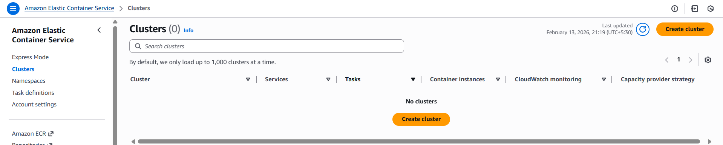

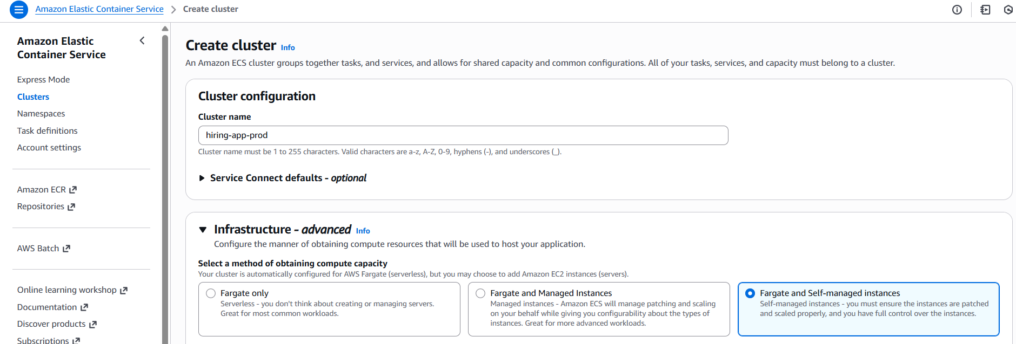
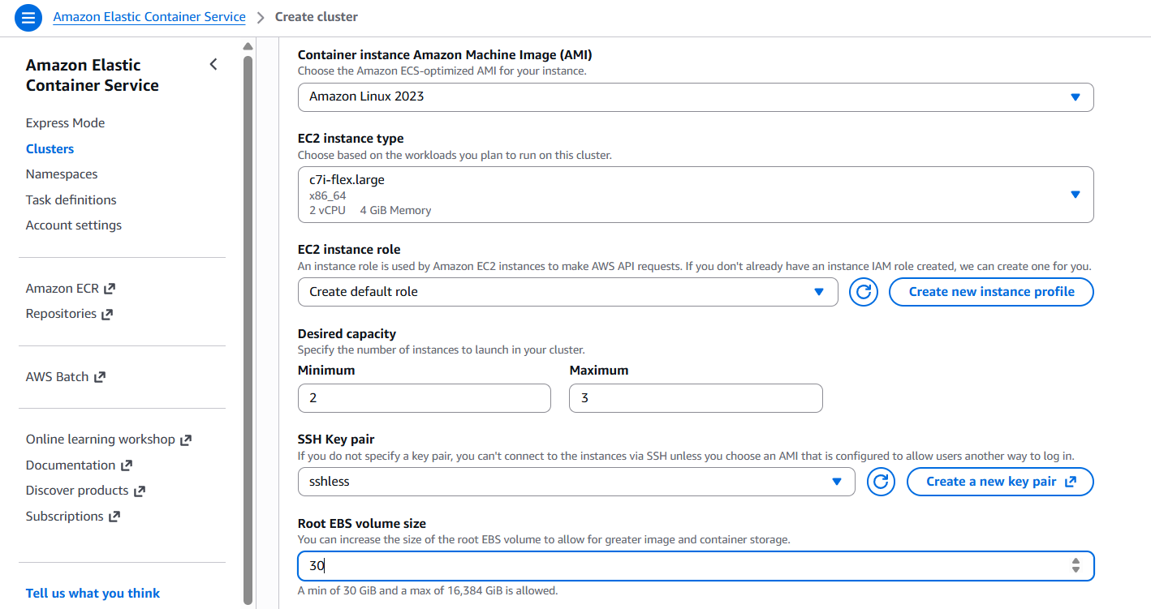
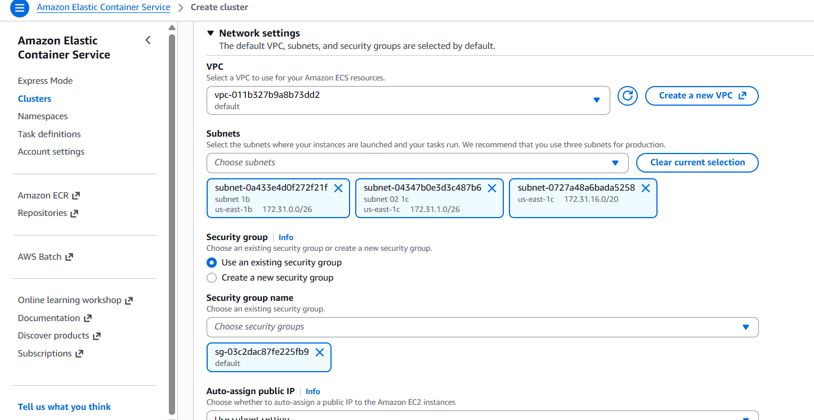
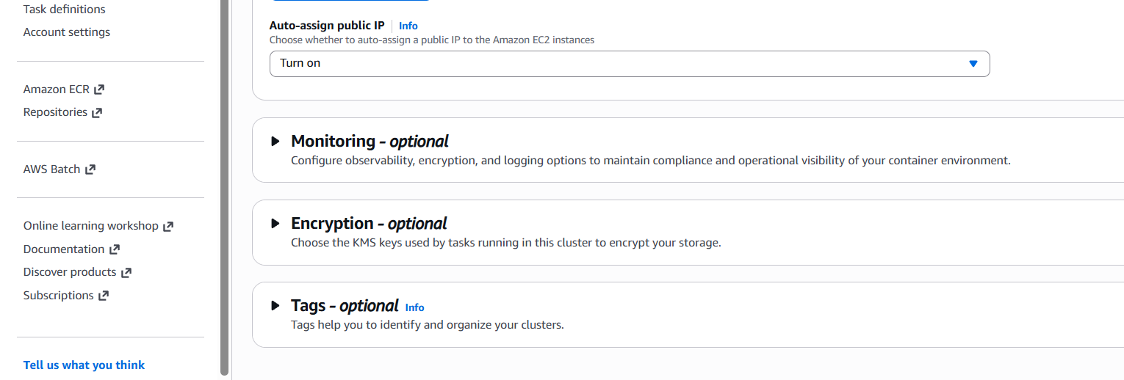
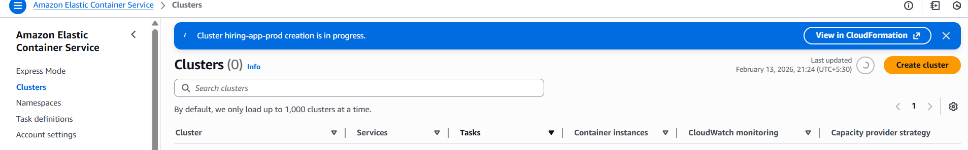
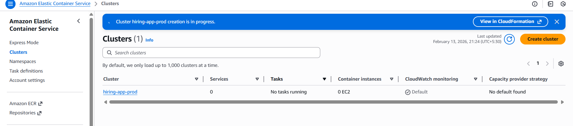
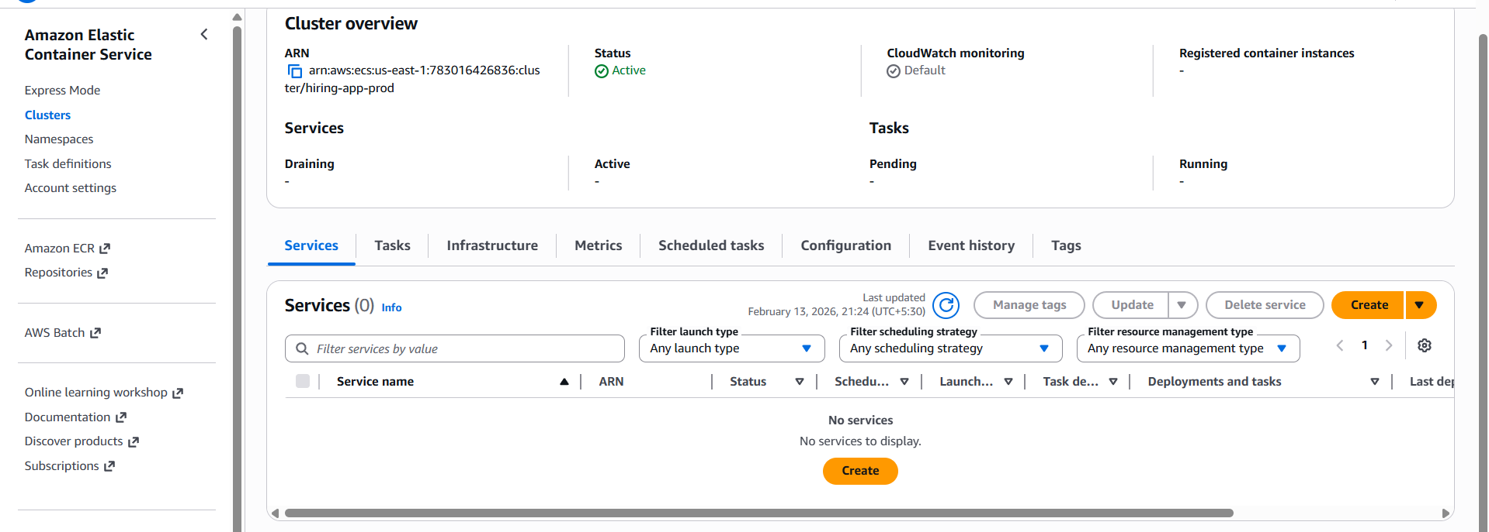
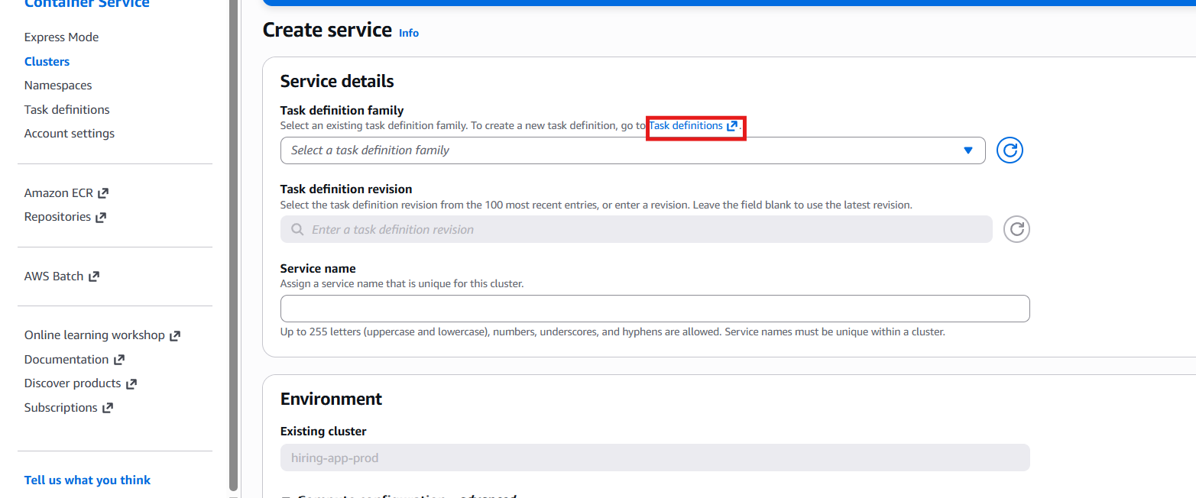
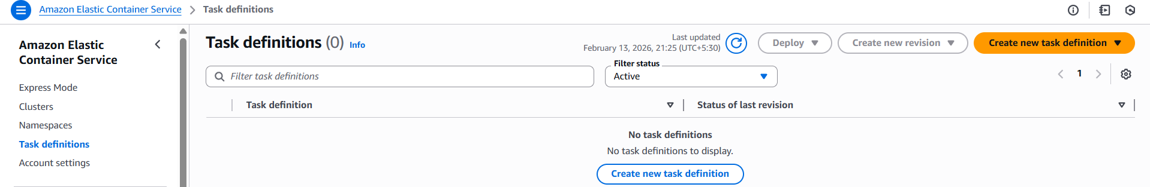
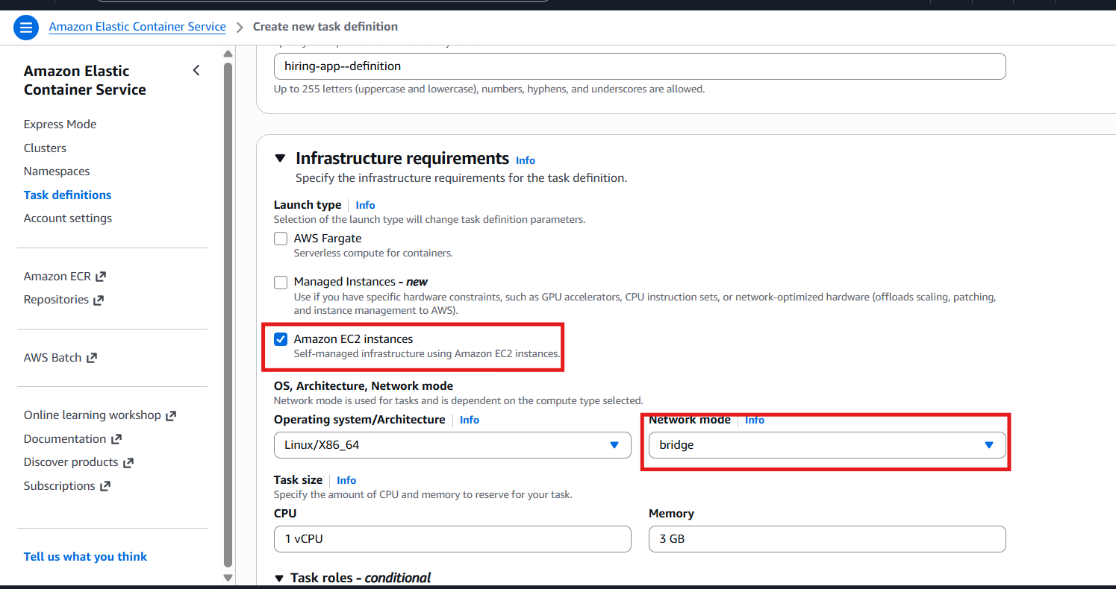
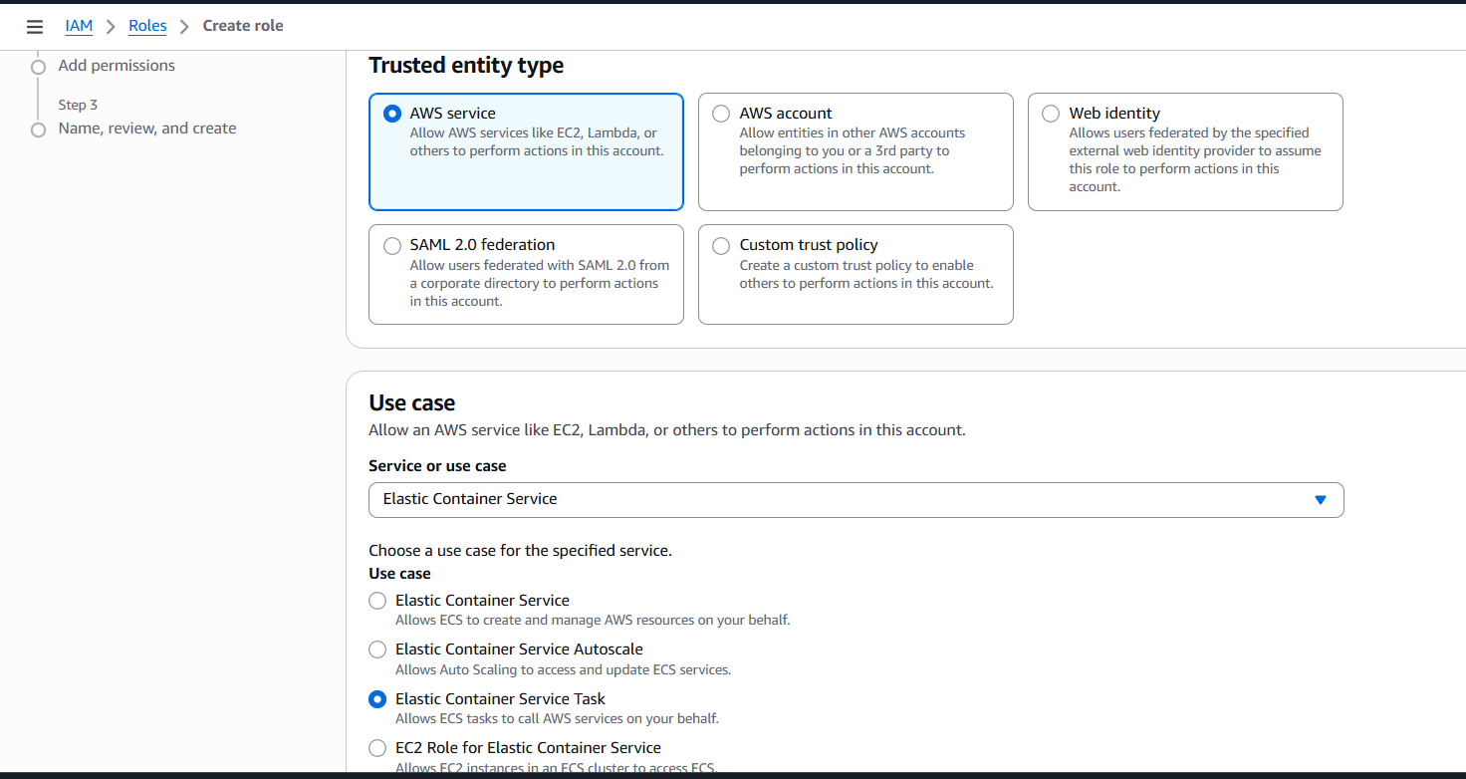
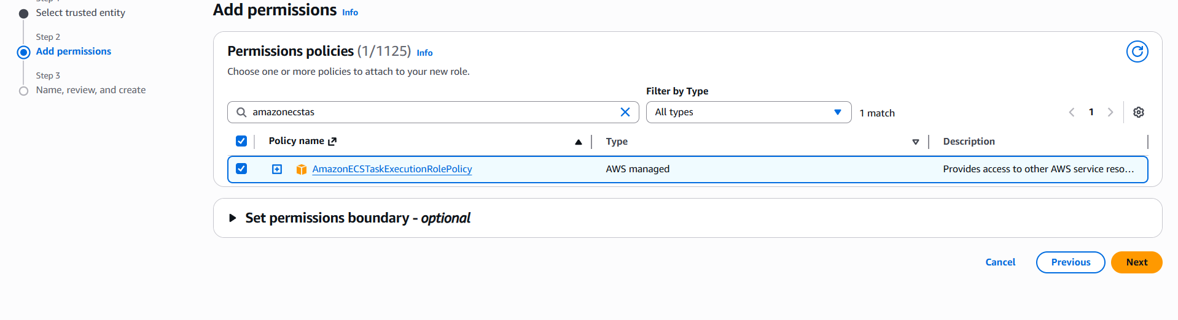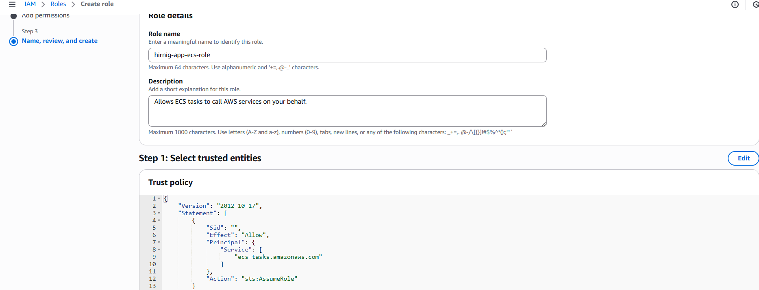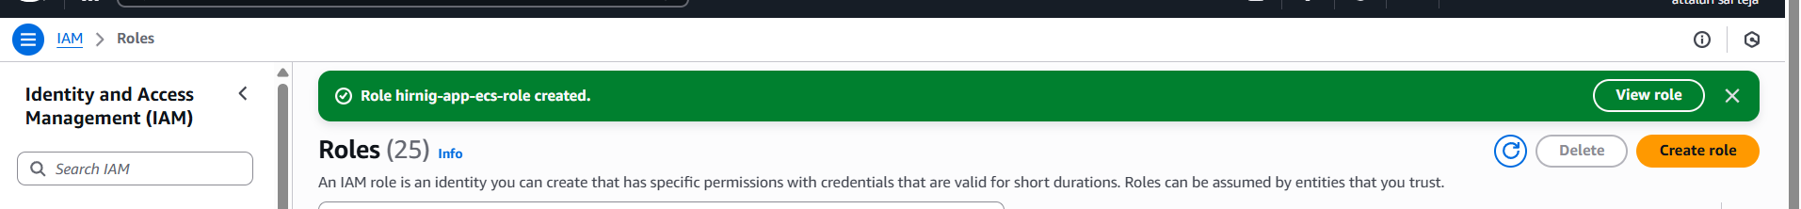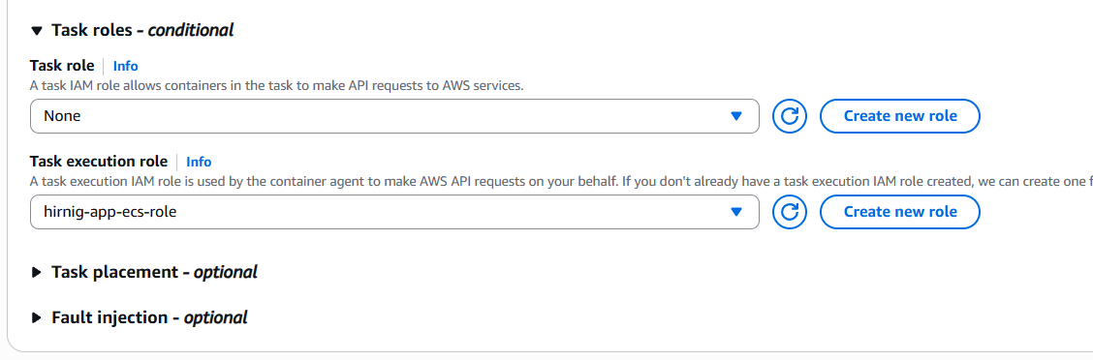
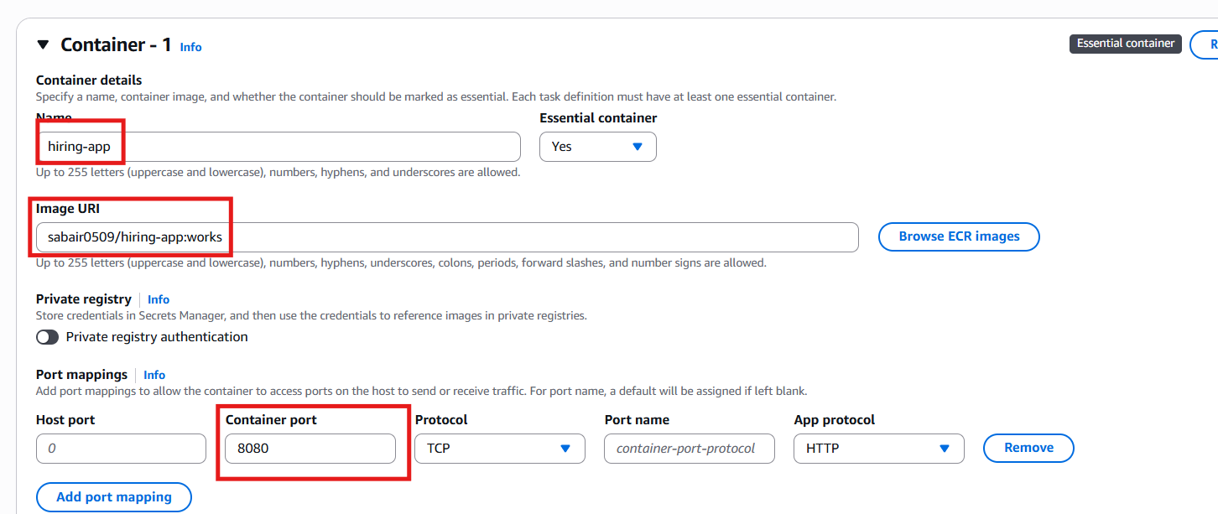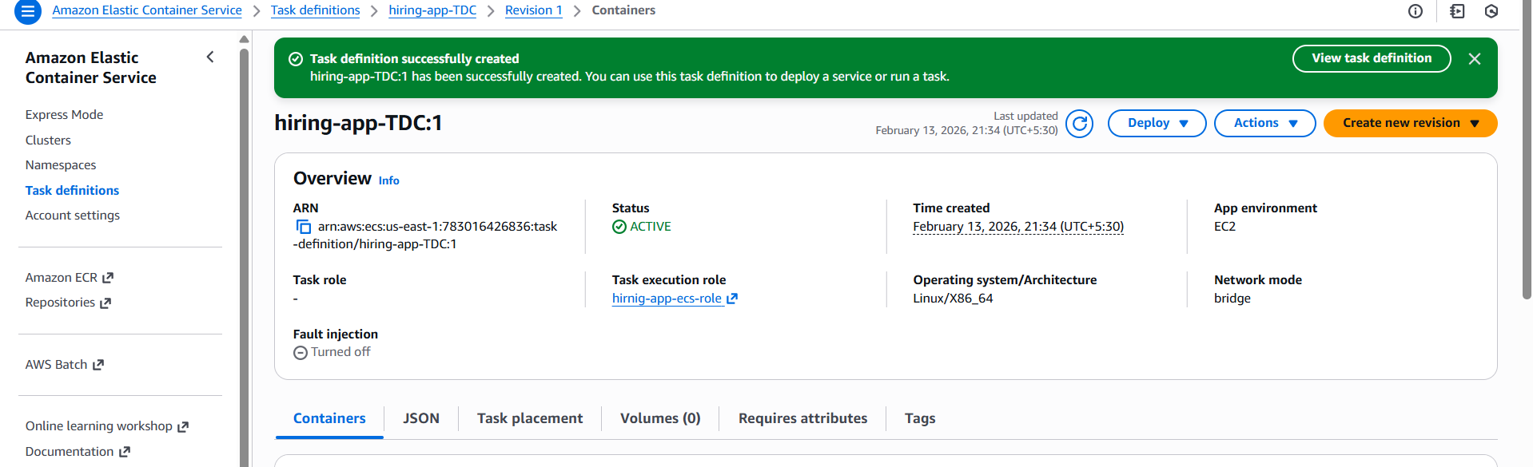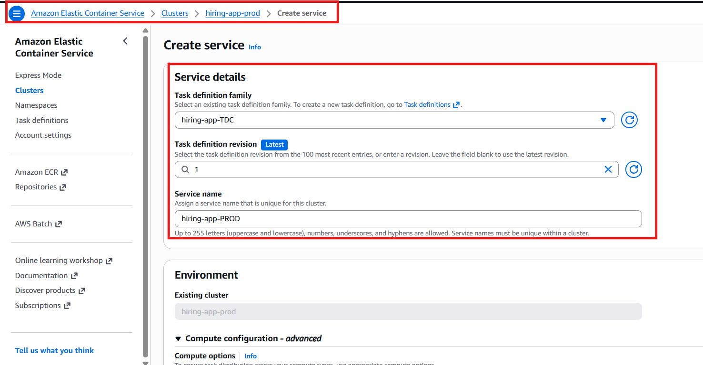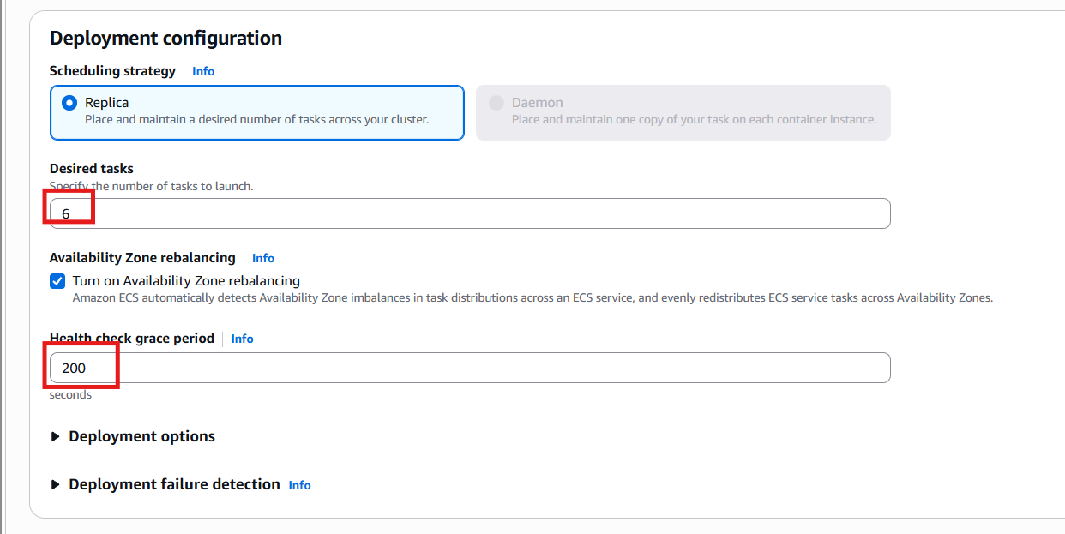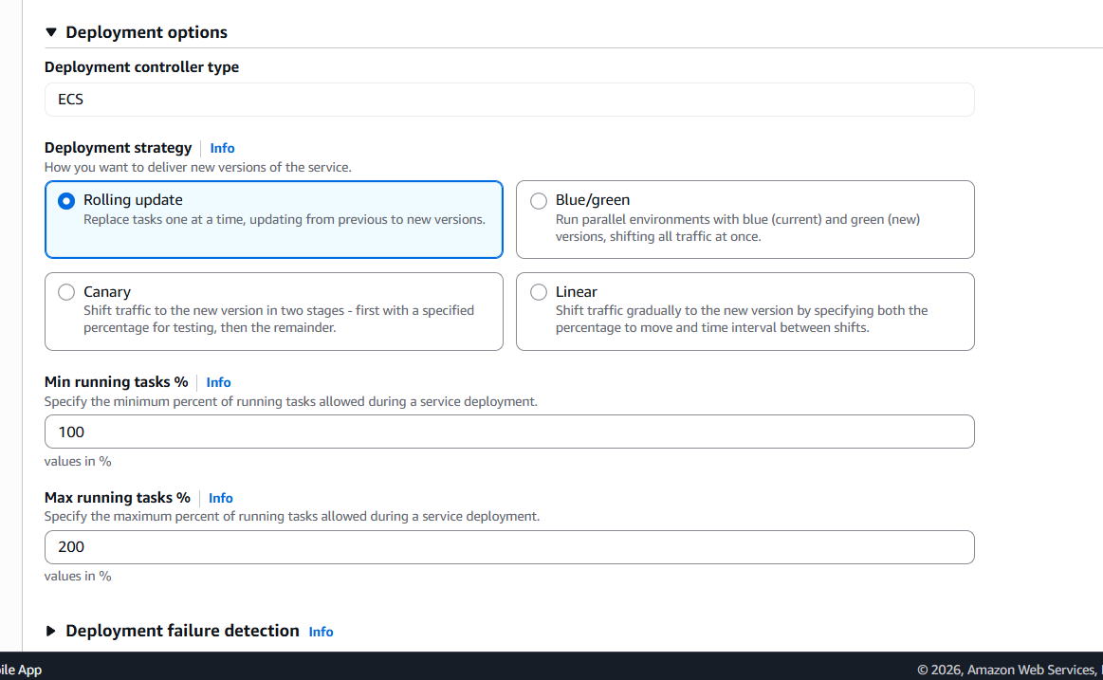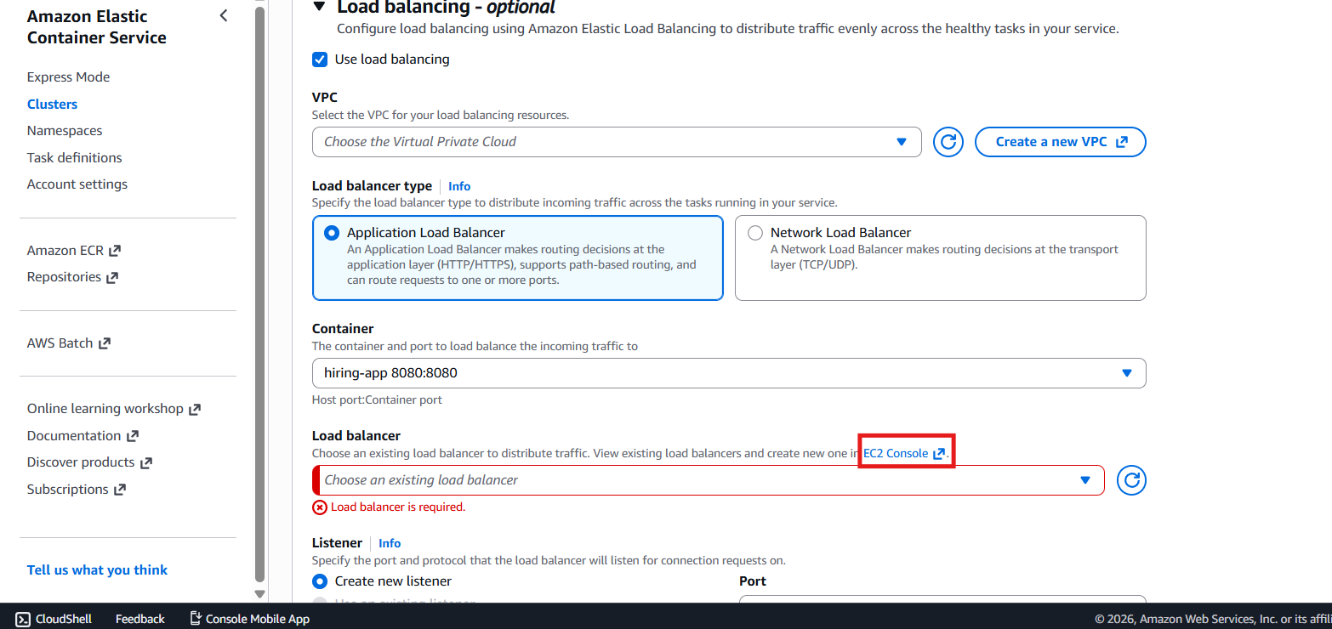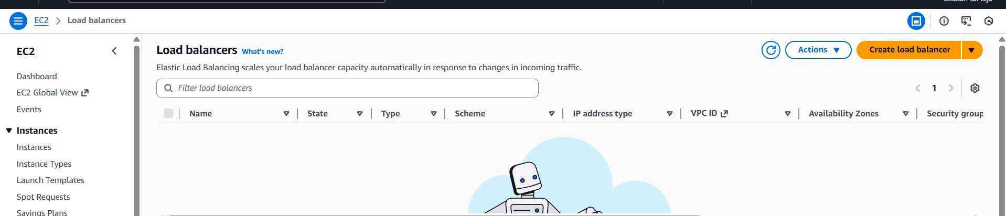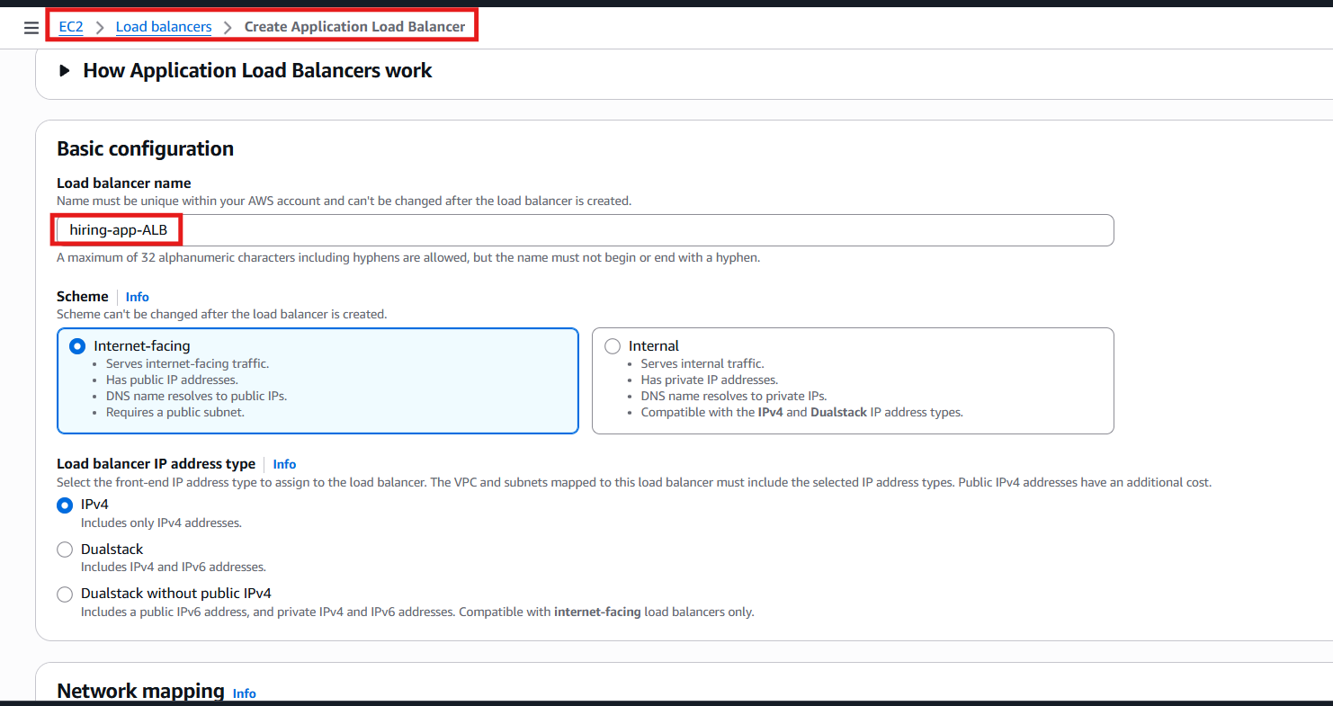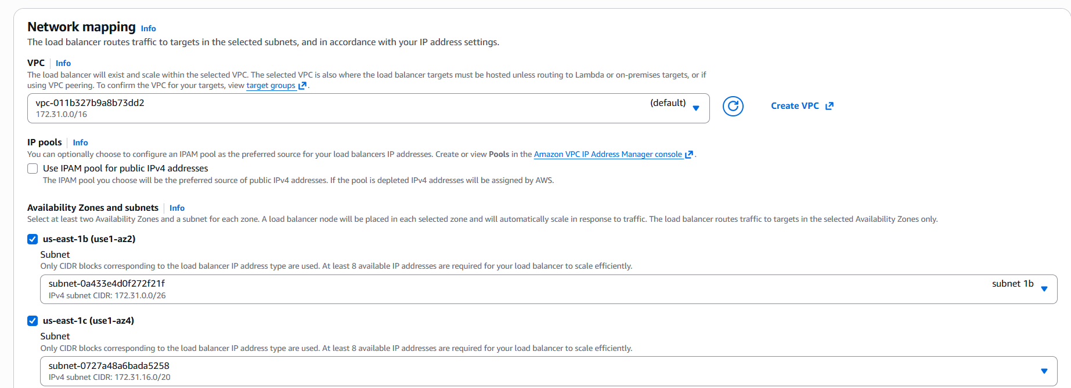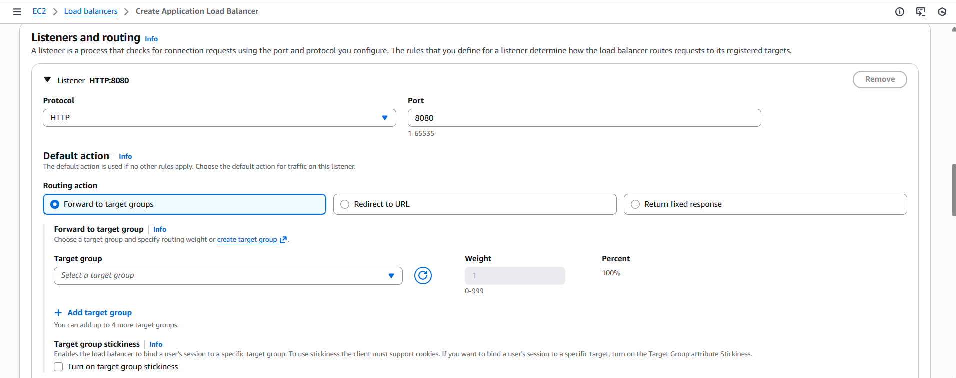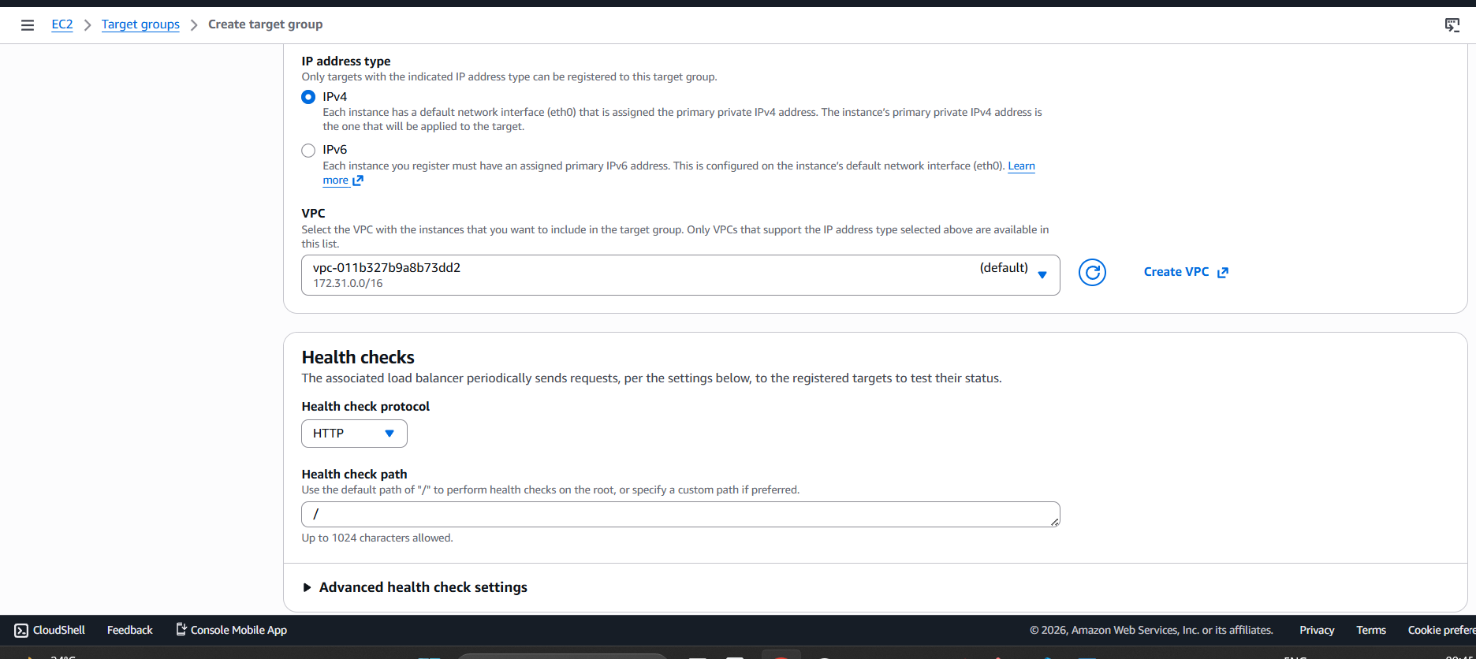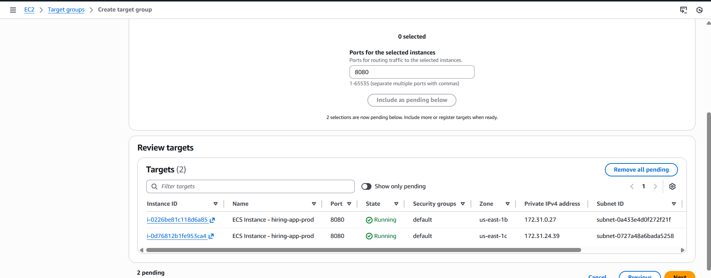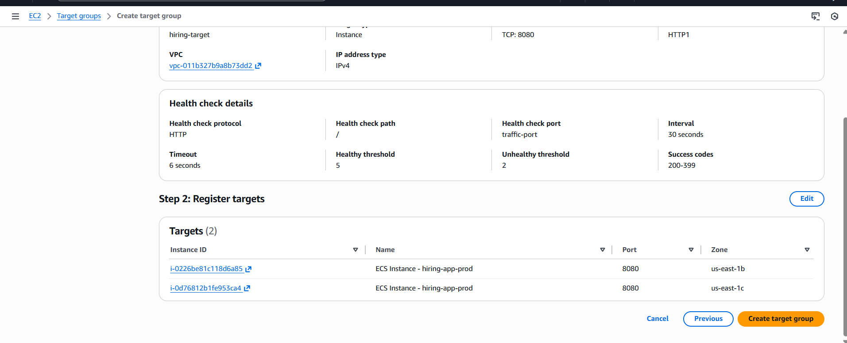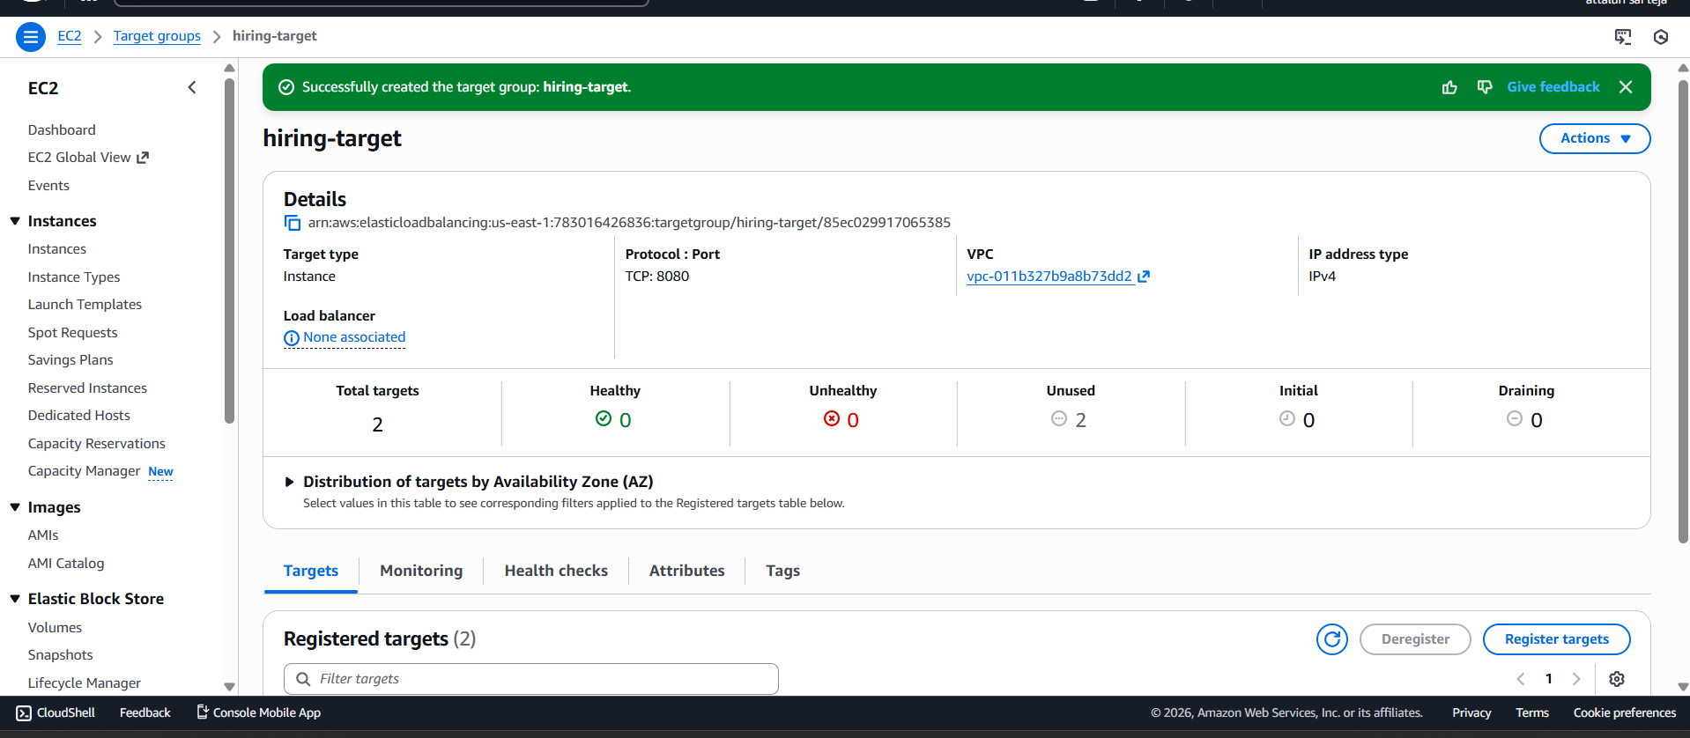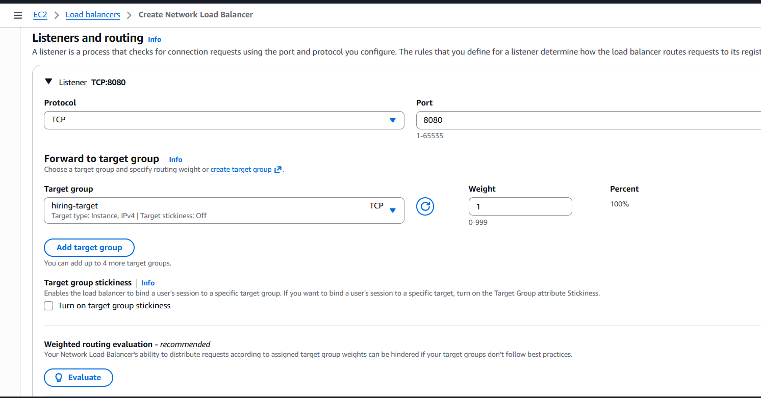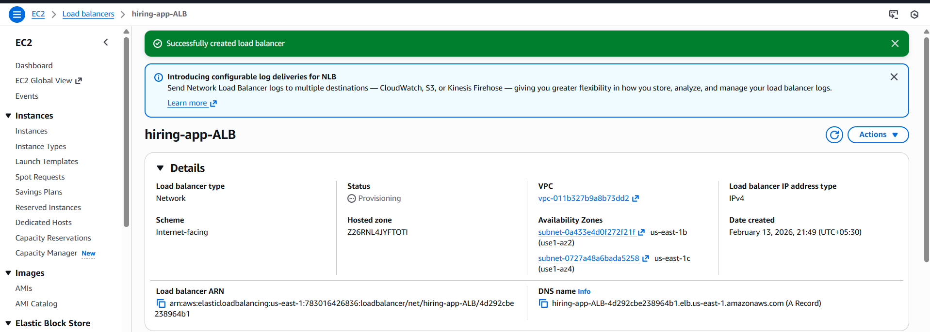
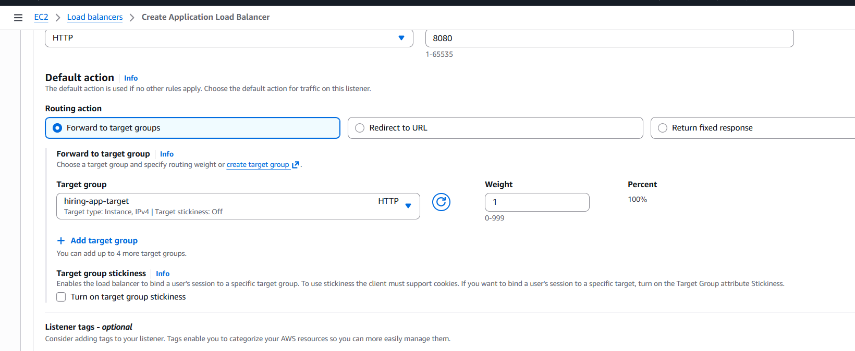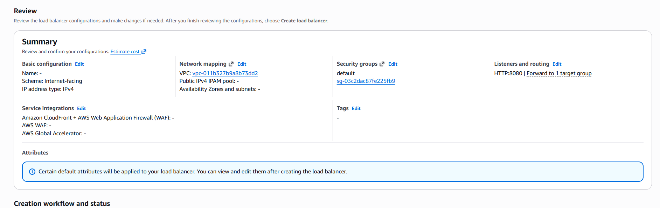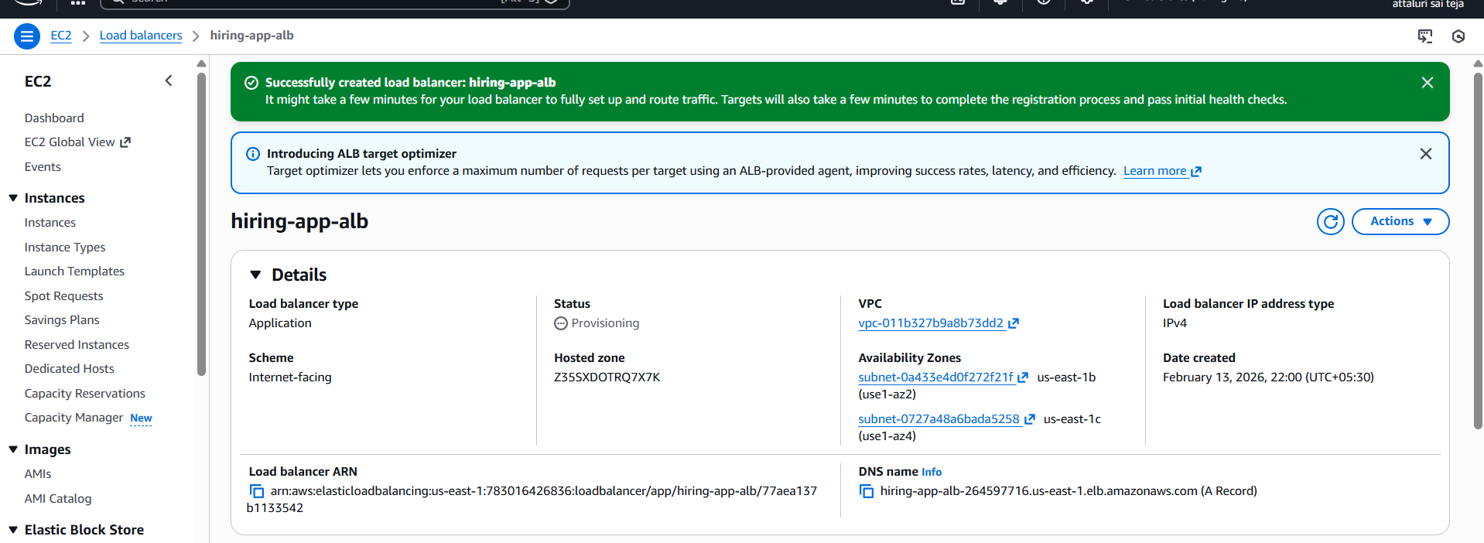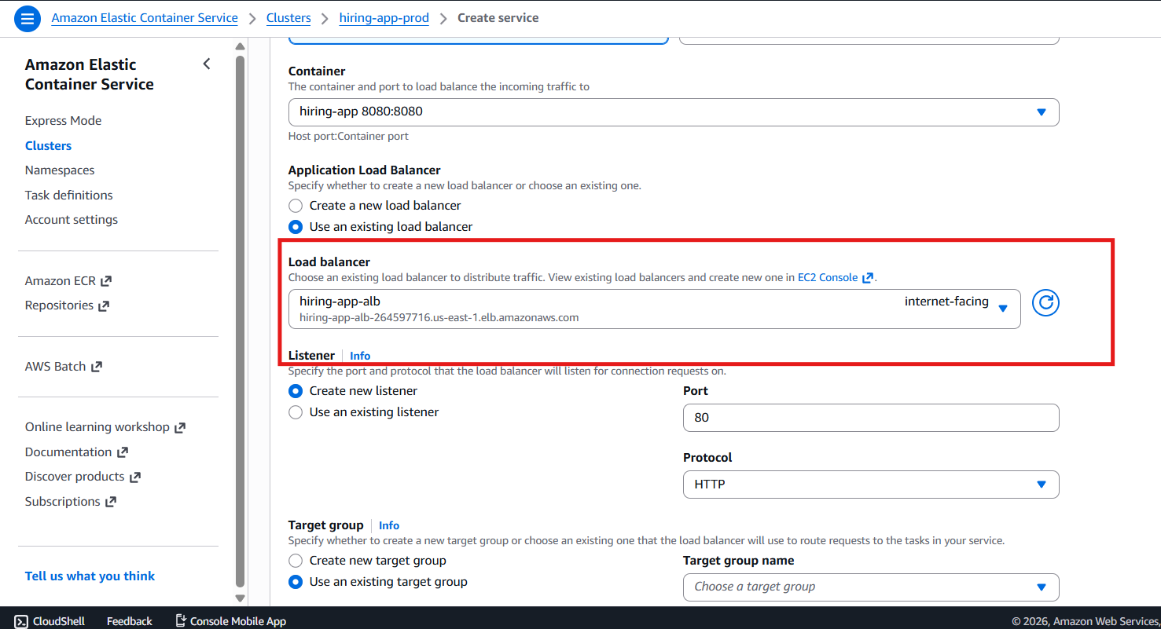
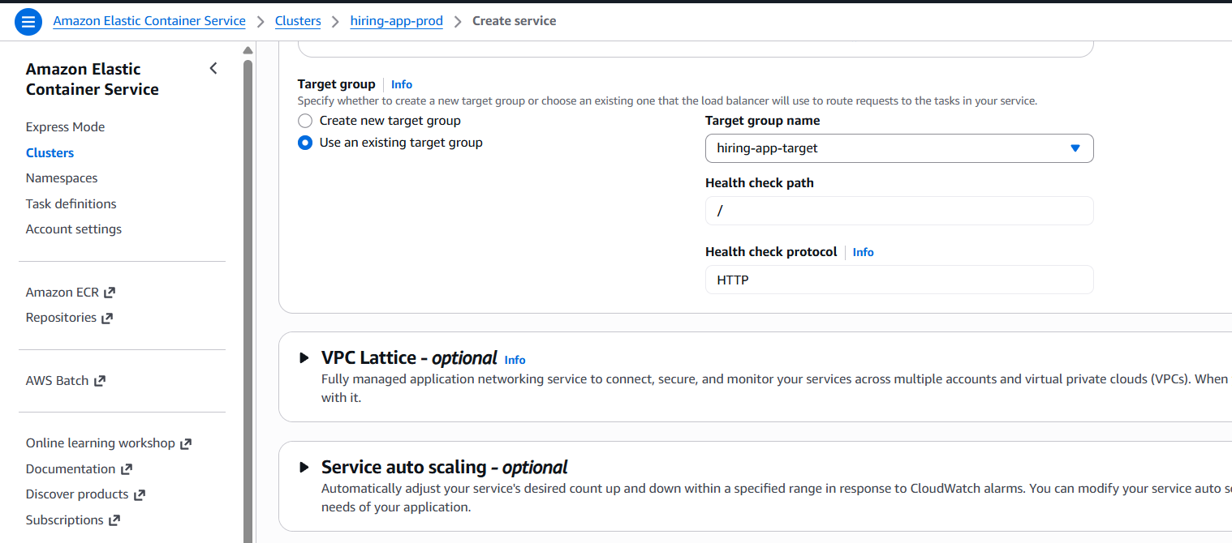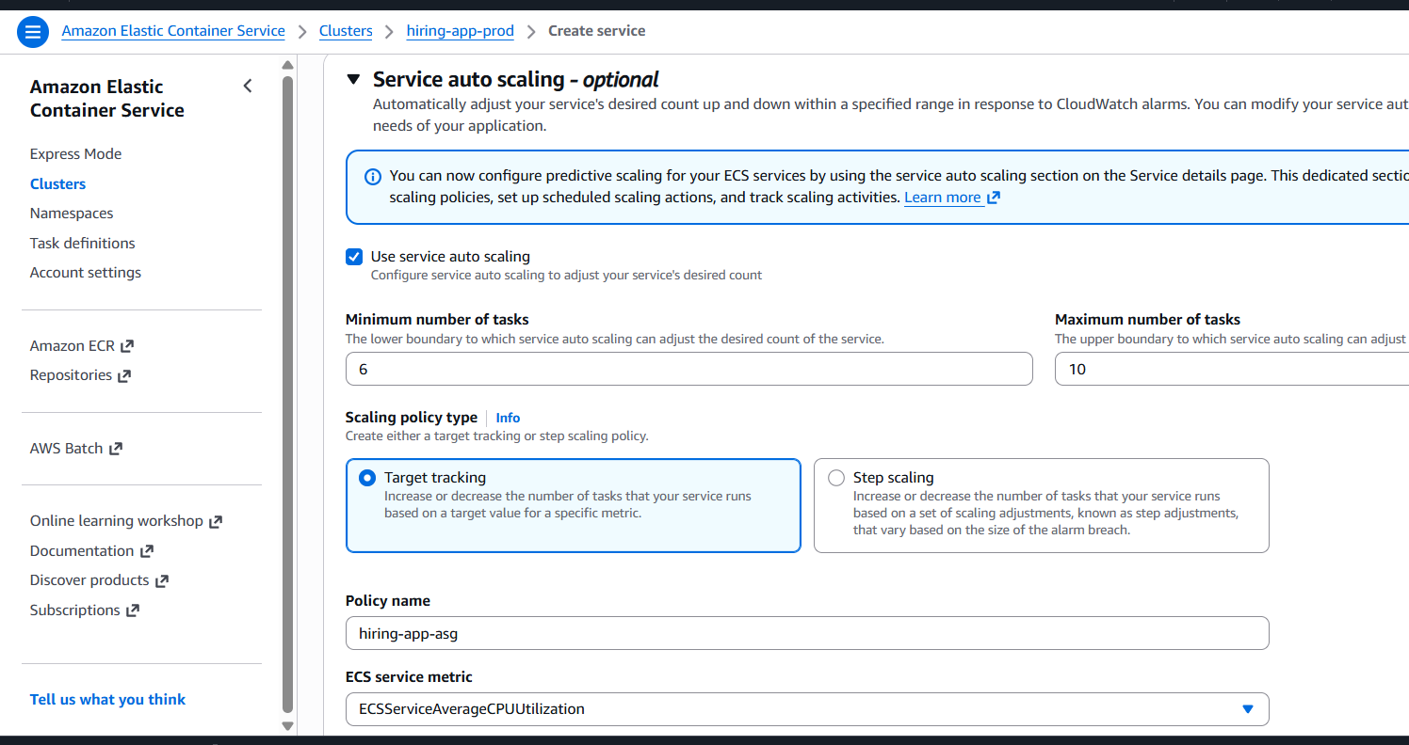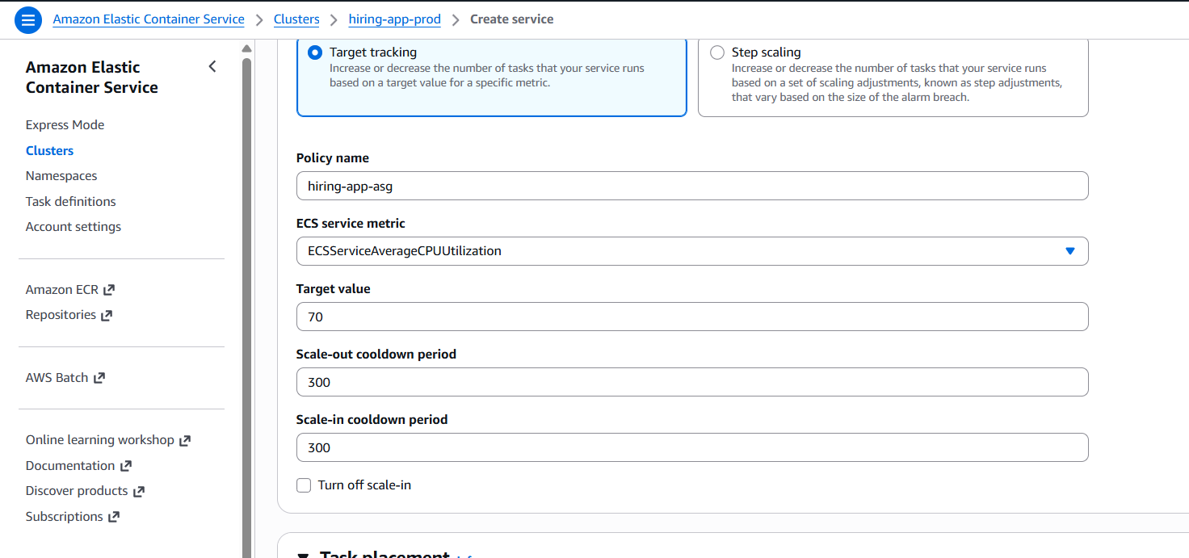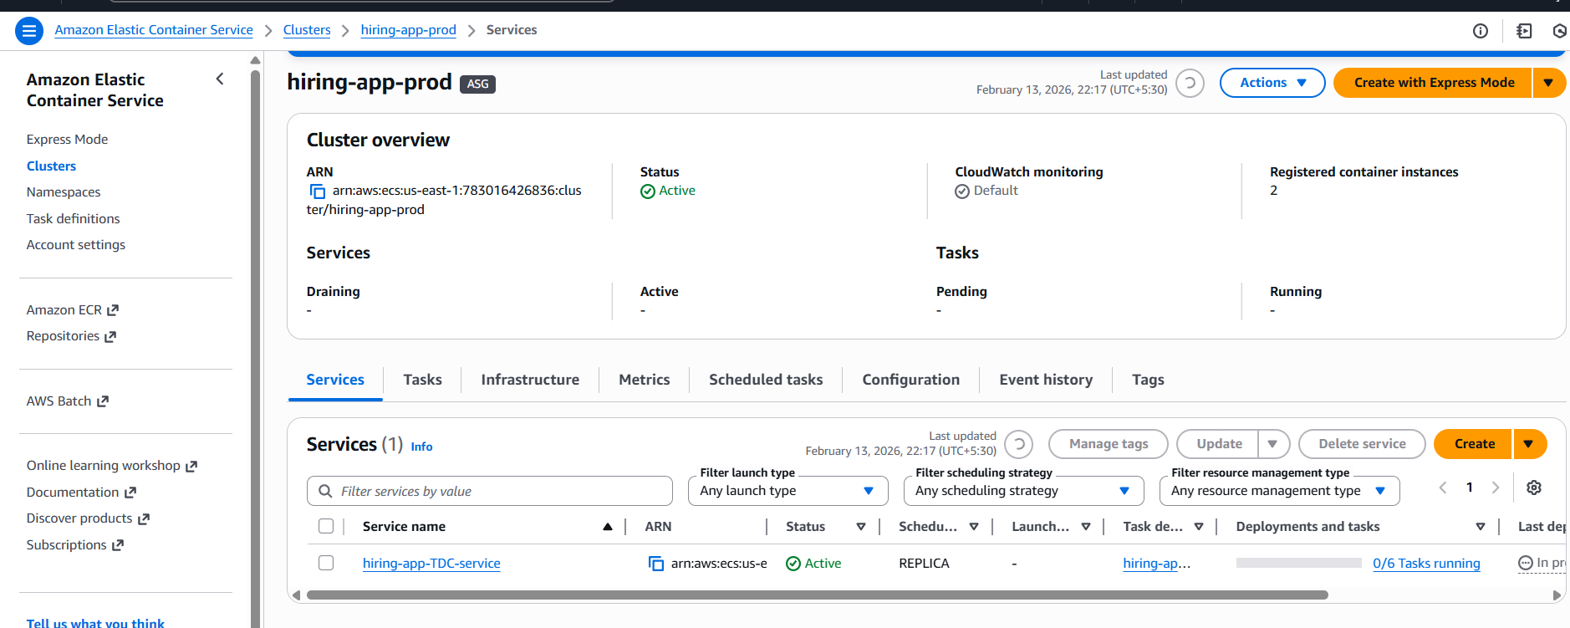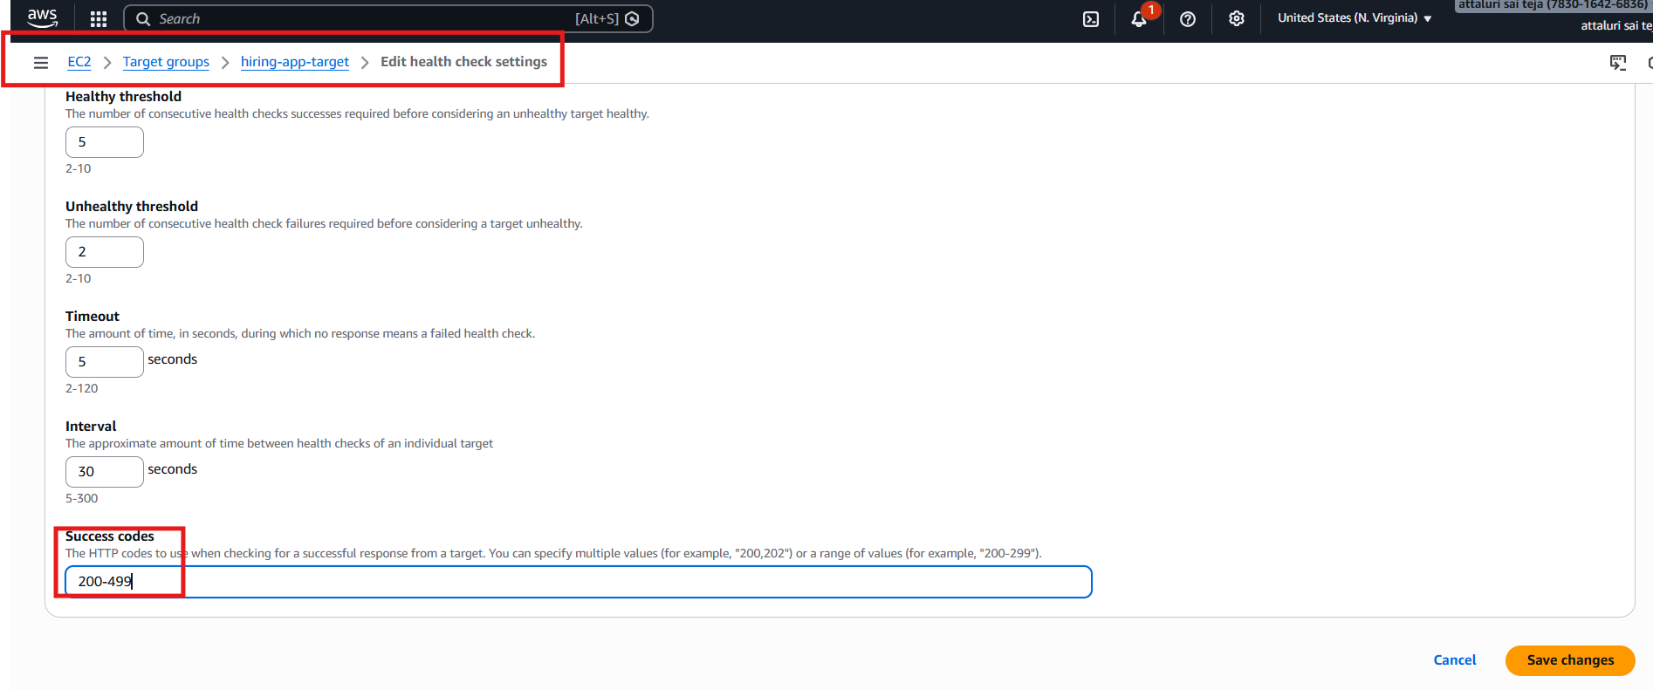
Conclusion
In this task, we successfully designed and deployed a highly available Amazon ECS cluster using the EC2 launch type with self-managed instances. The architecture ensures:
- Continuous availability with a minimum of 6 running tasks
- Deployment across multiple Availability Zones for fault tolerance
- Traffic distribution through a manually configured Application Load Balancer
- Efficient container placement using dynamic port mapping
- Automatic recovery through ECS service scheduling and EC2 Auto Scaling

