EC2 – GITHUB
Install GIT ON EC2
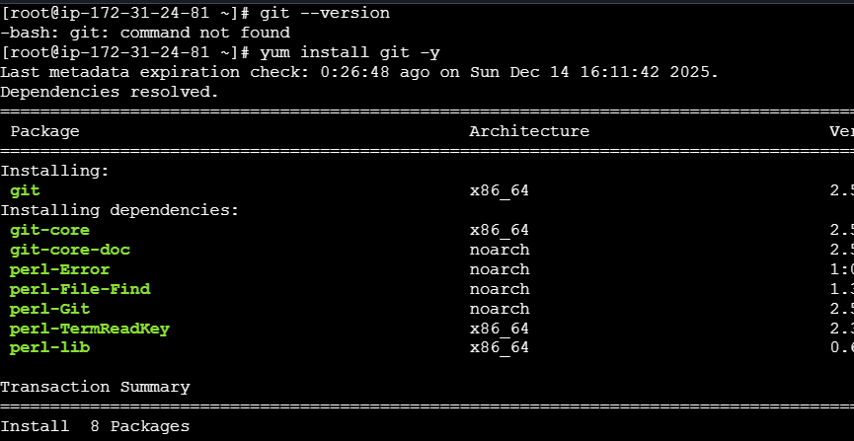
Check the git version
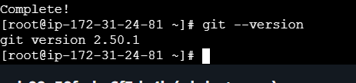
Step 2: Create a GitHub Personal Access Token (PAT)
On your local machine / browser:
- GitHub → Settings
- Developer settings
- Personal access tokens
- Tokens (classic) → Generate new token
- Select scopes:
  - ✅ repo
- Generate & COPY THE TOKEN (shown only once)
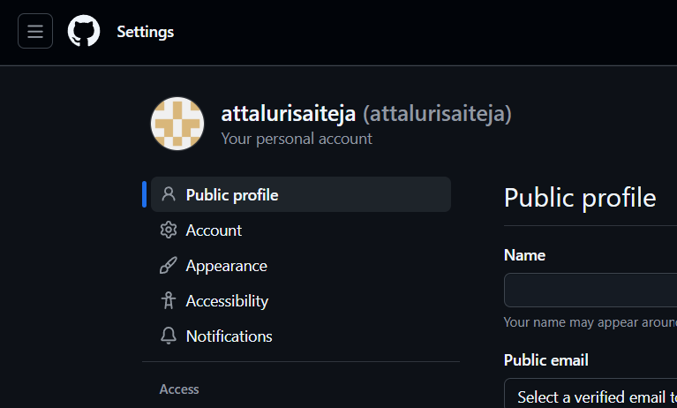
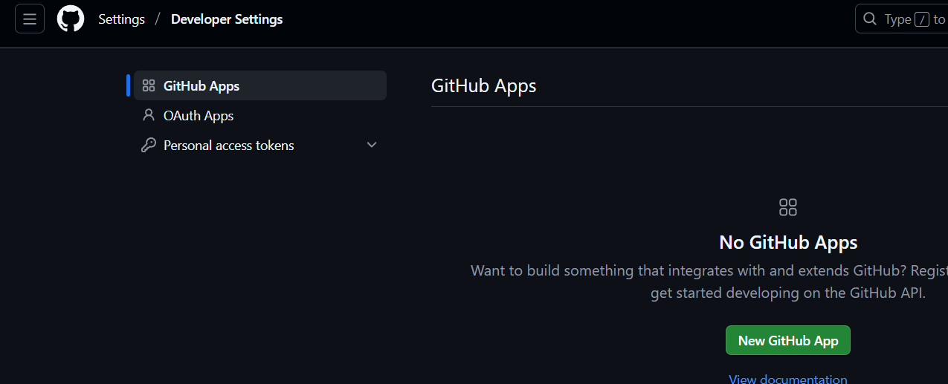
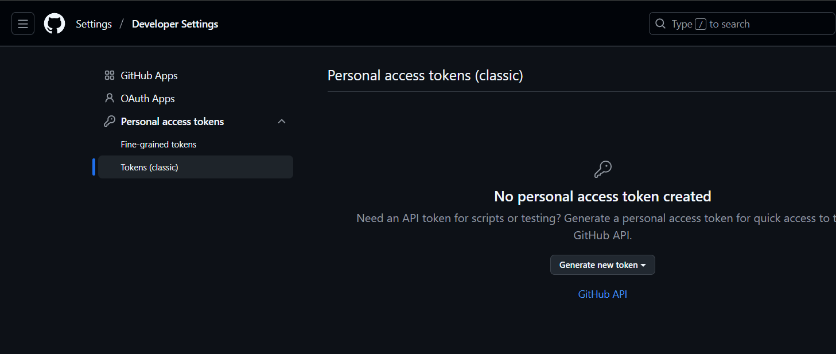
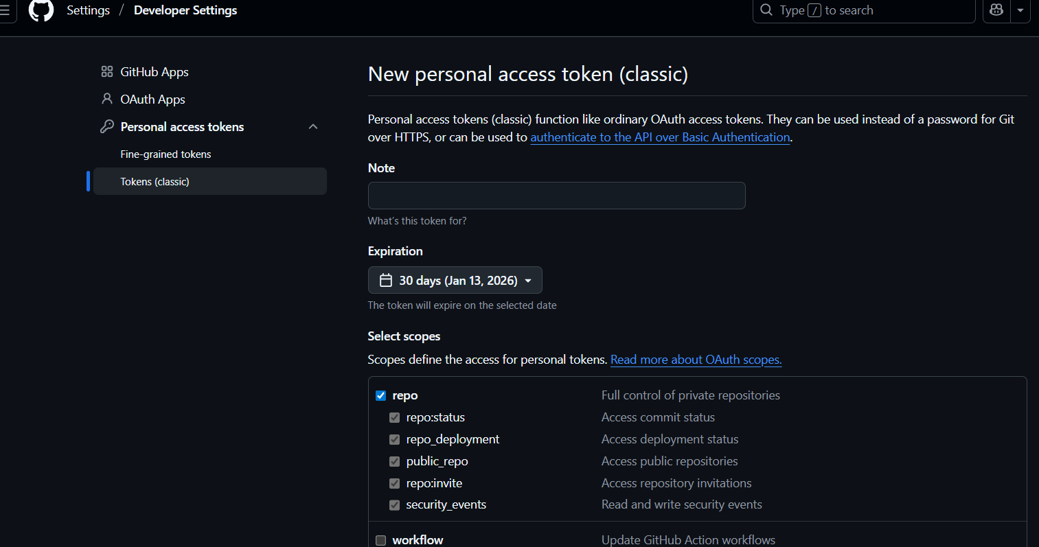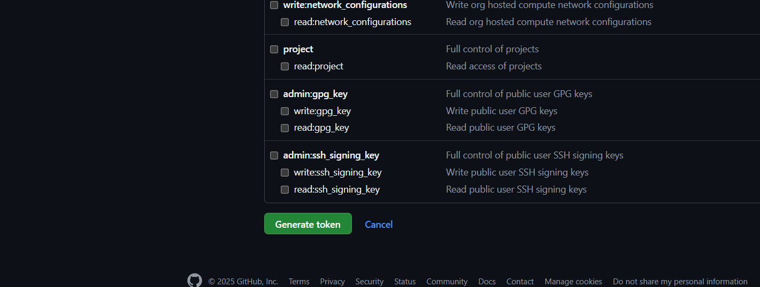
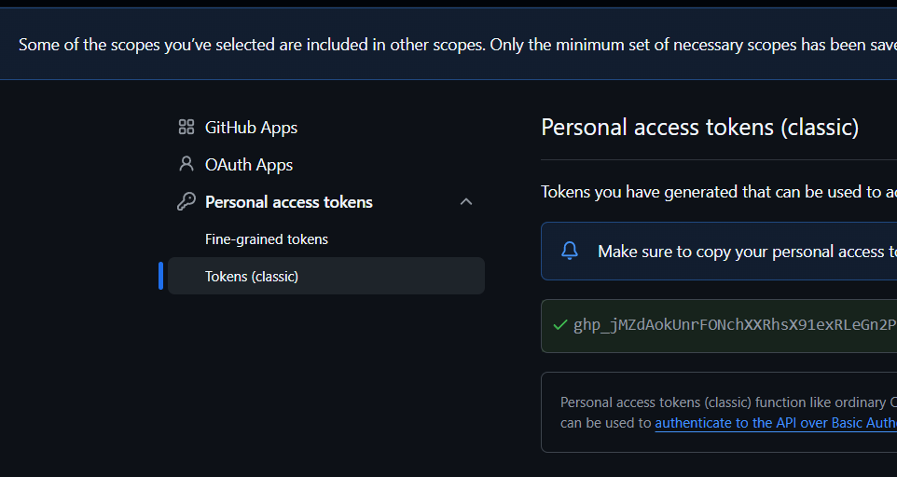

Navigate to git bash and send the file from local to Ec2 server
Using scp command
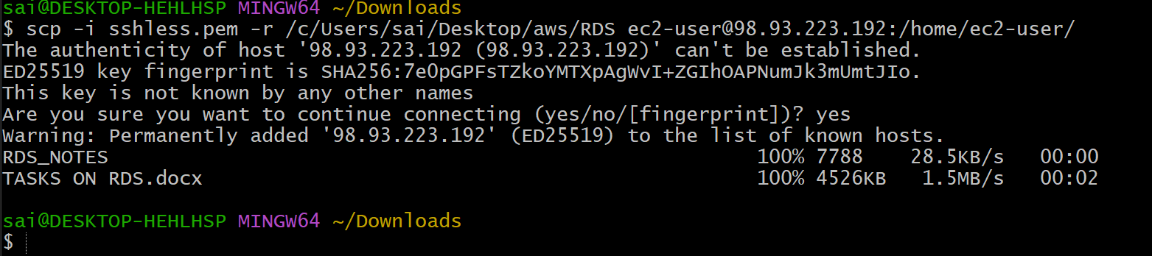
Check the file/folder in EC2
And Initialized git using git init
And added the files and checked the status
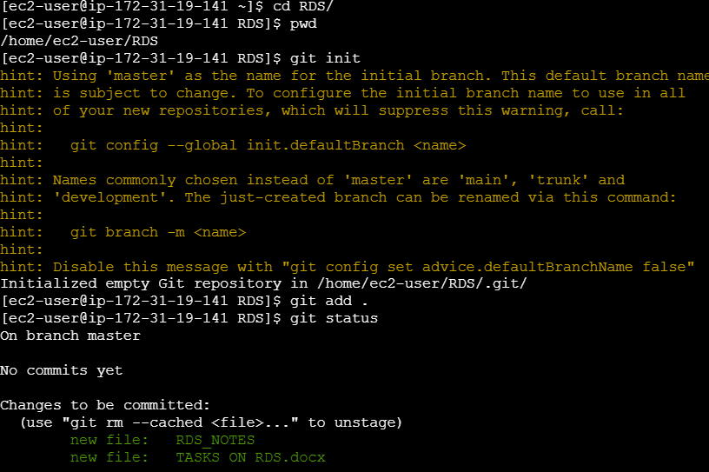

Commit the files with a message
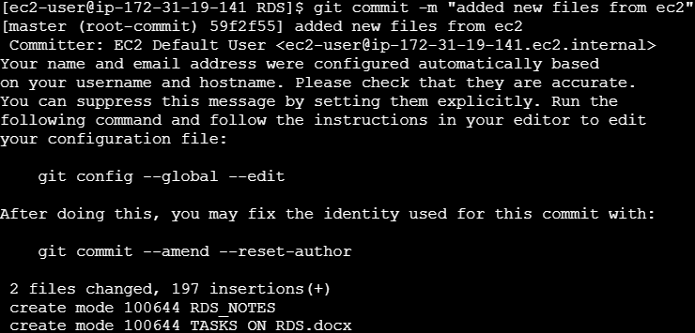
Navigate to GITHUB and copy https link
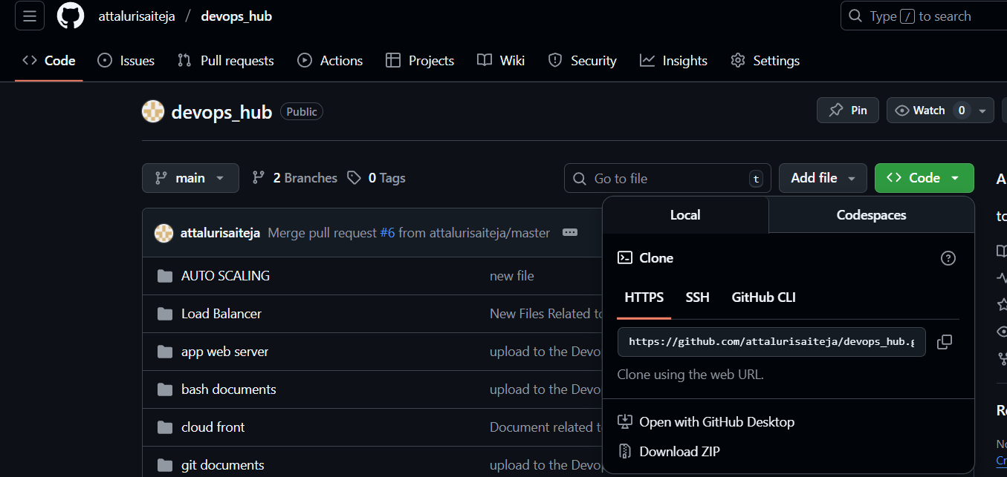
Use command git remote add to add origin and check

Use command git pull to get the repo
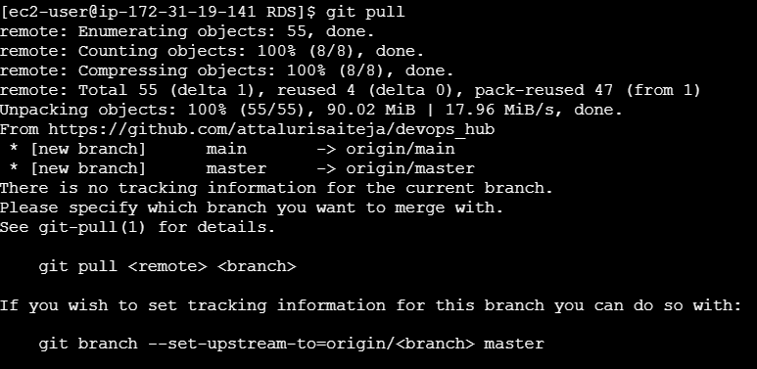
If any errors occur then use command
Git pull origin master –allow-unrelated-histories
By that the entire repo will be cloned
Or use git clone
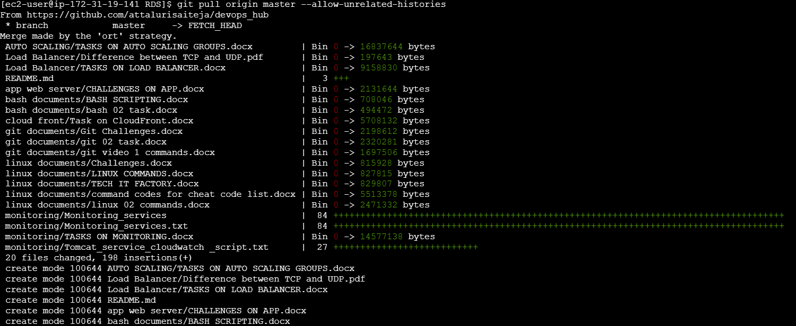

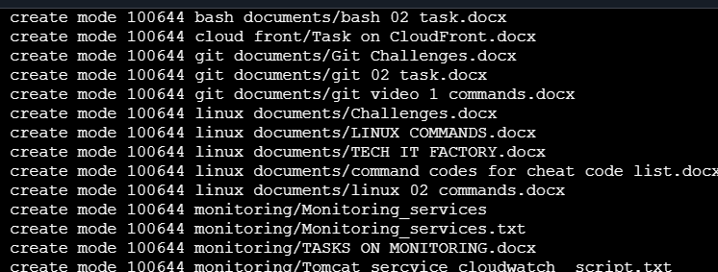
Now push the files
You need to enter the username and token which we generated earlier by that the files will be pushed to github
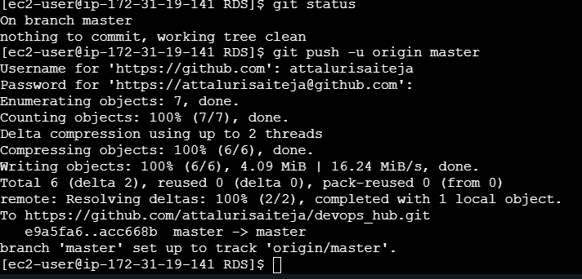
Validation:


