Kubeadm Installation & Minikube installation
# Minimum server requirements for K8s Installation
1. Master – t2.large (2 vCPU 8 GiB Memory)
2. Worker node 1&2 - t2.large (2 vCPU 8 GiB Memory)
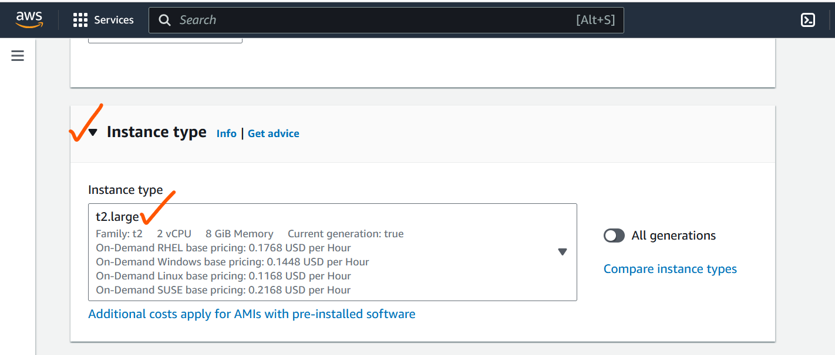
1. Install Docker
# yum -y install docker
-> Install docker on Master and worker nodes
/ Execute all below commands in workernodes as well
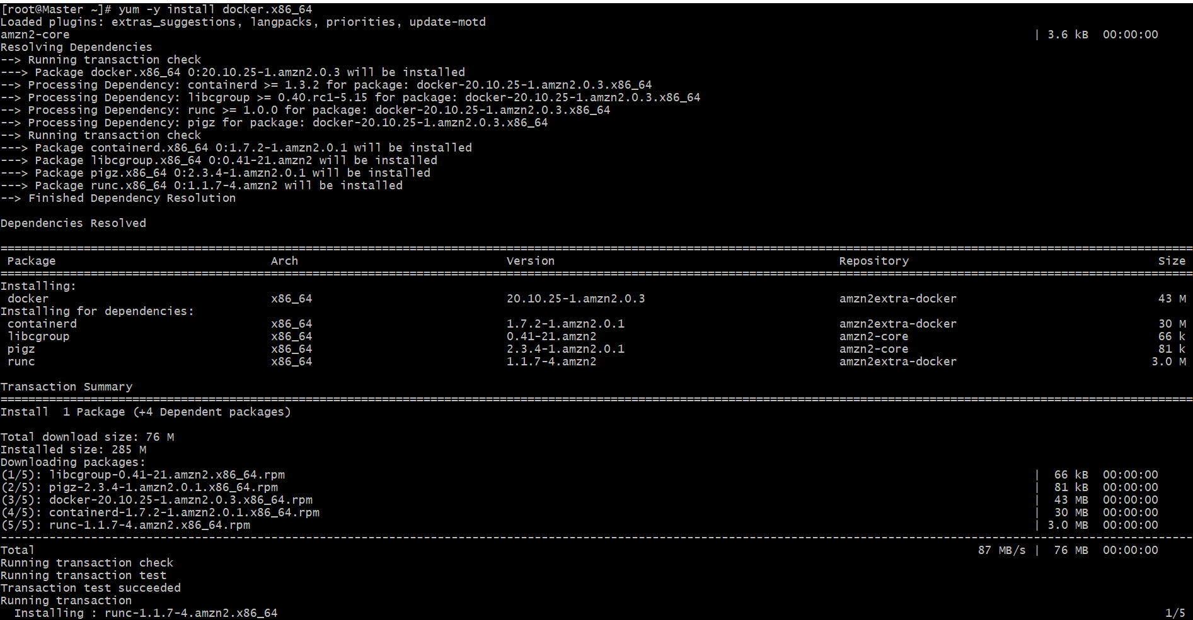
2.
# docker --version
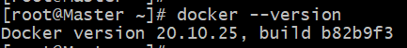
3.
# systemctl start docker

# systemctl status docker
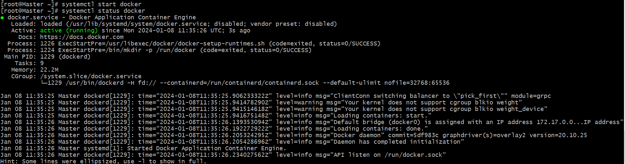
@ To setup k8s cluster we have different tools like kops and kubeadm. / Below mentioned the Google chrome installation path / After open the chrome page -> Select the OS type -> Like Redhat.
- https://kubernetes.io/docs/setup/production-environment/tools/kubeadm/install-kubeadm/
4. sudo sed -i 's/^SELINUX=enforcing$/SELINUX=permissive/' /etc/selinux/config

5. vi /etc/yum.repos.d/kubernetes.repo
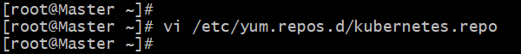

--> Place this script in this mentioned path in Master & Worker nodes -->
6. vi /etc/yum.repos.d/kubernetes.repo
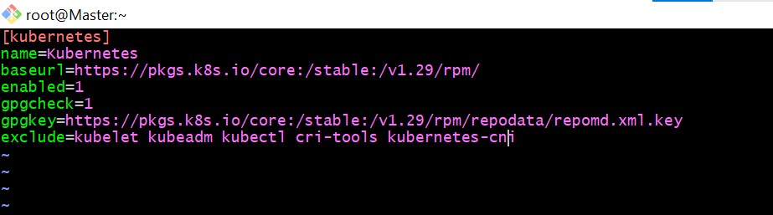
[kubernetes]
name=Kubernetes
baseurl=https://pkgs.k8s.io/core:/stable:/v1.29/rpm/
enabled=1
gpgcheck=1
gpgkey=https://pkgs.k8s.io/core:/stable:/v1.29/rpm/repodata/repomd.xml.key
exclude=kubelet kubeadm kubectl cri-tools kubernetes-cni

* For installation execute the below command
7. sudo yum install -y kubelet kubeadm kubectl --disableexcludes=kubernetes --disableplugin=priorities
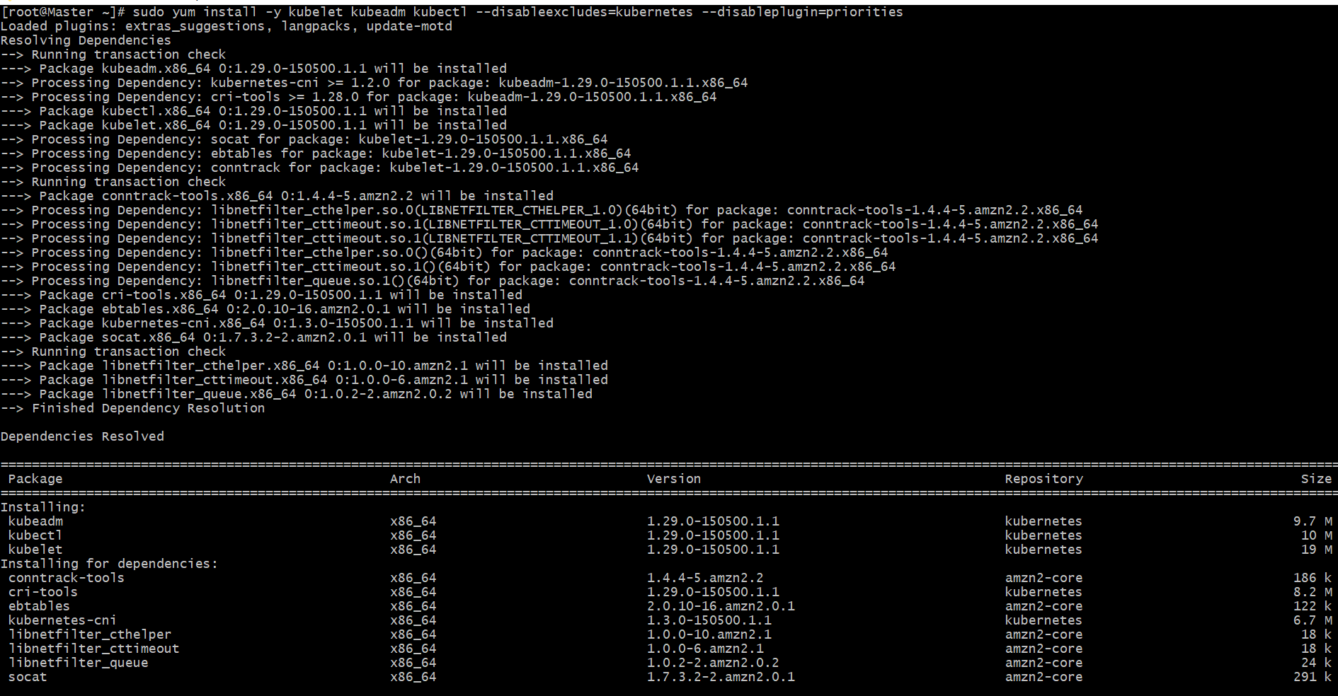
After executed Below command we will get some commands to execute / Mentioned Below
Note: Only master node will get the commands to execute in the workernodes
8. kubeadm init --pod-network-cidr=10.244.0.0/16
Note: We need to execute this command only in Master node
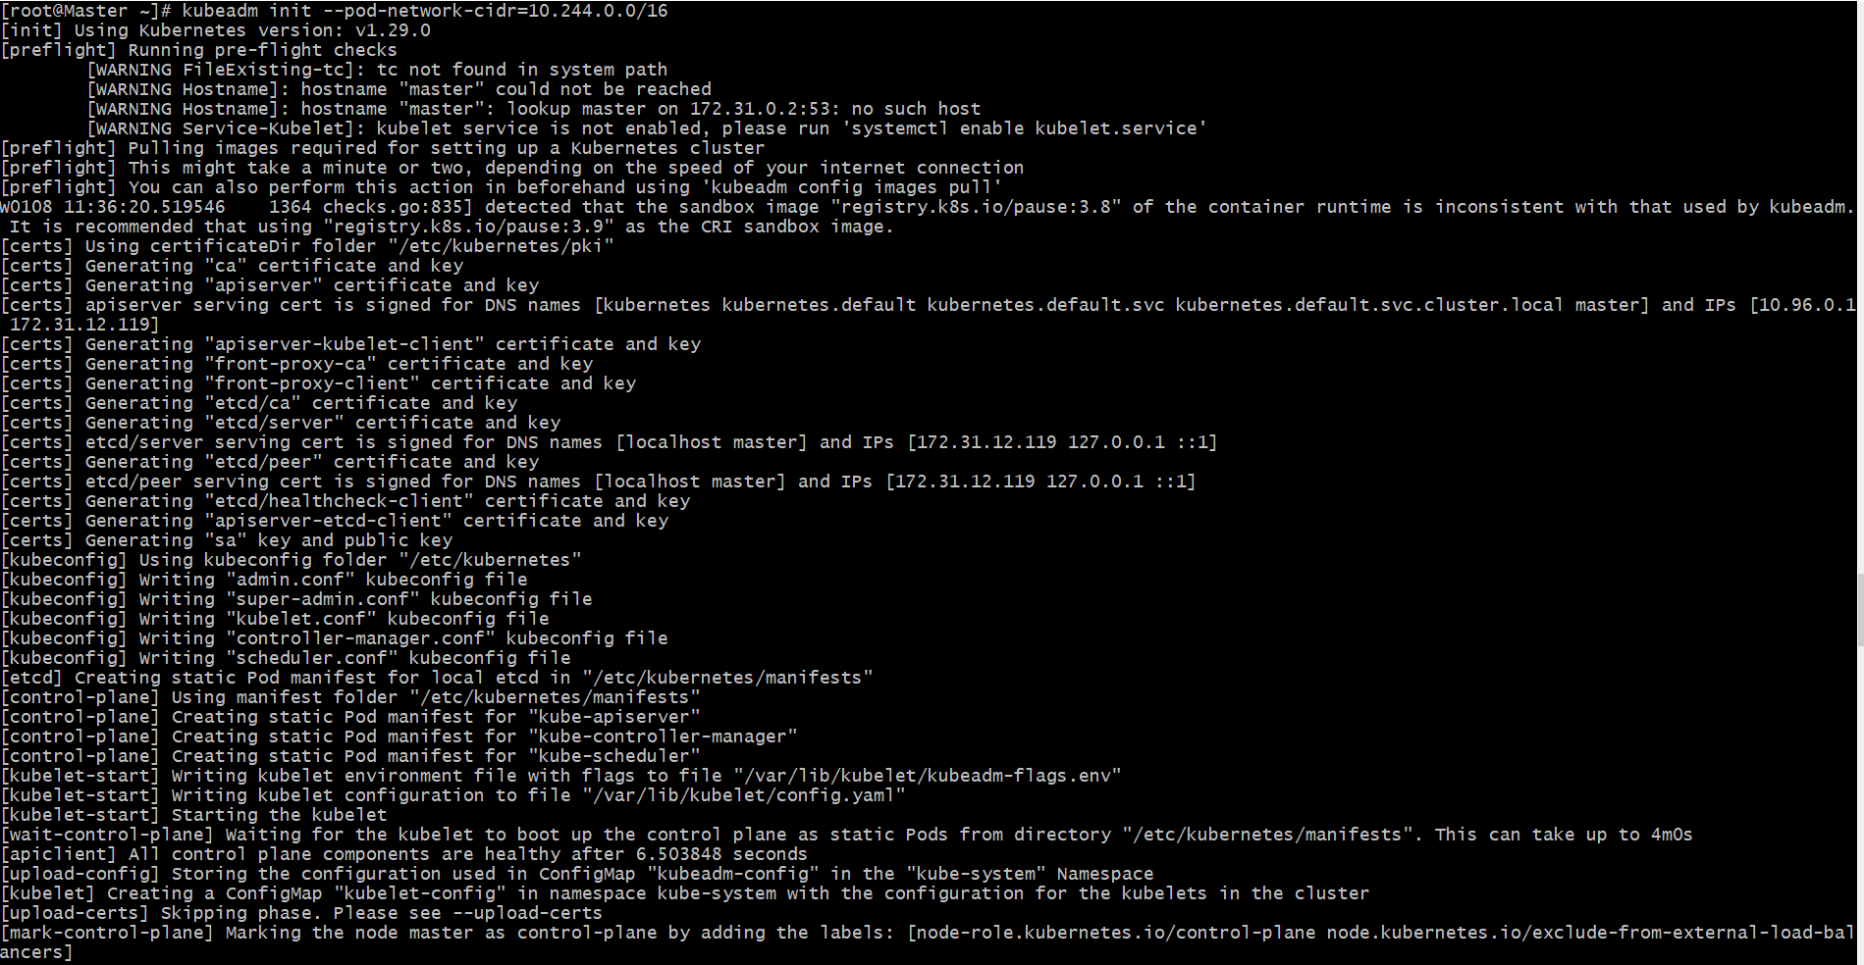
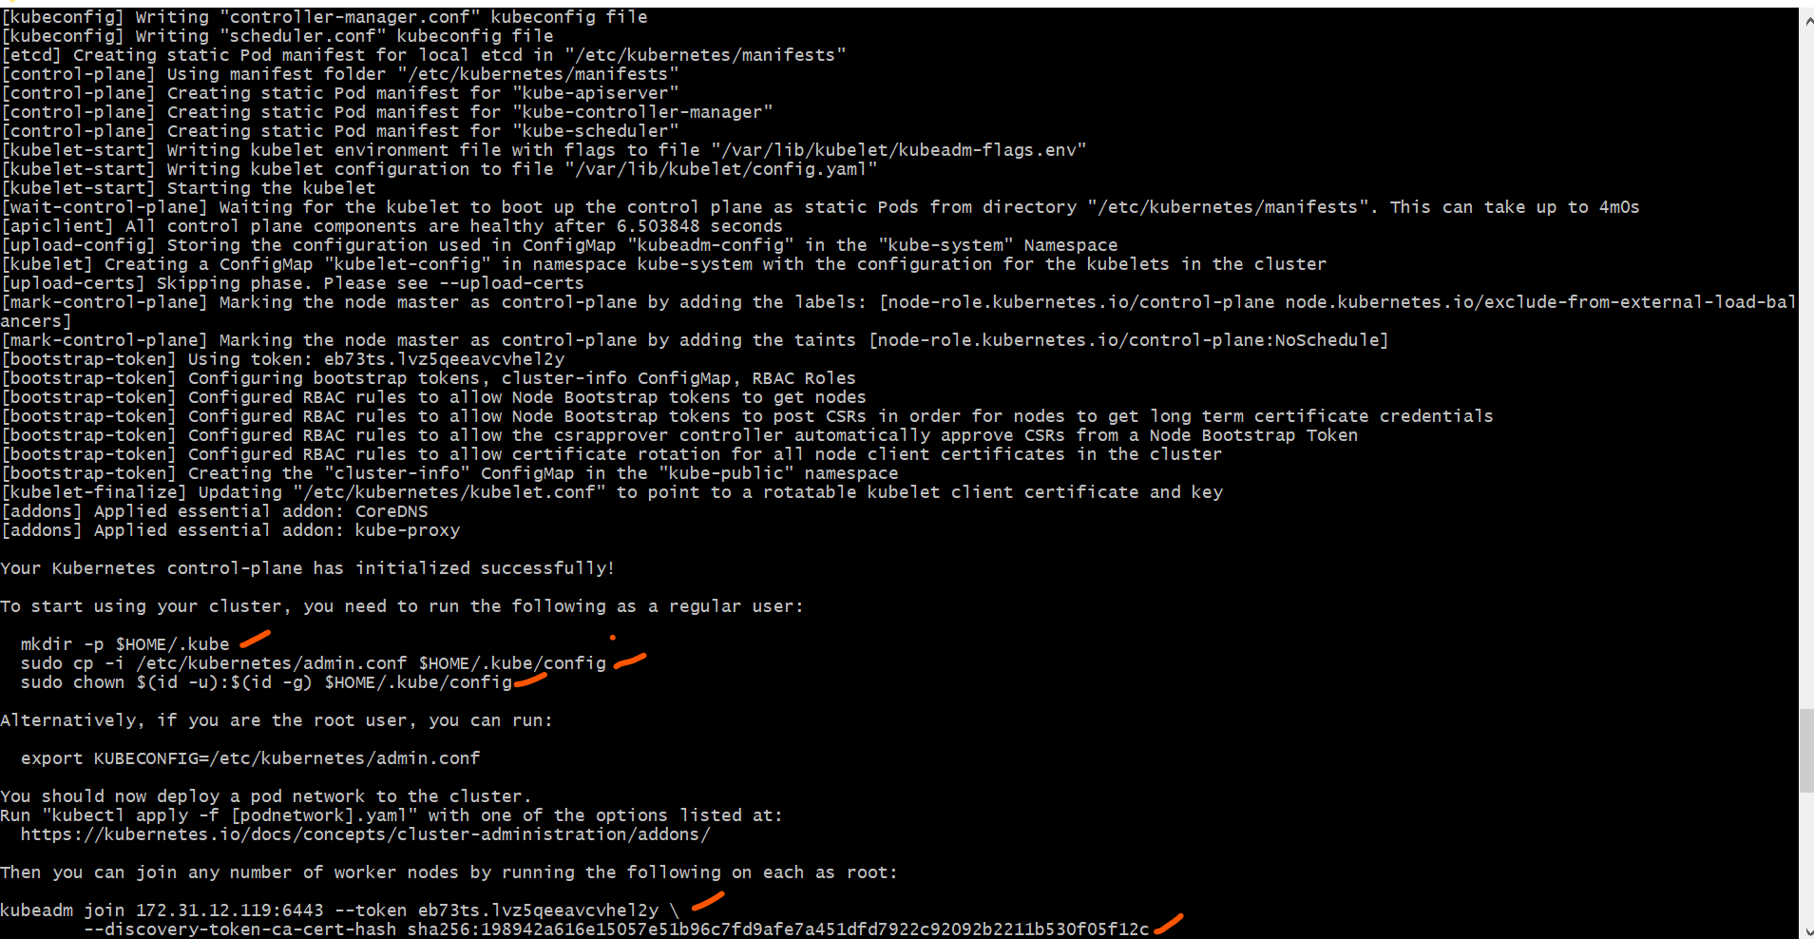
9. mkdir -p $HOME/.kube

10.sudo cp -i /etc/kubernetes/admin.conf $HOME/.kube/config

11.sudo chown $(id -u):$(id -g) $HOME/.kube/config

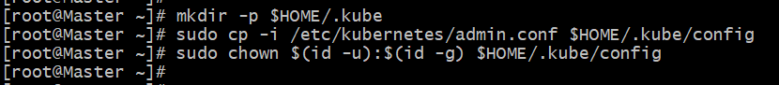

@ Execute this command in worker nodes. (Execute the master node to worker nodes)
12. kubeadm join 172.31.12.119:6443 --token eb73ts.lvz5qeeavcvhel2y \
--discovery-token-ca-cert-hash sha256:198942a616e15057e51b96c7fd9afe7a451dfd7922c92092b2211b530f05f12c

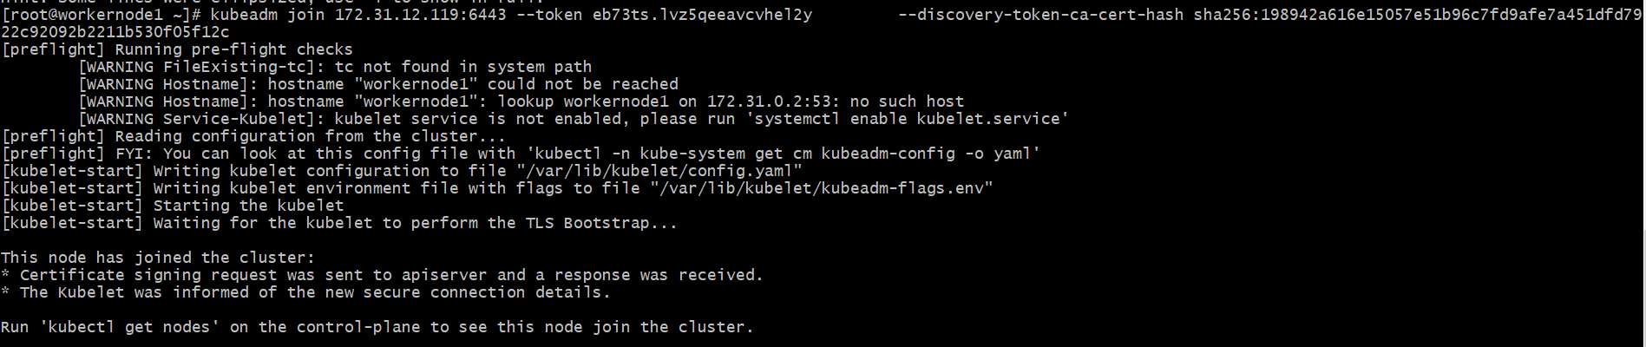

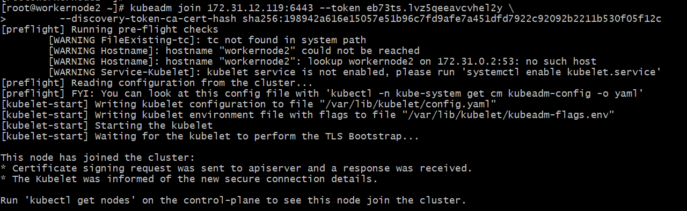

If we execute kubectl get nodes we can see the status as notready because we haven't installed flannel
13. kubectl get nodes

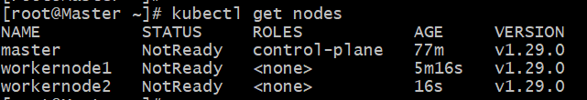

# Flannel is installed
kubectl apply -f https://github.com/flannel-io/flannel/releases/latest/download/kube-flannel.yml

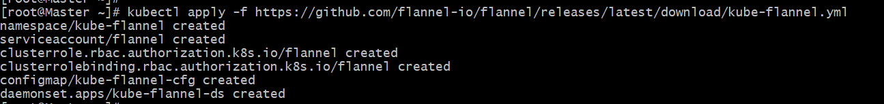

# Now Master and Worker nodes are ready

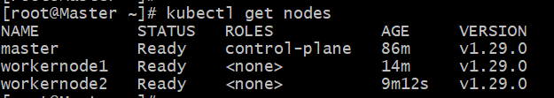
############################################################################
Minikube installation on Windows
Minikube:
========
Minikube is a single cluster with all k8s component.
minikube is used for learning and development purposes.

Install minikube on windows:
===========================
1) Install Docker on windows.
https://docs.docker.com/desktop/install/windows-install/
2) Install Oracle box on windows
https://adamtheautomator.com/install-virtualbox-on-windows-10/
3) Check system info in CMD
systeminfo
4) Install Minikube using powershell
https://minikube.sigs.k8s.io/docs/start/
5) Set the minikube path to environmental varaible
6) Restart powershell and start minikube
minikube start

To check minikube ip use : minikube ip
To ssh to minikube: minikube ssh
To connect or check the pods : kubectl get pods
To see minikube on dashboard: minikube dashboard
# https://docs.docker.com/desktop/install/windows-install/
1. Install docker desktop on windows
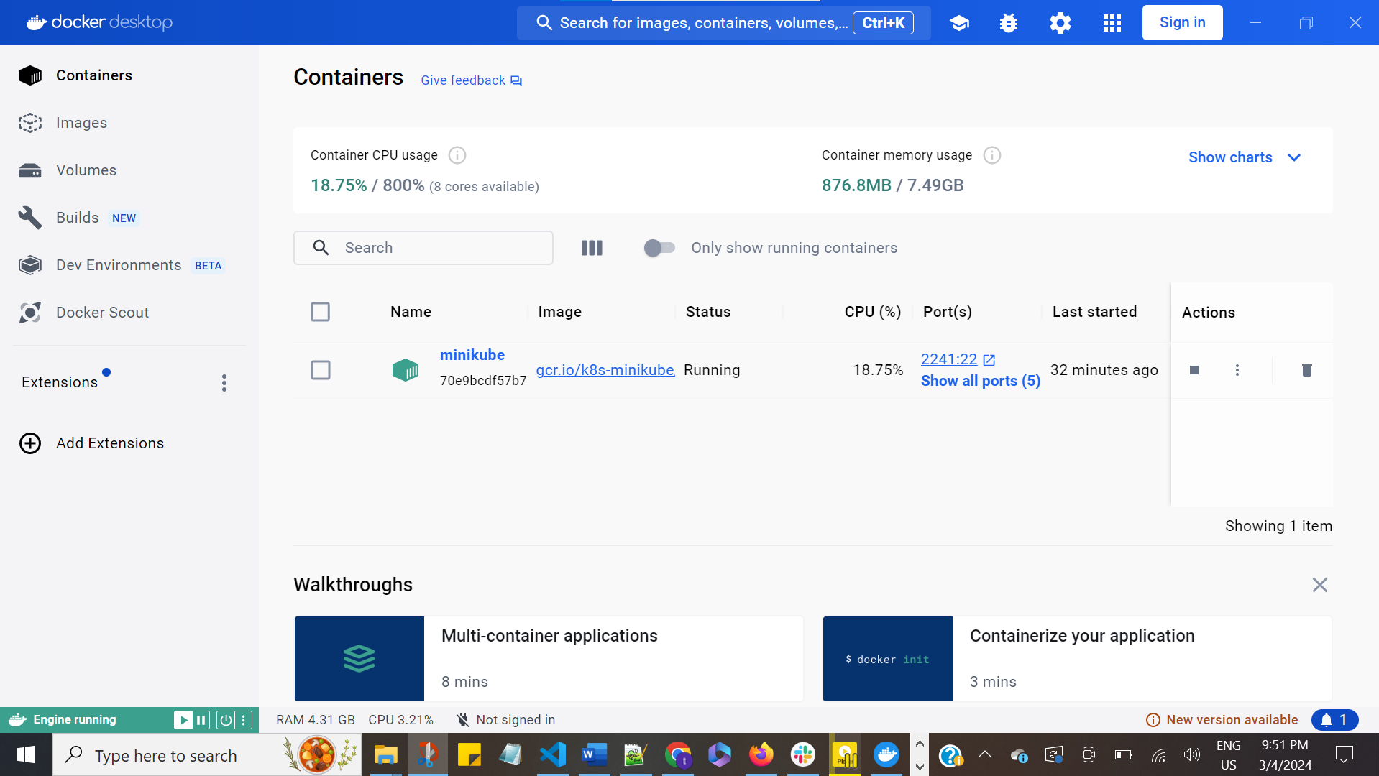
2. Check the docker version in the local / After docker desktop installation then only docker version will be shown in the git cli
# docker --version
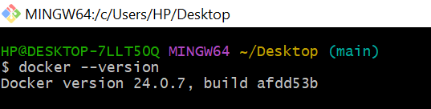
3. Go to this path for doenload the minikube installation commands
# https://minikube.sigs.k8s.io/docs/start/
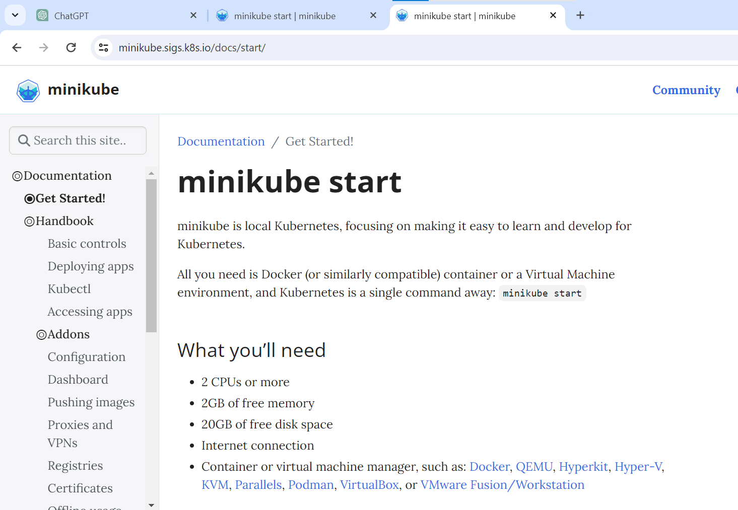
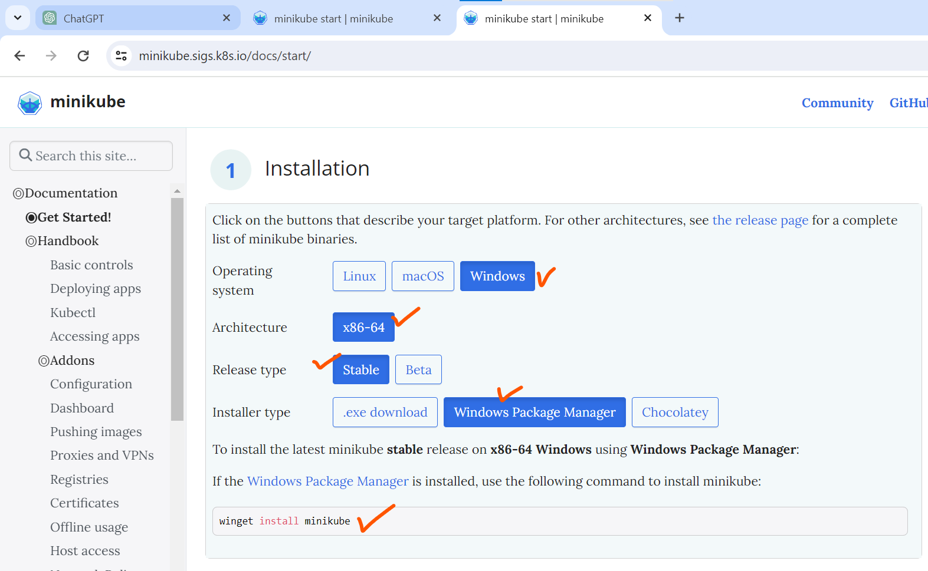
# winget install minikube

