
2. Setup a Jenkins CICD pipeline using Declarative pipeline using feature-1.1 branch. https://github.com/betawins/sabear_simplecutomerapp/tree/feature-1.1
stages:
Git Clone
SonarQube Integration
Maven Compilation
Nexus Artifactory
Slack Notification
Deploy On tomcat
Plugin name: Pipeline
Steps
Navigate to Jenkins and create a job with pipeline style and continue with providing description
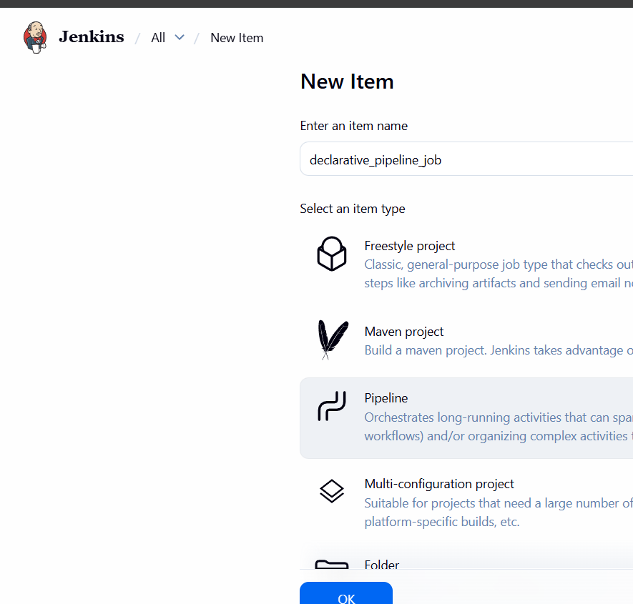

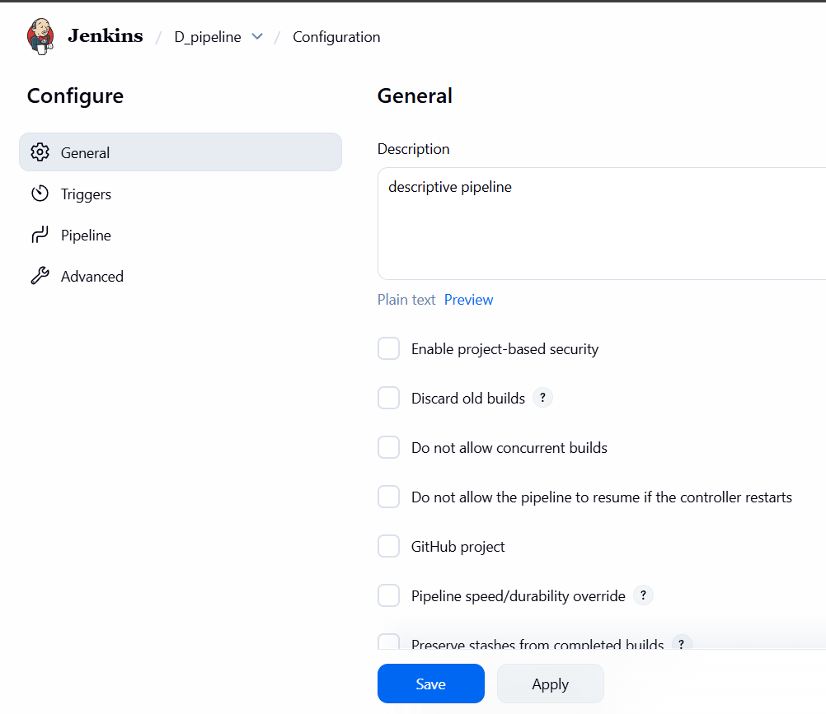
Write the pipeline including credential names
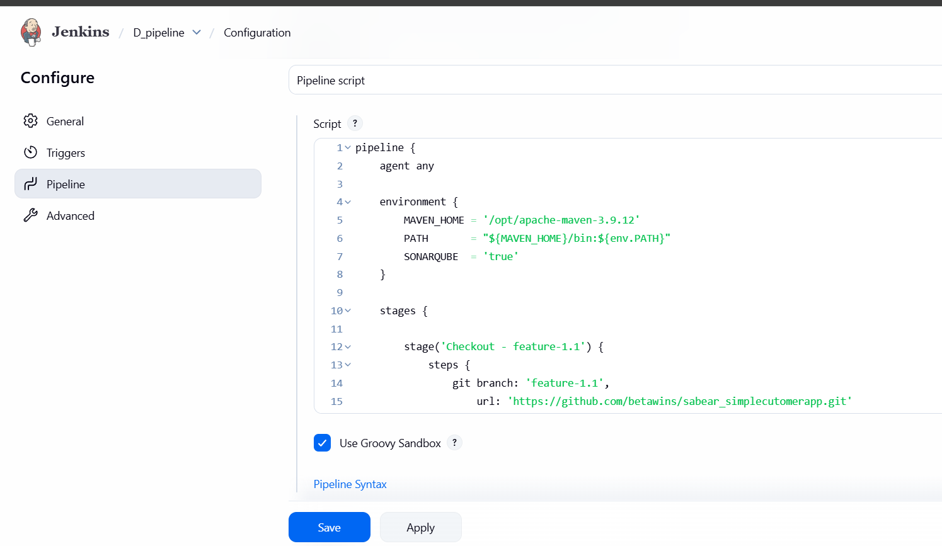
After writing pipeline script was executed successfully and verified in console and slack notification
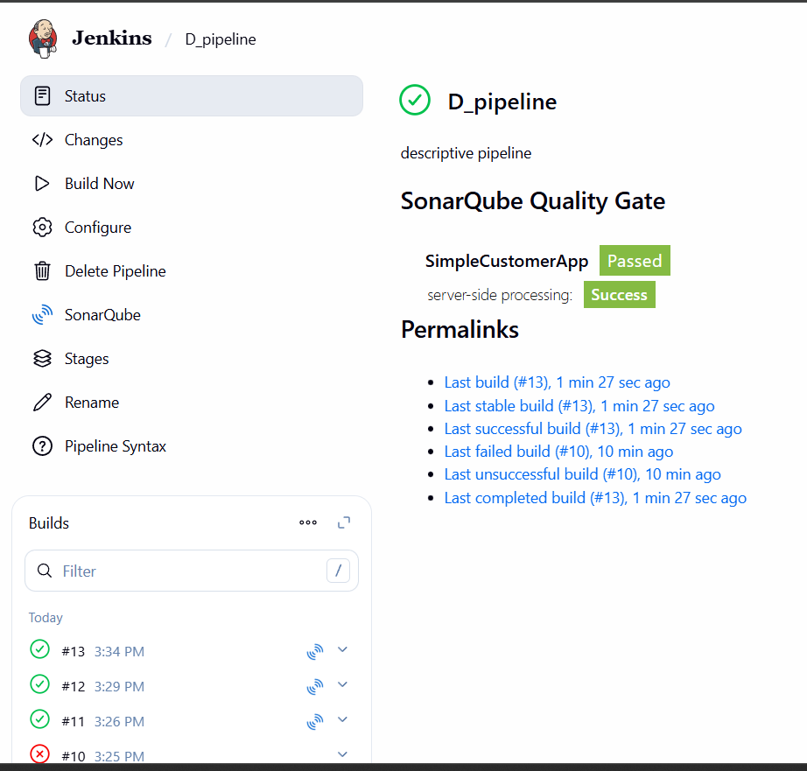
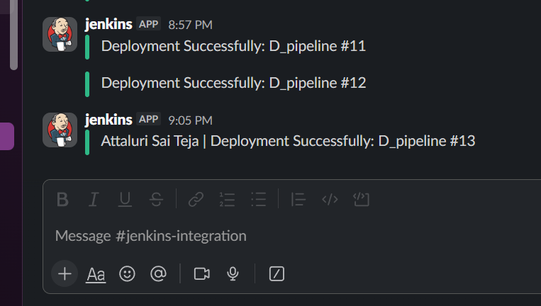
NOTE::: WHILE WRITING A PIPELINE
- Make sure flower brackets should be open and close {} in whole script and don’t close the main { in middle so that the execution will stop at middle..
- The best practice is when you are opening a { then close immediately and insert the data in it } by that the main { bracket will be open till end.
- After entering all details we can close } bracket
- Credential names should be same as in your Jenkins account and pipeline.

- Every Declarative pipeline must start with:
pipeline {
}
===========================================================================
- This tells Jenkins where to run the job.
agent any
Meaning:
“Run on any available Jenkins agent.”
===========================================================================
- environment – VARIABLES (optional but powerful)
Used for:
Paths, Flags, Credentials, Toggles
environment {
MVN_HOME = '/opt/apache-maven-3.9.12'
SONARQUBE = 'true'
}
Rule
- Strings must be in quotes
- Uppercase is convention, not mandatory
===========================================================================
- stages {} – WORKFLOW (mandatory)
All work happens inside stages.
stages {
}
===========================================================================
stage {} – ONE logical step
Each stage represents one action in your CI/CD flow.
Example:
stage('Build') {
}
Think:
“What am I doing here?”
======================================================================
steps {} – WHAT to execute
Inside a stage, Jenkins must know what to run.
stage('Build') {
steps {
sh 'mvn clean package'
}
}
❌ You cannot run sh directly inside stage.
========================================================================
Writing COMMON steps (this is where mistakes happen)
🔹 Git checkout
git branch: 'feature-1.1',
url: 'https://github.com/xxx/repo.git'
========================================================================
Shell commands
sh '''
mvn clean package
'''

Conditional execution (when)
when {
expression { env.SONARQUBE == 'true' }
}
Means:
“Run this stage only if SONARQUBE=true”

===========================================================================
SonarQube wrapper
withSonarQubeEnv('sonar') {
sh 'sonar-scanner'
}
This injects credentials automatically.
Tomcat deployment
deploy adapters: [
tomcat9(
credentialsId: 'tomcat-creds',
url: 'http://host:8080'
)
],
contextPath: '/app',
war: 'target/app.war'

===========================================================================post {} – AFTER the pipeline
Runs after all stages.
post {
success {
echo 'Success'
}
failure {
echo 'Failure'
}
}

My pipeline script::: for reference
pipeline {
agent any

environment {
MAVEN_HOME = '/opt/apache-maven-3.9.12'
PATH = "${MAVEN_HOME}/bin:${env.PATH}"
SONARQUBE = 'true'
}

stages {

stage('Checkout - feature-1.1') {
steps {
git branch: 'feature-1.1',
url: 'https://github.com/betawins/sabear_simplecutomerapp.git'
}
}

stage('Build') {
steps {
sh 'mvn clean package'
}
}

stage('sonarQube Analysis') {
when {
expression { env.SONARQUBE == 'true' }
}
steps {
withSonarQubeEnv('sonar-server') {
sh '''
/opt/sonar-scanner/bin/sonar-scanner \
-Dsonar.projectKey=sabear_simplecustomerapp \
-Dsonar.sources=. \
-Dsonar.exclusions=**/*.java
'''
}
}
}

stage('Deploy to Tomcat') {
steps {
deploy adapters: [
tomcat9(
credentialsId: 'tomcat',
url: 'http://54.84.232.100:8080'
)
],
contextPath: '/sabear',
war: 'target/*.war'
}
}
}

post {
success {
slackSend(
channel: '#jenkins-integration',
color: 'good',
message: "Attaluri Sai Teja | Deployment Successfully: ${env.JOB_NAME} #${env.BUILD_NUMBER}",
tokenCredentialId: 'slack_notification'
)
}
failure {
slackSend(
channel: '#jenkins-integration',
color: 'danger',
username: 'Attaluri Sai Teja',
message: "Attaluri Sai Teja | Deployment Successfully: ${env.JOB_NAME} #${env.BUILD_NUMBER}",
tokenCredentialId: 'slack_notification'
)
}
}
}

Forget to add Nexus repo in above task so added again
Need to create a new repo in NEXUS repo UI
And need to set env variables and creds
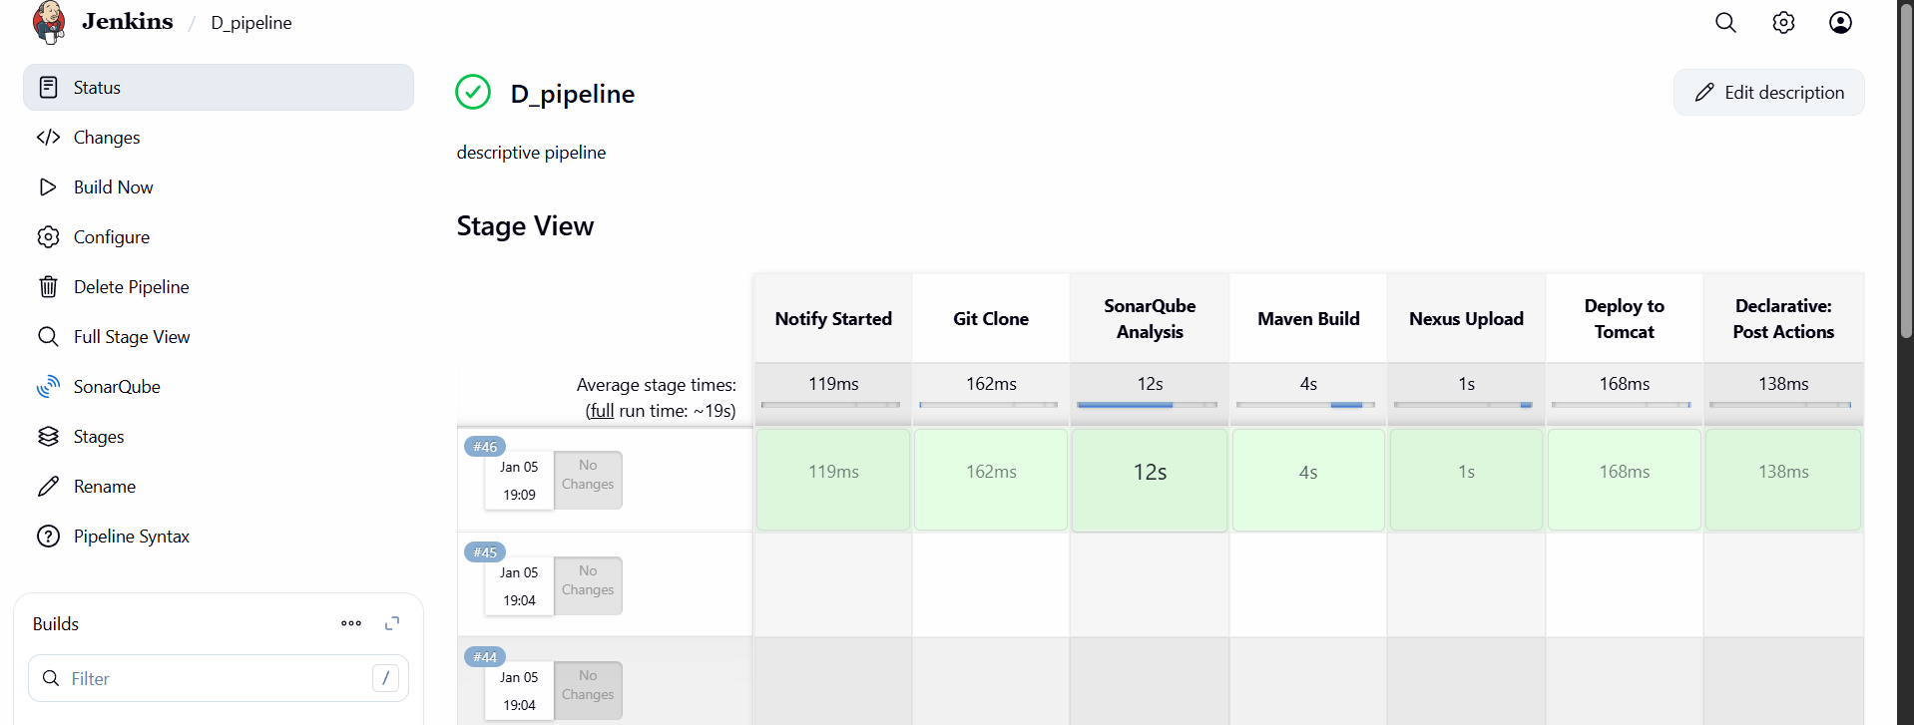
Script”::::
pipeline {
agent any
options {
timestamps()
}
environment {
MAVEN_HOME = '/opt/apache-maven-3.9.12'
PATH = "${MAVEN_HOME}/bin:${env.PATH}"

// SonarQube Details
SONAR_PROJECT_KEY = 'sabear_simplecustomerapp'
SONAR_PROJECT_NAME = 'SimpleCustomerApp'

// Nexus Details - Updated with your provided IP and Repository Name
NEXUS_URL = '52.54.121.150:8081'
NEXUS_REPOSITORY = 'simple_customer_app'
NEXUS_VERSION = 'nexus3'
NEXUS_PROTOCOL = 'http'

// Tomcat Details - Updated with your provided IP
TOMCAT_URL = 'http://34.229.204.43:8080'
}
stages {
stage('Notify Started') {
steps {
slackSend(
color: '#439FE0',
message: "Attaluri Sai Teja | ${env.JOB_NAME} - #${env.BUILD_NUMBER} Started (<${env.BUILD_URL}|Open>)",
tokenCredentialId: 'slack_notification'
)
}
}
stage('Git Clone') {
steps {
git branch: 'feature-1.1',
url: 'https://github.com/betawins/sabear_simplecutomerapp.git'
}
}
stage('SonarQube Analysis') {
steps {
// Using 'sonar-server' to match your previous Jenkins configuration
withSonarQubeEnv('sonar-server') {
sh '''
mvn clean verify \
org.sonarsource.scanner.maven:sonar-maven-plugin:sonar \
-Dsonar.projectKey=${SONAR_PROJECT_KEY} \
-Dsonar.projectName=${SONAR_PROJECT_NAME}
'''
}
}
}
stage('Maven Build') {
steps {
sh 'mvn clean package -DskipTests'
}
}
stage('Nexus Upload') {
steps {
script {
def WAR_FILE = sh(
script: "ls target/*.war",
returnStdout: true
).trim()

// Uses the Nexus Artifact Uploader Plugin
nexusArtifactUploader(
nexusVersion: NEXUS_VERSION,
protocol: NEXUS_PROTOCOL,
nexusUrl: NEXUS_URL,
repository: NEXUS_REPOSITORY,
credentialsId: 'nexus_server', // Updated to match your credential ID
groupId: 'com.javatpoint',
version: "${env.BUILD_NUMBER}-SNAPSHOT",
artifacts: [[
artifactId: 'SimpleCustomerApp',
classifier: '',
type: 'war',
file: WAR_FILE
]]
)
}
}
}
stage('Deploy to Tomcat') {
steps {
deploy adapters: [
tomcat9(
credentialsId: 'tomcat', // Updated to match your credential ID
url: "${TOMCAT_URL}"
)
],
contextPath: 'sabear',
war: 'target/*.war'
}
}
}
post {
success {
slackSend(
color: 'good',
message: "Attaluri Sai Teja | ${env.JOB_NAME} - #${env.BUILD_NUMBER} Success (<${env.BUILD_URL}|Open>)",
tokenCredentialId: 'slack_notification'
)
}
failure {
slackSend(
color: 'danger',
message: "Attaluri Sai Teja | ${env.JOB_NAME} - #${env.BUILD_NUMBER} Failed (<${env.BUILD_URL}|Open>)",
tokenCredentialId: 'slack_notification'
)
}
}
}

