
Title:
4. Write sample skeleton of pipelines.
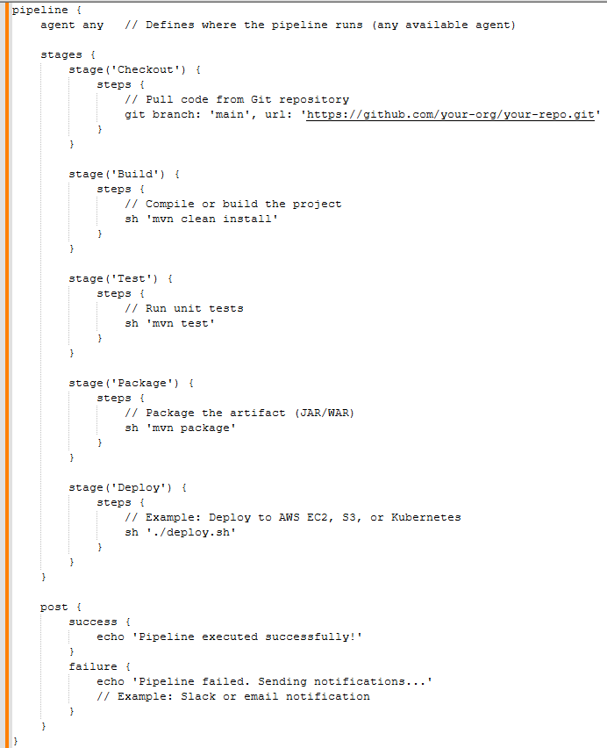

pipeline {
agent any // Defines where the pipeline runs (any available agent)

stages {
stage('Checkout') {
steps {
// Pull code from Git repository
git branch: 'main', url: 'https://github.com/your-org/your-repo.git'
}
}

stage('Build') {
steps {
// Compile or build the project
sh 'mvn clean install'
}
}

stage('Test') {
steps {
// Run unit tests
sh 'mvn test'
}
}

stage('Package') {
steps {
// Package the artifact (JAR/WAR)
sh 'mvn package'
}
}

stage('Deploy') {
steps {
// Example: Deploy to AWS EC2, S3, or Kubernetes
sh './deploy.sh'
}
}
}

post {
success {
echo 'Pipeline executed successfully!'
}
failure {
echo 'Pipeline failed. Sending notifications...'
// Example: Slack or email notification
}
}
}

Title:
5. Create a parameterized job in Jenkins. https://github.com/betawins/spring3-mvc-maven-xml-hello-world-1.git
Objective
The objective is to make the CI/CD pipeline flexible and reusable. By using parameters, you can use a single job to:
- Select Branches: Build any Git branch or tag dynamically.
- Target Environments: Choose between DEV, QA, or PROD at runtime.
- Toggle Features: Decide whether to run specific stages, like SonarQube or Nexus uploads, using checkboxes.
Implementation::
Navigate to Jenkins and click on new item

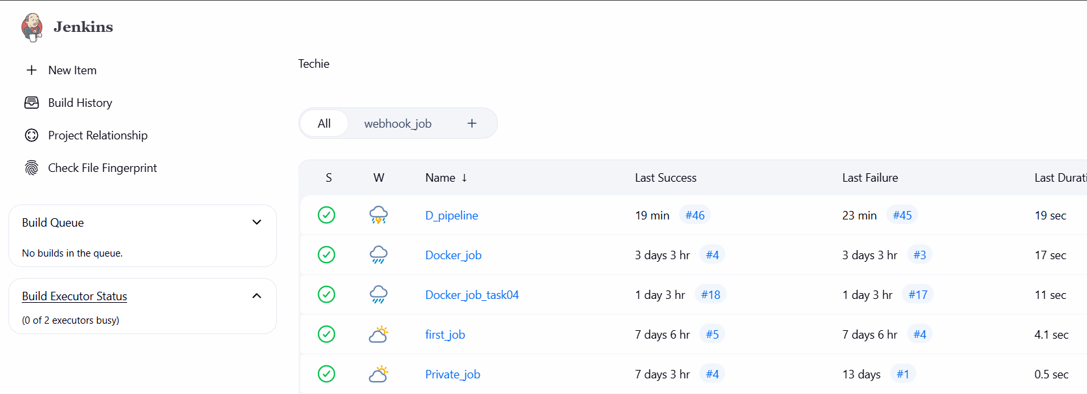

Click on freestyle and continue
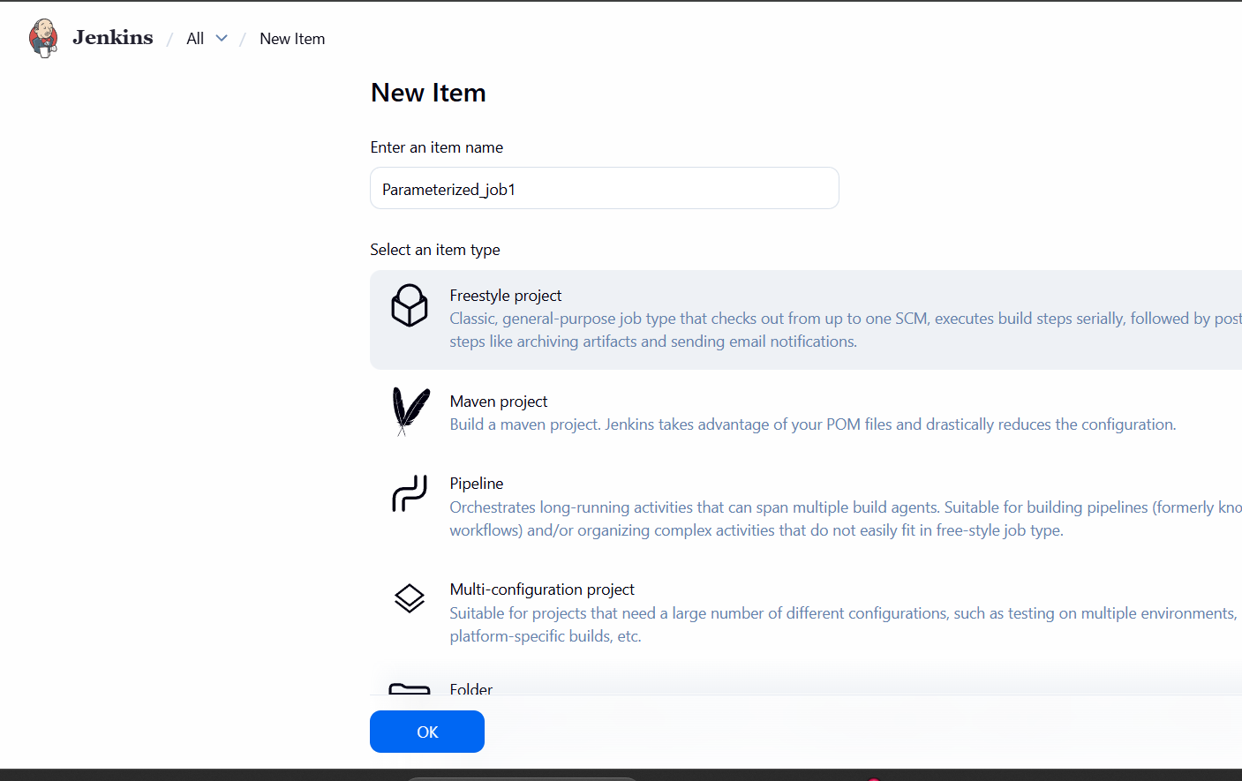
Click on THIS PROJECT IS PARAMETERIZED and continue by adding parametrs
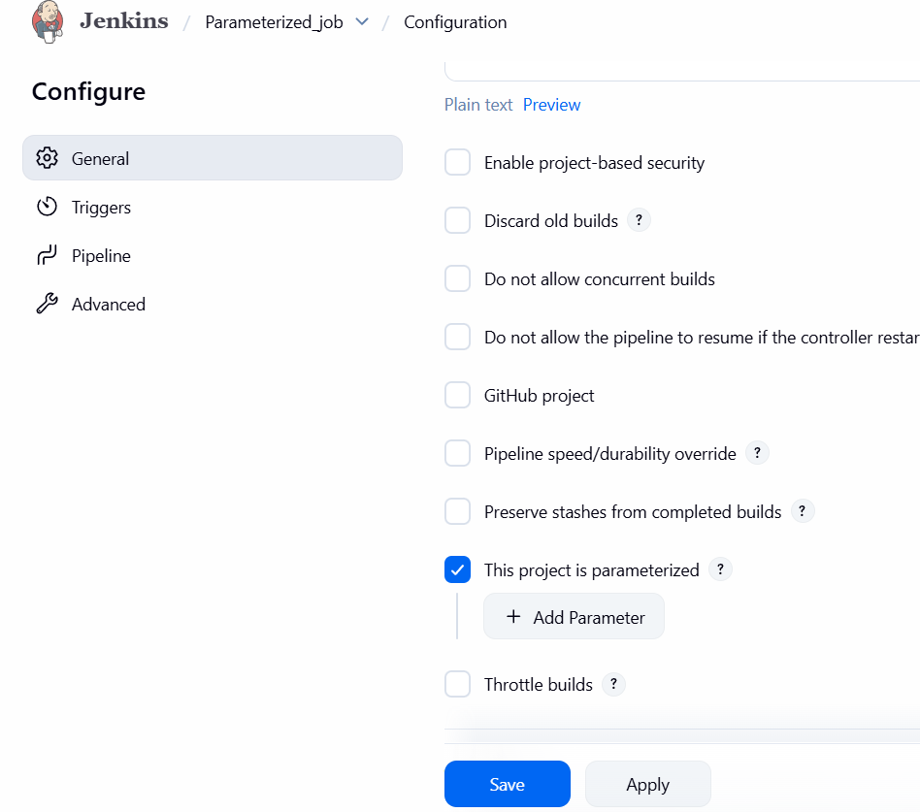
Added 3 env
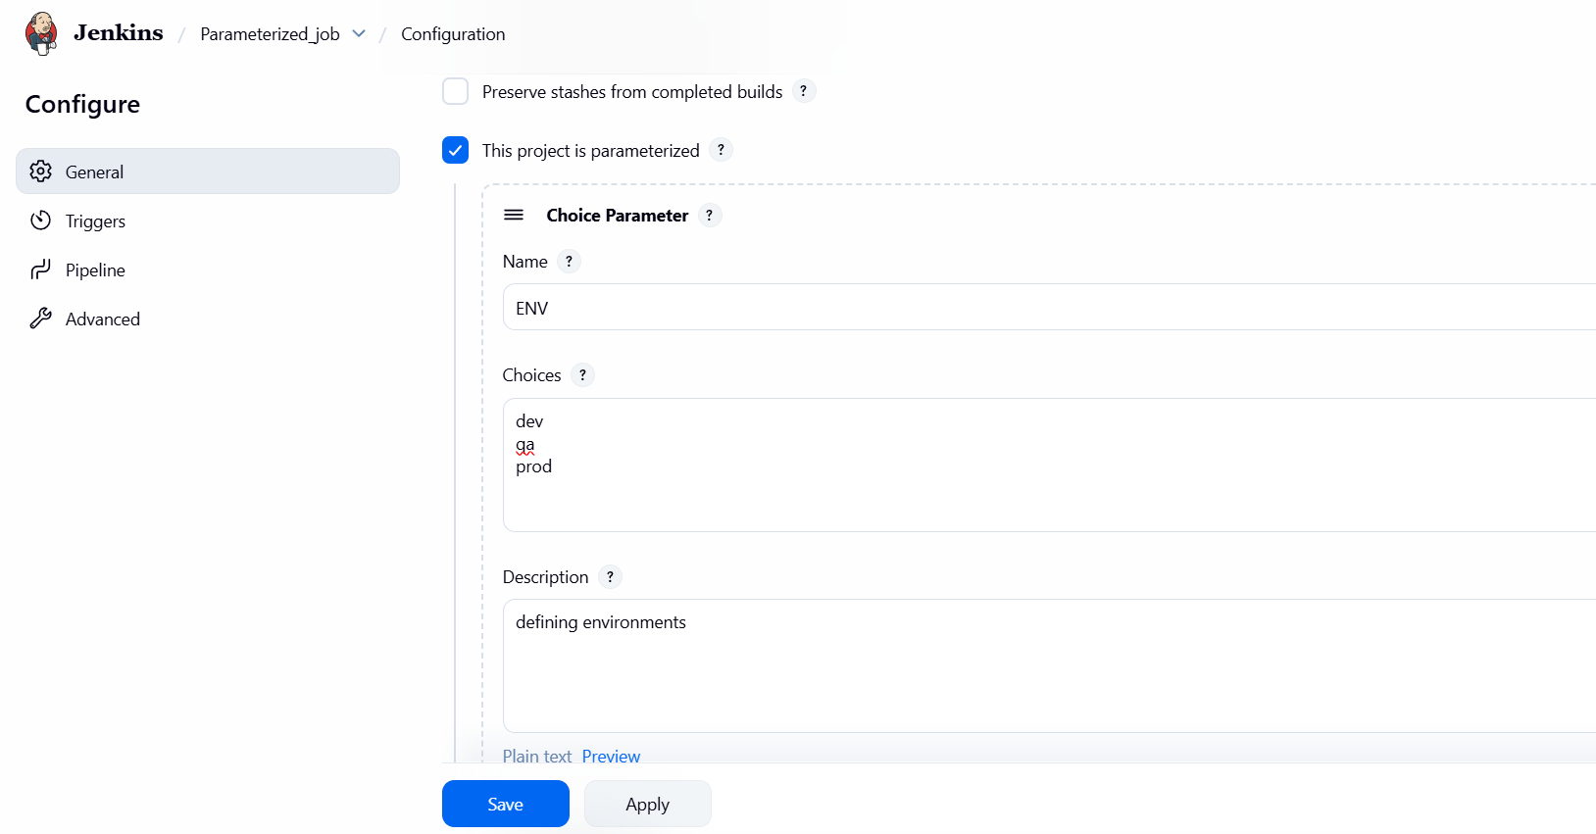
Add git branch and branch name from the repo which are available
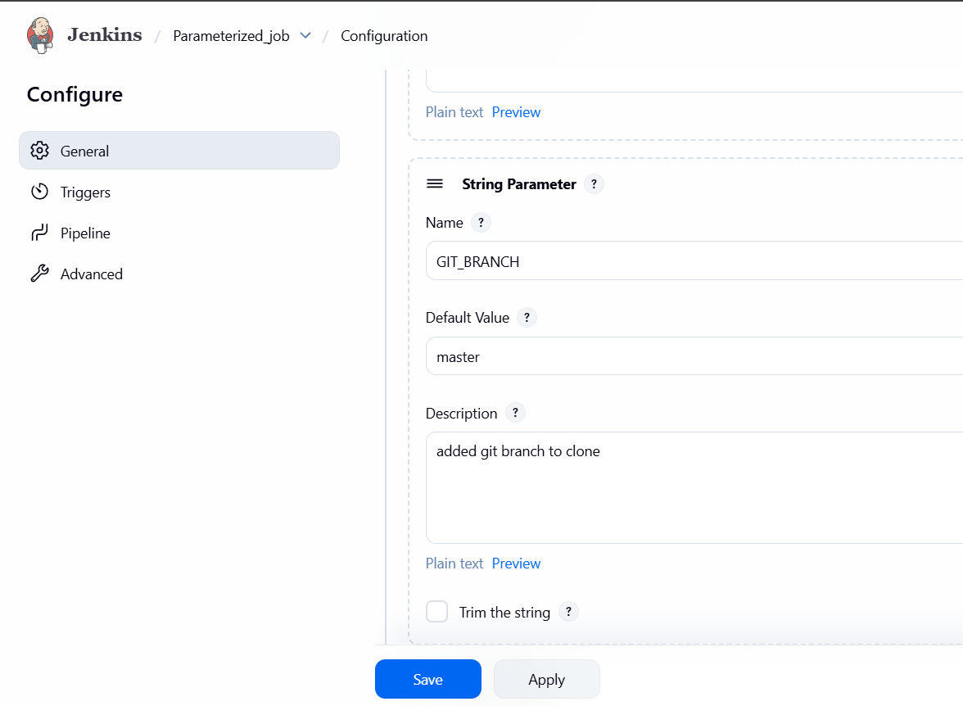

Add other Boolean parameter and skip the tests
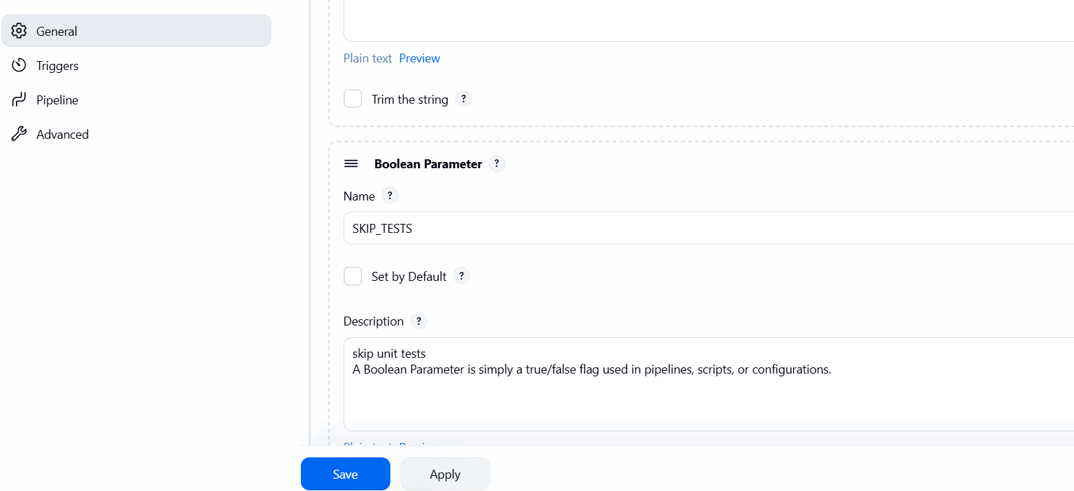
After that add source code management and add git repo url and continue
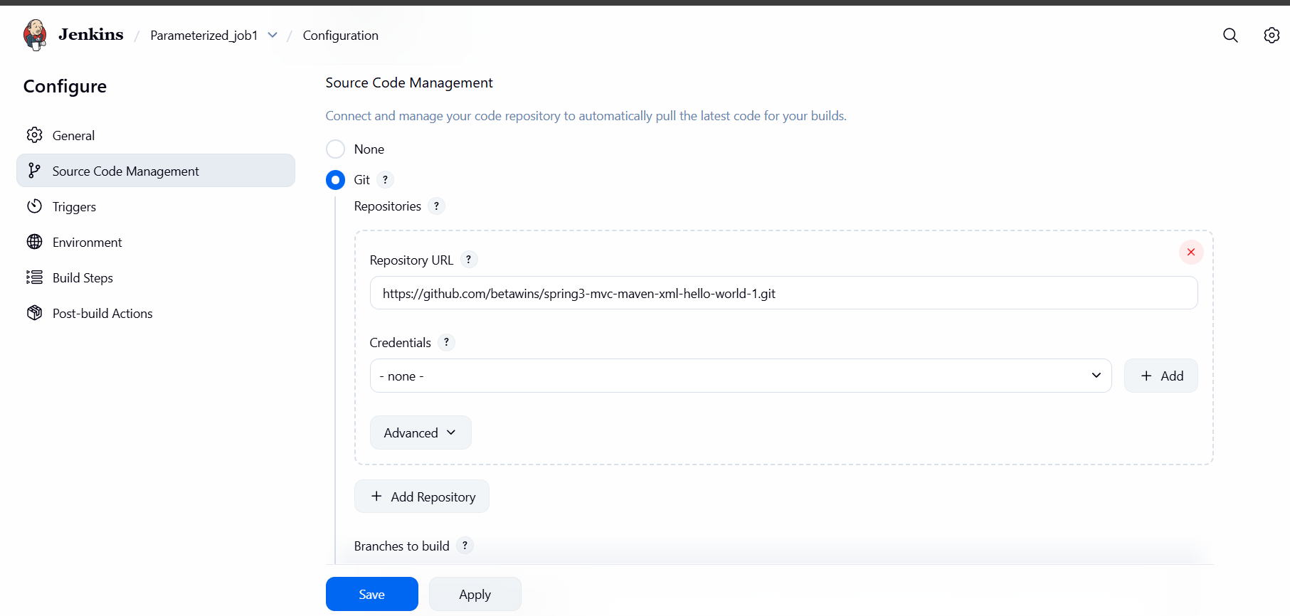
Add names in branches to build with {} not with ()
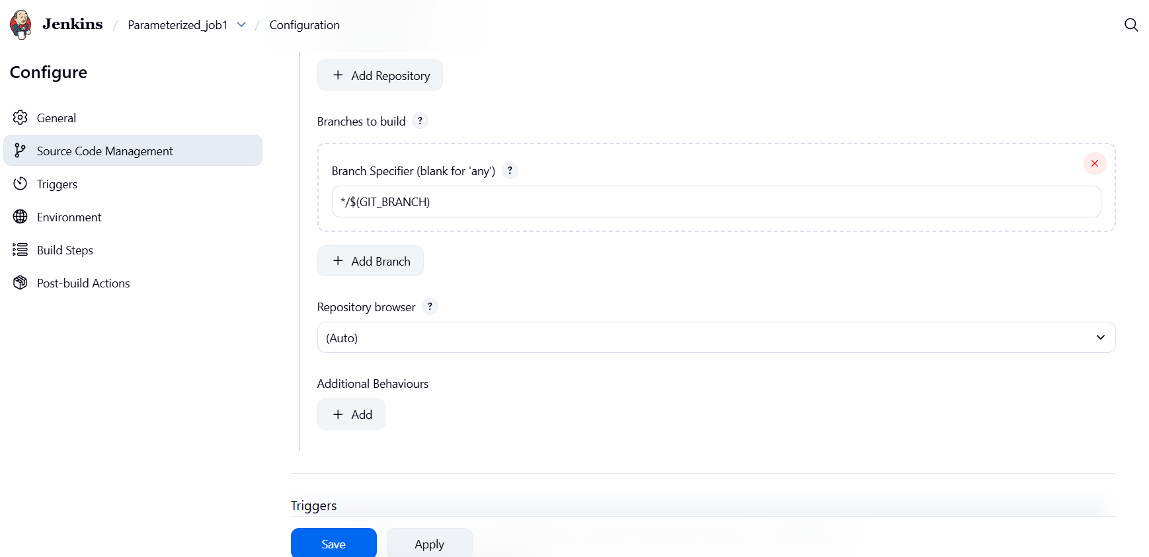
In the build steps add maven details and add command
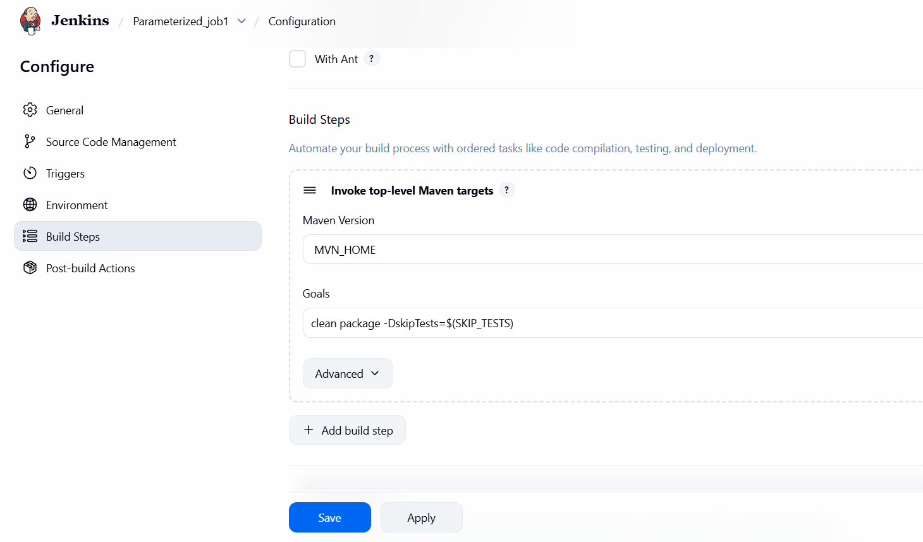
In the end add notification details to slack and continue
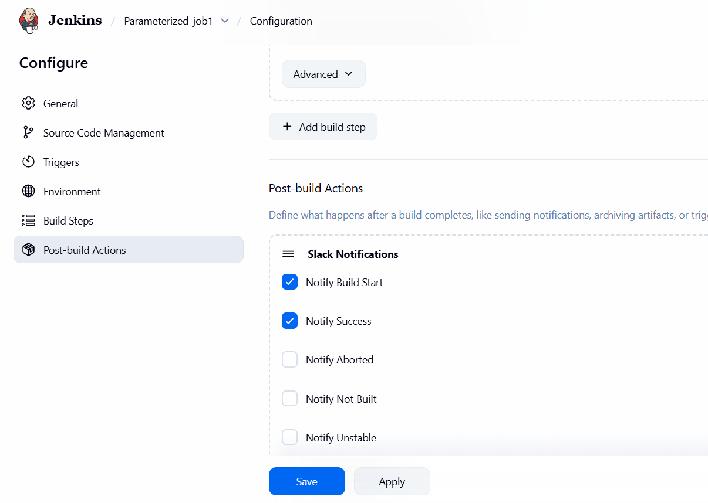.

Click on build parameterized job and click on BUILD
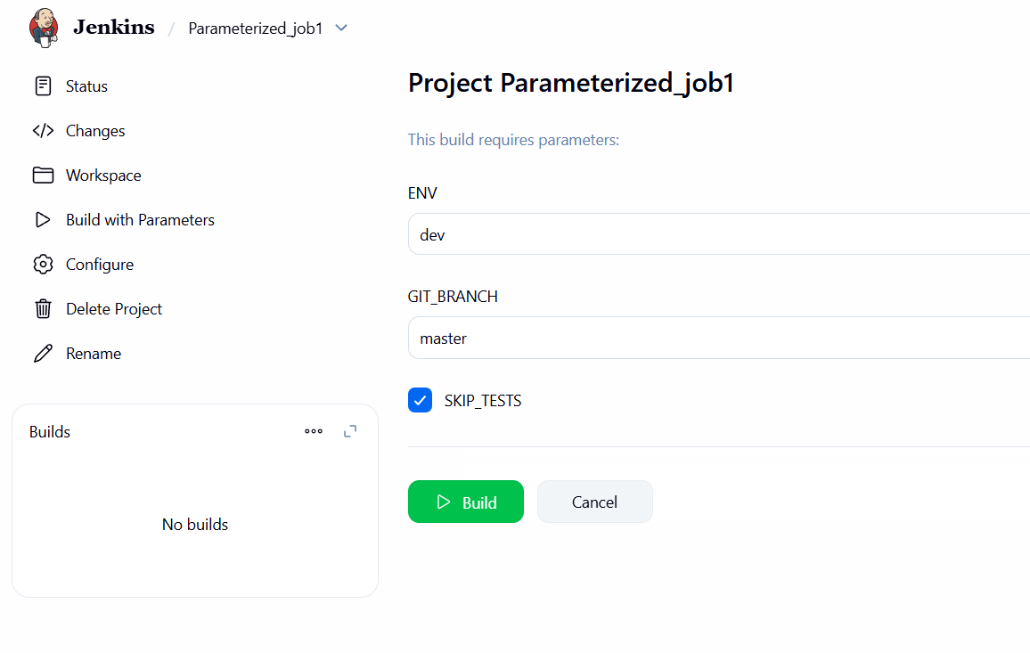
Output has because of java version so added the images and validation part
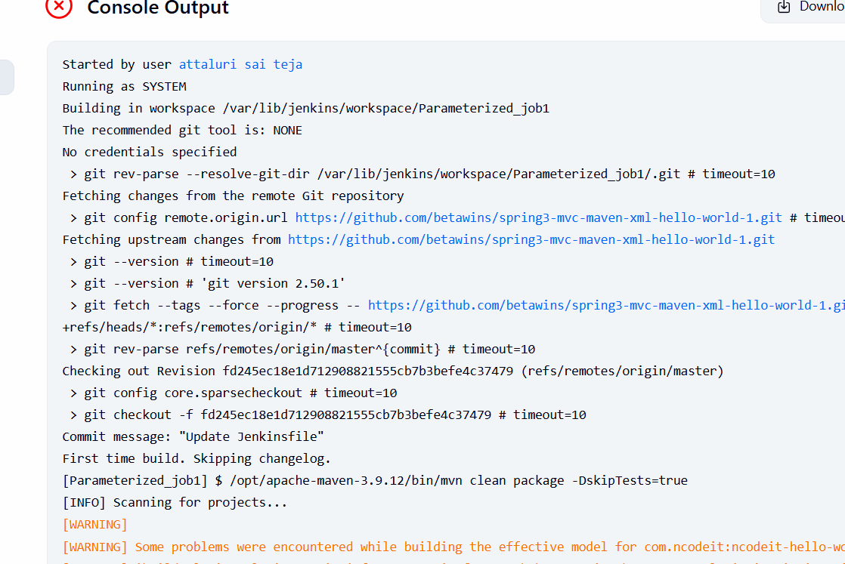
. 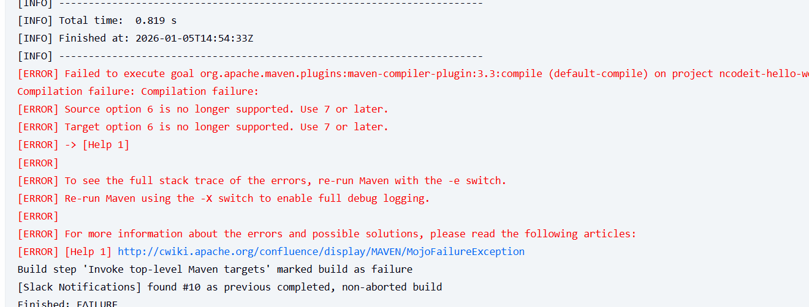
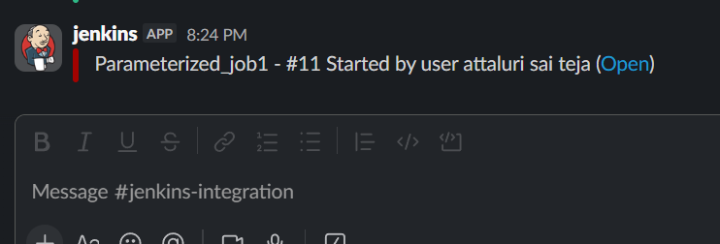

Conclusion
- Parameterized jobs transform static scripts into dynamic, user-driven workflows. This approach reduces job duplication and allows the team to handle different deployment scenarios without changing the Jenkinsfile. It is a critical step toward achieving scalable Infrastructure as Code.

TITLE:
6. Setup one slave machine for Jenkins.
Launch an dedicated instance for slave
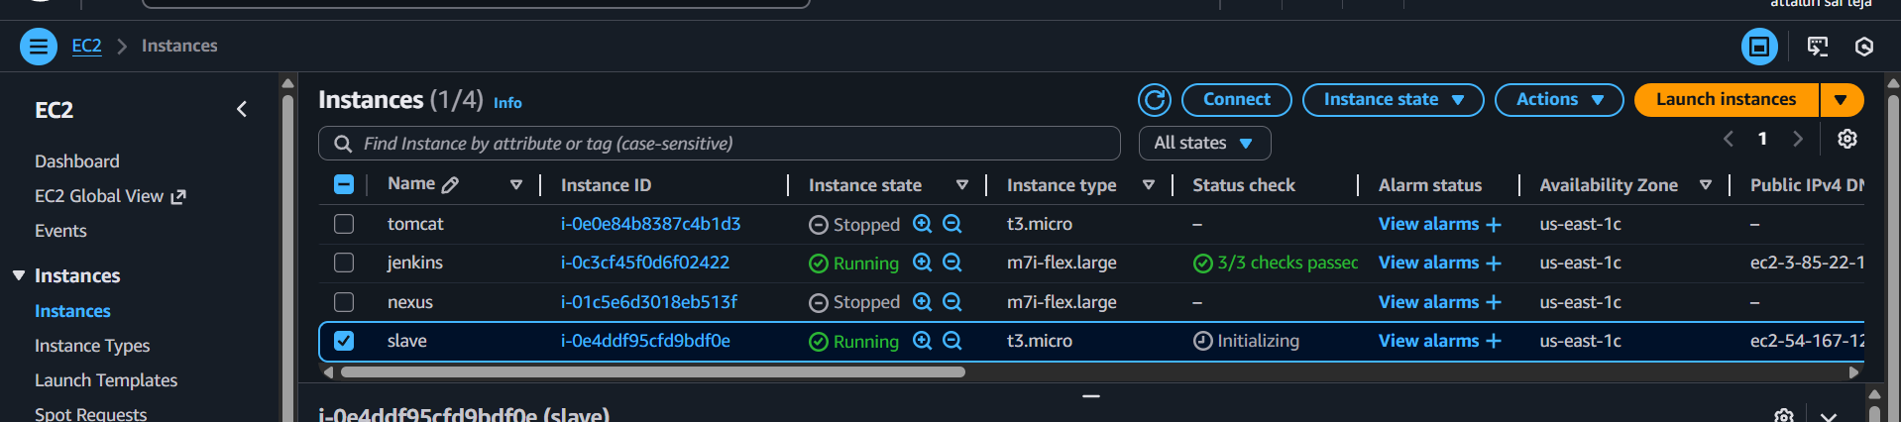
Things to be done on slave machine
Install java
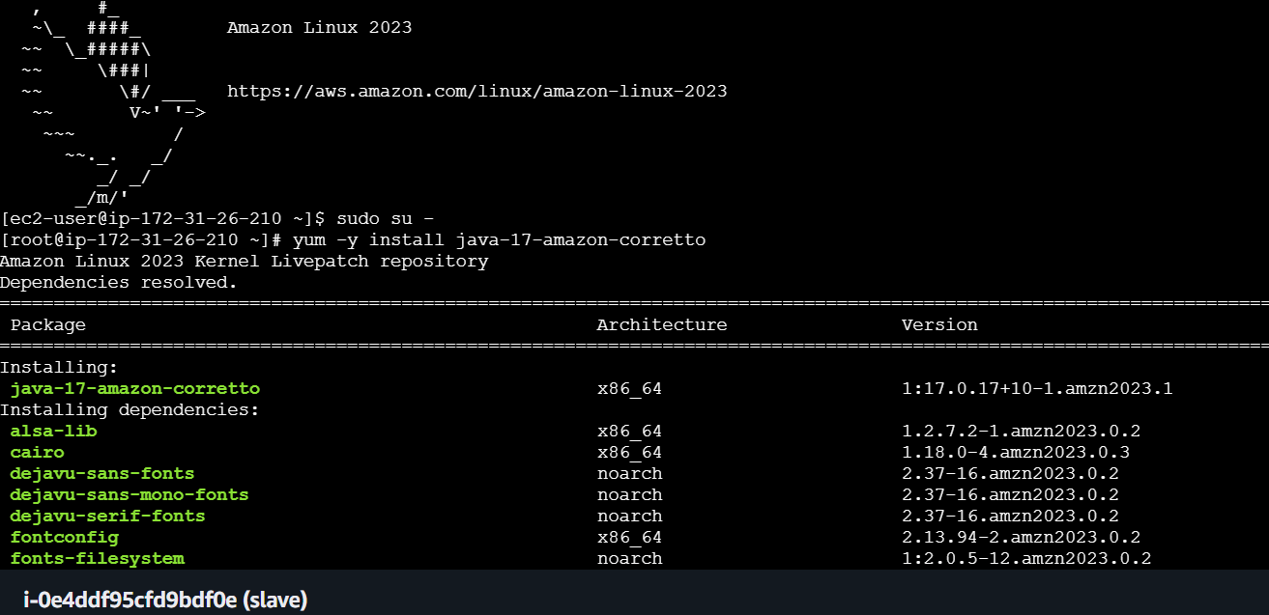

After that generate key using ssh-keygen
And paste it in authorize keys
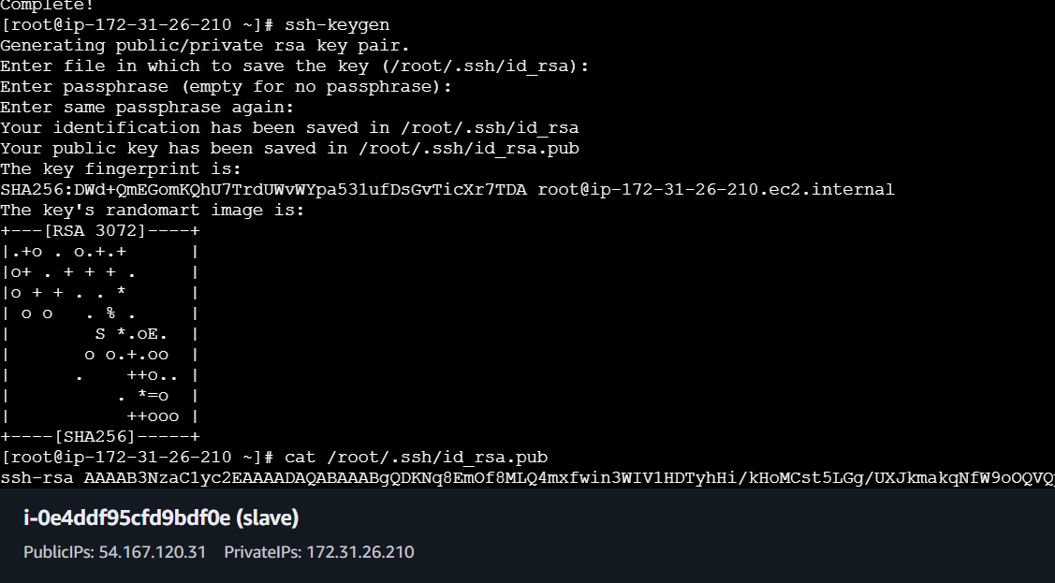
Copy the public ip
And provide permissions
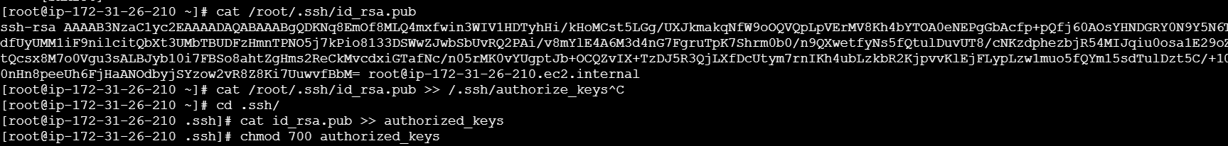

Things to be done on master machine like Jenkins main
Execute command ssh-keyscan -H publicipofslave >> /var/lib/Jenkins/.ssh/known_hosts
And change the ownership and provide permissions
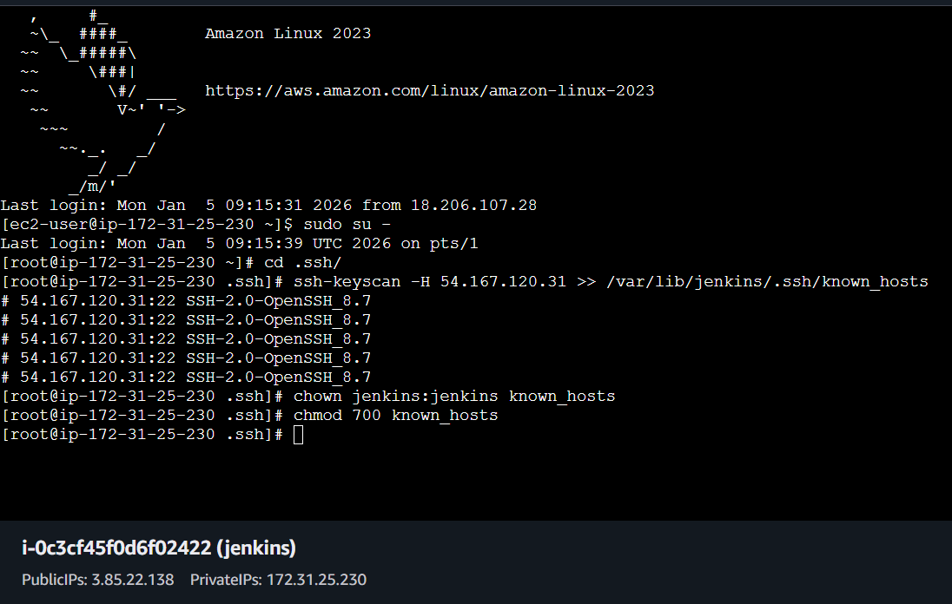
Things to be done on Jenkins GUI
Click on create new node and provide name
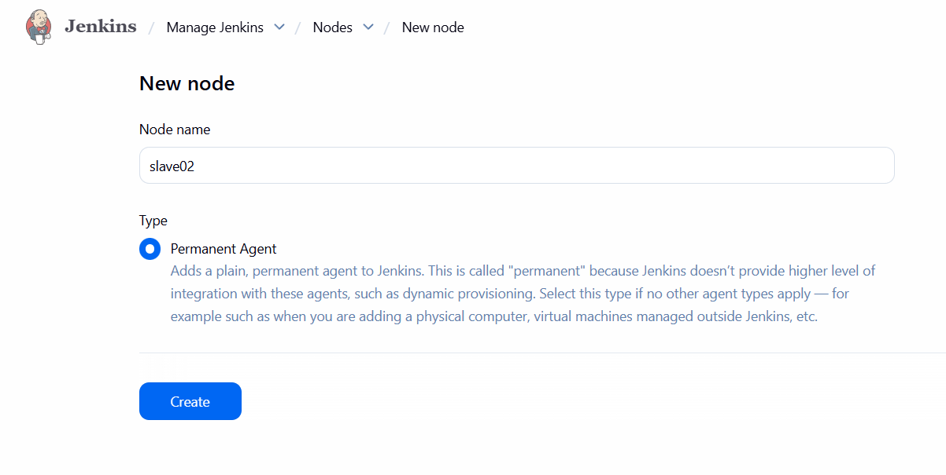

Note keep username as ec2-user not ec-user01
NOTE:: Enter the private key which is used to launch instance
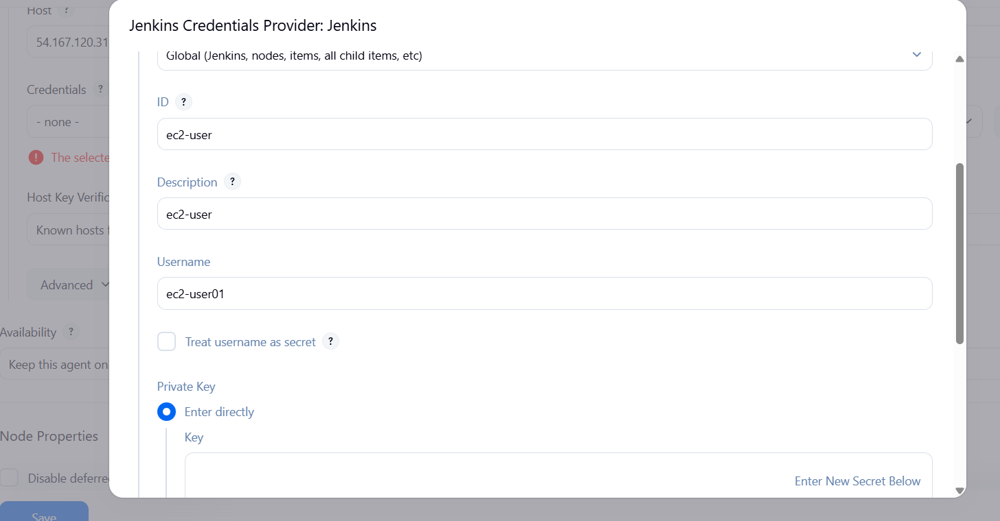
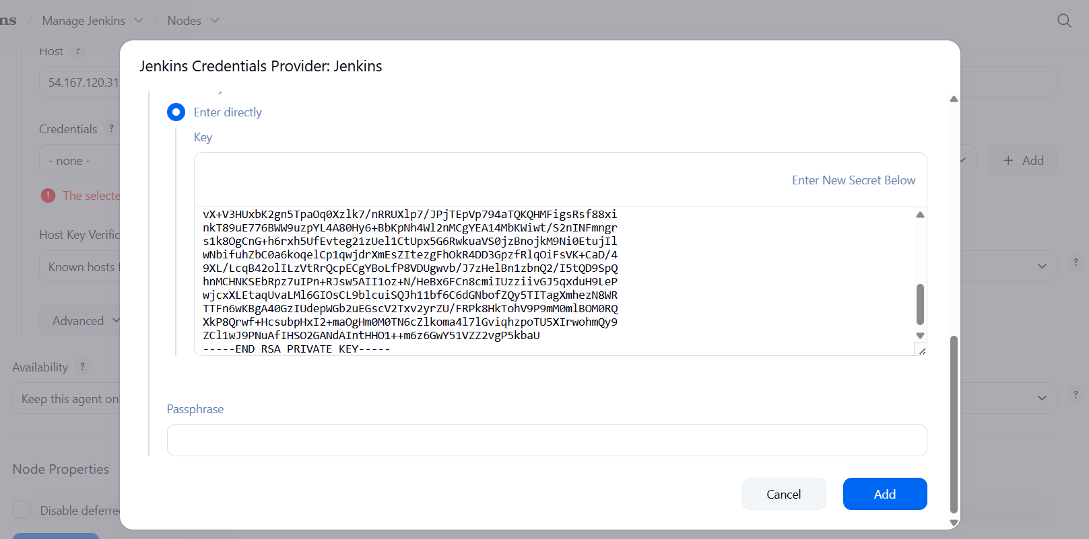
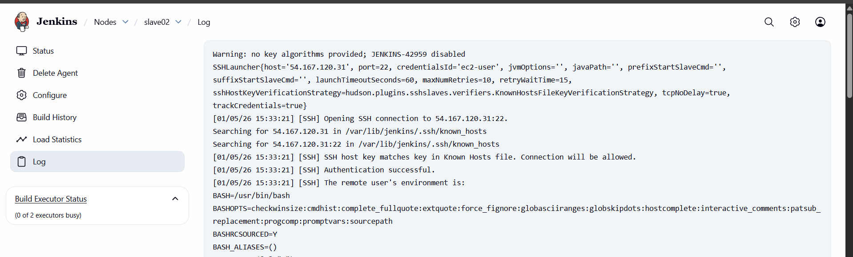
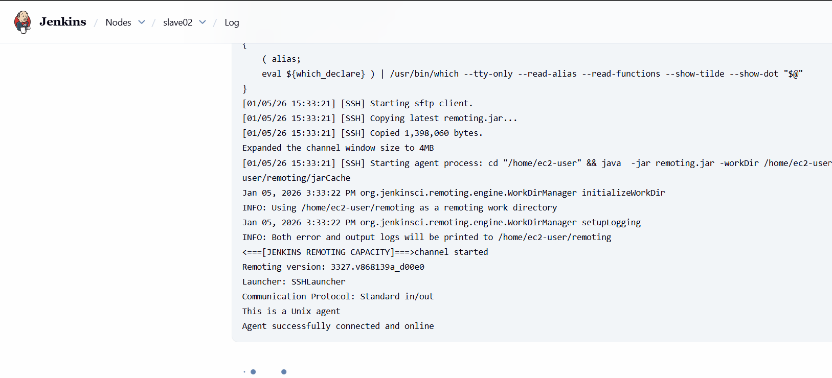
Verified via output and GUI

