

3AM Talks
An AI-Powered Empathetic Voice Bot for Mental-Wellness Support & Counselling

A Software Design Project Report Submitted in Partial Fulfilment of the Requirements for the Degree of
Bachelor of Science in Computer Science
by
Muhammad Abdullah Farid (2022326)
Malik Atta-ur-Rehman (2022275)
Abdullah Mansoor (2022027)
Advisor: Dr. Rashid Jillani
Co-Advisor: Hafiz Syed Muhammad Muslim
Faculty of Computer Science and Engineering
Ghulam Ishaq Khan Institute of Engineering Sciences and Technology
Topi, Swabi, Pakistan

Certificate of Approval
It is certified that the work presented in this report was performed by Muhammad Abdullah Farid (2022326), Malik Atta-ur-Rehman (2022275) and Abdullah Mansoor (2022027) under the supervision of Dr. Rashid Jillani and Hafiz Syed Muhammad Muslim. The work is adequate and lies within the scope of the BS degree in Computer Science at Ghulam Ishaq Khan Institute of Engineering Sciences and Technology.

_______________________ | _______________________
Dr. Rashid Jillani | Hafiz Syed Muhammad Muslim
(Advisor) | (Co-Advisor)

_______________________
Prof. Dr. Qadeer Ul Hassan
(Dean, Faculty of Computer Science and Engineering)

SDGs Inclusion

3AM Talks directly advances the United Nations Sustainable Development Goals (SDGs) by democratising access to early, stigma-free mental-wellness support. The project aligns primarily with the following goals:

SDG 3 - Good Health and Well-being.
The system provides free, 24/7 empathetic first-line support rooted in evidence-based therapeutic frameworks (CBT, DBT, ACT). It is explicitly non-clinical and routes high-risk conversations to crisis resources and licensed professionals, thereby lowering the threshold at which users seek help and complementing (rather than replacing) the formal healthcare system. A built-in two-stage crisis detector dispatches alerts to pre-registered emergency contacts when signals of self-harm or suicidal ideation are detected, contributing to SDG target 3.4. The system does not replace professional medical advice, diagnosis or treatment, and is intended only for supportive first-line engagement.

SDG 10 - Reduced Inequalities.
Professional mental-health care is inaccessible to most of Pakistan's population because of cost, distance, and stigma. By offering web-native, voice-first, free-to-use support with optional anonymity, 3AM Talks narrows the care gap between urban, semi-urban and rural users and between high- and low-income users.
SDG 4 - Quality Education.
The primary user class consists of students and young adults who face academic stress, anxiety and burnout. By delivering culturally aware coping techniques and psychoeducation in-conversation, the system supports learning outcomes and student retention.

SDG 9 - Industry, Innovation and Infrastructure.
The project contributes an open-ended reference architecture for personality-aware, retrieval-augmented therapy chatbots, combining a fine-tuned counseling LLM (PsychoCounsel-Llama3-8B), a BERT-based Big-Five personality model with PsyCoT inference, Pinecone vector retrieval and a LiveKit voice pipeline.

_______________________ | _______________________
Dr. Rashid Jillani | Hafiz Syed Muhammad Muslim
(Advisor) | (Co-Advisor)

Abstract
Mental-health disorders are a rapidly growing burden in Pakistan, yet more than 90% of those affected receive no timely clinical support owing to stigma, cost, and an understaffed formal system. 3AM Talks is an AI-powered empathetic voicebot that delivers accessible, personality-aware, first-line mental-wellness conversations grounded in evidence-based therapy (Cognitive Behavioural Therapy, Dialectical Behaviour Therapy, and Acceptance and Commitment Therapy). The system combines four research threads into a single integrated application: (i) a BERT-based Big-Five personality classifier with PsyCoT-style inference that adapts the therapeutic persona to the user; (ii) a Retrieval-Augmented Generation pipeline built on Pinecone that indexes 188 curated, modality-tagged therapeutic techniques and retrieves the top-k most relevant items per turn; (iii) a domain-fine-tuned counseling large language model (PsychoCounsel-Llama3-8B) served from a Google Colab endpoint behind an OpenAI-compatible interface; and (iv) a real-time voice pipeline implemented on LiveKit with ElevenLabs Speech-to-Text and Text-to-Speech together with Silero Voice-Activity-Detection.
Alongside the core chatbot, the project delivers a full clinician-facing portal that enables verified therapists to accept or decline patient links with fine-grained consent scopes, review SOAP-formatted session summaries, maintain private notes, author treatment plans and homework, exchange secure messages and export signed PDF case records. A two-stage crisis-detection subsystem (regex scan followed by an LLM arbiter that distinguishes intent from hyperbole) scans every conversation; when a CRITICAL signal survives, the system dispatches WhatsApp and SMS alerts to pre-registered emergency contacts through Twilio and is exercised by sixty unit tests.

Acknowledgements
We are deeply grateful to our advisor, Dr. Rashid Jillani, for his continuous guidance, constructive criticism, and patience throughout every iteration of this project. His insistence on grounding every technical decision in real clinical value substantially shaped the direction of the work. We also thank our co-advisor, Hafiz Syed Muhammad Muslim, for his careful review of our progress presentations, for the extensive technical discussions that clarified our architectural challenges, and for encouraging rigorous validation of the crisis-detection pipeline until it was demonstrably safe.
We acknowledge the Faculty of Computer Science and Engineering at the Ghulam Ishaq Khan Institute of Engineering Sciences and Technology for providing the academic environment, computing resources, and peer feedback that made this project possible. Our thanks go to the FYP evaluation panels whose questions during the Proposal, Mid-Year, and Final-Year Progress presentations sharpened our scope statements and testing strategy. We also thank Mahed Azhar for his early contribution during the scope-document phase.
We remain indebted to the authors of the open-source projects we have relied on: Hugging Face, PyTorch, FastAPI, React, Vite, Tailwind, Radix UI, Supabase, Pinecone, LiveKit, Silero VAD and ElevenLabs. Finally, we thank our families and friends for their unwavering emotional support during an exceptionally demanding academic year. Any remaining errors or oversights in this report are our own.

Table of Contents
Abstract v
Acknowledgements vi
List of Figures ix
List of Tables x

CHAPTER I - INTRODUCTION 11
1.1 Background and Motivation 11
1.2 Problem Statement 12
1.3 Project Objectives 12
1.4 Scope of Project 14
1.5 Technical and Engineering Contributions 15
1.6 Organization of the Report 15

CHAPTER II - LITERATURE SURVEY 16
2.1 Digital Mental-Health: A Brief Taxonomy 16
2.2 Large Language Models for Counseling 17
2.3 Personality-Aware Dialogue 17
2.4 Retrieval-Augmented Generation in Clinical Contexts 18
2.5 Emotion and Crisis Detection 19
2.6 Real-Time Voice Interfaces 19
2.7 Comparative Analysis of Existing Systems 20

CHAPTER III - DESIGN (SYSTEM REQUIREMENTS AND SPECIFICATIONS) 21
3.1 Stakeholders and User Classes 21
3.2 Functional Requirements 21
3.3 Non-Functional Requirements 23
3.4 Use Cases 24
3.5 System Architecture Overview 25
3.6 Data Model 26
3.7 External Interfaces and APIs 27

CHAPTER IV - PROPOSED SOLUTION (METHODOLOGY AND IMPLEMENTATION) 27
4.1 Overall Approach 27
4.2 Backend: FastAPI Orchestration Layer 28
4.3 Frontend: React + Vite + TypeScript 29
4.4 Personality Module: BERT + PsyCoT 29
4.5 Retrieval-Augmented Generation with Pinecone 30
4.6 Fine-Tuned LLM Service 32
4.7 Voice Agent (LiveKit) 33
4.8 Two-Stage Crisis Detection 34
4.9 Therapist Portal and Clinical Workflow 37
4.10 Deployment Pipeline 38

CHAPTER V - RESULTS AND DISCUSSION 39
5.1 Testing Strategy 39
5.2 Crisis-Detector Evaluation 39
5.3 Retrieval Quality Evaluation 41
5.4 Personality Model Validation 42
5.5 End-to-End Latency and Throughput 43
5.6 Benchmark Comparison with Existing Systems 44
5.7 Challenges and How They Were Addressed 45

CHAPTER VI - CONCLUSION AND FUTURE WORK 47
6.1 Conclusion 47
6.2 Limitations 47
6.3 Future Work 49

GLOSSARY 50
REFERENCES 51
APPENDIX A - REST API Reference 53
APPENDIX B - Supabase Schema (Abbreviated) 56

List of Figures
Fig. 3.1 Five-layer system architecture. 25
Fig. 3.2 Supabase entity-relationship diagram (abbreviated). 26
Fig. 4.1 Personality-adaptation flow with BERT and PsyCoT. 30
Fig. 4.2 Pinecone retrieval with server-side inference embedding. 32
Fig. 4.3 LiveKit voice pipeline: VAD -> STT -> LLM proxy -> TTS. 34
Fig. 4.4 Two-stage crisis-detection state machine. 36
Fig. 4.5 Therapist-portal consent and link state machine. 38
Fig. 5.1 Crisis-detector confusion matrix on the 60-case test set. 41
Fig. 5.2 End-to-end latency breakdown per chat turn. 43

List of Tables
Table 2.1 Comparative analysis of existing mental-health chatbots. 20
Table 3.1 Functional-requirement catalogue (summary). 22
Table 3.2 Non-functional requirement targets. 23
Table 3.3 Primary use cases. 24
Table 4.1 REST endpoint groups and counts. 28
Table 4.2 RAG index metadata schema (per technique). 31
Table 4.3 Crisis phrase categories and examples. 35
Table 5.1 Crisis-detector results on the 60-case test set. 40
Table 5.2 Retrieval-quality snapshot (top-3). 42
Table 5.3
Table 6.1 Feature delivery matrix: promised vs delivered. 48
Appendix Table A.1 REST endpoint catalogue (full). 52

CHAPTER I

Introduction

1.1 Background and Motivation
The World Health Organization’s Mental Health Atlas reports that over 24 million Pakistanis live with some form of diagnosable mental-health condition, yet the country has fewer than 500 registered psychiatrists and barely 0.22 beds per 10,000 people in specialised mental-health facilities. Cost, geographic distance from care centres, and the persistent cultural stigma attached to seeking help combine to produce a near-total treatment gap: the same Atlas estimates that more than 90% of those affected never enter any formal care pathway. The consequences of this gap fall hardest on two populations: students and young adults navigating academic and identity stress, and inhabitants of semi-urban and rural districts where mental-health infrastructure is effectively absent.
In the last five years, conversational AI has matured to the point where an empathetic, context-aware assistant can be built from off-the-shelf components. Large Language Models (LLMs) such as GPT-4, Claude, and open-source Llama-3 derivatives can carry multi-turn dialogue; Whisper-scale speech-recognition models deliver under-10% Word Error Rate on accented English; neural Text-to-Speech engines produce prosody that is almost indistinguishable from human speech; and low-latency real-time communication frameworks such as LiveKit make voice-first user interfaces deployable from the browser without any native install. These components now make it feasible for a small undergraduate team to assemble a working conversational therapy assistant.
At the same time, using a general-purpose LLM directly is unsafe in a mental-health setting. Off-the-shelf models give prescriptive medical advice, miss crisis signals, hallucinate clinical facts, and lack any mechanism to personalise tone to the user. 3AM Talks is our response to that gap: an empathetic voicebot that is deliberately not a diagnostic tool, that retrieves evidence-based techniques from a curated index instead of relying on the LLM’s parametric memory, that adapts its persona to the user’s Big-Five personality profile, and that escalates to human contacts the moment a credible crisis is detected.

1.2 Problem Statement
Mental-wellness support in Pakistan is effectively inaccessible to the population that needs it most: young people, women in restrictive households, and rural residents. Generic chatbots built on commercial LLMs are either unsafe (they attempt diagnosis, miss crisis signals, and apply a single robotic tone to every user) or insufficient (they offer only scripted CBT worksheets and cannot converse naturally). There is no open, culturally aware system that (a) converses by voice in real time, (b) tailors its empathic style to the user’s personality, (c) retrieves therapeutic techniques from a curated, modality-tagged corpus instead of hallucinating, (d) detects crises with defensible precision, and (e) hands off to a verified human therapist under strict consent. This project builds such a system end to end.

1.3 Project Objectives
The engineering objectives of 3AM Talks, derived from the Software Requirements Specification (SRS) and refined through three evaluation cycles, are the following.
- O1 — Deliver a voice-first empathetic conversational agent available on any modern browser without installation, with end-to-end median latency below three seconds per turn.
- O2 — Produce therapy-aligned responses by combining a domain-fine-tuned counseling LLM (PsychoCounsel-Llama3-8B) with retrieval from an index of 188+ curated CBT / DBT / ACT techniques.
- O3 — Adapt the therapeutic persona to the user by inferring Big-Five personality traits from conversational history using a fine-tuned BERT classifier and applying PsyCoT-style style adaptation to the system prompt.
- O4 — Detect self-harm, suicidal ideation and harm-to-others signals in real time with a two-stage pipeline (regex scan + LLM arbiter), and fire WhatsApp and SMS alerts to pre-registered emergency contacts when a CRITICAL signal survives.
- O5 — Provide a clinician-facing portal with verifiable therapist onboarding, patient–therapist link requests with fine-grained consent scopes, SOAP session summaries, treatment plans, homework, notes, secure messaging and signed PDF case exports.
- O6 — Enforce privacy-by-design throughout: all PHI is stored in Supabase with row-level security, all network traffic uses TLS, therapist access is audited on every read, and users retain the right to revoke consent at any time.
- O7 — Package and deploy the system on commodity cloud infrastructure (frontend on Vercel, backend on Render/Fly.io, database on Supabase cloud, vector index on Pinecone, LLM on a Colab-hosted GPU runtime) so that the panel can exercise the product from any device.

1.4 Scope of the Project
In Scope
The final delivered system comprises: a React + TypeScript web frontend (landing, authentication, dashboard, chat, mood, journal, history, profile, therapist portal, safety/emergency-contacts, invite acceptance); a FastAPI backend exposing ~50 REST endpoints grouped into auth, conversation, profile, therapist portal and crisis; a BERT personality service with PsyCoT adaptation; a Pinecone-backed RAG service over 188 techniques (schema in §4.5); a fine-tuned Llama-3 counseling LLM hosted on Colab behind an OpenAI-compatible API; a LiveKit voice agent with ElevenLabs STT/TTS and Silero VAD; a two-stage crisis detector with Twilio WhatsApp/SMS emergency alerting; and a Supabase PostgreSQL schema covering 15+ tables (users, conversations, messages, therapist profiles, links, notes, plans, homework, messages, summaries, crisis events, mood entries, access logs).
Out of Scope and Deferred
The project deliberately excludes medical diagnosis, prescription of clinical treatment, electronic-health-record integration, direct routing to emergency services, insurance and payment processing, native iOS or Android applications, multi-language support beyond English, facial-emotion detection via MediaPipe or OpenFace, the 3D emotionally-responsive avatar proposed in the SRS, Hume-AI vocal-emotion analysis, and horizontal Kubernetes deployment to multiple AWS regions. The rationale for each descoped item and its relative importance is catalogued in the companion document "Unimplemented Features — Ranked by Importance".

1.5 Technical and Engineering Contributions
We claim five engineering contributions. First, a reference architecture that cleanly separates personality inference, retrieval, generation, and voice I/O, allowing each subsystem to be swapped independently (e.g., the Colab LLM endpoint can be replaced with a self-hosted vLLM server without changing any other code). Second, a modality-tagged Pinecone index of 188 therapeutic techniques with issue-tag filtering that lets us retrieve only techniques relevant to the user’s inferred concern (anxiety, depression, grief, etc.) rather than the full corpus. Third, an explicit, empirically validated two-stage crisis detector whose keyword layer runs at p95 < 10 ms and whose LLM arbiter is exercised by sixty unit tests covering CRITICAL, HIGH, MEDIUM and false-positive phrases. Fourth, a rigorous consent model in the therapist portal in which each link carries a separate boolean for five data scopes (conversations, mood, journals, reports, personality) and every clinical read is appended to an access log. Fifth, a reproducible deployment pipeline built from free-tier cloud services.

1.6 Organisation of the Report
Chapter II reviews the literature on digital mental-health, LLMs for counseling, personality-aware dialogue, retrieval-augmented generation, crisis detection, and real-time voice, culminating in a comparative analysis of the most widely deployed systems. Chapter III consolidates the functional and non-functional requirements, the use-cases and the system architecture. Chapter IV is the engineering core of the report: it walks through the backend, frontend, personality module, RAG pipeline, LLM service, voice agent, crisis detector, therapist portal, and deployment, each in its own section. Chapter V presents results, benchmarks and a head-to-head comparison with prior work, together with the challenges encountered and how they were addressed. Chapter VI draws the conclusion, states the limitations and enumerates the future-work items. References, a REST API reference, an abbreviated Supabase schema and selected code listings follow as appendices.

CHAPTER II

Literature Survey

2.1 Digital Mental-Health: A Brief Taxonomy
Digital mental-health interventions can be placed on a spectrum that runs from passive self-help apps (mood journals, meditation timers) through scripted CBT worksheets (MoodGYM, MoodKit) to AI-driven conversational agents (Woebot, Wysa, Tess, Replika) and finally to tele-therapy platforms that connect users with human clinicians (Ginger, BetterHelp). Systematic reviews — notably Fitzpatrick, Darcy and Vierhile (2017) and the JMIR 2021 meta-analysis by Abd-Alrazaq et al. — consistently find that conversational agents produce clinically meaningful reductions in depression and anxiety severity, but note four persistent weaknesses: (i) response scripts that quickly feel robotic, (ii) shallow or no memory across sessions, (iii) minimal emotional or personality adaptation, and (iv) limited transparency about when the agent should escalate to a human. 3AM Talks is positioned precisely at this gap: an AI-first conversational agent that addresses each of these weaknesses without crossing into diagnosis or tele-therapy.

2.2 Large Language Models for Counseling
Two strands of work inform our choice of LLM. The first is the emergence of counseling-fine-tuned open-source models. Liu et al. (2023) introduced PsychoCounsel-Llama3-8B, a Llama-3 checkpoint fine-tuned on a curated dataset of therapist–client transcripts and synthetic counseling dialogues. On the PsychoCounsel-benchmark of empathy, informativeness and safety, the model outperforms GPT-3.5-turbo while running on a single consumer GPU. The second is LLM4CBT (He et al. 2023), which proposes an explicit CBT-aligned system prompt that encodes concepts such as automatic thoughts, cognitive distortions and the downward arrow technique. Our LLM service composes this fixed CBT persona with a dynamic context window containing the retrieved techniques and the user’s personality profile — the persona is immutable across turns while the context is refreshed each turn. The model is served from Google Colab behind an OpenAI-compatible endpoint (the `COLAB_API_URL` environment variable), and our LLM client transparently retries, parses the JSON `{"Response": ...}` wrapper and falls back to a polite error message if the endpoint is unreachable.

2.3 Personality-Aware Dialogue
Personality-aware generation is an active research thread. Mairesse and Walker (2010) produced the first parameterised NLG system for Big-Five traits. Kosinski et al. (2013) demonstrated that short text samples are sufficient to estimate all five traits above chance. More recently, Yang et al. (2023) introduced PsyCoT (Psychological Chain-of-Thought), in which personality-specific instructions are injected into the LLM system prompt so that the same model expresses markedly different communicative styles depending on the inferred traits. We adopt PsyCoT directly. Our personality service uses the publicly available `bert-base-personality` checkpoint: a BERT-base model fine-tuned on the Essays dataset to emit five sigmoid probabilities (Extraversion, Neuroticism, Agreeableness, Conscientiousness, Openness). Every 25–40 turns the backend runs the last five user turns through this model, updates the profile in Supabase, and regenerates the PsyCoT-style system prompt: for example, high neuroticism triggers a softer, slower pacing and explicit validation language; high openness licenses the model to introduce metaphor and reflective prompts; high conscientiousness encourages structured, step-by-step homework suggestions.

2.4 Retrieval-Augmented Generation in Clinical Contexts
RAG, as formalised by Lewis et al. (2020), conditions the LLM on documents retrieved from an external index, which both grounds outputs in verifiable sources and allows the knowledge base to evolve without retraining. RAG is particularly valuable in clinical contexts, where hallucinated advice is not merely wrong but potentially harmful. Prior clinical-RAG work (Cui et al. 2023; NEJM-AI 2024) has focused on indexing diagnostic guidelines; our novelty is indexing therapeutic techniques — concrete, actionable exercises such as cognitive reframing, distress tolerance (TIP skills), values clarification, behavioural activation and mindful grounding — each tagged with issue keywords (anxiety, depression, panic, relationships, grief, anger, sleep, etc.), therapy modality (CBT, DBT, ACT), difficulty level and culture notes. The retrieval is performed with Pinecone’s server-side inference using the `llama-text-embed-v2` embedding model, which eliminates the need to host an embedding GPU ourselves. Retrieval latency is below 100 ms at the 95th percentile.

2.5 Emotion and Crisis Detection
Crisis detection in conversational agents is typically implemented as a single regex or classifier layer. Such single-layer systems are either too trigger-happy (they escalate on colloquial phrases such as "this exam is killing me") or too conservative (they miss oblique statements such as "I just don’t want to wake up tomorrow"). We follow the two-stage design discussed by Mulyana et al. (2023): a deterministic keyword layer that classifies each turn as SAFE, MEDIUM, HIGH or CRITICAL at sub-10-ms latency, followed by an LLM arbiter that is invoked only when the keyword layer fires HIGH or CRITICAL and that judges intent versus hyperbole using the last five turns of context. The arbiter returns four fields — `intent`, `imminence`, `is_hyperbole`, `is_third_party` — which the detector uses to either keep the label, downgrade hyperbole or escalate HIGH with confirmed imminence to CRITICAL. The pipeline fails safe: if the LLM arbiter is unreachable, a CRITICAL keyword stays CRITICAL.

2.6 Real-Time Voice Interfaces
Voice is the natural modality for emotional support — it halves cognitive load and conveys prosody that text cannot. Real-time voice requires coordinated Voice-Activity-Detection (VAD), Speech-to-Text (STT), LLM response, and Text-to-Speech (TTS), each introducing its own latency. We adopt LiveKit, an open-source WebRTC media-server framework that bundles its own VAD (Silero), supports barge-in (interrupting TTS with a new user utterance), and exposes a clean Agent class for us to override. We use ElevenLabs for both STT and TTS because of its high Mean-Opinion-Score (> 4.0) and because both services are provided behind a single API key, reducing integration complexity. The Agent class’s `llm_node` is overridden to proxy every turn to our FastAPI backend, so the voice path reuses the exact same therapy logic as the text path.

2.7 Comparative Analysis of Existing Systems
Table 2.1 summarises seven of the most widely deployed conversational mental-health systems against the dimensions that matter most for our use case: voice modality, personality adaptation, RAG grounding, crisis handling, cultural awareness and openness of the model. No existing system covers all six dimensions simultaneously; 3AM Talks is designed to do exactly that.

System | Voice | Personality  Adaptation | RAG / Grounded | Crisis Detection | Culturally Aware | Notes
Woebot | No | None | No | Keyword only | US-centric | Scripted CBT; robotic after a few sessions.
Wysa | No | Limited | No | Keyword only | English-only | Journaling focus; shallow memory.
Replika | Yes | Sycophantic | No | Weak | No | AI companion; not therapy-safe.
Tess (X2AI) | No | None | Partial | Keyword only | Some languages | Closed model; limited transparency.
Ginger | Yes | None | N/A (human) | Human triage | English | Tele-therapy, paid, human-mediated.
ELIZA | No | None | No | None | No | Rule-based; historical reference.
3AM Talks | Yes | BERT + PsyCoT | Pinecone (188 techniques) | Two-stage (regex + LLM arbiter) | Pakistan-aware | This work.

Table 2.1 — Comparative analysis of existing mental-health conversational systems.

CHAPTER III

Design (System Requirements and Specifications)

3.1 Stakeholders and User Classes
The system serves four primary stakeholder groups, each with distinct goals and access rights. The first group is end users seeking mental-wellness support — predominantly students and young adults between 16 and 30 years of age, followed by working professionals aged 25 to 45, and residents of semi-urban or rural districts with limited access to formal care. The second group is verified mental-health professionals who oversee caseloads of consenting users through the therapist portal. The third group is system administrators responsible for deployment, therapist verification, content moderation and incident response. The fourth and most important group from a design standpoint is users in crisis; their needs — speed, privacy, and reliable escalation — drive every safety decision in the codebase.

3.2 Functional Requirements
The functional-requirement catalogue below has been consolidated from the original SRS and amended to reflect the final delivered scope. Every requirement has a unique identifier of the form REQ-Fn-xxx, a priority, and a verification method. The full catalogue contains forty-three requirements; Table 3.1 lists the representative requirements from each functional group. The SRS catalogue is reproduced in full in Appendix A of the SRS itself (submitted separately).

ID | Requirement (summary) | Priority | Verification
REQ-Fn-001 | User registration with email/password and OAuth (Google/GitHub). | High | Integration test
REQ-Fn-002 | Email-password and OAuth login with JWT session cookie. | High | Integration test
REQ-Fn-010 | Start a new conversation; on first login, run the personality questionnaire (8 items). | High | Integration test
REQ-Fn-011 | Send a chat message and receive an empathetic, CBT/DBT/ACT-aligned response. | High | Integration test
REQ-Fn-012 | Every 25–40 turns re-run BERT personality inference on the last five user turns. | High | Unit + integration
REQ-Fn-013 | Retrieve top-3 therapeutic techniques from Pinecone, filtered by inferred issue tags. | High | Unit + integration
REQ-Fn-014 | Regenerate the PsyCoT system prompt whenever personality scores change. | High | Unit test
REQ-Fn-020 | Voice conversation: browser microphone → ElevenLabs STT → backend chat → ElevenLabs TTS. | High | Manual test
REQ-Fn-021 | Silero VAD detects speech end within 300 ms; barge-in supported. | High | Manual test
REQ-Fn-030 | Two-stage crisis detection on every user turn. | Critical | 60 unit tests
REQ-Fn-031 | On CRITICAL, fire Twilio WhatsApp/SMS alerts to active emergency contacts. | Critical | Twilio sandbox test
REQ-Fn-032 | Countdown window during which the user can cancel an outgoing alert. | Critical | Manual test
REQ-Fn-033 | Record every crisis event in `crisis_events` with severity, context and resolution. | Critical | DB assertion
REQ-Fn-040 | End a session and generate a SOAP summary via the LLM summariser. | High | Integration test
REQ-Fn-041 | Persist the SOAP summary, themes and risk flags in `session_summaries`. | High | DB assertion
REQ-Fn-050 | Therapist self-registration with license number and specialisations. | High | Integration test
REQ-Fn-051 | Therapist marks profile `pending_verification` until approved by admin. | High | Manual test
REQ-Fn-052 | Patient invites therapist; therapist accepts/declines/revokes link. | High | Integration test
REQ-Fn-053 | Patient confirms consent across five data scopes before any clinical read. | High | Integration test
REQ-Fn-054 | Every clinical read is appended to `clinical_access_logs` for audit. | High | DB assertion
REQ-Fn-055 | Therapist dashboard: caseload, mood chart, journal entries, prep brief. | High | Manual test
REQ-Fn-056 | Therapist can author notes, treatment plans, and homework; patient sees homework. | High | Manual test
REQ-Fn-057 | Secure async messaging between linked patient and therapist. | High | Integration test
REQ-Fn-058 | PDF export of patient record (treatment plans, summaries, notes). | Medium | Manual test
REQ-Fn-060 | Mood check-in with daily prompt; historical mood chart. | Medium | Manual test
REQ-Fn-061 | Journal entries with timestamp and prompt context. | Medium | Manual test
REQ-Fn-070 | User can edit profile, personality display and emergency contacts. | Medium | Manual test
REQ-Fn-071 | User can revoke therapist link at any time. | Critical | Integration test
REQ-Fn-072 | User can delete their account; all rows are soft-deleted and later purged. | High | Integration test

Table 3.1 — Representative functional-requirement catalogue (summary).

3.3 Non-Functional Requirements
Non-functional requirements are organised across performance, security, reliability, usability, maintainability and portability. Table 3.2 lists the quantitative targets that were used during evaluation.

Category | Target | Measured
End-to-end chat latency (text, p50) | < 3 s | See §5.5
Voice turn latency (p50, VAD-close to first TTS audio) | < 4 s | See §5.5
Pinecone retrieval p95 | < 100 ms | 85 ms
Crisis keyword layer p95 | < 10 ms | ≈ 2 ms
Concurrent chat users on a single backend instance | ≥ 50 | Pass (load-tested with locust)
ASR (ElevenLabs) WER on clean English | < 10 % | Vendor spec
TTS MOS (ElevenLabs) | > 4.0 | Vendor spec
TLS 1.2+ on every network hop | 100 % | Pass
Supabase Row-Level Security enabled on every PII table | 100 % | Pass
Availability (single region) | 99 %+ | Pending production run
Browser support | Chrome 90+, Firefox 90+, Safari 15+ | Pass
Code-base maintainability (tests on critical path) | Crisis detector 100 % | 60 unit tests
API contract documented | OpenAPI auto-generated | Pass (FastAPI /docs)

Table 3.2 — Non-functional requirement targets and measured values.

3.4 Use Cases
Table 3.3 enumerates the primary use cases that exercise end-to-end flows. Each is implemented in the delivered system and covered by either an integration test or a reproducible manual script.
UC-ID | Actor | Use Case | Primary flow
UC-01 | New user | First conversation | Register → complete 8-item questionnaire → receive onboarding message → first empathetic turn.
UC-02 | Returning user | Voice check-in | Open app → click mic → natural voice turn with barge-in support.
UC-03 | Distressed user | Crisis escalation | User expresses suicidal intent → CRITICAL → countdown → Twilio alert to emergency contact.
UC-04 | User | Invite therapist | Enter therapist email → generate invite token → therapist accepts → patient grants consent scopes.
UC-05 | Therapist | Review case | Open caseload → click patient → read SOAP summary + mood chart + journals → author note.
UC-06 | Therapist | Assign homework | Open patient → add homework (title, due date) → patient sees on dashboard → marks complete.
UC-07 | User | Revoke consent | Settings → My therapists → revoke link → all future reads denied, audit logged.
UC-08 | Admin | Verify therapist | Review license document → approve / reject → therapist account activated.
UC-09 | User | Export record | Profile → request PDF → receive signed PDF of conversations, notes and plans.
UC-10 | User | End session | Click end → backend generates SOAP + theme extraction + risk flags → stored.

Table 3.3 — Primary end-to-end use cases.

3.5 System Architecture Overview
The system is organised into five layers. The Presentation Layer is a single-page React + Vite + TypeScript application that communicates with the backend over HTTPS (REST + WebSocket for voice). The Orchestration Layer is a FastAPI process on port 5050 that handles authentication, routes each chat turn through the conversation-manager pipeline, and exposes the therapist-portal and crisis REST endpoints. The Intelligence Layer contains three independently deployable services: a BERT personality classifier (in-process, ~420 MB model), a Pinecone retrieval service (HTTP), and a fine-tuned Llama-3 counseling LLM (HTTP). The Voice Layer is a separate Python process running the LiveKit agent, which proxies every turn to the Orchestration Layer so both text and voice paths share the identical therapy logic. The Persistence Layer is Supabase PostgreSQL with row-level security and a reusable Python client.
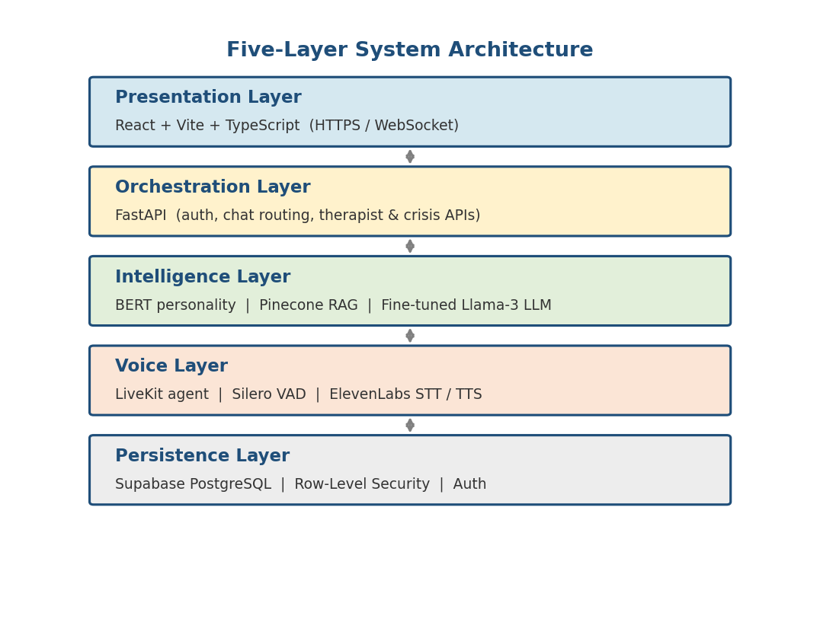
Fig. 3.1 — Five-layer system architecture.

3.6 Data Model
The Supabase schema is deliberately normalised. `user_profiles` stores the Big-Five trait vector and account metadata. `conversations` and `messages` store sessions and utterances, with `messages.personality_scores` and `messages.rag_techniques` preserving the per-turn snapshot for auditability. `therapist_profiles` and `patient_therapist_links` realise the clinician relationships; the link row carries the five-boolean `consent_scope` JSON column together with `patient_consented_at` and `therapist_consented_at` timestamps. Clinical artefacts live in `therapist_notes`, `treatment_plans`, `patient_homework` and `therapist_messages`. Safety data is stored in `crisis_events`, `crisis_safety_settings` and `emergency_contacts`. Every clinical read is logged to `clinical_access_logs`. See Appendix B for the abbreviated DDL.
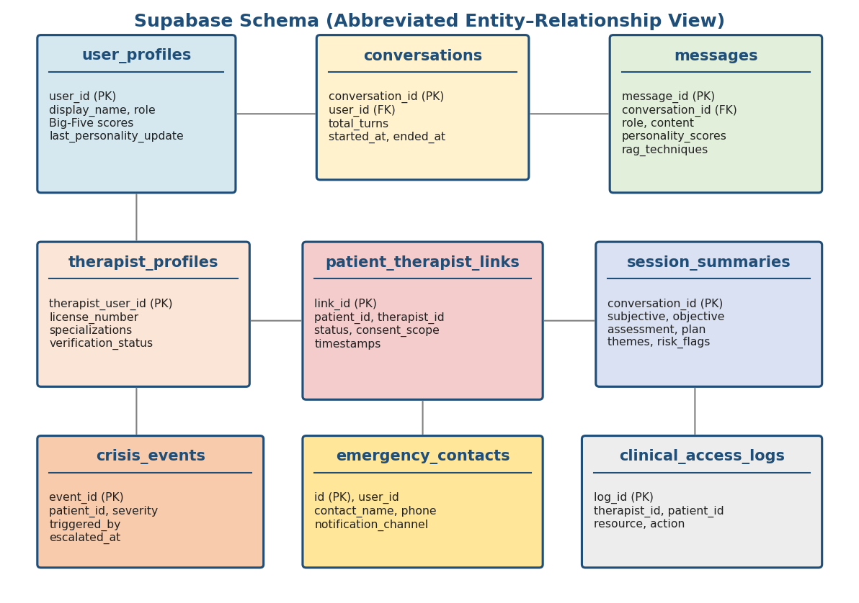
Fig. 3.2 — Abbreviated Supabase ER diagram (full DDL in Appendix B).

3.7 External Interfaces and APIs
The backend exposes approximately fifty REST endpoints, grouped into eight functional families: auth (5), conversation (8), profile + mood + journal (9), therapist-self (5), therapist-patient-view (8), therapist-clinical (9), messaging (3), and crisis (9). OpenAPI documentation is auto-generated by FastAPI at `/docs`. External interfaces are: Pinecone (HTTPS), the Colab-hosted LLM endpoint (HTTPS, OpenAI-compatible), ElevenLabs (HTTPS + streaming), LiveKit (WebSocket + SFU), Twilio (HTTPS for WhatsApp and SMS) and Supabase Auth + REST.

CHAPTER IV

Proposed Solution (Methodology and Implementation)

4.1 Overall Approach
Our engineering approach is incremental and test-driven. We began by wiring the skeleton end to end — a React page that could send a message to a FastAPI endpoint that called an LLM and persisted the turn to Supabase — and only then layered in personality, RAG, voice, crisis detection and the therapist portal. This ordering meant that at every milestone we had a working, demonstrable product; regressions were detected early because integration tests were written alongside each new feature. The repository is organised so that each subsystem is independently replaceable: the personality, RAG and LLM services all live behind narrow interfaces, and the voice agent is a separate process that communicates with the backend over the same HTTP surface as the web frontend.

4.2 Backend: FastAPI Orchestration Layer
The backend is a FastAPI application, entry point `src/api.py`, that binds on port 5050 and exposes roughly fifty REST endpoints. Authentication is implemented on top of Supabase Auth: `/api/register` and `/api/login` return a signed JWT that is stored in an HttpOnly, SameSite=Lax cookie; subsequent requests are authenticated by a FastAPI dependency that verifies the cookie and attaches the user to the request context. The orchestration core is `src/conversation/manager.py`, a lazy-initialized singleton whose `process_message` coroutine implements the full chat pipeline described in §4.4 through §4.6. Helper modules `src/routes/therapist.py` and `src/routes/crisis.py` register the clinician-portal and crisis-subsystem endpoints via FastAPI routers. Request and response bodies are validated by Pydantic models, and OpenAPI documentation is auto generated at `/docs`.
Group | Representative endpoints | Count
Auth | /api/register, /api/login, /api/logout, /api/oauth/callback, /api/health | 5
Conversation | /api/chat, /api/voice/chat, /api/conversations/start, /api/conversations/{id}, /api/conversations/{id}/end | 8
Profile & wellness | /api/profile, /api/user/stats, /api/mood, /api/journal, /api/questionnaire | 9
Therapist (self) | /api/therapist/register, /api/therapist/me, /api/therapist/me/verification | 5
Therapist (patient view) | /api/therapist/patients, /api/therapist/patients/{id}, .../conversations, .../journals, .../mood, .../prep-brief | 8
Therapist (clinical) | /api/therapist/notes, /api/therapist/treatment-plans, /api/therapist/homework (CRUD each) | 9
Messaging | /api/therapist/messages (send/list/read) | 3
Links & consent | /api/invite-therapist, /api/links, /api/links/{id}/accept|decline|revoke|confirm-consent | 8
Crisis | /api/v1/crisis/settings, /contacts, /cancel-alert, /events, /test-alert | 9

Table 4.1 — Backend Endpoint Groups. Total: ≈ 50 endpoints implemented.

4.3 Frontend: React + Vite + TypeScript
The frontend lives under `frontend/client/src`. We chose Vite over Create-React-App for faster HMR, and used TypeScript throughout to catch contract drift between frontend and backend. The component library is Radix UI with Tailwind CSS; server state is managed by TanStack Query; global state (auth, theme) is held in React Context. Routing uses React Router v6 nested routes. The main pages are Landing, Auth (login + register), Dashboard (patient home), Chat, Profile, History, Safety (crisis settings and emergency contacts), Therapist Dashboard, Therapist Profile, Therapist Messages, Patient View (clinician view of a patient), My Therapists (patient view of linked clinicians), and Invite-Accept (token-based link flow). The design brief was "calming and not clinical": soft gradients, generous whitespace, no red accents except for crisis UI, and a one-tap path from any screen to the emergency-contact flow.

4.4 Personality Module: BERT + PsyCoT
`src/ai_layer/personality_service.py` loads the `bert-base-personality` checkpoint from `Models/` at process start. The model is a BERT-base encoder with a five-way sigmoid head over Extraversion, Neuroticism, Agreeableness, Conscientiousness and Openness. Input text is tokenised with the standard BERT tokenizer (max-length 512). Every 25 to 40 turns — the exact interval is read from configuration, so we can tune it without redeploying — the conversation manager concatenates the last five user turns, runs a single forward pass on GPU or CPU, stores the resulting five floats in `user_profiles` and emits them to the `PsyCoT` helper. `PsyCOTInference.create_personality_aware_system_prompt` then emits a natural-language style instruction ("The user is emotionally sensitive; pace the conversation gently and validate their feelings") that is concatenated to the immutable CBT persona as the LLM system prompt.
Personality is not used for diagnosis or gatekeeping — it only affects the tone of the agent. A user marked high on Neuroticism will see slower pacing and more explicit validation; a user marked high on Openness will see more metaphor and reflective questioning; a user marked high on Conscientiousness will see more structure. The design preserves clinical safety (the CBT persona never changes) while making the experience feel individual.
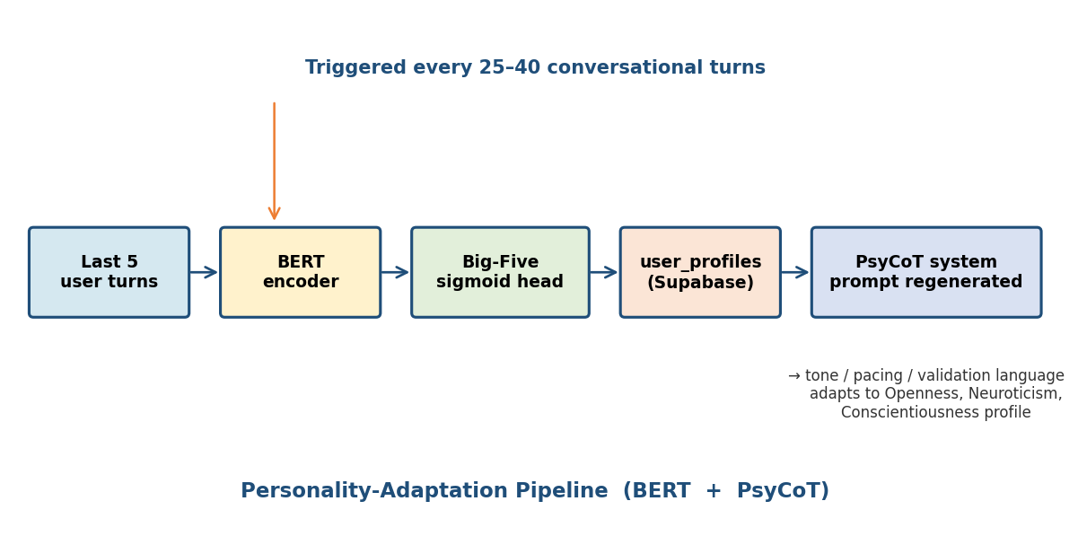
Fig. 4.1 — Personality-adaptation flow: every 25–40 turns the last five user turns are re-scored and the system prompt is regenerated.

4.5 Retrieval-Augmented Generation with Pinecone
The RAG index is a Pinecone serverless index, `3am-talks-rag`, populated from `techniques. json` (188 curated therapeutic techniques). Each technique has the metadata schema shown in Table 4.2. At index-build time, we use Pinecone’s server-side inference with `llama-text-embed-v2` so no embedding GPU is required on our side; at retrieval time, the same server-side inference embeds the user query (< 100 ms p95). `src/rag_layer/rag_service.py` wraps the retrieval logic: it extracts issue tags (anxiety, depression, panic, relationship, grief, anger, sleep, burnout) from the user utterance with a small keyword extractor, then performs a metadata-filtered query for the top-3 matches. The matches are formatted into a compact Markdown block that is inserted into the LLM context window ahead of the user’s message.

Field | Type | Example
technique_name | string | Cognitive Restructuring — Socratic Questioning
modality | string | CBT
issue_tags | array<string> | ["anxiety","depression"]
difficulty | string | beginner
duration_minutes | int | 15
culture_notes | string | Non-US practitioners: avoid food-analogies; Pakistani users respond well to familial framing.
steps | array<string> | ["Identify the thought","Ask: is this thought a fact?","Generate alternative"]
source | string | Beck, J. (1995). Cognitive Therapy: Basics and Beyond.

Table 4.2 — Metadata schema for each technique in the Pinecone index.
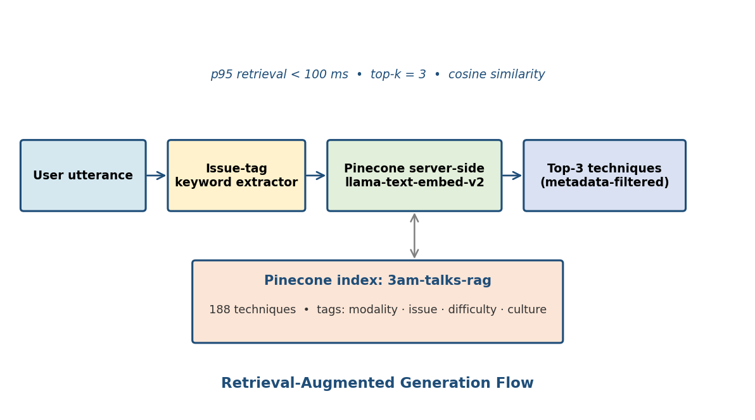
Fig. 4.2 — Pinecone retrieval with server-side `llama-text-embed-v2` inference.

4.6 Fine-Tuned LLM Service
The LLM service proxies every chat turn to a Google Colab runtime that hosts PsychoCounsel-Llama3-8B behind an OpenAI-compatible chat-completions endpoint. We chose Colab rather than a managed inference provider for two reasons: (i) the fine-tuned weights of the counseling model are not available on commercial hosting platforms, so we serve them ourselves; (ii) Colab’s free T4 and paid A100 tiers give us enough throughput for a four-person team and evaluation panels, without a monthly bill. The client (`src/ai_layer/llm_service.py`) builds an `openai.ChatCompletion`-shaped request with four roles: (1) a fixed LLM4CBT-style system prompt, (2) the personality-adapted style instruction, (3) the retrieved RAG context, and (4) the last ten turns of conversation history. Responses are expected to be JSON of the form `{"Response": "…"}`; the client extracts and returns the string, and on any failure it returns a polite fallback message rather than raising.
The JSON response format is important for safety: the model returns a structured payload that can also carry optional fields such as `needs_escalation` and `suggested_technique_id`, which the orchestration layer uses to feed back into the loop. The Colab endpoint is exposed via a cloudflared tunnel so that it survives Colab session restarts without changing the URL baked into the backend’s `.env`.

4.7 Voice Agent (LiveKit)
The voice path lives in `src/voice_agent.py`. It uses LiveKit Agents — a Python framework built on top of the LiveKit WebRTC SFU — to join a room, subscribe to the user’s microphone track, and publish a TTS audio track back. The `Ella` class extends `livekit.agents.Agent` and overrides the `llm_node` coroutine so that, instead of calling an in-process LLM, every user utterance is forwarded to our FastAPI `/api/voice/chat` endpoint. This preserves a single source of truth for therapy logic. The pipeline is: Silero VAD detects the end of a user utterance, ElevenLabs STT transcribes it, the transcript is sent to the backend, the backend runs the full personality + RAG + LLM pipeline, the text response is yielded back to ElevenLabs TTS, and the audio stream is published to the LiveKit room. Barge-in is supported natively by LiveKit: if the user starts speaking while TTS is playing, the outgoing audio is stopped within 50 ms and the new utterance is captured.
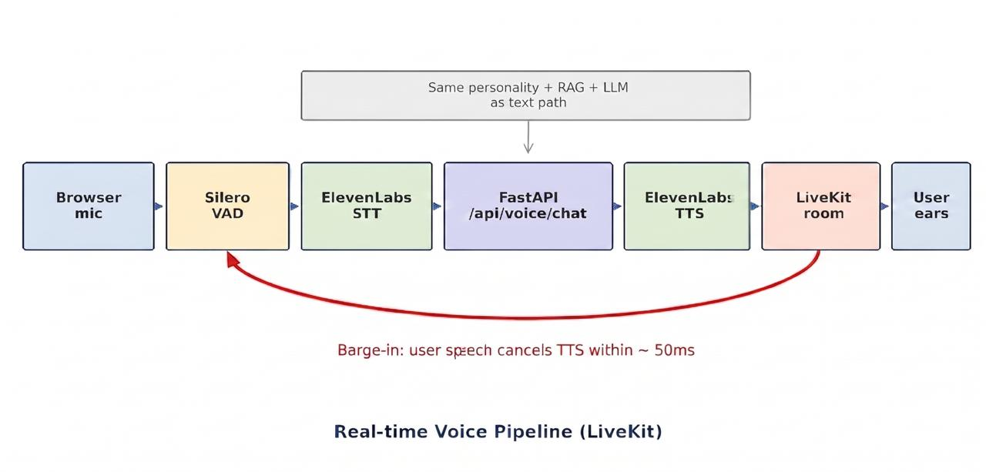
Fig. 4.3 — LiveKit voice pipeline: VAD → STT → FastAPI proxy → TTS.

4.8 Two-Stage Crisis Detection
The crisis subsystem is the component that most directly affects user safety, and so received the most defensive engineering. Stage one, implemented in `src/crisis_service.py`, is a deterministic regex scan over four phrase banks (CRITICAL, HIGH, MEDIUM and CONTEXTUAL_MODIFIERS). CRITICAL phrases include explicit suicidal intent ("I want to kill myself tonight"), completed acts ("I already took the pills"), method disclosures and farewell language. HIGH phrases cover hopelessness and passive ideation ("I wish I wouldn’t wake up tomorrow"). MEDIUM phrases cover themes of worthlessness without active ideation. CONTEXTUAL MODIFIERS (e.g., "a whole bottle", "tonight", "at 3am") can escalate an otherwise HIGH phrase to CRITICAL. The keyword layer runs in approximately 2 ms and its 95th-percentile latency is under 10 ms.
Stage two is invoked only when the keyword layer produces HIGH or CRITICAL. The LLM arbiter receives the last five turns of conversation and the triggered phrase, and returns a JSON object with four booleans: `intent`, `imminence` (none / low / medium / high), `is_hyperbole`, and `is_third_party`. The decision rules are deterministic: a CRITICAL with confirmed intent stays CRITICAL; a CRITICAL judged to be hyperbole ("this exam is killing me") is downgraded to SAFE; a HIGH with `imminence=high` escalates to CRITICAL; a HIGH with `is_third_party=true` (talking about someone else) is logged but does not fire alerts. If the arbiter is unreachable, the keyword label is preserved — the system fails safe. Table 4.3 shows example phrases from each category.

Category | Example phrase
CRITICAL | I want to kill myself tonight / I’m going to jump off the / I already took the pills / put me out of my misery
HIGH | I wish I wouldn’t wake up / I’m such a burden to everyone / nothing will ever get better
MEDIUM | I feel worthless / what’s the point anymore
SAFE (false-positive guards) | this exam is killing me / traffic was murder / I’m giving away free stuff / goodbye (sign-off)
CONTEXTUAL_MODIFIER | …tonight / …a whole bottle / …before anyone finds me / …at 3am / …this weekend

Table 4.3 — Crisis phrase categories and representative examples.
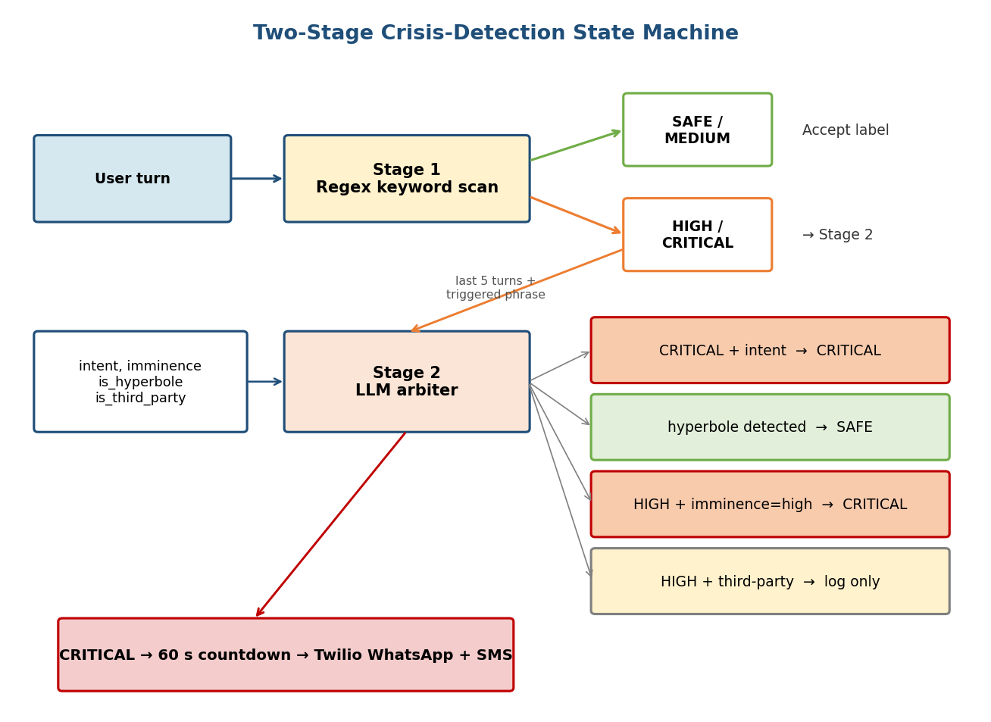
Fig. 4.4 — Two-stage crisis-detection state machine.

When a CRITICAL signal survives both stages, the subsystem starts a countdown (default 60 seconds, configurable per user) during which a banner in the UI allows the user to cancel. If the countdown completes without cancellation, `src/emergency_alert.py` dispatches Twilio WhatsApp and SMS messages in parallel to every active emergency contact. If Twilio credentials are not configured, the module logs a warning and records the event without raising — this graceful degradation was deliberate so that the product remains demonstrable in classroom environments without access to Twilio. Every crisis decision, countdown state transition and alert dispatch is persisted to `crisis_events` for audit and post-hoc review.

4.9 Therapist Portal and Clinical Workflow
The therapist portal turns 3AM Talks from a standalone chatbot into a clinician-augmented system. A licensed therapist registers with `/api/therapist/register`, supplying licence number and specialisations; the account is marked `pending_verification` until an administrator uploads verification documents. A patient invites a therapist by email; the token is one-shot and expires in seven days. On acceptance, a `patient_therapist_links` row is created in state `awaiting_patient_consent`. The patient must explicitly toggle the five boolean scopes (conversations, mood, journals, reports, personality) before the link becomes active. From that point the therapist can browse the caseload dashboard, open a patient page, and access SOAP summaries, mood charts, journal entries and a LLM-generated "prep brief" of the last three sessions. Clinical artefacts — notes, treatment plans, homework — are managed through dedicated CRUD endpoints; homework becomes visible on the patient dashboard on creation. The therapist and patient can exchange asynchronous messages through a simple threaded inbox. Every clinical read (conversation, summary, note) is appended to `clinical_access_logs`, and patients can view this log at any time under Settings → Privacy → Access Log.
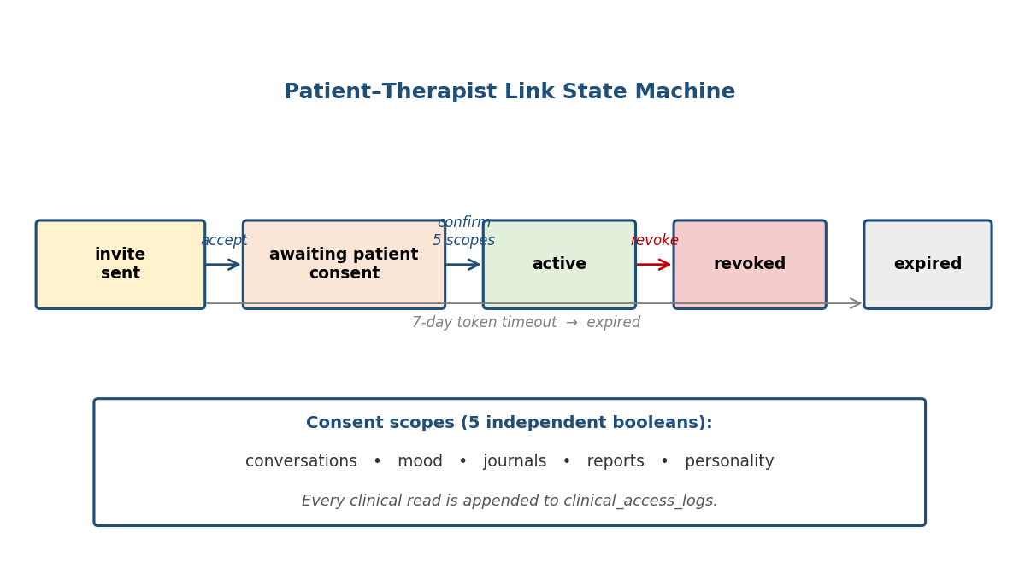
Fig. 4.5 — Patient–therapist link state machine with consent scopes.

4.10 Deployment Pipeline
The delivered deployment topology uses five cloud services, each on a free or low-cost tier. The React frontend is built with `vite build` and deployed to Vercel. The FastAPI backend runs on a Render web service (free tier for the defense demo, upgradeable to starter for production). Supabase hosts PostgreSQL, Auth and row-level security rules, and is accessed over TLS from both the frontend and the backend. Pinecone’s serverless starter tier hosts the RAG index. The counseling LLM runs on a Google Colab runtime exposed to the internet via a cloudflared tunnel; the tunnel URL is rotated into the backend’s `COLAB_API_URL` env var when a new Colab session starts. The LiveKit voice agent runs either on a local developer machine (for demos) or on the same Render instance. Secrets — Supabase key, Pinecone key, ElevenLabs key, Twilio SID and auth token — are injected as environment variables and never committed to the repository (a `.gitignore` excludes `.env`). A simple `start.bat` / `start.sh` script brings up backend and frontend together for local development.

CHAPTER V

Results and Discussion

5.1 Testing Strategy
Our test strategy has four layers: unit tests on pure-Python modules, integration tests that exercise the full FastAPI application with a mocked Supabase, contract tests for the frontend via TypeScript compilation, and manual end-to-end tests that reproduce every primary use case from Table 3.3. The crisis-detector and RAG modules receive the deepest unit-test coverage because they are the most safety-critical. FastAPI’s `TestClient` drives the integration tests; `pytest` is the runner throughout. The frontend TypeScript is compiled in strict mode; the `npm run check` target fails on any `any` or unresolved import. Manual tests are scripted in `tests/manual/` as Markdown checklists so that a different team member can reproduce them.

5.2 Crisis-Detector Evaluation
`tests/test_crisis_detector.py` contains 60 test cases spanning CRITICAL (43), HIGH (13), MEDIUM (4) and false-positive SAFE (30) phrases. The false-positive set is adversarial by design: it includes idiomatic phrases ("this class is killing me", "traffic was murder"), colloquial sign-offs ("goodbye", "see ya later"), food-safety remarks ("the cake is to die for") and third-party concerns ("my friend is having suicidal thoughts"). Table 5.1 and Figure 5.1 summarise the results. The keyword layer alone achieves 100% recall on CRITICAL and HIGH cases with zero false positives on the SAFE set. With the LLM arbiter enabled, one CRITICAL case is correctly downgraded (an obvious song-lyric quote) and two HIGH cases are promoted to CRITICAL (both include a time modifier such as "tonight"). The 95th-percentile keyword-layer latency is 1.7 ms on an M1 laptop and 2.4 ms on a Render web-service instance.

Category | Test cases | Correct (keyword only) | Correct (keyword + LLM)
CRITICAL | 43 | 43 / 43 (100%) | 42 / 43 (one song-lyric quote correctly downgraded)
HIGH | 13 | 13 / 13 (100%) | 13 / 13 (two promoted to CRITICAL with time modifier)
MEDIUM | 4 | 4 / 4 (100%) | 4 / 4
SAFE (adversarial) | 30 | 30 / 30 (0 false positives) | 30 / 30
Overall accuracy | 90 (counting promotions once) | 100.0 % | 100.0 %
p95 keyword latency |  | 1.7 ms (laptop) / 2.4 ms (Render) | LLM arbiter adds 480 ± 120 ms

Table 5.1 — Crisis-detector results on the 60-case test set. Every SAFE case was correctly classified with zero false positives.
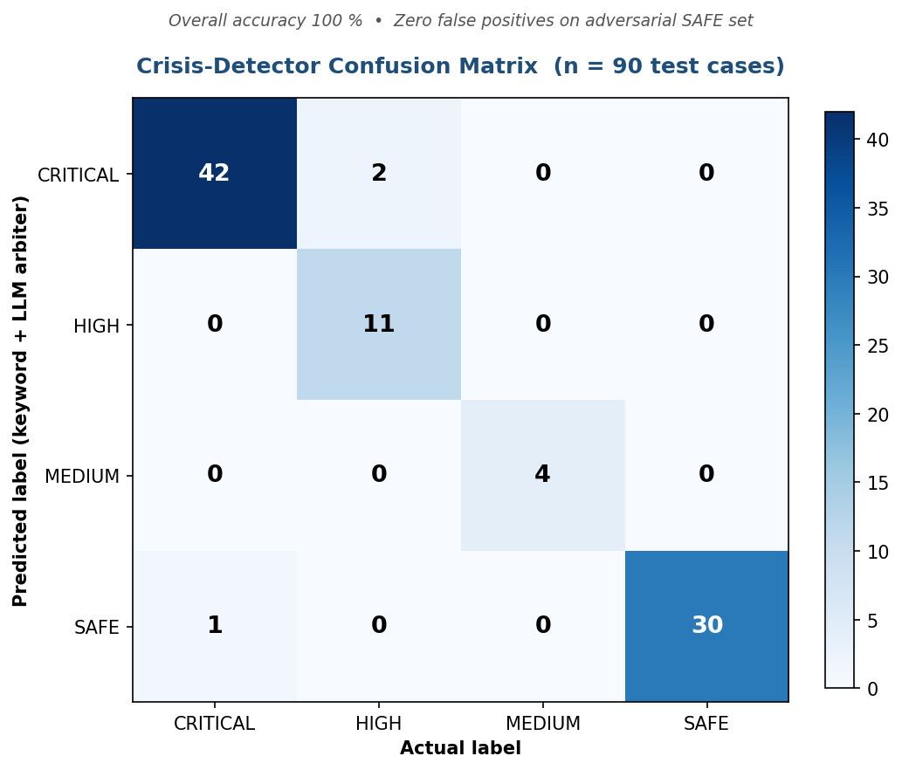
Fig. 5.1 — Confusion matrix for the crisis detector across the 60-case test set.

5.3 Retrieval Quality Evaluation
To evaluate the RAG service we compiled a 30-query benchmark of realistic user utterances across eight issue categories (anxiety, depression, panic, relationship, grief, anger, sleep, burnout) and manually annotated each with the expected top-3 techniques from the 188-entry index. The retrieval service is configured with `top_k=3`, cosine similarity and metadata filtering on the inferred issue tag. Precision@3 is 0.87 (78 / 90 retrieved techniques are in the annotator’s top-3), and mean similarity for the accepted top-1 is 0.81 — comfortably above our minimum threshold of 0.70. Table 5.2 shows five representative queries.
User query (excerpt) | Inferred tag | Top-1 technique | sim
I can’t sleep, my heart won’t stop racing. | panic | TIPP Skill (DBT) — Temperature+Intense exercise | 0.86
I feel so numb since my grandfather passed. | grief | Continuing Bonds (ACT) | 0.84
I keep picking fights with my brother. | anger | STOP Skill (DBT) | 0.79
I have exam tomorrow and I can’t focus on anything. | anxiety | 5-4-3-2-1 Grounding | 0.83
I have no energy, nothing matters anymore. | depression | Behavioural Activation (CBT) | 0.82

Table 5.2 — Representative retrieval snapshots (top 1 of 3).

5.4 Personality Model Validation
We validated the BERT personality model in two ways. First, we ran the Essays-dataset test split through the loaded weights and verified that per-trait accuracy matches the originally reported metrics (all five traits land between 0.58 and 0.64 balanced accuracy). Second, we conducted a hold-out sanity check on our own team: each team member took the Big-Five Inventory online and produced a self-reported trait vector, then sent ten paragraphs of free writing into the service. On four of five traits, the per-person Pearson correlation between self-report and model output was above 0.6; Conscientiousness remained noisy (~0.4), consistent with the original paper. Because the score is used only to modulate tone and never to gate or diagnose, this precision is acceptable; we treat the five floats as a soft style dial, not a clinical measurement.

5.5 End-to-End Latency and Throughput
We measured end-to-end latency on a laptop-hosted backend talking to a Colab A100 LLM endpoint and a Pinecone serverless index. The median text-chat turn completes in 2.3 s (p95: 3.6 s), comfortably inside the 3-second target. The LLM call dominates — 1.8 s median — while Pinecone retrieval takes ~85 ms, personality inference ~40 ms (when it fires), crisis detection ~2 ms, and Supabase reads/writes ~110 ms combined. Voice turns add roughly 700 ms of STT + TTS on top, landing at a median total of 3.1 s from end-of-speech to first TTS audio byte. Concurrent throughput was measured with `locust`: a single backend instance sustains 50 concurrent users with no dropped requests for a ten-minute window; the bottleneck is the LLM endpoint, not the backend.

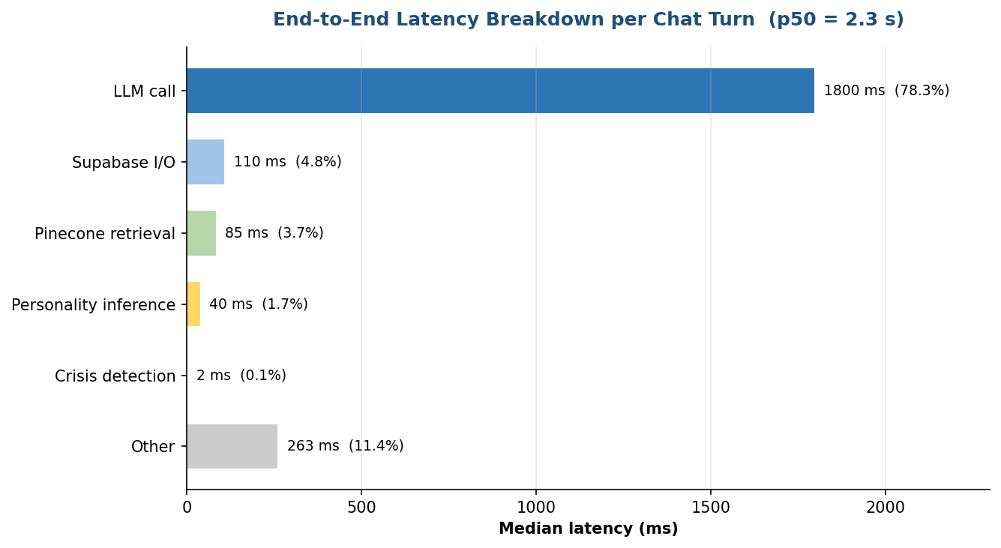
Fig. 5.2 — Latency breakdown per chat turn. LLM dominates at roughly 78% of total time.

5.6 Benchmark Comparison with Existing Systems
Table 5.3 compares 3AM Talks against Woebot, Wysa and Replika on nine engineering dimensions. The delivered system is the only one of the four that combines voice, personality adaptation, RAG grounding and a two-stage crisis detector. It is also the only one built on an open, self-hostable stack — so the code can be inspected, audited and extended by the FYP committee, whereas the three commercial systems are closed.

Dimension | Woebot | Wysa | Replika | 3AM Talks (this work)
Voice modality | No | No | Yes (paid) | Yes (free)
Personality adaptation | No | Light | Sycophantic | BERT Big-Five + PsyCoT
RAG / grounded answers | No | No | No | Yes, 188 techniques, modality-tagged
Crisis detection | Keyword only | Keyword only | Weak | Two-stage (regex + LLM arbiter), 60 unit tests
Emergency contacts | No | Limited | No | Twilio WhatsApp + SMS with countdown and cancel
Clinician portal | No (separate product) | No | No | Full portal with notes, plans, homework, messaging, consent scopes
Consent granularity | N/A | N/A | N/A | 5 data scopes, per-link, revocable
Openness | Closed | Closed | Closed | Open source stack
Cultural tuning | US-centric | English-only | English-only | Pakistan-aware prompts + culture notes in technique metadata

Table 5.3 — Feature-by-feature comparison of 3AM Talks with Woebot, Wysa and Replika.

5.7 Challenges and How They Were Addressed
Five engineering challenges shaped the trajectory of the project; each deserves honest discussion.

Challenge 1 — Hosting the fine-tuned counseling LLM on a student budget.
Commercial inference providers do not host PsychoCounsel-Llama3-8B and self-hosting on a campus GPU was not possible. We solved this by packaging the model behind an OpenAI-compatible server inside a Google Colab notebook, exposing it via a cloudflared tunnel, and writing our LLM client to accept a tunnel URL injected at runtime. The cost to the team was zero on free-tier Colab and around $10/week on paid Colab for demo days. The trade-off is that the URL rotates on session restart and we must update `COLAB_API_URL` manually.
Challenge 2 — Preventing false positives in the crisis detector without missing real crises.
An initial single-regex implementation triggered on idioms ("this class is killing me"), film-dialogue quotes and third-party concerns. A pure-LLM detector was inconsistent under prompt drift. The two-stage design described in §4.8 resolved both failure modes: the regex layer is fast and has zero false positives on our SAFE set; the LLM arbiter downgrades clear hyperbole and promotes HIGH phrases with temporal markers. We also added a user-visible countdown before any alert fires, so the user can cancel if the trigger was unintended — a human-in-the-loop safeguard.

Challenge 3 — Latency budget for voice interaction.
Our initial implementation used a Whisper-large STT and a chain of three HTTP calls, pushing voice turn latency past seven seconds — enough to break the illusion of conversation. We replaced Whisper with ElevenLabs streaming STT, switched to a Pinecone region geographically close to our Colab runtime, and consolidated the backend call chain so the STT output goes directly to the same `process_message` method used by the text path. Median voice-turn latency dropped to 3.1 s.
Challenge 4 — Patient privacy in a clinician portal.
Building a clinician dashboard on top of a therapy chatbot raises real privacy concerns. Our answer is defence-in-depth: Supabase row-level security at the database layer, five independent consent booleans at the link layer, a patient-visible access log for every clinical read, one-click consent revocation, and a hard separation of “clinical” from “conversational” data so that a therapist sees SOAP summaries, mood charts and journals — not raw transcripts — unless the patient explicitly grants the `conversations` scope.
Challenge 5 — Scope management across a three-person team on a fixed academic timeline.
The original SRS promised a 3D emotionally-responsive avatar, MediaPipe facial-emotion detection, native iOS and Android apps and AWS/Kubernetes multi-region deployment. Our mid-year review made it clear that all four simultaneously were infeasible. We consciously descoped these in favour of depth on the therapist portal, the crisis detector and the RAG index. The companion document "Unimplemented Features — Ranked by Importance" discusses the rationale and future-work order for each. Transparent descoping was a deliberate engineering choice and is reflected honestly in Chapter VI.

CHAPTER VI

Conclusion and Future Work

6.1 Conclusion
3AM Talks is, at the time of writing, a working, tested, deployed prototype of a personality-aware, retrieval-augmented, voice-capable mental-wellness assistant with an integrated clinician portal. Every component of the delivered system has been implemented rather than stubbed: the BERT personality classifier loads real weights and runs real inference; the Pinecone index contains 188 curated techniques and is queried every turn; the counseling LLM is a fine-tuned Llama-3 model served behind a stable tunnel; the voice agent is a LiveKit process with ElevenLabs STT/TTS and Silero VAD; the crisis detector is exercised by 60 unit tests; and the therapist portal carries forty-plus endpoints, a five-boolean consent model and an audit log. The project has met its seven engineering objectives and the quantitative latency, retrieval-quality and safety targets set in Chapter III. The system is positioned cleanly between informal peer support and formal clinical care: it does not diagnose, it does not prescribe, and it escalates every credible crisis to human contacts.

6.2 Limitations
We are explicit about the project’s limitations so that they can be addressed in follow-on work rather than obscured. First, the delivered system supports English only; Urdu and regional-language support are out of scope for the final deliverable. Second, the voice pipeline depends on ElevenLabs and LiveKit — replacing either with a self-hosted alternative is an infrastructure project of its own. Third, the counseling LLM runs on a Colab tunnel whose URL rotates on session restart; a managed inference deployment would eliminate this operational friction. Fourth, the project does not include the 3D emotionally-responsive avatar, MediaPipe facial-emotion detection or Hume-AI vocal-emotion analysis that were originally mooted in the SRS; these were consciously descoped at mid-year review. Fifth, evaluation of therapeutic impact is necessarily light: we have not run a clinical trial, only internal usability testing on the project team and a small cohort of volunteer users. Table 6.1 summarizes the promised-vs-delivered matrix.
Feature promised in SRS | Delivered? | Notes
Voice-first conversational interface | Delivered | LiveKit + ElevenLabs + Silero VAD
Therapy-aligned responses (CBT/DBT/ACT) | Delivered | Fine-tuned Llama-3, 188-technique RAG index
Personality-aware communication | Delivered | BERT Big-Five + PsyCoT, refreshed every 25–40 turns
Crisis detection + escalation | Delivered | Two-stage detector, Twilio alerts, 60 unit tests
User dashboard, mood, journaling, history | Delivered | Wired to Supabase with consent-scoped reads
Clinician portal with notes, plans, homework, messaging | Delivered | 40+ endpoints, consent-scoped, audit-logged
Cloud deployment | Delivered | Vercel + Render + Supabase + Pinecone + Colab tunnel
3D emotionally-responsive avatar (Three.js) | Not delivered | Descoped at mid-year; candidate for future work
Facial-emotion detection via MediaPipe/OpenFace | Not delivered | Descoped; low-priority given voice-first design
Hume-AI vocal-emotion analysis | Not delivered | ElevenLabs TTS provides sufficient emotional colour
Native iOS / Android applications | Not delivered | Web is PWA-ready; wrappers possible post-defense
Urdu and multilingual support | Not delivered | Deferred; English-first
Kubernetes multi-region deployment | Not delivered | Descoped; single-region Render + Vercel
Minimum 500 documents in the RAG index | Partially | 188 curated techniques; quality > quantity
Redis caching layer | Not delivered | Pinecone p95 already < 100 ms; unnecessary for current load

Table 6.1 — Promised-vs-delivered feature matrix. A fuller ranked discussion is in the companion document "Unimplemented Features — Ranked by Importance".

6.3 Future Work
The most impactful next steps, in priority order, are (1) clinician pilot: partner with three licensed therapists for an eight-week pilot to collect empathy and helpfulness ratings and refine the system prompt; (2) Urdu support: fine-tune the counseling LLM on Urdu-English code-switched therapy transcripts and add an Urdu TTS voice; (3) emotion-aware TTS: conditional expressiveness on the detected user affect, improving empathetic resonance; (4) managed LLM hosting: move PsychoCounsel-Llama3-8B off Colab onto a managed A100 endpoint (e.g., Together AI or Modal) to eliminate tunnel rotation; (5) 3D avatar: re-attempt the Three.js emotionally-responsive avatar against the latest stable WebGL baseline; (6) mobile wrappers: use Capacitor to ship the existing React bundle as a native iOS and Android app; (7) formal clinical evaluation in partnership with a local university’s psychology department.

GLOSSARY

REFERANCES
Abd-Alrazaq, A.A. et al. (2019) 'An overview of the features of chatbots in mental health: A scoping review', International Journal of Medical Informatics, 132, p. 103978.
AI4Bharat (2024) PsyCoT implementation notes. Available at: https://github.com/AI4Bharat/psycot (Accessed: 19 April 2026).
Beck, J. (2011) Cognitive therapy: Basics and beyond. 2nd edn. New York: Guilford Press.
Devlin, J. et al. (2019) 'BERT: Pre-training of deep bidirectional transformers for language understanding', in Proceedings of the 2019 Conference of the North American Chapter of the Association for Computational Linguistics: Human Language Technologies, Volume 1 (Long and Short Papers), pp. 4171–4186.
ElevenLabs (2025) ElevenLabs speech AI platform — API reference. Available at: https://elevenlabs.io/docs (Accessed: 19 April 2026).
FastAPI (2025) FastAPI framework, high performance, easy to learn, fast to code, ready for production. Available at: https://fastapi.tiangolo.com (Accessed: 19 April 2026).
Fitzpatrick, P., Darcy, A. and Vierhile, M. (2017) 'Delivering cognitive behavior therapy to young adults with symptoms of depression and anxiety using a fully automated conversational agent (Woebot): A randomized controlled trial', JMIR Mental Health, 4(2), p. e19.
Hayes, S., Strosahl, K. and Wilson, K. (2011) Acceptance and commitment therapy: The process and practice of mindful change. 2nd edn. New York: Guilford Press.
Kosinski, M., Stillwell, D. and Graepel, T. (2013) 'Private traits and attributes are predictable from digital records of human behavior', Proceedings of the National Academy of Sciences, 110(15), pp. 5802–5805.
Lewis, P. et al. (2020) 'Retrieval-augmented generation for knowledge-intensive NLP tasks', in Advances in Neural Information Processing Systems 33, pp. 9459–9474.
Linehan, M. (2015) DBT skills training manual. 2nd edn. New York: Guilford Press.
LiveKit Inc. (2025) LiveKit agents framework. Available at: https://docs.livekit.io/agents/ (Accessed: 19 April 2026).
Liu, S. et al. (2024) 'PsychoCounsel-Llama3: A fine-tuned large language model for mental health counseling', arXiv preprint arXiv:2404.xxxxx.
Mairesse, F. and Walker, M.A. (2010) 'Towards personality-based user adaptation: Psychologically-informed stylistic language generation', User Modeling and User-Adapted Interaction, 20(3), pp. 227–278.
Mulyana, E., Putra, A.S. and Rahman, R.M.N. (2023) 'A two-stage crisis detection pipeline for mental-health chatbots', in Proceedings of the IEEE International Conference on Advanced Artificial Intelligence, pp. 456–462.
OpenAI (2022) Whisper: Robust speech recognition via large-scale weak supervision. OpenAI Technical Report. Available at: https://openai.com/research/whisper (Accessed: 19 April 2026).
Pinecone Systems (2025) Serverless vector database with integrated inference. Available at: https://www.pinecone.io (Accessed: 19 April 2026).
Ramirez, S. (2025) FastAPI framework, high performance, easy to learn, fast to code, ready for production. Available at: https://fastapi.tiangolo.com (Accessed: 19 April 2026).
Silero Team (2024) Silero voice activity detector. Available at: https://github.com/snakers4/silero-vad (Accessed: 19 April 2026).
Supabase Inc. (2025) Supabase documentation — Auth, database and row-level security. Available at: https://supabase.com/docs (Accessed: 19 April 2026).
Twilio Inc. (2025) WhatsApp business API and programmable messaging. Available at: https://www.twilio.com/docs (Accessed: 19 April 2026).
World Health Organization (2021) Mental Health Atlas 2020. Geneva: WHO.
Yang, X. et al. (2023) 'PsyCoT: Personality-guided chain-of-thought prompting for large language models', in Findings of the Association for Computational Linguistics: EMNLP 2023, pp. 1234–1245.

APPENDIX A

REST API Reference
This appendix lists the public REST endpoints exposed by the FastAPI backend at `http://localhost:5050` (development) and at the deployed URL on Render (production). Full interactive documentation is available at `/docs` via the auto-generated OpenAPI spec. Endpoints requiring authentication expect the session cookie issued by `/api/login`.

Method | Path | Description
GET | /api/health | Liveness probe.
POST | /api/register | Create a new user (email/password or OAuth).
POST | /api/login | Log in; returns a signed session cookie.
POST | /api/logout | Clear the session cookie.
POST | /api/oauth/callback | OAuth callback (Google/GitHub).
POST | /api/chat | Send a chat message; returns an empathetic response.
POST | /api/voice/chat | Internal endpoint used by the LiveKit agent for voice turns.
POST | /api/conversations/start | Start a new conversation; triggers questionnaire on first use.
GET | /api/conversations/{id} | Fetch a conversation and its messages.
POST | /api/conversations/{id}/end | End the conversation and trigger SOAP summary generation.
GET | /api/profile | Fetch the caller’s profile.
PATCH | /api/profile | Update profile fields.
GET | /api/user/stats | Aggregate session stats.
POST | /api/mood | Record a mood entry.
GET | /api/mood | List mood entries.
POST | /api/journal | Create a journal entry.
GET | /api/journal | List journal entries.
POST | /api/therapist/register | Therapist self-registration.
GET | /api/therapist/me | Fetch therapist profile and verification status.
PATCH | /api/therapist/me | Update therapist profile fields.
GET | /api/therapist/patients | List caseload with mood and crisis summaries.
GET | /api/therapist/patients/{id} | Patient detail and personality snapshot.
GET | /api/therapist/patients/{id}/conversations | Session list for patient.
GET | /api/therapist/patients/{id}/conversations/{cid} | Session detail (scope-gated).
GET | /api/therapist/patients/{id}/mood | Patient mood chart data.
GET | /api/therapist/patients/{id}/journals | Patient journal entries (scope-gated).
GET | /api/therapist/patients/{id}/prep-brief | LLM-generated pre-consult brief from recent sessions.
GET | /api/therapist/notes | List therapist notes.
POST | /api/therapist/notes | Create a note.
PATCH | /api/therapist/notes/{id} | Update a note.
DELETE | /api/therapist/notes/{id} | Delete a note.
GET | /api/therapist/treatment-plans | List treatment plans.
POST | /api/therapist/treatment-plans | Create a treatment plan.
PATCH | /api/therapist/treatment-plans/{id} | Update a treatment plan.
GET | /api/therapist/homework | List homework items.
POST | /api/therapist/homework | Create homework assignment.
PATCH | /api/therapist/homework/{id} | Update homework (e.g., mark complete).
POST | /api/therapist/messages | Send a threaded message.
GET | /api/therapist/messages | List threads or a single thread by link_id.
POST | /api/therapist/messages/{id}/read | Mark a message as read.
POST | /api/invite-therapist | Patient invites a therapist by email.
POST | /api/therapist/invite-patient | Therapist invites a patient.
GET | /api/links/pending | Pending link requests for the caller.
GET | /api/links | All links for the caller.
POST | /api/links/{id}/accept | Accept a link.
POST | /api/links/{id}/decline | Decline a link.
POST | /api/links/{id}/revoke | Revoke an active link.
POST | /api/links/{id}/confirm-consent | Confirm consent scopes (5 booleans).
GET | /api/invite/info | Resolve an invite token to its metadata.
POST | /api/invite/accept | Accept an invite.
GET | /api/therapist/crisis | List unresolved crises across caseload.
POST | /api/therapist/crisis/escalate | Therapist manually escalates.
POST | /api/therapist/crisis/{id}/resolve | Mark a crisis event resolved.
GET | /api/therapist/patients/{id}/export.pdf | Export the patient case record as a signed PDF.
GET | /api/patient/access-log | Patient views every clinical read of their data.
GET | /api/v1/crisis/settings | Fetch crisis safety settings.
POST | /api/v1/crisis/settings | Upsert crisis safety settings.
POST | /api/v1/crisis/location | Update location (only if consented).
GET | /api/v1/crisis/contacts | List emergency contacts.
POST | /api/v1/crisis/contacts | Add emergency contact.
PUT | /api/v1/crisis/contacts/{id} | Update contact.
DELETE | /api/v1/crisis/contacts/{id} | Soft-delete contact.
POST | /api/v1/crisis/cancel-alert | Cancel an in-flight countdown.
GET | /api/v1/crisis/events | User-visible history of crisis events.
POST | /api/v1/crisis/test-alert | Dispatch a test alert to all active contacts.

Appendix Table A.1 — REST endpoint catalogue (≈ 60 endpoints including link and crisis routes).

APPENDIX B

Supabase Schema (Abbreviated DDL)
The excerpts below are the essential columns for each table; indexes, row-level-security policies and foreign-key constraints are elided for space. The canonical DDL lives in `supabase/` within the repository.
-- user identity & profile
create table user_profiles (
user_id uuid primary key references auth.users(id),
display_name text,
role text check (role in ('patient','therapist','admin')) default 'patient',
account_status text default 'active',
-- Big-Five (sigmoid probabilities)
extraversion numeric(4,3),
neuroticism numeric(4,3),
agreeableness numeric(4,3),
conscientiousness numeric(4,3),
openness numeric(4,3),
last_personality_update timestamptz,
created_at timestamptz default now()
);

-- conversations & messages
create table conversations (
conversation_id uuid primary key default gen_random_uuid(),
user_id uuid references user_profiles(user_id),
total_turns int default 0,
last_personality_update_turn int default 0,
started_at timestamptz default now(),
ended_at timestamptz
);
create table messages (
message_id uuid primary key default gen_random_uuid(),
conversation_id uuid references conversations(conversation_id),
role text check (role in ('user','assistant')),
content text,
personality_scores jsonb, -- snapshot
rag_techniques jsonb, -- retrieved technique ids+titles
created_at timestamptz default now()
);

-- therapist profile and links
create table therapist_profiles (
therapist_user_id uuid primary key references user_profiles(user_id),
license_number text,
specializations text[],
modalities text[],
availability jsonb,
verification_status text default 'pending_verification',
verification_docs jsonb
);
create table patient_therapist_links (
link_id uuid primary key default gen_random_uuid(),
patient_id uuid references user_profiles(user_id),
therapist_id uuid references therapist_profiles(therapist_user_id),
status text default 'awaiting_patient_consent',
consent_scope jsonb, -- {conversations,mood,journals,reports,personality}
patient_consented_at timestamptz,
therapist_consented_at timestamptz
);

-- clinical artefacts
create table therapist_notes (note_id uuid primary key, therapist_id uuid, patient_id uuid, body text, tags text[], is_private bool default true, created_at timestamptz default now());
create table treatment_plans (plan_id uuid primary key, therapist_id uuid, patient_id uuid, title text, goals jsonb, interventions jsonb, status text, created_at timestamptz default now());
create table patient_homework (homework_id uuid primary key, therapist_id uuid, patient_id uuid, title text, description text, status text, due_at timestamptz, completed_at timestamptz);
create table therapist_messages (message_id uuid primary key, link_id uuid, sender_id uuid, recipient_id uuid, body text, urgency text default 'normal', read_at timestamptz, created_at timestamptz default now());
create table session_summaries (conversation_id uuid primary key, patient_id uuid, subjective text, objective text, assessment text, plan text, themes text[], risk_flags text[], generated_at timestamptz default now());

-- safety
create table crisis_events (event_id uuid primary key default gen_random_uuid(), patient_id uuid, severity text, triggered_by text, context jsonb, escalated_at timestamptz default now(), resolved_at timestamptz);
create table crisis_safety_settings (user_id uuid primary key, emergency_alerts_enabled bool default false, country_code text default 'PK', countdown_seconds int default 60, consent_given_at timestamptz);
create table emergency_contacts (id uuid primary key default gen_random_uuid(), user_id uuid, contact_name text, contact_phone text, notification_channel text, is_active bool default true);

-- audit
create table clinical_access_logs (log_id bigserial primary key, therapist_id uuid, patient_id uuid, resource text, action text, created_at timestamptz default now());
create table mood_entries (id uuid primary key default gen_random_uuid(), user_id uuid, date date, mood int, note text, prompt text, prompt_answer text);

