**Objective Questions:**

1. **What is the total no. of tables present in the data?**

The Zomato restaurant data consists of 2 tables.

* 'Raw Data' – This sheet contains restaurant-related data such as location, pricing, cuisine, and ratings.
* 'country description' – This sheet maps country codes to their respective country names.

1. **What is the total no. of attributes present in the data?**

The Zomato restaurant data consists of 2 tables. The first table contains 20 attributes/fields, providing key details about Zomato restaurants. The second table includes 2 attributes/fields: country name and country code.

1. **How many categorical columns are there in the data? [Search about categorical and continuous data, and try to answer this question]**

There are 13 categorical columns in the data.

1. Restaurant Name
2. CountryCode
3. City
4. CountryCode/Country Name: the values of city type take on numerical values, they are describing non-numerical values. Hence city type would be considered a categorical variable
5. Address
6. Locality
7. Locality Verbose
8. Cuisines
9. Currency
10. Has_Table_booking
11. Has_Online_delivery
12. Is_delivering_now
13. Switch_to_order_menu

Note: Categorical columns are those that contain non-numerical data, such as text, dates, or binary values (yes/no). Continuous columns, on the other hand, contain numerical data that can take on any value within a range. In this data, examples of continuous columns include Longitude, Latitude, Votes, Average_Cost_for_two, and Rating.

1. **The data consists of some inconsistent and missing values so ensure that the data used for further analysis is cleaned.**

* Removed unnecessary columns: Address, LocalityVerbose, Longitude, and Latitude.
* Filled missing values: Replaced blanks in the Cuisines column with "Other Cuisines".
* Corrected date format: Applied the formula =DATEVALUE(SUBSTITUTE(P2, "_", "/")) to ensure proper date representation.

1. **Using the LookUp functions, fill up the countries in the original data using the country code.**

To fill up the countries in the Raw Data using the country code, we can use the following formula: “=VLOOKUP(C2,'country description'!$A$2:$B$16,2,FALSE)”

This formula looks up the country code in column C of the Raw Data tab, searches for it in the country description table (range A2:B16), and returns the corresponding country name from the second column of the lookup table.

* Absolute reference: The $ symbols in 'country description'!$A$2:$B$16 lock the reference to the exact cells in the country description table, so when the formula is dragged down, the reference range does not change.
* Exact match: The FALSE argument ensures that the VLOOKUP function finds an exact match for the country code in column C. If no exact match is found, it will return an error.

1. **Create a table to represent the number of restaurants opened in each country.**

|  |  |
| --- | --- |
| **Country Name** | **No. of Restaurants** |
| India | 8652 |
| United States of America | 434 |
| United Kingdom | 80 |
| Brazil | 60 |
| South Africa | 60 |
| United Arab Emirates | 60 |
| New Zealand | 40 |
| Turkey | 34 |
| Australia | 24 |
| Philippines | 22 |
| Indonesia | 21 |
| Sri Lanka | 20 |
| Singapore | 20 |
| Qatar | 20 |
| Canada | 4 |
| **Grand Total** | **9551** |

**Observation:**

The table shows the number of restaurants across different countries. India has the highest number with 8,652 restaurants, followed by the United States with 434. Other countries like the United Kingdom, Brazil, and South Africa have 60 restaurants each. The total number of restaurants across all countries is 9,551.

1. **Also, the management wants to look at the number of restaurants opened each year, so provide them with something here.**

|  |  |
| --- | --- |
| **Year** | **No. of Restaurants** |
| 2010 | 1080 |
| 2011 | 1098 |
| 2012 | 1022 |
| 2013 | 1061 |
| 2014 | 1051 |
| 2015 | 1024 |
| 2016 | 1027 |
| 2017 | 1086 |
| 2018 | 1102 |
| **Grand Total** | **9551** |

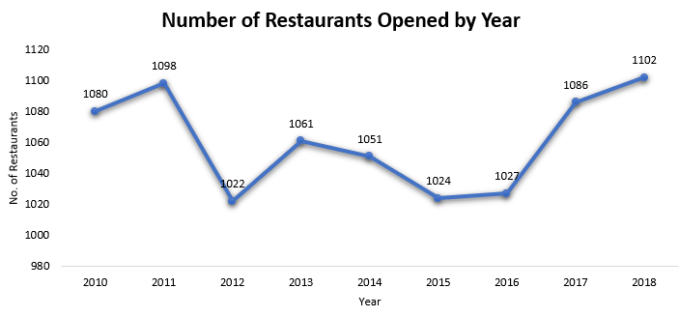

**Observation:**

The chart shows the number of restaurants opened each year from 2010 to 2018. The highest number of restaurants opened was in 2018, with 1102. The lowest was in 2012, with 1022 restaurants. Overall, the number of restaurants opened remained relatively consistent throughout the years, fluctuating around 1000 per year.

Consider examining the years with the highest openings (e.g., 2011, 2017, 2018) to understand the factors contributing to these peaks, and use those insights to replicate success in upcoming years.

1. **What is the total number of restaurants in India in the price range of 4?**

To find the total number of restaurants in India with a price range of 4, we can use the following formula:

“=COUNTIFS('Raw Data'!Q2:Q9552,"India",'Raw Data'!L2:L9552,4)”

This formula works as follows:

* 'Raw Data'!Q2:Q9552: This specifies the range of countries.
* "India": This filters the data for restaurants located in India.
* 'Raw Data'!L2:L9552: This specifies the range for the price range.
* 4: This filters the data for restaurants that have a price range of 4.

The formula will return the total number of restaurants in India with a price range of 4, which is 388

|  |  |  |
| --- | --- | --- |
| **Count of Restaurant** | **Column Labels** |  |
| **Prize range** | **India** | **Grand Total** |
| 1 | 4295 | 4295 |
| 2 | 2858 | 2858 |
| 3 | 1111 | 1111 |
| 4 | 388 | 388 |
| **Grand Total** | **8652** | **8652** |

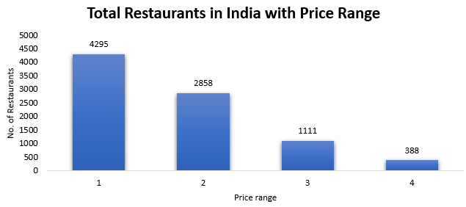

**Observation**

* Price Range 1 (4295 restaurants) – The majority of restaurants fall into the most affordable category, indicating a high demand for budget-friendly dining options.
* Price Range 2 (2858 restaurants) – A significant number of restaurants are in the mid-range pricing, catering to customers looking for a balance between affordability and quality.
* Price Range 3 (1111 restaurants) – Fewer restaurants exist in this premium category, suggesting that higher-priced establishments are less common.
* Price Range 4 (388 restaurants) – The least number of restaurants fall into this highest price range, indicating that luxury dining options are relatively rare.

1. **What is the average number of voters for the restaurants in each country according to the data?**

|  |  |  |
| --- | --- | --- |
| **Country Name** | | **Average of Votes** |
| Brazil | | 19.6 |
| Singapore | | 31.9 |
| Canada | | 103.0 |
| Australia | | 111.4 |
| India | | 137.2 |
| Sri Lanka | | 146.5 |
| Qatar | | 163.8 |
| United Kingdom | | 205.5 |
| New Zealand | | 243.0 |
| South Africa | | 315.2 |
| Philippines | | 407.4 |
| United States of America | | 428.2 |
| Turkey | | 431.5 |
| United Arab Emirates | | 493.5 |
| Indonesia | | 772.1 |
| **Grand Total** | **156.91** | |

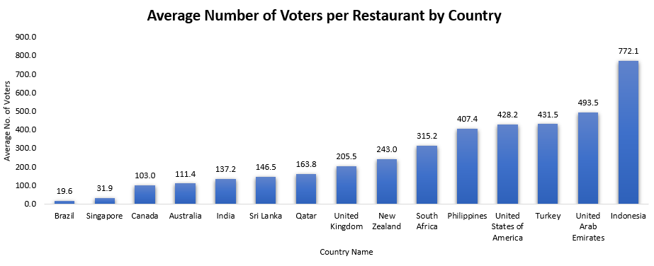

**Observation:**

* Indonesia and United Arab Emirates have the highest average number of votes per restaurant (772.10 and 493.52, respectively), indicating higher engagement or a more active voting population.
* Countries like Brazil, Singapore, show relatively lower averages (around 19 to 31 votes), which may suggest less customer engagement or fewer restaurants per country.
* South Africa, Philippines and United States of America have moderate averages (315 to 428), indicating a balanced level of voter participation.
* Focus on increasing customer engagement in countries with lower averages, such as Brazil and Singapore, by implementing targeted marketing strategies or loyalty programs.
* Investigate factors driving high voter engagement in countries like Indonesia and Turkey, and consider replicating successful practices in other countries.

1. **Calculate the average rating for all the restaurants that have price_range < 4 and provide online delivery. Use only the “IF” function, Logical Operators, and Aggregation functions to solve this problem. [Note: Don’t use Conditional aggregation in this question.]**

*Method 1: Using a Helper Column*

* Create a helper column to check if the restaurant meets the conditions (price_range < 4 and online delivery) “=IF(AND(L2 < 4, I2 = "Yes"), O2, "")” This will return the rating in column O if the restaurant has a price range less than 4 and provides online delivery. Otherwise, it returns an empty string.
* Then, calculate the average of the values “=AVERAGE('Raw Data'!S2:S9552)”

*Method 2: Using Array Formula*

* Array formula to directly calculate the average “=AVERAGE(IF(('Raw Data'!L2:L9552 < 4) * ('Raw Data'!I2:I9552 = "Yes"), 'Raw Data'!O2:O9552))”
* This formula uses the IF function along with logical operators to check if both conditions are met (price_range < 4 and online delivery is "Yes"). It calculates the average of the ratings from column S for the rows where both conditions are true.
* After typing the formula, press Ctrl + Shift + Enter to enter it as an array formula.

Final Result: The result for both methods will be an average rating of 3.27

1. **Using Conditional formatting highlight the rows of restaurants that are located in the countries or cities that you’ve suggested to the management for opening new restaurants.**



Select the "Highlight Cells Rules" → "Text that Contains" and entering the suggested country names. This will automatically highlight rows of restaurants located in the recommended expansion areas. Kindly refer the above screenshot.

1. **Create a new customized price column that consists of the abbreviation/symbol of the currency along with the Average_cost_for_two value. [Use string operations to do this task]**

Below formula to create new customized price column with the currency symbol and Average_cost_for_two “=CONCATENATE(MID(G2,SEARCH("(",G2)+1,SEARCH(")",G2)-SEARCH("(",G2)-1),N2)”

This formula combines the currency symbol from G2 with the value in N2 (Average_cost_for_two). The result will be, "$300" or "$200".

1. **How can you create an array formula in Excel or Google Sheets to count the number of restaurants listed that do not offer online delivery, are in the lowest price range, and have an average cost for two people less than or equal to 250 Indian Rupees?**

* To find Number of restaurants that do not offer online delivery, are in the lowest price range, and have an average cost for two less than or equal to 250 Indian Rupees, use the following array formula “=SUM(IF(('Raw Data'!L2:L9552=1) * ('Raw Data'!I2:I9552 = "No") * ('Raw Data'!V2:V9552 <= 250), 1, 0))”
* This formula evaluates the conditions and sums up the rows where all criteria are met.

The result is 1694. press Ctrl + Shift + Enter in Excel

Note: 'Raw Data'!V2:V9552 contains conversion formula “=IF(G4="Indian Rupees(Rs.)",N4,N4/VLOOKUP('Raw Data'!G4,HELP!$G$2:$J$12,4,FALSE))” that convert to INR value and HELP!$G$2:$J$12,4 is help table that contain conversion rates

**Subjective Question:**

1. **Suggest a few countries where the team can open newer restaurants with lesser competition. Which visualization/technique will you use here to justify the suggestions?**

|  |  |
| --- | --- |
| **Country Name** | **No. of Restaurants** |
| India | 8652 |
| United States of America | 434 |
| United Kingdom | 80 |
| Brazil | 60 |
| South Africa | 60 |
| United Arab Emirates | 60 |
| New Zealand | 40 |
| Turkey | 34 |
| Australia | 24 |
| Philippines | 22 |
| Indonesia | 21 |
| Sri Lanka | 20 |
| Singapore | 20 |
| Qatar | 20 |
| Canada | 4 |
| **Grand Total** | **9551** |

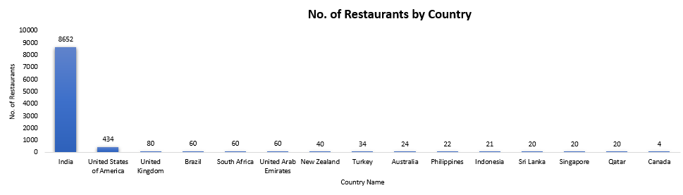

**Insights:**

* Low Restaurant Density in Certain Countries: Countries like Canada (4 restaurants), Qatar (20 restaurants), Sri Lanka (20 restaurants) and followed by Indonesia, Philippines and Australia have significantly fewer restaurants, suggesting they have lower competition and potential for new restaurants.
* Highly Competitive Markets: Countries like India (8652 restaurants) and the United States (434 restaurants) have high restaurant counts, indicating fierce competition and possibly saturated markets.

**Recommendations:**

The following countries have relatively fewer restaurants listed, making them potential locations for new restaurant openings:

- Australia

- Philippines

- Indonesia

- Singapore

- Qatar

- Sri Lanka

- Canada

These countries present opportunities for market penetration with less competition.

1. **Come up with the names of States and cities in the suggested countries suitable for opening restaurants.**

Based on Number of restaurants, Avg cost of two, Avg of rating and range picking cities which performed good in all mentioned parameters.

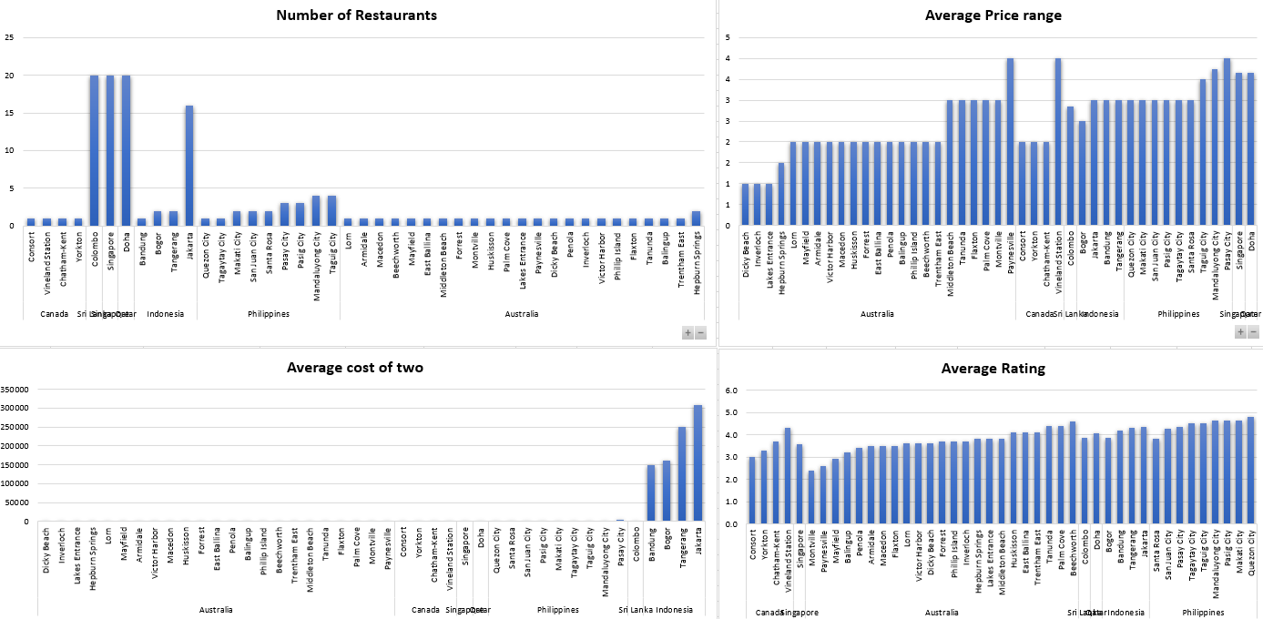

Mentioned cities offer potential opportunities for restaurant expansion based on Number of restaurants, Avg cost of two, Avg of rating and range

|  |  |
| --- | --- |
| **Country Name** | **City names** |
| Canada | Consort |
| Canada | Yorkton |
| Sri Lanka | Colombo |
| Sri Lanka | Galle* |
| Singapore | Singapore |
| Indonesia | Bandung |
| Indonesia | Bogor |
| Philippines | Tagaytay City |
| Philippines | Quezon City |
| Australia | Dicky Beach |
| Australia | Inverloch |
| Qatar | Al Khor* |
| Qatar | Doha |

*\* New cities have been added, apart from the listed ones, to expand the network to other cities, as we currently cover only a few cities in those countries.*

Kindly refer to the attached Pivot table below for more details

|  |  |  |  |  |
| --- | --- | --- | --- | --- |
|  | **Count of RestaurantID** | **Average of Average_Cost_for_two in INR(Rs.)** | **Average of Rating** | **Average of Price_range** |
| **Canada** | **4** | **3152** | **3.6** | **3** |
| Consort | 1 | 2174 | 3.0 | 2 |
| Vineland Station | 1 | 6087 | 4.3 | 4 |
| Chatham-Kent | 1 | 2174 | 3.7 | 2 |
| Yorkton | 1 | 2174 | 3.3 | 2 |
| **Sri Lanka** | **20** | **617** | **3.9** | **3** |
| Colombo | 20 | 617 | 3.9 | 3 |
| **Singapore** | **20** | **13543** | **3.6** | **4** |
| Singapore | 20 | 13543 | 3.6 | 4 |
| **Qatar** | **20** | **5340** | **4.1** | **4** |
| Doha | 20 | 5340 | 4.1 | 4 |
| **Indonesia** | **21** | **1593** | **4.3** | **3** |
| Bandung | 1 | 850 | 4.2 | 3 |
| Bogor | 2 | 907 | 3.9 | 3 |
| Tangerang | 2 | 1416 | 4.3 | 3 |
| Jakarta | 16 | 1748 | 4.4 | 3 |
| **Philippines** | **22** | **10627** | **4.5** | **3** |
| Quezon City | 1 | 5291 | 4.8 | 3 |
| Tagaytay City | 1 | 7937 | 4.5 | 3 |
| Makati City | 2 | 7606 | 4.7 | 3 |
| San Juan City | 2 | 5622 | 4.3 | 3 |
| Santa Rosa | 2 | 5456 | 3.8 | 3 |
| Pasay City | 3 | 22046 | 4.4 | 4 |
| Pasig City | 3 | 6173 | 4.6 | 3 |
| Mandaluyong City | 4 | 13228 | 4.6 | 4 |
| Taguig City | 4 | 11409 | 4.5 | 4 |
| **Australia** | **24** | **2094** | **3.7** | **2** |
| Lorn | 1 | 1739 | 3.6 | 2 |
| Armidale | 1 | 1739 | 3.5 | 2 |
| Macedon | 1 | 1739 | 3.5 | 2 |
| Beechworth | 1 | 1739 | 4.6 | 2 |
| Mayfield | 1 | 1739 | 2.9 | 2 |
| East Ballina | 1 | 1739 | 4.1 | 2 |
| Middleton Beach | 1 | 2609 | 3.8 | 3 |
| Forrest | 1 | 1739 | 3.7 | 2 |
| Montville | 1 | 2609 | 2.4 | 3 |
| Huskisson | 1 | 1739 | 4.1 | 2 |
| Palm Cove | 1 | 2609 | 4.4 | 3 |
| Lakes Entrance | 1 | 609 | 3.8 | 1 |
| Paynesville | 1 | 10435 | 2.6 | 4 |
| Dicky Beach | 1 | 609 | 3.6 | 1 |
| Penola | 1 | 1739 | 3.4 | 2 |
| Inverloch | 1 | 609 | 3.7 | 1 |
| Victor Harbor | 1 | 1739 | 3.6 | 2 |
| Phillip Island | 1 | 1739 | 3.7 | 2 |
| Flaxton | 1 | 2609 | 3.5 | 3 |
| Tanunda | 1 | 2609 | 4.4 | 3 |
| Balingup | 1 | 1739 | 3.2 | 2 |
| Trentham East | 1 | 1739 | 4.1 | 2 |
| Hepburn Springs | 2 | 1174 | 3.8 | 2 |
| **Grand Total** | **131** | **5497** | **4.0** | **3** |

1. **According to the countries you suggested, what is the current quality regarding ratings for restaurants that are open there?**

|  |  |
| --- | --- |
| **Country Name** | **Average of Rating** |
| Canada | 3.6 |
| Qatar | 4.1 |
| Singapore | 3.6 |
| Sri Lanka | 3.9 |
| Indonesia | 4.3 |
| Philippines | 4.5 |
| Australia | 3.7 |

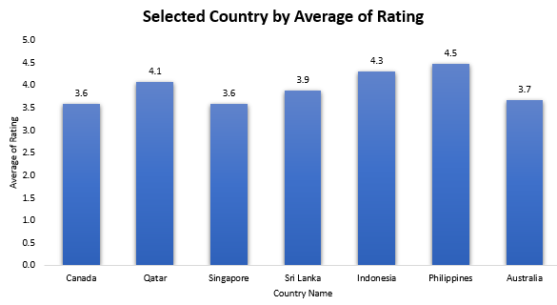

**Insights:**

* The Philippines (4.5), Indonesia (4.3), Qatar (4.1) have the highest ratings, indicating strong food culture and customer satisfaction.
* Canada (3.6), Singapore (3.6), and Australia (3.7) have lower ratings, possibly due to higher customer expectations or inconsistent service.

**Recommendations:**

* High-rated countries should maintain quality and leverage positive reviews for tourism marketing.
* Lower-rated countries should focus on improving consistency in service and food quality to boost customer satisfaction.

1. **Also, what is the current expenditure on food in the suggested countries, so we can keep our financial expenditure in control?**

|  |  |
| --- | --- |
| **Country Name** | **Average_Cost_for_two** |
| Canada | 3152 |
| Qatar | 5340 |
| Singapore | 13543 |
| Sri Lanka | 617 |
| Indonesia | 1593 |
| Philippines | 10627 |
| Australia | 2094 |

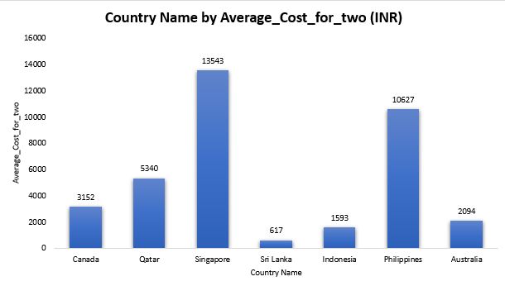

**Insights:**

* Singapore (₹13,543) and the Philippines (₹10,627) have the highest dining costs, indicating a preference for premium dining, while Sri Lanka (₹617) and Indonesia (₹1,593) are the most budget-friendly.
* Qatar (₹5,340), Canada (₹3,152), and Australia (₹2,094) fall in the mid-range, offering a mix of casual and premium dining options.

**Recommendations:**

* Optimize Expansion Budget: Focus on cost-effective locations like Sri Lanka and Indonesia to maximize profit margins while considering premium pricing in Singapore and the Philippines to balance high food expenses.
* Menu & Pricing Strategy: Adjust pricing strategies based on location offer premium pricing in Singapore and the Philippines while maintaining affordability in Sri Lanka and Indonesia to attract local customers.

1. **Come up with the names of restaurants from the recommended states that are our biggest competitors and also those that are rated in the lower brackets, i.e. 1-2 or 2-3.**
2. The graph below shows the overall average rating by restaurant name for selected cities.

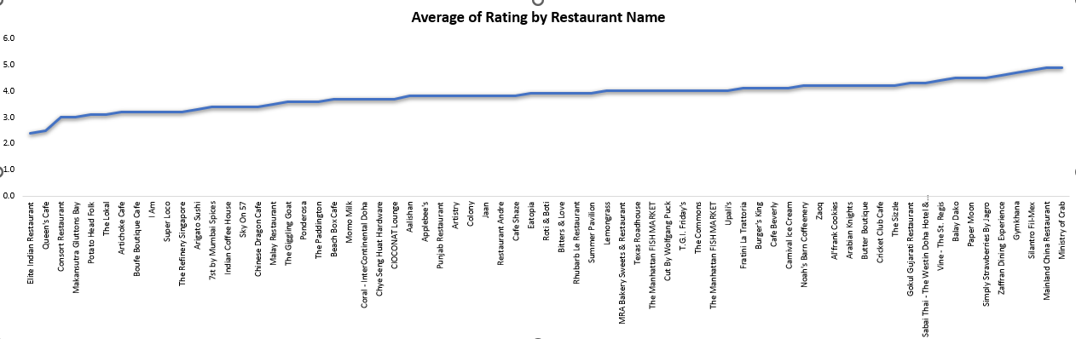

**Insights:**

* Highly Rated Competitors: Ministry of Crab (4.9), Mainland China Restaurant (4.9), and Gymkhana (4.7) dominate the premium restaurant space.
* Moderate Competition Zone: Several restaurants fall in the 3.5 - 4.0 range, indicating a balanced mix of average to good-performing restaurants.
* Low-Rated Establishments: Restaurants like Elite Indian Restaurant (2.4) and Queen’s Cafe (2.5) indicate a potential opportunity to introduce high-quality options.

1. The below table shows the average rating by restaurant name for selected cities with price range <=3 (lower brackets, i.e. 1-2 or 2-3)

|  |  |
| --- | --- |
| **Row Labels** | **Average of Rating** |
| **Australia** | **3.7** |
| **Dicky Beach** | **3.6** |
| The Giggling Goat | 3.6 |
| **Inverloch** | **3.7** |
| Beach Box Cafe | 3.7 |
| **Canada** | **3.2** |
| **Consort** | **3.0** |
| Consort Restaurant | 3.0 |
| **Yorkton** | **3.3** |
| Arigato Sushi | 3.3 |
| **Indonesia** | **4.0** |
| **Bandung** | **4.2** |
| Noah's Barn Coffeenery | 4.2 |
| **Bogor** | **3.9** |
| Lemongrass | 4.0 |
| Momo Milk | 3.7 |
| **Philippines** | **4.7** |
| **Quezon City** | **4.8** |
| Silantro Fil-Mex | 4.8 |
| **Tagaytay City** | **4.5** |
| Balay Dako | 4.5 |
| **Qatar** | **3.8** |
| **Doha** | **3.8** |
| Aalishan | 3.8 |
| Gokul Gujarati Restaurant | 4.3 |
| Indian Coffee House | 3.4 |
| MRA Bakery Sweets & Restaurant | 4.0 |
| Ponderosa | 3.6 |
| Punjab Restaurant | 3.8 |
| **Singapore** | **3.6** |
| **Singapore** | **3.6** |
| Al'frank Cookies | 4.2 |
| Artistry | 3.8 |
| Bitters & Love | 3.9 |
| Boufe Boutique Cafe | 3.2 |
| Chye Seng Huat Hardware | 3.7 |
| Makansutra Gluttons Bay | 3.0 |
| **Sri Lanka** | **3.8** |
| **Colombo** | **3.8** |
| Arabian Knights | 4.2 |
| Burger's King | 4.1 |
| Butter Boutique | 4.2 |
| Cafe Beverly | 4.1 |
| Cafe Shaze | 3.8 |
| Carnival Ice Cream | 4.1 |
| Chinese Dragon Cafe | 3.4 |
| CIOCONAT Lounge | 3.7 |
| Cricket Club Cafe | 4.2 |
| Elite Indian Restaurant | 2.4 |
| Malay Restaurant | 3.5 |
| Queen's Cafe | 2.5 |
| Simply Strawberries By Jagro | 4.5 |
| The Commons | 4.0 |
| The Paddington | 3.6 |
| The Sizzle | 4.2 |
| Upali's | 4.0 |
| **Grand Total** | **3.8** |

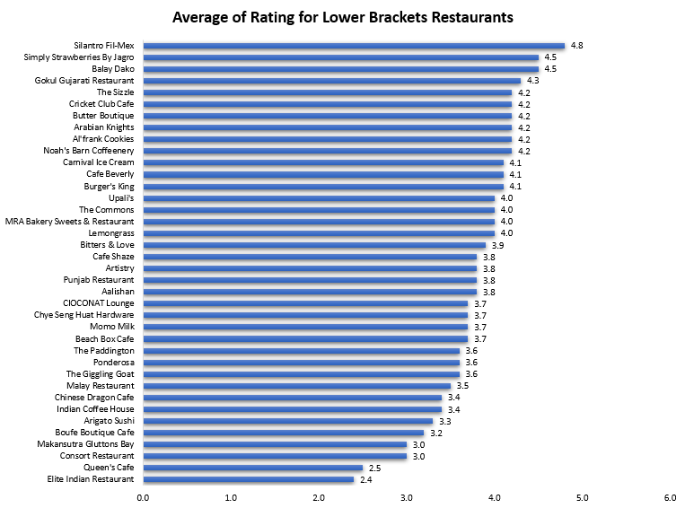

**Insights:**

* Lower-Rated Restaurants Need Improvement: Restaurants like Elite Indian Restaurant (2.4) and Queen’s Cafe (2.5) have the lowest ratings, indicating potential issues with food quality, service, or customer satisfaction.
* Strong Competition in the 4+ Rating Segment: Many restaurants, such as Balay Dako (4.5), Simply Strawberries By Jagro (4.5), and Silantro Fil-Mex (4.8), have high ratings, suggesting that customers have strong preferences for certain high-quality establishments.
* Majority of Restaurants Fall Between 3.5 - 4.2 Ratings: The majority of restaurants are rated between 3.5 to 4.2, indicating that most places provide decent quality but might lack the unique factor needed to excel beyond 4.5 ratings.

**Recommendations:**

* Quality & Service Enhancement for Low-Rated Restaurants: Restaurant should focus on improving menu quality, customer experience, and service training to enhance their ratings.
* Brand Differentiation in the 3.5 - 4.2 Range: Restaurants in this range should introduce unique dishes, improve ambiance, or offer promotions to move up in rankings and compete with the top-tier establishments.

1. The below table shows the average rating by restaurant name for selected cities with price range >3 (Higher Range)

|  |  |
| --- | --- |
| **Row Labels** | **Average of Rating** |
| **Qatar** | **4.2** |
| **Doha** | **4.2** |
| 7st by Mumbai Spices | 3.4 |
| Applebee's | 3.8 |
| Coral - InterContinental Doha | 3.7 |
| Eatopia | 3.9 |
| Gymkhana | 4.7 |
| Mainland China Restaurant | 4.9 |
| Paper Moon | 4.5 |
| Roti & Boti | 3.9 |
| Sabai Thai - The Westin Doha Hotel & Spa | 4.3 |
| Texas Roadhouse | 4.0 |
| The Manhattan FISH MARKET | 4.0 |
| Vine - The St. Regis | 4.4 |
| Zaffran Dining Experience | 4.6 |
| Zaoq | 4.2 |
| **Singapore** | **3.6** |
| **Singapore** | **3.6** |
| Artichoke Cafe | 3.2 |
| Colony | 3.8 |
| Cut By Wolfgang Puck | 4.0 |
| Fratini La Trattoria | 4.1 |
| I Am | 3.2 |
| Jaan | 3.8 |
| Potato Head Folk | 3.1 |
| Restaurant Andre | 3.8 |
| Rhubarb Le Restaurant | 3.9 |
| Sky On 57 | 3.4 |
| Summer Pavilion | 3.9 |
| Super Loco | 3.2 |
| The Lokal | 3.1 |
| The Refinery Singapore | 3.2 |
| **Sri Lanka** | **4.3** |
| **Colombo** | **4.3** |
| Ministry of Crab | 4.9 |
| T.G.I. Friday's | 4.0 |
| The Manhattan FISH MARKET | 4.0 |
| **Grand Total** | **3.9** |

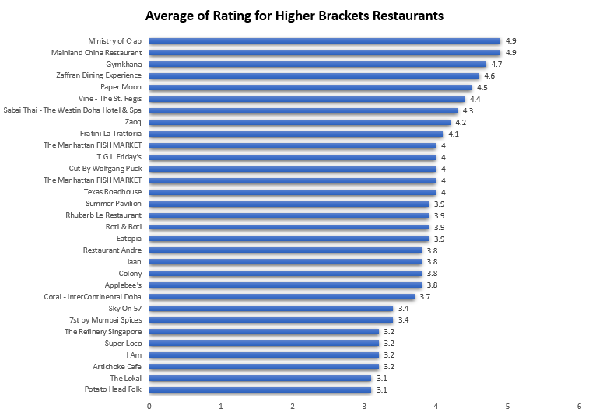

**Insights:**

* Top-Rated Restaurants: Ministry of Crab (4.9), Mainland China Restaurant (4.9), and Gymkhana (4.7) are the highest-rated, showing strong customer satisfaction.
* Mid-Tier Ratings (3.0 - 4.0): Many restaurants, like Potato Head Folk (3.1) and The Lokal (3.1), fall in the moderate range, indicating potential areas for improvement.
* Consistent Performance: The Manhattan FISH MARKET appears twice with a rating of 4.0, showing steady quality but lacking exceptional differentiation.

**Recommendations:**

* Improve Mid-Tier Restaurants: Focus on food quality, service, and ambiance to push ratings above 4.0.
* Capitalize on High Ratings: Maintain quality while introducing loyalty programs, exclusive menus, or expansion strategies.

1. **Which cuisines should we focus on in the newer restaurants to get better feedback? Does the choice of cuisines affect the restaurant ratings?**

Yes, the choice of cuisines does affect restaurant ratings. To get better feedback in newer restaurants, focus on high-performing cuisines such as Japanese, Seafood, Indonesian, and fusion cuisines (e.g., Filipino-Mexican, European-Asian-Indian), as they consistently receive higher ratings. Refer to the below graph and summary, which show the top 20 cuisines by average rating for more insights.

|  |  |
| --- | --- |
| **Row Labels** | **Average of Rating** |
| Sunda, Indonesian | 4.9 |
| Seafood | 4.9 |
| Sushi, Japanese | 4.9 |
| European, Asian, Indian | 4.9 |
| Filipino, Mexican | 4.9 |
| French, Japanese, Desserts | 4.8 |
| Japanese, Korean | 4.8 |
| Seafood, American, Mediterranean, Japanese | 4.7 |
| Pizza, Bar Food | 4.6 |
| Cafe, Italian, Coffee and Tea, Western, Indonesian | 4.6 |
| Asian, Indonesian, Western | 4.6 |
| Desserts, Bakery, Western | 4.6 |
| Cafe, Korean, Desserts | 4.5 |
| Juices, Desserts | 4.5 |
| American, Asian, Italian, Seafood | 4.5 |
| Filipino | 4.5 |
| Mediterranean, Seafood | 4.4 |
| Burger | 4.4 |
| Modern Australian, Australian | 4.4 |
| Japanese, Sushi, Ramen | 4.4 |

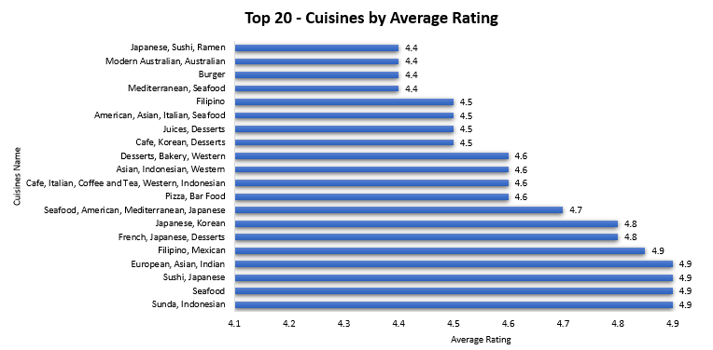

**Insights**

* + Cuisines with the Highest Ratings (4.9) Should Be Prioritized
  + The top-rated cuisines include Sunda, Indonesian, Seafood, Sushi, Japanese, European, Asian, Indian Filipino, Mexican – all scoring 4.9.
  + These cuisines are consistently well-received, indicating strong customer preference and satisfaction.
* Japanese and Seafood Perform Consistently Well
  + Japanese cuisine appears multiple times (Sushi, Ramen, Korean fusion) with ratings between 4.4 and 4.9, showing high acceptance.
  + Seafood also appears in various combinations, always rated 4.4 or higher, suggesting strong demand.

**Recommendation:**

* Focus on High-Performing Cuisines: New restaurants should prioritize Japanese, Seafood, Indonesian, and fusion cuisines (e.g., Filipino-Mexican, European-Asian-Indian) to get better customer feedback.

1. **According to our current data, should we go for online delivery and table booking? Does that affect the customer’s ratings?**

First table shows online delivery & second table shows table booking

|  |  |
| --- | --- |
| **Row Labels** | **Average of Rating** |
| No | 2.75 |
| Yes | 3.29 |
| **Grand Total** | **2.9** |

|  |  |
| --- | --- |
| **Row Labels** | **Average of Rating** |
| No | 2.81 |
| Yes | 3.48 |
| **Grand Total** | **2.89** |

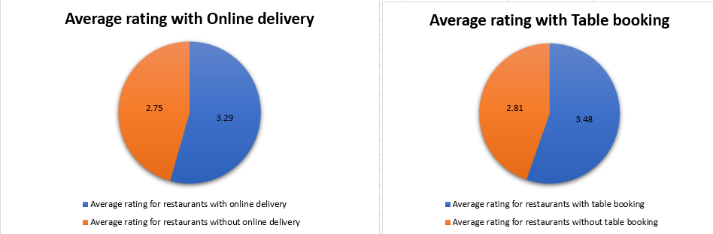

**Insight:**

* Restaurants with online delivery have a higher average rating (3.29) than those without (2.75), and those with table booking also perform better (3.48 vs. 2.81). This suggests that both services positively impact customer ratings.

**Recommendation:**

* Implementing online delivery and table booking is advisable to enhance customer satisfaction and ratings. Prioritize seamless user experience and service quality to maximize benefits.

1. **Should the team keep the rate of cuisines higher? Will that affect the feedback? According to our data are the rates of cuisines and ratings, correlated?**

**Formula “=CORREL('Raw Data'!N2:N9552,'Raw Data'!O2:O9552)”**

**Insight:**  
With a correlation of **0.06**, there is almost no relationship between cuisine rates and customer ratings. This suggests that pricing changes are unlikely to directly impact feedback.

**Recommendation:**  
The team should not focus on raising prices to improve ratings but instead enhance food quality and service. A balanced pricing strategy with value-driven offerings will be more effective.

1. **What is the distribution of the number of restaurants of different price ranges in all the countries?**

|  |  |  |  |  |  |
| --- | --- | --- | --- | --- | --- |
| **No. of Restaurants** | **Price_range** |  |  |  |  |
| **Country Name** | **1** | **2** | **3** | **4** | **Grand Total** |
| Australia | 4 | 14 | 5 | 1 | 24 |
| Brazil | 2 | 7 | 16 | 35 | 60 |
| Canada |  | 3 |  | 1 | 4 |
| India | 4295 | 2858 | 1111 | 388 | 8652 |
| Indonesia |  | 1 | 20 |  | 21 |
| New Zealand | 3 | 4 | 17 | 16 | 40 |
| Philippines |  | 1 | 12 | 9 | 22 |
| Qatar |  | 1 | 5 | 14 | 20 |
| Singapore |  | 1 | 5 | 14 | 20 |
| South Africa |  | 4 | 17 | 39 | 60 |
| Sri Lanka |  | 6 | 11 | 3 | 20 |
| Turkey |  | 11 | 18 | 5 | 34 |
| United Arab Emirates |  | 9 | 29 | 22 | 60 |
| United Kingdom | 4 | 28 | 32 | 16 | 80 |
| United States of America | 136 | 165 | 110 | 23 | 434 |
| **Grand Total** | **4444** | **3113** | **1408** | **586** | **9551** |

* Below chart shows overall Distribution of Restaurants by Price Range Across Countries

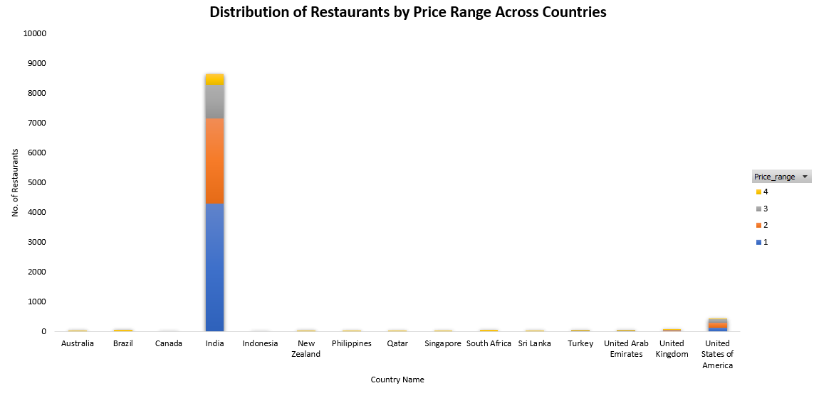

* Below chart shows overall Distribution of Restaurants by Price Range Across Countries, filtering India & United States of America for better visual

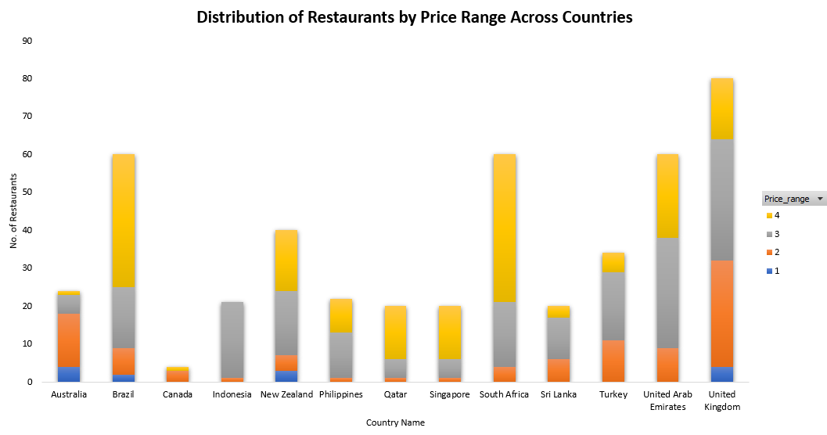

**Insight:**

* India dominates the restaurant count, with the majority falling under lower price ranges (1 & 2), showing a preference for affordable dining.
* Developed nations like the U.S., U.K., and Australia have a more even distribution across all price ranges, indicating diverse customer preferences.
* Countries like Brazil and South Africa have a higher number of premium restaurants (price range 4), suggesting a market for fine dining.
* Some countries, such as Canada and Indonesia, smaller restaurant market compare to other countries.

**Recommendation:**

* Focus on expanding budget-friendly restaurants in India and other high-volume markets to cater to the larger customer base.
* For developed countries, like the U.S., U.K., and Australia offer a mix of casual and fine dining to match the broad consumer demand across all price ranges.
* Capitalize on premium dining in Brazil, South Africa, and Qatar, where high-end restaurants have a stronger presence.

1. **Explain your approach in brief for suggesting countries/cities in order to open new restaurants, if the objective and subjective questions would have not been given to assist you. [you have to give bullet pointers in order to answer this question]**

Approach for Suggesting New Restaurant Locations:

1. Market Demand & Competition: Identify cities with a high number of restaurants but low average ratings, indicating demand for better options.
2. Customer Engagement: Prioritize locations with high votes and reviews, showing active customer interest.
3. Affordability & Pricing: Compare "Average Cost for Two" across cities to find profitable yet competitive pricing opportunities.
4. Online & Delivery Trends: Cities with high adoption of online ordering and delivery services indicate growing digital engagement.
5. Geographic Expansion: Identify countries/cities with fewer restaurants but growing urbanization.
6. Cuisine Preferences: Check which cuisines are popular in different locations to align with customer taste.