Alexander Attard

4.2C

Designing and creating a basic 2D game

**Question 1**:

1. Two types of game engines are Unity and Gamebryo.
   * Unity has a lot of resources one can use to learn from.
   * Unity also offers a wide variety of scripting languages that can be used by the user, for example C# and Boo.
   * Unity is totally free whereas Gamebryo only offers a free trail for a limited time.
   * Unity is very popular as it is ranked 2nd while Gamebryo is ranked 31st, due to this fact is very easy to get a license from Unity compared to Gamebryo which is very hard to get one.
2. Two types of programming languages are C# and C++.

* C# is very simple and modern compared to C++ which is a bit complicated to get used to.
* C# contains much more libraries than C++ making it easier to use.
* C# is also object-oriented meaning that is supports interfaces and inheritance.
* C# is also updateable keeping it update.

**Question 2**:

A.

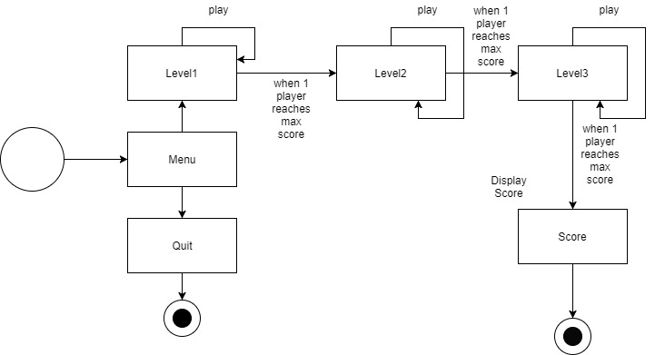

B.

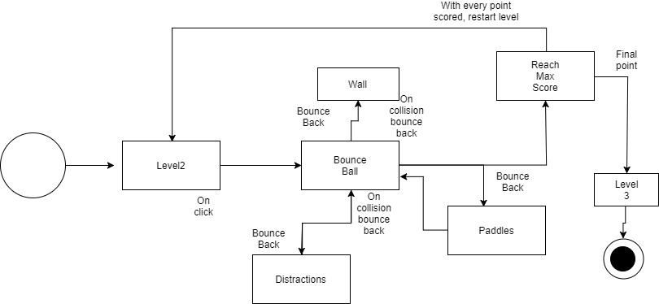

**Question 3:**

With good compression in media assets, one shouldn’t be able to loss the quality of the picture or the sound. Compression also makes the files shrink thus making them much more portable and practical to store and also share them. An example of video compression program could be QuickTime. Compression normally works by removing repetitive or also redundant information, this therefore makes the content have a much more original meaning. An email containing a video which is uncompressed, the video might not be sent with the email as it would be large than what the email can take. Compressed files have an advantage as they remove the time to attach, upload and finally download the files.

**References:**

* <http://www.careerride.com/view/what-is-compression-why-is-it-necessary-to-compress-files-multimedia-compression-3536.aspx>
* <http://www1.curriculum.edu.au/digitalvideo/compression.htm>
* <https://www.google.com.mt/url?sa=t&rct=j&q=&esrc=s&source=web&cd=1&cad=rja&uact=8&ved=0ahUKEwiR0vbVjJLYAhWOCewKHdO9B4IQFggjMAA&url=https%3A%2F%2Fwww.slant.co%2Fversus%2F1047%2F5148%2F~unity_vs_gamebryo&usg=AOvVaw2TjL3HMEmKr93LdTyLoXOU>
* <https://www.google.com.mt/url?sa=t&rct=j&q=&esrc=s&source=web&cd=1&cad=rja&uact=8&ved=0ahUKEwjK7PDjjJLYAhXE_KQKHTt3AkgQFggjMAA&url=https%3A%2F%2Fwww.upwork.com%2Fhiring%2Fdevelopment%2Fc-sharp-vs-c-plus-plus%2F&usg=AOvVaw19hI5-u0QSwtEPG514qn6p>