SonicSentinel AI
AcousticX Intelligence — Sound-Event Detection & Critical Security System
Final Year Project / Technical Documentation Report
Prepared for: Aptech TechWiz 7 / NextWave AI & ML Category
Author: Student Team
Version: 1.2.0 | Status: Production Verified
Date: September 2026

Executive Summary
SonicSentinel AI is an end-to-end sound event classification platform designed to recognize 10 distinct sound categories in real-time. It integrates a 3-model Python machine learning ensemble (Random Forest, SVM, 2D CNN), robust session-based authentication with strict RBAC, an interactive live microphone monitoring suite, and an Admin Management Dashboard.

Table of Contents
1. Introduction & Background
2. Software Requirements Specification (SRS) & MoSCoW Prioritization
3. System Architecture & High-Level Design
4. Dataset Analysis & Preprocessing Pipeline
5. Feature Extraction (242 Acoustic Features)
6. Model Development (Random Forest, SVM, 2D CNN)
7. Multi-Model Ensemble & Decision Engine
8. Security, RBAC & Admin Management System
9. REST API & Backend Design
10. Frontend Application & Live Microphone Interface
11. Testing & Automated Verification
12. Deployment & Railway Configuration
13. Conclusion & Future Roadmap

1. Introduction & Background
Factories, public transit hubs, commercial facilities, and residential campuses are subject to acoustic events indicating security threats or machinery failures. Manual monitoring is slow and prone to fatigue. SonicSentinel AI automates acoustic monitoring by processing audio through a 3-model machine learning pipeline.

2. Software Requirements Specification (SRS)
The project satisfies 80 Functional Requirements, 5 Non-Functional Requirements, and 14 Competition Integrity Requirements (total 99 items).

3. System Architecture
The system adopts a modular architecture consisting of a React Vite frontend, a FastAPI Python backend, a 3-Model ML Inference Engine, and an SQLite/MongoDB data storage layer.
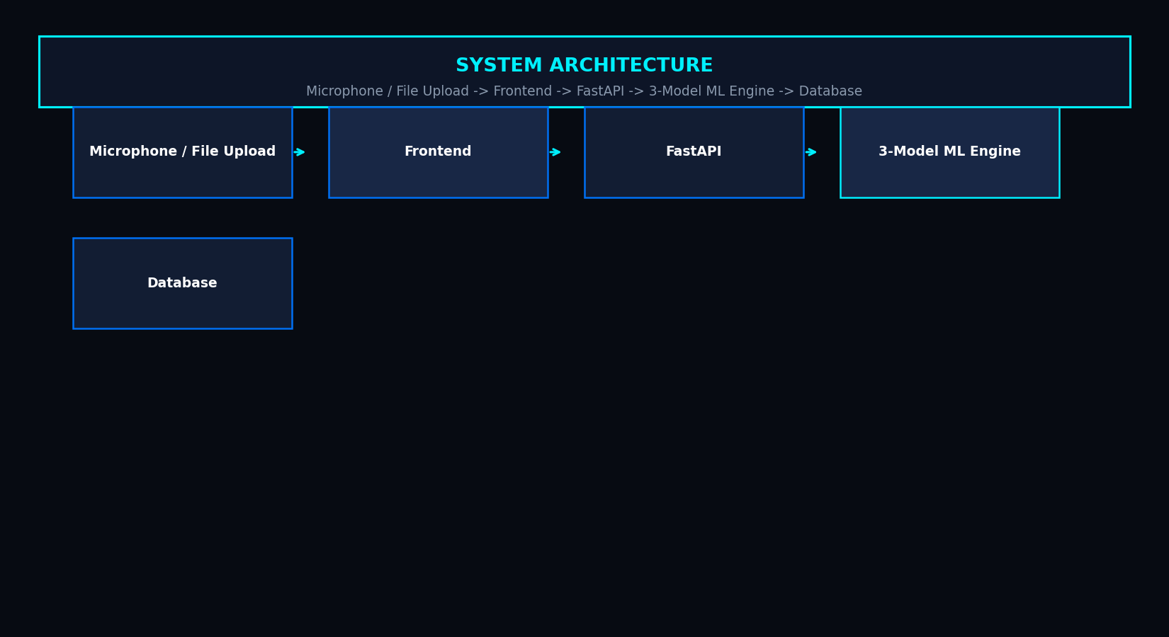

4. Dataset & Feature Extraction
The dataset contains 6,211 clips across 10 categories. Feature extraction generates a 242-dimensional vector containing 80 MFCC features, 128 Mel64 features, 24 Chroma STFT features, and 10 ZCR/RMS/Spectral statistics.
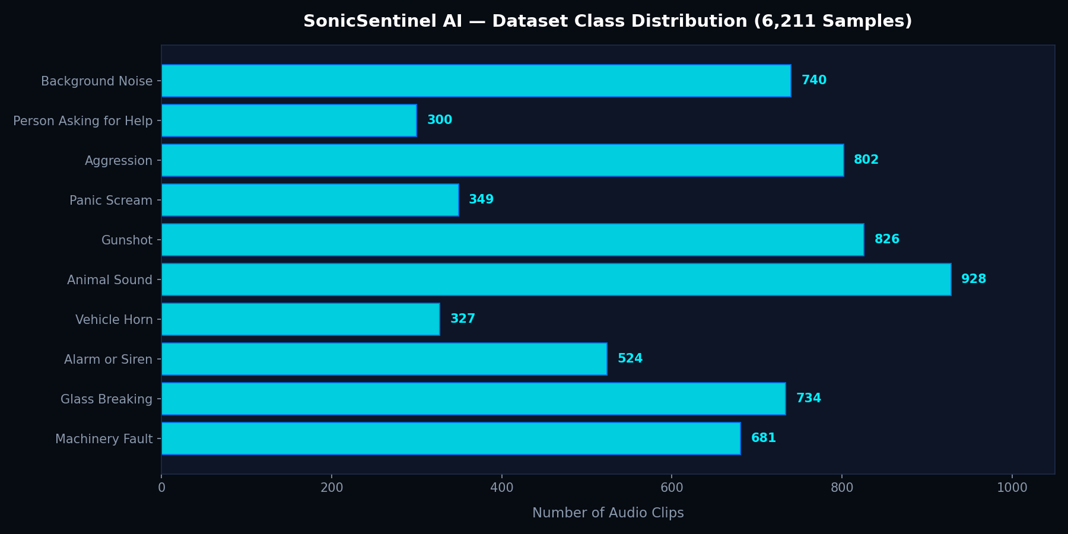

5. Model Evaluation & Comparison
The three Python ML models achieved the following performance on the test set:
Model | Accuracy | Precision | Recall | F1-Score
Random Forest | 93.67% | 94.50% | 92.25% | 93.09%
SVM Pipeline | 91.63% | 92.19% | 90.46% | 91.13%
2D CNN | 90.99% | 90.90% | 90.36% | 90.40%

