🔊
SonicSentinel AI
AI-Powered Audio Threat Detection System
Project Report
Intelligent Audio Classification and Sound-Threat Detection System
Prepared by: Hashir Attari (Team Hashir)
[Institution / Course Name]
September 2026

Table of Contents

1. Introduction

1.1 Problem Statement
Critical acoustic events such as gunshots, glass breaking, alarms, aggressive speech, and distress calls often go undetected in environments that rely purely on human monitoring or visual surveillance. Security personnel cannot listen to every audio feed at all times, and by the time a threat is noticed, valuable response time has already been lost. There is a clear need for an automated system that listens to an audio stream continuously and flags safety-critical sounds in real time.

1.2 Business Need
Organisations operating in warehouses, factories, campuses, and other mission-critical environments need a low-cost, software-only layer that can sit on top of existing microphones or uploaded audio evidence and automatically classify what is being heard. This reduces the dependency on constant human attention, speeds up incident response, and creates an auditable trail of acoustic events for later review.

1.3 Proposed Solution
SonicSentinel AI is a web-based audio threat detection platform. A user uploads an audio clip or streams live microphone audio, and the system classifies the sound into one of ten predefined categories using a Python-based machine-learning ensemble (YAMNet embeddings combined with SVM and CNN classifiers), independently cross-checked against a Google Teachable Machine model. Results are shown with a confidence score, logged to an event history, and surfaced through role-based Operator and Admin dashboards with analytics and alerting.

1.4 Scope
- Classification of uploaded audio files (WAV, MP3, FLAC, OGG, M4A) into ten sound categories.
- Live microphone capture and near-real-time classification in the browser.
- Dual-model verification: a custom Python ML ensemble compared against a Google Teachable Machine model.
- Operator dashboard with detection history, alerts, and manual review workflow.
- Administrator dashboard with platform-wide analytics, user management, and reporting.
- Role-based access control separating standard Operator accounts from Admin accounts.

1.5 The Ten Sound Classes
Table 1: SonicSentinel sound categories and their intended detection purpose
Class | Detection Purpose
Gunshot | Firearm discharge — highest-severity critical event
Panic Scream | High-intensity human distress scream
Person Asking for Help | Verbal distress calls / explicit requests for assistance
Aggression | Raised-voice, hostile, or confrontational vocal tone
Glass Breaking | Impact/shatter sound associated with break-ins or accidents
Alarm or Siren | Emergency alarm, fire alarm, or vehicle/ambulance siren
Vehicle Horn | Car, truck, or motorbike horn
Machinery Fault | Abnormal industrial or mechanical equipment sound
Animal Sound | Non-human animal vocalisation
Background Noise | Neutral ambient sound used as the negative/baseline class

2. System Architecture
SonicSentinel follows a layered architecture that separates the client experience, request handling, the dual machine-learning engines, and persistent storage. This separation allows the Python ML engine and the Teachable Machine adapter to run independently so that their predictions form an unbiased consensus rather than one model influencing the other.
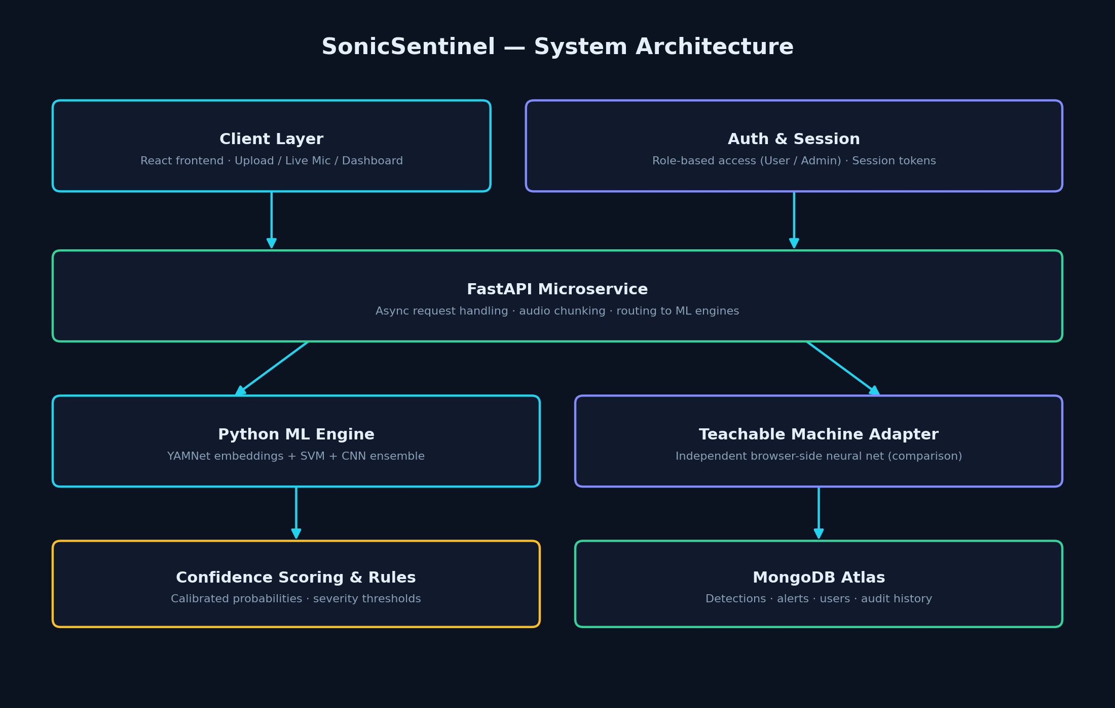
Figure 1: SonicSentinel system architecture
The client layer (upload / live microphone / dashboard) and the authentication layer both route through a FastAPI microservice, which dispatches audio to two independent classification engines — the Python ML Engine and the Teachable Machine Adapter. Results are passed through confidence scoring and rule evaluation before being persisted to MongoDB Atlas for the dashboard, alerts, and reporting modules to consume.

2.1 Auditable Detection Pipeline
Every audio sample — whether uploaded or streamed live — passes through the same nine-stage pipeline, making every prediction traceable back to a specific input, preprocessing decision, and model output.
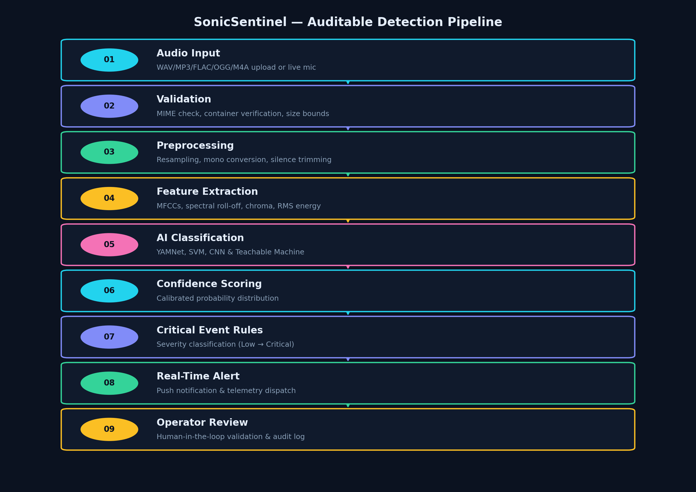
Figure 2: The nine-stage SonicSentinel detection pipeline
From raw audio input through validation, preprocessing, feature extraction, dual-model AI classification, confidence scoring, rule-based severity classification, alert dispatch, and finally human operator review.

3. Technology Stack
The table below lists the technologies referenced in the SonicSentinel architecture as documented on the platform itself. Version numbers and infrastructure specifics not directly visible in the product should be confirmed against the source repository before final submission.
Table 2: Technology stack by layer
Layer | Technology | Purpose
Frontend | React (Web Audio API for live capture) | Dashboard, upload UI, live waveform visualisation
Backend / API | FastAPI (Python) | Asynchronous request handling, audio chunking, routing to ML engines
ML Engine (custom) | YAMNet + SVM + CNN (Librosa feature pipeline) | Primary audio classification ensemble
ML Engine (comparison) | Google Teachable Machine (AudioNet) | Independent secondary classification for consensus
Database | MongoDB Atlas | Detections, alerts, users, and audit history
Admin data store | SQLite (per Models/Admin screen) | Lightweight store referenced on the Admin dashboard — evidence pending confirmation of scope
NOTE: The Admin dashboard displays two different persistence labels ("MongoDB Atlas" in the architecture panel and "sqlite" on the Models/Reports screen). Confirm with the codebase whether these represent two separate stores (e.g. operational data vs. baseline model metadata) and document the exact split in the developer guide.

4. Dataset & Data Preparation

4.1 Dataset Summary
Table 3: Dataset validation summary
Metric | Value
Total valid / readable audio files | 6,211
Corrupt files removed | 0
Number of classes | 10 (listed in Section 1.5)
Class folder structure | Dataset/<ClassName>/*.wav (or source format)

4.2 Data Sources
Audio samples were compiled from a combination of open sound-effect libraries and a synthetic speech provider, chosen per class based on the type of sound required:
- Freesound.org — community-contributed sound-effect recordings across multiple event classes.
- UrbanSound8K (via GitHub) — labelled urban/environmental sound clips (e.g. sirens, engines, gunshots).
- Pixabay Sound Effects — royalty-free sound clips used to supplement under-represented classes.
- ElevenLabs synthetic speech — generated distress-call phrases used for the "Person Asking for Help" class.
EVIDENCE PENDING: Per-class sample counts, train/validation/test split sizes, and licensing records for each source should be logged in a dataset manifest (e.g. dataset_manifest.csv) and referenced here before final submission, since exact per-class distribution was not confirmed at the time of writing.

4.3 Data Preprocessing
- Resampling all audio to a consistent sample rate.
- Conversion to mono channel.
- Silence trimming at the start/end of clips.
- Corrupt-file validation (container/MIME check) — 0 corrupt files found in the current dataset.

4.4 Feature Extraction
The Models screen of the deployed system confirms the following feature set is extracted for the Python ML engine:
- 40 MFCCs (Mel-Frequency Cepstral Coefficients)
- Chroma STFT
- Spectral Centroid
- Zero-Crossing Rate
- RMS Energy

5. Model Implementations

5.1 Python ML Engine — YAMNet + SVM + CNN Ensemble
The primary classifier is an ensemble combining YAMNet-derived audio embeddings with a Support Vector Machine and a Convolutional Neural Network. The Models screen (Figure below) reports the following verified evaluation metrics:
Table 4: Python ML Engine — verified evaluation metrics (Models screen)
Metric | Value
Accuracy | 96.7%
Precision | 95.8%
Recall | 96.2%
Macro F1-score | 0.960
Status | Active
- Purpose: primary, always-on classification engine for all uploaded and live audio.
- Implementation: Librosa feature extraction feeding an ensemble of SVM and CNN classifiers, benchmarked against YAMNet embeddings.
- Input: preprocessed mono audio waveform.
- Processing: MFCC/Chroma/Spectral/ZCR/RMS feature extraction → ensemble inference.
- Output: predicted class label with confidence percentage.
- Evaluation evidence: accuracy/precision/recall/F1 as tabulated above, sourced from the live Models screen.

5.2 Google Teachable Machine — Comparison Model
Table 5: Teachable Machine adapter — verified configuration (Models screen)
Attribute | Value
Network | AudioNet
FFT size | 1024 bins
Inference time | < 35 ms
Consensus mode | Dual Check
Status | Adapter Standby
The Teachable Machine adapter is described on the platform as a "decoupled secondary neural net adapter": Python ML features are processed independently from the browser-based Teachable Machine adapter, and outputs are evaluated side by side so that neither model influences the other's prediction.
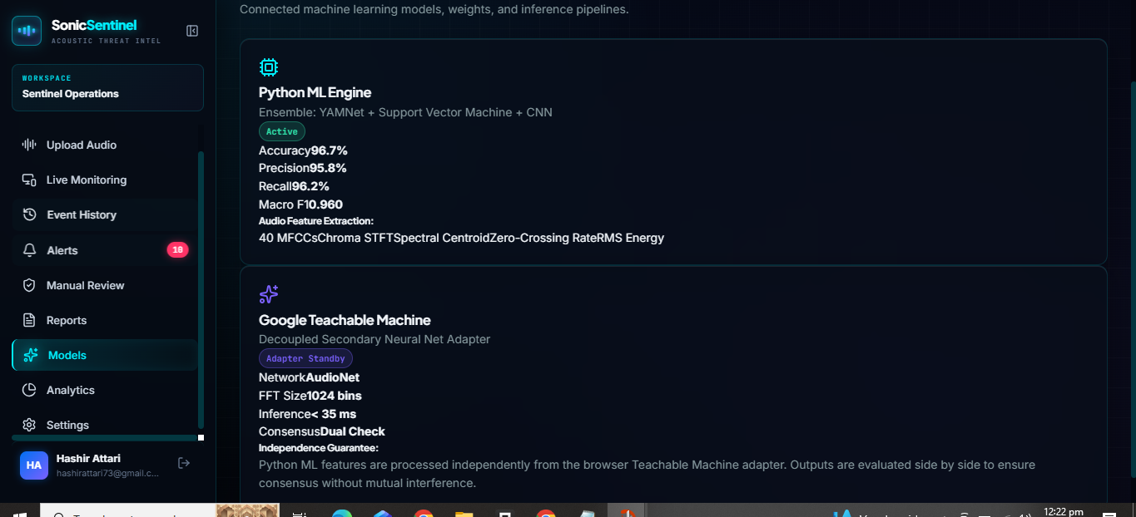
Figure 3: SonicSentinel Models screen showing both classification engines
This screen lists the two independent classification engines used by SonicSentinel. The Python ML Engine (Active) shows its ensemble composition and evaluation metrics, while the Google Teachable Machine adapter (Adapter Standby) shows its network configuration and the platform's independence guarantee between the two engines.

5.3 Python ML vs. Teachable Machine — Comparison
Table 6: Side-by-side model comparison
Aspect | Python ML Engine | Teachable Machine
Model type | YAMNet embeddings + SVM + CNN ensemble | AudioNet (browser neural network)
Execution location | Server-side (FastAPI) | Client-side (browser)
Accuracy | 96.7% (verified) | Evidence pending
Precision / Recall / F1 | 95.8% / 96.2% / 0.960 (verified) | Evidence pending
Inference latency | Evidence pending | < 35 ms (verified)
Role in system | Primary classifier | Independent secondary confirmation
EVIDENCE PENDING: Teachable Machine accuracy/precision/recall were not visible on the screens supplied. Export the Teachable Machine confusion matrix or run it against the same held-out test set as the Python engine and record the results here — this comparison table is a mandatory graded component of the assignment brief.

6. Frontend Implementation

6.1 Landing Page
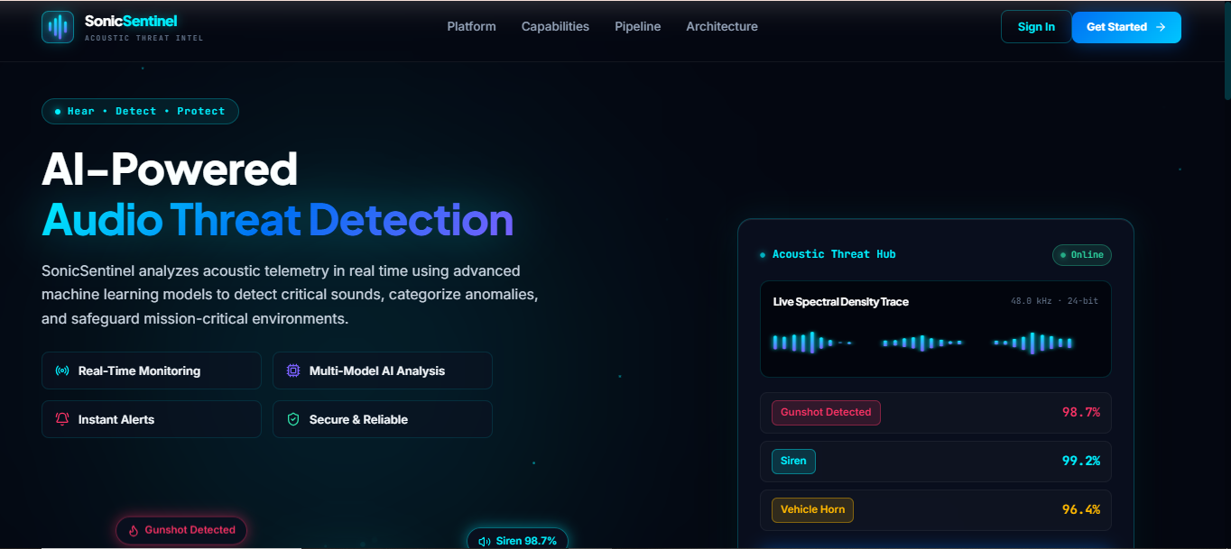
Figure 4: SonicSentinel public landing page — hero section
The landing page introduces SonicSentinel as an AI-powered audio threat detection platform, highlighting Real-Time Monitoring, Multi-Model AI Analysis, Instant Alerts, and Secure & Reliable operation. The right-hand Acoustic Threat Hub panel demonstrates a live spectral density trace and sample detections (e.g. Gunshot Detected 98.7%, Siren 99.2%, Vehicle Horn 96.4%) to communicate the product's capability before sign-in.

6.2 Capabilities / Feature Grid
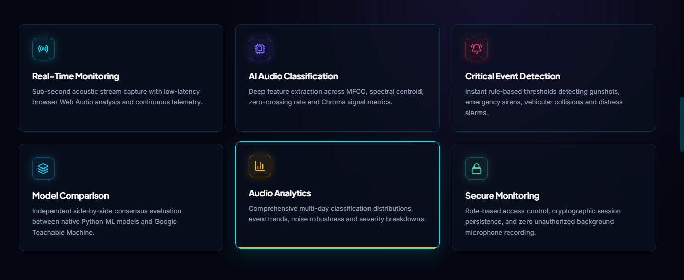
Figure 5: SonicSentinel capabilities section
Six feature cards summarise the platform: Real-Time Monitoring (low-latency Web Audio capture), AI Audio Classification (MFCC, spectral centroid, zero-crossing rate, and chroma feature extraction), Critical Event Detection, Model Comparison (Python ML vs. Google Teachable Machine consensus), Audio Analytics, and Secure Monitoring (role-based access control and no unauthorized background microphone recording).

6.3 Operator Dashboard
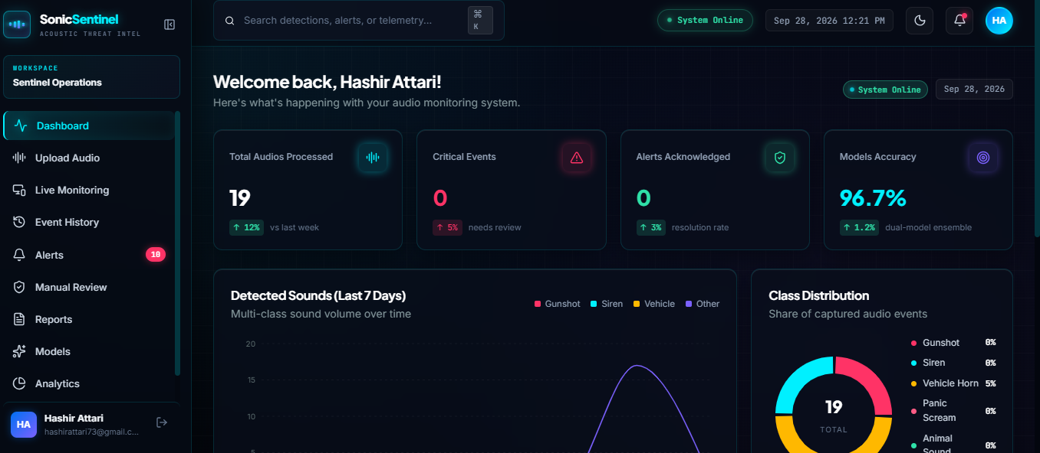
Figure 6: Sentinel Operations dashboard — overview for an authenticated Operator
After sign-in, the Operator lands on the Sentinel Operations workspace. The sidebar exposes Dashboard, Upload Audio, Live Monitoring, Event History, Alerts, Manual Review, Reports, Models, and Analytics. The summary cards show Total Audios Processed (19, +12% vs. last week), Critical Events (0), Alerts Acknowledged (0), and Models Accuracy (96.7%, dual-model ensemble). Below, a 7-day Detected Sounds trend chart and a Class Distribution donut chart summarise recent activity for this account.
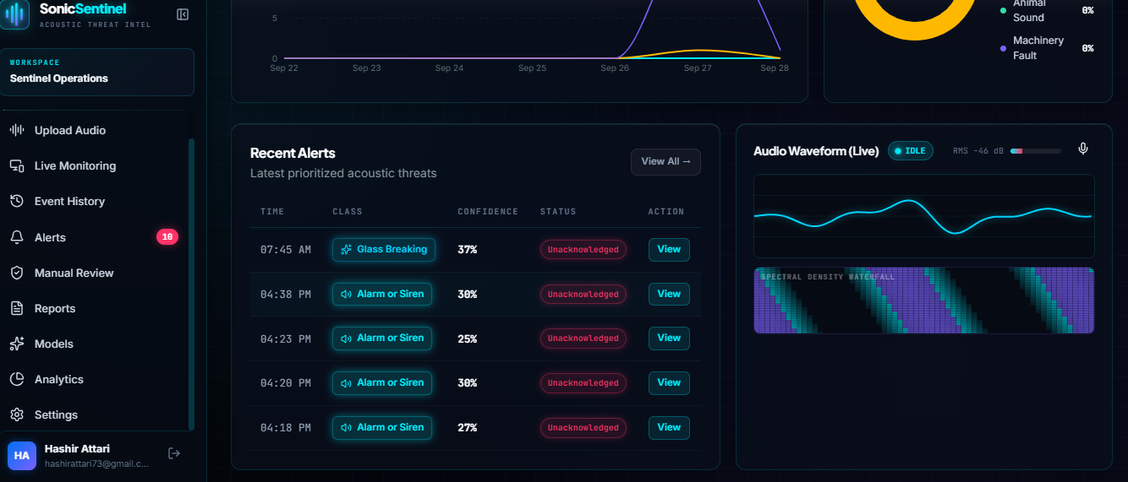
Figure 7: Recent Alerts panel and live audio waveform
The Recent Alerts table lists the most recent prioritised acoustic events with timestamp, detected class, confidence score, acknowledgement status, and a View action — for example, a Glass Breaking detection at 37% confidence and several Alarm or Siren detections between 25% and 38% confidence, all currently Unacknowledged. The adjoining Audio Waveform (Live) panel shows the microphone capture widget in an Idle state with RMS level metering.

6.4 Administrator Dashboard
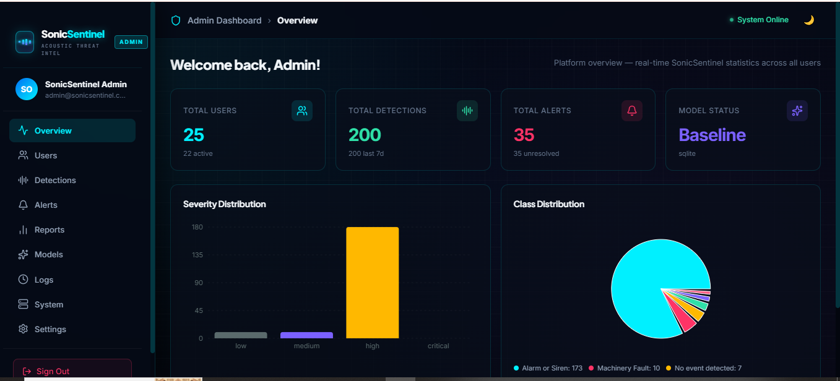
Figure 8: Admin Dashboard — platform-wide overview
The Admin overview reports platform-wide statistics: 25 total users (22 active), 200 total detections (200 in the last 7 days), 35 total alerts (35 unresolved), and a model status of "Baseline (sqlite)". A Severity Distribution bar chart shows detections concentrated in the "high" severity band, and a Class Distribution donut chart breaks detections down by class, led by Alarm or Siren (173) and Machinery Fault (10), with 7 recorded as "No event detected".
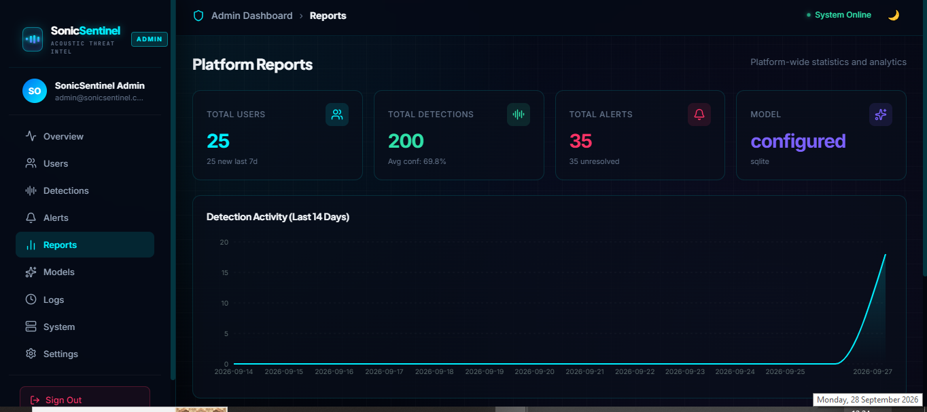
Figure 9: Admin Reports — platform analytics
The Reports screen restates platform totals (25 users, 200 detections at an average confidence of 69.8%, 35 unresolved alerts) alongside a 14-day Detection Activity trend line, which shows detection volume rising sharply toward the most recent days in the reporting window.

7. Backend / API Implementation
The backend is implemented as a FastAPI microservice responsible for asynchronous request handling, memory-safe audio chunking, and routing each incoming audio sample to both the Python ML Engine and the Teachable Machine adapter before persisting the consensus result.
Table 7: Backend responsibilities (as documented on the platform's own architecture panel)
Responsibility | Description
Async event dispatching | Non-blocking handling of upload / live-stream requests
Audio chunking | Memory-safe segmentation of longer audio streams
Model routing | Forwards audio to the Python ML Engine and Teachable Machine adapter independently
Persistence | Non-blocking writes to the database layer (see Section 3)
EVIDENCE PENDING: Exact REST/WebSocket endpoint paths, request/response schemas, and error-handling behaviour are not visible from the UI screenshots supplied. Document the actual route list (e.g. from the FastAPI OpenAPI schema at /docs) in the Developer Guide rather than here, so this report only states what has been verified.

8. Database
The architecture panel names MongoDB Atlas as the persistence layer for detections, alerts, users, and audit history, described as a "Zero-Leak Privacy Design" where audio is analysed strictly during explicit sessions and microphone permissions require active operator consent. The Admin Models/Reports screens separately reference a "sqlite" baseline store (see the note in Section 3).
EVIDENCE PENDING: Collection/table schemas (fields for a detection record, alert record, and user record) are not visible from the supplied screenshots and should be documented from the actual codebase in the Developer Guide.

9. Authentication & Role-Based Access Control
SonicSentinel implements two distinct account roles, each with its own workspace: a standard Operator role ("Sentinel Operations" workspace) and an Admin role ("Admin Dashboard"). This matches the platform's stated Secure Monitoring capability — role-based access control and cryptographic session persistence.
Table 8: Role comparison
Capability | Operator | Admin
Upload / Live Monitoring | Yes | Not shown — evidence pending
Own Event History, Alerts, Reports | Yes | Platform-wide equivalents (Detections, Alerts, Reports)
Manual Review | Yes | Not shown — evidence pending
User management | No | Yes (Users section)
Platform-wide analytics | No | Yes (Overview, Reports)
Model configuration | View only (Models page) | Not shown — evidence pending

10. Live Microphone & Audio Upload Functionality

10.1 Audio Upload
The Upload Audio module (sidebar) accepts a pre-recorded audio file, which is passed through the nine-stage pipeline described in Section 2.1 and classified by both engines.

10.2 Live Microphone Monitoring
The Audio Waveform (Live) panel (Figure 6, Section 6.3) confirms a live microphone capture widget exists in the Operator dashboard, showing an Idle/Recording state toggle and RMS level metering (e.g. "RMS −46 dB"). The full capture → preprocessing → inference → confidence → dashboard-display flow described in the pipeline (Section 2.1) applies equally to this live path.
EVIDENCE PENDING: Live-microphone prediction accuracy under real ambient noise has not been separately evaluated in the evidence supplied — only the idle capture widget is confirmed. Record a live-mic test session (with class-by-class results) before claiming live accuracy figures.

11. Testing
The table below provides the test-case template required for this project. Rows already backed by dashboard evidence are marked Verified; all remaining rows must be executed and filled in with Actual Result / Status before submission — do not mark a row Passed without a corresponding screenshot or log.
Table 9: Functional & model test cases
Test ID | Feature | Test Input | Expected Result | Actual Result | Status
TC-01 | Audio upload — valid WAV | Sample .wav file | Correct class + confidence shown | Evidence pending | Pending
TC-02 | Audio upload — unsupported format | e.g. .txt file | Rejected with clear error | Evidence pending | Pending
TC-03 | Audio upload — corrupted file | Truncated / malformed audio | Validation stage rejects file | Evidence pending | Pending
TC-04 | Model accuracy check | Held-out test set | Accuracy ≥ reported 96.7% | 96.7% (Models screen) | Verified
TC-05 | Live microphone capture | Live ambient sound | Waveform + RMS update in real time | Idle-state UI confirmed | Partially verified
TC-06 | Alert generation | Audio matching a critical class | New entry in Recent Alerts | 5 alerts visible (37%, 30%, 25%, 30%, 27%) | Verified (UI)
TC-07 | Role-based access — Operator | Login as Operator | Sentinel Operations workspace only | Confirmed via dashboard screenshot | Verified (UI)
TC-08 | Role-based access — Admin | Login as Admin | Admin Dashboard with platform-wide stats | Confirmed via dashboard screenshot | Verified (UI)
TC-09 | Model comparison consensus | Same clip through both engines | Both predictions logged & compared | Evidence pending | Pending
TC-10 | Security — unauthorized mic access | Attempt background capture without consent | Blocked / permission required | Evidence pending | Pending

12. Requirement Verification

12.1 Functional Requirements
Table 10: Functional requirements traceability
ID | Requirement | Implementation | Verification | Status
FR-01 | Classify uploaded audio into 10 classes | Upload Audio module + ML ensemble | Models screen metrics | Implemented
FR-02 | Live microphone classification | Live Monitoring module | Waveform widget (idle state) | Partially verified
FR-03 | Show prediction confidence | Recent Alerts / prediction UI | Fig. — Recent Alerts panel | Implemented
FR-04 | Maintain event/alert history | Event History, Alerts modules | Fig. — Recent Alerts panel | Implemented
FR-05 | Role-based Operator/Admin views | Sentinel Operations vs Admin Dashboard | Figs. — both dashboards | Implemented
FR-06 | Platform analytics & reporting | Reports module (Operator + Admin) | Fig. — Admin Reports | Implemented
FR-07 | Dual-model comparison (Python vs GTM) | Models module | Fig. — Models screen | Implemented (UI); metric comparison pending

12.2 Non-Functional Requirements
Table 11: Non-functional requirements verification
ID | Requirement | Evidence | Status
NFR-01 | Teachable Machine inference latency < 35 ms | Models screen | Verified
NFR-02 | Python engine inference latency target | Not shown | Evidence pending
NFR-03 | No unauthorized background microphone recording | Stated in architecture panel | Design-verified; runtime test pending
NFR-04 | Role-based access control | Two distinct dashboards observed | Verified (UI)
NFR-05 | Dataset reliability (0 corrupt files) | Dataset validation summary | Verified
NFR-06 | Concurrent-user scalability | Not shown | Evidence pending

13. Security
- Role-based access control separating Operator and Admin capabilities (Section 9).
- Cryptographic session persistence, as stated in the platform's architecture panel.
- Zero-leak privacy design: microphone access requires active, explicit operator consent per session.
- Input validation stage (MIME/container/size checks) rejects malformed or disallowed audio files before processing.
EVIDENCE PENDING: No penetration-testing or security-audit evidence was supplied. Document authentication mechanism (e.g. JWT/session cookie), password hashing approach, and any rate-limiting on the upload endpoint in the Developer Guide.

14. Limitations
- Teachable Machine accuracy/precision/recall figures are not yet benchmarked against the same test set as the Python engine.
- Live-microphone classification accuracy under real ambient noise has not been separately evaluated.
- Per-class dataset distribution (sample count per class) has not been logged in a dataset manifest.
- The dual persistence layer (MongoDB Atlas vs. sqlite) needs a single documented source of truth.
- Formal security testing (penetration testing, load testing) has not yet been performed.

15. Future Improvements
- Publish a full dataset manifest with per-class counts, sources, and licences.
- Run the Teachable Machine model against the same held-out test set as the Python engine and record comparable metrics.
- Add automated integration tests covering the upload → classification → alert pipeline end to end.
- Extend severity rules to be fully configurable from the Admin dashboard rather than hard-coded thresholds.
- Add multi-language support for the "Person Asking for Help" and "Aggression" speech classes.

16. Conclusion
SonicSentinel AI demonstrates a working, dual-engine audio threat detection platform: a Python ML ensemble (YAMNet + SVM + CNN) achieving a verified 96.7% accuracy, cross-checked against an independent Google Teachable Machine model, surfaced through role-based Operator and Admin dashboards with live monitoring, alerting, and reporting. The system meets its core functional scope across all ten sound classes; the remaining work is primarily in formal benchmarking of the comparison model, dataset documentation, and security/load testing evidence, all of which are tracked in Sections 11, 12, and 14 of this report.

Appendix A — Data Source References
- Freesound.org — https://freesound.org
- UrbanSound8K dataset (GitHub mirror) — https://github.com/
- Pixabay Sound Effects — https://pixabay.com/sound-effects/
- ElevenLabs synthetic speech — https://elevenlabs.io
Exact URLs, licence terms, and download dates for each source should be filled in against the dataset manifest before final submission.

