🔊
SonicSentinel AI
AI-Powered Audio Threat Detection System
User Guide
A step-by-step guide for Operators using the SonicSentinel dashboard
Prepared by: Hashir Attari (Team Hashir)
[Institution / Course Name]
September 2026

Table of Contents

1. About This Guide
This guide is for day-to-day Operators of SonicSentinel — the people who upload audio, monitor live sound, and review alerts. It covers everything from signing in to understanding a detection result. For installation, architecture, and API details, see the separate Developer Guide.

1.1 Who Should Use This Guide
- Security or operations staff monitoring acoustic events.
- Anyone uploading recorded audio for classification.
- Team members reviewing and acknowledging alerts.

2. Getting Started

2.1 Signing In
Open the SonicSentinel landing page and click "Sign In" if you already have an account, or "Get Started" / "Create Free Account" to register. The landing page also lets you preview the platform's capabilities before signing in.
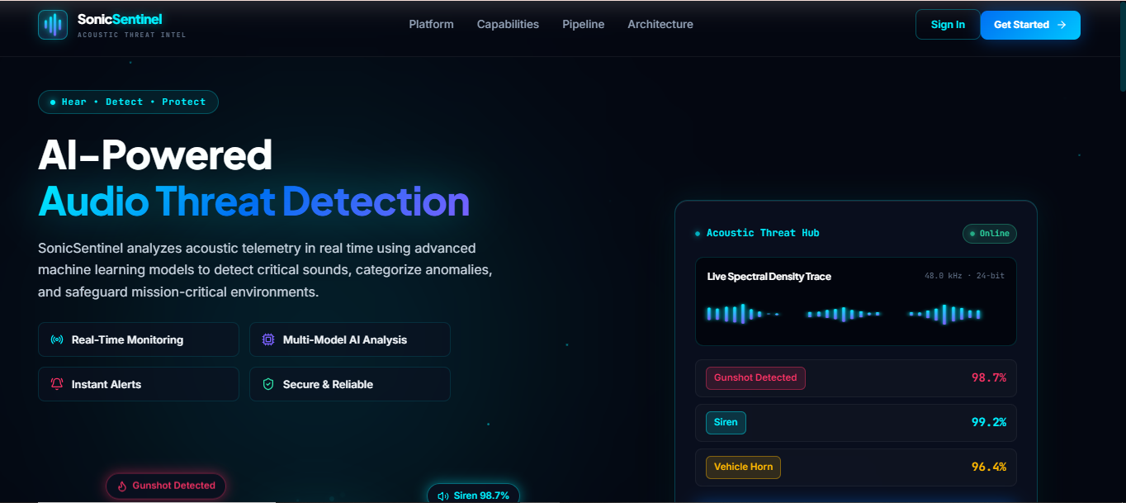
Figure 1: SonicSentinel landing page
The public landing page. Use "Sign In" (top right) if you already have an account, or "Get Started" to create one.

2.2 Your Workspace
Once signed in, you land on your "Sentinel Operations" workspace — your personal dashboard. Your name and email appear at the bottom of the left-hand sidebar so you can confirm you are signed into the right account.

3. Dashboard Overview
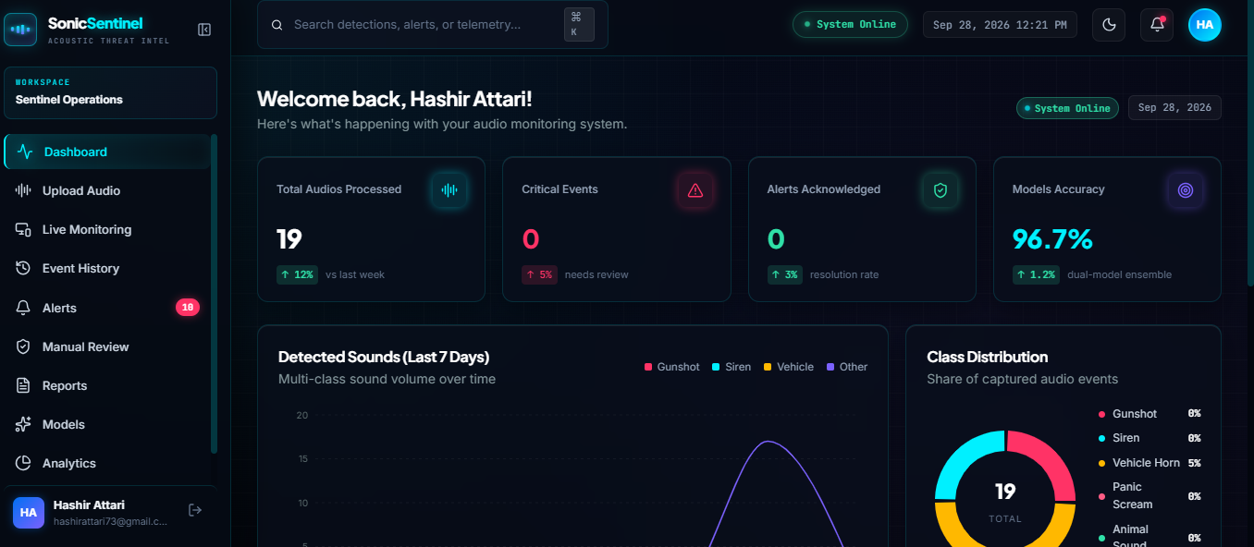
Figure 2: The main Operator dashboard
Your dashboard greets you by name and shows four key numbers at a glance: Total Audios Processed, Critical Events, Alerts Acknowledged, and Models Accuracy. Below that, a 7-day Detected Sounds chart and a Class Distribution donut chart summarise what has been picked up recently.

3.1 Reading the Summary Cards
Table 1: Dashboard summary cards explained
Card | What it tells you
Total Audios Processed | How many audio clips you have submitted (uploaded or live) in total, with the trend vs. last week.
Critical Events | How many detections were classified as critical severity (e.g. Gunshot, Panic Scream).
Alerts Acknowledged | How many of your alerts you have already reviewed and marked as handled.
Models Accuracy | The current accuracy of the dual-model ensemble powering your predictions.

3.2 Sidebar Navigation
- Dashboard — your home overview.
- Upload Audio — submit a pre-recorded file for classification.
- Live Monitoring — stream your microphone for real-time detection.
- Event History — a full log of everything detected on your account.
- Alerts — acoustic events that need your attention.
- Manual Review — double-check low-confidence or disputed detections.
- Reports — analytics over your own detection history.
- Models — see which AI engines are powering your predictions.
- Analytics — deeper trends and breakdowns.
- Settings — manage your account.

4. Uploading Audio for Classification
- Click "Upload Audio" in the sidebar.
- Choose a WAV, MP3, FLAC, OGG, or M4A file from your device.
- Wait while SonicSentinel validates, preprocesses, and classifies the clip.
- Review the predicted class and confidence percentage shown on screen.
- If the result looks wrong, send it to Manual Review (Section 8).
NOTE: If your file is rejected, double-check the format and file size — only WAV, MP3, FLAC, OGG, and M4A files are currently supported.

5. Live Microphone Monitoring
Live Monitoring lets SonicSentinel listen through your device's microphone and classify sound as it happens.
- Click "Live Monitoring" in the sidebar.
- Grant microphone permission when your browser asks — SonicSentinel only listens during an active, explicit session.
- Watch the live waveform and RMS level meter to confirm audio is being captured.
- Detected classes and confidence scores will appear as they are recognised.
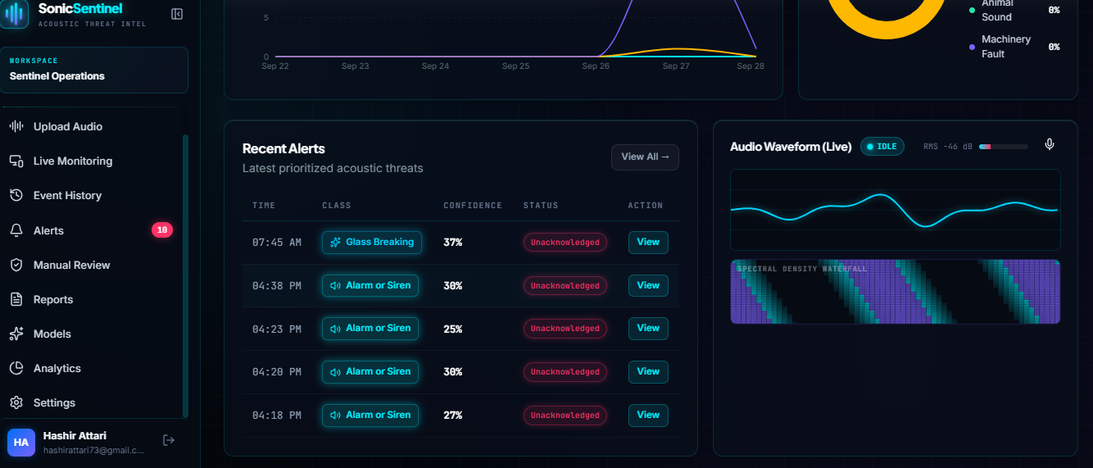
Figure 3: Live waveform panel and Recent Alerts
The Audio Waveform (Live) panel on the right shows the microphone status (Idle / Recording) with an RMS level meter. The Recent Alerts table on the left lists your most recent detections with time, class, confidence, and status.

6. Understanding the 10 Sound Classes
Every detection is classified into one of the following ten categories:
Table 2: The ten SonicSentinel sound classes
Class | What it means
Gunshot | Firearm discharge — treat as highest priority.
Panic Scream | A person screaming in distress.
Person Asking for Help | Someone verbally calling for assistance.
Aggression | Raised or hostile voices.
Glass Breaking | Glass shattering — possible break-in or accident.
Alarm or Siren | Fire alarm, emergency alarm, or vehicle siren.
Vehicle Horn | A car, truck, or motorbike horn.
Machinery Fault | An abnormal industrial or mechanical sound.
Animal Sound | Any non-human animal vocalisation.
Background Noise | Normal ambient sound — no threat detected.

7. Viewing Alerts & Event History
Every detection is logged automatically. Use Event History for a full chronological log, and Alerts for events that specifically need your attention.

7.1 Recent Alerts Table
Table 3: Columns shown in the Recent Alerts table
Column | Meaning
Time | When the sound was detected.
Class | The predicted sound category.
Confidence | How confident the model is in this prediction (%).
Status | Acknowledged / Unacknowledged.
Action | Click "View" to see full detection details.

7.2 Acknowledging an Alert
- Open Alerts from the sidebar.
- Click "View" next to the alert you want to review.
- Confirm the detection, or forward it to Manual Review if you are unsure.
- Mark it as Acknowledged once handled — this updates your Alerts Acknowledged count on the dashboard.

8. Manual Review
Manual Review is where a human makes the final call on detections the model was not fully confident about, or that you want a second opinion on. Use it whenever a prediction's confidence looks low or the class seems implausible for the context.

9. Reports
The Reports section summarises your detection activity over time — useful for shift handovers or periodic reviews. It mirrors the kind of platform-wide reporting shown to Administrators (Figure below), scoped to your own account.
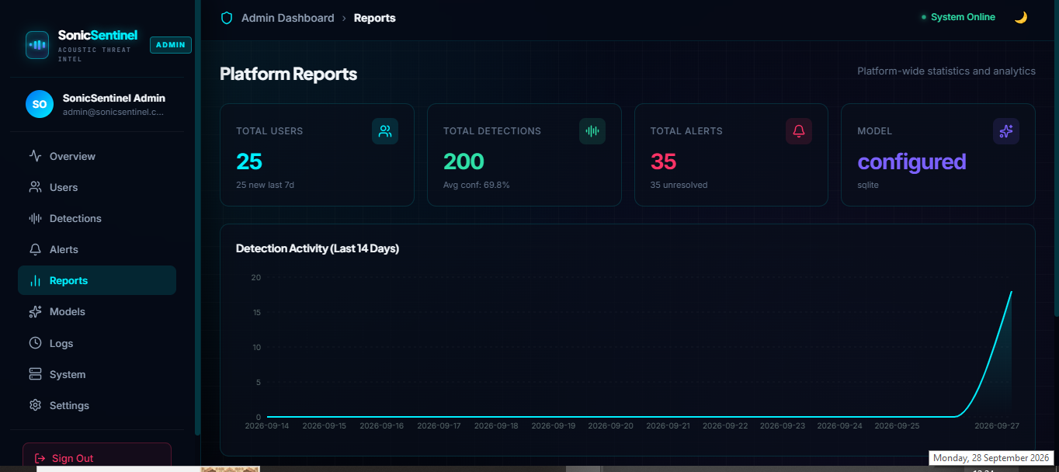
Figure 4: Example of a Reports-style analytics screen
Reports show total activity, average confidence, unresolved alerts, and a detection-activity trend line over the selected period. Your own Reports screen shows the same style of analytics scoped to your account.

10. Settings & Account
- Open Settings from the sidebar to manage your account details.
- Confirm your signed-in identity at any time via the name/email shown at the bottom of the sidebar.

11. Troubleshooting / FAQ

My audio file won't upload.
Confirm it is a WAV, MP3, FLAC, OGG, or M4A file and is not corrupted or empty.

Live Monitoring shows "Idle" and nothing happens.
Check that you granted microphone permission in your browser, and that the correct microphone is selected in your system audio settings.

A detection looks wrong.
Send it to Manual Review (Section 8) so it can be double-checked by a person rather than acted on automatically.

I can't see the Admin Dashboard.
Admin features are only available to Admin-role accounts. Contact your platform administrator if you believe you need access.

