An

Industrial Training Report on

**Web Development**

### At

***StampMyVisa* , Bangalore**

*Submitted in partial fulfillment of the requirements for*

*the award of the degree of*

**Bachelor of Technology**

in

**Computer Engineering**



**(Session 2022-23)**

**Submitted to:**

**Ms. SONAM GOUR**

Assistant Professor

(Coordinators- Industrial Training)

**Submitted by:**

**Shaurya Tomer**

PCE21CS157

Class: 3CS-C

# **DEPARTMENT OF COMPUTER ENGINEERING**

**POORNIMA COLLEGE OF ENGINEERING, JAIPUR**

**RAJASTHAN TECHNICAL UNIVERSITY, KOTA**

**SEPTEMBER, 2022**

**DECLARATION**

I hereby declare that the work which is being presented in the **Industrial Training** report titled Web Development in partial fulfillment for the award of the Degree of **Bachelor of Technology** in **Computer Engineering** and submitted to the Department of **Computer Engineering**, **Poornima College of Engineering, Jaipur**, is an authentic record of my own work carried out at *StampMyVisa*, Bangalore during the session 2022-23.

I have not submitted the matter presented in this report anywhere for the award of any other Degree.

Signature of the Student :

Name: Shaurya Tomer

Reg. No.: PCE21CS157

Place: Jaipur

Date: 08/09/2022

**Training Certificate from Company**

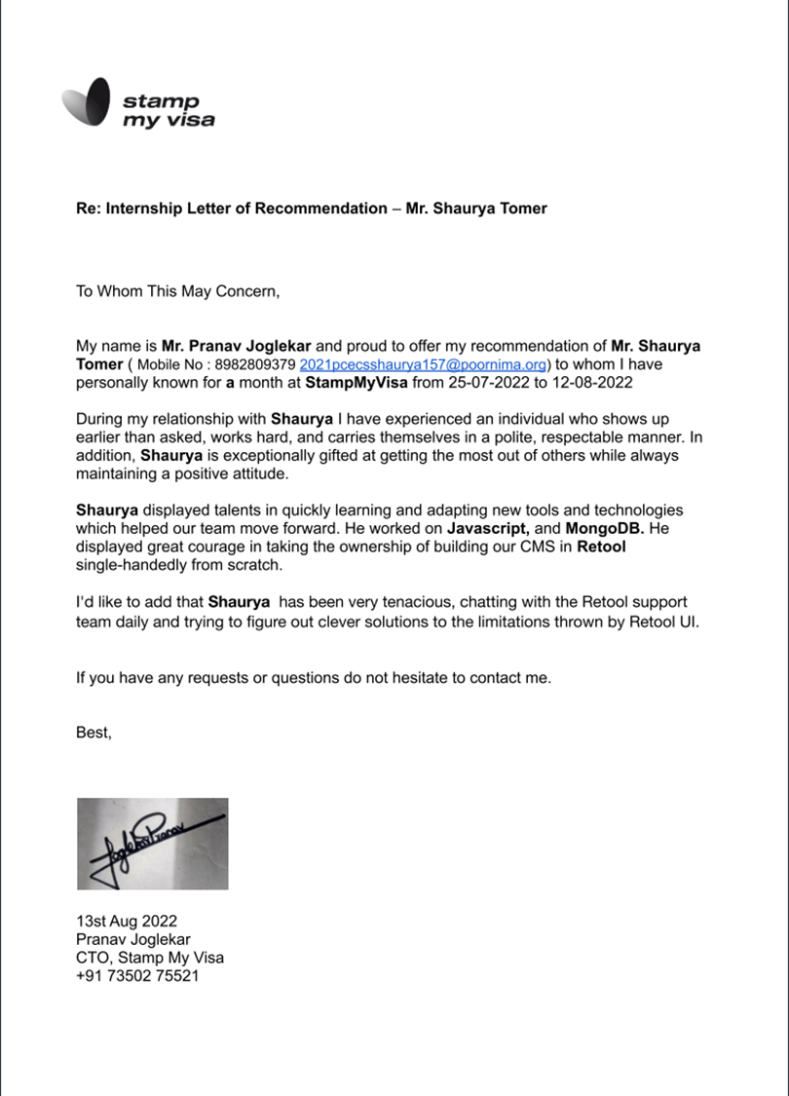

**DEPARTMENT OF COMPUTER ENGINEERING**

**Date: 08/09/2022**

**CERTIFICATE**

This is to certify that Industrial Training report **Web Development** has been submitted by **Shaurya Tomer**, **PCE21CS157** in partial fulfillment for the award of the Degree of Bachelor of Technology in Computer Engineering during the session 2022-23. The industrial training work is found satisfactory and approved for submission.

**Ms. Sonam Gour Dr. Surendra Kumar Yadav**

Assistant Professor Professor & Head

Coordinators- Industrial Training Department of Computer Engineering

# **ACKNOWLEDGEMENT**

I would like to convey my profound sense of reverence and admiration to my supervisor **Mr.Rahul Borude** , **Founding CEO of *StampMyVisa* f**or his intense concern, attention, priceless direction, guidance and encouragement throughout this internship.

I extend my heartiest gratitude to **Ms. Sonam Gour**, Coordinator-Industrial Training, who extended their cooperation to steer the topic towards its successful completion.

My special heartfelt gratitude goes to **Dr. Surendra Kumar Yadav,** Head, Department of Computer Engineering, Poornima College of Engineering, for unvarying support, guidance and motivation during the course of this research.

I am grateful to **Dr. Mahesh Bundele**, Director, Poornima College of Engineering for his helping attitude with a keen interest in completing this training work in time.

I would like to express my deep sense of gratitude towards management of Poornima College of Engineering including **Dr. S. M. Seth**, Chairman Emeritus, Poornima Group and former Director NIH, Roorkee, **Shri Shashikant Singhi**, Chairman, Poornima Group, **Mr. M. K. M. Shah**, Director Admin & Finance, Poornima Group and **Ar. Rahul Singhi**, Director Poornima Group for establishment of institute and providing facilities for my studies.

I am deeply thankful to my parents and all other family members for their blessings and inspiration. At last, but not least I would like to give special thanks to God who enabled me to complete my training work on time.

**Shaurya Tomer**

**PCE21CS157**

Note: You can change the language of acknowledgement as per your requirements

**TABLE OF CONTENTS**

| **PARTICULARS** | **PAGE NO.** |
| --- | --- |
| Title Page | i |
| Candidate’s Declaration | ii |
| Certificate by the Department | iii |
| Acknowledgment | iv |
| Table of Contents | v-vi |
| List of Tables | vii |
| List of Figures | vii |
| Abstract | 1 |
| **Chapter 1: Introduction**  1.1 About company  1.2 Training Platform  1.3 Training Starting Date  1.4 Training Ending Date  1.5 Total Training Duration  1.6 Date of Certification  1.7 Training Pictures/Images  1.8 Conclusion | 2-3  2  2  2  2  2  2  3  3 |
| **Chapter 2: Technical Training Platform**  2.1 Introduction  2.2 Reason for selecting this platform  2.3 Profile of university/organization providing the course and technical profile of instructor  2.4 Conclusion | 4-5  4  4  4  5 |
| Chapter 3: Overview of Technology Learn  3.1 HyperText Markup Language  3.2 Cascading Style Sheets  3.3 JavaScript  3.4 NodeJS  3.5 Jira  3.6 Retool | 6-10  6  6  7  8  9  10 |
| **Chapter 4: Project Description**  4.1 Basic Webpage using HTML and CSS  4.2 Simon Game using JavaScript | 11-12  11  12 |
|  |  |
| **Conclusion** |  |
| **References ~** |  |

**LIST OF FIGURES**

| **Figure No.** | **Figure Discerption** | **Page No.** |
| --- | --- | --- |
| 1.1 | Senior at StampMyVisa | 3 |
| 3.4.1 | Functional |  |
| 3.5.1 | Example Jira Workflow |  |
| 3.6.1 | Example Project in Retool |  |

**ABSTRACT**

**Web development** is the work involved in developing a [website](https://en.wikipedia.org/wiki/Web_site) for the [Internet](https://en.wikipedia.org/wiki/Internet) ([World Wide Web](https://en.wikipedia.org/wiki/World_Wide_Web)) or an [intranet](https://en.wikipedia.org/wiki/Intranet) (a private network). Web development can range from developing a simple single [static page](https://en.wikipedia.org/wiki/Static_Web_page) of [plain text](https://en.wikipedia.org/wiki/Plain_text) to complex [web applications](https://en.wikipedia.org/wiki/Web_application), [electronic businesses](https://en.wikipedia.org/wiki/Electronic_business), and [social network services](https://en.wikipedia.org/wiki/Social_network_service). A more comprehensive list of tasks to which Web development commonly refers, may include [Web engineering](https://en.wikipedia.org/wiki/Web_engineering), [Web design](https://en.wikipedia.org/wiki/Web_design), [Web content development](https://en.wikipedia.org/wiki/Web_content_development), client liaison, [client-side](https://en.wikipedia.org/wiki/Client-side_scripting)/[server-side scripting](https://en.wikipedia.org/wiki/Server-side_scripting), [Web server](https://en.wikipedia.org/wiki/Web_server) and [network security](https://en.wikipedia.org/wiki/Network_security) configuration, and [e-commerce](https://en.wikipedia.org/wiki/E-commerce) development.

Technologies used in Web development HTML, CSS, Javascript are mainly used to develop the frontend along with various JS frameworks like Vue, React, Angular and many more, out of these you can choose any framework to work on

the frontend of your website.

Moving on to the backend of the website, which is responsible for storing user data, session cookies, caching and many more. In the backend we use a database like MongoDB or GraphQL to store user data. API’s are used to connect website to database and to call data back from database to website.

**CHAPTER 1**

**INTRODUCTION**

**1.1 About Company:**

***StampMyVisa*** is a Bangalore based Startup with focus on providing users with Visa for international travel. Center of focus being reducing the barrier to International travel for Indian Citizens for now. *StampMyVisa* has a small but a great team of developers with whom I worked during the internship period and learned a lot under their guidance.

**1.2 Training Platform:**

*StampMyVisa* Office, Bangalore

**1.3 Training Starting Date:**

25-07-2022

**1.4 Training Ending Date:**

12-08-2022

**1.5 Total Training Duration:**

3 Weeks and 160 Hours

**1.6 Date of Certification:**

13-08-2022

**1.7 Training Pictures/Images:**

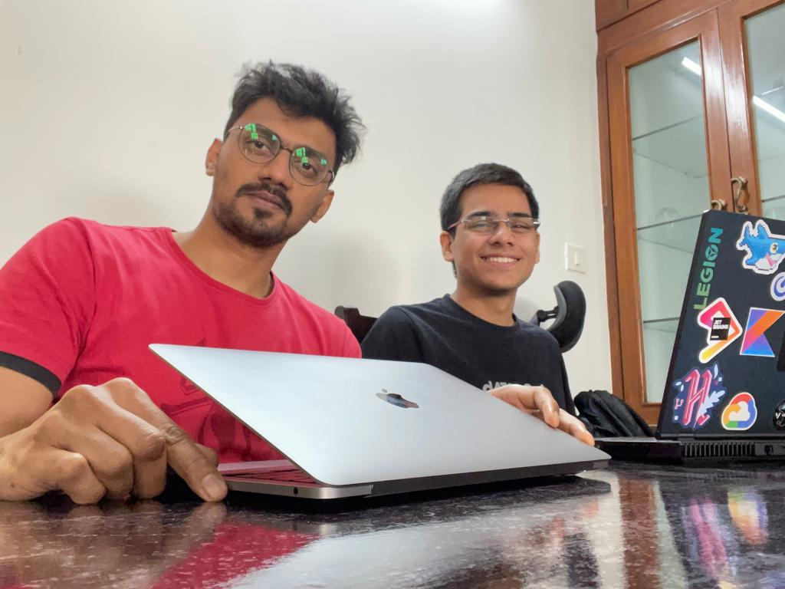

Fig 1.1

**1.8 Conclusion:**

Given, students can pass the criteria to enter companies to get real world experience, it is a really great opportunity. It was really great working with the StampMyVisateam. Got to learn a lot along with great career guidance.

**CHAPTER 2**

**TECHNICAL TRAINING PLATFORM**

**2.1 Introduction :**

***StampMyVisa*** , a Bangalore based startup started by Founding CEO Mr.Rahul Borude and CTO Mr. Pranav Joglekar. *StampMyVisa* aims to provide their users the ease to apply for and get Visa from the comfort of their homes without the hassle of multiple visa formalities.

**2.2 Reason for selecting this platform :**

StampMyVisa as mentioned before is a startup lead by some great people and has an excellent team of developers. Being a startup with a lot of work and tasks to be finished, it provides a lot of opportunities to learn whichever field you want to study in and then exploring that field under the guidance of people who already have the much required knowledge and experience to guide new people to the field like me.

**2.3.1 Profile of Organization**

**Linkedin :** [**https://www.linkedin.com/company/stampmyvisa/?originalSubdomain=in**](https://www.linkedin.com/company/stampmyvisa/?originalSubdomain=in)

**Website :**

[**https://www.stampmyvisa.com/**](https://www.stampmyvisa.com/)

**2.3.2 Profile of Instructor :**

**Mr. Rahul Borude**

**Linkedin :** [**https://www.linkedin.com/in/rahulborude/**](https://www.linkedin.com/in/rahulborude/)

**Mr. Pranav Joglekar**

**Linkedin :** [**https://www.linkedin.com/in/pranav-joglekar/**](https://www.linkedin.com/in/pranav-joglekar/)

**2.4 Conclusion :**

It was a gratifying experience to work at StampMyVisa with a lot of great people who guided me throughout my internship. I started as a Quality Analyst at StampMyVisa and built StampMyVisa CMS build using Retool. By the end of my internship I got to know that I want to explore the field of Backend engineering and it is great to know what you want to do in the coming future and have set life goals for yourself.

**CHAPTER 3**

**Overview of Technology Learnt**

**List of Technology Learnt**

**3.1 HyperText Markup Language**

**3.2 Cascading Style Sheets**

**3.3 JavaScript**

**3.4 NodeJs**

**3.5 Jira**

**3.6 Retool**

**3.1 HyperText Markup Language**

HTML is the Standard Markup Language. It is used for developing Web Pages. HTML is HyperText Markup Language and is used for describing the structure of web pages. Various Tags are used in HTML like & quot, heading & quot, , & quot, paragraph & quot, , & quot, table & quot, , and so on.

A code sample of HTML

<!DOCTYPE html>

<**html**>

<**head**>

<**title**>This is My First Website </**title**>

</**head**>

<**body**>

<**p**>Welcome to HTML5, CSS3 and JavaScript!</**p**>

</**body**>

</**html**>

**3.2 Cascading Style Sheets**

Cascading Style Sheets, fondly referred to as CSS, is a simple design language intended to simplify the process of making web pages presentable.

CSS handles the look and feel part of a web page. Using CSS, you can control the color of the text, the style of fonts, the spacing between paragraphs, how columns are sized and laid out, what background images or colors are used, layout designs,variations in display for different devices and screen sizes as well as a variety of other effects.

CSS is easy to learn and understand but it provides powerful control over the presentation of an HTML document. Most commonly, CSS is combined with the markup languages HTML or XHTML.

**3.3 JavaScript**

JavaScript is a scripting or programming language that allows you to implement complex features on web pages — every time a web page does more than just sit there and display static information for you to look at — displaying timely content updates, interactive maps, animated 2D/3D graphics, scrolling video jukeboxes, etc. — you can bet that JavaScript is probably involved. It is the third layer of the layer cake of standard web technologies, two of which ([HTML](https://developer.mozilla.org/en-US/docs/Learn/HTML) and [CSS](https://developer.mozilla.org/en-US/docs/Learn/CSS)).

3.3.1 JavaScript Document Object Model

The DOM (Document Object Model) API allows you to manipulate HTML and CSS, creating, removing and changing HTML, dynamically applying new styles to your page, etc. Every time you see a popup window appear on a page, or some new content displayed for example, when you click a button a popup window appears that's the DOM in action. For the popup we create a button using HTML and then assign an Id or class to that button. After that, using [document.getElementById(id)] in JS, we connected that button to Javascript.

**3.4 Node JS**

Node.js is a server-side platform built on Google Chrome's JavaScript Engine (V8 Engine). Node.js was developed by Ryan Dahl in 2009 and its latest version is v0.10.36.

Node.js is an open source, cross-platform runtime environment for developing server-side and networking applications. Node.js applications are written in JavaScript, and can be run within the Node.js runtime on OS X, Microsoft Windows, and Linux.

Node.js also provides a rich library of various JavaScript modules which simplifies the development of web applications using Node.js to a great extent.

Node.js = Runtime Environment + JavaScript Library

Sample code for Nodejs.

const http = require('http');

const hostname = '127.0.0.1';

const port = 8080;

const server = http.createServer((req, res) => {

res.statusCode = 200;

res.setHeader('Content-Type', 'text/plain');

res.end('Hello World');

});

server.listen(port, hostname, () => {

console.log(`Server running at http://${hostname}:${port}/`);

});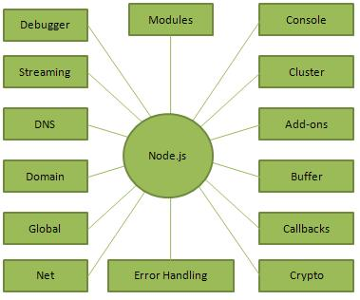

fig 3.4.1

**3.5 Jira**

Jira Software is part of a family of products designed to help teams of all types manage work. Originally, Jira was designed as a bug and issue tracker. But today, Jira has evolved into a powerful work management tool for all kinds of use cases, from requirements and test case management to agile software development.

**Jira for Agile Teams :**

For teams who practice agile methodologies, Jira Software provides [scrum](https://www.atlassian.com/software/jira/features/scrum-boards) and [kanban boards](https://www.atlassian.com/agile/kanban/boards) out-of-the-box. Boards are task management hubs, where tasks are mapped to customizable workflows. Boards provide transparency across teamwork and visibility into the status of every work item. Time tracking capabilities and real-time performance reports (burn-up/down charts, sprint reports, velocity charts) enable teams to closely monitor their productivity over time.

Example of a workflow in Jira fig 3.5.1 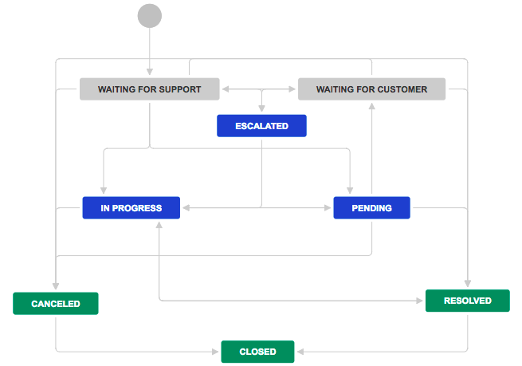

**3.6 Retool**

**Retool enables you to quickly build and deploy internal apps for your team. Connect to your databases and APIs, assemble UIs with drag-and-drop building blocks like tables and forms, and write queries to interact with data using SQL and JavaScript.**

**Retool allows you to create a CMS (Customer Management System) where you only have to worry about writing API’s and managing your backend. Complete frontend of your CMS can be created using Retool drag and drop options. In retool you mainly use JavaScript methods to manipulate data that you take from your database using API calls to the Database mostly a Non-relational database.**

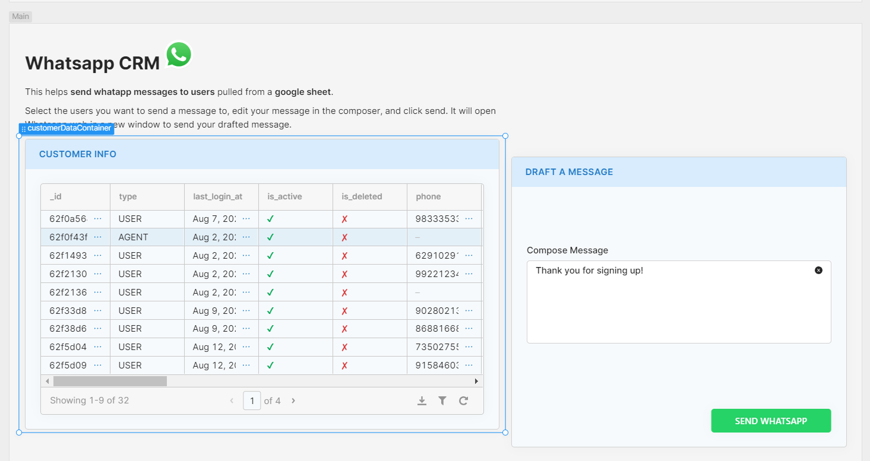**Below is an example of Whatsapp CMS created using retool**

**fig 3.6.1**

**Here, I’m taking example data from Google sheets for all the users and when you click the Send Whatsapp button, Whatsapp Web will open with a message Thank you for signing up! for whichever user you clicked on.**

**CHAPTER 4**

**PROJECT DESCRIPTION**

List of Projects

4.1 Basic Webpage using HTML and CSS

4.2 Simon Game using JavaScript

**4.1 Basic Webpage using HTML and CSS**

§HTML was used to make the basic structure of the website, adding in images and the text content for the website

§CSS was used for styling, to give the website a good look, making borders of pictures round, aligning them and such.

§Link to webpage:

<https://shauryatomer.github.io/beginner_project.github.io/>

On this webpage if you click on Contact Me you’ll be directed to email me directly this was made using Simple Transfer Mail Protocol.

In Future this website can be extended to be used like a Wiki or a source of information for whatever hobby you have or whatever you like.

**4.2 Simon Game using JavaScript**

§HTML Simon game is a game played by children, where you are given a sequence of buttons to press out of the 4 buttons, and every time a new button is added for you to press.

§This game is JavaScript heavy, HTML and CSS are used just to create the playground.

§Then Js is used to made the playground dynamic

§First, using JavaScript Document Object Model, to add buttons added using HTML to JS code

§Then adding event listeners to button DOM, to let us know when one the four buttons have been pressed by the user.

§Then rest is logic and structuring the game by creating several functions and assigning when to run which function.

§Link to Simon Game :

<https://shauryatomer.github.io/simon_game.github.io/>

**REFERENCES**

1. <https://en.wikipedia.org/wiki/Web_development>
2. <https://developer.mozilla.org/en-US/>
3. <https://retool.com/in>
4. <https://github.com/>
5. <https://www.atlassian.com/>