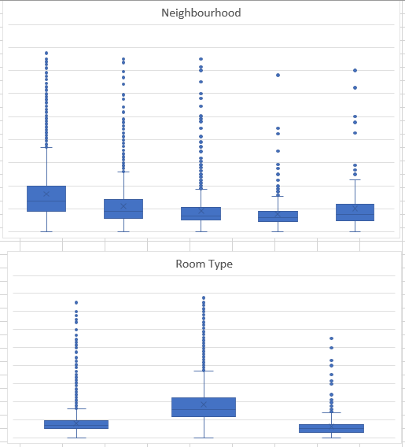

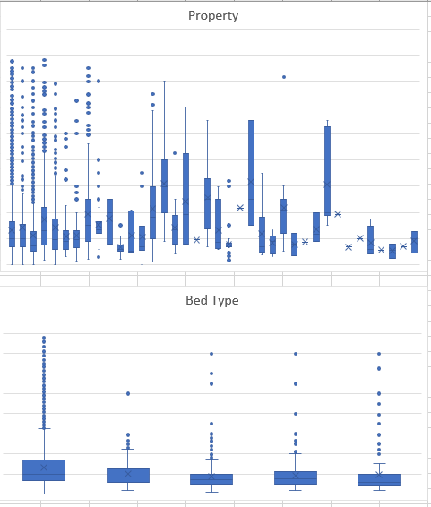

Iter 0: 8.079385181732617

Iter 1: 39.583609815187295

Iter 2: 12.901525966350404

Iter 3: 64.16183776681561

Iter 4: 38.19793258950207

Iter 5: 9.683722129326497

Iter 6: 18.0660127802924

Iter 7: 7.279068750711975

Iter 8: 10.78528225712732

Iter 9: 5.832754292940914

21.457113152998712