**Mohamed Attia**

Address: Al Sulaymaniyah, Al Riyadh, Saudi Arabia [Mohamed Attia | LinkedIn](https://www.linkedin.com/in/mohamedattiaabuelnil/) M: +966580060012

Email: [Mohammed.attia@live.co.uk](mailto:Mohammed.attia@live.co.uk)

# Objective

As a Multi-Cloud Chief Solutions Architect, I serve and excel as a trusted advisor and technical architect, delivering expert cloud solutions to STC clients. My role involves direct engagement and collaboration with our partners to address complex technology challenges by architecting the needed solutions that fit the customers’ needs. With a consultancy and advisory mindset, I excel in designing, architecting, and leading the execution of large-scale, complex customer multi-cloud solutions. I build and foster trusted relationships with clients, partners, and internally across cloud teams. My professional background includes comprehensive practical experience, supported by Expert Architect certifications across all five major hyperscalers (Azure, AWS, Google, Alibaba, and VMware). With over 15 years of experience in planning, designing, and architecting large-scale and complex IT enterprise services, I specialize in digital transformation and cloud migration solutions by applying the 7Rs strategies service. I am seeking a challenging role within an organization where I can contribute to an ambitious team, bringing my relentless curiosity and drive for innovation in IT cloud adoption and service management.

# Technical / Business Skills

* + Expertise in transforming customer organizations and digitizing business processes from any environment to cloud.
  + Designing and architecting solutions across multi-clouds (Azure, AWS, Google, and Alibaba) with a clear Roadmap and timeline with milestones.
  + Solid experience and hands-on of multiple solution domains, Business Management, Service Management, Operations Management and Application Development & modernization driven by TCO, ROI and TCV.
  + Experience presenting insights, solutions, metrics and roadmaps to technology leaders and customers.
  + Design and architecting, Dev-ops Pipeline, SCM, SDLC solutions, methodologies, and strategies.
  + Provide guidance and lead the Dev-ops practices with a team across CI/CD solutions and tools chain (Terraform, Git, GitHub, Gitlab, Azure Dev-ops, Jenkins, Ansible, Kubernetes, Containers, Prometheus)
  + Excellent understanding and leadership of applying IT operational models, including shared services, outsourcing, right sourcing and brokered services.

# Technical IT Certifications

* + Togaf v 9.2 Certified
  + **Dev-ops: -** CKA, CKS, CKAD, GitLab Service Engineer professional, GitHub associate, Azure dev-ops certified engineer, VMware Tanzu.
  + VMware Master Specialist- Tanzu “Cloud Native” / Application modernization
  + Microsoft Azure Architect Technologies Expert “Microsoft Certification ID: 7169027”
  + Microsoft Azure Architect Technologies Design AZ-304 “Microsoft Certification ID: 7169027”
  + Microsoft Certified Solutions Expert – Productivity “Microsoft Certification ID: 7169027”
  + Google Cloud Professional Architect- GCP.
  + AWS Solutions Architect Associate.
  + Alibaba Cloud Professional Architect – ACP.
  + Dell: Certified Systems Engineer: Cloud
  + ITIL V3 Certified “Certificate Number: GR656070637ME”
  + PRINCE2® Foundation “Certificate Number: GR656070637ME”

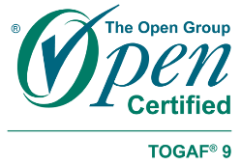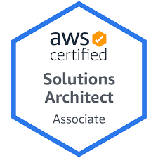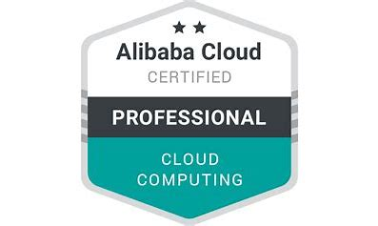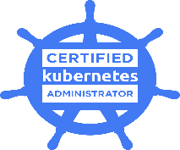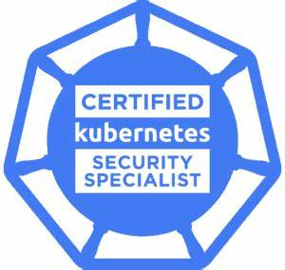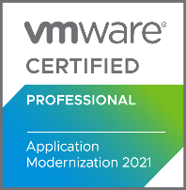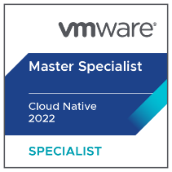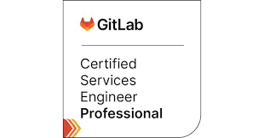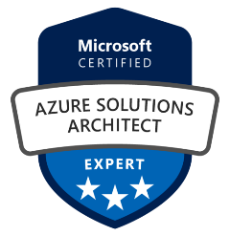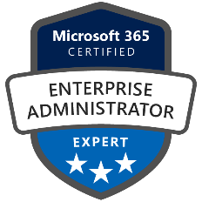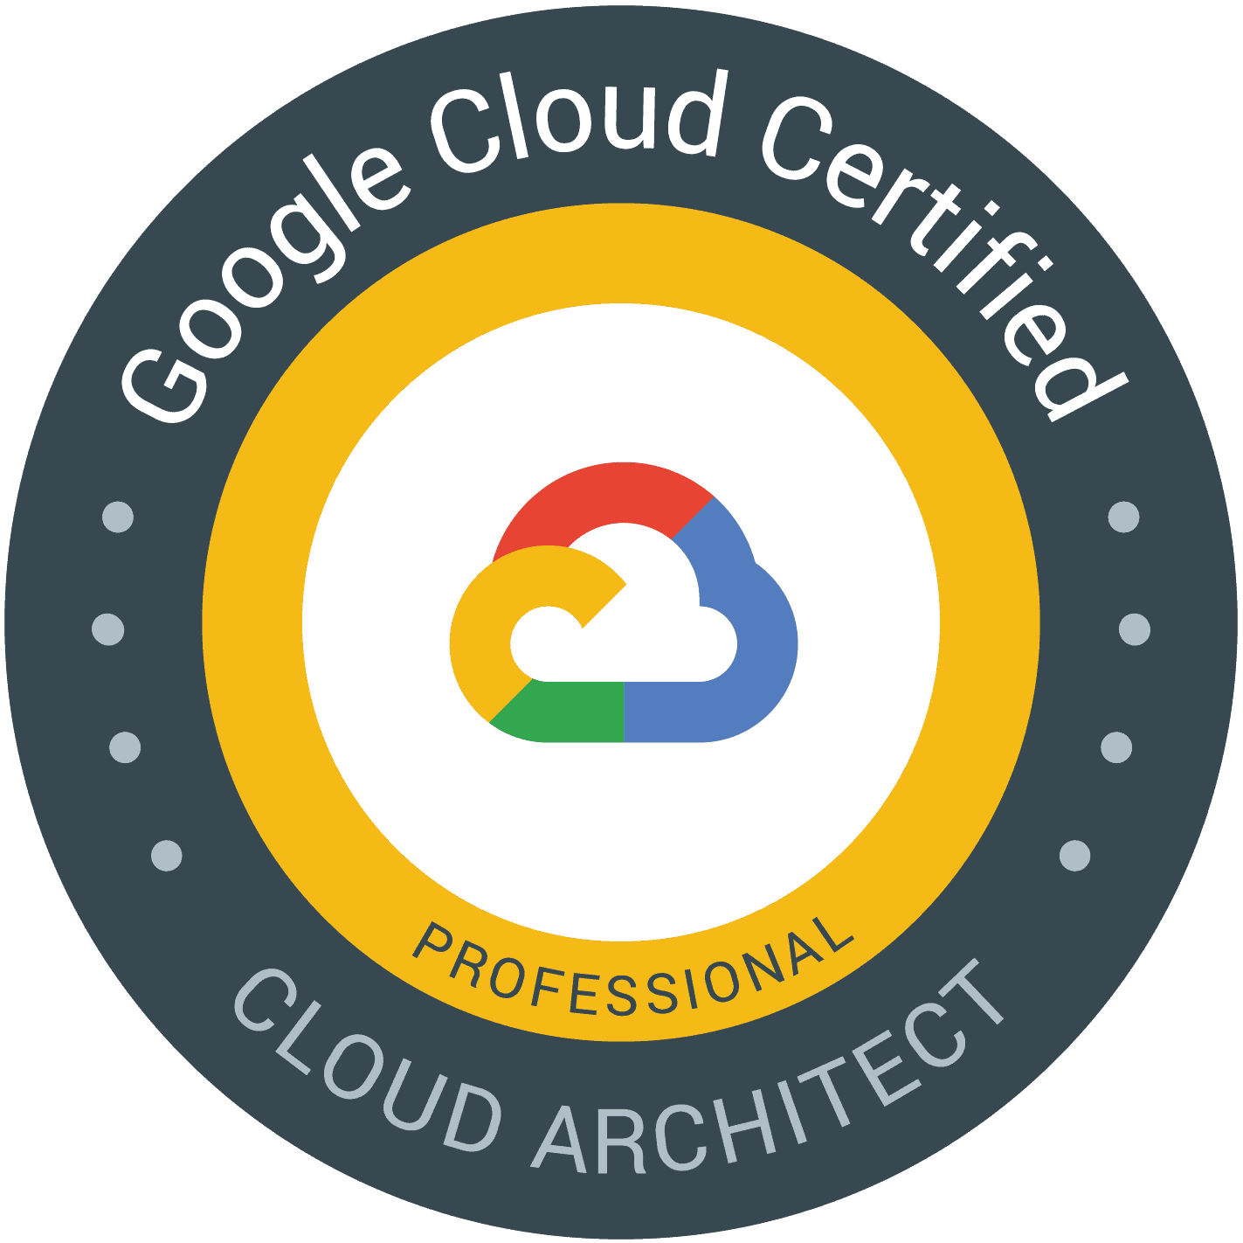

# Professional Experience

Position: Chief Multi-Cloud Solutions Architect

**From:** Jan 2022 until Present

As a Multi-Cloud Solutions Architect, with 4x Cloud Expert Certificates, I am responsible for the following.

* + Respond in a timely fashion manner to Account team / customers’ queries and requests that are relevant to cloud IaaS, PaaS, SaaS implementation / Migration & BCDR, and application modernization across the multi clouds that we manage. responses could be to direct invitations, RFP, RFQ and Tenders in a form of proposals, presentations, POCs, ROI documents and TCO.
  + leading complex projects’ execution that includes any hyperscale single vendor or Multi Clouds engagement that we manage at STC “Alibaba, Microsoft, AWS and Google” and make sure of customer satisfaction and solutions adoption.
  + Conducting & building the deep and complex technical POCs & Demos & Projects’ kick off meetings, whenever needed for our enterprise customers to prove the value of our solution using the ROI, TCO, and Value proposition driven discussions.
  + Develop deep relationships with key customer IT decision makers, who drive long-term cloud adoption within their company to enable them to be cloud advocates. Be the Voice of the Customer; Share insights and best practices and connect with Engineering teams to remove blockers.
  + Consumption (Cloud & Support) growth: Develop opportunities to drive Customer Success business results by working with technical decision makers to ensure they understand Microsoft's Azure Infrastructure services required to operate AI solutions at scale, inclusive of value proposition and how they get value from their investment in the Microsoft technology.
  + Architecture Design and Deployment: Run Architectural Design Sessions to build plan for implementing solution –governing design in line with customer business goals and their technical environment.  Use CAF Landing Zones to rapidly enable migrations, help build customer resiliency in priority areas including Networking, Zonal/multi-region, and Security and prepare our customers for AI Innovation.
  + Responsible to provide architectural designs and guidance to my team in the area of Local STC cloud “SDDC” & “VDC”, Alibaba, AWS, Azure, and GCP clouds, & along with Dev-ops / App modernization platforms and tools.
  + Define the multi-cloud solutions impact on customers’ ability to operate and transform their business and showing them the best ROI of their investment through the cloud economy best practices in a shape of Digital transformation strategy roadmap.
  + Laser focus on protentional customer opportunities that leads to closed deals, also develop and assist on pipeline generation and inflation (drive, assist and help creating opportunities through successful POCs, Demos, that can be closed as won deals).
  + Design, and deliver customer Strategy roadmaps to accelerate the adoption of cloud Services.
  + Provide thought leadership and collaborate with internal STC cloud, Managed Services, and Product management teams / business units.
  + Plan, lead and monitor to the creation of best practices, white papers, workshops, SOPs, and cloud solutions business cases.

## Expertise:

* + Complex cross Solutions consulting, Architecting and management abilities for (Microsoft, Alibaba, Google, and AWS clouds), driven by ROI, TCO and Building Customer Digital transformation strategy journey.
  + Sales Pipeline management, and laser focus for big deals closure.
  + Excellent cross-group collaboration skills and ability to work in a team environment or leading solely.
  + Support the field sales teams with POCs, use cases, case studies, industry-based use cases, battle cards and fact Sheets which are required to close the deals with big sale.

## Projects / Achievements / Awards

* + ***Managed to Win around 80,790,413 SAR through FY23, and 160 M SAR YTD,*** across MOH, SAMA, SME Bank, Ministry Of Sport, MENAHUB, D360 Bank, though cross Solutions selling within the technologies within (STC, Microsoft, and Alibaba clouds), driven by ROI, TCO and Building Customer Digital transformation strategy journey from early stage.
  + Led successful enterprise-wide practice of adoption of Microsoft Cloud technologies with our customers by implementing the Microsoft Adoption Framework, driving seamless transitions and empowering teams to maximize the value of cloud solutions.
  + Developed and sharpen the technical delivery and consultancy team skills, by offering coaching sessions, trainings, and providing guidance to the whole team, he did around 10 Team sessions last year



Position: Partner Technology Strategist / Cloud Solution Architect

**From:** Jan 2021 until Dec 2021

As a Partner Technology Strategist -Surface, I am responsible for building the sales and technical capacity and capability with our Surface partners through practice development, technical and sales enablement, also PTS is leading the POCs and Demos for customers alone or with the assist of partners. PTS also enable partners to provide architectural guidance in the space of M365 (deployment, management and security) and develop technical plans that promote the adoption of the Microsoft Surface within the devices product portfolio. PTS shares and builds technical expertise at partners to grow the share of Microsoft Surface device in the collaboration, AV, and productivity spaces. The PTS is a representative for the partner’s technical asks and concerns back to the engineering/product teams.

## Description:

* + Lead the partners’ technical enablement process and ensure complex POCs and demos run in a professional timely manner with the highest satisfaction rates.
  + Ensure Microsoft Surface devices along with M365 Modern Management practices receives technical acceptance with Surface partners.
  + Communicate the technical merits of Microsoft Surface and M365 solutions and related services to partners.
  + Proven record of delivering business value thru partners.
  + Excellent cross-group collaboration skills and ability to work in a team environment.
  + Enable Surface Resellers to design, develop and deliver device and service offerings to drive the value of Microsoft solutions in the market.
  + Drive the long-term technical strategy and engagement with Resellers as it relates to Microsoft Surface device solution when bundled with M365 deployment (Windows Autopilot), management (Microsoft Endpoint Manager) and security (Windows Update to include Defender ATP)
  + Support the field sales teams with partners who are enabled to provide technical sales support for sell-through activities.
  + Provide enablement and technical assistance/escalation for Microsoft Surface to Resellers and their partners.
  + Ensure partner technical issues and requirements are effectively communicated to product engineering teams.
  + Support technical acceptance of Microsoft Surface solutions to Resellers and their partners.
  + Engage with customers to understand business/technical requirements
  + Build the solution design including technical architecture, operating processes, economics, benefits and evolution. Translate business requirements throughout the architecture procedure and deliver technical solutions in accordance with architecture standards, and design specifications in Cloud
  + Support the sales team in presenting the solution design and benefits to the customer

## Projects / Achievements / Awards

* Top performing WW Subject Matter Expert – PTS for Surface cross solutions with Autopilot.
* Customer and Partner Experience hero Award for FY 21 across MEA,
* 2 Customer Success stories, one of them at Tahakom to enable them using Microsoft Endpoint Manager, specifically Intune Autopilot for Surface devices white gloves large scale deployment, and other success stories with partners for onboarding and managing 20 partners across MEA.
* Token of Appreciating from the Product engineering group for leading complex and large-scale deployments with Aramco and Tahakom “Intune Autopilot – White Gloves, Modern workplace enablement”

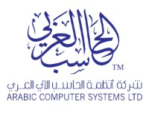

Position: Solution Architect Cloud & Infra

**From:** Jan 2017 until Jan 2021

## Description:

* Lead the team of 4 engineers\consultants.
* Lead customer-facing technical experts to represent company software solutions.
* Prepare for and participate in the Bid Review Committee and engage with Finance and Contracts to ensure profitability clearance and partner compliance of the solution presented
* Review, understand, analyze, and evaluate technology trends and new business models ideas
* Architecting, designing and lead implementations of any customer requirements that includes but not limited to Microsoft cloud services Private or Public, Azure IAAS, Office 365, EMS + Security, SCCM CB, OMS, IDAM, hardware platforms, and other essential security & third part solutions.
* Building, designing and managing a complex virtualized and automated datacenter, containing both Hyper-V & VMware servers.
* Deliver proactive onsite support and knowledge transfer to the customer for Microsoft SCCM, SCOM, SCVMM and Microsoft office 365, Microsoft EM+S and Skype For Business.
* Deliver technical workshops, presentations, and professional documentations (proposal, Quotes, Design documents, and Solution Architecture.
* Work with Business development team during project envisioning to properly scoping technical components and solution architecture.
* Demonstrate critical thinking, strong communication skills and ability to develop strategic on-going customer and partners relationships.
* hands-on experience in building DevOps infrastructures and applying its methodologies.
* Leads the workforce transformation strategies, building roadmaps, design and implementation.
* Proactively participates in client change management and IT planning activities, document and apply critical changes that affect the project scope.
* Conducts a comprehensive review of new Microsoft technology trends, best practices and methodology and tool updates, leveraging internal company knowledge base as well as external sources.
* Continual improvement of ACS internal (technical/Pre-Sales Documents) and either the documents templates that will be delivered to the client's program based on the findings;
* Help customer to realize the Total cost of ownership, ROI, and Provides high level cost and showcase solution benefits to close the deals.
* Create business architecture models demonstrating how products, operations and systems interoperate within Cloud solutions
* Conduct analysis to determine best path for solving business problems/opportunities that may include process improvement, systems enhancement, user training
* Apply and utilize appropriate methods to ensure results-oriented deliverables in a way that can be recreated and leveraged as intellectual capital
* Ensure solutions designed are aligned to enterprise architecture standards and principles, leverage common solutions and services, and meet financial targets (cost and benefits)
* Lead the effort to translate business strategies and objectives into capabilities

## Projects

* Over 30 Projects with different business sectors [Government, Education, Banking, Manufacturing, Oil and Gas].
* Migrate One Saudi Gov customer & Other one Local Gov Bank to Microsoft Office 365 & EM+S
* Managed to get two major government customers up after the Shamon attack demolish the whole two datacenters within 48 hours.



Position: Microsoft FastTrack SME /Migration Engineer/ Consultant

**From:** Jun 2015 until December 2016

## Description:

* Execute, manage, and lead a set of Office 365 customers and partners through the Onboarding technical process, and adoption of Office 365 and EMS suites.
* Lead, Develop, foster, and maintain highly effective customer and partner relationships.
* Assist Office 365 customers and partners with configuration of onboarding tools and processes technology.
* Interact daily with other Onboarding Engineers to provide technical action plans or take ownership of cases that require escalation.
* Develop foster and maintain effective working relationships with engineering, marketing, Enterprise Services\Support and field sales and partner teams to deliver key business metrics.
* Manage customer and partner Onboarding programs within expected timeframes while continually driving increased effectiveness and thus reducing costs.

## Projects / Achievements / Awards

* Over 50 hyper Scale Migration to office 365 Projects within different business sectors [ Commercial, education, Banking and Manufacturing in addition to governments] with top satisfaction closure ratio 99%.
* Few Lists of customers “United Nations, Uber, Manchester Airport Group, Alshaya Group, Savola, Panda, NADEC and University of Botswana”
* Top performing EMEA Subject Matter Expert – Migration to Exchange online from Gmail, lotus domino and Zimbra mail systems.
* Customer and Partner Experience hero Award for FY 16 in EMEA, we helped Al-soraiya group to consume the office 365 from 0 percent up to 100% in one month and resolved a CPE big risk between the customer and Partner.
* 8 Success stories, one of them at the early beginning of the Onboarding center with Government of Zanzibar and other success stories to mention Manchester Airport Group, Careem, Savola Group, and Oilibya Group.
* Unified Communication workload champ across EMEA region, main responsibility to design new engineers study roadmap, and helping other team members to conduct the Microsoft engagements and implement Microsoft unified solution on a professional way.

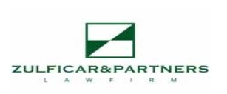Position: Senior Datacenter Administrator

**From:** Feb 2015 until May 2015.

## Description:

* + Administrating, analyzing, upgrading, managing, and monitoring full automated Datacenter with Microsoft System Center Management family, Z&P systems infrastructure, servers, software performance, desktop systems, Datacenter Operations, and communications devices related to IT operations located in both HQ and DR site.
  + Responsible for securing Z&P environment using Cisco ASA, Fortigate and Fortimail 200 D appliances.
  + Architecting, managing scalable Microsoft SCCM CB deployment on Z&P also performing critical updates and performance tuning on Infrastructure Services using SCCM Current Branch.
  + Develop, implement, test and review an organization's information security & IT Policies in order to protect information and prevent unauthorized access.

## Projects:

* + - Z&P Network infrastructure renovation “Cisco Nexus n5k”.
    - Develop and activate Z&P Information Security policy.
    - Exchange Server Migration Project to new blades servers.
    - Office 365 implementation Project.



Position: Systems Administrator

**From:** March 2013 until Feb-2015

* + - Migrating the legacy Louts Domino mail system to Modern Microsoft Exchange 2016
    - Demoting Blackberry servers, and Implement new Active sync servers to serve the whole group users.
    - Implementing and configuring whole Microsoft System Center management family.
    - 3X Data Center allocation projects.

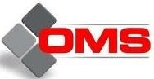

**From:** December 2011–March 2013

**Position:** Infrastructure Systems Administrator



**Position:** Systems Administrator

**From:** December 2010 – November 2011



**Position:** Junior System Administrator

**From:** Jan 2008 November 2010:

# Education & Accreditations

Bachelor of Commerce - Graduation year: 2007

# Languages:

* + Arabic: mother tongue
  + English: Excellent

# Personal Information:

Nationality: Egyptian

Date of birth: 24 December 1985 Marital status: Married

Military status: Exempted