Assignment 3 Report:

Lyrics Generation Using Recurrent Neural Network

**Dataset Analysis:**

Train set:

Number of songs: 600

Number of sentences: 24086

Number of words: 181577

Test set:

Number of songs: 5

Number of sentences: 189

Number of words: 1353

Vocabulary size: 7563

**Pre – Processing:**

Lyrics (Text) Processing

Our pre-process phase includes the following steps:

1. Tokenize Lyrics with regex: r'\w+|&+.
2. lower case all the text.
3. replace & with ‘eos’ and add ‘eol’ token at the end of each song.
4. remove all tokens that are not words (special char and digits).

Then for each of the clean tokenized lyrics we generated sequences of length **4** for our model to train and test on it. We tried different length of sequences from 3 – 10 and it gave as the best performance (accuracy and processing time).

**Model Architecture:**

We used two different architectures. Each one is handling the integration of the melodies with the lyrics differently, one is pretty simple and the other is more complex.

**Parameters:**

train_parameters = {

    "verbose": 1,

    "epochs": 4,

    "batch_size":512,

    "loss": 'categorical_crossentropy',

    "optimizer": Adam(lr=1e-3),

    "metrics": ['accuracy'],

    "callback": [tensorboard_callback]

}

model parameters:

    drop_prob = 0.2

    voc_size = len(voc_index) + 1

    LSTM_UNIT_SIZE = 100

    DENSE_SIZE = 1024

    ENCODE_MIDI_DIM = 10

    dense_act = 'relu'

**Simple Approach Description:**

Melody (midi) processing:

For our simple approach we used summarized data from the midi files and extracted a total of 141 features per midi file. We used the following data:

1. summary (Normalized) of semitones (12 features).
2. Summary (Normalized) of piano roll (128 features).
3. normalized bpm (1 feature).

Model Architecture:

We used RNN (LSTM) only on the lyrics and to the output we concatenated the melody features after a dropout layer to help the model to learn the connection but not to rely on it to much.

**Simple Model Summary:**

**Simple Model Plot:**

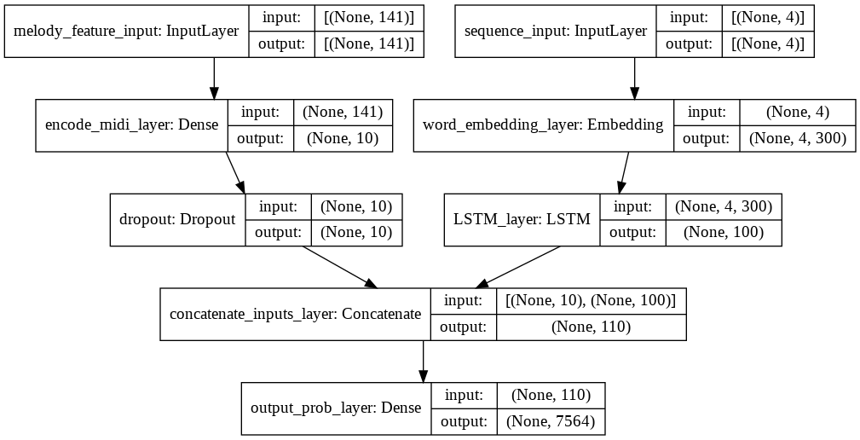

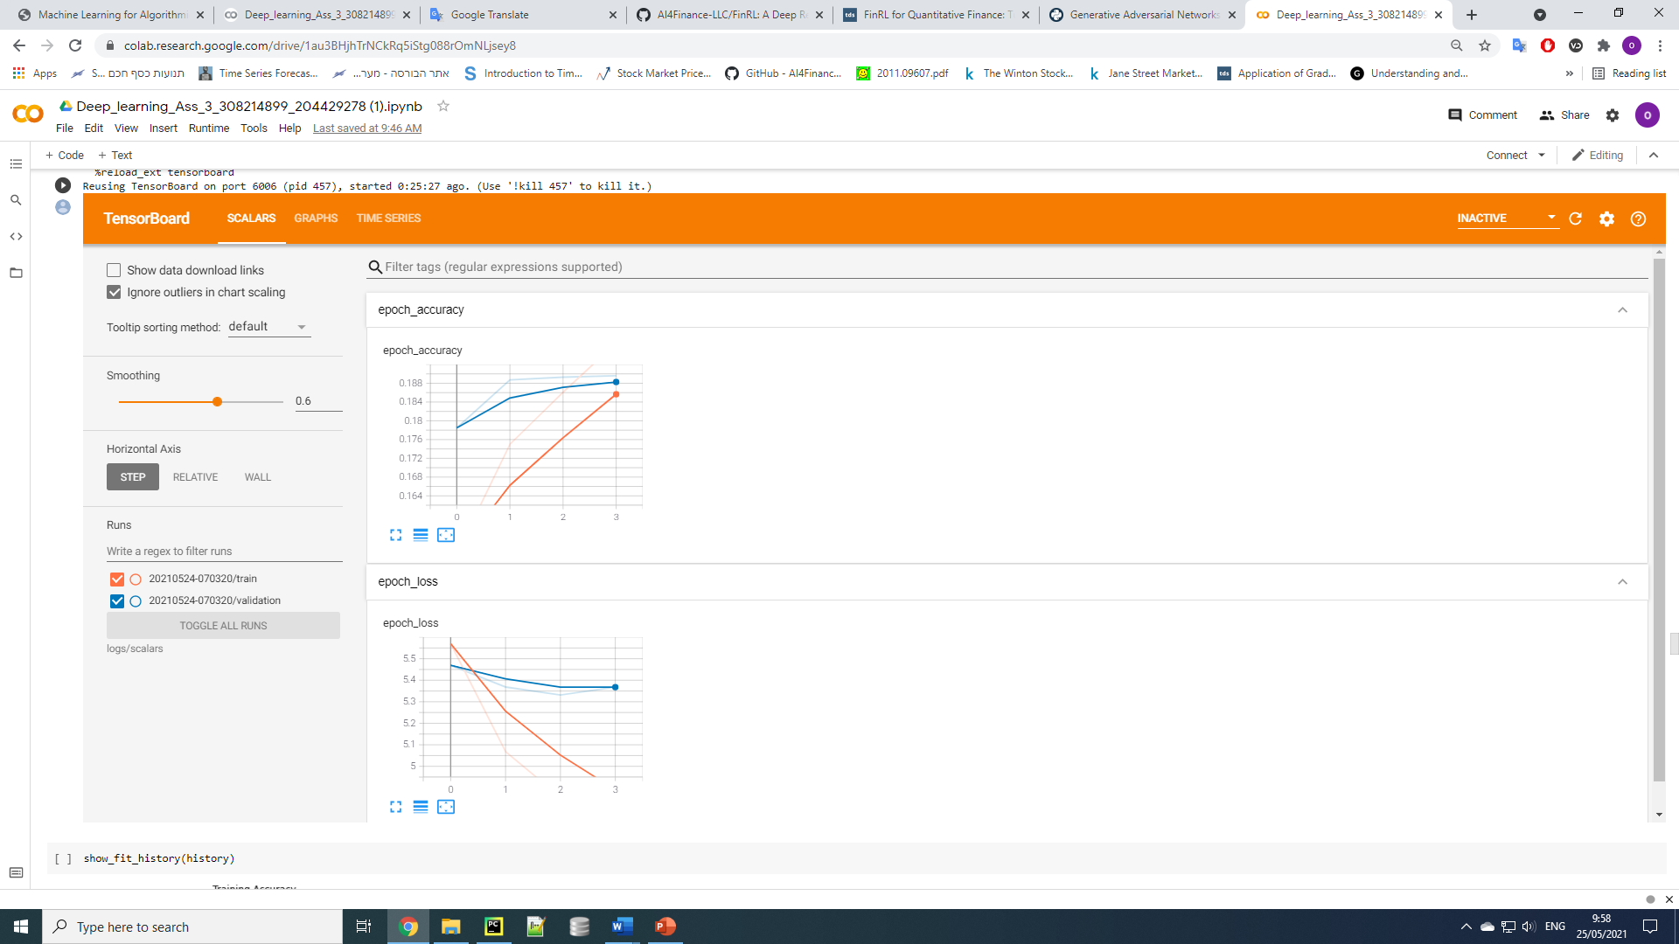Simple Model Training Graphs: (Orange - train, Blue – validation)

We can see that the model accuracy increases after each epoch and that the model loss decreases after each epoch, both on the train and the validation.

**Complex Approach Description:**

Melody (midi) processing:

For our complex approach we divide each song into intervals base on its length to create a fix size (200, 140) matrix of rolls features describing this melody. These features are sampling of the melody roll that can hopefully encode a representation of the melody.

Model Architecture:

We used RNN (LSTM) both on the lyrics and for this approach also on the melody. The melody features are sequence of roll and hopefully the RNN can learn to represent the melody as well. After applying dropout on the melody rnn output we concatenate the output.

**Complex Model Summary:**

Complex Model Plot:

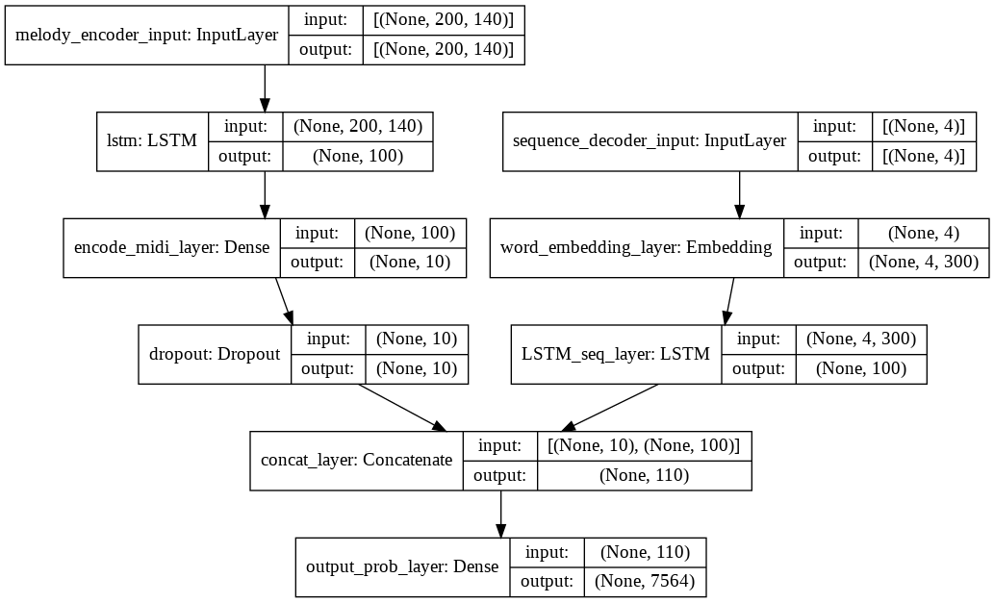

Complex Model Training Graphs:

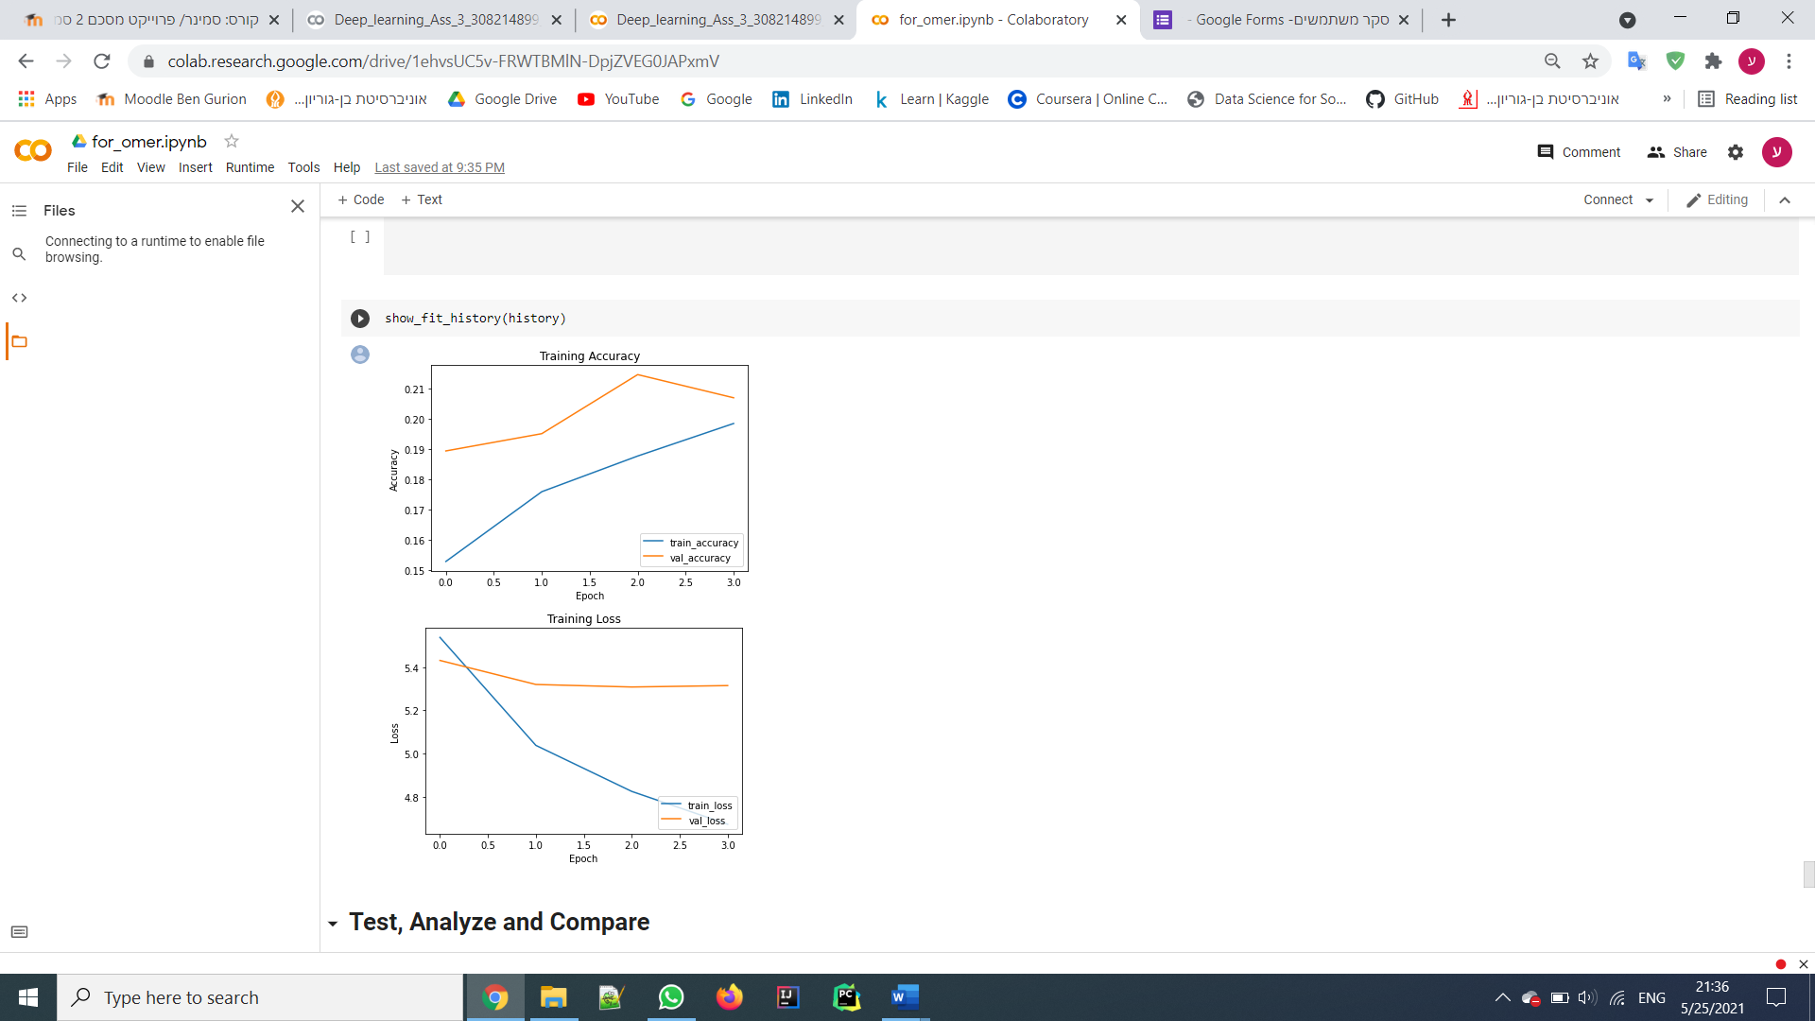

**Analysis Lyrics Outputs:**

In this section we will try to analyze the effect of the selection of the first word on the generated lyrics.

**Please note:** due to its length we put the generated lyrics after this section.

The three first word we chose alongside the real first words are: 'love', 'hate' and 'fear'.

There is no straightforward way to do this type measurement, but we came up with two ideas to do so:

1. Using sentiment analysis. The three first words we chose has strong sentiment.

Our assumption is that the lyrics generated by each word will have similar sentiment to the first word which used to generate them.

1. Calculate the cosine similarity between each output and the original lyrics.

Our assumption is that the lyrics generated by the real first word will be more similar to the original lyrics than the lyrics generated by the other first words.

**Sentiment Analysis Results:**

The sentiment score for each word:

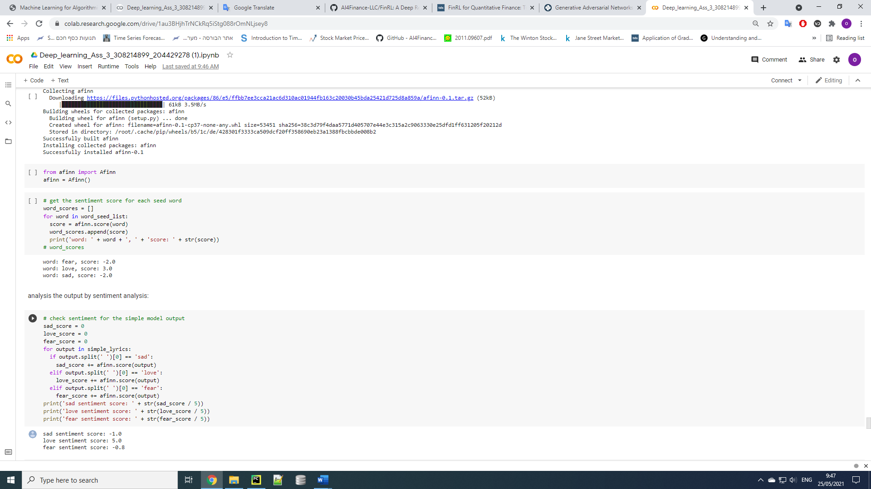

The sentiment score of the lyrics generated by the **simple model** for each word:

The sentiment score of the lyrics generated by the **complex model** for each word:

We can see that our assumption was correct. For both the simple model output and the complex model output we can clearly see the correlation between the first word sentiment and the generated lyrics sentiment.

**Cosine Similarity Results:**

Simple model cosine similarity table:

Complex model cosine similarity table:

From the tables above we can see that our assumption about the cosine similarity is not correct.

We can see that almost always the lyrics generated by the original seed do not have the highest similarity to the original lyrics.

Our conclusion from this phenomenon is that in this case the melodies have higher impact on our models output than the seed word.

**All Lyrics Outputs:**

We have 4 seed words, the first seed is the song original first word, and the other three seeds are the words 'fear', 'love' and 'sad'.

Also, we have 2 approaches for handling the midi files, simple and complex.

For each song in the test set we generated a total of 8 lyrics. One for every combination of seed word and midi approach.

===============

Generating Lyrics for 'eternal flame' by 'the bangles'

----------

Original Lyric Seed: close

>> Simple Model Lyrics:

close

im dont get a little

i just so

i got a song

im gonna

you got to make me

when if you want be you go to see

>> Complex Model Lyrics:

close

cause the morning

i cant want a man is it in an the day

that i could you have to do

i was the one day

and its a time

and you can to be all

you will know its time

and the way i feel my world of the time

its gonna to be this world

i do you want

its the time

----------

----------

Seed: fear

>> Simple Model Lyrics:

fear to the life

and i know you feel

but a chance of the

in the same man for the a man

i can go on me that it and a man that

>> Complex Model Lyrics:

fear

but you feel i want you be right

and we will the all

and they dont you want

and youre so in the end you cant

----------

----------

Seed: love

>> Simple Model Lyrics:

love

and tell me the love to have

you know you want to be

>> Complex Model Lyrics:

love

i never can be the world of a man

i was all the way now its a man

but it i am not

you dont know i could be the

----------

----------

Seed: sad

>> Simple Model Lyrics:

sad

its

>> Complex Model Lyrics:

sad that one of hollywood

and the night

i feel a friend of the way

the way it to do

i really to make you

i just never do

----------

===============

===============

Generating Lyrics for 'honesty' by 'billy joel'

----------

Original Lyric Seed: if

>> Simple Model Lyrics:

if

to the your face

>> Complex Model Lyrics:

if im got on you

its a new day of this

but if i dont need it the way

if is not you want it

i dont think me

you know you were this

and i was a way

just that i have i never want to be a friend

----------

----------

Seed: fear

>> Simple Model Lyrics:

fear that i do to take it

>> Complex Model Lyrics:

fear

----------

----------

Seed: love

>> Simple Model Lyrics:

love for you want you

i was so a chance

i dont do you go down

you was the way of time

when

when i need to me a friend of his night

i got it the

and i know

i got

you can to make the time

its a song of you

>> Complex Model Lyrics:

love you

i cant never never have to me

its time and i was gonna for me

i can love you dont

my love

and if you know my head

to me it

so the to be

i just love you

----------

----------

Seed: sad

>> Simple Model Lyrics:

sad

oh im gonna for me on the world is me

its the of the

and my own

im in the world

i can never say the a dream in a lot and youre

you want to the the heart

and i been never

dont make me like it to you be the world to go and tell it you

and the of the world

>> Complex Model Lyrics:

sad you feel

i have to say

when its been the one in the night

if i need it what i was all

i just to be

when i can see this the of hollywood

i got to have

----------

===============

===============

Generating Lyrics for 'lovefool' by 'cardigans'

----------

Original Lyric Seed: dear

>> Simple Model Lyrics:

dear and you can want to make me i can

i need it it

and i can be

you need to me

i have

>> Complex Model Lyrics:

dear

i know my a girl

you just me dont want to be

now it is you are to you

but i feel that

we just a friend

you feel you and im been a time to be mine

i know

no i say you

that you be the one day

----------

----------

Seed: fear

>> Simple Model Lyrics:

fear

>> Complex Model Lyrics:

fear

and its not

i dont see you just

i cant never know

youre the in you

----------

----------

Seed: love

>> Simple Model Lyrics:

love

oh its love in the night

and we i feel my head

i feel i want do my

>> Complex Model Lyrics:

love it

to love you

you know you be

so the way to go

----------

----------

Seed: sad

>> Simple Model Lyrics:

sad for me

cause i love you be the

i got to make me it

>> Complex Model Lyrics:

sad love

you need to know the time

----------

===============

===============

Generating Lyrics for 'barbie girl' by 'aqua'

----------

Original Lyric Seed: hiya

>> Simple Model Lyrics:

hiya yeah that can be

in on me that

i feel me

and me

and its my love

you want me in me

but the

>> Complex Model Lyrics:

hiya

and then we just is in the way

and he are a girl girl

so you do the time

when you feel the

----------

----------

Seed: fear

>> Simple Model Lyrics:

fear you

oh oh when i know i know for my heart

oh the a way to the

to be

and i do to the

but i love a chance

you know

i know that i was the the way to do you

i never want you

do a big on my mind of the

so all the one of your own

and the of my arms and i love you

you have a time

>> Complex Model Lyrics:

fear

cause i do you have the day

----------

----------

Seed: love

>> Simple Model Lyrics:

love

and the world

and tell me that

so it youre

cause i love that i say my heart

the world

and the one on on and i want to be

and its way

dont you know for me for me

and i know you dont do be a hero

you can get me

we can see her life

im in the the

and you say im gonna for

and i say that its time

so my love i never see

i got to the day and then

my own

and the in the life

i do to you to the love

oh its only for the world

oh i need a life

i dont want you want to the your

and a new life to the

but im the heart and they dont want to the a hero on my way im love

i am

dont know to the to make you see you to do to you say that im just

and a little

and it

i feel the the time

just the night

and im dont say i want to find the eyes

so i feel me

i dont be to me

oh i been i was so is it

to you to tell it

you can to do i can you have my body of my love im a man

>> Complex Model Lyrics:

love you

oh its been time

i think to get to get your mind

i just that the world was

we would know i love to find it

i got in

its a place

cause its love

when youre a friend

----------

----------

Seed: sad

>> Simple Model Lyrics:

sad that you know

and i dont you to be the in

i dont know you want you

i been i have

we want to make the love i was your heart

but a time to me you got out

the world and tell me

dont you know for you

its just

>> Complex Model Lyrics:

sad

cause i think

when im not you want to be the way

i gotta know i never i can never

i just that to do it what is

you never never ever say you can make the things for me

its not never you

never knew you go

you can see

but the night of love and me

i dont see that you dont be a bottle in the world

you want you say that the sun of me

i just cant make you love like me

you want to you

you know

i need a dream is all to love

oh i can i just wanna know my baby and i have you say my love with the way

its not to be a time

so you never will be this day of time

that you feel me

----------

===============

===============

Generating Lyrics for 'all the small things' by 'blink 182'

----------

Original Lyric Seed: all

>> Simple Model Lyrics:

all love its time

to be with the world of in

i got the way to be your head

if a little of me

im dont to the

but you dont make me

the love that in the world

its all

and if i want a new to the of my mind to the

i dont see the way and it that i need you want to get the way

its

oh

oh in the way to see the a song with the the world

i love to be with the your mind

im sorry oh

oh

>> Complex Model Lyrics:

all i just to say the night

when the one to me

i can do me all is

you dont want to find your to do

its got and they were to me

im always

what i will i never could never love you feel

i was gonna be

so i want it

so you see it a new

im no to me

all you just

to be that i want me

you can to be your mind

if you never go all me in

oh oh

i love you need

to the day

its the time and i do

when me to make

cause you need for

i know it all you

i cant be so you

i wanna make me to be with it

you are a song and my

i cant be

so we are a way to say

i can be

to know youre all

cause i know

youre got a song in love

----------

----------

Seed: fear

>> Simple Model Lyrics:

fear

i need to be

>> Complex Model Lyrics:

fear me and i cant have you

cause its the world

and a lot is right you to love you say you

oh why that we could make it i have to say

you just the a big day

when i can be the you

----------

----------

Seed: love

>> Simple Model Lyrics:

love to stay

>> Complex Model Lyrics:

love you just you

----------

----------

Seed: sad

>> Simple Model Lyrics:

sad

i got to the

i know yeah oh you can be all

just me

if i see

>> Complex Model Lyrics:

sad for my head

its the of the one one time

i dont think to be here

i never got in the world

the night

and i can love you

do you can be it

to live the way you say

oh im a new

for you dont get for me

you can want to live

now the the day

----------

===============