April 26th 2018

Min Cho, PhD   
Senior Editor/Team Manager (Life Sciences)  
Nature Communications   
min.cho@nature.com

Dear Dr. Cho,

Thank you for your editorial handling of our manuscript throughout the review process. We have made changes requested by you and reviewer 2 and trust that the manuscript is now suitable. Please do tell us if we’ve missed addressing any points you want addressed and we will, in consultation with you, make appropriate changes.

Regards,

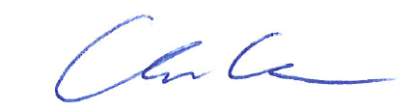

Andrew Chess