Webshop

Student: Szekely Attila

**Group: 30236**

Table of Contents

1. Requirements Analysis 3

1.1 Assignment Specification 3

1.2 Functional Requirements 3

1.3 Non-functional Requirements 3

2. Use-Case Model 3

3. System Architectural Design 3

4. UML Sequence Diagrams 3

5. Class Design 3

6. Data Model 3

7. System Testing 3

8. Bibliography 3

1. Requirements Analysis

# Assignment Specification

This is a client-server desktop application, which realizes a simple webshop for selling electronic products (min. 3 categories: telephones, laptops, etc). It is multi-user, there are many normal users and admins.

# Functional Requirements

The application will have 2 types of users: normal user and administrator. Login must be implemented.

User operations:

* Show list with all products on the main page
* Show category list on left side
* Click on a category renders that category’s page, where only product from that category are shown.
* Hierarchic list of categories

Admin operations:

* Add/remove products
* Add/remove categories
* Add products to a given category
* All categories can have children. Add/remove subcategories.

Non-functional Requirements

* Use one of the following MVC frameworks:
  + Java Spring MVC
  + ASP .NET MVC
  + (Ruby on Rails)
* Build data access layer based on JDBC/ADO.NET
* Data will be stored in one of the following databases: MySql / Sql Server Express / Oracle Express
* Implement data access layer with an Object Relational Mapping (ORM) framework
* Java: Hibernate
* .NET: Entity framework
* (RoR: ActiveRecord)
* Use composite desing pattern in implementation

2. Use-Case Model

**Use case:** list products

**Level:** user-goal level

**Primary actor:** normal user

**Main success scenario:** login, choose category, the system shows products from that category

**Extensions:** if there are no product in that category, it shows an alert message in the browser.

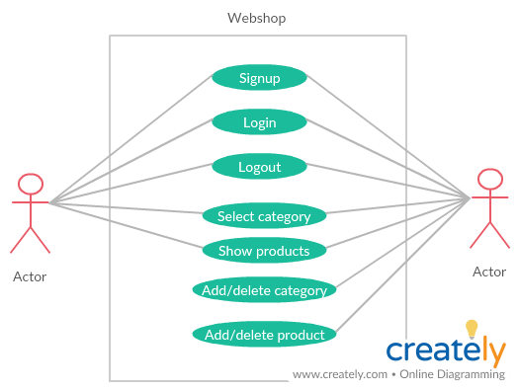

3. System Architectural Design

**3.1 Architectural Pattern Description**

The application consists of 2 parts:

* Server side: Ruby on Rails
  + Database management
  + Model
  + Grape API endpoints
* Client side: React JavaScript
  + View component
  + Access API enpoint with Axios

**3.2 Diagrams**

4. UML Sequence Diagrams

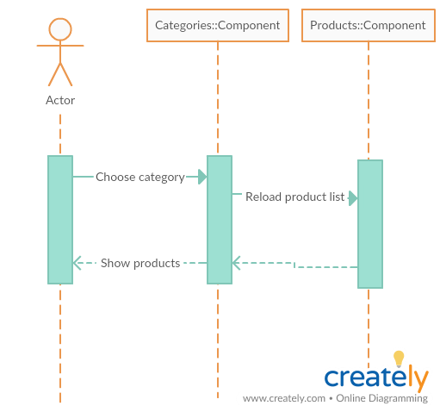

5. Class Design

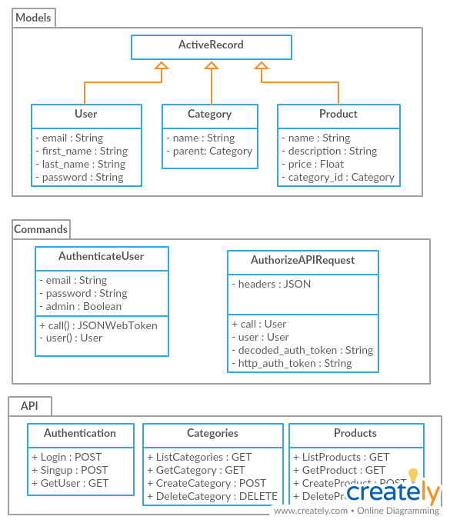

**5.1 Design Patterns Description**

Composite design pattern: hierarchical categories.

**5.2 UML Class Diagram**

6. Data Model

The application database has 5 tables:

* Users (email, first_name, last_name, password, admin): contains both the admin and normal users(admin: false – user, true – admin)
* Categories (id, name, parent)
* Products (id, name, price, description, category_id)

7. System Testing

The system was tested manually. All admin and cashier functionalities were tested.

8. Bibliography

1. <https://docs.microsoft.com/en-us/dotnet/csharp/programming-guide/>
2. <https://www.w3schools.com/sql/>
3. https://en.wikipedia.org/wiki/Multitier_architecture