Ivan Flores, Alix Naugler, Hanna Willwerth

Data Science

Bigfoot, Bigger Data: The Tale of Crunk Cryptids

**Introduction:**

Bigfoot – also known as Sasquatch from the First Nation Halkomelem word Sasq’ets, meaning “hairy, wild man” – originated in Native American tribes in the Pacific Northwest and British Columbia. The Sasquatch was an important figure in Native American/First Nation folklore and tradition – at times a supernatural figure, a caretaker of the land, an auspicious symbol.

The term “Sasquatch” was first coined by J.W Burns, a teacher on the Chehalis Indian Reservation in an article he wrote for the magazine *Maclean*. The first documented sighting of Bigfoot dates to an 1884 article in the *British Colonist* – which described a “half man, half beast” near Yale, British Columbia. Since then, the myth/legend of Sasquatch has taken hold in the American imagination – from loggers in the wilderness of Oregon to hikers across the country.

Previous research leveraging georeferenced Bigfoot sightings and ecological niche models has found that the purported geographic distribution of Bigfoot closely maps that of the American black bear (Lozier et al). This provides evidence that many sightings of Bigfoot are, in fact, bearly there.

By integrating geocoded, US reports of Bigfoot sightings from 2002 to 2012 from the Bigfoot Field Researchers Organization (BFRO) with detailed, county-level data on alcohol consumption/binge drinking from the Global Health Data Exchange, this paper will help unearth the mystery of Bigfoot. Are drunk people more likely to see Bigfoot? Or rather, does Bigfoot only show themselves to the intoxicated?

**Exploratory Analysis:**

* The majority of Bigfoot sightings took place on days with high visibility (8 miles or greater)
* Bigfoot sightings were relatively evenly distributed across moon phases, with slight spike during the full moon phase.
* The top five states with the most Bigfoot sightings are, in order: Washington, Florida, Texas, California, and Illinois. This is interesting, as Florida, Texas, and Illinois are well outside of the traditional/original range of Bigfoot.
* Sightings peaked in 2004 before dropping steadily until 2010, when sightings started to rebound.
* The rate of binge drinkers at the national level appears to be relatively consistent across time – ranging from 31 to 35% of people.
* The states with the highest drinking rates do not overlap with the states where Bigfoot sightings occur most often. The top five states are, in order: North Dakota, Nevada, Wisconsin, South Dakota, and Iowa.

**Text Analysis:**

* The most common words across the dataset (removing stop words), were primarily action words like “heard,” “saw,” and “looked.” A few other more interesting words were “road,” “woods,” “night,” “sound,” “feet,” and “large.” The most common words did not change significantly across the five states with the most Bigfoot sightings, although notable exceptions include “creature” in Florida; “animal” in Texas; “bigfoot,” “lake,” and “bear” in California; and “house” and “deer” in Illinois. This disaggregated word list provides evidence supporting the hypothesis that Bigfoot sightings are likely cases of mistaken identity with other fauna – including deers and bears.

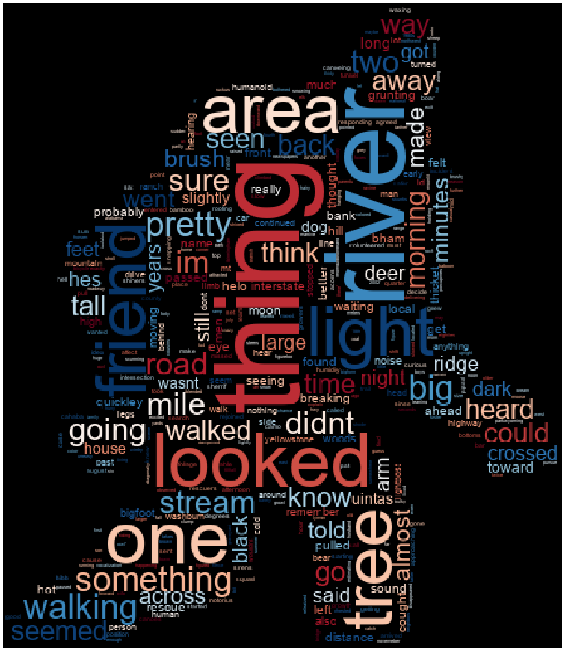

* The mean sentiment score was 0.1145; the median was 0.2050.
* Most negative observation with a polarity score of -0.9985:

“This is a compilation of experiences over a period of years in the same area (1988- 2009) - feeling of being watched, wildlife silenced, tree breaks, strong smell once, numerous late night vocalizations, rock knocking, things being thrown near our tent and an actual daytime sighting … Birdsong of various types is always present, but as we made our way toward the tree line, the birdsong and even insect noise seemed to cease. I looked up, no indication of foul weather or damp wind, indicating rain. Our group ( I think 7 or 8 of us) was familiar with the deep woods and a couple people noted that this was strange. For some reason, we all stopped in our tracks, even though no one had heard anything; everyone was looking around at each other and listening. Something seemed wrong … We got out of our vehicle to begin setting up camp as we had done several other times in this area and noticed an almost vomit-inducing stench. It was not the smell of something dead, it was like a combination of sun-baked garbage and feces …. But then later in 2003, another type of sound in this area made my blood turn to ice water … I came to a sickeningly horrifying conclusion that in all the years of voice I'd studied and heard, not one human had ever uttered something at this tone, nor could they do it at this volume …. I was too frightened with the realization that what I had just heard was impossible- impossible! No creature existed that could make that sound-- unless-- no way-- NO WAY! Then I remembered that this area had quite a few sightings of Bigfoot over the years … The ranger looked at me like I was under the influence ... Then I felt faint, like I was going blind & seeing colors and shot up with some halucinogen all at once- I watched as a HUGE, hair-covered, dark cinnamon-colored human-like thing cleared the ditch in one stride, glided into the tree line in one more lightning step and then stood absolutely still. …. Fear and curiosity-yikes.”

* Most positive observation with a polarity score of 0.9994:

My encounter happened in early June of 2010. I took a friend to the Marienville/Timberline ATV trails northeast of Marienville, Pennsylvania in the Allegheny National Forest, to ride ATV’s for the day …That’s when I noticed rocks kept hitting the front right side of my ATV. They weren’t large rocks, maybe about or just smaller than hand sized. It took a minute or so before it occurred to me that I was stopped and that rocks should not be flying through the air and hitting my atv. I was turning my head towards the right to follow the path of these "air rocks" as I called them, when my turn stopped. I noticed this “Stump” which turned out to be a dark figure, approximately 70-90 feet away, that appeared to be in a sitting or crouching, or just a low position, then stand up into an upright position. I’ll never forget how it seemed to pop right up like it was on a spring, with very little effort. Initially I looked at its hands because I was interested to see what was in its hand, if anything. It was much taller than a normal human – best guess at this point would be 7.5 feet or so, and absolutely NOT a bear … I went from not caring or thinking about Sasquatch to a full blown enthusiast. I attend conferences and have actually received an invitation to Beachfoot in Oregon in 2016. For this years Ohio Bigfoot conference, Sybilla Irwin (a BFRO member and artist) is doing a drawing of what I've described to her, and will be unveiling it at the conference. All of this is exciting, and I cannot wait to see her bring this back to life, and return my emotions back to that 1 minute of my life that changed how I think now … I wasn't out looking for a bigfoot that day. I did not ask for this encounter to happen. But it did, and it changed many things about me. I stopped hunting deer and have not hunted since that day. I now cannot put Bigfoot stuff down and even started a bigfoot book collection with some very old and hard to find, autographed bigfoot books. This doesn't happen to a person overnight, unless something occurred to change them. That day certainly did change me.

* Sentiment over time:

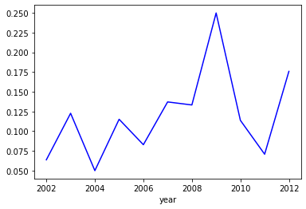

**References:**

Lozier, J.D., Aniello, P. and Hickerson, M.J. (2009), Predicting the distribution of Sasquatch in western North America: anything goes with ecological niche modelling. Journal of Biogeography, 36: 1623-1627. <https://doi.org/10.1111/j.1365-2699.2009.02152.x>

<http://www.native-languages.org/sasquatch.htm>

<https://oregonwild.org/wildlife/sasquatch>

<https://www.thecanadianencyclopedia.ca/en/article/sasquatch>

https://sesqui.ca/en/news/kristi-lane-sinclair-on-the-legend-of-the-sasquatch/