**5. Implement "to-do list" app in Flask(python).**

**Create a "to-do list" to organize and prioritize your tasks.**

* **Hit the gym**
* **Movie time**
* **Office work**
* **Reading**
* **Meet liaquat**
* **Family time**

**Constraints:**

* **Use Rest client for API, don’t need to design frontend (GUI) for app**
* **Cover all usecase for to-do list, like add and delete item**

**For this we have to install sqlite3,SQLAlchemy,flask-SQLAlchemy**

**todo.py**

**from flask import Flask, render_template, request, redirect, url_for**

from flask_sqlalchemy import SQLAlchemy

app = Flask(__name__)

app.config['SQLALCHEMY_DATABASE_URI'] = 'sqlite://///home/attique/PycharmProjects/todo/todo.db'

db = SQLAlchemy(app)

class Todo(db.Model):

id = db.Column(db.Integer, primary_key=True)

text = db.Column(db.String(200))

complete = db.Column(db.Boolean)

@app.route('/')

def index():

incomplete = Todo.query.filter_by(complete=False).all()

complete = Todo.query.filter_by(complete=True).all()

return render_template('index.html', incomplete=incomplete , complete = complete)

@app.route('/add' , methods=['POST'])

def add():

todo = Todo(text=request.form['todoitem'], complete=False)

db.session.add(todo)

db.session.commit()

return redirect(url_for('index'))

@app.route('/complete/<id>')

def complete(id):

#return '<h1>{}</h1>'.format(id)

todo = Todo.query.filter_by(id=int(id)).first()

todo.complete = True;

db.session.commit()

return redirect(url_for('index'))

#delete

@app.route('/delete/<id>')

def delete(id):

todo = Todo.query.filter_by(id=int(id)).first()

#*todo.delete = delete(id);*

#*todo = Todo(text=request.form['todoitem'], complete=False)*

db.session.delete(todo)

db.session.commit()

return redirect(url_for('index'))

if __name__ == '__main__':

app.run(debug=True)

**index.html**

**<!DOCTYPE html>**

<html lang="en">

<head>

<meta charset="UTF-8">

<title>Todo</title>

</head>

<body>

<h1>TODO LIST</h1>

<div>Add a new todo item:

<form action="{{ url_for('add') }}" method="POST">

<input type="text" name="todoitem">

<input type="submit" value="Add item">

</form>

</div>

<div>

<h2>Incomplete Items</h2>

<ul>

{% for todo **in** incomplete %}

<li style="font-size: 30pt ">{{ todo.text }}<a href="{{ url_for('complete',id=todo.id) }}" style="font-size: 10pt ">(Mark as Complete)</a> <a href="{{ url_for('delete',id=todo.id) }}" style="font-size: 5pt ">(delete)</a> </li>

{% endfor %}

</ul>

<h2>Completed Items</h2>

<ul>

{% for todo **in** complete %}

<li style="font-size: 30pt ">

{{ todo.text }} <a href="{{ url_for('delete',id=todo.id) }}" style="font-size: 5pt ">(delete)</a>

</li>

{% endfor %}

</ul>

</div>

</body>

</html>

**output :**

**running the app**

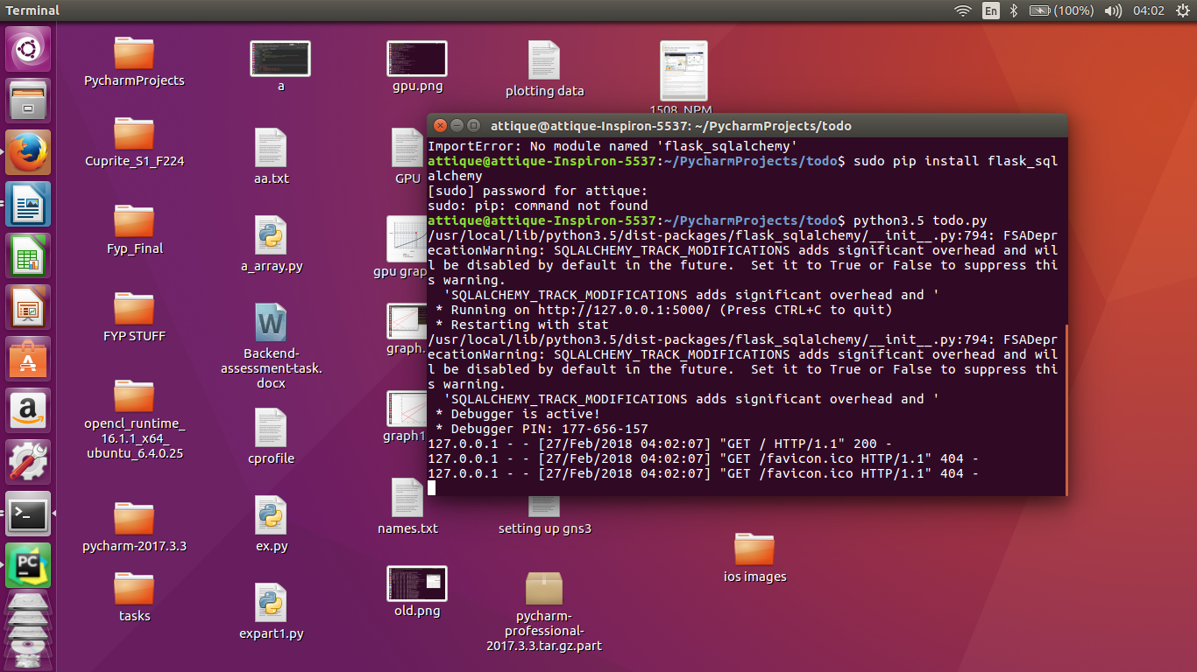

**all entries of to do list**

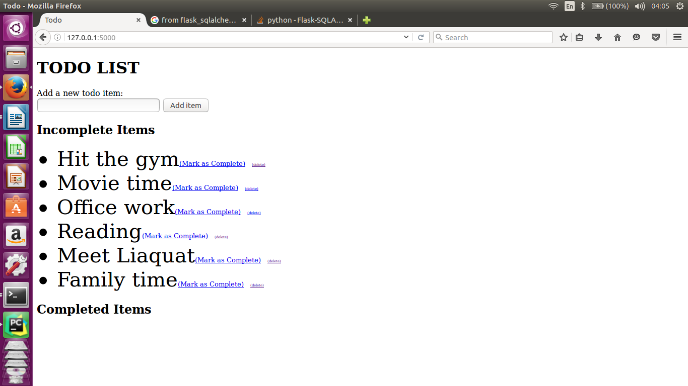

**marked first three entries as complete**

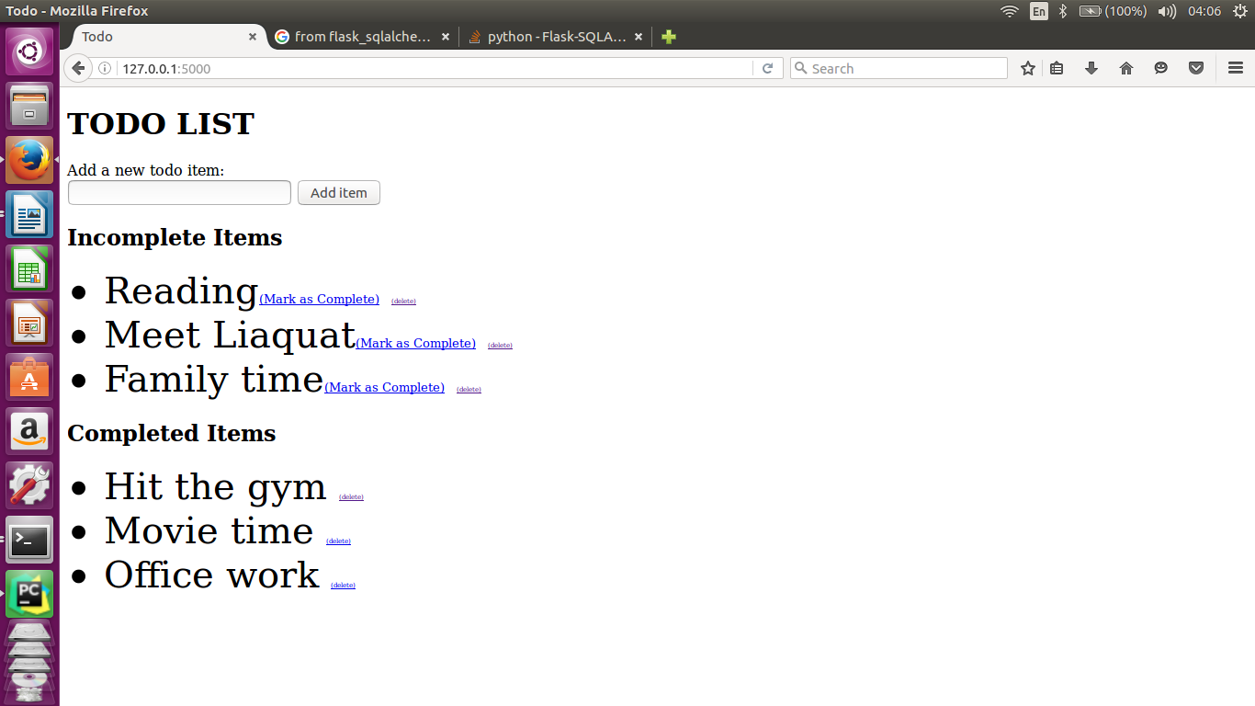

**deleting “movie time” from the completed list**

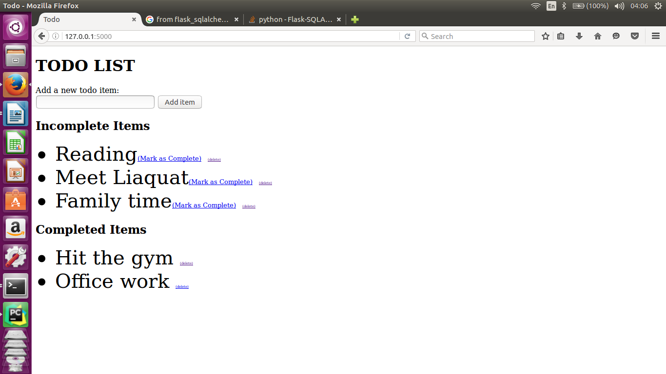

**Deleting “reading” from the Incomplete list**

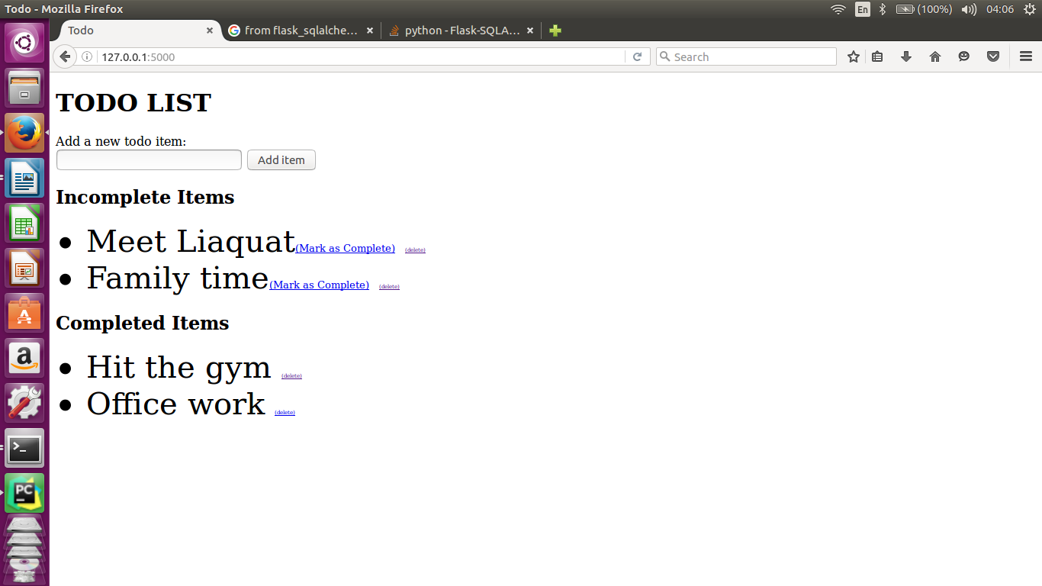

**showing the remaining entries in Database (todo.db)**

