

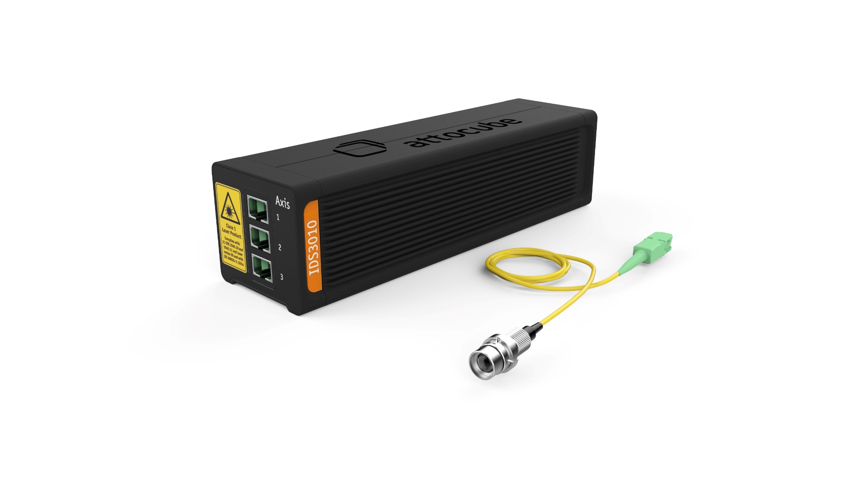
Interface Manual
Interferometric Displacement Sensor (IDS)
Manual version: | 2.0.0
Manual modified: | 05.2026
Firmware version: | 2.0.0
API version: | 2.0.0
WAVE version: | 1.5
attoDiscovery | 1.5.0
© 2001-2026 attocube systems GmbH. Product and company names listed are trademarks or trade names of their respective companies. Any rights not expressly granted herein are reserved. ATTENTION: Specifications and technical data are subject to change without notice.

© 2001-2026 attocube systems GmbH. Product and company names listed are trademarks or trade names of their respective companies. Any rights not expressly granted herein are reserved. ATTENTION: Specifications and technical data are subject to change without notice.

© 2001-2026 attocube systems GmbH. Product and company names listed are trademarks or trade names of their respective companies. Any rights not expressly granted herein are reserved. ATTENTION: Specifications and technical data are subject to change without notice.

© 2001-2026 attocube systems GmbH. Product and company names listed are trademarks or trade names of their respective companies. Any rights not expressly granted herein are reserved. ATTENTION: Specifications and technical data are subject to change without notice.
Table of Contents
1. Real-time interfaces 4
1.1. Introduction 4
1.2. Digital interfaces 5
1.2.1. HSSL 5
1.2.2. AquadB 7
1.3. Analog interfaces 10
1.3.1. Sin/Cos (only differential) 10
1.4. Anti-Aliasing Filter 12
1.5. 3 dB cut-off frequency (Average N filter) 12
1.6. Error signal 14
1.7. Optional interfaces 16
1.7.1. Linear Analog Output (only differential) 16
1.7.2. BiSS C 23
1.7.2.1. Overview 23
1.7.2.2. Interface connector 23
1.7.2.3. Interface configuration 24
1.7.2.4. Protocol description 26
1.8. Real-time interface connector 26

Real-time interfaces

Introduction
Overview | The IDS provides real-time position signals for each axis. The user can select five different output modes offering different output signal levels. Only one mode and signal level is available at a time. The setting applies to all outputs simultaneously.  - HSSL (binary signal, LVTTL or LVDS)  - AquadB (binary signal, LVTTL or LVDS)  - Sin/Cos (differential analog signal, LVTTL or LVDS error signal)  - Linear Analog Output (differential analog signal, LVTTL or LVDS error signal) – note that this feature is available on request  - Deactivated (all pins on GND)  Note: Using LVTTL (Low-Voltage Transistor-Transistor-Logic) every signal is transferred single-ended, whereas LVDS (Low-Voltage Differential Signal) twisted pairs are used to obtain the advantages of a differential signal transfer.  Digital signals:  LVTTL:  - High voltage level: 3.3 V  LVDS:  - Common voltage: 1.125 to 1.375 V  - Differential output voltage: typ. 340 mV at 100 Ω differential termination (we recommend using the 100 Ω differential termination near the receiver)  - Positive signals are denoted by X(+) and the negative signals by X(-)  Analog signals (only differential):  - Common voltage:  - 1.3 V at 50 Ω termination (single ended)  - 2 V at 1 MΩ termination (single ended)  - Differential voltage:  - 1 Vpp +/- 10 % at 50 Ω termination (single ended)  - 1.4 Vpp +/- 10 % at 1MΩ termination (single ended)  - Source impedance: 30 Ω  - Load current: 7 mA - 20 mA  - Positive signals are denoted by X(+) and the negative signals by X(-)
Web interface setting | The settings can be configured via the IDS web interface in the Interface tab (see Figure 1) or via the available software communication interfaces.  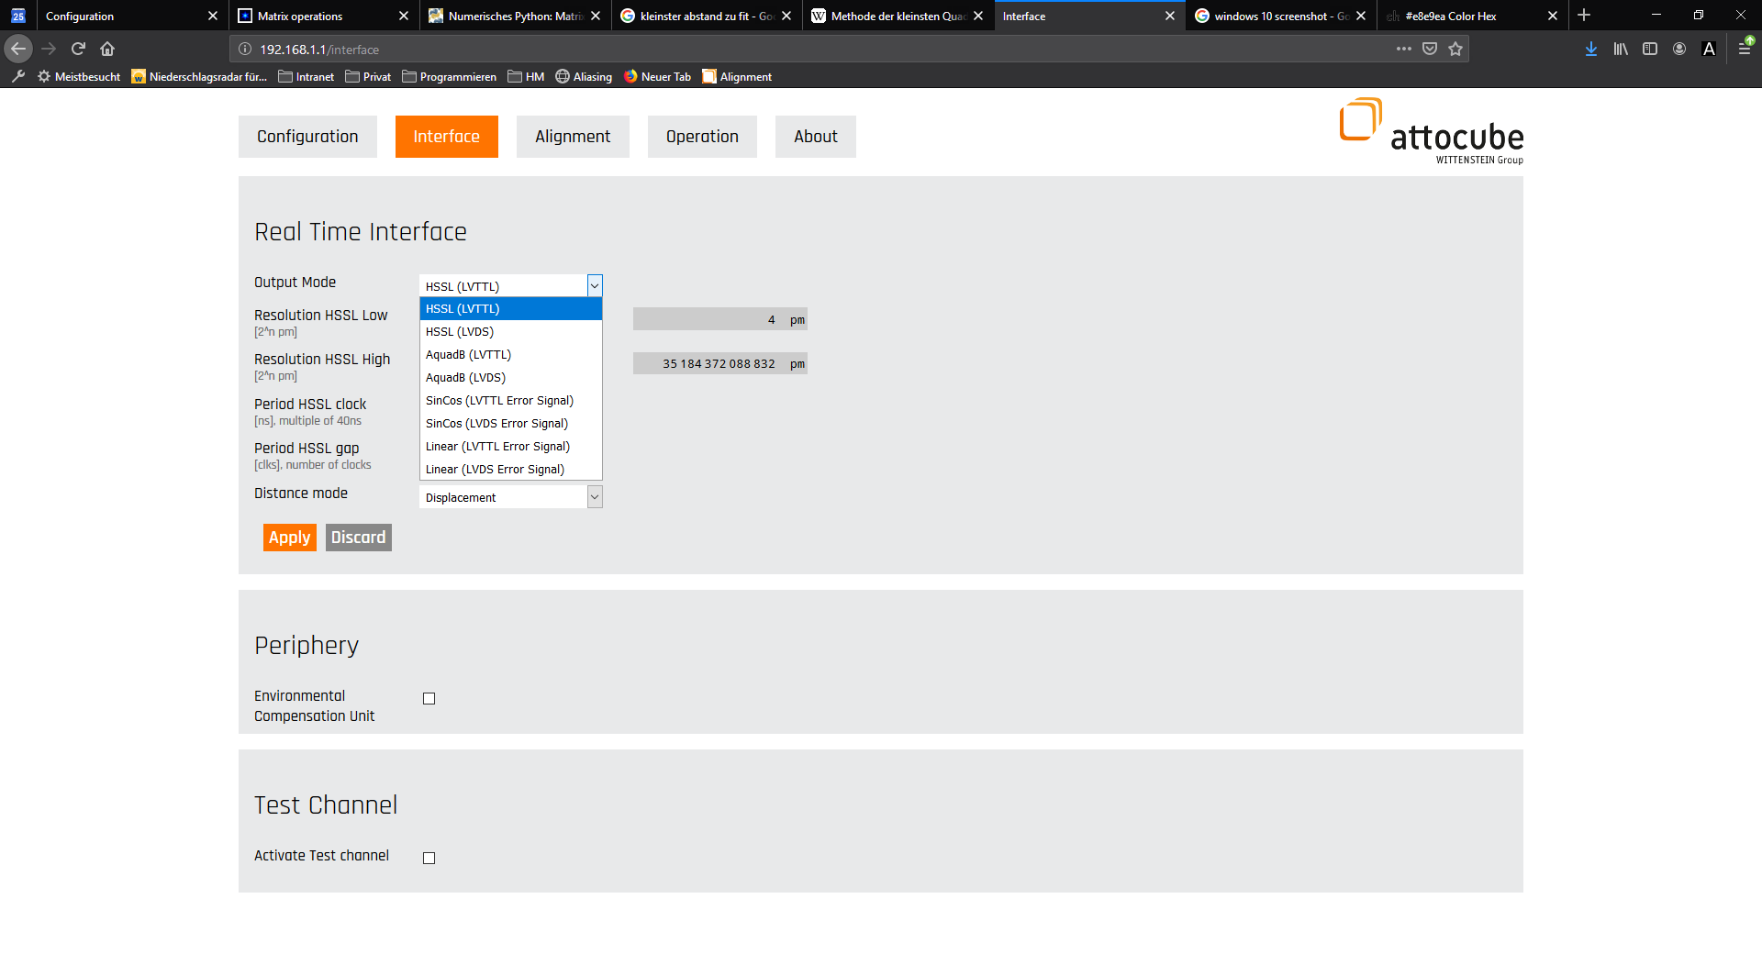  Figure 1: Setting the output mode in the IDS web interface

Digital interfaces

HSSL
Overview | HSSL (High Speed Serial Link) supports two different measurement modes, the Displacement and the Absolute position mode. HSSL uses a binary serial format based on 1 pm resolution. The HSSL protocol is defined by its resolution, clock time and gap. The clock time represents the bit output rate, and resolution defines the binary bit configuration, which provides the position information. The low resolution tab indicates the starting bit (= least significant bit, LSB) and the high resolution tab sets the final bit (= most significant bit, MSB). An example is shown below. The signal itself starts with the low resolution bit.  The HSSL word is encoded using the two's complement system.  The required gap is a time value in terms of clock time, which separates the different position signals from each other. The maximum clock rate is limited to 25 MHz, equal to 40 ns clock time. For real-time outputs it is recommended to use a DIO or DAQ card, which is compatible with a multiple of 40 ns. The clock period, gap and number of bits can be user adjusted in the web interface or via software communication interfaces (API). Between two sets of position information, synchronization of reader/sender can be gained through a continuous stream of position information. The data is synchronized with the rising edge of the clock signal.  The signals are available with two different signaling standards (only one at a time, please refer to chapter Introduction):  • Single-ended with LVTTL levels  • Differential with LVDS levels  A third signal (POS_ERROR) indicates an error condition e.g. when the position is lost due to laser beam interruption.
Web interface setting | The HSSL signal in Displacement mode starts with a zero displacement value as soon as the measurement initialization process is done, and the absolute position is shown in the Operation tab. Figure 2 shows an exemplary HSSL setting in the Interface tab.  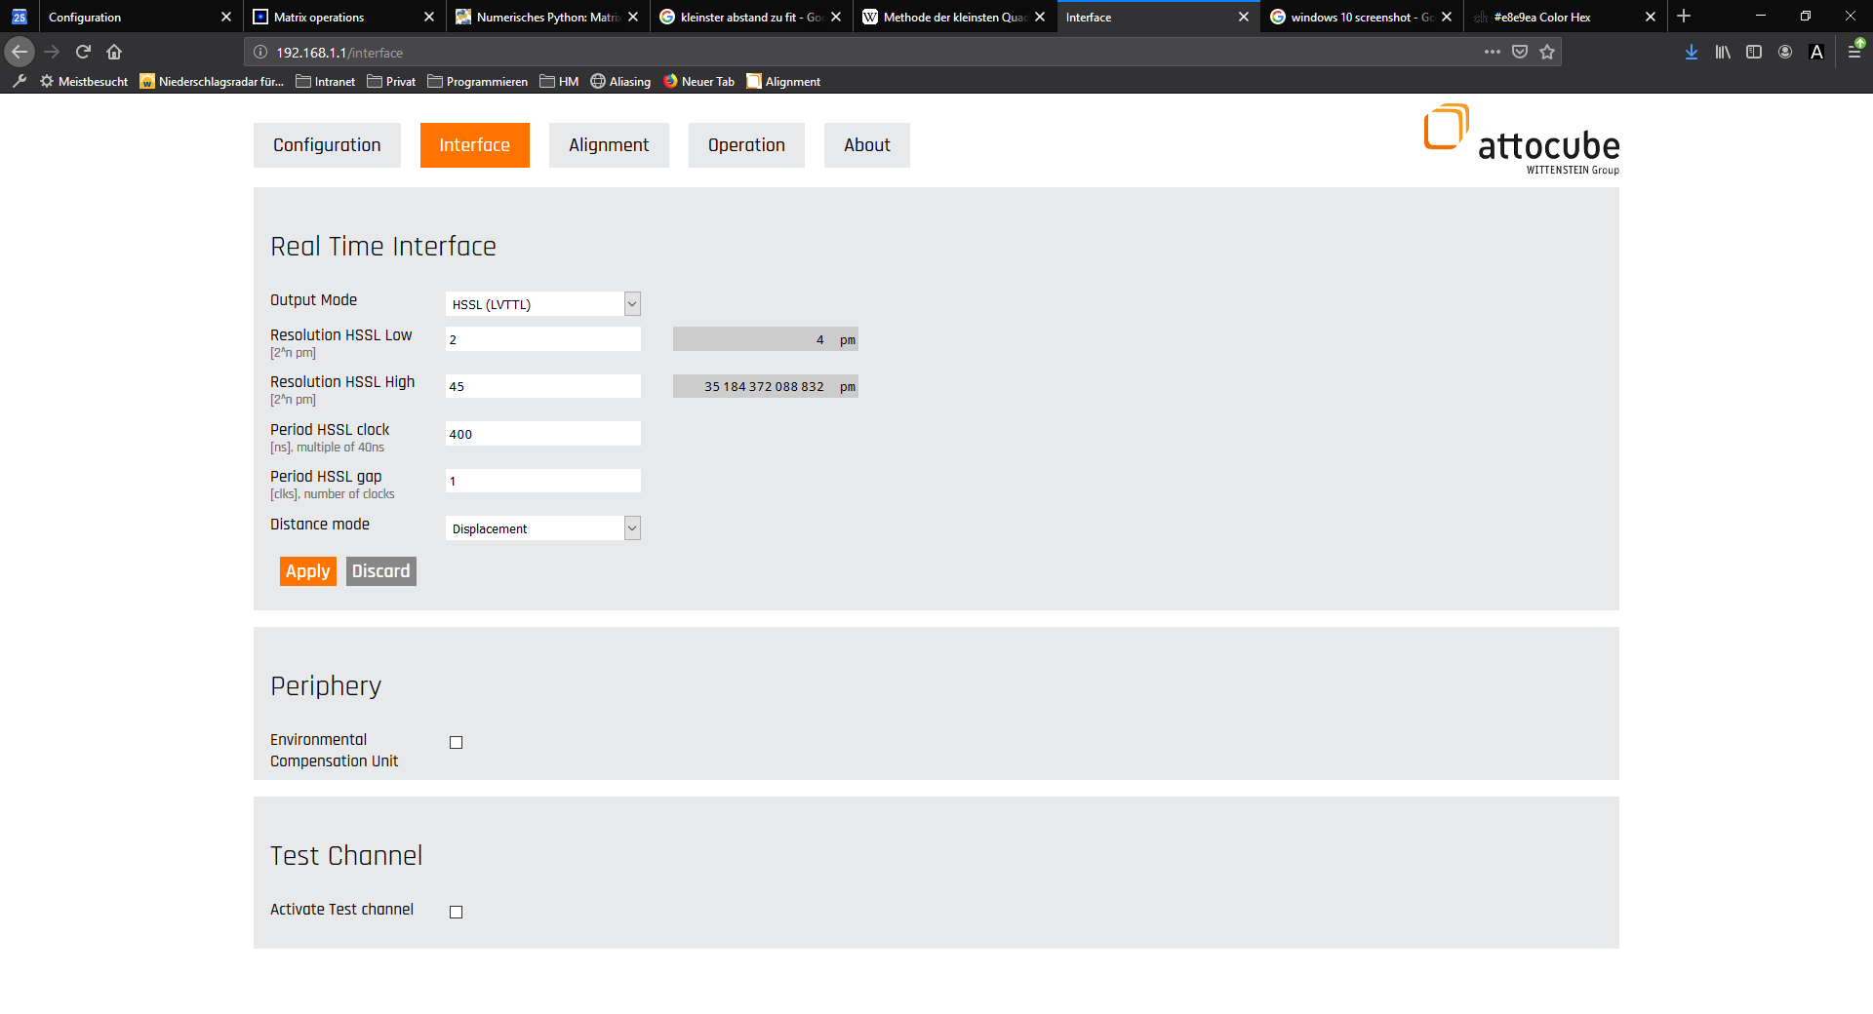  Figure 2: Defining the HSSL settings in the IDS web interface  The digital resolution of the HSSL interface is 1 pm. However, for high-speed measurements it might be necessary to limit the number of transmitted bits.
Resolution HSSL Low | Resolution HSSL Low defines the position resolution of the HSSL interface. It allows specifying the lowest bit of the 48-bit distance value. The position resolution is therefore given by  $$Resolution=2^{Resolution HSSL Low} *1 pm$$  The lowest bit value for this setting is 0 and the highest is 46.
Resolution HSSL High | Resolution HSSL High specifies the highest bit to be used of the 48-bit distance value. The lowest bit value for this setting is 1 and the highest is 47. The HSSL word size is therefore given by equation  $$word size= Resolution HSSL High - Resolution HSSL Low +1$$
Period HSSL Clock | The clock defines the time period at which the serial word bits are outputted (inverse of the bit rate). The clock is programmable as integer multiples of 40 ns. The maximum setting is 10.2 µs.
Period HSSL Gap | The gap argument is given in HSSL clock periods that are omitted and specifies the gap between the end of a HSSL word and the beginning of the subsequent HSSL word. The lowest gap bit for this setting is 1 and the highest is 255.
Total length of signal and position update rate | The total HSSL length of the signal is defined by the equation  $$total HSSL length of signal = \left(word size + number of gap bits\right)*clock$$  The achievable position update rate in Hz is the inverse of the HSSL length.  The total HSSL length of signal can be set maximum to 3.09 ms (324 Hz) by 48 bit word size, 255 bit gap and maximum clock of 10.2 µs. The minimum signal length for the 48 bit word size is 2 µs (500 kHz) for minimum gap and clock settings. For further acceleration of the position update rate the word size can be reduced.  Figure 3 shows an example trace of the HSSL signal with full 48 bit word length and a gap of 3 bits. Here, the first and second line represent the time trace of the data channel and clock channel, respectively. Each word is separated by 3 omitted clock bits.  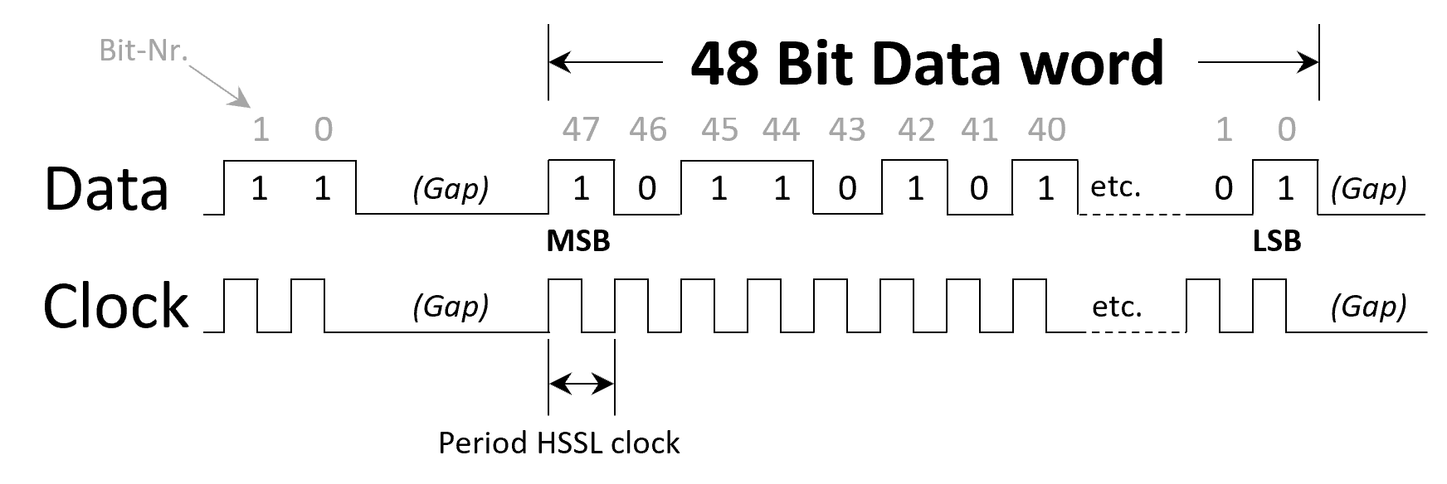  Figure 3: Signal pattern of a HSSL transfer
Displacement mode | In Displacement mode the displacement data is transferred according to the set HSSL parameters starting with zero displacement value. The maximum transferred position value, for positive and negative displacements, corresponds to the set MSB value (= Resolution HSSL High Bit). As mentioned above, the HSSL word is encoded using the two's complement system.
Absolute position mode | In Absolute position mode the absolute position data is transferred according to the set HSSL parameters. Please note that the word size should be large enough to fit the measured absolute position. Otherwise, the absolute position will be truncated.

AquadB
Overview | In contrast to HSSL, the AquadB protocol is an incremental protocol that only transfers information about the change of the measured position. The AquadB interface is used to transmit both the displacement and the direction of the target movement. Using this interface higher bandwidths are achievable compared to the HSSL interface. However, the user continuously needs to keep reading out the position as there is no information about the absolute value of the current position.  The AquadB protocol is defined by the parameters Resolution and Clock. The signal is transferred to channels A and B. The levels’ amplitude is either LVTTL or LVDS (one at a time, please refer to chapter Introduction):  - Single-ended with LVTTL levels  - Differential with LVDS levels  The Resolution parameter defines the minimum displacement that can be detected and transferred via AqudB interface. This displacement results in a state change of either A or B, depending on the change direction. This is sometimes also referred to X4-Encoding.  Figure 4 shows the signal pattern of AquadB signals A and B and the resulting current displacement. In an A-leads-B situation, the position has to be incremented and vice versa in a B-leads-A situation the position has to be decremented.  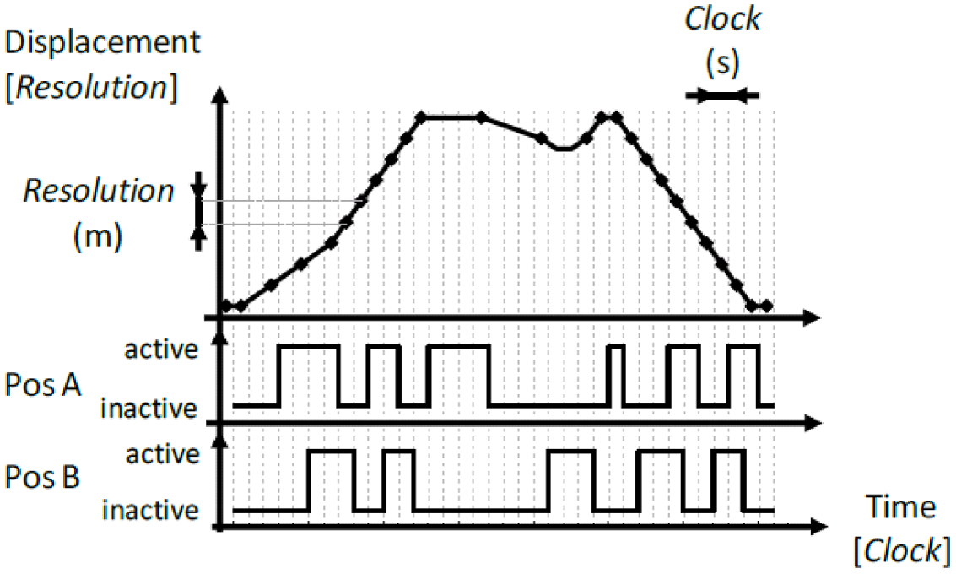  Figure 4: Signal pattern of a AquadB transfer  A third signal (POS_ERROR) indicates an error condition e.g. when the position is lost due to laser beam interruption.  Another way of visualizing the AquadB protocol is to plot channels A and B against each other, which creates a square. In Figure 5, a signal change of 90° represents, depending on the direction and displacement of ± Resolution. Going clockwise represents an increment in position (A-leads-B) and going counterclockwise represents a decrement in position (B-leads-A). From this way of visualizing the AquadB protocol it becomes clear that only one channel can change its state at a time.  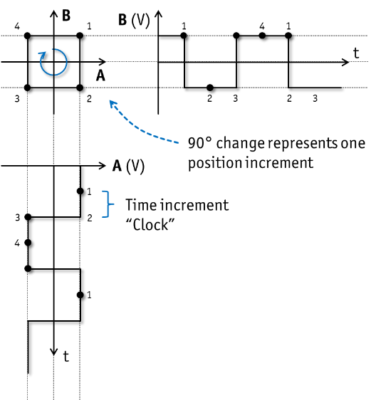  Figure 5: Interpretating the AquadB signal lines as a square pattern
Web interface setting | Figure 6 shows an exemplary AquadB settings in the Interface tab. The digital resolution of the AquadB interface is 1 pm. The scaling and the update rate of the A/B outputs are defined by the Resolution and Clock parameters.  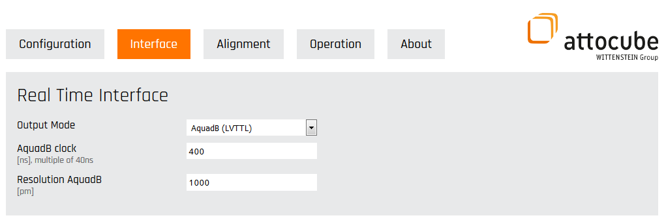  Figure 6: Defining the AquadB settings in the IDS web interface
Resolution AquadB | The Resolution AquadB parameter defines the position resolution of the AquadB interface and is user adjustable in the range from 1 pm to 64.93 nm (programmable as 2^n steps, where n is an integer). We recommend using a high resolution for the first test, afterwards you can decrease the resolution and adjust it to the application.
AquadB clock | The AquadB clock defines the period at which the quadrature signal increment can be outputted. The fastest possible clock setting is 40 ns (i.e. 25 MHz), equal to the update interval of the absolute distance accumulator. The slowest setting is 10.2 µs (i.e. 98 kHz). The clock is programmable as integer multiples of 40 ns.
Maximum target velocity | The maximum velocity outputted by the AquadB interface is limited by the interface itself. The maximum velocity supported by the AquadB interface can be calculated by following equation  $$maximum target velocity= \frac{Resolution}{Clock}$$  As a result, when choosing the right Resolution, there is always a trade-off between the maximum velocity that AquadB protocol can transmit and the resolution of the transmitted position. Choosing the right clock is simpler, as there are no negative side-effects by choosing the fastest possible rate the receiving system can handle (e.g. a DAQ-Card or a Counter), other than resulting in larger datasets.
 | Note: When the target displacement is above the maximum velocity that can be handled by the AquadB output, then the data needs more time to be transmitted, which can be seen as a low pass filtering of the data.
 | Note: When using the AquadB interface, the signal must be recorded constantly, otherwise the position information is lost.
 | Note: If the signal to noise ratio is not high enough during the target displacement or if the speed limit is exceeded, the AquadB interface error signal will be raised.

Analog interfaces

Sin/Cos (only differential)
Overview | Sin/Cos uses two analog signals in quadrature. For voltage levels please refer to the chapter Introduction. The maximum output bandwidth is 25 MHz.  The Sin/Cos interface is used to transmit both the displacement and the direction of the target movement (similar to the AquadB interface). The Resolution defines the smallest displacement which results in an increment or decrement of the signals A and B, depending on the direction. The clock parameter defines the maximum frequency at which the incremental change of the signal can be outputted.  A third signal (POS_ERROR) indicates an error condition e.g. when the position is lost due to laser beam interruption. The levels’ amplitude is either LVTTL or LVDS (one at a time, please refer to chapter Introduction):  - Single-ended with LVTTL levels  - Differential with LVDS levels  Figure 7 shows the Sin/Cos signal pattern of the oscilloscope.  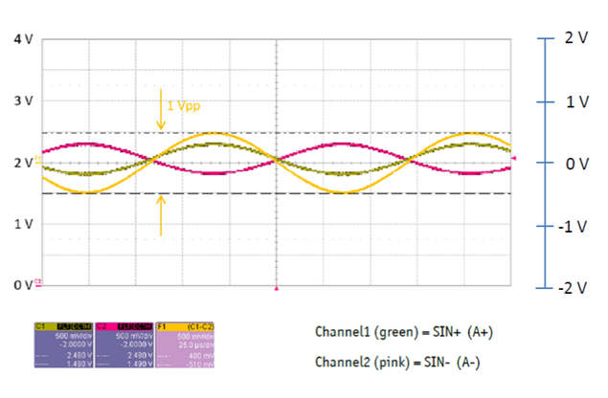  Figure 7: Sin/Cos signal pattern oscilloscope screenshot: C1 (green) = SIN+ (A+), C2 (pink) = SIN- (A-), F1 (yellow) = Math-function C1 - C2  Signal F1 shows 1 Vpp (right scale bar)  Signals C1 and C2 show the common mode voltage (CMV) of 2.05 V (left scale bar).
Web Interface setting | Figure 8 shows an exemplary AquadB settings in the Interface tab. The resolution of the Sin/Cos interface is 1 pm. The scaling and the update rate of the A/B outputs are defined by the Resolution and Clock parameters.  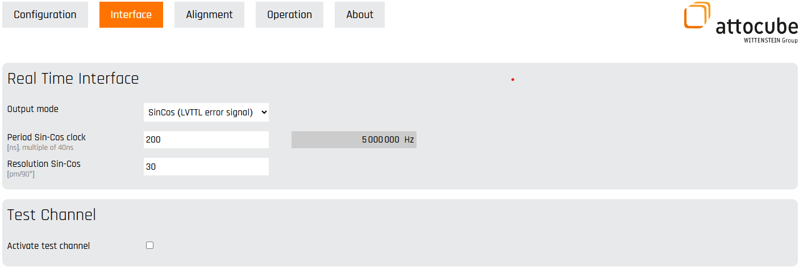  Figure 8: Defining the Sin/Cos settings in the IDS web interface
Resolution Sin/Cos | The largest Sin/Cos interface resolution (see Figure 9) is 16.8 µm/90° (corresponding to a resolution range of 24 bits given in pm units), the smallest useful resolution is 1024 pm/90°.  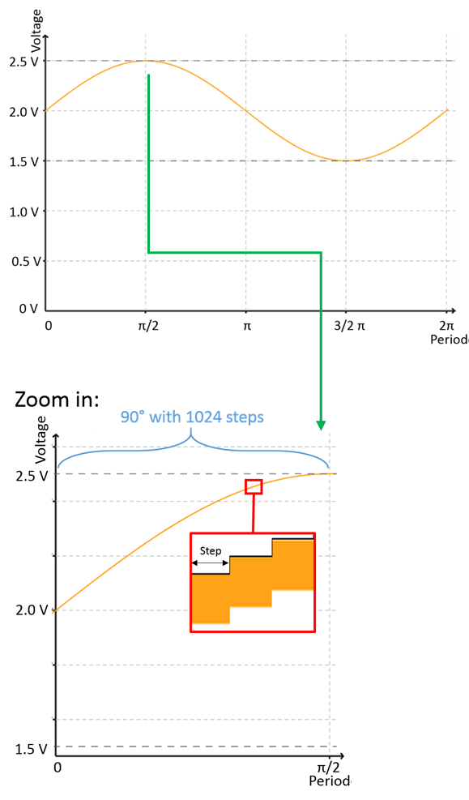  Figure 9: Sin/Cos signal resolution  The Sin/Cos output is controlled by a 12-bit D/A converter. Therefore, the resolution for a whole sin/cos period (360°) contains 2¹² = 4096 steps.  For example, setting the position resolution to 5000 nm/90° of the sin/cos signal leads to 1024 steps with a resolution per step of 4.88 nm.
Period Sin/Cos clock | The clock period can be adjusted in multiples of 40 ns. The longest possible period is 10.2 µs, the shortest is 40 ns.

Anti-Aliasing Filter
Overview | Aliasing is a common problem when a signal is under sampled. Depending on the applied interface, the effective output rate is given by the particular parameters. To avoid Aliasing effects in the representing output signal an Anti-Aliasing filter (AAF) for all real-time interfaces (except Biss C) has been implemented. The AAF is based on a 256 elements FIR-Filter. The individual low pass filter cut-off frequencies regarding the Anti-Aliasing are given by the table below:  Output mode $$f_{cutoff}$$  Linear Analog $$5 MHz$$  HSSL $$\frac{1}{2*(word size + number of gap bits) * clock time }$$  Sin/Cos and AquadB $$\frac{1}{2*clock time }$$  Table 1: Low pass filter cut-off frequencies for different rel-time interfaces regarding Anti-Aliasing  Note: For individual setting parameters please refer to the corresponding interface chapter.
Anti-Aliasing filter settings | The AAF filter parameters can be set via software communication interfaces. The AAF filter window can be selected between:  - Rectangular  - Cosine  - Cosine^2  - Hamming  - Raised Cosine (default)  The attenuation of the filter can be varied between 3 and 30 dB (default = 15 dB). A detailed function description can also be found in the related header file for C and Attocube.chm for C#.

3 dB cut-off frequency (Average N filter)
Overview | The IDS has an integrated FIR low-pass filter, the Average N filter. This filter calculates the output samples (position value) using average from a finite number of input samples (measured position). The averaging time is given by following equation  $$Averaging time=2^{N}*40 ns, N∈\left[1, 24\right]$$  The minimum setting for N is 0 (= no averaging) and the maximum setting is 24 which corresponds to the averaging time of 0.67 s.  Note: This filter will be applied independently on the real-time interface or other interfaces for data transmission.  The averaging time and the 3 dB cut-off frequency depending on the N setting is shown in the table below.  N Average time in ns Bandwidth in Hz Decimate N_{d} 3 dB cut-off frequency in Hz  0 40 25000000 1 4000000  1 80 12500000 2 1900000  2 160 6250000 4 730000  3 320 3125000 8 340000  4 640 1562500 16 160000  5 1280 781250 32 80000  6 2560 390625 64 40000  7 5120 195312,5 128 20000  8 10240 97656,25 256 10000  9 20480 48828,125 512 5000  10 40960 24414,0625 1024 2500  11 81920 12207,0313 2048 1250  12 163840 6103,51563 4096 625  13 327680 3051,75781 8192 312  14 655360 1525,87891 16384 160  15 1310720 762,939453 32768 80  16 2621440 381,469727 65536 40  17 5242880 190,734863 131072 20  18 10485760 95,3674316 262144 10  19 20971520 47,6837158 524288 5  20 41943040 23,8418579 1048576 2,5  21 83886080 11,920929 2097152 1.25  22 167772160 5,96046448 4194304 0.7  23 335544320 2,98023224 8388608 0.35  24 671088640 1,49011612 16777216 0.175  Table 2: The averaging time and the 3 dB cut-off frequency depending on the N setting
Average N filter settings | The average parameter N can be set via software communication interfaces with the function setAverageN.  The web interface allows directly defining the desired 3 dB cut-off frequency, which is more intuitive to use.

Error signal
Overview | The real-time interface provides an error signal for each individual interferometric axis. The voltage level of the error signal can be either differential LVDS or single ended LVTTL (see chapter Introduction). For digital interfaces the error signal has the same voltage level as the data lines. All analog interfaces are differential signals, whereas the error signals can be either LVTTL or LVDS (see Figure 10).  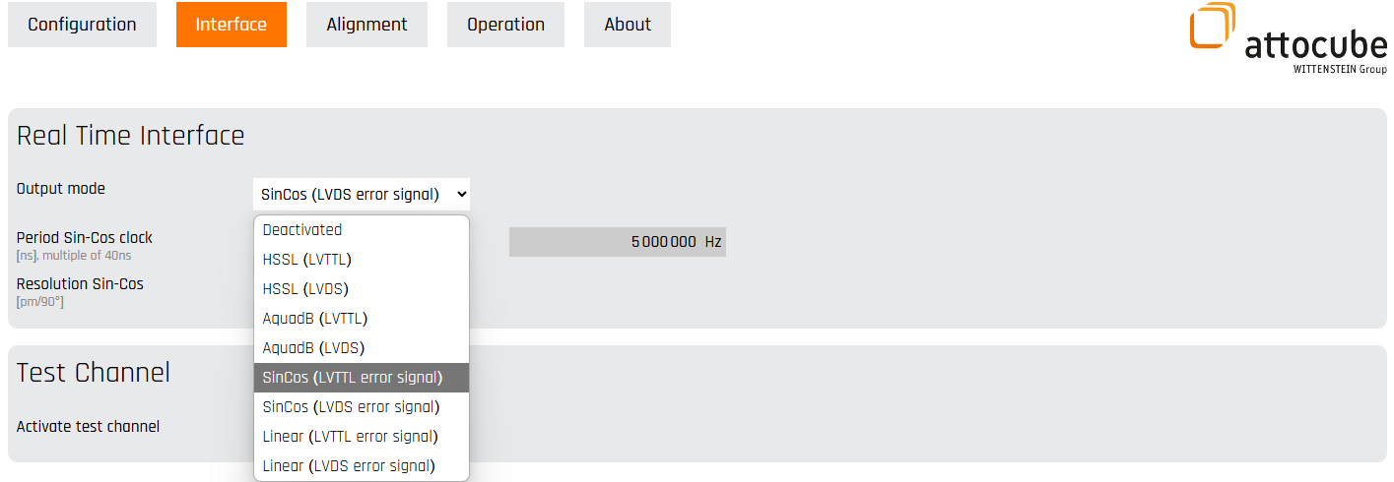  Figure 10: LVTTL and LVDS options are available  The error signal is high (= 1) as long as no measurement is running. During the measurement the error signal is low (= 0) and changes to high (= 1) if an error condition is indicated e.g. when the position is lost due to laser beam interruption.
Error example:  signal too high (overload) | If the interference signal saturates the photo detector, a signal overload is recognized and indicated by the error signal (see Figure 11).  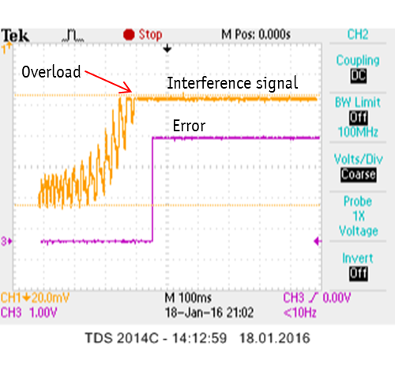  Figure 11: Overload detection situation via the error signal
Error example:  signal too low | The error signal indicates the case when the interference signal is less than the minimum threshold (see Figure 12).  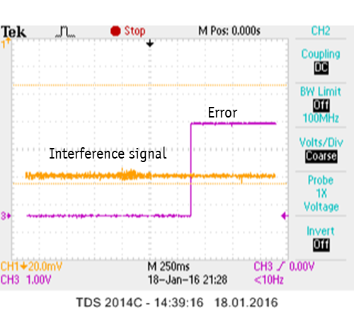  Figure 12: Signal loss detection situation via the error signal
Error example:  beam interruption | The error signal indicates a beam interruption (see Figure 13).  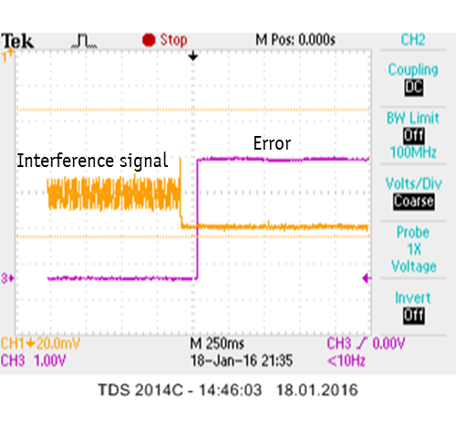  Figure 13: Beam interruption detected via the error signal

Optional interfaces

Linear Analog Output (only differential)
Overview | The Linear Analog Output mode (see Figure 14) returns a voltage level, which is proportional to the displacement (please refer to chapter Introduction). This Linear Analog Output is an optional IDS feature on request, which can be activated with an attocube license file, for further information please refer to the IDS User Manual.  This output supports two different measurement modes, the Displacement and the Vibrometry mode. In Displacement mode, the displacement is directly represented by the given voltage. In Vibrometry mode, the high pass filtering can additionally be applied to the displacement to exclude low frequent disturbances. The maximum bandwidth of the signal is 10 MHz, so frequency analysis can be performed up to 5 MHz with respect to the Nyquist-theorem. The output is quantized by a 12-bit bipolar Digital Analog Converter (DAC). Basically, this interface takes 12 out of 48 HSSL position bits and is carried by a voltage offset. The offset arises from the handling and interfacing of the IDS itself.
Web interface settings | As well as the other interfaces, the Linear Analog Output appears as an additional option in the drop-down menu of the interface tab output modes.  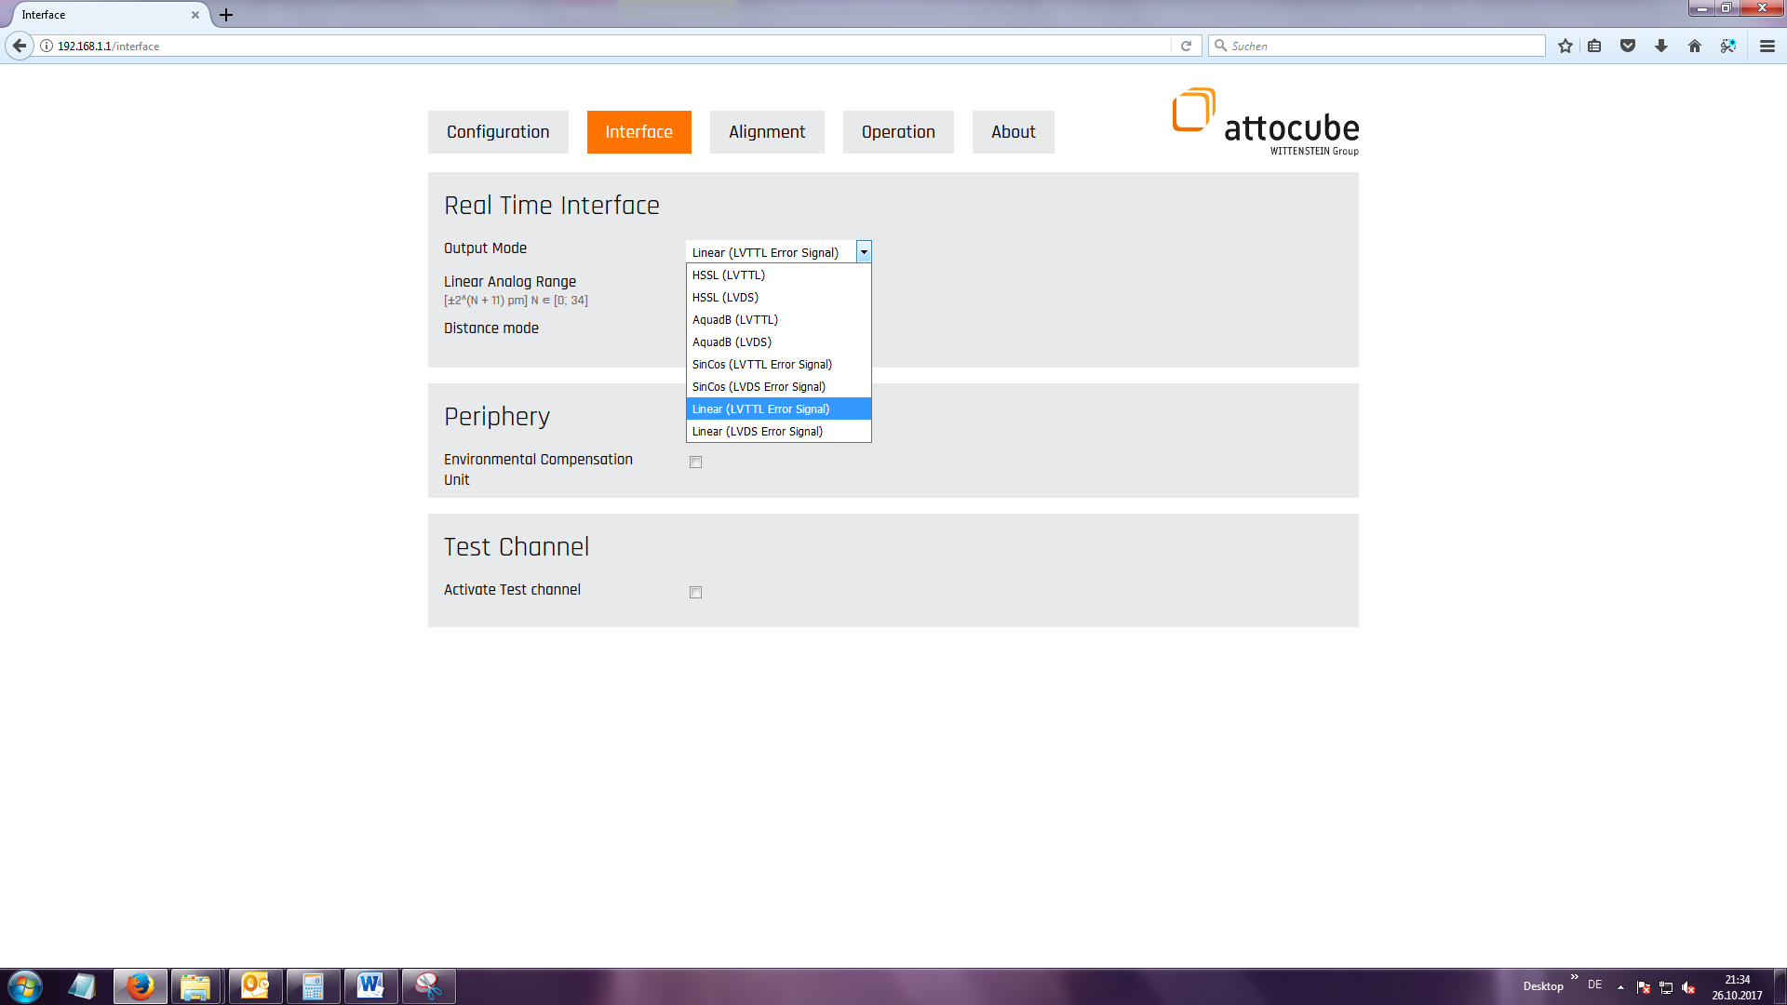  Figure 14: Using the Linear Analog Output mode
Linear analog resolution and range | The resolution for the output is given by the equation  $$±2^{N} pm, N∈\left[0, 34\right]$$  Since the outputed voltage level is converted by 12 bit, the minimum resolution of 1 pm can only be achieved for $N=0$. It is recommended to read out the signal at least with 12 bit (ADC/DAC) to prevent a loss in resolution. For N = 0, the first possible 12 bits out of the whole 48 bit HSSL word are shifted into the DAC. Therefore, the Linear Analog range is given by the equation  $$±2^{N+11} pm, N∈\left[0, 34\right]$$  The table below and the Figure 15 indicates all possible results and parameters in terms of Linear Analog configuration.  N Max Range + in pm Max Range – in pm Resolution in pm  0 2047 -2048 1  1 4095 -4096 2  2 8191 -8192 4  3 16383 -16384 8  4 32767 -32768 16  5 65535 -65536 32  6 131071 -131072 64  7 262143 -262144 128  8 524287 -524288 256  9 1048575 -1048576 512  10 2097151 -2097152 1024  11 4194303 -4194304 2048  12 8388607 -8388608 4096  13 16777215 -16777216 8192  14 33554431 -33554432 16384  15 67108863 -67108864 32768  16 134217727 -134217728 65536  17 268435455 -268435456 131072  18 536870911 -536870912 262144  19 1073741823 -1073741824 524288  20 2147483647 -2147483648 1048576  21 4294967295 -4294967296 2097152  22 8589934591 -8589934592 4194304  23 17179869183 -17179869184 8388608  24 34359738367 -34359738368 16777216  25 68719476735 -68719476736 33554432  26 1.37439E+11 -1.37439E+11 67108864  27 2.74878E+11 -2.74878E+11 134217728  28 5.49756E+11 -5.49756E+11 268435456  29 1.09951E+12 -1.09951E+12 536870912  30 2.19902E+12 -2.19902E+12 1073741824  31 4.39805E+12 -4.39805E+12 2147483648  32 8.79609E+12 -8.79609E+12 4294967296  33 1.75922E+13 -1.75922E+13 8589934592  34 3.51844E+13 -3.51844E+13 17179869184  Table 3: Signal range and resolution configurations for the Linear Analog Output in accordance with 35 different HSSL configurations  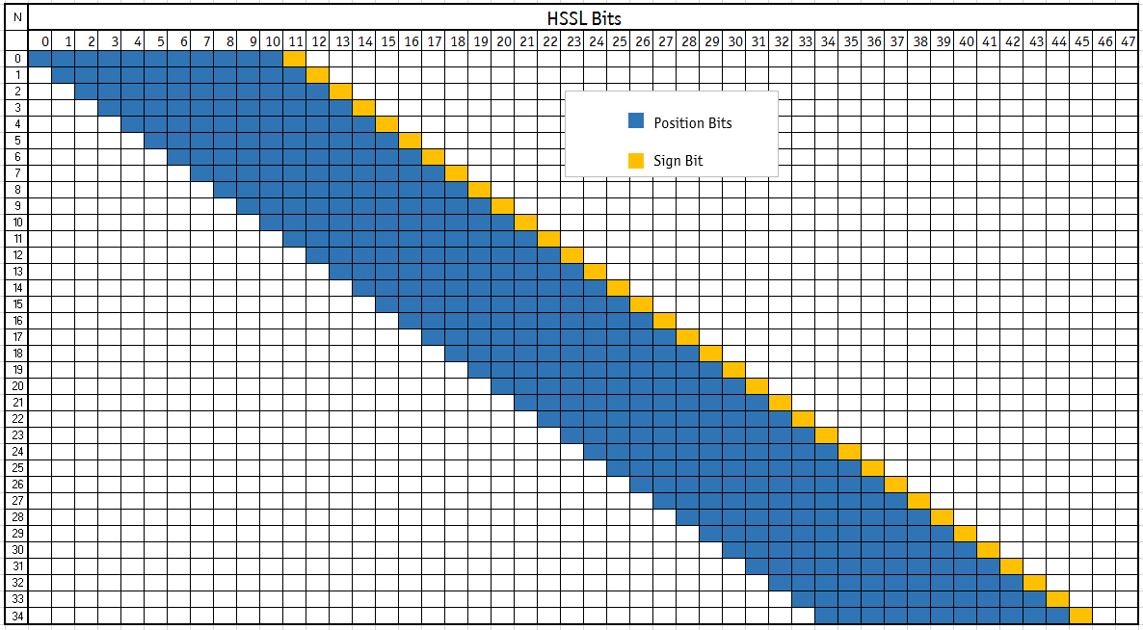  Figure 15: 35 different HSSL configurations that are transferred to the Linear Analog Output
Determining full range with Test Channel | The Linear Analog Output feature provides an additional window in the Interface tab to activate a test signal channel (see Figure 16).  Figure 16: Activating the test channel
By setting the check mark to the box, the differential test signal is transferred to pin 21 and 8 (see Chapter Real-time interface connector). The output is based on a rectangular signal to fill and determine the full output range.
Note: The test channel can be only activated on the measurement axis 1, as it is firmly connected to the output pin 21 and 8. Other measurement axes provide the measured signal, but have no test channel connection.
Note: The test channel on measurement axis 1 can only be activated in the idle state when no measurement or optics alignemnt is running.
Since linear analog is used in differential mode, the levels of pin 21 and 8 can be subtracted to evaluate the full range [V] (see Figure 17).
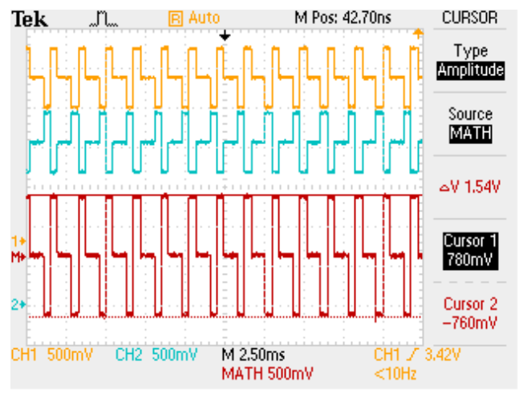
Figure 17: Using the test channel when working with differential transfer
The red line ist built by substracting the level of Pin 8 from Pin 21. The resulting signal reveals a full range of 1,54 V at 1 MΩ termination (single ended) in this example measurement.
Exceeding full range | If the full range is exceeded by means of displacement, the DAC will lead to a jump between the maximum and the minimum threshold of the analog output (see exemplary Figure 18), which is attributed to the characteristics of the DAC itself. Theoretically the full range can also be determined by the size of thoses jumps.  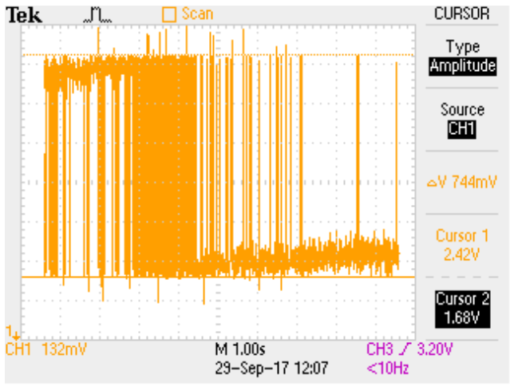  Figure 18: Exceeding the Linear Analog Output range  If the “reset axes” command is executed, the signal of the Linear Analog Output will be centered around the general signal offset (= zero position). From there on the range is limited by the positive and negative maximum from the table above, respectively a certain resolution parameter N.
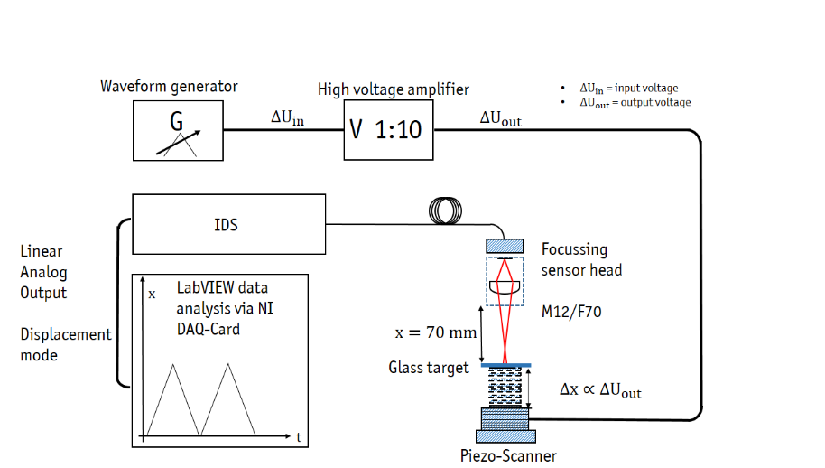
Figure 19: Example application
In an application example (see Figure 19) the target was actively excited by a waveform generator with a triangle voltage, according to the principal test setup in the picture above. The real-time data was acquired via a National Instruments Data Acquisition (DAQ)- Card and analysed with LabVIEW based software. The Linear Analog Resolution was set to N = 10. If the maximum range is not well aligned, the signal cosequently produces signal jumps (see Figure 20).
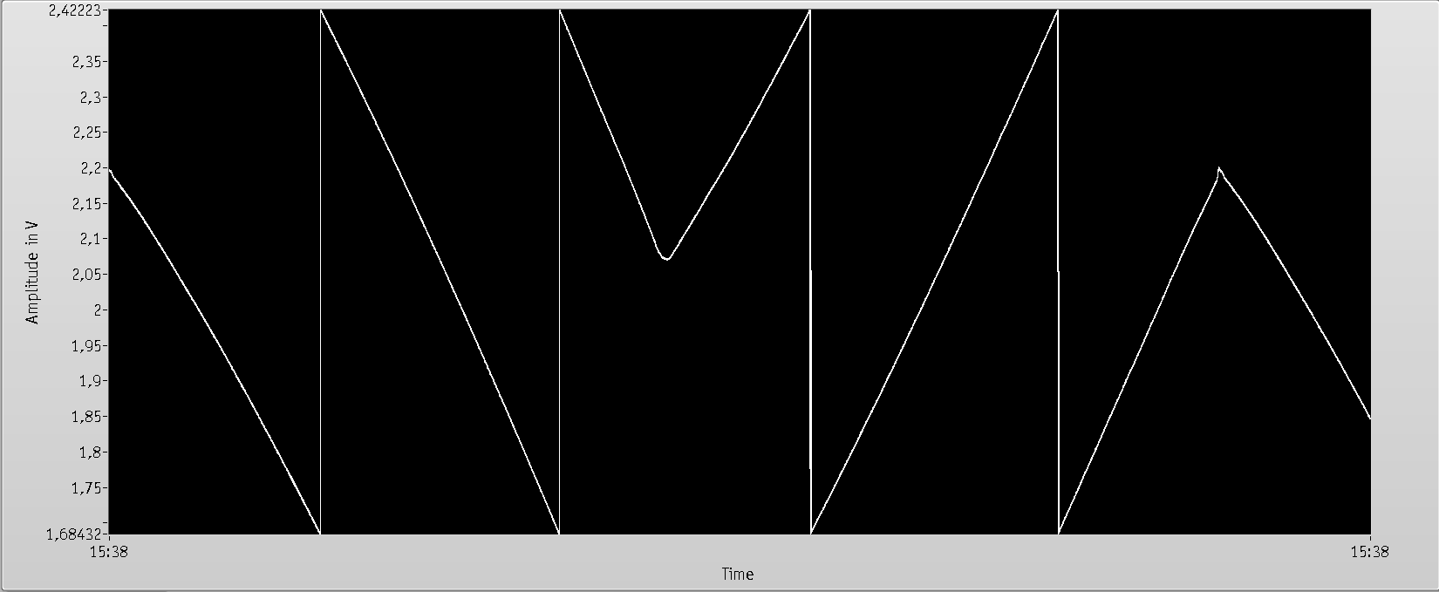
Figure 20: Signal jumps due to exceeding the Linear Analog Output range
It appeals to execute a reset axes command to center the signal around the offset, when the voltage exceeds its boundaries on first glance. Figure 21 shows a triangle oscillation of a piezo scanner within the predefined boundaries of the Linear Analog Output with no jumps distorting the displacement information. The range of the output should always be adapted to the expected target movement. In order to not exceed the boundaries it makes sense to apply higher ranges in the first step. Therefore, the measurement needs to be stopped and the range might be changed in terms of a higher maximum range.
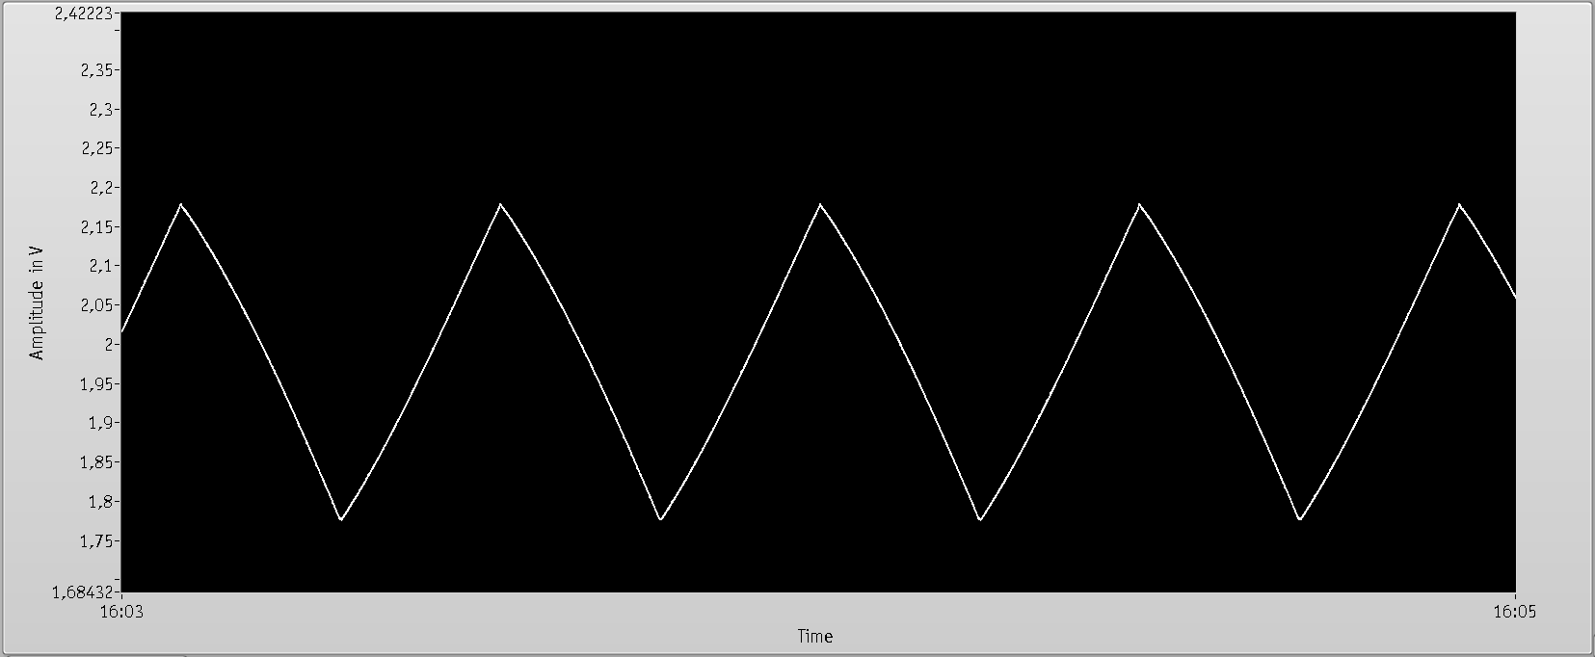
Figure 21: Range-conform displacement measurement
In order to achieve good signal-to-noise ratio, it is recommended to use the whole dynamic output span of the Linear Analog Output, because the DAC only quantizes 4095 steps within the whole range.
Vibrometry mode | As already mentioned, the Vibrometry setting (see Figure 22) contains a high pass filter option to get rid of low frequent influences in signal analysis.  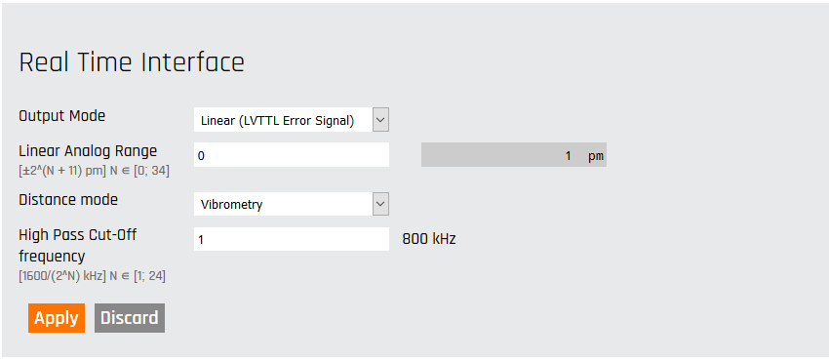  Figure 22: Vibrometry setting  The filter function is built by a cascaded first order two filter block. The high pass cut-off frequency is given by the equation  $$f_{-3dB}=\frac{1600}{2^{N}} kHz, N∈\left[1, 24\right]$$  All values are listed on the table below. The pass band decreases with a slope of -20 dB/decade.  N -3 dB high pass cut-off frequency in Hz  1 800000,000  2 400000,000  3 200000,000  4 100000,00  5 50000,000  6 25000,000  7 12500,000  8 6250,000  9 3125,000  10 1562,500  11 781,250  12 390,625  13 195,313  14 97,656  15 48,828  16 24,414  17 12,207  18 6,104  19 3,052  20 1,526  21 0,763  22 0,381  23 0,191  24 0,095  Table 4: High pass cut-off frequency in the Linear Analog Vibrometry setting
 | Note: The high pass filter uses the same register as the Average N filter (3 dB cut-off frequency). Therefore, in Vibrometry mode the high pass filter setting will be used for the measurement and the Average N filter setting has no impact on the measurement data.
Vibrometry example | With following example setup it is shown how the high pass filter in the vibrometry mode is working. A schematic of the principal setup can be found in Figure 23.  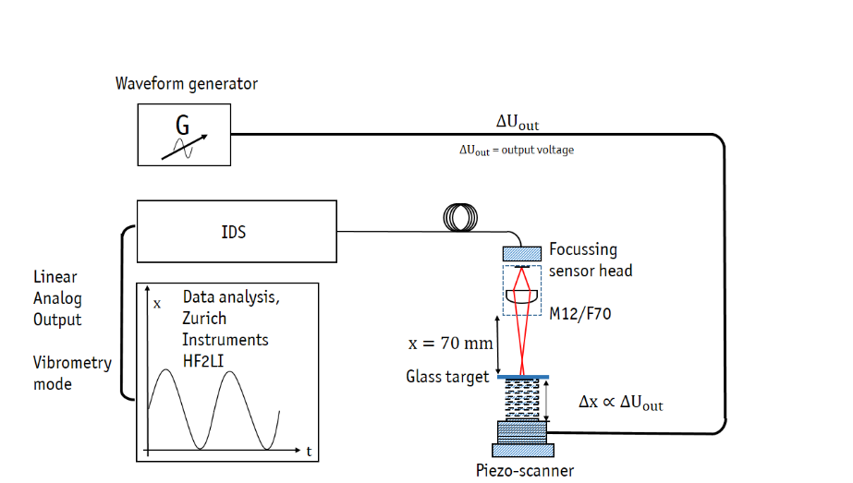  Figure 23: Vibrometry example setup  The first screenshot indicates a measurement amplitude of 8.18 mV at an oscillation frequency of 194 Hz in the frequency spectrum. In this case the used filter setting was N = 24 to gain the full spectral information (see Figure 24).  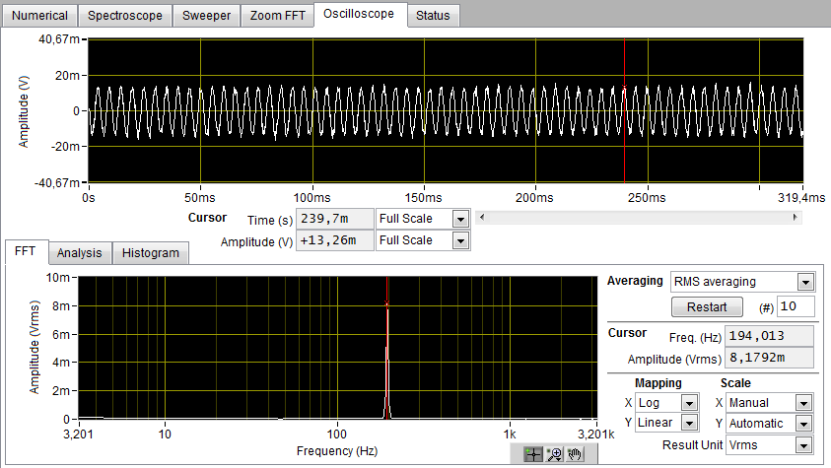  Figure 24: HF2LI result for N=24  In the next step the filter setting was changed to N = 13 which equals the -3 dB cut-off frequency of 195 Hz. Now the measured oscillation is supposed to be attenuated by – 3 dB, which corresponds to a factor of 0.707 (see Figure 25).  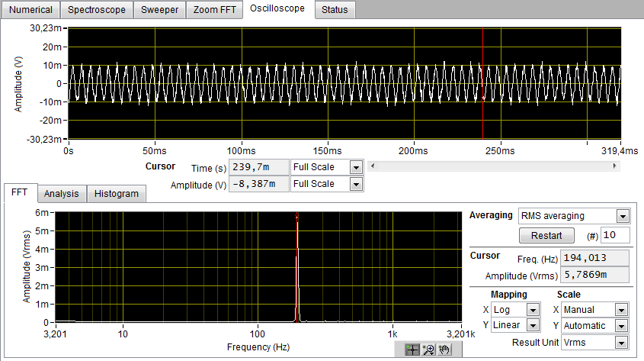  Figure 25: HF2LI result for N=13  After the cut-off frequency is set, the amplitude in the frequency spectrum reduces to 5.79 mV.
Detector signal during Alignment | 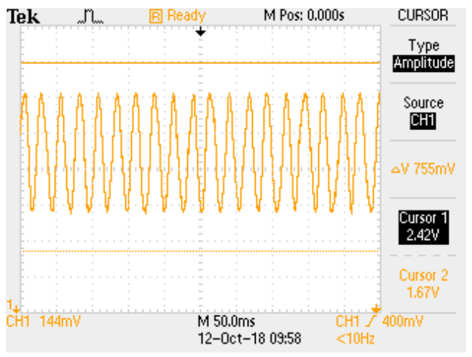  Figure 26: Detector signal routed to Linear Analog output during Optical Alignment  The detector signal (see Figure 26) is routed out through the Linear Analog output while the optical alignment is running. The cursors indicate the maximum and minimum load of the output which can be determined by activating the test channel on the measurement axis 1 (pin 21 and 8), first. Comparing this signal to the indicator bar in the web interface shows that the Linear Analog output is much faster. The feedback from adjusting a target with Linear Analog is more precise and freer of any quantization, like it is used in the web interface’s alignment bar algorithm.

BiSS C

Overview
The IDS can optionally be upgraded with the BiSS C interface (digital interface). BiSS C is an open standard introduced by the company iC-Haus. In contrast to the standard real-time interfaces, the BiSS signals are provided via the 14 pin GPIO connector (please refer to the IDS User Manual for the electrical interface). The BiSS C option requires a hardware update, in which the GPIO electronic board is replaced by the BiSS C interface module. All other real-time interfaces are disabled in this mode. The main difference to the HSSL mode is that the clock signal is provided by an external master. The master clock frequency is supported up to a frequency of 10 MHz. This is a local clock domain. There are three such clock domains in the FPGA because each BiSS C device gets its own clock from its master. The IDS uses the mc103z1 IP-core.
The BiSS C position data is encoded using the two's complement system.

Interface connector
Overview | The BiSS C signals are provided via the 14 pin GPIO connector. The matching connector is the Honda HDR-E14MAG1+ (see Figure 27).  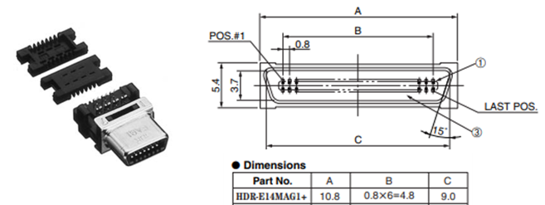  Figure 27: Honda HDR-E14MAG1+ connector  The GPIO interface cable with 14 open ended wires (see Figure 28) is provided with the BiSS C feature. Each wire is numbered according to the pinout table in Figure 29.  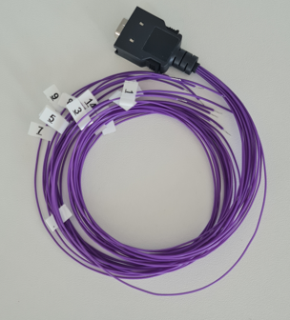  Figure 28: BiSS C connector cable as part of the BiSS-C IDS delivery scope
Pinout | Figure 29 shows the pinout of the BiSS C interface connector. The signal levels comply with the differential RS422 standard. The clock channel is denoted master (MA) and the data channels are denoted slave out (SLO).  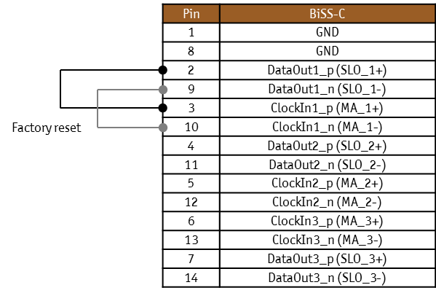  Figure 29: BiSS C connector pinout
Factory reset | A factory reset requires the short circuit of the following pins:  DataOut1_p ClockIn1_p  DataOut1_n ClockIn1_n
 | During the boot procedure of the IDS, a test pattern is sent to the GPIO DataOut1 channel. If this pattern is received at the ClockIn1 channel, the IDS executes a factory reset. In case the IDS is connected to a BiSS C master, this pattern could be interpreted as a position word or an invalid position word by mistake!
 | Note: depending on the IDS hardware version, the factory reset can be executed via the factory reset button. If there is a factory reset button, the option of the factory reset via pin short circuit doesn’t exist. For more information, please refer to the IDS User Manual.

Interface configuration
Web interface settings | The BiSS C interface can be configured in the Interface tab of the web interface (see Figure 30). BissC supports two different measurement modes Displacement and Absolute position.  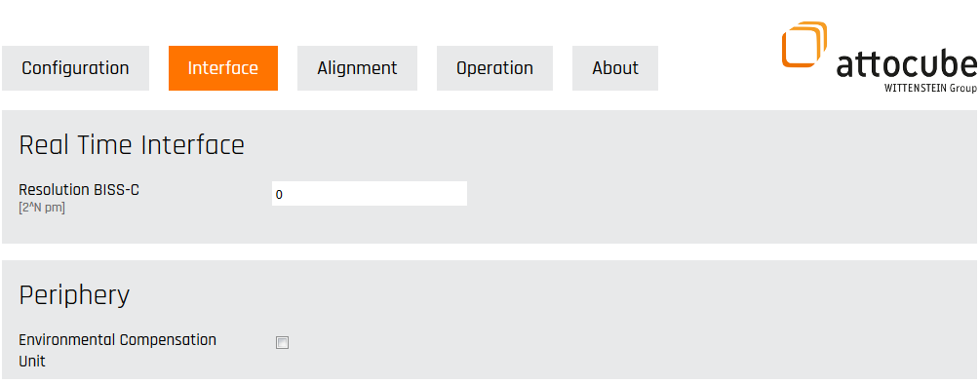  Figure 30: Configurating the BiSS C interface
Resolution BiSS C | This parameter N defines the position resolution of the BiSS C interface. It sets the lowest bit of the 32 bit distance value out of the full 48 bit position word (similar to HSSL, please refer to chapter HSSL). The position resolution is therefore given by the equation  $$Resolution BiSS C= 2^{N}*1 pm, N∈\left[0, 16\right]$$  The given resolution, as well as the resulting maximum range can be found in the table below.  N Max. Range + in pm Resolution in pm  0 4294967296 1  1 8589934592 2  2 17179869184 4  3 34359738368 8  4 68719476736 16  5 1.37439E+11 32  6 2.74878E+11 34  7 5.49756E+11 128  8 1.09951E+12 256  9 2.19902E+12 512  10 4.39805E+12 1024  11 8.79609E+12 2048  12 1.75922E+13 4096  13 3.51844E+13 8192  14 7.03687E+13 16384  15 1.40737E+14 32768  16 2.81475E+14 65536  Table 5: Biss C configuration table  Figure 31 shows 32 bit section of the full 48-bit position word depending on the setting for N.  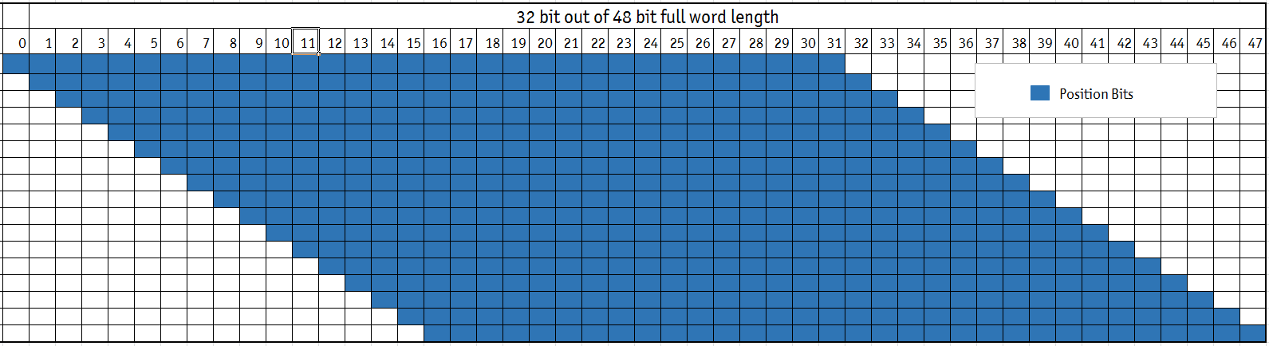  Figure 31: 32 bit section depending on N
 | Note: Biss C interface has no Anti-Alising filter by itself. Therefore, it is recommended to set the 3 dB cut-off frequency as low pass filter. This setting can be set in the web interface in the Operation tab or via software communication interfaces (please refer to chapter 3 dB cut-off frequency (Average N filter).
Displacement mode | In Displacement mode the displacement data starts with zero displacement value. The maximum transferred positive displacement corresponds to the maximum range according to Table 5. The maximum transferred negative displacement is half of the positive range due to the two’s complement encoding.
Absolute position mode | In Absolute position mode the absolute position data is transferred according to the set BiSS C parameters. Please note that the word size should be large enough to fit the measured absolute position. Otherwise, the absolute position will be truncated.

Protocol description
The signal levels comply with the RS422 standard. The slaves are linear sensors using the BISS C profile BP3.
The data format of the single cycle data (SCD) is
POS(32) + nE(1) + nW(1) + CRC(6),
where POS(32) denotes the 32 bit position value (the resolution is user adjustable), nE(1) is an error bit, nW(1) is a warning bit, and CRC(6) is the 6 bit cyclic redundancy check, using the BP3 default polynomial 0x43 (start value 0).
Note: the warning bit nW (= “not warning”) is unused and is always set to 1. The error bit nE (= “not error”) is set to 1 and changes to 0 if an error condition is indicated e.g. when the position is lost due to laser beam interruption.

Real-time interface connector
Overview | The IDS has a 26 pin connector for the real-time output signals from HSSL, AquadB, Sin/Cos and Linear Analog Output interfaces (please refer to the IDS User Manual for the electrical interface). Figure 32 shows the front view of the real-time connector:  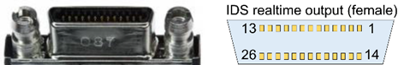  Figure 32: Front view of the real-time connector  A matching connector is the Honda HDR-E26 MAG1+ (see Figure 33).  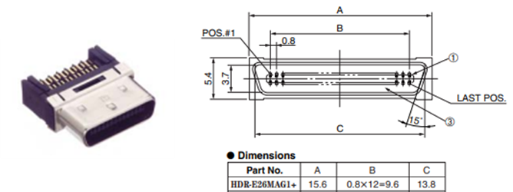  Figure 33: HDR-E26 MAG1+ male connector that can be used to finish a cable  The real-time interface cable with 26 open ended wires (see Figure 34) is provided in the accessories box. The table below shows the pinout of this cable.  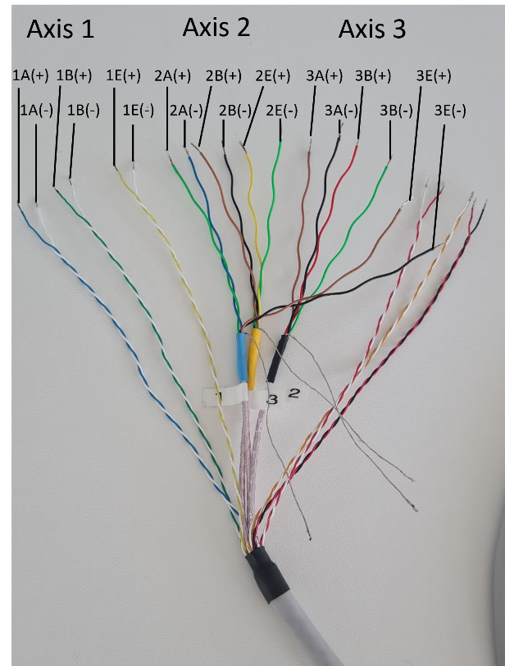  Figure 34: Real-time output cable with open ends (description using example of AquadB LVDS pinout)

Pin IDS top view | Pin 3M SDR Cable | Signal |  | HSSL  LVTTL |  | HSSL  LVDS |  | AquadB  LVTTL |  | AquadB  LVDS |  | Sin/Cos  (error: LVTTL) |  | Sin/Cos  (error: LVDS) |  | Linear Analog  (error: LVTTL) | Linear  Analog  (error: LVDS)
Axis 1
21 | blue (white) | POSITION 1 |  | CLK1 |  | CLK1(+) |  | 1A |  | 1A(+) |  | 1A(+) |  | 1A(+) |  | 1(+) | 1(+)
8 | white (blue) |  |  | - |  | CLK1(-) |  | - |  | 1A(-) |  | 1A(-) |  | 1A(-) |  | 1(-) | 1(-)
22 | green (white) |  |  | DATA1 |  | DATA1(+) |  | 1B |  | 1B(+) |  | 1B(+) |  | 1B(+) |  | - | -
9 | white (green) |  |  | - |  | DATA1(-) |  | - |  | 1B(-) |  | 1B(-) |  | 1B(-) |  | - | -
23 | yellow (white) | ERROR 1 |  | 1E |  | 1E(+) |  | 1E |  | 1E(+) |  | 1E |  | 1E(+) |  | 1E | 1E(+)
10 | white (yellow) |  |  | - |  | 1E(-) |  | - |  | 1E(-) |  | - |  | 1E(-) |  | - | 1E(-)
Axis 2
18 | 1 blue | POSITION 2 |  | CLK2 |  | CLK2(+) |  | 2A |  | 2A(+) |  | 2A(+) |  | 2A(+) |  | 2(+) | 2(+)
5 | 1 green |  |  | - |  | CLK2(-) |  | - |  | 2A(-) |  | 2A(-) |  | 2A(-) |  | 2(-) | 2(-)
19 | 3 brown |  |  | DATA2 |  | DATA2(+) |  | 2B |  | 2B(+) |  | 2B(+) |  | 2B(+) |  | - | -
6 | 3 black |  |  | - |  | DATA2(-) |  | - |  | 2B(-) |  | 2B(-) |  | 2B(-) |  | - | -
20 | 3 yellow | ERROR 2 |  | 2E |  | 2E(+) |  | 2E |  | 2E(+) |  | 2E |  | 2E(+) |  | 2E | 2E(+)
7 | 3 green |  |  | - |  | 2E(-) |  | - |  | 2E(-) |  | - |  | 2E(-) |  | - | 2E(-)
Axis 3
15 | 2 brown | POSITION 3 |  | CLK3 |  | CLK3(+) |  | 3A |  | 3A(+) |  | 3A(+) |  | 3A(+) |  | 3(+) | 3(+)
2 | 2 black |  |  | - |  | CLK3(-) |  | - |  | 3A(-) |  | 3A(-) |  | 3A(-) |  | 3(-) | 3(-)
16 | 2 red |  |  | DATA3 |  | DATA3(+) |  | 3B |  | 3B(+) |  | 3B(+) |  | 3B(+) |  | - | -
3 | 2 green |  |  | - |  | DATA3(-) |  | - |  | 3B(-) |  | 3B(-) |  | 3B(-) |  | - | -
17 | 1 brown | ERROR 3 |  | 3E |  | 3E(+) |  | 3E |  | 3E(+) |  | 3E |  | 3E(+) |  | 3E | 3E(+)
4 | 1 black |  |  | - |  | 3E(-) |  | - |  | 3E(-) |  | - |  | 3E(-) |  | - | 3E(-)
GND
12 | black (red) |  | GND
26 | red (white) |  | GND
1 | white (red) |  | GND
24 | gold (white) |  | GND
11 | white (gold) |  | GND
13 + 14 | inner shield |  | GND
25 | red (black) |  |  |  | Internal use only
Table 6: Pinout for different real-time interfaces

At least one GND pin must be connected to ground when using the real-time interface.

Software communication & interfaces
You can integrate your attocube device into complex automated processes via individual software interfaces. attocube provides APIs for the programming languages C, C#, LabVIEW, Python & Matlab as well as short programming examples to get you started.
The following sections provide information on methods, commands and parameters to be used for calling up device functions with the respective language.

Introduction
The device provides a set of software communication interfaces offering a broad set of functions and options. These can be used to configure the device as well as to read out data. The following software communication interfaces exist:
• Web interface (please also refer to the User Manual)
• JSON-RPC
• C DLL
• C# DLL
• LabVIEW VIs
• Matlab library
• Python library

Most of the different functions are accessible within every interface. This is why we sort by functions not by interfaces. For every function, we show how the implementation in the particular interface is done. Anyway, first we give a short explanation of the different interfaces:
Note: Part of the conventions mentioned below are specific for the handling of attocube devices and are not necessarily applicable in other contexts.

Web Interface
The device runs a built-in webserver. This means that a web interface can be accessed via a common web browser. How to set up the IP and a first connection is given in the User Manual. The web interface is the most straightforward way to communicate with the device and almost full functionality is implemented.

JSON-RPC
The device allows platform-independent communication using JSON-RPC via TCP/IP and websocket. The JSON commands are the lower level that all other wrappers (e.g. Python or C) use.

C/C# DLLs
Based on the JSON interface, C/C# libraries are available to implement the functions within C/C#-based coding environments.

LabVIEW VIs
We offer ready-made VIs to have fast and easy implementation in National Instrument’s LabVIEW environment.

Matlab library
Based on the JSON interface, we offer ready-made Matlab functions to have a fast and easy implementation in Mathwork’s Matlab environment.

Python library
Based on the JSON interface, we offer ready-made Python functions to have a fast and easy implementation in Python environment.

Overview and implementation of the APIs

JSON-RPC (JRPC2.0)
Your attocube device allows platform-independent communication using JSON-RPC via TCP/IP. When using JSON-RPC, the following conventions apply.
Transport protocols | TCP  Uses communication port 9090.
Calling a JSON RPC 2.0 method | A JSON RPC method is called by sending a message to the device.  { "jsonrpc": "2.0", "method": "<method>", "params": [<param [0]>, <param [1]>, …], "id": <call id>, “api”: <api version>}  <method>: String defined in chapter 2.2.  <param x>: Parameter for the method call. If PARAM is put between two “, it is a string. Without “ it is a number  <call id>: A unique id to find the corresponding answer  <api version>: A version identifier for backward compatibility, please set to 2
Example | Example:  { "jsonrpc": "2.0", "method": "com.attocube.sen.displacement.getAxisDisplacement", "params": [1], "id": 1, “api”: 2}
Receiving a JSON RPC 2.0 response | The JSON RPC method answer is then sent back as payload to the OK message:  { "jsonrpc": "2.0", "result": [<return values [0]>, <return values [1]>, …],  "id": <call id>}  <return values [x]>: The return parameters  <call id>: The unique id of the method call
Example | Example:  { "jsonrpc": "2.0", "results": [0, 4], "id": 1}
Example | Example:  Communication via PuTTY  Open a Telnet connection with PuTTY.  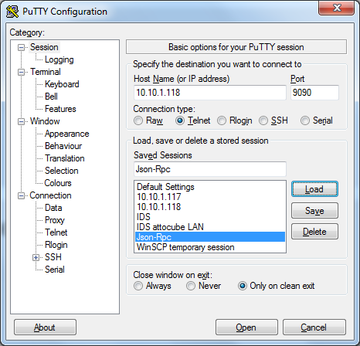  Sending JSON-RPC commands in the command line interface.  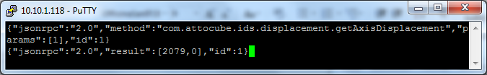

C Library
The C API is provided to integrate the device with all its functionality within your C programs.
Overview | The C API contains the following files:  Standard C API:  - attocubeJSON.dll (x64 and x86 versions for a windows environment)  - attocubeJSON.lib (x64 and x86 versions for a windows environment)  - attocubeJSON.so (x64 and x86 versions for a linux environment)  - attocubeJSONCall.h (header file for the general functions)  - generatedAPI.h (header file for the device specific functions)  Disovery C API:  - attocube-discovery-dll.dll  - attocube discovery-dll.lib  - attocube-discovery.h (header file)
Using the .dll’s with different systems | Note that if you want to use the .dlls within x64 based systems outside the framework of Visual C, you might need to convert the library into a static .a format.
Establishing a connection | To connect to a device, please use (part of attocubeJSONCall.h):  int ATTOCUBE_API Connect(const char *deviceAddress, int* deviceHandle)  The device handle is the reference to the connection and the device and is input to all other device functions that are following.  To close the connection, please use:  int ATTOCUBE_API Disconnect(int * deviceHandle)  Both functions are included in the API.  For a TCP/IP connection, the port 9090 is used.
Discovering devices within the same network | The discovery function can be used:  It searches your network for available attocube devices and returns a list of properties. This is done by a SSDP broadcast. If no devices are found, please check the device connection via TCP/IP (e.g. via the websever). The device must be in the same subnet than the requesting PC.  IMPORTANT NOTE: These functions are part of an additional discovery .dll – the “attocube discovery dll”, which is also part of the standard delivery content.  Therefore, following functions are available:  int DLL_EXP AD_GetDeviceInfos(int index, DeviceInfo* info)  (Get informations about a discovered device)  void DLL_EXP AD_ReleaseInfo();  (Release memory allocated by AD_Check)  int DLL_EXP AD_Check(deviceType)  (Checks discoverable devices on the network and retrieves informations)  Special data types:  typedef struct {  char ipAddress[32]; /**< IP address of the device */  char modelName[32]; /**< Type of the device */  char serialNumber[32]; /**< Serial number of the device */  char deviceName[32]; /**< Friendly name assigned to the device */  char macAddress[32]; /**< MAC address of the device */  bool locked; /**< Device locked by other program */  } DeviceInfo;  typedef enum {  IDS,  MOTION_CTRLER,  BOTH  } deviceType;

C# Library
The C# API is provided to integrate the device with all its functionality within your C# programs.
Overview | The C# API contains of following files:  - CSharpAPIDLL.dll (compiled as “any” version)  - Newtonsoft.Json.dll (compiled as “any” version)  - Attocube.chm (helpfile)
Establishing a connection | To connect to a device, please create an device object  public static Attocube<Device> client = new Attocube<Device>()  where <Device> is e.g. AMC or IDS  The connect function is a property of the Attocube<Device> class.  public void Connect(string ipAddress, int port)  The device handle is the reference to the connection to the device and is input to all other device functions that are following.  To close the connection, please use:  public void Disconnect()  Both functions are included in the API and part of the device class (so initialize a member of the class first).  For a TCP/IP connection, use the port 9090.
Discovering devices within the same network | The discovery function can be used:  It searches your network for available devices and returns a list of properties. This is done by an SSDP broadcast. If no devices are found, please check the device connection via TCP/IP (e.g. via the websever) or make sure that the device is in the same subnet than your PC  IMPORTANT NOTE: These functions are part of an additional discovery .dll – the “attocube discovery dll”, which is also part of the standard delivery content.  Therefore, following function is available:  public DiscoveryData[] Check()  Special data type:  Type: DiscoveryData  Class for handling the data of devices discovered using the discovery protocol

LabVIEW
The LabVIEW API is provided to integrate the device with all its functionality within your LabVIEW VIs.
Overview | The LabVIEW API contains a LabVIEW project which contains all single function VIs and a master example VI that uses almost all functions available and that mimics the web interfaces UI for easy navigation.
Implementation | To reduce complexity and external dependencies all TCP/IP calls have been implemented with native LabVIEW TCP/IP elements. For older LabVIEW Versions where there is no native TCP/IP support, DLL based VIs have been created taking care of the TCP/IP communication.  The folders “DLLHandler” or “TCPHandler” contain the respective SubVIs handling the messaging and communication with your attocube device, which are used within all low-level VIs. Those should not be modified or used directly.
High-level Wrapper VIs | For most functions that do have both a set and a get method a higher level “controlMethod” VI has been created to reduce the number of VIs and also be as backwards compatible as possible to the older motion controller series ECC100 and ANC350. Some additional high level VIs like the deviceInfo VI have been created where multiple low-level VIs are combined into one VI and all In- and Outputs are bundled into clusters.  In case you still want to use those low-level VIs instead, they can be found inside folders that contain the word “SubVIs”. For code cleanliness it is not recommended to use those. However to keep the documentation consistent over all programming languages, only the low-level methods are documented (see chapter 3).
Establishing a connection | To connect to an device, please use the connect VI  The output is the reference to the connection to the device and is needed as an input to all other device functions that are following.  To close the connection, please use the Close VI  Both VIs are included in the API.
Discovering devices within the same network | The discovery function can be used:  It searches your network for available devices and returns a list of properties. This is done by an SSDP broadcast. If no devices are found, please check the device connection via TCP/IP (e.g. via the websever) or make sure that your device is in the same subnet than your PC.  IMPORTANT NOTE: These functions are part of an external DLL – the “attocube discovery dll”, which is also part of the standard delivery content.  Therefore, the “Check.vi” is available.

Matlab
The Matlab API is provided to integrate the device with all its functionality within your Matlab scripts.
Establishing a connection | To connect to an device, please use:  [success, DeviceHandle] = connect(IPAddress, port)  The device handle is the reference to the connection to the device and is input to all other device functions that are following.  To close the connection, please use:  [success] = disconnect(DeviceHandle)  Both functions are included in the API.  For a TCP/IP connection, use the port 9090

Python
The Python API is provided to integrate the device with all its functionality within your Python programs.
Overview | The Python API contains a folder with domain specific files.  To have access to the python functions, please import the Device within your python script:  import <Device>  where <Device> is your DeviceType, e.g. AMC or IDS
Establishing a connection | To connect to an device, please use:  device = <Device>.Device(ipAdress)  device.connect()  The device handle is the reference to the connection to the device and is input to all other device functions that are following.  To close the connection, please use:  device .close()  Both functions are included in the API and part of the device class (so initialize a member of the class first).  For a TCP/IP connection, the port 9090 is used per default.
Discovering devices within the same network | The discovery function can be used:  It searches your network for available devices and returns a list of properties. This is done by an SSDP broadcast. If no devices are found, please check the device connection via TCP/IP (e.g. via the websever) or make sure that the device is in the same subnet than your PC  Therefore, following module function is available:  <Device>.discover()  This returns a dictionary containing all found devices combined with their device information.

Error handling

C error handling
Introduction | The error handling in C is realized with return values, directly returned by each function. On success, the function yields zero. Negative error numbers indicate an error within the DLL itself and are specified in the header File ( attocubeJSONCall.h). Positive Error numbers indicate an error in the Device, and can be translated to readable strings with system_errorNumberToString()
Example | int value;  int ret = Device_Function(device, &value);  if( ret == ATTOCUBE_Ok) {  //success  }  else if (res < ATTOCUBE_Ok) {  //DLL Error, e.g. not connected  }  else if (res > ATTOCUBE_Ok) {  //Device Error  char errorNameBuf[BUF_SIZE];  system_errorNumberToString(device, 0, ret, errorNameBuf, BUF_SIZE);  printf("%s", errorNameBuf)  }

C# error handling
Introduction | The error handling in C# is realized with exceptions not by error numbers. Errors can be caught using a try-catch statement. To include the device specific exceptions, the catch clause will need the AttocubeAPIException as argument. An example code is shown below.
Example | public class AttocubeApiException:  ApplicationException  Example: Exception handling  try  {  attoDevice.<Method>();  }  catch (AttocubeApiException e)  {  int err = e.ErrorCode; // passes the errorcode of type int to "err"  string errmsg = attoDevice .ErrorNumberToString(0, err);  // converts "err" into the corresponding error message and passes it to "errmsg" of type string  }

Python error handling
Introduction | The error handling in Python is realized with exceptions not by error numbers. Errors can be caught using a try-except statement. To include the specific exceptions, the catch clause will need the AttoException as argument. An example code is shown below.
Example | #example for exception handling  from ACS import AttoException  try:  print(dev.<Method> ()) #OK  except AttoException as e:  print(e)

LabVIEW error handling
Introduction | The error handling in LabVIEW is realized by using an error message variable which should be looped through all VIs. Therefore, every VI provides an error in and error out connector. Note that we divide the error variable in error messages and “real” errors, which are treated differently. Error messages have a positive error number value combined with the Boolean error status set on inactive (Boolean value on false – visualized by a green hook icon), whereas “real” errors have a negative error number values with an active (Boolean value on true – visualized by a red cross icon) error status. Error messages do not influence the execution of the following VIs, they are used to inform the user. “Real” errors hinder the execution of following VIs, they are meant to stop the program. Examples are shown below:
Example | Example for an error message. An indicator is used to visualize the error message in the front panel (see Figure 35). Facing a positive error code value, an error message is indicated. The status is still set on green meaning no real error available. Error messages are intended to inform the user or other functions about certain cases. If an error message is inputted in the following VI, this VI still is executed.  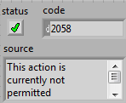  Figure 35: LabVIEW example for an error message
Example for a “real” error. Facing a negative error code value, a “real” error is indicated (see Figure 36). Therefore, also the status is set on red, which means that the error is active. When an active error is inputted in the next VI, this VI will not execute its function.
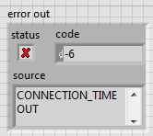
Figure 36: LabVIEW example for a "real" error

Streaming
The streaming functionality is available as an optional feature and allows high-speed data access through a software interface. For additional information about feature activation please refer to the User Manual. With streaming, measurement data can be retrieved at defined sample rates of up to 1 MHz, without requiring a dedicated hardware connection. This makes it the simplest method for accessing high-speed measurement data. The data can be accessed either through the API, which is available in C, C#, and Python, or through the WAVE software, which provides a graphical user interface for the streaming feature.

Streaming C
Overview | The C streaming API contains following files:  - SEN.Stream.dll  - SEN.stream.h  - README.txt  - streaming_example_recording.cpp  - streaming_example_while_loop.cpp
Implementation | From the README.txt:  The basic steps required to get the dll running with your C application  Step 1: Include the DLL's Header  In your C/C++ project, you need to include the header for the DLL. Ensure the header file can be found in the project file path.  e.g. include "SEN.Stream.h"  Step 2: Link the DLL  You need to link your C++ project with the SEN.Stream.dll. If you are using an import library (like SEN.Stream.lib), ensure it is linked correctly in your project settings.  - In Visual Studio:  Open the Project Properties.  Go to Configuration Properties > Linker > Input.  Add SEN.Stream.lib to Additional Dependencies.  - In GCC/MinGW:  g++ -o MyApp MyApp.cpp -L. -lSEN.Stream  Step 3: Ensure DLL Availability  Make sure that SEN.Stream.dll is accessible when running your application:  Place SEN.Stream.dll in the same directory as the executable.  Or add the directory containing SEN.Stream.dll to the system’s PATH environment variable.
Examples | An example is given to verify the correct implementation of the library and to help with the understanding of the functions.  streaming_example_recording.cpp  The program loops the data recording until at least 5000 (note that only packages of max. 1023 values are received) samples were streamed and decoded. The received data is written into a .txt file. Furthermore the data gets recorded into a .aws file using the StartStreamRecording function.  streaming_example_while_loop.cpp  The program streams and decodes 1023 position values with a streaming rate of 100 kHz from axis 1, 2 and 3. Note that error buffers should contain values of 0s or 1s after successful decoding. Error flag 1 indicates that error detected on the corresponding position value whereas 0 indicates no error detected. The ecu buffer holds the 4 ecu data: temperature, humidity, pressure and refractive index respectively.

Streaming C#
Overview | The C# streaming API is wrapping the C streaming API and contains following files:  - SEN.Stream.dll (the actual C dll that gets wrapped)  - SEN.StreamDLLWrapper.dll: the C# wrapper  - README.txt  - streaming_example.cs
Implementation | From the README.txt:  Step 1: Placing the two DLLs:  The C# API Wrapper DLL (SEN.StreamDLLWrapper.dll): The C# API wrapper DLL is a managed assembly, which means it is part of your .NET project. You need to reference it in your project so that you can use its functionality to interact with the C DLL.  You don't need to place the C# wrapper DLL directly in the executable folder at build time. Instead, you should ensure that it's referenced by your .NET project. When you build the project, Visual Studio (or the .NET CLI) will output this DLL to your project’s output directory, typically either bin\Debug or bin\Release.  The C_DLL (SEN.Stream.dll) is the original Streaming library that the C# API wrapper (SEN.StreamDLLWrapper.dll) interacts with using P/Invoke. This DLL needs to be located in the platform-specific directory where the application can find and load it during runtime.  The C DLL should be placed in the same directory as the application’s executable (or in a platform-specific folder within the application's directory). This ensures that the application can find the unmanaged library without issues. Missing or incorrectly placing the SEN.Stream.dll can result in runtime errors.  example target location: YourProject\bin\Debug\SEN.Stream.dll  Step 2: Referencing the C# API Wrapper DLL (SEN.StreamDLLWrapper):  When developing in Visual Studio (or using the .NET CLI), you need to reference the C# API wrapper DLL in your project. You’ll need to manually add a reference.  Right-click on your project in Solution Explorer > Add > Reference > Browse and select the C# API wrapper(SEN.StreamDLLWrapper.dll) file.  Step 3: Usage:  Once the DLL is referenced, you can use its methods just like any other .NET class. You’ll call the methods exposed in your wrapper, which in turn will call the unmanaged C functions from the C DLL.  Example of calling a method from the C# API wrapper:  using SEN.StreamDLLWrapper;  class Program  {  static void Main()  {  var wrapper = new StreamDLLWrapper();  wrapper.Open_Stream("192.168.1.1", true, 10, channelMask); // Calling a function that interacts with the C DLL  }  }
Example | One example is given to verify the correct implementation of the library and to help with the understanding of the functions.  streaming_example.cs  This is an exemplary implementation of the C# API Wrapper for the IDS streaming feature. The program uses the SEN.StreamDLLWrapper which interact with the SEN.Stream native C library to stream and decode at least 5000 position values with a streaming rate of 100 kHz from axis 1, 2 and 3. Note that error buffers should contain values of 0s or 1s after successful decoding. Error flag 1 indicates that error detected on the corresponding position value whereas 0 indicates no error detected.

Streaming Python
Overview | The Python streaming API is wrapping the C streaming API and contains the following files:  - SEN.Stream.dll  - stream.py  - streaming.py  - README.txt  - streaming_example_while_loop.py  - streaming_example_animate_loop.py  - streaming_example_backgroundStreaming.py
Implementation | The SEN.Stream.dll provides functionality to read and decode streams of positional data from attocube interferometer devices.  The DLL contains functions that take input buffers, establish the initial http connection to the attocube interferometer device for streaming, process streams, and write decoded data.  The Python wrapper contains modules to call and use functions from the SEN.Stream.dll. This is typically done using Python’s built-in ctypes libraries, which enable Python to load the DLL, define the C function signatures, and pass data between Python and C correctly.  Here's what to know when using SEN.Stream.dll through the python API wrapper.  Streaming can be accessed via the Python streaming API in two ways:  - the Device class form SEN.py  - the Stream class form stream.py in the streaming folder  Streaming via the Device class from SEN.py is the most straight forward way to stream displacement data from the IDS3010.  An example how to use streaming this way can be found in streaming_example_backgroundStreaming.py. This file has to be run via the console, see the Readme.txt in the ./streaming/Examples folder. To run the script as a file some modifications are required, that are described in the Readme.txt in the ./streaming/Examples folder.  Available methods are:  startBackgroundStreaming: Starts concurrent and permanent position streaming to an aws file in background.  stopBackgroundStreaming: Stops the permanent position streaming  isRunningBackgroundStreaming: Get state of background position reading  loadFile: Load content of recorded aws stream file  These methods can be used by defining an instance of the Device class form SEN.py, e.g.  sen = SEN.Device('192.168.1.1')  sen.connect()  and using the streaming subclass form Device, e.g.  sen.streaming.startBackgroundStreaming(isMaster=True, intervalInMicroseconds=20, bufferSize=2<<3, filePath=filename+'.aws', axis0=True, axis1=True, axis2=True)  Streaming via Stream class form stream.py provides interactive, low latency streaming. The Stream class provides the interface to the core streaming functions of the SEN.Streaming.dll. It loads the DLL, sets up correct function signatures, wraps and exposes the C functions as simpler Python-callable methods.  Examples how to use streaming this way can be found in streaming_example_while_loop.py and streaming_example_animate_loop.py.  Available methods are:  open: Open stream connection to device  close: Close stream and stop recording if necessary  read: Read and decode position data  readRaw: Read raw position data  decodeBuffer: Decode the raw position data to positions in pm  startRecording: Start stream recording of raw data to .aws file  stopRecording: Stop stream recording to file  These methods can be called on an instance of the Stream object, e.g:  senStream = Stream(deviceIp="192.168.1.1", isMaster=true, intervalInMicroseconds=10, axis0=true, axis1=true, axis2=true).  NOTE: There is only one way of streaming possible at the same time for a device. Trying to use streaming in a different way, when streaming is already running via one way of python streaming API or via WAVE, will throw an error.
Examples | Three examples are given to verify the correct implementation of the library and to help with the understanding of the functions. Further information about these examples are in the Readme.txt in the ./streaming/Examples folder.  streaming_example_while_loop.py  This script shows how to use streaming using the Stream class form stream.py in the streaming folder. It connects to a device via IP and streams high-frequency position data for up to three axes. It initializes the stream, continuously reads data in a while loop and prints the first 10 samples per axis along with associated error bits.  streaming_example_animate_loop.py  This is another example how to use streaming using the Stream class form stream.py in the streaming folder. It connects to a device via IP and streams high-frequency position data for up to three axes. It initializes the stream, using a minimal buffer size based on the stream packet size, the read function is able to read and decode single data frames upon call and visualizes the data in real-time using Matplotlib.  streaming_example_backgroundStreaming.py  This script shows how to use streaming using the Device class of SEN.py. It connects to an IDS device via IP, initializes it (if necessary), and records background streaming data for all three axes over 5 seconds. The data is saved to a .aws file, then loaded and visualized using Plotly. The script converts position data from picometers to nanometers and plots it over time with appropriate axis formatting. It provides a quick way to test streaming functionality and visualize recorded displacement data. To run the script as a file some modifications are required that are described in the Readme.txt in the ./streaming/Examples folder.

Streaming error handling
Introduction | The streaming error handling can be revised using the return values of each function. Functions like ReadStream and DecodeStream that have int return types will return 0 when unsuccessful whereas functions like StartStreamRecording and StopStreamRecording that have bool return types may return False for failures. The OpenStream function in particular returns void* or IntPtr(c#), an unsuccessful connection may return null or 0.
Example | //example in C  auto stream = OpenStream("192.168.1.1", true, 10, channelMask);  if (!stream)  {  // something went wrong  return;  }  //example in c#  IntPtr stream = wrapper.Open_Stream("192.168.1.1", true, 10, channelMask);  if (stream == IntPtr.Zero)  {  Debug.WriteLine("**Failed to open stream**");  return;  }
Error bit streaming | To indicate measurement errors an error bit is included in the data stream. The error bit indicates the presence or absence of a measurement error for each measurement axis and is included in the data packet. Errors can only be detected with the resolution of the data packet size, but for most applications, this will be sufficient. The approach is conservative: the error bit is set if even one invalid position is detected within the packet, ensuring more data is marked as invalid rather than less. The error bit can be obtained using the decodeStream function. To identify the specific error, it is recommended to use the getSystemError function, which receives an error number. With the errorNumberToString function this error number can then be mapped to the corresponding error description and recommendation for troubleshooting. Those two functions are part of the general device API.

Overview about state machine
In the following a state machine is presented. The pilot laser can be activated parallel to the alignment or the measurement mode.
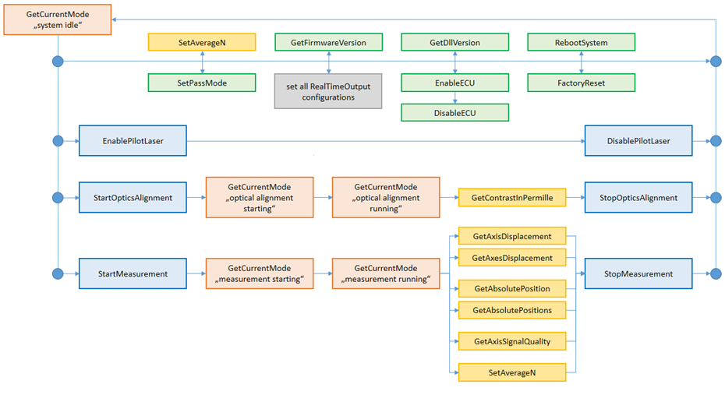

Overview about the Nonlinearity Compensation Feature
The following flow chart gives an overview about the available functions of the Nonlinearity Compensation Feature.
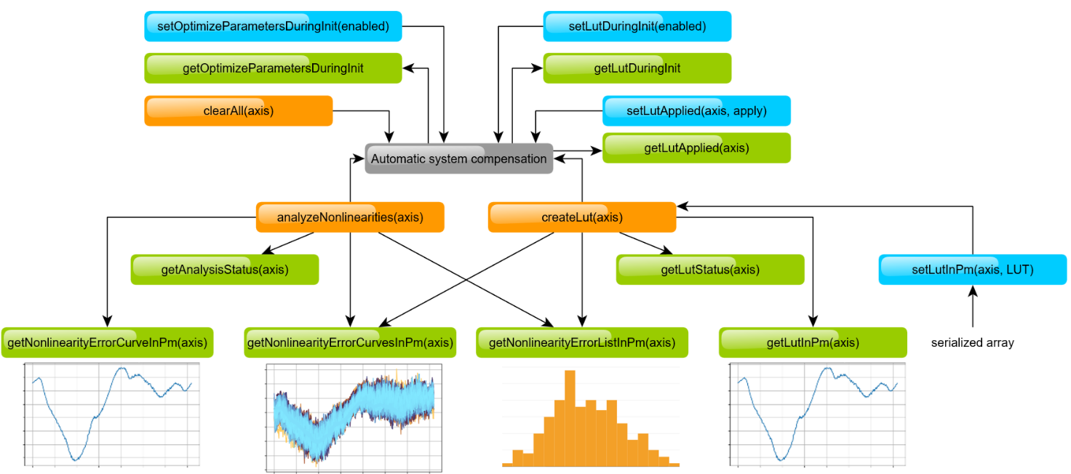

A typical workflow using the Nonlinearity Compensation Feature is shown in the following flow chart.
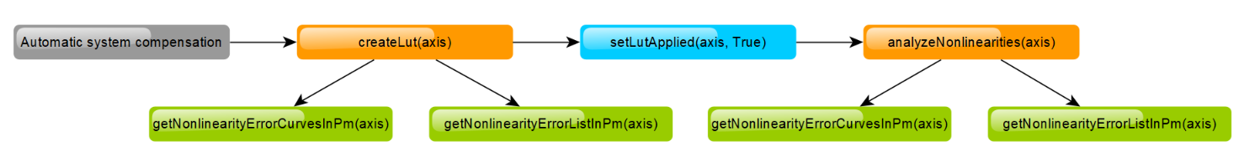

Description of API-Functions

About
getInstalledPackages
Gets list of packages installed on the device.
Function specific parameters
Out | errNo | error code, if there was an error, otherwise 0 for ok
 | value_string1 | string comma separated list of packages
JSON Method
method: com.attocube.system.about.getInstalledPackages
params: []
Result: [errNo, value_string1]
C-DLL call
int SEN_about_getInstalledPackages(int deviceHandle, char* value_string1, int size0)
Python
value_string1 = [dev].about.getInstalledPackages()
Matlab
[value_string1] = SEN_about_getInstalledPackages()
C#
string value = [Device].About_GetInstalledPackages()
LabVIEW
getInstalledPackages.vi

getPackageLicense
Gets the license for a specific package.
Function specific parameters
In | pckg | package name string
Out | errNo | error code, if there was an error, otherwise 0 for ok
 | value_string1 | string license for this package
JSON Method
method: com.attocube.system.about.getPackageLicense
params: [pckg]
Result: [errNo, value_string1]
C-DLL call
int SEN_about_getPackageLicense(int deviceHandle, const char* pckg, char* value_string1, int size0)
Python
value_string1 = [dev].about.getPackageLicense(pckg)
Matlab
[value_string1] = SEN_about_getPackageLicense(pckg)
C#
string value = [Device].About_GetPackageLicense(string pckg)
LabVIEW
getPackageLicense.vi

Access
getLockStatus
Gets the lock status of the device and if the current client is authorized to use the device.
Function specific parameters
Out | errNo | error code, if there was an error, otherwise 0 for ok
 | locked | true = locked; false = unlocked
 | authorized | true if the client is authorized, else false
JSON Method
method: getLockStatus
params: []
Result: [errNo, locked, authorized]
C-DLL call
int SEN_getLockStatus(int deviceHandle, bool* locked, bool* authorized)
Python
locked, authorized = [dev].access.getLockStatus()
Matlab
[locked, authorized] = SEN_getLockStatus()
C#
Tuple<bool,bool> value = [Device].GetLockStatus()
LabVIEW
getLockStatus.vi

grantAccess
Grants access to a locked device by checking against the password.
Function specific parameters
In | password | current password string
Out | errNo | error code, if there was an error, otherwise 0 for ok
JSON Method
method: grantAccess
params: [password]
Result: [errNo]
C-DLL call
int SEN_grantAccess(int deviceHandle, const char* password)
Python
[dev].access.grantAccess(password)
Matlab
[] = SEN_grantAccess(password)
C#
void value = [Device].GrantAccess(string password)
LabVIEW
grantAccess.vi

lock
Locks the device with a given password. Afterwards, the device functions are only accessible with this password. The computer IP address, which locks the device, is automatically added to the device and doesn't need the password for functions access.
Function specific parameters
In | password | set password string
Out | errNo | error code, if there was an error, otherwise 0 for ok
JSON Method
method: lock
params: [password]
Result: [errNo]
C-DLL call
int SEN_lock(int deviceHandle, const char* password)
Python
[dev].access.lock(password)
Matlab
[] = SEN_lock(password)
C#
void value = [Device].Lock(string password)
LabVIEW
lock.vi

unlock
Unlocks the device. Afterwards, the device functions are accessible without any password. For grant access without unlocking the device, please use the grantAccess function.
Function specific parameters
In | password | current password string
Out | errNo | error code, if there was an error, otherwise 0 for ok
JSON Method
method: unlock
params: [password]
Result: [errNo]
C-DLL call
int SEN_unlock(int deviceHandle, const char* password)
Python
[dev].access.unlock(password)
Matlab
[] = SEN_unlock(password)
C#
void value = [Device].Unlock(string password)
LabVIEW
unlock.vi

Adjustment
getAdjustmentEnabled
This function can be used to see if the adjustment is running.
Function specific parameters
Out | errNo | error code, if there was an error, otherwise 0 for ok
 | enabled | true = enabled; false = disabled
JSON Method
method: com.attocube.sen.adjustment.getAdjustmentEnabled
params: []
Result: [errNo, enabled]
C-DLL call
int SEN_adjustment_getAdjustmentEnabled(int deviceHandle, bool* enabled)
Python
enabled = [dev].adjustment.getAdjustmentEnabled()
Matlab
[enabled] = SEN_adjustment_getAdjustmentEnabled()
C#
bool value = [Device].Adjustment_GetAdjustmentEnabled()
LabVIEW
getAdjustmentEnabled.vi

getContrastInPermille
This function can be used to monitor the alignment contrast (peak-to-peak of the basic interference signal amplitude) and the baseline (its offset) during alignment mode. It is used to monitor and optimize the optical alignment such that it allows the successful initialization of a measurement. To monitor the optical contrast during a running measurement, please use the getAxisSignalQuality function.
Important: The baseline and contrast need to be added, otherwise an overload can occur without being recognized. Example: baseline 15 permille and contrast 850 permille. Just from the contrast it looks good. Adding the baseline the overload is visible.
Function specific parameters
In | axis | [0|1|2]
Out | warningNo | warning code, can be converted into a string using the errorNumberToString function
 | contrast | contrast of the base band signal in permille
 | baseline | offset of the contrast measurement in permille
 | mixcontrast | lower contrast measurement when measuring a mixed contrast (indicated by error code)
JSON Method
method: com.attocube.sen.adjustment.getContrastInPermille
params: [axis]
Result: [warningNo, contrast, baseline, mixcontrast]
C-DLL call
int SEN_adjustment_getContrastInPermille(int deviceHandle, int axis, int* warningNo, int* contrast, int* baseline, int* mixcontrast)
Python
warningNo, contrast, baseline, mixcontrast = [dev].adjustment.getContrastInPermille(axis)
Matlab
[warningNo, contrast, baseline, mixcontrast] = SEN_adjustment_getContrastInPermille(axis)
C#
Tuple<int,int,int,int> value = [Device].Adjustment_GetContrastInPermille(int axis)
LabVIEW
getContrastInPermille.vi

Axis
apply
Applies new axis settings. Necessary after JSON set commands.
Function specific parameters
Out | errNo | error code, if there was an error, otherwise 0 for ok
JSON Method
method: com.attocube.sen.axis.apply
params: []
Result: [errNo]
C-DLL call
int SEN_axis_apply(int deviceHandle)
Python
[dev].axis.apply()
Matlab
[] = SEN_axis_apply()
C#
void value = [Device].Axis_Apply()
LabVIEW
apply.vi

discard
Discards new axis settings. Necessary after JSON set commands instead of apply() in case of failure.
Function specific parameters
Out | errNo | error code, if there was an error, otherwise 0 for ok
JSON Method
method: com.attocube.sen.axis.discard
params: []
Result: [errNo]
C-DLL call
int SEN_axis_discard(int deviceHandle)
Python
[dev].axis.discard()
Matlab
[] = SEN_axis_discard()
C#
void value = [Device].Axis_Discard()
LabVIEW
discard.vi

getAutoMasterAxis
Gets status of the automatic configuration of the master axis.
Function specific parameters
Out | errNo | error code, if there was an error, otherwise 0 for ok
 | automatic | true = automatic; false = manual (default: true)
JSON Method
method: com.attocube.sen.axis.getAutoMasterAxis
params: []
Result: [errNo, automatic]
C-DLL call
int SEN_axis_getAutoMasterAxis(int deviceHandle, bool* automatic)
Python
automatic = [dev].axis.getAutoMasterAxis()
Matlab
[automatic] = SEN_axis_getAutoMasterAxis()
C#
bool value = [Device].Axis_GetAutoMasterAxis()
LabVIEW
getAutoMasterAxis.vi

getMasterAxis
Returns the master axis (for more information, please refer to the IDS User Manual).
Please note that the master axis is not updated during the automatic configuration of the master axis. The getMasterAxis returns the last set value of the setMasterAxis function.
Function specific parameters
Out | errNo | error code, if there was an error, otherwise 0 for ok
 | axis | [0|1|2]
JSON Method
method: com.attocube.sen.axis.getMasterAxis
params: []
Result: [errNo, axis]
C-DLL call
int SEN_axis_getMasterAxis(int deviceHandle, int* axis)
Python
axis = [dev].axis.getMasterAxis()
Matlab
[axis] = SEN_axis_getMasterAxis()
C#
int value = [Device].Axis_GetMasterAxis()
LabVIEW
getMasterAxis.vi

getPassMode
Reads out the current pass mode.
Function specific parameters
Out | errNo | error code, if there was an error, otherwise 0 for ok
 | mode | 0 = single; pass 1 = dual pass
JSON Method
method: com.attocube.sen.axis.getPassMode
params: []
Result: [errNo, mode]
C-DLL call
int SEN_axis_getPassMode(int deviceHandle, int* mode)
Python
mode = [dev].axis.getPassMode()
Matlab
[mode] = SEN_axis_getPassMode()
C#
int value = [Device].Axis_GetPassMode()
LabVIEW
getPassMode.vi

getSupportedAxes
Gets supported IDS axes for application. Only applicable to specific IDS devices.
Function specific parameters
Out | errNo | error code, if there was an error, otherwise 0 for ok
 | supportedAxis1 | true = supported; false = unsupported
 | supportedAxis2 | true = supported; false = unsupported
 | supportedAxis3 | true = supported; false = unsupported
JSON Method
method: com.attocube.sen.axis.getSupportedAxes
params: []
Result: [errNo, supportedAxis1, supportedAxis2, supportedAxis3]
C-DLL call
int SEN_axis_getSupportedAxes(int deviceHandle, bool* supportedAxis1, bool* supportedAxis2, bool* supportedAxis3)
Python
supportedAxis1, supportedAxis2, supportedAxis3 = [dev].axis.getSupportedAxes()
Matlab
[supportedAxis1, supportedAxis2, supportedAxis3] = SEN_axis_getSupportedAxes()
C#
Tuple<bool,bool,bool> value = [Device].Axis_GetSupportedAxes()
LabVIEW
getSupportedAxes.vi

setAutoMasterAxis
Enables the automatic configuration of the master axis during measurement initialization. The master axis chosen is the axis furthest away.
This function is only available in the "system idle" state (please refer to the getCurrentMode function).
Function specific parameters
In | automatic | true = automatic; false = manual
Out | errNo | error code, if there was an error, otherwise 0 for ok
JSON Method
method: com.attocube.sen.axis.setAutoMasterAxis
params: [automatic]
Result: [errNo]
C-DLL call
int SEN_axis_setAutoMasterAxis(int deviceHandle, bool automatic)
Python
[dev].axis.setAutoMasterAxis(automatic)
Matlab
[] = SEN_axis_setAutoMasterAxis(automatic)
C#
void value = [Device].Axis_SetAutoMasterAxis(bool automatic)
LabVIEW
setAutoMasterAxis.vi

setMasterAxis
Sets the master axis (for more information, please refer to the IDS User Manual).
This function is only available in the "system idle" state (please refer to the getCurrentMode function) and can be applied only if the automatic configuration of the master axis is deactivated (please refer to the getAutoMasterAxis function).
Function specific parameters
In | axis | [0|1|2]
Out | errNo | error code, if there was an error, otherwise 0 for ok
JSON Method
method: com.attocube.sen.axis.setMasterAxis
params: [axis]
Result: [errNo]
C-DLL call
int SEN_axis_setMasterAxis(int deviceHandle, int axis)
Python
[dev].axis.setMasterAxis(axis)
Matlab
[] = SEN_axis_setMasterAxis(axis)
C#
void value = [Device].Axis_SetMasterAxis(int axis)
LabVIEW
setMasterAxis.vi

setPassMode
Sets the desired pass mode. Effectively this mode defines if the correction factor of two (necessary for measurements in optical dual pass configuration) is applied.
This function is only available in the "system idle" state (please refer to the getCurrentMode function).
Function specific parameters
In | mode | 0 = single pass; 1 = dual pass
Out | errNo | error code, if there was an error, otherwise 0 for ok
JSON Method
method: com.attocube.sen.axis.setPassMode
params: [mode]
Result: [errNo]
C-DLL call
int SEN_axis_setPassMode(int deviceHandle, int mode)
Python
[dev].axis.setPassMode(mode)
Matlab
[] = SEN_axis_setPassMode(mode)
C#
void value = [Device].Axis_SetPassMode(int mode)
LabVIEW
setPassMode.vi

Displacement
getAbsolutePosition
This function outputs the sum of the static absolute position register value and the continuously updated displacement register value for a specific measurement axis.
Function specific parameters
In | axis | [0|1|2]
Out | warningNo | warning code, can be converted into a string using the errorNumberToString function
 | position | absolute position of the axis in pm
JSON Method
method: com.attocube.sen.displacement.getAbsolutePosition
params: [axis]
Result: [warningNo, position]
C-DLL call
int SEN_displacement_getAbsolutePosition(int deviceHandle, int axis, int* warningNo, double* position)
Python
warningNo, position = [dev].displacement.getAbsolutePosition(axis)
Matlab
[warningNo, position] = SEN_displacement_getAbsolutePosition(axis)
C#
Tuple<int,double> value = [Device].Displacement_GetAbsolutePosition(int axis)
LabVIEW
getAbsolutePosition.vi

getAbsolutePositions
This function outputs the sum of the static absolute position register value and the continuously updated displacement register value for all three measurement axes.
Function specific parameters
Out | warningNo | warning code, can be converted into a string using the errorNumberToString function
 | position0 | absolute position of the axis 0 in pm
 | position1 | absolute position of the axis 1 in pm
 | position2 | absolute position of the axis 2 in pm
JSON Method
method: com.attocube.sen.displacement.getAbsolutePositions
params: []
Result: [warningNo, position0, position1, position2]
C-DLL call
int SEN_displacement_getAbsolutePositions(int deviceHandle, int* warningNo, double* position0, double* position1, double* position2)
Python
warningNo, position0, position1, position2 = [dev].displacement.getAbsolutePositions()
Matlab
[warningNo, position0, position1, position2] = SEN_displacement_getAbsolutePositions()
C#
Tuple<int,double,double,double> value = [Device].Displacement_GetAbsolutePositions()
LabVIEW
getAbsolutePositions.vi

getAverageN
Reads out the averaging (lowpass) parameter N. The averaging time is calculated by (2^N)*40ns, where N is the averaging value. Please refer to the manual for a table with stopband and 3dB cut-off frequency.
Function specific parameters
Out | errNo | error code, if there was an error, otherwise 0 for ok
 | averageN | value from 0 to 24
JSON Method
method: com.attocube.sen.displacement.getAverageN
params: []
Result: [errNo, averageN]
C-DLL call
int SEN_displacement_getAverageN(int deviceHandle, int* averageN)
Python
averageN = [dev].displacement.getAverageN()
Matlab
[averageN] = SEN_displacement_getAverageN()
C#
int value = [Device].Displacement_GetAverageN()
LabVIEW
getAverageN.vi

getAxesDisplacement
Reads out the displacement values of all three measurement axes.
Function specific parameters
Out | warningNo | warning code, can be converted into a string using the errorNumberToString function
 | displacement0 | displacement of the axis 0 in pm
 | displacement1 | displacement of the axis 1 in pm
 | displacement2 | displacement of the axis 2 in pm
JSON Method
method: com.attocube.sen.displacement.getAxesDisplacement
params: []
Result: [warningNo, displacement0, displacement1, displacement2]
C-DLL call
int SEN_displacement_getAxesDisplacement(int deviceHandle, int* warningNo, double* displacement0, double* displacement1, double* displacement2)
Python
warningNo, displacement0, displacement1, displacement2 = [dev].displacement.getAxesDisplacement()
Matlab
[warningNo, displacement0, displacement1, displacement2] = SEN_displacement_getAxesDisplacement()
C#
Tuple<int,double,double,double> value = [Device].Displacement_GetAxesDisplacement()
LabVIEW
getAxesDisplacement.vi

getAxisDisplacement
Reads out the displacement value of a specific measurement axis.
Function specific parameters
In | axis | [0|1|2]
Out | warningNo | warning code, can be converted into a string using the errorNumberToString function
 | displacement | displacement of the axis in pm
JSON Method
method: com.attocube.sen.displacement.getAxisDisplacement
params: [axis]
Result: [warningNo, displacement]
C-DLL call
int SEN_displacement_getAxisDisplacement(int deviceHandle, int axis, int* warningNo, double* displacement)
Python
warningNo, displacement = [dev].displacement.getAxisDisplacement(axis)
Matlab
[warningNo, displacement] = SEN_displacement_getAxisDisplacement(axis)
C#
Tuple<int,double> value = [Device].Displacement_GetAxisDisplacement(int axis)
LabVIEW
getAxisDisplacement.vi

getAxisSignalQuality
This function can be used to monitor the signal contrast (peak-to-peak of the basic interference signal amplitude) and the baseline (its offset) during a running measurement. In comparison to the getContrastInPermille function, the contrast is additionally corrected by a normalization factor.
Please note that the getAxisSignalQuality function output is only updated when a displacement is measured. This means that angular misalignments without displacement changes on the measurement axes cannot be detected.
Furthermore, we recommend using the high accuracy initialization to obtain correct values directly after measurement initialization. When using the quick initialization, the initial value might be compromised at first but correct after some detected measurement (because it is updated with the correct value then).
Function specific parameters
In | axis | [0|1|2]
Out | warningNo | warning code, can be converted into a string using the errorNumberToString function
 | contrast | contrast of the base band signal in permille
 | baseline | offset of the contrast measurement in permille
JSON Method
method: com.attocube.sen.displacement.getAxisSignalQuality
params: [axis]
Result: [warningNo, contrast, baseline]
C-DLL call
int SEN_displacement_getAxisSignalQuality(int deviceHandle, int axis, int* warningNo, int* contrast, int* baseline)
Python
warningNo, contrast, baseline = [dev].displacement.getAxisSignalQuality(axis)
Matlab
[warningNo, contrast, baseline] = SEN_displacement_getAxisSignalQuality(axis)
C#
Tuple<int,int,int> value = [Device].Displacement_GetAxisSignalQuality(int axis)
LabVIEW
getAxisSignalQuality.vi

getMeasurementEnabled
This function can be used to see if the measurement is running.
Function specific parameters
Out | errNo | error code, if there was an error, otherwise 0 for ok
 | enabled | true = enabled; false = disabled
JSON Method
method: com.attocube.sen.displacement.getMeasurementEnabled
params: []
Result: [errNo, enabled]
C-DLL call
int SEN_displacement_getMeasurementEnabled(int deviceHandle, bool* enabled)
Python
enabled = [dev].displacement.getMeasurementEnabled()
Matlab
[enabled] = SEN_displacement_getMeasurementEnabled()
C#
bool value = [Device].Displacement_GetMeasurementEnabled()
LabVIEW
getMeasurementEnabled.vi

getReferencePosition
Reads out the reference position value of the specific measurement axis.
The reference position information is estimated at the measurement initialization procedure or on reset position. This initial absolute position information is not updated during system operation, whereas the device continuously measures the relative displacement from that point.
Function specific parameters
In | axis | [0|1|2]
Out | warningNo | warning code, can be converted into a string using the errorNumberToString function
 | position | reference position of the axis in pm
JSON Method
method: com.attocube.sen.displacement.getReferencePosition
params: [axis]
Result: [warningNo, position]
C-DLL call
int SEN_displacement_getReferencePosition(int deviceHandle, int axis, int* warningNo, double* position)
Python
warningNo, position = [dev].displacement.getReferencePosition(axis)
Matlab
[warningNo, position] = SEN_displacement_getReferencePosition(axis)
C#
Tuple<int,double> value = [Device].Displacement_GetReferencePosition(int axis)
LabVIEW
getReferencePosition.vi

getReferencePositions
Reads out the reference position value of all three measurement axes.
The reference position information is estimated at the measurement initialization procedure or on reset position. This initial absolute position information is not updated during system operation, whereas the device continuously measures the relative displacement from that point.
Function specific parameters
Out | warningNo | warning code, can be converted into a string using the errorNumberToString function
 | position0 | reference position of the axis 0 in pm
 | position1 | reference position of the axis 1 in pm
 | position2 | reference position of the axis 2 in pm
JSON Method
method: com.attocube.sen.displacement.getReferencePositions
params: []
Result: [warningNo, position0, position1, position2]
C-DLL call
int SEN_displacement_getReferencePositions(int deviceHandle, int* warningNo, double* position0, double* position1, double* position2)
Python
warningNo, position0, position1, position2 = [dev].displacement.getReferencePositions()
Matlab
[warningNo, position0, position1, position2] = SEN_displacement_getReferencePositions()
C#
Tuple<int,double,double,double> value = [Device].Displacement_GetReferencePositions()
LabVIEW
getReferencePositions.vi

setAverageN
Sets the averaging (lowpass) parameter N. The averaging time is calculated by (2^N)*40ns, where N is the averaging value. Please refer to the manual for a table with stopband and 3dB cut-off frequency.
Function specific parameters
In | averageN | value from 0 to 24
Out | errNo | error code, if there was an error, otherwise 0 for ok
JSON Method
method: com.attocube.sen.displacement.setAverageN
params: [averageN]
Result: [errNo]
C-DLL call
int SEN_displacement_setAverageN(int deviceHandle, int averageN)
Python
[dev].displacement.setAverageN(averageN)
Matlab
[] = SEN_displacement_setAverageN(averageN)
C#
void value = [Device].Displacement_SetAverageN(int averageN)
LabVIEW
setAverageN.vi

Ecu
disable
Disables the ECU interface.
Function specific parameters
Out | errNo | error code, if there was an error, otherwise 0 for ok
JSON Method
method: com.attocube.ecu.disable
params: []
Result: [errNo]
C-DLL call
int SEN_ecu_disable(int deviceHandle)
Python
[dev].ecu.disable()
Matlab
[] = SEN_ecu_disable()
C#
void value = [Device].Ecu_Disable()
LabVIEW
disable.vi

enable
Enables the ECU interface.
Function specific parameters
Out | errNo | error code, if there was an error, otherwise 0 for ok
JSON Method
method: com.attocube.ecu.enable
params: []
Result: [errNo]
C-DLL call
int SEN_ecu_enable(int deviceHandle)
Python
[dev].ecu.enable()
Matlab
[] = SEN_ecu_enable()
C#
void value = [Device].Ecu_Enable()
LabVIEW
enable.vi

getConnected
Reads out whether the ECU interface is physically connected or not.
Function specific parameters
Out | errNo | error code, if there was an error, otherwise 0 for ok
 | connected | true = connected; false = disconnected
JSON Method
method: com.attocube.ecu.getConnected
params: []
Result: [errNo, connected]
C-DLL call
int SEN_ecu_getConnected(int deviceHandle, bool* connected)
Python
connected = [dev].ecu.getConnected()
Matlab
[connected] = SEN_ecu_getConnected()
C#
bool value = [Device].Ecu_GetConnected()
LabVIEW
getConnected.vi

getEnabled
Reads out whether the ECU interface is enabled or not. Enabling the ECU interface is crucial for working with the ECU.
Function specific parameters
Out | errNo | error code, if there was an error, otherwise 0 for ok
 | enabled | true = enabled; false = disabled
JSON Method
method: com.attocube.ecu.getEnabled
params: []
Result: [errNo, enabled]
C-DLL call
int SEN_ecu_getEnabled(int deviceHandle, bool* enabled)
Python
enabled = [dev].ecu.getEnabled()
Matlab
[enabled] = SEN_ecu_getEnabled()
C#
bool value = [Device].Ecu_GetEnabled()
LabVIEW
getEnabled.vi

getHumidityInPercent
Reads out the ECU measured air humidity in percent.
Function specific parameters
Out | errNo | error code, if there was an error, otherwise 0 for ok
 | humidity | value in percent
JSON Method
method: com.attocube.ecu.getHumidityInPercent
params: []
Result: [errNo, humidity]
C-DLL call
int SEN_ecu_getHumidityInPercent(int deviceHandle, double* humidity)
Python
humidity = [dev].ecu.getHumidityInPercent()
Matlab
[humidity] = SEN_ecu_getHumidityInPercent()
C#
double value = [Device].Ecu_GetHumidityInPercent()
LabVIEW
getHumidityInPercent.vi

getPressureInHPa
Reads out the ECU measured air pressure in hPa.
Function specific parameters
Out | errNo | error code, if there was an error, otherwise 0 for ok
 | pressure | value in hPa
JSON Method
method: com.attocube.ecu.getPressureInHPa
params: []
Result: [errNo, pressure]
C-DLL call
int SEN_ecu_getPressureInHPa(int deviceHandle, double* pressure)
Python
pressure = [dev].ecu.getPressureInHPa()
Matlab
[pressure] = SEN_ecu_getPressureInHPa()
C#
double value = [Device].Ecu_GetPressureInHPa()
LabVIEW
getPressureInHPa.vi

getRefractiveIndex
Reads out the ECU estimated refractive index from the current ECU values. To get the refractive index for other compensation modes, please refer to the getRefractiveIndexForCompensation function.
Function specific parameters
Out | errNo | error code, if there was an error, otherwise 0 for ok
 | rIndex | refractive index
JSON Method
method: com.attocube.ecu.getRefractiveIndex
params: []
Result: [errNo, rIndex]
C-DLL call
int SEN_ecu_getRefractiveIndex(int deviceHandle, double* rIndex)
Python
rIndex = [dev].ecu.getRefractiveIndex()
Matlab
[rIndex] = SEN_ecu_getRefractiveIndex()
C#
double value = [Device].Ecu_GetRefractiveIndex()
LabVIEW
getRefractiveIndex.vi

getRefractiveIndexCompensationMode
Reads out the compensation mode which is currently used for the environmental compensation.
Function specific parameters
In | axis | [0|1|2]  Parameter has to be -1 for the moment,  individual axes will be supported in the next firmware release
Out | errNo | error code, if there was an error, otherwise 0 for ok
 | mode | 0 = direct ECU mode  1 = uses refractive index calculated from the manually set values  2 = uses manually set refrative index
JSON Method
method: com.attocube.ecu.getRefractiveIndexCompensationMode
params: [axis]
Result: [errNo, mode]
C-DLL call
int SEN_ecu_getRefractiveIndexCompensationMode(int deviceHandle, int axis, int* mode)
Python
mode = [dev].ecu.getRefractiveIndexCompensationMode(axis)
Matlab
[mode] = SEN_ecu_getRefractiveIndexCompensationMode(axis)
C#
int value = [Device].Ecu_GetRefractiveIndexCompensationMode(int axis)
LabVIEW
getRefractiveIndexCompensationMode.vi

getRefractiveIndexForCompensation
Reads out the refractive index used according to the current environmental compensation mode for a specific measurement axis.
Function specific parameters
In | axis | [0|1|2]  Parameter has to be -1 for the moment,  individual axes will be supported in the next firmware release
Out | errNo | error code, if there was an error, otherwise 0 for ok
 | rIndex | refractive index
JSON Method
method: com.attocube.ecu.getRefractiveIndexForCompensation
params: [axis]
Result: [errNo, rIndex]
C-DLL call
int SEN_ecu_getRefractiveIndexForCompensation(int deviceHandle, int axis, double* rIndex)
Python
rIndex = [dev].ecu.getRefractiveIndexForCompensation(axis)
Matlab
[rIndex] = SEN_ecu_getRefractiveIndexForCompensation(axis)
C#
double value = [Device].Ecu_GetRefractiveIndexForCompensation(int axis)
LabVIEW
getRefractiveIndexForCompensation.vi

getTemperatureInDegrees
Reads out the ECU measured air temperature in degrees Celsius.
Function specific parameters
Out | errNo | error code, if there was an error, otherwise 0 for ok
 | temperature | value in degrees Celsius
JSON Method
method: com.attocube.ecu.getTemperatureInDegrees
params: []
Result: [errNo, temperature]
C-DLL call
int SEN_ecu_getTemperatureInDegrees(int deviceHandle, double* temperature)
Python
temperature = [dev].ecu.getTemperatureInDegrees()
Matlab
[temperature] = SEN_ecu_getTemperatureInDegrees()
C#
double value = [Device].Ecu_GetTemperatureInDegrees()
LabVIEW
getTemperatureInDegrees.vi

setRefractiveIndexCompensationMode
Sets the refractive index compensation mode.
Function specific parameters
In | axis | [0|1|2]  Parameter has to be -1 for the moment,  individual axes will be supported in the next firmware release
 | mode | 0 = direct ECU mode  1 = uses refractive index calculated from the manually set values  2 = uses manually set refrative index
Out | errNo | error code, if there was an error, otherwise 0 for ok
JSON Method
method: com.attocube.ecu.setRefractiveIndexCompensationMode
params: [axis, mode]
Result: [errNo]
C-DLL call
int SEN_ecu_setRefractiveIndexCompensationMode(int deviceHandle, int axis, int mode)
Python
[dev].ecu.setRefractiveIndexCompensationMode(axis, mode)
Matlab
[] = SEN_ecu_setRefractiveIndexCompensationMode(axis, mode)
C#
void value = [Device].Ecu_SetRefractiveIndexCompensationMode(int axis, int mode)
LabVIEW
setRefractiveIndexCompensationMode.vi

Manual
getHumidityInPercent
Reads out the manually configured humidity for compensation mode 1.
Function specific parameters
In | axis | [0|1|2]  Parameter has to be -1 for the moment,  individual axes will be supported in the next firmware release
Out | errNo | error code, if there was an error, otherwise 0 for ok
 | humidity | value in percent
JSON Method
method: com.attocube.ecu.manual.getHumidityInPercent
params: [axis]
Result: [errNo, humidity]
C-DLL call
int SEN_manual_getHumidityInPercent(int deviceHandle, int axis, double* humidity)
Python
humidity = [dev].manual.getHumidityInPercent(axis)
Matlab
[humidity] = SEN_manual_getHumidityInPercent(axis)
C#
double value = [Device].Manual_GetHumidityInPercent(int axis)
LabVIEW
getHumidityInPercent.vi

getPressureInHPa
Reads out the manually configured air pressure for compensation mode 1.
Function specific parameters
In | axis | [0|1|2]  Parameter has to be -1 for the moment,  individual axes will be supported in the next firmware release
Out | errNo | error code, if there was an error, otherwise 0 for ok
 | pressure | value in hPa
JSON Method
method: com.attocube.ecu.manual.getPressureInHPa
params: [axis]
Result: [errNo, pressure]
C-DLL call
int SEN_manual_getPressureInHPa(int deviceHandle, int axis, double* pressure)
Python
pressure = [dev].manual.getPressureInHPa(axis)
Matlab
[pressure] = SEN_manual_getPressureInHPa(axis)
C#
double value = [Device].Manual_GetPressureInHPa(int axis)
LabVIEW
getPressureInHPa.vi

getRefractiveIndex
Reads out the manually configured refractive index for compensation mode 2.
Function specific parameters
In | axis | [0|1|2]  Parameter has to be -1 for the moment,  individual axes will be supported in the next firmware release
Out | errNo | error code, if there was an error, otherwise 0 for ok
 | rindex | refractive index
JSON Method
method: com.attocube.ecu.manual.getRefractiveIndex
params: [axis]
Result: [errNo, rindex]
C-DLL call
int SEN_manual_getRefractiveIndex(int deviceHandle, int axis, double* rindex)
Python
rindex = [dev].manual.getRefractiveIndex(axis)
Matlab
[rindex] = SEN_manual_getRefractiveIndex(axis)
C#
double value = [Device].Manual_GetRefractiveIndex(int axis)
LabVIEW
getRefractiveIndex.vi

getTemperatureInDegrees
Reads out the manually configured temperature for compensation mode 1.
Function specific parameters
In | axis | [0|1|2]  Parameter has to be -1 for the moment,  individual axes will be supported in the next firmware release
Out | errNo | error code, if there was an error, otherwise 0 for ok
 | temperature | value in degrees Celsius
JSON Method
method: com.attocube.ecu.manual.getTemperatureInDegrees
params: [axis]
Result: [errNo, temperature]
C-DLL call
int SEN_manual_getTemperatureInDegrees(int deviceHandle, int axis, double* temperature)
Python
temperature = [dev].manual.getTemperatureInDegrees(axis)
Matlab
[temperature] = SEN_manual_getTemperatureInDegrees(axis)
C#
double value = [Device].Manual_GetTemperatureInDegrees(int axis)
LabVIEW
getTemperatureInDegrees.vi

setHumidityInPercent
Sets the manually configured humidity for compensation mode 1. The input range is defined to 0 to 100 % (valid range for the Ciddor Equation).
Function specific parameters
In | axis | [0|1|2]  Parameter has to be -1 for the moment,  individual axes will be supported in the next firmware release
 | humidity | value from 0 % to 100 %
Out | errNo | error code, if there was an error, otherwise 0 for ok
JSON Method
method: com.attocube.ecu.manual.setHumidityInPercent
params: [axis, humidity]
Result: [errNo]
C-DLL call
int SEN_manual_setHumidityInPercent(int deviceHandle, int axis, double humidity)
Python
[dev].manual.setHumidityInPercent(axis, humidity)
Matlab
[] = SEN_manual_setHumidityInPercent(axis, humidity)
C#
void value = [Device].Manual_SetHumidityInPercent(int axis, double humidity)
LabVIEW
setHumidityInPercent.vi

setPressureInHPa
Sets the manually configured air pressure for compensation mode 1. The input range is defined to 800 to 1200 hPa (valid range for the Ciddor Equation).
Function specific parameters
In | axis | [0|1|2]  Parameter has to be -1 for the moment,  individual axes will be supported in the next firmware release
 | pressure | value from 800 hPa to 1200 hPa
Out | errNo | error code, if there was an error, otherwise 0 for ok
JSON Method
method: com.attocube.ecu.manual.setPressureInHPa
params: [axis, pressure]
Result: [errNo]
C-DLL call
int SEN_manual_setPressureInHPa(int deviceHandle, int axis, double pressure)
Python
[dev].manual.setPressureInHPa(axis, pressure)
Matlab
[] = SEN_manual_setPressureInHPa(axis, pressure)
C#
void value = [Device].Manual_SetPressureInHPa(int axis, double pressure)
LabVIEW
setPressureInHPa.vi

setRefractiveIndex
Sets the manually configured refractive index for the compensation mode 2. The input range is defined to be greater than 1.
Function specific parameters
In | axis | [0|1|2]  Parameter has to be -1 for the moment,  individual axes will be supported in the next firmware release
 | rindex | refractive index
Out | errNo | error code, if there was an error, otherwise 0 for ok
JSON Method
method: com.attocube.ecu.manual.setRefractiveIndex
params: [axis, rindex]
Result: [errNo]
C-DLL call
int SEN_manual_setRefractiveIndex(int deviceHandle, int axis, double rindex)
Python
[dev].manual.setRefractiveIndex(axis, rindex)
Matlab
[] = SEN_manual_setRefractiveIndex(axis, rindex)
C#
void value = [Device].Manual_SetRefractiveIndex(int axis, double rindex)
LabVIEW
setRefractiveIndex.vi

setTemperatureInDegrees
Sets the manually configured temperature for compensation mode 1. The input range is defined to -40 to +100 °C (valid range for the Ciddor Equation).
Function specific parameters
In | axis | [0|1|2]  Parameter has to be -1 for the moment,  individual axes will be supported in the next firmware release
 | temperature | value from -40 °C to +100 °C
Out | errNo | error code, if there was an error, otherwise 0 for ok
JSON Method
method: com.attocube.ecu.manual.setTemperatureInDegrees
params: [axis, temperature]
Result: [errNo]
C-DLL call
int SEN_manual_setTemperatureInDegrees(int deviceHandle, int axis, double temperature)
Python
[dev].manual.setTemperatureInDegrees(axis, temperature)
Matlab
[] = SEN_manual_setTemperatureInDegrees(axis, temperature)
C#
void value = [Device].Manual_SetTemperatureInDegrees(int axis, double temperature)
LabVIEW
setTemperatureInDegrees.vi

Network
apply
Applies the temporary IP configuration and loads it.
Function specific parameters
Out | errNo | error code, if there was an error, otherwise 0 for ok
JSON Method
method: com.attocube.system.network.apply
params: []
Result: [errNo]
C-DLL call
int SEN_network_apply(int deviceHandle)
Python
[dev].network.apply()
Matlab
[] = SEN_network_apply()
C#
void value = [Device].Network_Apply()
LabVIEW
apply.vi

configureWifi
Changes the WiFi configuration and applies it.
Function specific parameters
In | mode | 0 = access point; 1 = WiFi client
 | SSID | SSID string
 | psk | pre-shared key
Out | errNo | error code, if there was an error, otherwise 0 for ok
JSON Method
method: com.attocube.system.network.configureWifi
params: [mode, SSID, psk]
Result: [errNo]
C-DLL call
int SEN_network_configureWifi(int deviceHandle, int mode, const char* SSID, const char* psk)
Python
[dev].network.configureWifi(mode, SSID, psk)
Matlab
[] = SEN_network_configureWifi(mode, SSID, psk)
C#
void value = [Device].Network_ConfigureWifi(int mode, string SSID, string psk)
LabVIEW
configureWifi.vi

discard
Discards the temporary IP configuration.
Function specific parameters
Out | errNo | error code, if there was an error, otherwise 0 for ok
JSON Method
method: com.attocube.system.network.discard
params: []
Result: [errNo]
C-DLL call
int SEN_network_discard(int deviceHandle)
Python
[dev].network.discard()
Matlab
[] = SEN_network_discard()
C#
void value = [Device].Network_Discard()
LabVIEW
discard.vi

getDefaultGateway
Gets the default gateway of the device.
Function specific parameters
Out | errNo | error code, if there was an error, otherwise 0 for ok
 | gateway | default gateway as string
JSON Method
method: com.attocube.system.network.getDefaultGateway
params: []
Result: [errNo, gateway]
C-DLL call
int SEN_network_getDefaultGateway(int deviceHandle, char* gateway, int size0)
Python
gateway = [dev].network.getDefaultGateway()
Matlab
[gateway] = SEN_network_getDefaultGateway()
C#
string value = [Device].Network_GetDefaultGateway()
LabVIEW
getDefaultGateway.vi

getDnsResolver
Gets the DNS resolver.
Function specific parameters
In | priority | priority of DNS resolver (0 = default; 1 = backup)
Out | errNo | error code, if there was an error, otherwise 0 for ok
 | resolver | IP address of DNS resolver
JSON Method
method: com.attocube.system.network.getDnsResolver
params: [priority]
Result: [errNo, resolver]
C-DLL call
int SEN_network_getDnsResolver(int deviceHandle, int priority, char* resolver, int size0)
Python
resolver = [dev].network.getDnsResolver(priority)
Matlab
[resolver] = SEN_network_getDnsResolver(priority)
C#
string value = [Device].Network_GetDnsResolver(int priority)
LabVIEW
getDnsResolver.vi

getEnableDhcpClient
Gets the status of DHCP client.
Function specific parameters
Out | errNo | error code, if there was an error, otherwise 0 for ok
 | enabled | true = enabled; false = disabled
JSON Method
method: com.attocube.system.network.getEnableDhcpClient
params: []
Result: [errNo, enabled]
C-DLL call
int SEN_network_getEnableDhcpClient(int deviceHandle, bool* enabled)
Python
enabled = [dev].network.getEnableDhcpClient()
Matlab
[enabled] = SEN_network_getEnableDhcpClient()
C#
bool value = [Device].Network_GetEnableDhcpClient()
LabVIEW
getEnableDhcpClient.vi

getEnableDhcpServer
Gets the status of DHCP server.
Function specific parameters
Out | errNo | error code, if there was an error, otherwise 0 for ok
 | enabled | true = enabled; false = disabled
JSON Method
method: com.attocube.system.network.getEnableDhcpServer
params: []
Result: [errNo, enabled]
C-DLL call
int SEN_network_getEnableDhcpServer(int deviceHandle, bool* enabled)
Python
enabled = [dev].network.getEnableDhcpServer()
Matlab
[enabled] = SEN_network_getEnableDhcpServer()
C#
bool value = [Device].Network_GetEnableDhcpServer()
LabVIEW
getEnableDhcpServer.vi

getIpAddress
Gets the IP address of the device.
Function specific parameters
Out | errNo | error code, if there was an error, otherwise 0 for ok
 | IP | address as string
JSON Method
method: com.attocube.system.network.getIpAddress
params: []
Result: [errNo, IP]
C-DLL call
int SEN_network_getIpAddress(int deviceHandle, char* IP, int size0)
Python
IP = [dev].network.getIpAddress()
Matlab
[IP] = SEN_network_getIpAddress()
C#
string value = [Device].Network_GetIpAddress()
LabVIEW
getIpAddress.vi

getProxyServer
Gets the proxy settings of the device.
Function specific parameters
Out | errNo | error code, if there was an error, otherwise 0 for ok
 | proxyServer | proxy server setting, empty for no proxy
JSON Method
method: com.attocube.system.network.getProxyServer
params: []
Result: [errNo, proxyServer]
C-DLL call
int SEN_network_getProxyServer(int deviceHandle, char* proxyServer, int size0)
Python
proxyServer = [dev].network.getProxyServer()
Matlab
[proxyServer] = SEN_network_getProxyServer()
C#
string value = [Device].Network_GetProxyServer()
LabVIEW
getProxyServer.vi

getRealIpAddress
Gets the real IP address of the device set to the network interface (br0, eth1 or eth0).
Function specific parameters
Out | errNo | error code, if there was an error, otherwise 0 for ok
 | IP | IP address
JSON Method
method: com.attocube.system.network.getRealIpAddress
params: []
Result: [errNo, IP]
C-DLL call
int SEN_network_getRealIpAddress(int deviceHandle, char* IP, int size0)
Python
IP = [dev].network.getRealIpAddress()
Matlab
[IP] = SEN_network_getRealIpAddress()
C#
string value = [Device].Network_GetRealIpAddress()
LabVIEW
getRealIpAddress.vi

getSubnetMask
Gets the subnet mask of the device.
Function specific parameters
Out | errNo | error code, if there was an error, otherwise 0 for ok
 | netmask | subnet mask as string
JSON Method
method: com.attocube.system.network.getSubnetMask
params: []
Result: [errNo, netmask]
C-DLL call
int SEN_network_getSubnetMask(int deviceHandle, char* netmask, int size0)
Python
netmask = [dev].network.getSubnetMask()
Matlab
[netmask] = SEN_network_getSubnetMask()
C#
string value = [Device].Network_GetSubnetMask()
LabVIEW
getSubnetMask.vi

getWifiMode
Gets the operation mode of the WiFi adapter.
Function specific parameters
Out | errNo | error code, if there was an error, otherwise 0 for ok
 | mode | 0 = access point; 1 = WiFi client
JSON Method
method: com.attocube.system.network.getWifiMode
params: []
Result: [errNo, mode]
C-DLL call
int SEN_network_getWifiMode(int deviceHandle, int* mode)
Python
mode = [dev].network.getWifiMode()
Matlab
[mode] = SEN_network_getWifiMode()
C#
int value = [Device].Network_GetWifiMode()
LabVIEW
getWifiMode.vi

getWifiPassphrase
Gets the passphrase of the network hosted (mode: Access point) or connected to (mode: client).
Function specific parameters
Out | errNo | error code, if there was an error, otherwise 0 for ok
 | psk | pre-shared key
JSON Method
method: com.attocube.system.network.getWifiPassphrase
params: []
Result: [errNo, psk]
C-DLL call
int SEN_network_getWifiPassphrase(int deviceHandle, char* psk, int size0)
Python
psk = [dev].network.getWifiPassphrase()
Matlab
[psk] = SEN_network_getWifiPassphrase()
C#
string value = [Device].Network_GetWifiPassphrase()
LabVIEW
getWifiPassphrase.vi

getWifiPresent
Checks if a WiFi interface is present.
Function specific parameters
Out | errNo | error code, if there was an error, otherwise 0 for ok
 | present | true if the interface is present, else false
JSON Method
method: com.attocube.system.network.getWifiPresent
params: []
Result: [errNo, present]
C-DLL call
int SEN_network_getWifiPresent(int deviceHandle, bool* present)
Python
present = [dev].network.getWifiPresent()
Matlab
[present] = SEN_network_getWifiPresent()
C#
bool value = [Device].Network_GetWifiPresent()
LabVIEW
getWifiPresent.vi

getWifiSSID
Gets the SSID of the network hosted (mode: access point) or connected to (mode: client).
Function specific parameters
Out | errNo | error code, if there was an error, otherwise 0 for ok
 | SSID | SSID string
JSON Method
method: com.attocube.system.network.getWifiSSID
params: []
Result: [errNo, SSID]
C-DLL call
int SEN_network_getWifiSSID(int deviceHandle, char* SSID, int size0)
Python
SSID = [dev].network.getWifiSSID()
Matlab
[SSID] = SEN_network_getWifiSSID()
C#
string value = [Device].Network_GetWifiSSID()
LabVIEW
getWifiSSID.vi

setDefaultGateway
Sets the default gateway of the device.
Function specific parameters
In | gateway | default gateway as string
Out | errNo | error code, if there was an error, otherwise 0 for ok
JSON Method
method: com.attocube.system.network.setDefaultGateway
params: [gateway]
Result: [errNo]
C-DLL call
int SEN_network_setDefaultGateway(int deviceHandle, const char* gateway)
Python
[dev].network.setDefaultGateway(gateway)
Matlab
[] = SEN_network_setDefaultGateway(gateway)
C#
void value = [Device].Network_SetDefaultGateway(string gateway)
LabVIEW
setDefaultGateway.vi

setDnsResolver
Sets the DNS resolver.
Function specific parameters
In | priority | priority of DNS resolver (0 = default; 1 = backup)
 | resolver | IP address of DNS resolver
Out | errNo | error code, if there was an error, otherwise 0 for ok
JSON Method
method: com.attocube.system.network.setDnsResolver
params: [priority, resolver]
Result: [errNo]
C-DLL call
int SEN_network_setDnsResolver(int deviceHandle, int priority, const char* resolver)
Python
[dev].network.setDnsResolver(priority, resolver)
Matlab
[] = SEN_network_setDnsResolver(priority, resolver)
C#
void value = [Device].Network_SetDnsResolver(int priority, string resolver)
LabVIEW
setDnsResolver.vi

setEnableDhcpClient
Enables or disables DHCP client.
Function specific parameters
In | enable | true = enable; false = disable
Out | errNo | error code, if there was an error, otherwise 0 for ok
JSON Method
method: com.attocube.system.network.setEnableDhcpClient
params: [enable]
Result: [errNo]
C-DLL call
int SEN_network_setEnableDhcpClient(int deviceHandle, bool enable)
Python
[dev].network.setEnableDhcpClient(enable)
Matlab
[] = SEN_network_setEnableDhcpClient(enable)
C#
void value = [Device].Network_SetEnableDhcpClient(bool enable)
LabVIEW
setEnableDhcpClient.vi

setEnableDhcpServer
Enables or disables DHCP server.
Function specific parameters
In | enable | true = enable; false = disable
Out | errNo | error code, if there was an error, otherwise 0 for ok
JSON Method
method: com.attocube.system.network.setEnableDhcpServer
params: [enable]
Result: [errNo]
C-DLL call
int SEN_network_setEnableDhcpServer(int deviceHandle, bool enable)
Python
[dev].network.setEnableDhcpServer(enable)
Matlab
[] = SEN_network_setEnableDhcpServer(enable)
C#
void value = [Device].Network_SetEnableDhcpServer(bool enable)
LabVIEW
setEnableDhcpServer.vi

setIpAddress
Sets the IP address of the device.
Function specific parameters
In | address | IP address as string
Out | errNo | error code, if there was an error, otherwise 0 for ok
JSON Method
method: com.attocube.system.network.setIpAddress
params: [address]
Result: [errNo]
C-DLL call
int SEN_network_setIpAddress(int deviceHandle, const char* address)
Python
[dev].network.setIpAddress(address)
Matlab
[] = SEN_network_setIpAddress(address)
C#
void value = [Device].Network_SetIpAddress(string address)
LabVIEW
setIpAddress.vi

setProxyServer
Sets the proxy server of the device.
Function specific parameters
In | proxyServer | proxy server setting
Out | errNo | error code, if there was an error, otherwise 0 for ok
JSON Method
method: com.attocube.system.network.setProxyServer
params: [proxyServer]
Result: [errNo]
C-DLL call
int SEN_network_setProxyServer(int deviceHandle, const char* proxyServer)
Python
[dev].network.setProxyServer(proxyServer)
Matlab
[] = SEN_network_setProxyServer(proxyServer)
C#
void value = [Device].Network_SetProxyServer(string proxyServer)
LabVIEW
setProxyServer.vi

setSubnetMask
Sets the subnet mask of the device.
Function specific parameters
In | netmask | subnet mask as string
Out | errNo | error code, if there was an error, otherwise 0 for ok
JSON Method
method: com.attocube.system.network.setSubnetMask
params: [netmask]
Result: [errNo]
C-DLL call
int SEN_network_setSubnetMask(int deviceHandle, const char* netmask)
Python
[dev].network.setSubnetMask(netmask)
Matlab
[] = SEN_network_setSubnetMask(netmask)
C#
void value = [Device].Network_SetSubnetMask(string netmask)
LabVIEW
setSubnetMask.vi

setWifiMode
Changes the operation mode of the WiFi adapter.
Function specific parameters
In | mode | 0 = access point; 1 = WiFi client
Out | errNo | error code, if there was an error, otherwise 0 for ok
JSON Method
method: com.attocube.system.network.setWifiMode
params: [mode]
Result: [errNo]
C-DLL call
int SEN_network_setWifiMode(int deviceHandle, int mode)
Python
[dev].network.setWifiMode(mode)
Matlab
[] = SEN_network_setWifiMode(mode)
C#
void value = [Device].Network_SetWifiMode(int mode)
LabVIEW
setWifiMode.vi

setWifiPassphrase
Changes the passphrase of the network hosted (mode: access point) or connected to (mode: client).
Function specific parameters
In | psk | pre-shared key
Out | errNo | error code, if there was an error, otherwise 0 for ok
JSON Method
method: com.attocube.system.network.setWifiPassphrase
params: [psk]
Result: [errNo]
C-DLL call
int SEN_network_setWifiPassphrase(int deviceHandle, const char* psk)
Python
[dev].network.setWifiPassphrase(psk)
Matlab
[] = SEN_network_setWifiPassphrase(psk)
C#
void value = [Device].Network_SetWifiPassphrase(string psk)
LabVIEW
setWifiPassphrase.vi

setWifiSSID
Changes the SSID of the network hosted (mode: access point) or connected to (mode: client).
Function specific parameters
In | SSID | SSID string
Out | errNo | error code, if there was an error, otherwise 0 for ok
JSON Method
method: com.attocube.system.network.setWifiSSID
params: [SSID]
Result: [errNo]
C-DLL call
int SEN_network_setWifiSSID(int deviceHandle, const char* SSID)
Python
[dev].network.setWifiSSID(SSID)
Matlab
[] = SEN_network_setWifiSSID(SSID)
C#
void value = [Device].Network_SetWifiSSID(string SSID)
LabVIEW
setWifiSSID.vi

verify
Verifies if the temporary IP configuration is correct.
Function specific parameters
Out | errNo | error code, if there was an error, otherwise 0 for ok
JSON Method
method: com.attocube.system.network.verify
params: []
Result: [errNo]
C-DLL call
int SEN_network_verify(int deviceHandle)
Python
[dev].network.verify()
Matlab
[] = SEN_network_verify()
C#
void value = [Device].Network_Verify()
LabVIEW
verify.vi

Nlc
analyzeNonlinearities
Estimates the nonlinearities for the current measurement without modifying any settings. After applying a LUT, this function can be used to determine the effectiveness of the applied LUT. The error curve as a function of phase can be retrieved using getNonlinearityErrorCurveInPm(). The error list, for example for histogram evaluation, can be retrieved using getNonlinearityErrorListInPm(). If the estimation fails, for example due to an unstable measurement setup, the previously stored estimation results are not updated. In this case, subsequent calls to the corresponding get-functions return the last valid results.
This function is only available in the "measurement running" state. While analysis, the device state changes to "measurement starting" (please refer to the getCurrentMode function).
Function specific parameters
In | axis | [0|1|2]
Out | errNo | error code, if there was an error, otherwise 0 for ok
JSON Method
method: com.attocube.sen.nlc.analyzeNonlinearities
params: [axis]
Result: [errNo]
C-DLL call
int SEN_nlc_analyzeNonlinearities(int deviceHandle, int axis)
Python
[dev].nlc.analyzeNonlinearities(axis)
Matlab
[] = SEN_nlc_analyzeNonlinearities(axis)
C#
void value = [Device].Nlc_AnalyzeNonlinearities(int axis)
LabVIEW
analyzeNonlinearities.vi

clearAll
Deactivates the active LUT and clears all associated data created by createLut() and analyzeNonlinearities(), including the cached results returned by getLutInPm(), getNonlinearityErrorCurveInPm(), getNonlinearityErrorCurvesInPm(), and getNonlinearityErrorListInPm().
Function specific parameters
In | axis | [0|1|2]
Out | errNo | error code, if there was an error, otherwise 0 for ok
JSON Method
method: com.attocube.sen.nlc.clearAll
params: [axis]
Result: [errNo]
C-DLL call
int SEN_nlc_clearAll(int deviceHandle, int axis)
Python
[dev].nlc.clearAll(axis)
Matlab
[] = SEN_nlc_clearAll(axis)
C#
void value = [Device].Nlc_ClearAll(int axis)
LabVIEW
clearAll.vi

createLut
Estimates the nonlinearities for a specific measurement axis and creates a new LUT based on the result. The initial nonlinearities can be analyzed using getNonlinearityErrorListInPm(). The generated LUT can be applied with setLutApplied() and retrieved with getLutInPm(). After applying a LUT, this function can be called again for further optimization. The newly generated LUT is then combined with the existing LUT. If the estimation fails, for example due to an unstable measurement setup, the previously stored LUT results are not updated. In this case, subsequent calls to the corresponding get-functions return the last valid results.
This function is only available in the "measurement running" state. While the LUT is being created, the device state changes to "measurement starting" (please refer to the getCurrentMode function).
Function specific parameters
In | axis | [0|1|2]
Out | errNo | error code, if there was an error, otherwise 0 for ok
JSON Method
method: com.attocube.sen.nlc.createLut
params: [axis]
Result: [errNo]
C-DLL call
int SEN_nlc_createLut(int deviceHandle, int axis)
Python
[dev].nlc.createLut(axis)
Matlab
[] = SEN_nlc_createLut(axis)
C#
void value = [Device].Nlc_CreateLut(int axis)
LabVIEW
createLut.vi

getAnalysisStatus
Reads out whether the analysis of nonlinearities was performed or not for a specific measurement axis.
Function specific parameters
In | axis | [0|1|2]
Out | warningNo | warning code, can be converted into a string using the errorNumberToString function
 | status | true if analysis data is available, else false
JSON Method
method: com.attocube.sen.nlc.getAnalysisStatus
params: [axis]
Result: [warningNo, status]
C-DLL call
int SEN_nlc_getAnalysisStatus(int deviceHandle, int axis, int* warningNo, bool* status)
Python
warningNo, status = [dev].nlc.getAnalysisStatus(axis)
Matlab
[warningNo, status] = SEN_nlc_getAnalysisStatus(axis)
C#
Tuple<int,bool> value = [Device].Nlc_GetAnalysisStatus(int axis)
LabVIEW
getAnalysisStatus.vi

getLutApplied
Returns whether a LUT is applied or not for a specific measurement axis.
Function specific parameters
In | axis | [0|1|2]
Out | errNo | error code, if there was an error, otherwise 0 for ok
 | apply | true = applied; false = disabled
JSON Method
method: com.attocube.sen.nlc.getLutApplied
params: [axis]
Result: [errNo, apply]
C-DLL call
int SEN_nlc_getLutApplied(int deviceHandle, int axis, bool* apply)
Python
apply = [dev].nlc.getLutApplied(axis)
Matlab
[apply] = SEN_nlc_getLutApplied(axis)
C#
bool value = [Device].Nlc_GetLutApplied(int axis)
LabVIEW
getLutApplied.vi

getLutDuringInit
Reads out the current configuration of the LUT creation during the measurement initialization.
Function specific parameters
Out | errNo | error code, if there was an error, otherwise 0 for ok
 | enabled | true for create LUT during measurement initialization, else false
JSON Method
method: com.attocube.sen.nlc.getLutDuringInit
params: []
Result: [errNo, enabled]
C-DLL call
int SEN_nlc_getLutDuringInit(int deviceHandle, bool* enabled)
Python
enabled = [dev].nlc.getLutDuringInit()
Matlab
[enabled] = SEN_nlc_getLutDuringInit()
C#
bool value = [Device].Nlc_GetLutDuringInit()
LabVIEW
getLutDuringInit.vi

getLutInPm
This function returns the LUT after calling the createLut() function. If no estimation has been performed, the function returns an error.
Function specific parameters
In | axis | [0|1|2]
Out | errNo | error code, if there was an error, otherwise 0 for ok
 | lut | JSON-encoded string containing an array of 512 integer values representing the LUT
JSON Method
method: com.attocube.sen.nlc.getLutInPm
params: [axis]
Result: [errNo, lut]
C-DLL call
int SEN_nlc_getLutInPm(int deviceHandle, int axis, char* lut, int size0)
Python
lut = [dev].nlc.getLutInPm(axis)
Matlab
[lut] = SEN_nlc_getLutInPm(axis)
C#
string value = [Device].Nlc_GetLutInPm(int axis)
LabVIEW
getLutInPm.vi

getLutStatus
Reads out whether the LUT is available or not for a specific measurement axis.
Function specific parameters
In | axis | [0|1|2]
Out | warningNo | warning code, can be converted into a string using the errorNumberToString function
 | status | true if a LUT exists, else false
JSON Method
method: com.attocube.sen.nlc.getLutStatus
params: [axis]
Result: [warningNo, status]
C-DLL call
int SEN_nlc_getLutStatus(int deviceHandle, int axis, int* warningNo, bool* status)
Python
warningNo, status = [dev].nlc.getLutStatus(axis)
Matlab
[warningNo, status] = SEN_nlc_getLutStatus(axis)
C#
Tuple<int,bool> value = [Device].Nlc_GetLutStatus(int axis)
LabVIEW
getLutStatus.vi

getNonlinearityErrorCurveInPm
Returns a string containing a serialized list of the residual nonlinearities in pm for the current measurement. The returned values represent the median nonlinearity error curve within one interferometric fringe and are based on the most recent successful result of analyzeNonlinearities(). If no estimation has been performed, the function returns an error. The returned values are only updated after a successful call to analyzeNonlinearities().
Use createLUT() followed by setLutApplied() for nonlinearity compensation.
Function specific parameters
In | axis | [0|1|2]
Out | errNo | error code, if there was an error, otherwise 0 for ok
 | curve | JSON-encoded string containing an array of 512 integer values representing the error curve
JSON Method
method: com.attocube.sen.nlc.getNonlinearityErrorCurveInPm
params: [axis]
Result: [errNo, curve]
C-DLL call
int SEN_nlc_getNonlinearityErrorCurveInPm(int deviceHandle, int axis, char* curve, int size0)
Python
curve = [dev].nlc.getNonlinearityErrorCurveInPm(axis)
Matlab
[curve] = SEN_nlc_getNonlinearityErrorCurveInPm(axis)
C#
string value = [Device].Nlc_GetNonlinearityErrorCurveInPm(int axis)
LabVIEW
getNonlinearityErrorCurveInPm.vi

getNonlinearityErrorCurvesInPm
Returns a string containing a serialized matrix of nonlinearity error curves in pm for the current measurement. The returned values are based on the most recent successful estimation performed by createLut() or analyzeNonlinearities(). Each row represents the nonlinearity error curve of one measured interferometric fringe. If no estimation has been performed, the function returns an error.
For the median nonlinearity error curve or static LUT calculated from these individual fringes, use getNonlinearityErrorCurveInPm() or getLutInPm(), respectively.
Function specific parameters
In | axis | [0|1|2]
Out | errNo | error code, if there was an error, otherwise 0 for ok
 | curves | JSON-encoded string containing a 2-dimensional array representing multiple error curves
JSON Method
method: com.attocube.sen.nlc.getNonlinearityErrorCurvesInPm
params: [axis]
Result: [errNo, curves]
C-DLL call
int SEN_nlc_getNonlinearityErrorCurvesInPm(int deviceHandle, int axis, char* curves, int size0)
Python
curves = [dev].nlc.getNonlinearityErrorCurvesInPm(axis)
Matlab
[curves] = SEN_nlc_getNonlinearityErrorCurvesInPm(axis)
C#
string value = [Device].Nlc_GetNonlinearityErrorCurvesInPm(int axis)
LabVIEW
getNonlinearityErrorCurvesInPm.vi

getNonlinearityErrorListInPm
Returns a string containing a serialized list of the measured nonlinearities in pm for the current measurement. The returned data represents peak-to-peak values of the single fringes based on the most recent successful estimation performed by createLut() or analyzeNonlinearities(). It can be visualized as a histogram to analyze the distribution and magnitude of the residual nonlinearities. If no estimation has been performed, the function returns an error.
Function specific parameters
In | axis | [0|1|2]
Out | errNo | error code, if there was an error, otherwise 0 for ok
 | histogram | JSON-encoded string containing a list of the nonlinearity residuals
JSON Method
method: com.attocube.sen.nlc.getNonlinearityErrorListInPm
params: [axis]
Result: [errNo, histogram]
C-DLL call
int SEN_nlc_getNonlinearityErrorListInPm(int deviceHandle, int axis, char* histogram, int size0)
Python
histogram = [dev].nlc.getNonlinearityErrorListInPm(axis)
Matlab
[histogram] = SEN_nlc_getNonlinearityErrorListInPm(axis)
C#
string value = [Device].Nlc_GetNonlinearityErrorListInPm(int axis)
LabVIEW
getNonlinearityErrorListInPm.vi

setLutApplied
Applies the LUT for a specific measurement axis.
Function specific parameters
In | axis | [0|1|2]
 | apply | true = apply LUT; false = disable LUT
Out | errNo | error code, if there was an error, otherwise 0 for ok
JSON Method
method: com.attocube.sen.nlc.setLutApplied
params: [axis, apply]
Result: [errNo]
C-DLL call
int SEN_nlc_setLutApplied(int deviceHandle, int axis, bool apply)
Python
[dev].nlc.setLutApplied(axis, apply)
Matlab
[] = SEN_nlc_setLutApplied(axis, apply)
C#
void value = [Device].Nlc_SetLutApplied(int axis, bool apply)
LabVIEW
setLutApplied.vi

setLutDuringInit
Enables or disables the creation of the LUT during measurement initialization.
Function specific parameters
In | enabled | true for create LUT during measurement initialization, else false
Out | errNo | error code, if there was an error, otherwise 0 for ok
JSON Method
method: com.attocube.sen.nlc.setLutDuringInit
params: [enabled]
Result: [errNo]
C-DLL call
int SEN_nlc_setLutDuringInit(int deviceHandle, bool enabled)
Python
[dev].nlc.setLutDuringInit(enabled)
Matlab
[] = SEN_nlc_setLutDuringInit(enabled)
C#
void value = [Device].Nlc_SetLutDuringInit(bool enabled)
LabVIEW
setLutDuringInit.vi

setLutInPm
Uploads a LUT for a specific measurement axis, which can be applied by the setLutApplied() function.
Function specific parameters
In | axis | [0|1|2]
 | lut | JSON-encoded string containing an array of 512 integer values representing the LUT
Out | errNo | error code, if there was an error, otherwise 0 for ok
JSON Method
method: com.attocube.sen.nlc.setLutInPm
params: [axis, lut]
Result: [errNo]
C-DLL call
int SEN_nlc_setLutInPm(int deviceHandle, int axis, const char* lut)
Python
[dev].nlc.setLutInPm(axis, lut)
Matlab
[] = SEN_nlc_setLutInPm(axis, lut)
C#
void value = [Device].Nlc_SetLutInPm(int axis, string lut)
LabVIEW
setLutInPm.vi

Pilotlaser
disable
Disables the pilot laser.
Function specific parameters
Out | errNo | error code, if there was an error, otherwise 0 for ok
JSON Method
method: com.attocube.sen.pilotlaser.disable
params: []
Result: [errNo]
C-DLL call
int SEN_pilotlaser_disable(int deviceHandle)
Python
[dev].pilotlaser.disable()
Matlab
[] = SEN_pilotlaser_disable()
C#
void value = [Device].Pilotlaser_Disable()
LabVIEW
disable.vi

enable
Enables the pilot laser.
Function specific parameters
Out | errNo | errNo
JSON Method
method: com.attocube.sen.pilotlaser.enable
params: []
Result: [errNo]
C-DLL call
int SEN_pilotlaser_enable(int deviceHandle)
Python
[dev].pilotlaser.enable()
Matlab
[] = SEN_pilotlaser_enable()
C#
void value = [Device].Pilotlaser_Enable()
LabVIEW
enable.vi

getEnabled
Reads out whether the pilot laser is enabled or not.
Function specific parameters
Out | errNo | error code, if there was an error, otherwise 0 for ok
 | enabled | true = enabled; false = disabled
JSON Method
method: com.attocube.sen.pilotlaser.getEnabled
params: []
Result: [errNo, enabled]
C-DLL call
int SEN_pilotlaser_getEnabled(int deviceHandle, bool* enabled)
Python
enabled = [dev].pilotlaser.getEnabled()
Matlab
[enabled] = SEN_pilotlaser_getEnabled()
C#
bool value = [Device].Pilotlaser_GetEnabled()
LabVIEW
getEnabled.vi

Realtime
apply
Applies new real-time settings. Necessary after JSON real-time set commands.
Function specific parameters
Out | errNo | error code, if there was an error, otherwise 0 for ok
JSON Method
method: com.attocube.sen.realtime.apply
params: []
Result: [errNo]
C-DLL call
int SEN_realtime_apply(int deviceHandle)
Python
[dev].realtime.apply()
Matlab
[] = SEN_realtime_apply()
C#
void value = [Device].Realtime_Apply()
LabVIEW
apply.vi

disableTestChannel
Disables the test channel.
This function is only available if the test channels were previously activated, and the system is in the "test channels enabled" state (please refer to the getCurrentMode function).
Function specific parameters
Out | errNo | error code, if there was an error, otherwise 0 for ok
JSON Method
method: com.attocube.sen.realtime.disableTestChannel
params: []
Result: [errNo]
C-DLL call
int SEN_realtime_disableTestChannel(int deviceHandle)
Python
[dev].realtime.disableTestChannel()
Matlab
[] = SEN_realtime_disableTestChannel()
C#
void value = [Device].Realtime_DisableTestChannel()
LabVIEW
disableTestChannel.vi

discard
Discards new real-time settings. Necessary after JSON set commands in case of failure.
Function specific parameters
Out | errNo | errNo
JSON Method
method: com.attocube.sen.realtime.discard
params: []
Result: [errNo]
C-DLL call
int SEN_realtime_discard(int deviceHandle)
Python
[dev].realtime.discard()
Matlab
[] = SEN_realtime_discard()
C#
void value = [Device].Realtime_Discard()
LabVIEW
discard.vi

enableRtAxis
Enables the real-time output of the specific measurement axis.
Function specific parameters
In | axis | [0|1|2]
 | enabled | true = enable; false = disable
Out | errNo | error code, if there was an error, otherwise 0 for ok
JSON Method
method: com.attocube.sen.realtime.enableRtAxis
params: [axis, enabled]
Result: [errNo]
C-DLL call
int SEN_realtime_enableRtAxis(int deviceHandle, int axis, bool enabled)
Python
[dev].realtime.enableRtAxis(axis, enabled)
Matlab
[] = SEN_realtime_enableRtAxis(axis, enabled)
C#
void value = [Device].Realtime_EnableRtAxis(int axis, bool enabled)
LabVIEW
enableRtAxis.vi

enableTestChannel
Enables the test channel on measurement axis 0, which can be used for estimating the maximum signal range.
This function is only available in the "system idle" state (please refer to the getCurrentMode function).
Function specific parameters
Out | errNo | error code, if there was an error, otherwise 0 for ok
JSON Method
method: com.attocube.sen.realtime.enableTestChannel
params: []
Result: [errNo]
C-DLL call
int SEN_realtime_enableTestChannel(int deviceHandle)
Python
[dev].realtime.enableTestChannel()
Matlab
[] = SEN_realtime_enableTestChannel()
C#
void value = [Device].Realtime_EnableTestChannel()
LabVIEW
enableTestChannel.vi

getAafAttenuation
Returns the current attenuation of the anti-aliasing filter.
Function specific parameters
Out | errNo | error code, if there was an error, otherwise 0 for ok
 | attenuation | value from 3 dB to 30 dB (default: 15 dB)
JSON Method
method: com.attocube.sen.realtime.getAafAttenuation
params: []
Result: [errNo, attenuation]
C-DLL call
int SEN_realtime_getAafAttenuation(int deviceHandle, int* attenuation)
Python
attenuation = [dev].realtime.getAafAttenuation()
Matlab
[attenuation] = SEN_realtime_getAafAttenuation()
C#
int value = [Device].Realtime_GetAafAttenuation()
LabVIEW
getAafAttenuation.vi

getAafEnabled
Checks if the anti-aliasing filter is enabled.
Function specific parameters
Out | errNo | error code, if there was an error, otherwise 0 for ok
 | enabled | true = enabled; false = disabled
JSON Method
method: com.attocube.sen.realtime.getAafEnabled
params: []
Result: [errNo, enabled]
C-DLL call
int SEN_realtime_getAafEnabled(int deviceHandle, bool* enabled)
Python
enabled = [dev].realtime.getAafEnabled()
Matlab
[enabled] = SEN_realtime_getAafEnabled()
C#
bool value = [Device].Realtime_GetAafEnabled()
LabVIEW
getAafEnabled.vi

getAafWindow
Returns the current filter window of the anti-aliasing filter.
Function specific parameters
Out | errNo | error code, if there was an error, otherwise 0 for ok
 | window | 0 = Rectangular,  1 = Cosine,  2 = Cosine^2,  3 = Hamming,  4 = Raised Cosine (default)
JSON Method
method: com.attocube.sen.realtime.getAafWindow
params: []
Result: [errNo, window]
C-DLL call
int SEN_realtime_getAafWindow(int deviceHandle, int* window)
Python
window = [dev].realtime.getAafWindow()
Matlab
[window] = SEN_realtime_getAafWindow()
C#
int value = [Device].Realtime_GetAafWindow()
LabVIEW
getAafWindow.vi

getHighPassCutOffFreq
Reads out the high pass filter number of Linear analog output mode.
Function specific parameters
Out | errNo | error code, if there was an error, otherwise 0 for ok
 | filternumber | value from 1 to 24
JSON Method
method: com.attocube.sen.realtime.getHighPassCutOffFreq
params: []
Result: [errNo, filternumber]
C-DLL call
int SEN_realtime_getHighPassCutOffFreq(int deviceHandle, int* filternumber)
Python
filternumber = [dev].realtime.getHighPassCutOffFreq()
Matlab
[filternumber] = SEN_realtime_getHighPassCutOffFreq()
C#
int value = [Device].Realtime_GetHighPassCutOffFreq()
LabVIEW
getHighPassCutOffFreq.vi

getInvertedErrorSignal
Checks if the error signal is inverted.
Function specific parameters
Out | errNo | error code, if there was an error, otherwise 0 for ok
 | inverted | true = inverted; false = non-inverted
JSON Method
method: com.attocube.sen.realtime.getInvertedErrorSignal
params: []
Result: [errNo, inverted]
C-DLL call
int SEN_realtime_getInvertedErrorSignal(int deviceHandle, bool* inverted)
Python
inverted = [dev].realtime.getInvertedErrorSignal()
Matlab
[inverted] = SEN_realtime_getInvertedErrorSignal()
C#
bool value = [Device].Realtime_GetInvertedErrorSignal()
LabVIEW
getInvertedErrorSignal.vi

getLinearRange
Reads out the range number N of Linear analog output mode.
Function specific parameters
Out | errNo | error code, if there was an error, otherwise 0 for ok
 | rangenumber | value from 0 to 34
JSON Method
method: com.attocube.sen.realtime.getLinearRange
params: []
Result: [errNo, rangenumber]
C-DLL call
int SEN_realtime_getLinearRange(int deviceHandle, int* rangenumber)
Python
rangenumber = [dev].realtime.getLinearRange()
Matlab
[rangenumber] = SEN_realtime_getLinearRange()
C#
int value = [Device].Realtime_GetLinearRange()
LabVIEW
getLinearRange.vi

getPeriodHsslClk
Reads out the HSSL period clock.
Function specific parameters
Out | errNo | error code, if there was an error, otherwise 0 for ok
 | period | value from 40 ns to 10200 ns
JSON Method
method: com.attocube.sen.realtime.getPeriodHsslClk
params: []
Result: [errNo, period]
C-DLL call
int SEN_realtime_getPeriodHsslClk(int deviceHandle, int* period)
Python
period = [dev].realtime.getPeriodHsslClk()
Matlab
[period] = SEN_realtime_getPeriodHsslClk()
C#
int value = [Device].Realtime_GetPeriodHsslClk()
LabVIEW
getPeriodHsslClk.vi

getPeriodHsslGap
Reads out the HSSL period gap as number of clocks.
Function specific parameters
Out | errNo | error code, if there was an error, otherwise 0 for ok
 | gap | value from 1 to 255
JSON Method
method: com.attocube.sen.realtime.getPeriodHsslGap
params: []
Result: [errNo, gap]
C-DLL call
int SEN_realtime_getPeriodHsslGap(int deviceHandle, int* gap)
Python
gap = [dev].realtime.getPeriodHsslGap()
Matlab
[gap] = SEN_realtime_getPeriodHsslGap()
C#
int value = [Device].Realtime_GetPeriodHsslGap()
LabVIEW
getPeriodHsslGap.vi

getPeriodSinCosClk
Reads out the Sin/Cos and AquadB period clock.
Function specific parameters
Out | errNo | error code, if there was an error, otherwise 0 for ok
 | period | value from 40 ns to 10200 ns
JSON Method
method: com.attocube.sen.realtime.getPeriodSinCosClk
params: []
Result: [errNo, period]
C-DLL call
int SEN_realtime_getPeriodSinCosClk(int deviceHandle, int* period)
Python
period = [dev].realtime.getPeriodSinCosClk()
Matlab
[period] = SEN_realtime_getPeriodSinCosClk()
C#
int value = [Device].Realtime_GetPeriodSinCosClk()
LabVIEW
getPeriodSinCosClk.vi

getResolutionBissC
Reads out the BiSS C resolution.
Function specific parameters
Out | errNo | error code, if there was an error, otherwise 0 for ok
 | resolution | value from 0 to 16
JSON Method
method: com.attocube.sen.realtime.getResolutionBissC
params: []
Result: [errNo, resolution]
C-DLL call
int SEN_realtime_getResolutionBissC(int deviceHandle, int* resolution)
Python
resolution = [dev].realtime.getResolutionBissC()
Matlab
[resolution] = SEN_realtime_getResolutionBissC()
C#
int value = [Device].Realtime_GetResolutionBissC()
LabVIEW
getResolutionBissC.vi

getResolutionHsslHigh
Reads out the HSSL resolution high bit.
Function specific parameters
Out | errNo | error code, if there was an error, otherwise 0 for ok
 | resolution | value from 1 to 47
JSON Method
method: com.attocube.sen.realtime.getResolutionHsslHigh
params: []
Result: [errNo, resolution]
C-DLL call
int SEN_realtime_getResolutionHsslHigh(int deviceHandle, int* resolution)
Python
resolution = [dev].realtime.getResolutionHsslHigh()
Matlab
[resolution] = SEN_realtime_getResolutionHsslHigh()
C#
int value = [Device].Realtime_GetResolutionHsslHigh()
LabVIEW
getResolutionHsslHigh.vi

getResolutionHsslLow
Reads out the HSSL resolution low bit.
Function specific parameters
Out | errNo | error code, if there was an error, otherwise 0 for ok
 | resolution | value from 0 to 46
JSON Method
method: com.attocube.sen.realtime.getResolutionHsslLow
params: []
Result: [errNo, resolution]
C-DLL call
int SEN_realtime_getResolutionHsslLow(int deviceHandle, int* resolution)
Python
resolution = [dev].realtime.getResolutionHsslLow()
Matlab
[resolution] = SEN_realtime_getResolutionHsslLow()
C#
int value = [Device].Realtime_GetResolutionHsslLow()
LabVIEW
getResolutionHsslLow.vi

getResolutionSinCos
Reads out the Sin/Cos and AquadB resolution.
Function specific parameters
Out | errNo | error code, if there was an error, otherwise 0 for ok
 | resolution | value from 1 pm to 65535 pm
JSON Method
method: com.attocube.sen.realtime.getResolutionSinCos
params: []
Result: [errNo, resolution]
C-DLL call
int SEN_realtime_getResolutionSinCos(int deviceHandle, int* resolution)
Python
resolution = [dev].realtime.getResolutionSinCos()
Matlab
[resolution] = SEN_realtime_getResolutionSinCos()
C#
int value = [Device].Realtime_GetResolutionSinCos()
LabVIEW
getResolutionSinCos.vi

getRtAxisEnabled
Checks if the real-time output of the specific measurement axis is enabled.
Function specific parameters
In | axis | [0|1|2]
Out | errNo | error code, if there was an error, otherwise 0 for ok
 | enabled | true = enabled; false = disabled
JSON Method
method: com.attocube.sen.realtime.getRtAxisEnabled
params: [axis]
Result: [errNo, enabled]
C-DLL call
int SEN_realtime_getRtAxisEnabled(int deviceHandle, int axis, bool* enabled)
Python
enabled = [dev].realtime.getRtAxisEnabled(axis)
Matlab
[enabled] = SEN_realtime_getRtAxisEnabled(axis)
C#
bool value = [Device].Realtime_GetRtAxisEnabled(int axis)
LabVIEW
getRtAxisEnabled.vi

getRtDistanceMode
Reads out the distance mode. Depending on the real-time output mode, the mode can be Displacement, Absolute Distance or Vibrometry.
Function specific parameters
Out | errNo | error code, if there was an error, otherwise 0 for ok
 | mode | 1 = Displacement (all modes)  2 = Absolute Distance (HSSL mode and BiSS C mode)  3 = Vibrometry (Linear mode only)
JSON Method
method: com.attocube.sen.realtime.getRtDistanceMode
params: []
Result: [errNo, mode]
C-DLL call
int SEN_realtime_getRtDistanceMode(int deviceHandle, int* mode)
Python
mode = [dev].realtime.getRtDistanceMode()
Matlab
[mode] = SEN_realtime_getRtDistanceMode()
C#
int value = [Device].Realtime_GetRtDistanceMode()
LabVIEW
getRtDistanceMode.vi

getRtOutMode
Reads out the current real-time output mode.
Function specific parameters
Out | errNo | error code, if there was an error, otherwise 0 for ok
 | rtOutMode | 0 = HSSL (LVTTL), 1 = HSSL (LVDS), 2 = AquadB (LVTTL),  3 = AquadB (LVDS), 4 = Sin/Cos (LVTTL error signal),  5 = Sin/Cos (LVDS error signal), 6 = Linear (LVTTL error signal), 7 = Linear (LVDS error signal),  8 = BiSS-C, 9 = Deactivated
JSON Method
method: com.attocube.sen.realtime.getRtOutMode
params: []
Result: [errNo, rtOutMode]
C-DLL call
int SEN_realtime_getRtOutMode(int deviceHandle, int* rtOutMode)
Python
rtOutMode = [dev].realtime.getRtOutMode()
Matlab
[rtOutMode] = SEN_realtime_getRtOutMode()
C#
int value = [Device].Realtime_GetRtOutMode()
LabVIEW
getRtOutMode.vi

getTestChannelEnabled
Checks if the test channels are enabled.
Function specific parameters
Out | errNo | error code, if there was an error, otherwise 0 for ok
 | enabled | true = enabled; false = disabled
JSON Method
method: com.attocube.sen.realtime.getTestChannelEnabled
params: []
Result: [errNo, enabled]
C-DLL call
int SEN_realtime_getTestChannelEnabled(int deviceHandle, bool* enabled)
Python
enabled = [dev].realtime.getTestChannelEnabled()
Matlab
[enabled] = SEN_realtime_getTestChannelEnabled()
C#
bool value = [Device].Realtime_GetTestChannelEnabled()
LabVIEW
getTestChannelEnabled.vi

setAaf
Sets the anti-aliasing filter with assigned filter window.
Function specific parameters
In | enable | true = enable; false = disable
 | attenuation | value from 3 dB to 30 dB
 | window | 0 = Rectangular,  1 = Cosine,  2 = Cosine^2,  3 = Hamming,  4 = Raised Cosine
Out | errNo | error code, if there was an error, otherwise 0 for ok
JSON Method
method: com.attocube.sen.realtime.setAaf
params: [enable, attenuation, window]
Result: [errNo]
C-DLL call
int SEN_realtime_setAaf(int deviceHandle, bool enable, int attenuation, int window)
Python
[dev].realtime.setAaf(enable, attenuation, window)
Matlab
[] = SEN_realtime_setAaf(enable, attenuation, window)
C#
void value = [Device].Realtime_SetAaf(bool enable, int attenuation, int window)
LabVIEW
setAaf.vi

setHighPassCutOffFreq
Sets the high pass filter number of Linear analog output mode.
Function specific parameters
In | filternumber | value from 1 to 24
Out | errNo | error code, if there was an error, otherwise 0 for ok
JSON Method
method: com.attocube.sen.realtime.setHighPassCutOffFreq
params: [filternumber]
Result: [errNo]
C-DLL call
int SEN_realtime_setHighPassCutOffFreq(int deviceHandle, int filternumber)
Python
[dev].realtime.setHighPassCutOffFreq(filternumber)
Matlab
[] = SEN_realtime_setHighPassCutOffFreq(filternumber)
C#
void value = [Device].Realtime_SetHighPassCutOffFreq(int filternumber)
LabVIEW
setHighPassCutOffFreq.vi

setInvertedErrorSignal
Inverts the error signal.
Function specific parameters
In | inverted | true = inverted; false = non-inverted
Out | errNo | error code, if there was an error, otherwise 0 for ok
JSON Method
method: com.attocube.sen.realtime.setInvertedErrorSignal
params: [inverted]
Result: [errNo]
C-DLL call
int SEN_realtime_setInvertedErrorSignal(int deviceHandle, int inverted)
Python
[dev].realtime.setInvertedErrorSignal(inverted)
Matlab
[] = SEN_realtime_setInvertedErrorSignal(inverted)
C#
void value = [Device].Realtime_SetInvertedErrorSignal(int inverted)
LabVIEW
setInvertedErrorSignal.vi

setLinearRange
Sets the range number of Linear analog output mode.
Function specific parameters
In | rangenumber | value from 0 to 34
Out | errNo | errNo
JSON Method
method: com.attocube.sen.realtime.setLinearRange
params: [rangenumber]
Result: [errNo]
C-DLL call
int SEN_realtime_setLinearRange(int deviceHandle, int rangenumber)
Python
[dev].realtime.setLinearRange(rangenumber)
Matlab
[] = SEN_realtime_setLinearRange(rangenumber)
C#
void value = [Device].Realtime_SetLinearRange(int rangenumber)
LabVIEW
setLinearRange.vi

setPeriodHsslClk
Set the HSSL period clock. The value must be a multiple of 40 ns. If not, the value will be rounded automatically.
Function specific parameters
In | period | value from 40 ns to 10200 ns
Out | errNo | error code, if there was an error, otherwise 0 for ok
JSON Method
method: com.attocube.sen.realtime.setPeriodHsslClk
params: [period]
Result: [errNo]
C-DLL call
int SEN_realtime_setPeriodHsslClk(int deviceHandle, int period)
Python
[dev].realtime.setPeriodHsslClk(period)
Matlab
[] = SEN_realtime_setPeriodHsslClk(period)
C#
void value = [Device].Realtime_SetPeriodHsslClk(int period)
LabVIEW
setPeriodHsslClk.vi

setPeriodHsslGap
Set the HSSL period gap as number of clocks.
Function specific parameters
In | gap | value from 1 to 255
Out | errNo | error code, if there was an error, otherwise 0 for ok
JSON Method
method: com.attocube.sen.realtime.setPeriodHsslGap
params: [gap]
Result: [errNo]
C-DLL call
int SEN_realtime_setPeriodHsslGap(int deviceHandle, int gap)
Python
[dev].realtime.setPeriodHsslGap(gap)
Matlab
[] = SEN_realtime_setPeriodHsslGap(gap)
C#
void value = [Device].Realtime_SetPeriodHsslGap(int gap)
LabVIEW
setPeriodHsslGap.vi

setPeriodSinCosClk
Sets the Sin/Cos and AquadB period clock. The value must be a multiple of 40ns. If not, the value will be rounded automatically.
Function specific parameters
In | period | value from 40 ns to 10200 ns
Out | errNo | error code, if there was an error, otherwise 0 for ok
JSON Method
method: com.attocube.sen.realtime.setPeriodSinCosClk
params: [period]
Result: [errNo]
C-DLL call
int SEN_realtime_setPeriodSinCosClk(int deviceHandle, int period)
Python
[dev].realtime.setPeriodSinCosClk(period)
Matlab
[] = SEN_realtime_setPeriodSinCosClk(period)
C#
void value = [Device].Realtime_SetPeriodSinCosClk(int period)
LabVIEW
setPeriodSinCosClk.vi

setResolutionBissC
Sets the BiSS C resolution.
Function specific parameters
In | resolution | value from 0 to 16
Out | errNo | error code, if there was an error, otherwise 0 for ok
JSON Method
method: com.attocube.sen.realtime.setResolutionBissC
params: [resolution]
Result: [errNo]
C-DLL call
int SEN_realtime_setResolutionBissC(int deviceHandle, int resolution)
Python
[dev].realtime.setResolutionBissC(resolution)
Matlab
[] = SEN_realtime_setResolutionBissC(resolution)
C#
void value = [Device].Realtime_SetResolutionBissC(int resolution)
LabVIEW
setResolutionBissC.vi

setResolutionHsslHigh
Sets the HSSL resolution high bit.
Function specific parameters
In | resolution | value from 1 to 47
Out | errNo | error code, if there was an error, otherwise 0 for ok
JSON Method
method: com.attocube.sen.realtime.setResolutionHsslHigh
params: [resolution]
Result: [errNo]
C-DLL call
int SEN_realtime_setResolutionHsslHigh(int deviceHandle, int resolution)
Python
[dev].realtime.setResolutionHsslHigh(resolution)
Matlab
[] = SEN_realtime_setResolutionHsslHigh(resolution)
C#
void value = [Device].Realtime_SetResolutionHsslHigh(int resolution)
LabVIEW
setResolutionHsslHigh.vi

setResolutionHsslLow
Sets the HSSL resolution low bit.
Function specific parameters
In | resolution | value from 0 to 46
Out | errNo | error code, if there was an error, otherwise 0 for ok
JSON Method
method: com.attocube.sen.realtime.setResolutionHsslLow
params: [resolution]
Result: [errNo]
C-DLL call
int SEN_realtime_setResolutionHsslLow(int deviceHandle, int resolution)
Python
[dev].realtime.setResolutionHsslLow(resolution)
Matlab
[] = SEN_realtime_setResolutionHsslLow(resolution)
C#
void value = [Device].Realtime_SetResolutionHsslLow(int resolution)
LabVIEW
setResolutionHsslLow.vi

setResolutionSinCos
Sets the Sin/Cos and AquadB resolution.
Function specific parameters
In | resolution | value from 1 pm to 65535 pm
Out | errNo | error code, if there was an error, otherwise 0 for ok
JSON Method
method: com.attocube.sen.realtime.setResolutionSinCos
params: [resolution]
Result: [errNo]
C-DLL call
int SEN_realtime_setResolutionSinCos(int deviceHandle, int resolution)
Python
[dev].realtime.setResolutionSinCos(resolution)
Matlab
[] = SEN_realtime_setResolutionSinCos(resolution)
C#
void value = [Device].Realtime_SetResolutionSinCos(int resolution)
LabVIEW
setResolutionSinCos.vi

setRtDistanceMode
Sets the distance mode. Depending on the configuration of the device, the mode can be Displacement, Absolute Distance or Vibrometry.
Function specific parameters
In | mode | 1 = Displacement (all modes)  2 = Absolute Distance (HSSL mode and BiSS C mode)  3 = Vibrometry (Linear mode only)
Out | errNo | error code, if there was an error, otherwise 0 for ok
JSON Method
method: com.attocube.sen.realtime.setRtDistanceMode
params: [mode]
Result: [errNo]
C-DLL call
int SEN_realtime_setRtDistanceMode(int deviceHandle, int mode)
Python
[dev].realtime.setRtDistanceMode(mode)
Matlab
[] = SEN_realtime_setRtDistanceMode(mode)
C#
void value = [Device].Realtime_SetRtDistanceMode(int mode)
LabVIEW
setRtDistanceMode.vi

setRtOutMode
Sets the real-time output mode.
Function specific parameters
In | rtOutMode | 0 = HSSL (LVTTL), 1 = HSSL (LVDS), 2 = AquadB (LVTTL),  3 = AquadB (LVDS), 4 = Sin/Cos (LVTTL error signal),  5 = Sin/Cos (LVDS error signal), 6 = Linear (LVTTL error signal), 7 = Linear (LVDS error signal),  8 = BiSS-C, 9 = Deactivated
Out | errNo | error code, if there was an error, otherwise 0 for ok
JSON Method
method: com.attocube.sen.realtime.setRtOutMode
params: [rtOutMode]
Result: [errNo]
C-DLL call
int SEN_realtime_setRtOutMode(int deviceHandle, int rtOutMode)
Python
[dev].realtime.setRtOutMode(rtOutMode)
Matlab
[] = SEN_realtime_setRtOutMode(rtOutMode)
C#
void value = [Device].Realtime_SetRtOutMode(int rtOutMode)
LabVIEW
setRtOutMode.vi

System
getAutoRestart
Gets the current configuration of the automatic measurement restart after reboot.
Function specific parameters
Out | errNo | error code, if there was an error, otherwise 0 for ok
 | enabled | true = enabled; false = disabled (default: true)
JSON Method
method: com.attocube.sen.system.getAutoRestart
params: []
Result: [errNo, enabled]
C-DLL call
int SEN_system_getAutoRestart(int deviceHandle, bool* enabled)
Python
enabled = [dev].system.getAutoRestart()
Matlab
[enabled] = SEN_system_getAutoRestart()
C#
bool value = [Device].System_GetAutoRestart()
LabVIEW
system_getAutoRestart.vi

getCurrentMode
Reads out the current device system state.
Function specific parameters
Out | errNo | error code, if there was an error, otherwise 0 for ok
 | mode | "system idle", "measurement starting", "measurement running", "measurement restarting",  "optics alignment starting", "optics alignment running", "test channels enabled"
JSON Method
method: com.attocube.sen.system.getCurrentMode
params: []
Result: [errNo, mode]
C-DLL call
int SEN_system_getCurrentMode(int deviceHandle, char* mode, int size0)
Python
mode = [dev].system.getCurrentMode()
Matlab
[mode] = SEN_system_getCurrentMode()
C#
string value = [Device].System_GetCurrentMode()
LabVIEW
system_getCurrentMode.vi

getDeviceType
Reads out the device type. For different device types please refer to the IDS User Manual.
Function specific parameters
Out | errNo | error code, if there was an error, otherwise 0 for ok
 | type | type of the device (e.g. "IDS3010")
JSON Method
method: com.attocube.sen.system.getDeviceType
params: []
Result: [errNo, type]
C-DLL call
int SEN_system_getDeviceType(int deviceHandle, char* type, int size0)
Python
type = [dev].system.getDeviceType()
Matlab
[type] = SEN_system_getDeviceType()
C#
string value = [Device].System_GetDeviceType()
LabVIEW
system_getDeviceType.vi

getErrorParameterSet
Gets the applied error parameter set.
Function specific parameters
Out | errNo | error code, if there was an error, otherwise 0 for ok
 | setnumber | 1 = New defaults from 2.0.0: more senstive beam interrupt detection  2 = Old defaults till 1.9.3: less senstive beam interrupt detection (legacy version)
JSON Method
method: com.attocube.sen.system.getErrorParameterSet
params: []
Result: [errNo, setnumber]
C-DLL call
int SEN_system_getErrorParameterSet(int deviceHandle, int* setnumber)
Python
setnumber = [dev].system.getErrorParameterSet()
Matlab
[setnumber] = SEN_system_getErrorParameterSet()
C#
int value = [Device].System_GetErrorParameterSet()
LabVIEW
system_getErrorParameterSet.vi

getFeaturesName
Converts the device feature number to its corresponding name.
Function specific parameters
In | featurenumber | number of features
Out | errNo | error code, if there was an error, otherwise 0 for ok
 | names | name of the corresponding feature
JSON Method
method: com.attocube.sen.system.getFeaturesName
params: [featurenumber]
Result: [errNo, names]
C-DLL call
int SEN_system_getFeaturesName(int deviceHandle, int featurenumber, char* names, int size0)
Python
names = [dev].system.getFeaturesName(featurenumber)
Matlab
[names] = SEN_system_getFeaturesName(featurenumber)
C#
string value = [Device].System_GetFeaturesName(int featurenumber)
LabVIEW
system_getFeaturesName.vi

getFpgaVersion
Reads out the device FPGA version.
Function specific parameters
Out | errNo | error code, if there was an error, otherwise 0 for ok
 | version | version in the form X.Y.Z
JSON Method
method: com.attocube.sen.system.getFpgaVersion
params: []
Result: [errNo, version]
C-DLL call
int SEN_system_getFpgaVersion(int deviceHandle, char* version, int size0)
Python
version = [dev].system.getFpgaVersion()
Matlab
[version] = SEN_system_getFpgaVersion()
C#
string value = [Device].System_GetFpgaVersion()
LabVIEW
system_getFpgaVersion.vi

getInitMode
Returns the initialization mode.
Function specific parameters
Out | errNo | error code, if there was an error, otherwise 0 for ok
 | mode | 0 = High Accuracy Initialization; 1 = Quick Initialization (default: 0)
JSON Method
method: com.attocube.sen.system.getInitMode
params: []
Result: [errNo, mode]
C-DLL call
int SEN_system_getInitMode(int deviceHandle, int* mode)
Python
mode = [dev].system.getInitMode()
Matlab
[mode] = SEN_system_getInitMode()
C#
int value = [Device].System_GetInitMode()
LabVIEW
system_getInitMode.vi

getNbrFeaturesActivated
Reads out the number of the activated features on the device.
Function specific parameters
Out | errNo | error code, if there was an error, otherwise 0 for ok
 | nbr | the number of activated features
JSON Method
method: com.attocube.sen.system.getNbrFeaturesActivated
params: []
Result: [errNo, nbr]
C-DLL call
int SEN_system_getNbrFeaturesActivated(int deviceHandle, int* nbr)
Python
nbr = [dev].system.getNbrFeaturesActivated()
Matlab
[nbr] = SEN_system_getNbrFeaturesActivated()
C#
int value = [Device].System_GetNbrFeaturesActivated()
LabVIEW
system_getNbrFeaturesActivated.vi

getOptimizeParametersDuringInit
Reads out the current parameter optimization configuration used for the automatic system compensation.
Function specific parameters
Out | errNo | error code, if there was an error, otherwise 0 for ok
 | enableFineTuning | true = enable; false = disable
JSON Method
method: com.attocube.sen.system.getOptimizeParametersDuringInit
params: []
Result: [errNo, enableFineTuning]
C-DLL call
int SEN_system_getOptimizeParametersDuringInit(int deviceHandle, bool* enableFineTuning)
Python
enableFineTuning = [dev].system.getOptimizeParametersDuringInit()
Matlab
[enableFineTuning] = SEN_system_getOptimizeParametersDuringInit()
C#
bool value = [Device].System_GetOptimizeParametersDuringInit()
LabVIEW
system_getOptimizeParametersDuringInit.vi

getSystemError
Reads out the system error. The function returns an integer number which represents the error. The number can be converted into a string using the errorNumberToString function.
Use this function to query errors occurred while starting and running measurement and alignment.
Function specific parameters
Out | errNo | error code, if there was an error, otherwise 0 for ok
JSON Method
method: com.attocube.sen.system.getSystemError
params: []
Result: [errNo]
C-DLL call
int SEN_system_getSystemError(int deviceHandle)
Python
[dev].system.getSystemError()
Matlab
[] = SEN_system_getSystemError()
C#
void value = [Device].System_GetSystemError()
LabVIEW
system_getSystemError.vi

resetAxes
Resets the displacement value of all measurement axes to zero.
Function specific parameters
Out | errNo | error code, if there was an error, otherwise 0 for ok
JSON Method
method: com.attocube.sen.system.resetAxes
params: []
Result: [errNo]
C-DLL call
int SEN_system_resetAxes(int deviceHandle)
Python
[dev].system.resetAxes()
Matlab
[] = SEN_system_resetAxes()
C#
void value = [Device].System_ResetAxes()
LabVIEW
system_resetAxes.vi

resetAxis
Resets the displacement value of a specific measurement axis to zero.
Function specific parameters
In | axis | [0|1|2]
Out | errNo | error code, if there was an error, otherwise 0 for ok
JSON Method
method: com.attocube.sen.system.resetAxis
params: [axis]
Result: [errNo]
C-DLL call
int SEN_system_resetAxis(int deviceHandle, int axis)
Python
[dev].system.resetAxis(axis)
Matlab
[] = SEN_system_resetAxis(axis)
C#
void value = [Device].System_ResetAxis(int axis)
LabVIEW
system_resetAxis.vi

resetError
Resets a measurement error that has been raised with the aim to continue the interrupted measurement.
It is configurable if an additional renormalization process (please refer to the IDS User Manual) should be performed or not.
This function can be used in two cases:
1. FALSE: This function only clears displacement errors (e.g. after a beam interruption) of all three axes,
while the displacement measurement is running.
2. TRUE: This function can be used to normalize the Lissajous figure of all three axes during the running displacement measurement by sweeping the laser temperature and to clear all displacement errors. This normalization process takes around 14-20 seconds. This function can be used, for example, in two main applications:
A. The alignment contrast decreases due to the angular change of the target and/or sensor head without any displacements. Using this function, the Lissajous figure of each measurement axis gets normalized and the high-resolution measurement is guaranteed.
B. After changing the optical components as, for example, the retroreflector this function can be used to normalize the Lissajous figure after completely losing the signal.
Attention: Depending on the boolean input parameter performRenormalization, it can be decided, whether the
renormalization process should be executed or skipped. If it is executed, the system needs around 14-20 seconds
to get back into the measurement mode. It is also important to comment that the recommended action after an error
has been raised is to stop or to restart the measurement. Moreover, losing displacement values due to an occurred
error the internal absolute position can be different to the real absolute position and this can could result in
dynamic movement errors or a wrong ECU compensation during the long-term displacement measurements.
Function specific parameters
In | performRenormalization | true = enable; false = disable
Out | errNo | error code, if there was an error, otherwise 0 for ok
JSON Method
method: com.attocube.sen.system.resetError
params: [performRenormalization]
Result: [errNo]
C-DLL call
int SEN_system_resetError(int deviceHandle, bool performRenormalization)
Python
[dev].system.resetError(performRenormalization)
Matlab
[] = SEN_system_resetError(performRenormalization)
C#
void value = [Device].System_ResetError(bool performRenormalization)
LabVIEW
system_resetError.vi

restartMeasurement
Restarts the absolute measurement system state.
This function is only available in the "measurement running" state (please refer to the getCurrentMode function).
Function specific parameters
Out | errNo | error code, if there was an error, otherwise 0 for ok
JSON Method
method: com.attocube.sen.system.restartMeasurement
params: []
Result: [errNo]
C-DLL call
int SEN_system_restartMeasurement(int deviceHandle)
Python
[dev].system.restartMeasurement()
Matlab
[] = SEN_system_restartMeasurement()
C#
void value = [Device].System_RestartMeasurement()
LabVIEW
system_restartMeasurement.vi

setAutoRestart
Enables or disables the automatic measurement restart after reboot.
Function specific parameters
In | enable | true = enable; false = disable
Out | errNo | error code, if there was an error, otherwise 0 for ok
JSON Method
method: com.attocube.sen.system.setAutoRestart
params: [enable]
Result: [errNo]
C-DLL call
int SEN_system_setAutoRestart(int deviceHandle, bool enable)
Python
[dev].system.setAutoRestart(enable)
Matlab
[] = SEN_system_setAutoRestart(enable)
C#
void value = [Device].System_SetAutoRestart(bool enable)
LabVIEW
system_setAutoRestart.vi

setErrorParameterSet
Sets the error parameter set.
Function specific parameters
In | setnumber | 1 = default mode: standard beam interruption detection (less sensitive)  2 = strict mode: more sensitive beam interruption detection; improves responsiveness but may increase false positives
Out | errNo | error code, if there was an error, otherwise 0 for ok
JSON Method
method: com.attocube.sen.system.setErrorParameterSet
params: [setnumber]
Result: [errNo]
C-DLL call
int SEN_system_setErrorParameterSet(int deviceHandle, int setnumber)
Python
[dev].system.setErrorParameterSet(setnumber)
Matlab
[] = SEN_system_setErrorParameterSet(setnumber)
C#
void value = [Device].System_SetErrorParameterSet(int setnumber)
LabVIEW
system_setErrorParameterSet.vi

setInitMode
Sets the mode for the initialization procedure that is performed when starting a measurement.
Function specific parameters
In | mode | 0 = High Accuracy Initialization; 1 = Quick Initialization
Out | errNo | error code, if there was an error, otherwise 0 for ok
JSON Method
method: com.attocube.sen.system.setInitMode
params: [mode]
Result: [errNo]
C-DLL call
int SEN_system_setInitMode(int deviceHandle, int mode)
Python
[dev].system.setInitMode(mode)
Matlab
[] = SEN_system_setInitMode(mode)
C#
void value = [Device].System_SetInitMode(int mode)
LabVIEW
system_setInitMode.vi

setOptimizeParametersDuringInit
Enables or disables the parameter optimization used for the automatic system compensation. If enabled, it can further improve the performance of the dynamic nonlinearity compensation. For robust operation using this mode, it is strongly recommended to initialize the measurement at distances above 150 mm.
Function specific parameters
In | enableFineTuning | true = enable; false = disable
Out | errNo | error code, if there was an error, otherwise 0 for ok
JSON Method
method: com.attocube.sen.system.setOptimizeParametersDuringInit
params: [enableFineTuning]
Result: [errNo]
C-DLL call
int SEN_system_setOptimizeParametersDuringInit(int deviceHandle, bool enableFineTuning)
Python
[dev].system.setOptimizeParametersDuringInit(enableFineTuning)
Matlab
[] = SEN_system_setOptimizeParametersDuringInit(enableFineTuning)
C#
void value = [Device].System_SetOptimizeParametersDuringInit(bool enableFineTuning)
LabVIEW
system_setOptimizeParametersDuringInit.vi

startMeasurement
Starts the measurement system state.
This function is only available in the "system idle" state (please refer to the getCurrentMode function)
Function specific parameters
Out | errNo | error code, if there was an error, otherwise 0 for ok
JSON Method
method: com.attocube.sen.system.startMeasurement
params: []
Result: [errNo]
C-DLL call
int SEN_system_startMeasurement(int deviceHandle)
Python
[dev].system.startMeasurement()
Matlab
[] = SEN_system_startMeasurement()
C#
void value = [Device].System_StartMeasurement()
LabVIEW
system_startMeasurement.vi

startOpticsAlignment
Starts the optical alignment system state.
This function is only available in the "system idle" state (please refer to the getCurrentMode function).
Function specific parameters
Out | errNo | error code, if there was an error, otherwise 0 for ok
JSON Method
method: com.attocube.sen.system.startOpticsAlignment
params: []
Result: [errNo]
C-DLL call
int SEN_system_startOpticsAlignment(int deviceHandle)
Python
[dev].system.startOpticsAlignment()
Matlab
[] = SEN_system_startOpticsAlignment()
C#
void value = [Device].System_StartOpticsAlignment()
LabVIEW
system_startOpticsAlignment.vi

stopMeasurement
Stops the measurement system state.
This function is only available in the "measurement running" state (please refer to the getCurrentMode function).
Function specific parameters
Out | errNo | error code, if there was an error, otherwise 0 for ok
JSON Method
method: com.attocube.sen.system.stopMeasurement
params: []
Result: [errNo]
C-DLL call
int SEN_system_stopMeasurement(int deviceHandle)
Python
[dev].system.stopMeasurement()
Matlab
[] = SEN_system_stopMeasurement()
C#
void value = [Device].System_StopMeasurement()
LabVIEW
system_stopMeasurement.vi

stopOpticsAlignment
Stops the optical alignment system state.
This function is only available in the "optics alignment running" state (please refer to the getCurrentMode function).
Function specific parameters
Out | errNo | error code, if there was an error, otherwise 0 for ok
JSON Method
method: com.attocube.sen.system.stopOpticsAlignment
params: []
Result: [errNo]
C-DLL call
int SEN_system_stopOpticsAlignment(int deviceHandle)
Python
[dev].system.stopOpticsAlignment()
Matlab
[] = SEN_system_stopOpticsAlignment()
C#
void value = [Device].System_StopOpticsAlignment()
LabVIEW
system_stopOpticsAlignment.vi

System_service
errorNumberToRecommendation
Gets a recommendation for the error code.
Function specific parameters
In | language | integer: Language code
 | errNbr | error code to translate
Out | errNo | error code, if there was an error, otherwise 0 for ok
 | value_string1 | string: error recommendation (currently returning an int = 0 until we have recommendations)
JSON Method
method: com.attocube.system.errorNumberToRecommendation
params: [language, errNbr]
Result: [errNo, value_string1]
C-DLL call
int SEN_errorNumberToRecommendation(int deviceHandle, int language, int errNbr, char* value_string1, int size0)
Python
value_string1 = [dev].system_service.errorNumberToRecommendation(language, errNbr)
Matlab
[value_string1] = SEN_errorNumberToRecommendation(language, errNbr)
C#
string value = [Device].ErrorNumberToRecommendation(int language, int errNbr)
LabVIEW
errorNumberToRecommendation.vi

errorNumberToString
Gets a description of an error code.
Function specific parameters
In | language | integer: Language code 0 for the error name, 1 for a more user-friendly error message
 | errNbr | error code to translate
Out | errNo | error code, if there was an error, otherwise 0 for ok
 | message | error description
JSON Method
method: com.attocube.system.errorNumberToString
params: [language, errNbr]
Result: [errNo, message]
C-DLL call
int SEN_errorNumberToString(int deviceHandle, int language, int errNbr, char* message, int size0)
Python
message = [dev].system_service.errorNumberToString(language, errNbr)
Matlab
[message] = SEN_errorNumberToString(language, errNbr)
C#
string value = [Device].ErrorNumberToString(int language, int errNbr)
LabVIEW
errorNumberToString.vi

factoryReset
Turns on the factory reset flag. To perform the factory reset, a reboot is necessary afterwards. All settings will be set to default, and the device will be configured as DHCP server.
Function specific parameters
Out | errNo | error code, if there was an error, otherwise 0 for ok
JSON Method
method: com.attocube.system.factoryReset
params: []
Result: [errNo]
C-DLL call
int SEN_factoryReset(int deviceHandle)
Python
[dev].system_service.factoryReset()
Matlab
[] = SEN_factoryReset()
C#
void value = [Device].FactoryReset()
LabVIEW
factoryReset.vi

getDeviceName
Gets the current device name.
Function specific parameters
Out | errNo | error code, if there was an error, otherwise 0 for ok
 | name | current device name
JSON Method
method: com.attocube.system.getDeviceName
params: []
Result: [errNo, name]
C-DLL call
int SEN_getDeviceName(int deviceHandle, char* name, int size0)
Python
name = [dev].system_service.getDeviceName()
Matlab
[name] = SEN_getDeviceName()
C#
string value = [Device].GetDeviceName()
LabVIEW
getDeviceName.vi

getFirmwareVersion
Gets the firmware version of the device.
Function specific parameters
Out | errNo | error code to translate
 | FWversion | firmware version
JSON Method
method: com.attocube.system.getFirmwareVersion
params: []
Result: [errNo, FWversion]
C-DLL call
int SEN_getFirmwareVersion(int deviceHandle, char* FWversion, int size0)
Python
FWversion = [dev].system_service.getFirmwareVersion()
Matlab
[FWversion] = SEN_getFirmwareVersion()
C#
string value = [Device].GetFirmwareVersion()
LabVIEW
getFirmwareVersion.vi

getFluxCode
Gets the flux code of the system.
Function specific parameters
Out | errNo | error code, if there was an error, otherwise 0 for ok
 | code | flux code
JSON Method
method: com.attocube.system.getFluxCode
params: []
Result: [errNo, code]
C-DLL call
int SEN_getFluxCode(int deviceHandle, char* code, int size0)
Python
code = [dev].system_service.getFluxCode()
Matlab
[code] = SEN_getFluxCode()
C#
string value = [Device].GetFluxCode()
LabVIEW
getFluxCode.vi

getHardwareInfo
Retrieves the hardware information of the device.
Function specific parameters
Out | errNo | error code
 | hardware_info_string | hardware_info_string
JSON Method
method: com.attocube.system.getHardwareInfo
params: []
Result: [errNo, hardware_info_string]
C-DLL call
int SEN_getHardwareInfo(int deviceHandle, char* hardware_info_string, int size0)
Python
hardware_info_string = [dev].system_service.getHardwareInfo()
Matlab
[hardware_info_string] = SEN_getHardwareInfo()
C#
string value = [Device].GetHardwareInfo()
LabVIEW
getHardwareInfo.vi

getHostname
Returns the device hostname.
Function specific parameters
Out | errNo | error code, if there was an error, otherwise 0 for ok
 | name | hostname
JSON Method
method: com.attocube.system.getHostname
params: []
Result: [errNo, name]
C-DLL call
int SEN_getHostname(int deviceHandle, char* name, int size0)
Python
name = [dev].system_service.getHostname()
Matlab
[name] = SEN_getHostname()
C#
string value = [Device].GetHostname()
LabVIEW
getHostname.vi

getMacAddress
Gets the mac address of the device.
Function specific parameters
Out | errNo | error code, if there was an error, otherwise 0 for ok
 | mac | mac address
JSON Method
method: com.attocube.system.getMacAddress
params: []
Result: [errNo, mac]
C-DLL call
int SEN_getMacAddress(int deviceHandle, char* mac, int size0)
Python
mac = [dev].system_service.getMacAddress()
Matlab
[mac] = SEN_getMacAddress()
C#
string value = [Device].GetMacAddress()
LabVIEW
getMacAddress.vi

getSerialNumber
Gets the serial number of the device.
Function specific parameters
Out | errNo | error code, if there was an error, otherwise 0 for ok
 | SN | serial number
JSON Method
method: com.attocube.system.getSerialNumber
params: []
Result: [errNo, SN]
C-DLL call
int SEN_getSerialNumber(int deviceHandle, char* SN, int size0)
Python
SN = [dev].system_service.getSerialNumber()
Matlab
[SN] = SEN_getSerialNumber()
C#
string value = [Device].GetSerialNumber()
LabVIEW
getSerialNumber.vi

rebootSystem
Reboots the device.
Function specific parameters
Out | errNo | error code, if there was an error, otherwise 0 for ok
JSON Method
method: com.attocube.system.rebootSystem
params: []
Result: [errNo]
C-DLL call
int SEN_rebootSystem(int deviceHandle)
Python
[dev].system_service.rebootSystem()
Matlab
[] = SEN_rebootSystem()
C#
void value = [Device].RebootSystem()
LabVIEW
rebootSystem.vi

setDeviceName
Sets custom name for the device.
Function specific parameters
In | name | device name
Out | errNo | error code, if there was an error, otherwise 0 for ok
JSON Method
method: com.attocube.system.setDeviceName
params: [name]
Result: [errNo]
C-DLL call
int SEN_setDeviceName(int deviceHandle, const char* name)
Python
[dev].system_service.setDeviceName(name)
Matlab
[] = SEN_setDeviceName(name)
C#
void value = [Device].SetDeviceName(string name)
LabVIEW
setDeviceName.vi

setTime
Sets system time manually.
Function specific parameters
In | day | value from 1 to 31
 | month | value from 1 to 12
 | year | value (e.g. 2021)
 | hour | value from 0 to 23
 | minute | value from 0 to 59
 | second | value from 0 to 59
Out | errNo | error code, if there was an error, otherwise 0 for ok
JSON Method
method: com.attocube.system.setTime
params: [day, month, year, hour, minute, second]
Result: [errNo]
C-DLL call
int SEN_setTime(int deviceHandle, int day, int month, int year, int hour, int minute, int second)
Python
[dev].system_service.setTime(day, month, year, hour, minute, second)
Matlab
[] = SEN_setTime(day, month, year, hour, minute, second)
C#
void value = [Device].SetTime(int day, int month, int year, int hour, int minute, int second)
LabVIEW
setTime.vi

softReset
Performs a soft reset (factory reset without deleting the network settings). Please reboot the device directly afterwards.
Function specific parameters
Out | errNo | error code, if there was an error, otherwise 0 for ok
JSON Method
method: com.attocube.system.softReset
params: []
Result: [errNo]
C-DLL call
int SEN_softReset(int deviceHandle)
Python
[dev].system_service.softReset()
Matlab
[] = SEN_softReset()
C#
void value = [Device].SoftReset()
LabVIEW
softReset.vi

updateTimeFromInternet
Updates system time by querying attocube.com.
Function specific parameters
Out | errNo | error code, if there was an error, otherwise 0 for ok
JSON Method
method: com.attocube.system.updateTimeFromInternet
params: []
Result: [errNo]
C-DLL call
int SEN_updateTimeFromInternet(int deviceHandle)
Python
[dev].system_service.updateTimeFromInternet()
Matlab
[] = SEN_updateTimeFromInternet()
C#
void value = [Device].UpdateTimeFromInternet()
LabVIEW
updateTimeFromInternet.vi

Update
getLicenseUpdateProgress
Gets the progress of running license update.
Function specific parameters
Out | errNo | error code, if there was an error, otherwise 0 for ok
 | progress | value in %
JSON Method
method: com.attocube.system.update.getLicenseUpdateProgress
params: []
Result: [errNo, progress]
C-DLL call
int SEN_update_getLicenseUpdateProgress(int deviceHandle, int* progress)
Python
progress = [dev].update.getLicenseUpdateProgress()
Matlab
[progress] = SEN_update_getLicenseUpdateProgress()
C#
int value = [Device].Update_GetLicenseUpdateProgress()
LabVIEW
getLicenseUpdateProgress.vi

getSwUpdateProgress
Gets the progress of running update.
Function specific parameters
Out | errNo | error code, if there was an error, otherwise 0 for ok
 | progress | value in %
JSON Method
method: com.attocube.system.update.getSwUpdateProgress
params: []
Result: [errNo, progress]
C-DLL call
int SEN_update_getSwUpdateProgress(int deviceHandle, int* progress)
Python
progress = [dev].update.getSwUpdateProgress()
Matlab
[progress] = SEN_update_getSwUpdateProgress()
C#
int value = [Device].Update_GetSwUpdateProgress()
LabVIEW
getSwUpdateProgress.vi

licenseUpdateBase64
Executes the license update with base64 file uploaded. After execution, a manual reboot is necessary.
Function specific parameters
Out | errNo | error code, if there was an error, otherwise 0 for ok
JSON Method
method: com.attocube.system.update.licenseUpdateBase64
params: []
Result: [errNo]
C-DLL call
int SEN_update_licenseUpdateBase64(int deviceHandle)
Python
[dev].update.licenseUpdateBase64()
Matlab
[] = SEN_update_licenseUpdateBase64()
C#
void value = [Device].Update_LicenseUpdateBase64()
LabVIEW
licenseUpdateBase64.vi

softwareUpdateBase64
Executes the update with base 64 file uploaded. After completion, a manual reboot is necessary.
Function specific parameters
Out | errNo | error code, if there was an error, otherwise 0 for ok
JSON Method
method: com.attocube.system.update.softwareUpdateBase64
params: []
Result: [errNo]
C-DLL call
int SEN_update_softwareUpdateBase64(int deviceHandle)
Python
[dev].update.softwareUpdateBase64()
Matlab
[] = SEN_update_softwareUpdateBase64()
C#
void value = [Device].Update_SoftwareUpdateBase64()
LabVIEW
softwareUpdateBase64.vi

uploadLicenseBase64
Uploads new license file in format base 64.
Function specific parameters
In | offset | offset of the data
 | b64Data | base64 data string
Out | errNo | error code, if there was an error, otherwise 0 for ok
JSON Method
method: com.attocube.system.update.uploadLicenseBase64
params: [offset, b64Data]
Result: [errNo]
C-DLL call
int SEN_update_uploadLicenseBase64(int deviceHandle, int offset, const char* b64Data)
Python
[dev].update.uploadLicenseBase64(offset, b64Data)
Matlab
[] = SEN_update_uploadLicenseBase64(offset, b64Data)
C#
void value = [Device].Update_UploadLicenseBase64(int offset, string b64Data)
LabVIEW
uploadLicenseBase64.vi

uploadSoftwareImageBase64
Uploads new firmware image in format base 64.
Function specific parameters
In | offset | offset of the data
 | b64Data | base64 data string
Out | errNo | error code, if there was an error, otherwise 0 for ok
JSON Method
method: com.attocube.system.update.uploadSoftwareImageBase64
params: [offset, b64Data]
Result: [errNo]
C-DLL call
int SEN_update_uploadSoftwareImageBase64(int deviceHandle, int offset, const char* b64Data)
Python
[dev].update.uploadSoftwareImageBase64(offset, b64Data)
Matlab
[] = SEN_update_uploadSoftwareImageBase64(offset, b64Data)
C#
void value = [Device].Update_UploadSoftwareImageBase64(int offset, string b64Data)
LabVIEW
uploadSoftwareImageBase64.vi

Streaming
The streaming API can be used with the optional streaming feature. These functions are used to implement the IDS position data streaming functionality. With streaming, defined sample rates of up to 1 MHz (only one measurement axis) can be retrieved via a software interface. To access the streaming functionality, the streaming feature must be activated on the IDS. Furthermore, the IDS must be already within measurement mode.
Please note that data can only be streamed by one instance. This means, that if you already use WAVE to stream data, you cannot stream via the C API in addition. The same applies to different ways of streaming via the API. Please note that we offer different examples for the usage of the streaming API according to the environment.
If the streamed values are zero despite your expectations and a correct implementation, this can have resulted in an already closed stream. If your network resource is not sufficient for the desired streaming rates and number of axes, the IDS automatically stops streaming (please refer to the IDS WAVE Manual).

Streming using the Stream class
OpenStream
Initializes the data streaming on the IDS and returns the stream ID that is used as an input for the other streaming functions.
Note that the streaming will be started immediately. Until the target buffer is initialized, the values are written in the operating system’s cache. If the cache runs full, the streaming automatically gets aborted.
The streaming is also aborted if the desired streaming rate is higher than 1 MHz with one measurement axis, higher than 500 kHz with more measurement axes or extends your network capability in general.
Function specific parameters
In | host | The IDS IP address
 | isMaster | Only needed if multiple IDS are connected (not implemented yet) – therefore please always set this to “true”
 | intervallInMicroseconds | Sampling time in µs resulting in streaming rate 1/intervallInMicroseconds (max. 1 MHz for one measurement axis, 500 kHz for more measurement axes)
 | channelMask  (except python) | Defines measurement axes by a channel mask (a value of 2^0 = 1 equals axis 1, 2^1 = 2 equals axis 2, 2^2 = 4 equals axis 3 – use a bitwise OR (“|”) to combine several axes: e.g.:  “1 | 4” for axis 1 and 3)
 | Axes  (python only) | Enable/disable axes through the class initializer using the respective axis variables and setting them to True or False (e.g.: axis0 = True, axis1 = False, axis2 = False)
 | timeoutInSeconds | Timout in s
JSON Method
/
C-DLL call
void* OpenStream(const char * host, const bool isMaster, const int intervalInMicroseconds, const uint8_t channelMask , int timeoutInSeconds)
C#-DLL call
IntPtr Open_Stream(string baseUrl, bool isMaster, int intervalInMicroseconds, uint channelMask, int timeoutInSeconds)
Python
idsStream = Stream(string host, bool isMaster, int intervalInMicroseconds, axis0=False, axis1=False, axis2=False)
idsStream.open()
Matlab
/
LabVIEW
/

CloseStream
Terminates the data streaming on the IDS. It is recommended to close the stream when it is not needed anymore.
Function specific parameters
In | stream  (except python) | The stream ID variable (initialized by the OpenStream function)
JSON Method
/
C-DLL call
void CloseStream(void* stream)
C#-DLL call
void Close_Stream(IntPtr stream)
Python
[idsStream].close()
Matlab
/
LabVIEW
/

GetStreamInfo
Gives information about current streaming.
Function specific parameters
In | stream | The stream ID variable (initialized by the OpenStream function)
 | packetSize | Packet size.
 | samplesPerPacket | Samples per packet.
JSON Method
/
C-DLL call
void GetStreamInfo(void* stream, int* packetSize, int* samplesPerPacket)
C#-DLL call
void GetStreamInfo(IntPtr stream, int packetSize, int samplesPerPacket)
Python
/
Matlab
/
LabVIEW
/

ReadStream
Retrieves the binary streaming data that has arrived in the system’s cache and returns the number of retrieved bytes. The binary data is packed into a buffer that has to be specified.
The buffer size can be configured between 2^4 (16 bytes) and 2^18 (262,144 bytes), corresponding to values from 1 << 4 to 1 << 18. It is important to note that only full buffers are transmitted, which may affect latency depending on the selected size and data rate.
To ensure optimal performance and minimal latency, the following buffer sizes are recommended for different streaming rates:
- 1 << 4 (16 bytes): up to 50 kHz
- 1 << 6 (64 bytes): 50 kHz to 100 kHz
- 1 << 11 (2048 bytes): 100 kHz to 250 kHz
- 1 << 17 (131,072 bytes): 250 kHz to 1 MHz
Function specific parameters
In | Stream  (c & c#) | The stream ID variable (initialized by the OpenStream function)
 | Buffer  (c & c#) | The buffer that the retrieved binary streaming data is stored to
 | bufferSize  (python only) | Buffer’s size (see description above)
Out | buffer  (python only) | The buffer that the retrieved binary streaming data is stored to
JSON Method
/
C-DLL call
int ReadStream(void* stream, uint8_t * buffer, int bufferSize)
C#-DLL call
int Read_Stream(IntPtr stream, byte[] buffer, int buffersize)
Python
bytearray buffer = [idsStream].readRaw(int bufferSize)
Matlab
/
LabVIEW

DecodeStream
Decodes the binary data that has been retrieved by the ReadStream function into the final position data including an error bit for each axis and the ECU data (temperature [°C], humidity [%], pressure [mbar], refractive index [mA]). The return value is the number of bytes that were finally decoded. Note that the decodeStream function can only decode full data frames. Therefore, trying to decode less samples than a full frame contains returns 0 samples. IDS frames hold up to 1023 position samples, depending on streaming rate and number of channels. To allow decoding arbitrary "samplesToReceive" number of samples, we simply overallocate the channel buffers by 1022 samples. This is shown in the examples.
Function specific parameters
In | stream | The stream ID variable (initialized by the OpenStream function)
 | buffer | The buffer for storing binary streaming data
 | bufferSize | Buffer’s size
 | sampleBuffer 0-2 | Target buffer for the decoded position data from axis 1 - 3
 | errorBuffer 0-2 | Target buffer for the decoded error bit data from axis 1 - 3
 | ecuBuffer | Target buffer for the ECU data (temperature [°C], humidity [%], pressure [mbar], refractive index [mA])
 | destinationBuffersSize | Target-buffer’s size
 | bytearray buffer  (python only) | List containing binary data from stream
Out | decodedSamplesCount | Number of decoded position samples (please be aware of the minimum frame size)
 | axis lists  (python only) | List containing the position data for the selected measurement axes in pm
 | error lists  (python only) | List containing the error bit data for the selected measurement axes
JSON Method
/
C-DLL call
int DecodeStream(void* stream, const uint8_t* buffer, int bufferSize, int64_t* sampleBuffer0, int64_t* sampleBuffer1, int64_t* sampleBuffer2, uint8_t* errorBuffer0, uint8_t* errorBuffer1, uint8_t* errorBuffer2, float* ecuBuffer, int destinationBuffersSize, int* decodedSamplesCount)
C#-DLL call
int Decode_Stream(IntPtr stream, byte[] buffer, int buffersize, long[] sampleBuffer1, long[] sampleBuffer2, long[] sampleBuffer3, byte[] errorBuffer1, byte[] errorBuffer2, byte[] errorBuffer3, float[] ecuBuffer, int destinationBuffersSize, int* decodedSamplesCount)
Python
Int decodedBytes, list axis0, list axis1, list axis2, list err0, list err1, list err2, list temperature, list humidity, list pressure, list refractiveIndex = [idsStream].decodeBuffer(bytearray buffer)
Matlab
/
LabVIEW
/

StartStreamRecording
Streams raw position data to an .aws file.
Function specific parameters
In | Stream  (c & c#) | The stream ID variable (initialized by the OpenStream function)
 | Path  (c & c#) | Path of the .aws file.
Out | bool  (python only) | Streaming to file successful.
JSON Method
/
C-DLL call
bool StartStreamRecording(void* stream, const char* path)
C#-DLL call
bool Start_StreamRecording(IntPtr stream, string destinationFilePath)
Python
[idsStream].startRecording(str filePath)
Matlab
/
LabVIEW

StopStreamRecording
Stop streaming raw position data to an .aws file.
Function specific parameters
In | Stream  (c & c#) | The stream ID variable (initialized by the OpenStream function)
Out | bool  (python only) | Streaming to file successful.
JSON Method
/
C-DLL call
bool StopStreamRecording(void* stream)
C#-DLL call
bool Stop_StreamRecording(IntPtr stream)
Python
[idsStream].stopRecording()
Matlab
/
LabVIEW

read
Reads the final position data including an error bit for each axis and the ECU data (temperature [°C], humidity [%], pressure [mbar], refractive index [mA]). It uses readRaw to read raw data and converts them using decodeStream.
Function specific parameters
In | bufferSize | Buffer’s size
Out | decodedBytes | A list containing all samples as tuples in the following format:  (time, axis0, axis1, axis2)
 | axis1-3 | decoded position data from axis 1 - 3
 | err1-3 | decoded error bit data from axis 1 - 3
 | temperature | ECU data: temperature
 | humidity | ECU data: humidity
 | pressure | ECU data: air pressure
 | refractiveIndex | ECU data: refractive index
JSON Method
/
C-DLL call
/
C#-DLL call
/
Python
int decodedBytes, list axis1, list axis2, list axis3, list err1, list err2, list err3, list temperature, list humidity, list pressure, list refractiveIndex = [idsStream].read(bytearray bufferSize)
Matlab
/
LabVIEW

Streaming using the Device class in python
startBackgroundStreaming
Starts concurrent and permanent position streaming to an .aws file in background.
Program must run in a main function:
def main():
do_everything()
if __name__ == '__main__':
main()
Function specific parameters
In | isMaster | Only needed if multiple IDS are connected (not implemented yet) – therefore please always set this to “true”
 | intervallInMicroseconds | Samping time in microseconds -the desired streaming rate then is 1/intervallInMicroseconds (max. 1 MHz for one measurement axis, 500 kHz for more measurement axes)
 | filePath | Path to the .aws file where raw streaming data are saved
 | bufferSize | Size of each buffer in bytes
 | Axes | Desired measurement axis can be enabled/disabled, setting them to True or False (e.g. axis0 = True, axis1 = False, axis2 = False)
JSON Method
/
C-DLL call
/
C#-DLL call
/
Python
[dev].streaming.startBackgroundStreaming(bool isMaster, int intervalInMicroseconds, str filePath, int bufferSize, bool axis0=True, bool axis1=True, bool axis2=True)
Matlab
/
LabVIEW

stopBackgroundStreaming
Stops concurrent and permanent position streaming to an .aws file in background.
Function specific parameters
In | / | /
JSON Method
/
C-DLL call
/
C#-DLL call
/
Python
[dev].streaming.stopBackgroundStreaming()
Matlab
/
LabVIEW

isRunningBackgroundStreaming
Get state of background position reading.
Function specific parameters
In | / | /
Out | bool/ | background position reading is alive and running
JSON Method
/
C-DLL call
/
C#-DLL call
/
Python
bool = [dev].streaming.isRunningBackgroundStreaming()
Matlab
/
LabVIEW

loadFile
Load content of recorded .aws stream file.
Function specific parameters
In | filePath / | Path of the .aws file.
Out | list(tuple(float, float, float, float, float, float, float, float, float, float, float)) | A list containing all samples as tuples in the following format:  (time, axis0, axis1, axis2, error0, error1, error2, temperature, humidity, pressure, refractiveIndex)
JSON Method
/
C-DLL call
/
C#-DLL call
/
Python
list(tuple(float, float, float, float, float, float, float, float, float, float, float)) = [dev].streaming.loadFile(str filePath)
Matlab
/
LabVIEW

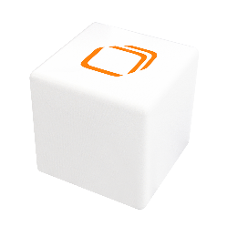
attocube systems GmbH
Eglfinger Weg 2
85540 Haar, Germany
Phone: +49-89 -420 7970
E-Mail: info@attocube.com
www.attocube.com

For technical queries, contact:
support@attocube.com

Reginal US Sales Representatives:
West Coast: Arcadia, CA
Phone: +1 510 631 2154
Southwest: Henderson, NV
Phone: +1 510 631 1784
Midwest: Delaware, OH
Phone: +1 510 631 133

attocube systems GmbH
Eglfinger Weg 2
85540 Haar, Germany
Phone: +49-89 -420 7970
E-Mail: info@attocube.com
www.attocube.com

For technical queries, contact:
support@attocube.com

Reginal US Sales Representatives:
West Coast: Arcadia, CA
Phone: +1 510 631 2154
Southwest: Henderson, NV
Phone: +1 510 631 1784
Midwest: Delaware, OH
Phone: +1 510 631 133

attocube systems GmbH
Eglfinger Weg 2
85540 Haar, Germany
Phone: +49-89 -420 7970
E-Mail: info@attocube.com
www.attocube.com

For technical queries, contact:
support@attocube.com

Reginal US Sales Representatives:
West Coast: Arcadia, CA
Phone: +1 510 631 2154
Southwest: Henderson, NV
Phone: +1 510 631 1784
Midwest: Delaware, OH
Phone: +1 510 631 133

attocube systems GmbH
Eglfinger Weg 2
85540 Haar, Germany
Phone: +49-89 -420 7970
E-Mail: info@attocube.com
www.attocube.com

For technical queries, contact:
support@attocube.com

Reginal US Sales Representatives:
West Coast: Arcadia, CA
Phone: +1 510 631 2154
Southwest: Henderson, NV
Phone: +1 510 631 1784
Midwest: Delaware, OH
Phone: +1 510 631 133

