**Abstract Title**

Author Name1, Presenting Author2

*1Affiliation*

*2Affiliation*

name@email.domain

The length of the abstract is limited to one-page. The submitted abstracts will be included in the book of abstracts of the AttoChem Young Scientist Symposium. The book of abstracts will be published online on the conference webpage. If you want to make your abstract more attractive and informative, you can include figures and references to articles [1] or books [2].

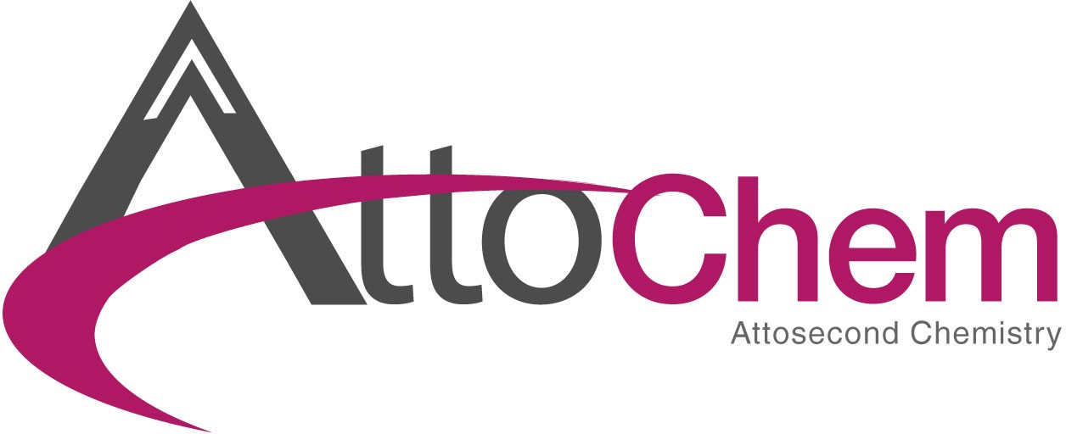

Figure 1: Figure example. Here comes the caption

The **one-page** abstract should be written in English and prepared using this Word template. Please convert your abstract to a PDF file and submit it via mail to [attoyss2023+abstracts@gmail.com](mailto:attoyss2023+abstracts@gmail.com?subject=%5BAbstract%20submission%5D).

# **References**

1. T. Name, Article Title, Journal 34, (2019), 154–160
2. Á. Näm, Book Title, Publisher Name and Town, (2018), 50–68