## 4. Linux CLI – More Tools…

So you’re now on your way to becoming a Linux ninja! But there are many more tools and tricks to learn! Here are a few more to put in your toolbox.

date

You can probably guess what date does. It outputs the current date and time of the system!

>: date

If you are using a Raspberry Pi, the date/time is probably wrong as the Pi doesn’t keep time when there is no power connected. It doesn’t have a hardware cock. This is ok though as we can set the date and time with the date command. Use the following command to construct the correct date time.

:> date --set ="Sat May 02 21:20:15 GMT 2015"

man

man is probably one of the most useful commands on the Linux command line. If you ever get stuck or cant remember how to use nearly every other tool on the system, simply type man then the command to read the manual for the tool. Try it our with some of the tools you should know already. Press spacebar to go to the next page or the page up/page down keys on your keyboard (if you have them). You can also use the arrow keys. Press ‘q’ to quit from man.

:> man nano

:> man date

:> man vim

clear

If you have run lots of commands and your shell session has got a bit full and messy, just type clear and it will give you a nice, clean, uncluttered shell to work from.

**:> clear**

history

If you know you’ve typed a long command or one that is tricky to remember, you can type history to see all of the commands you have made.

:> history

:> history –c This will clear the history.

Remember you can also cycle through your previous command using the up and down arrows on your keyboard.

sudo

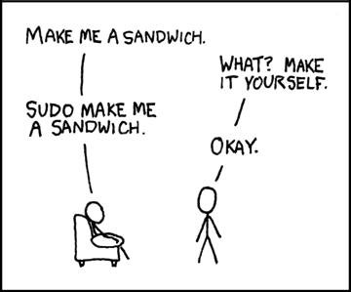sudo really is a super command. No really! It stands for Super User DO. There are lots of commands in Linux that require security privileges of an administrator or the root user (an account which can do everything). If you are logged into the system as a user in the sudoers file, you can elevate your privileges by prefixing your command with sudo. Sudo will ask you for your account password when you run the command.

You can view which users are allowed to run commands as sudo by looking in the /etc/sudoers file. Use cat to look at this file. You may even need to use sudo to view it!

shutdown

I bet you can guess what this command does! Shutdown is a command that requires the use of sudo. It also needs a number of options in order to work. You have to provide the type of shutdown you want to perform and the time you want the command performed. The time is usually provided in the number of minutews away from now but you can read the man page for more instructions. Some of the most common usage is below:

:> sudo shutdown –r now This will reboot the system straight away.

:> sudo shutdown –h 5 This will halt (shutdown) the system in 5 minutes.

:> sudo shutdown –s 0 This will put the system to sleep straight away like now.

startx

You won’t often need to use this command but it is a useful one to know. Startx will start an X window session, essentially starting the Linux Graphical User Interface (GUI). You will only see the result of this if you are connected to your system with a monitor and not via an SSH session. If you are using Raspbain on a Raspberry Pi and connected to it with a monitor with a HDMI cable, you may need to use this command to start the GUI.

:> startx