Lab Assignment 4 — Azure VM & Apache Web Server

Q1(i-iv): VM Created & Apache Running
VM: lab4-vm | Region: East Asia | OS: Ubuntu 22.04 LTS | Size: Standard_B2ats_v2
Apache installed, started, and enabled on boot. Port 80 (HTTP) open via NSG.
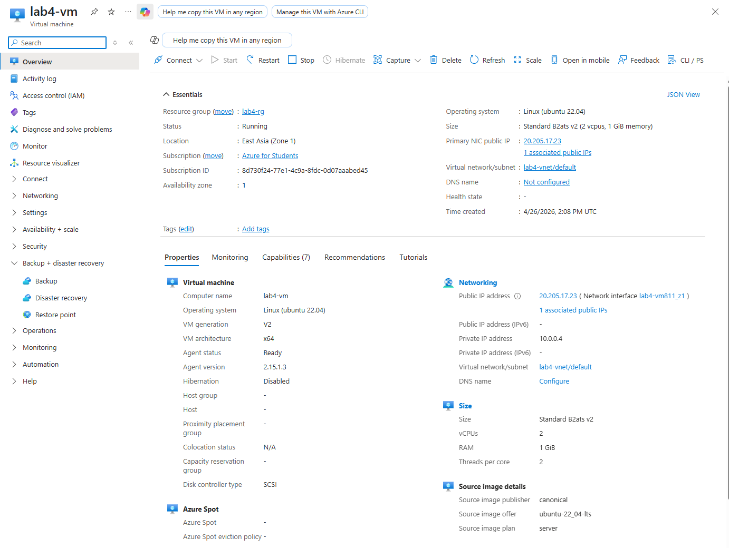
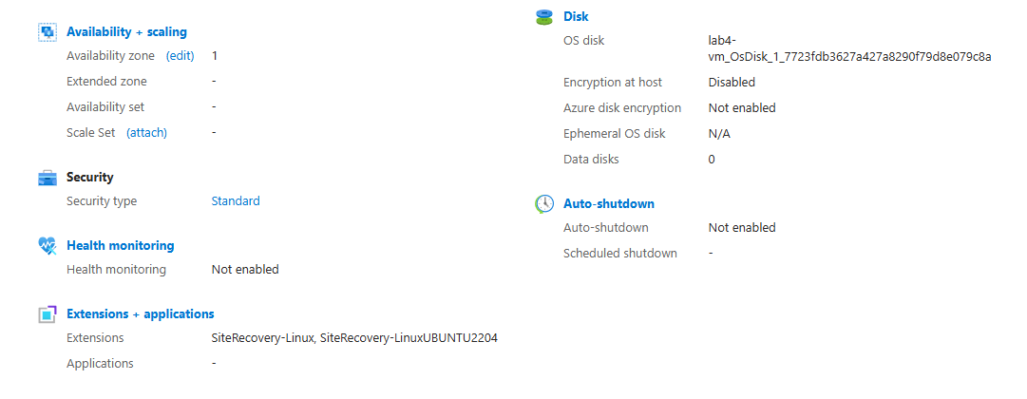
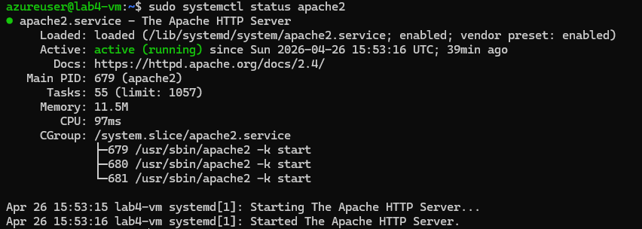

Q1(v): index.html Hosted on VM
Basic HTML webpage accessible via Public IP: http://20.205.17.23
[http://20.205.17.23]
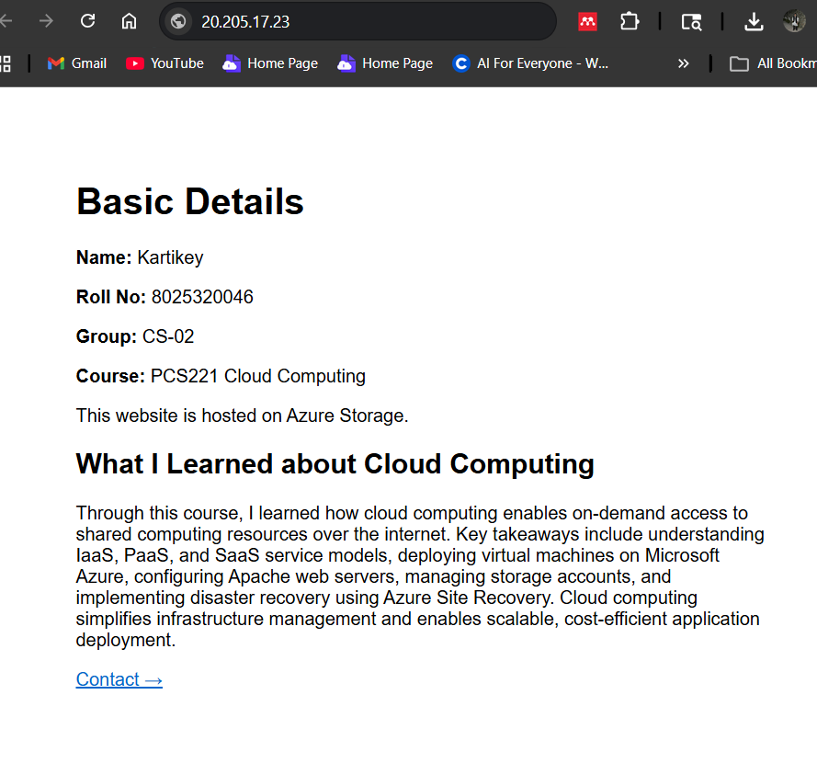

Q2: contact.html with Navigation Links
contact.html deployed with email, and navigation links between index.html and contact.html.
[http://20.205.17.23/contact.html]
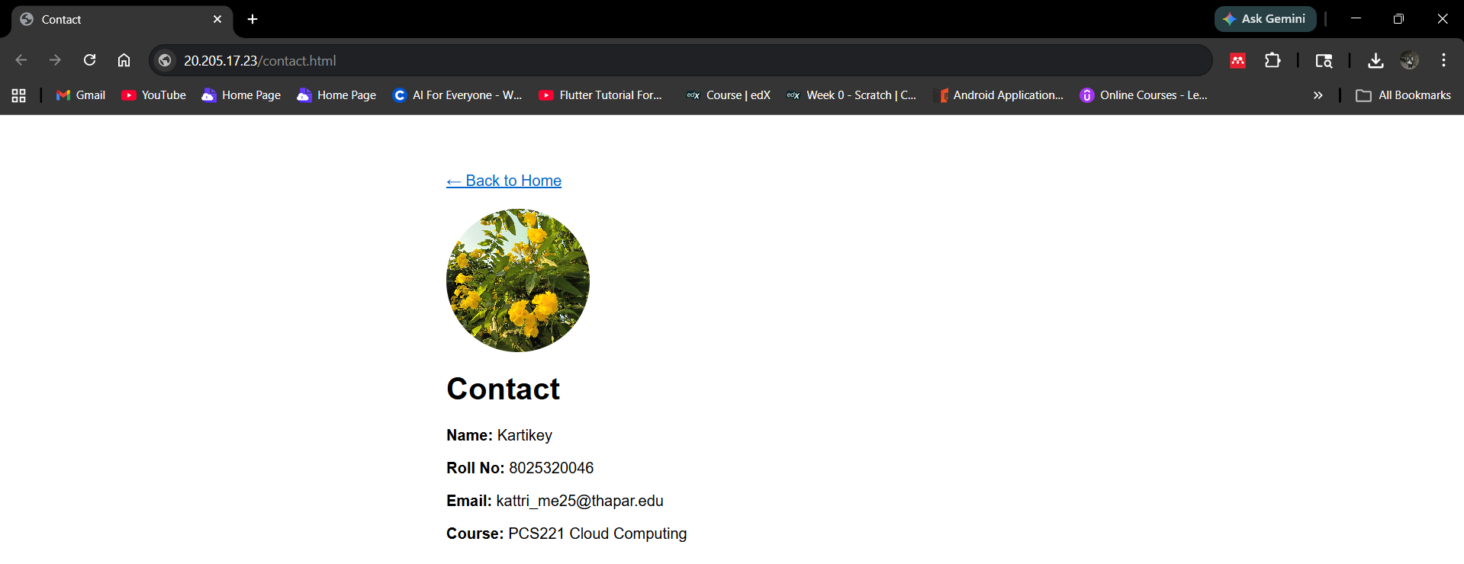

Q3: Azure Storage Static Website
Storage Account: lab4storage8025 | Static website enabled | index.html uploaded to $web container.
