Lab Assignment 5 — Azure Site Recovery (VM Migration)

Q1: Azure Site Recovery — Replication Enabled
Recovery Services Vault: lab5-vault | Region: Central India
Source VM: lab4-vm (East Asia) replicated to Central India using ASR.

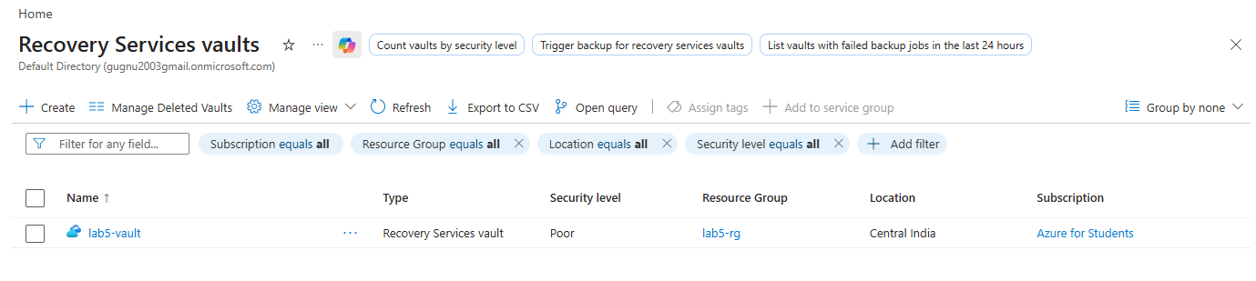
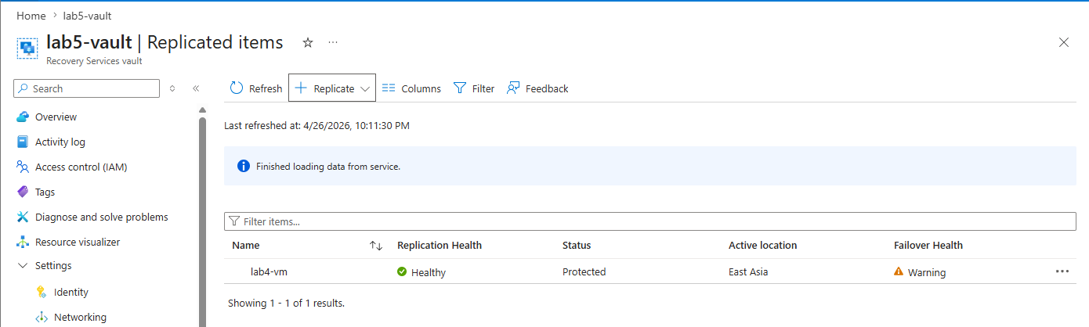
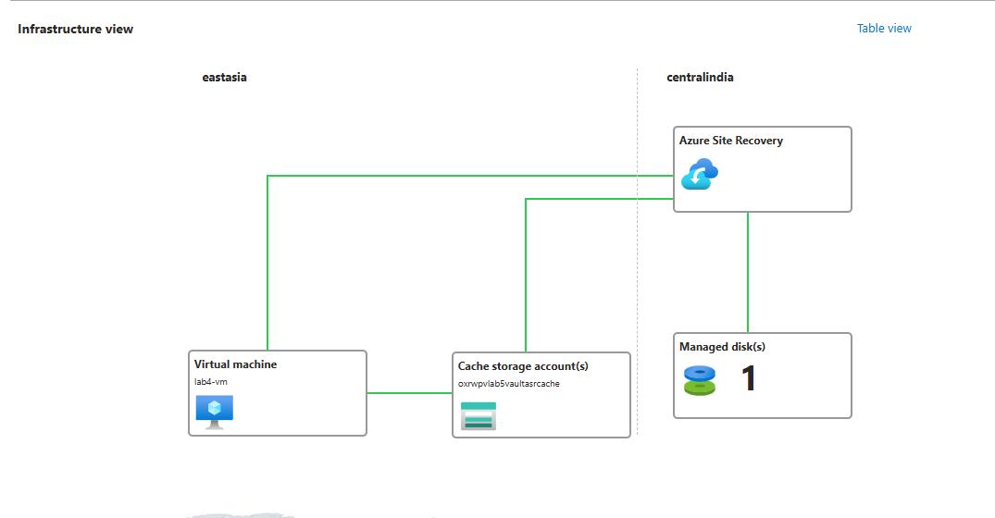

Q2: Test Failover
Test Failover initiated using latest recovery point on isolated test VNet.
Apache service verified running on test VM. Webpage accessible via test VM public IP.
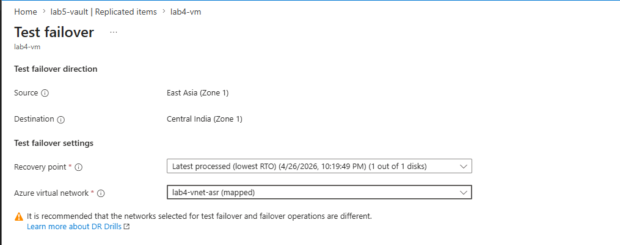

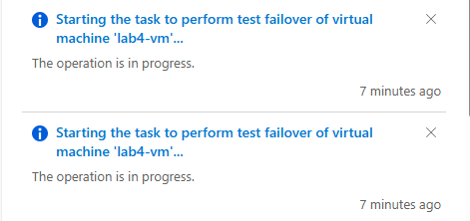

Q3: Actual Failover (VM Migration)
Actual Failover initiated and committed. VM successfully migrated to Central India.
Apache web server verified running. Webpage accessible. Data consistency maintained.
