Lab Assignment 6 — VM Migration via Snapshot (Cold Migration)

Step 1: Stop VM (Cold Snapshot)
lab4-vm stopped (deallocated) before taking snapshot to ensure data consistency (cold migration).
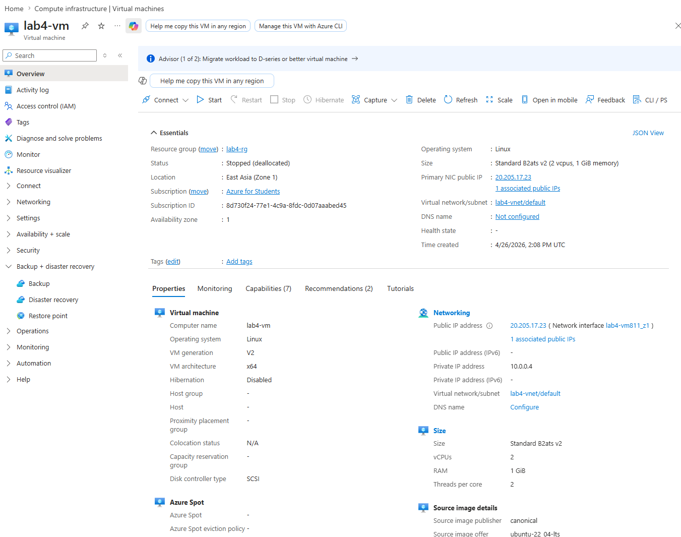

Step 2: Create Snapshot
Full snapshot of lab4-vm OS disk. Name: lab6-snapshot | Resource group: lab4-rg | Type: Full
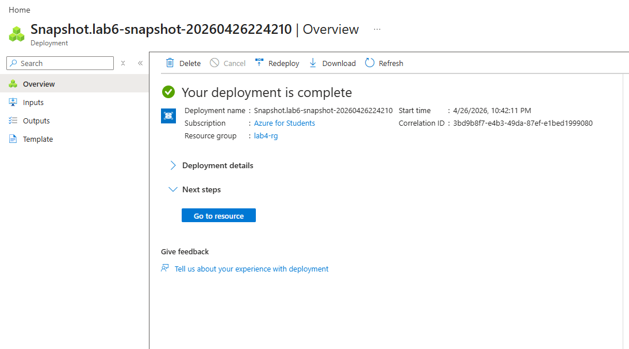

Step 3: Create New Disk from Snapshot
New managed disk created from lab6-snapshot. Name: lab6-disk | Region: East Asia | Size: 30 GiB | OS: Linux
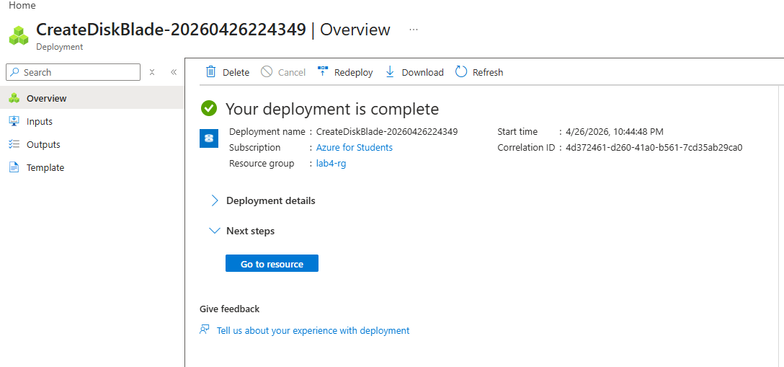

Step 4: Create New VM from Disk
New VM created from lab6-disk. Name: lab6-vm | Region: East Asia | Size: Standard_B2ats_v2 | Public IP: 20.2.141.94
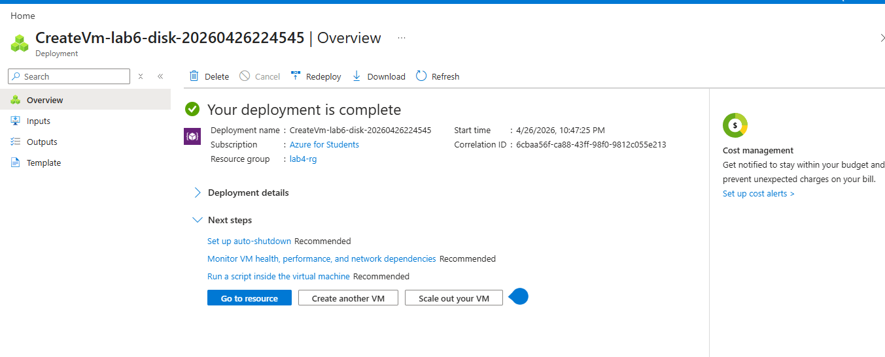

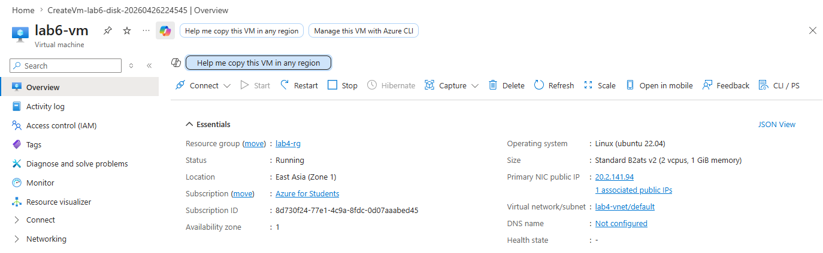

Step 5: Verify Apache & Webpage on Migrated VM
SSH into lab6-vm and verified Apache web server running. Webpage accessible via new public IP: http://20.2.141.94
