Kartikey Attri 8025320046 PCS223 — Advanced Computer Networks Lab
DHCP Server Configuration
Assignment 4

Objective
To configure a DHCP server on a Cisco router (pool: xyz, network: 192.168.10.0/24, DNS: 1.2.3.4, lease: 3 hours) and verify automatic IP assignment to clients.

Screenshots & Observations
Screenshot 1: Topology Overview
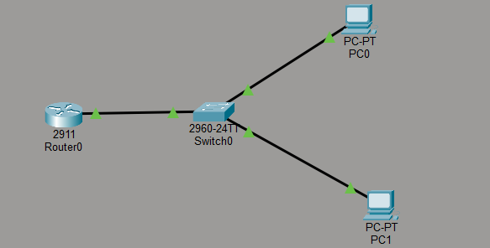
________________________________________________________________________
Screenshot 2: Router R1 — DHCP Pool
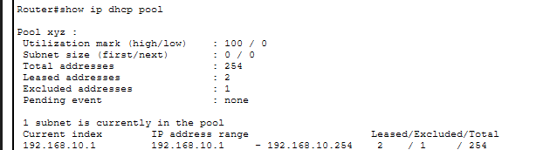
________________________________________________________________________

Screenshot 3: PC1 — DHCP Mode IP Address Assigned
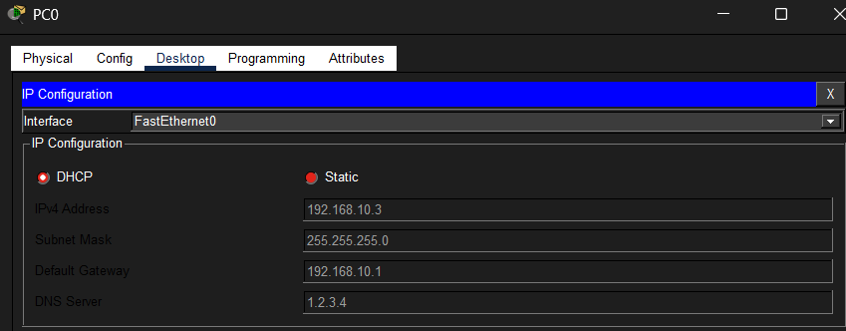
________________________________________________________________________
Screenshot 5: PC2 — DHCP Mode IP Address Assigned
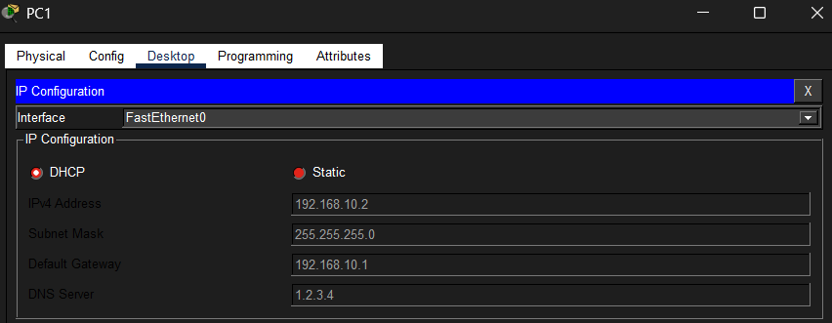
________________________________________________________________________
Screenshot 4: show ip dhcp binding

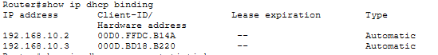 ________________________________________________________________________

Screenshot 5: Ping Test PC1 to PC2
 

