Kartikey Attri 8025320046 PCS223 — Advanced Computer Networks Lab
Static Routing Configuration
Assignment 5

Objective
To configure static routes in Cisco Packet Tracer to connect two LANs (Tehran: 192.168.1.0/24 and Shiraz: 172.16.0.0/16) via a serial WAN link.

Screenshots & Observations
Screenshot 1: Physical Topology
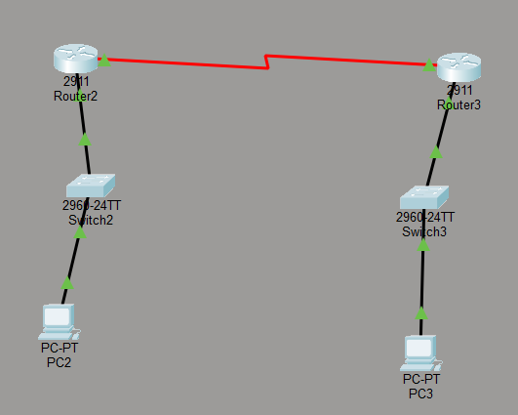
________________________________________________________________________
Screenshot 2: R1 — Interface Configuration
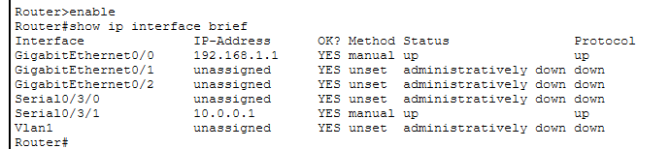________________________________________________________________________
Screenshot 3: R2 — Interface Configuration
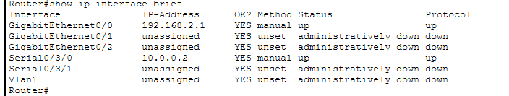________________________________________________________________________
Screenshot 4: R1 — Routing Table
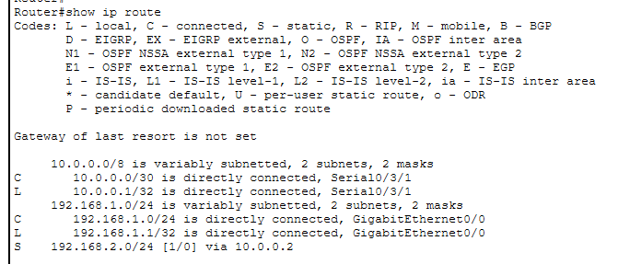
________________________________________________________________________
Screenshot 5: R2 — Routing Table
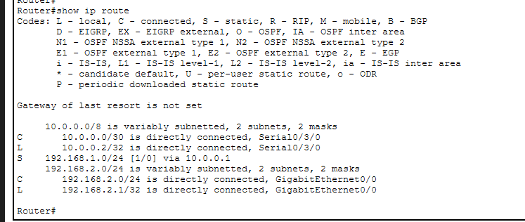________________________________________________________________________

Screenshot 6: Ping Test — PC1 to PC2


