**Signals of variation in human mutation rate at multiple levels of sequence context**

Rachael Aikens1,2,3 and Benjamin Voight2,3,4

1Department of Mathematics, Swarthmore College, Swarthmore, PA 19081

2Department of Systems Pharmacology and Translational Therapeutics, Perelman School of Medicine, University of Pennsylvania, PA 19104

3Department of Genetics, Perelman School of Medicine, University of Pennsylvania, PA 19104

4Institute for Translational Medicine and Therapeutics, University of Pennsylvania, PA 19104

Correspondence to:

Benjamin F. Voight, PhD

Associate Professor of Systems Pharmacology and Translational Therapeutics

Associate Professor of Genetics

University of Pennsylvania

Perelman School of Medicine

3400 Civic Center Boulevard

10-126 Smilow Center for Translational Research

Philadelphia, PA 19104

Email: bvoight@pennmedicine.upenn.edu

**ABSTRACT**

Our understanding of mutation rate helps us build evolutionary models and make sense of genetic variation. Recent work indicates that the frequencies of specific mutation types have been elevated in Europe, and that many more, subtler signatures of global polymorphism variation may yet remain unidentified. Here, we present an analysis of the 1,000 Genomes Project (phase 3), suggesting additional putative signatures of mutation rate variation across populations and the extent to which they are shaped by local sequence context. First, we compiled a list of the most significantly variable polymorphism types in a cross-continental statistical test. Clustering polymorphisms together, we observed several sets of substitution types that showed similar trends of relative mutation rate across populations, and describe the patterns of these mutational clusters among continental groups. For the majority of these signatures, we found that a single flanking base pair of sequence context was sufficient to determine the majority of enrichment or depletion of a mutation type. However, local genetic context up to 2-3 base pairs away contributes additional variability, and helps to interpret a previously noted enrichment of certain polymorphism types in some East Asian groups. Building our understanding of mutation rate in this way can help us to construct more accurate evolutionary models and better understand the mechanisms that underlie genetic change.

**Words: 215**

**INTRODUCTION**

The process of mutation is a formative force in molecular evolution because it generates the genetic variation that can be acted upon by natural selection. Quantitative and qualitative insights regarding the mutation rate in human populations can facilitate the construction of increasingly informative models of human evolutionary history, targets of natural selection, and perhaps even genetic or environmental mechanisms that confer genomic stability and drive genetic change. While the rates of DNA mutation and repair have been known to differ widely between certain individuals1, within and between chromosomes2, and down to specific local sequences3, the biological mechanisms underlying mutation rate variability across the genome are not yet completely known. Recent work has suggested that the mutation rate in humans may itself have been in flux over recent evolutionary history4–6. Key evidence supporting this hypothesis stems from the observation that the relative proportions of certain types of polymorphisms vary across populations. Most notably, studies cite the strong enrichment of C→T substitutions at certain trinucleotide contexts in Europe and South Asia4–6. These reports have also documented additional polymorphism types that appear to vary in frequency across populations5,6.

However, there are two lines of inquiry that have not yet been fully explored in these data. First, because clusters of polymorphisms with similar global profiles of enrichment might be driven by a shared mechanism, is worthwhile to ask not only which polymorphism types vary across the globe but also how variable polymorphism types group together as putative “profiles” of mutation rate variations. Developing a better understanding of these signatures of polymorphism variation may help to link such changes to a putative genetic or environmental cause. Second, models of local genetic sequence context beyond a single flanking nucleotide have not yet been applied to the study of variability in mutation rates across populations. Our previous work has demonstrated that windows of sequence broader than the trinucleotide context may uncover additional detail in mutation rate variability across the genome3,7. The consideration of greater numbers of upstream and downstream base pairs of context could help to interpret the context and mechanism in which mutation rate varies across populations. For example, strong effects stemming from broader sequence context may drive signals of polymorphism in an observed lower order context (*i.e.,* trinucleotide) context, indicating that the underlying mechanism may rely on the local nucleotide configuration. As such, models that consider broader windows of local context may highlight subtle variation in polymorphism that might not have otherwise been detected.

For these reasons, we sought to expand upon previous studies by identifying polymorphisms at multiple context levels and quantifying how they vary across populations. To this end, we have applied a combination of sequence context frameworks to analyze the current release of the 1,000 Genomes project, spanning >2,000 subjects across four continents. With this information in hand, we sought to catalog population-level heterogeneity in polymorphism across the spectrum of sequence contexts clustered into common mutational signatures across populations.

**RESULTS**

To quantify differences in the frequencies of mutation types across populations, we assembled sets of genetic variants specific to Africans, Europeans, South Asians, and East Asians (504, 503, 489, and 504 individuals, respectively, excluding admixed populations) from the 1000 Genomes Project (phase 3)8. As genetic variants in the coding genome are likely to be under purifying selection, we focused on variants observed in the non-coding genome to minimize the influence of selective pressures (**Methods**). Our final sets consisted of 7,049,495; 1,296,125; 1,964,196 and 1,985,436 variants private to African, European, East Asian and South Asian populations, respectively.

**Identifying novel 3-mer substitution classes that vary across continents**

We first compiled a list of polymorphisms in trinucleotide (*i.e.*, ‘3-mer’) contexts that appear heterogeneous in their representation across the globe. To this end, we extended a previously described4,6 approach (**Methods**) to perform a test for homogeneity in private polymorphism across Africa, Europe, East Asia, and South Asia, to compare counts of polymorphisms between pairs of continental groups. In addition to reducing the required number of hypothesis tests compared to previous methods (important later for analyses with broader windows of sequence context), this statistical framework allowed us to rank order polymorphism types by the significance of their variation across multiple continental groups. After replicating previous results4,6 as a technical control (**Supplemental Note**), we applied our test to each 3-mer polymorphism type (96 total), applying a modified p-value correction (Pordered) as previously described6, and using Bonferroni correction for multiple hypothesis testing (nominal significance threshold Pordered < 5 x 10-4).

As expected, the most compelling group of substitution classes was composed of C→T polymorphism types previously reported to be enriched in Europe and South Asia (**Table 1**). All four types that have been previously noted as part of this signal: TCC→T, ACC→T, TCT→T, and CCC→T were among the 6 most variable polymorphisms (all Pordered < 1 x 10-68). We further observed that all four possible types of CpG transition mutations were variable between populations (Pordered < 1 x 10-31, **Table 1, Supplementary Note**). Previous work has suggested that proportions of CpG substitutions are weakly variable between populations5; we also noted that all CpGs appear to have a shared profile of enrichment in South and East Asia, but that this enrichment is smaller relative to the overall abundance of C/T polymorphism at CpG sites. Importantly, Mathieson and Reich5 have cautioned that an apparent CpG enrichment may be a signature of recurrent mutation in populations which have experienced recent exponential growth5. However, if this were the case, we would expect to see a strong excess of CpG polymorphisms at doubletons (i.e., allele count 2), which we did not observe (**Supplementary Note**).

We next examined the remaining variable polymorphisms for novel signatures of mutation rate variation. Surprisingly, we found that 63 of the 96 possible 3-mer types exceeded our Bonferroni correction for multiple tests across ancestral continental groups. Therefore, we opted first to consider the top 15 most heterogeneous polymorphism contexts (corresponding to a Pordered < 2 x 10-37, **Table 1**). To facilitate comparison of the relative enrichment between continental groups, we used all private polymorphisms to infer a mutation rate for each 3-mer (per generation per site) calibrated to the average estimated *de novo* mutation rate from Kong et. al9 (**Methods**).

In addition to the C→T polymorphisms mentioned above, we observed eight additional contexts in our top ranked set that have not yet been specifically noted in previous studies (**Table 1**). One polymorphism - TCA→T - showed enrichment in Europe and South Asia, a profile similar to the previously reported C→T polymorphism contexts in Europe (**Table 1**). The ACT→T context was similar to this, with greatest representation in Europe and South Asia, but with a higher proportion in Africa compared to other substitution classes from this group. A final polymorphism, GCC→T, was likewise enriched in Europe and South Asia, but also showed an elevation in East Asia. Interestingly GAT→T, ACC→A, GAC→T, and GCT→T polymorphisms displayed a similar profile of heterogeneity distinct from previously reported signatures of variation: the highest rates in East and South Asia with intermediate levels in Europe, relative to Africa. This suggests that these three substitution classes may represent a group of polymorphism types enriched in Asia. A final substitution class, ACA→T, was highest in Africans, with lower rates in East Asians and Europeans, perhaps suggestive an Africa-enriched signature.

As an additional validation, we estimated mutation rate separately on each chromosome and found that these patterns of enrichment hold relatively consistently across the genome for each of these substitution classes (**Supplementary Note**). Taken together, these results indicate that there may be several previously unreported signatures of variation in mutation rate observed at the 3-mer scale, beyond the previously reported signal of European C→T enrichment.

**Hierarchical clustering of 3-mer mutational signatures**

We next sought to identify sets of substitution classes that share similar profiles of enrichment or depletion across the globe, which we hypothesize might be influenced by a common underlying mechanism. To this end, we performed hierarchical clustering of 3-mer polymorphism types based upon their relative inferred mutation rates in each of the twenty 1,000 Genomes Project subpopulations comprising the non-admixed continental groups from our initial analysis.

We highlight five “profiles” of substitution rates that emerged from the clusters of 3-mer substitution classes (**Figure 1A**). Profile #1 corresponds to European C→T enrichment, and includes all four 3-mers previously reported to comprise this signal5,6 (**Figure 1B**). The remaining three polymorphisms in this group, TCA→T, ACT→T, and GCC→T are noted in the previous section (**Table 1**), and represent variable polymorphisms not previously highlighted as part of this group of Europe-enriched mutations.

The next profile (#2) consists of GAT→T, ACC→A, and GAC→T, which are elevated in East and South Asia (**Figure 1C**). All three of these were noted above for their cross-continental heterogeneity (Pordered < 7 x 10-40, **Table 1**). Next, we observed two clusters (Profiles #3a and #3b) that appear enriched in Japan and other groups in East Asia, relative to other continental groups. This unit is comprised of the *AC→C polymorphisms, as well as ATA→A, corresponding with a previous report6 which documented that *AC→C, and TAT→T mutation types separate East Asians in a principal component analysis. Together, profiles #2 and #3 may represent two distinct signatures of enrichment for certain mutation types in Asia.

The remaining two profiles both involve substitutions within CpG contexts. Profile #4, corresponds to the CpG transitions, which cluster together even after the data are normalized to show only relative mutation rates (**Figure 1D**). The final profile (#5) is comprised of CpG transversions which appear to be elevated in Africa. However, Harris and Pritchard6 report that the proportions of these polymorphism types do not appear to agree between the Simons Diversity Genome Project and the 1,000 Genomes Project. This suggests that this profile may be the result of an experimental artifact, rather than a true divergence in mutation rate. In sum, the clusters identified here highlight sets of polymorphisms whose relative proportions are similar across populations ascertained by the 1,000 Genomes Project.

**Broader sequence contexts around 3-mer signatures**

Our previous work has indicated that broader windows of sequence context around a genetic locus can have a substantive effect on the probability of substitution3,7. Thus, we next took each 3-mer type identified as heterogeneous in the previous section and measured the frequency of private substitutions in a broader window of local sequence context that considered three flanking nucleotides (*i.e.*, a heptanucleotide, or ‘7-mer’ context window). This subdivided each 3-mer substitution into 256 distinct 7-mer classes, allowing us to ask whether the population-specific heterogeneity was common to all 7-mer expansions, or confined to a specific subset of those contexts. To this end, we plotted the relative inferred mutation rates of those polymorphisms in pairs of populations. If there were no signal of mutation rate difference between populations, we would expect all 7-mer expansions to be distributed along the y = x diagonal (*e.g.*, **Figure 2A,** case I). If the most important local features driving a mutational signal lay within a single nucleotide base of the substitution, then we would expect all 7-mers to lie together off the diagonal (*e.g.*, **Figure 2B,** case II). Alternatively, if a 3-mer signal were actually driven by a handful of highly variable 7-mer substitution types, only a handful of exceptional 7-mer types would lie far from the y = x line (case III).

We found that nearly all of the 3-mers comprising profiles #1, #2, and #4 matched case II (**Figure 2B**, **Supplementary Note**). Thus, the global variation in European C→T elevation, the CpG transitions, and the Asian GAT→T, ACC→A, and GAC→T elevation was not clearly linked with sequence context features beyond a single flanking nucleotide base. However, the polymorphisms comprising profile #3 more closely matched case III, indicating that the Japanese enrichment of the *AC→C and TAT→T substitutions might be driven by a handful of 7-mer polymorphisms heterogeneous across East Asia (**Figure 3B, Supplementary Note**).

To explore this finding in more detail, we sought to identify the key 7-mer types underlying this 3-mer signature. To this end, we considered each of the 1,280 possible 7-mer expansions *AC →C and TAT→T 3-mer substitutions, testing for heterogeneity between Japanese from Tokyo (JPT, higher profile #3 polymorphism proportion) and Chinese Dai from Xishuangbanna (CDX, lower profile #3 polymorphism proportion). We found fourteen 7-mer polymorphism contexts that were elevated in JPT relative to CDX (FDR-adjusted P < 0.05, **Figure 3A**). Of these, ten have the shared motif XXXACAG→C (**Figure 3C**). Curiously, we also observed that four out of the fourteen polymorphism types were enriched on the X chromosome in East Asia, relative to the autosomes (though we note that many of the ten other substitution classes had too few observed polymorphisms on the X chromosome to justify a valid statistical test).

**Variable polymorphism types among broader sequence context models**

Motivated by this result and previous work3, we next hypothesized that additional signals of mutation rate variation might be observable only in specific pentanucloetide (*i.e.*, ‘5-mer’) or 7-mer polymorphism types. If this were true, considering a broader span of sequence context would highlight novel signals of mutation rate variation not evident from 3-mer level analyses. To this end, we applied the homogeneity testing framework described above to each of the 1,536 possible 5-mers and the 24,576 possible 7-mer polymorphism types.

Within a 5-mer sequence context, we found that 156 out of 1,535 tested polymorphism types surpassed Bonferroni multiple test correction (**Methods and Supplementary Note;** one 5-mer polymorphism was not observed a sufficient number of times in each population to justify a valid statistical test). Of these, 48 represent expansions of Europe-elevated 3-mer polymorphisms which have been highlighted by previous analyses (e.g., CTCCA→T an expansion of the TCC→T 3-mer)4,5. An additional 59 represent expansions of other 3-mers noted in Table 1. However, the remaining 49 significantly variable 5-mer polymorphisms involve 3-mer contexts that have not yet been highlighted.

We next moved to our broadest, 7-mer sequence context model. Out of 20,668 possible 7-mer substitution types with sufficient data available for a statistical test, 141 surpassed Bonferroni multiple test correction (**Figure 4A, Methods, and Supplementary Note**). Of these, 119 represent expansions of polymorphisms identified at the 3-mer level, while 22 have not been previously noted. The strongest effect at the 7-mer level was the CAAACCC→C substitution (Homogeneity test Pordered = 3 x 10-39, **Figure 4**) corresponding to one of the Japanese-enriched 7-mers we identified above (**Figure 3A**). In total, 4 of the 22 previously unreported significant 7-mer polymorphisms were one of the fourteen Japanese-enriched substitution types (**Figure 3C**). Interestingly, the third most significant unreported 7-mer polymorphism, AAACAAA→A (Pordered = 1 x 10-18) has a similar profile within East Asia as the other profile #3 polymorphisms (**Supplementary Note**). In fact, we find that multiple 7-mer types with 3-mer subcontexts outside of *AC →C or TAT→T are enriched in Han Chinese and Japanese groups. This suggests that there exist additional 7-mer mutations comprising this signature that have not yet been discovered.

Finally, two of the 7-mer polymorphism types with variable rates across populations are TTTAAAA→T and ATTAAAA→T (Pordered < 2 x 10-21), both of which were enriched in Africa (**Figure 4B and Supplementary Note**). These correspond to the 3-mer TAA→A, which is the 16th most significant polymorphism from our 3-mer-level heterogeneity analysis (Pordered = 6.2 x 10-36). Examining the rates of the 7-mer expansions of TAA→A, we find that TTTAAAA→T and ATTAAAA→T are indeed outliers among other 7-mer expansions both in terms of their African enrichment and the overall number of mutations of those types (**Figure 4C**). These results suggest that the heterogeneity we observe in proportions of TAA→A polymorphisms is in fact driven by an elevation of these two highly variable 7-mers in Africa.

**DISCUSSION**

In this report, we describe a number of patterns of variability in polymorphism frequencies between human populations at a global scale. Whether these patterns reflect a true difference in underlying mutational processes, and what those underlying causes might be, remains unclear. Even the most prominent signature, European C→T, is still poorly understood: Although this rate appears to correlate with mutational signatures linked to ultraviolet radiation or alkylating agents in one cancer study5,10, evidence supporting either of these causal mechanisms is limited5.

Although European C→T enrichment is by far the most prominent signature of variation5,6, the large number of variable polymorphism types and the variety of patterns they follow at a global scale suggest that several different processes are at work in shaping the ratios of polymorphisms we observe. If this is correct, further scrutiny of these differences may provide an opportunity to better understand the processes that shape genomic stability and genetic change. Moreover, quantifying and modeling polymorphism patterns as accurately as possible can help us fine-tune our predictions and interpretations of single nucleotide genetic variation, potentially advancing our understanding of evolution or genetic disease.

One approach that may aid these efforts is the consideration of local genetic sequence. Previous studies have identified different patterns of heterogeneity in polymorphism levels that can be observed between substitution classes just within different 3-mer motifs6, illustrating the importance of a single flanking base pair of context in shaping substitution probability. In this report, we consider a broader window of local sequence information, noting that while certain signatures are fully shaped within a single flanking base pair or context, others appear to vary with sequence context up to 2-3 base pairs from the locus of substitution (**Figures 2, 3B, and 4C**). We report that ten of the fourteen heterogeneous 7-mers between Chinese Dai and Japanese in profile #3 contain the 7-mer motif XXXACAG→C (**Figure 3**). In addition, we find that the apparent elevation of TAA→T 3-mer polymorphisms between Africa and Europe may in fact be driven by a strong enrichment of substitutions within WTTAAAA contexts (where ‘W’ represents a weak ‘A’ or ‘T’ base), which also appear to segregate more substitutions than other TAA contexts (**Figures 4B and 4C**).

There are some limitations to note in our given report. First, is sample size: while broader sequence context models can capture more information, they can also require much more total genetic data to be sufficiently well-powered for our statistical analysis. This is made especially difficult because asking comprehensive questions about global mutation rate patterns requires a large and ethnically diverse dataset of genetic variation, which are only recently becoming available. Additional, deeply sequenced samples from diverse populations would be ideal for further targeted hypothesis testing, validation, and improving the mathematical models designed to capture this variability. For example, in this report, we noted evidence suggesting that East Asian heterogeneity in *AC→C and TAT→T mutations may be strongest on the X chromosome (**Figure 3C**). Given this observation, it may be informative to examine the dispersion of these polymorphisms across the X-chromosome, since a genetic variant responsible for an increase in mutation rate is likely to be found in a genetic context with high polymorphism11. Unfortunately, however, a problem of power quickly emerges, since the total number of polymorphisms of any 7-mer type we observe on the X chromosome is still relatively small. As a result, analyses regarding this signature may be difficult until a larger amount of East Asian genetic data is made available.

A second complication is that signals of polymorphism enrichment from population-level data may reflect some contemporary and some ancestral mutation rate variation, so that the biological mechanisms driving these phenomena may not be active today. Measurements of enrichment of these polymorphism types in ancient DNA and across allele frequency bins suggest that this signal may correspond to an ancestral increase in mutation rate of certain C→T mutations ~15,000 years ago which may have subsided ~2,000 years ago5,6. Further analyses which consider polymorphism enrichment by allele frequency may help us piece together the timescale over which mutation rates may have changed6.

It is likely that further investigation will reveal details of mechanism, evolutionary timing, and genome-wide or subpopulation-level patterns in mutation rate variation, and our report here is by no means exhaustive. We detail evidence suggesting that mutation rate variation acts in a variety of ways across human populations based on local sequence context cues at varying distances from the mutated locus. While some of these signals manifest at the 3-mer level, consideration of a broader context brings new patterns of variation to light.

**METHODS**

**Compilation of private variant sets**

Variants from the 1,000 Genomes Project release (downloaded 02/26/2016, phase 3)8 were filtered to include single nucleotide polymorphisms (SNPs), excluding multiallelic variants, in/dels, and any variants with a filter tag other than “PASS”. Based on the exclusion criteria from previous work, we also omitted variants in coding regions, centromeres, telomeres and additional sections of the genome predicted to have low accessibility3. From this set, we considered variants with a minor allele count 2 or greater across all samples. Although including singleton variants (those observed only once in the dataset) in theory would provide more information about the recent *de novo* mutation rate, previous efforts to analyze human polymorphism variation with singletons have proven difficult to replicate4, so we opted to exclude them from our analyses.

From the list of variants that passed our filters, we compiled lists of variants ‘private’ to each non-admixed continental group from the dataset: Africans from Africa (AFR), Europeans (EUR), East Asians (EAS), and South Asians (SAS). We defined a SNP as ‘private’ to a continental group if it is observed in that group, but not in each of the other three. For all analyses, Americans of African Ancestry in Southwest USA (ASW) and African Carribeans from Barbados (ACB) were considered to be admixed American populations rather than ancestral African groups.

For subpopulation-level analyses, we passed along private polymorphisms defined for each continental group into each respective subpopulation list. For example, a polymorphism which was private to AFR and observed in both Kenya and Gambia would be added to the subpopulation lists for both LWK (Luhya in Webuye, Kenya) and GWD (Gambians in Western Divisions in Gambia). American admixed variant lists were compiled from all SNPs which were present in an American subpopulation but not present in more than one ancestral continental group. All filtration steps were carried out using vcftools and the vcf-isec tool (v0.1.12b)12.

From each continental or subpopulation list, we tallied counts of private variants by increasingly broader windows of sequence context, include one, two, and three flanking nucleotides (*i.e.*, 3-mer, 5-mer, and 7-mer context, respectively). During all this process, mutation classes were ‘folded’ to include its reverse-complimentary equivalent (*e.g.*, TCC→T and GGA→A were considered together). Code utilized for each step is available online (github.com/raikens1/mutation_rate).

**Statistical comparison with homogeneity test**

To replicate previous work by Harris and Pritchard4,6, we first performed pairwise chi-squared comparisons of polymorphism count between each possible pair of populations for each 3-mer polymorphism type (**Supplementary Note**). Next, to partially relieve the multiple testing burden of six pairwise population comparisons over each possible mutation type, we performed a single test using a 2x4 cell contingency table which included mutation proportions for each continental groups, from which the resulting chi-squared test for homogeneity has three degrees of freedom. An issue with performing this type of analysis across all sequence contexts is that the P-values from these tests are non-independent: a polymorphism that is profoundly heterogeneous across populations may alter the proportions of other polymorphism types. For these reasons, we used the *Pordered* correction as previously described6. Using this procedure, each polymorphism type is initially tested and ranked according to increasing significance based on a simple homogeneity test using all the data. A corrected p-value is then calculated for each polymorphism. To do this, the least significant polymorphism is assigned its original p-value using all of the data. After this, the p-value for the *i*th least significant polymorphism type is recalculated using a homogeneity test with only the data for the *i* least significantly variable polymorphisms from the initial ranking. All chi-squared comparisons were performed using the chisq.test function in R (v3.4.0), and significance thresholds were determined based on a Bonferroni correction with a nominal error rate (α = 0.05).

**Mutation rate inference**

The probability of observing a given polymorphism in a population is determined by a composite of mutation rate, demography, sample size, and other factors13. To facilitate comparisons across populations, we calculated a mutation rate, calibrated to the average *de novo* mutation rate estimated by Kong et al9. Assuming all populations have a total mutation rate of 1.2 x 10-8, we inferred the mutation rate of a specific type (say TCC→T) as

μm = 1.2 x 10-8 x Θ-1 x Θm

Where μm represents the inferred private germline TCC→T mutation rate per generation per site, Θm represents the proportion of all TCC sites in the genome with private C/T polymorphism in the population, and Θrepresents the total proportion of all sites of any type in the genome which are private polymorphisms in the population. It can be shown that this formulation of μm gives an overall genome wide mutation rate of 1.2 x 10-8 when all mutation types are pooled. 95% confidence intervals for μm were calculated using the normal approximation to the binomial, assuming the variance in Θ-1 to be approximately zero.

**Clustering polymorphism types**

We used the heatmaps 2 hierarchical clustering methods from the basic stats package in R (v3.4.0) in order to heuristically identify mutation types that vary in similar ways across the globe. In doing so, we defined the “profile” of a mutation *m* across a set of populations as a vector of the inferred mutation rate of *m* in each population. Each pattern of rates across populations was normalized by fold difference above or below the mean rate for that profile. We used Euclidean distance to construct each heatmap and for comparison, selected because these methods gave the most clearly interpretable results and agreed the most closely with previous work4–6 (**Supplementary Note**)

**Testing for enrichment of profile #3 on the X chromosome**

In order to test the highly variable polymorphism types for enrichment on the X chromosome (**Figure 3A**), we used a one-sided binomial test to determine whether the observed proportion of privately polymorphic sites on the X chromosome was greater than *p0*, the expected proportion under the null hypothesis. For demographic and sampling reasons, we expect to observe fewer polymorphic sites of any given type on the X chromosome than on the autosomes, even if the mutation rate of that polymorphism type is identical across chromosomes. Thus, to estimate *p0*, we first needed to calculate the ratio, *ξ*, of X-chromosome to autosomal substitution probability across all other 7-mer types. We then used this as a scaling factor, estimating *p0* as *ξpA*, where *pA* represents the maximum likelihood estimate for the substitution probability for that polymorphism across all autosomes.

**ACKNOWLEDGEMENTS**

R.C.A. is thankful for the guidance and feedback of Elizabeth Vallen, Nick Kaplinsky, Bradley Davidson, and Ameet Soni. The authors would also like to thank Varun Aggarwala and Onur Yörük, who offered helpful advice on the implementation of 5-mer and 7-mer sequence context analyses. B.F.V. is grateful for support from the US National Institutes of Health/National Institute of Diabetes and Digestive and Kidney Disorders (R01DK101478).

**AUTHOR CONTRIBUTION**

R.C.A. and B.F.V. conceived, designed, and performed the experiments, developed the methods, analyzed the data, and wrote the manuscript. B.F.V. supervised the research.

**LITERATURE CITED**

1. Conrad, D. F. *et al.* Variation in genome-wide mutation rates within and between human families. *Nat. Genet.* **43,** 712–4 (2011).

2. Hodgkinson, A. & Eyre-Walker, A. Variation in the mutation rate across mammalian genomes. *Nat. Rev. Genet.* **12,** 756–66 (2011).

3. Aggarwala, V. & Voight, B. F. An expanded sequence context model broadly explains variability in polymorphism levels across the human genome. *Nat. Genet.* **advance on,** (2016).

4. Harris, K. Evidence for recent, population-specific evolution of the human mutation rate. *Proc. Natl. Acad. Sci. U. S. A.* **112,** 3439–44 (2015).

5. Mathieson, I. *et al.* Differences in the rare variant spectrum among human populations. *PLOS Genet.* **13,** e1006581 (2017).

6. Harris, K. & Pritchard, J. K. Rapid evolution of the human mutation spectrum. *Elife* **6,** (2017).

7. Zhu, Y., Neeman, T., Yap, V. B. & Huttley, G. A. Statistical Methods for Identifying Sequence Motifs Affecting Point Mutations. *Genetics* **205,** (2017).

8. Auton, A. *et al.* A global reference for human genetic variation. *Nature* **526,** 68–74 (2015).

9. Kong, A. *et al.* Rate of de novo mutations and the importance of father’s age to disease risk. *Nature* **488,** 471–5 (2012).

10. Forbes, S. A. *et al.* COSMIC: exploring the world’s knowledge of somatic mutations in human cancer. *Nucleic Acids Res.* **43,** D805–D811 (2015).

11. Seoighe, C. *et al.* Inference of Candidate Germline Mutator Loci in Humans from Genome-Wide Haplotype Data. *PLOS Genet.* **13,** e1006549 (2017).

12. Danecek, P. *et al.* The variant call format and VCFtools. *Bioinformatics* **27,** 2156–2158 (2011).

13. Watterson, G. A. On the number of segregating sites in genetical models without recombination. *Theor. Popul. Biol.* **7,** 256–276 (1975).

**TABLE LEGENDS**

**Table 1:** **A cross-continental test for polymorphism variability at the 3-mer level.** 15 polymorphism classes with 3-mer sequence contexts, shown here, were highly significant (Pordered < 2 x 10-37) according to a chi-squared test for heterogeneity across non-admixed continental groups. Boldface numbers indicate a significant difference in polymorphism proportion compared with Africa (P < 1 x 10-5) in a pairwise chi squared test. Pordered was calculated as previously described6 (**Methods**). *To facilitate comparison, approximate private mutation rates (per generation per site) for each continent were inferred by normalizing estimate substitution probabilities using all private mutations to the *de novo* mutation rate estimated from Kong et al9, and then subsequently normalized relative to inferred rate in Africa.

**TABLES**

**Table 1**

|  |  |  |  |  |  |  |
| --- | --- | --- | --- | --- | --- | --- |
| Notes | 3-mer | Relative rate in Africa* | Relative rate in Europe* | Relative rate in South Asia* | Relative rate in East Asia* | Pordered |
| Previously reported C→T elevation in Europe4–6 | TCC→T | 1 | **1.56** | **1.20** | 1.00 | ≈ 0 |
| ACC→T | 1 | **1.20** | **1.07** | **0.93** | 3×10-308 |
| TCT→T | 1 | **1.17** | **1.06** | 0.98 | 3×10-196 |
| CCC→T | 1 | **1.06** | **1.03** | **0.95** | 2×10-69 |
| CpG transition | TCG→T | 1 | 1.02 | **1.06** | **1.04** | 2×10-49 |
| ACG→T | 1 | 1.01 | **1.04** | **1.03** | 2×10-48 |
| GCG→T | 1 | 1.01 | **1.04** | **1.04** | 4×10-45 |
| Not previously highlighted | GAT→T | 1 | **1.06** | **1.13** | **1.21** | 5×10-111 |
| ACC→A | 1 | **1.04** | **1.10** | **1.15** | 1×10-98 |
| ACA→T | 1 | **0.95** | 0.97 | **0.93** | 3×10-60 |
| TCA→T | 1 | **1.06** | **1.03** | 0.97 | 9×10-52 |
| ACT→T | 1 | 1.02 | 1.00 | **0.94** | 3×10-51 |
| GCT→T | 1 | 1.02 | **1.04** | **1.06** | 2×10-40 |
| GAC→T | 1 | 1.02 | **1.09** | **1.20** | 6×10-40 |
| GCC→T | 1 | **1.06** | 1.03 | 1.02 | 1×10-37 |

**FIGURE CAPTIONS**

**Figure 1: Profiles of mutation rate in trinucleotide sequence context highlight variability across populations.** **(A)** Heat map of all 3-mer polymorphisms, clustered based on their relative rates in each of twenty non-admixed 1,000 Genomes Project populations. Clusters of interest are labeled, and their membership is detailed in the table to the right. Polymorphisms are clustered and colored based on fold elevation over the mean mutation rate for each mutation type. All units are log base 2 transformed, with red color corresponding to enrichment and blue to depletion. **(B-D)** Approximate 95% confidence interval estimates of inferred mutation rate across continental groups for profiles 1-3. **(E)** Inferred mutation rates for profile 4 shown across Europe, Africa, South Asia, and five East Asian subpopulations: Chinese Dai in Xishuangbanna (CDX), Vietnamese (KHV), Han Chinese from Beijing and Southern China (CHB and CHS), and Japanese in Tokyo (JPT).

**Figure 2:** **Mutational signatures driven at the 3-mer level**. Each point represents a 7-mer expansion of the 3-mer subtype shown, plotted based on its estimated mutation rate in each of the two populations displayed. Colors indicate the log (base 10) of the number of substitutions observed for that 7-mer class. **(A)** When a 3-mer substitution type occurs at equal rates in two related populations, most of the 256 7-mer expansions of this 3-mer appear along the diagonal y=x line. **(B)** For TCC→T and the other C→T polymorphism types elevated in Europe, the bulk of the 7-mer expansions lie above the y=x diagonal, indicating that there has been a substantial difference in mutation rate between Europe and East Asia, and this difference is driven by effects at the 3-mer, rather than the 7-mer level.

**Figure 3:** **Highly variable 7-mers within signature 4 in East Asia.** **(A)** Nine polymorphisms enriched in Japan compared to Chinese Dai (Chi-squared test false discovery rate (FDR) < 0.05). *Fold increase in inferred mutation rate in Japan compared to CDX. Bold p values indicate nominal significance of enrichment on the X chromosome in East Asia according to a one-sided binomial test (**Methods**).The significance values of tests for contexts with 5 or fewer observations on the X chromosome were not calculated. **(B)** Most 7-mer expansions of AAC→C are the same in Chinese Dai versus Japanese, with the exception of some highly variable 7-mer polymorphism types. Polymorphisms significantly heterogeneous between Japan and Chinse Dai are labeled. **(C)** Estimated private mutation rate of the nine 7-mer polymorphisms shown in part A displayed across each East Asian subpopulation. Brackets indicate approximate 95% confidence intervals.

**Figure 4:** **Signatures of mutation rate variation detected at 7-mer level.** **(A)** Five most significantly heterogeneous polymorphism types at a 7-mer level, removing expansions of known 3-mer signals. Each P-value was calculated from a chi-squared test for heterogeneity across non-admixed continental groups. The Bonferroni significance for this test would be 2.5 x 10-6. Boldface numbers indicate a significant difference in polymorphism proportion compared with Africa (P < 1 x 10-7) in a pairwise chi-squared test with Pordered correction. *Approximate mutation rates (per generation per site), inferred assuming a total mutation rate of 1.2 x 10-8 mutations per base pair per generation. **(B)** Estimated pooled mutation rate of TTTAAAA→T and ATTAAAA→T across continental groups, with approximate 95% confidence intervals shown. **(C)** TTTAAAA→T and ATTAAAA→T appear to be both more variable between continental groups and more common than other 7-mer expansions of TAA→T. These two substitution types are the only ones from the 256 TAA→T expansions that are significantly different (FDR < 0.05) between Africa and Europe.

**FIGURES**

**Figure 1: Putative signatures of mutation rate variability at the 3-mer level.**

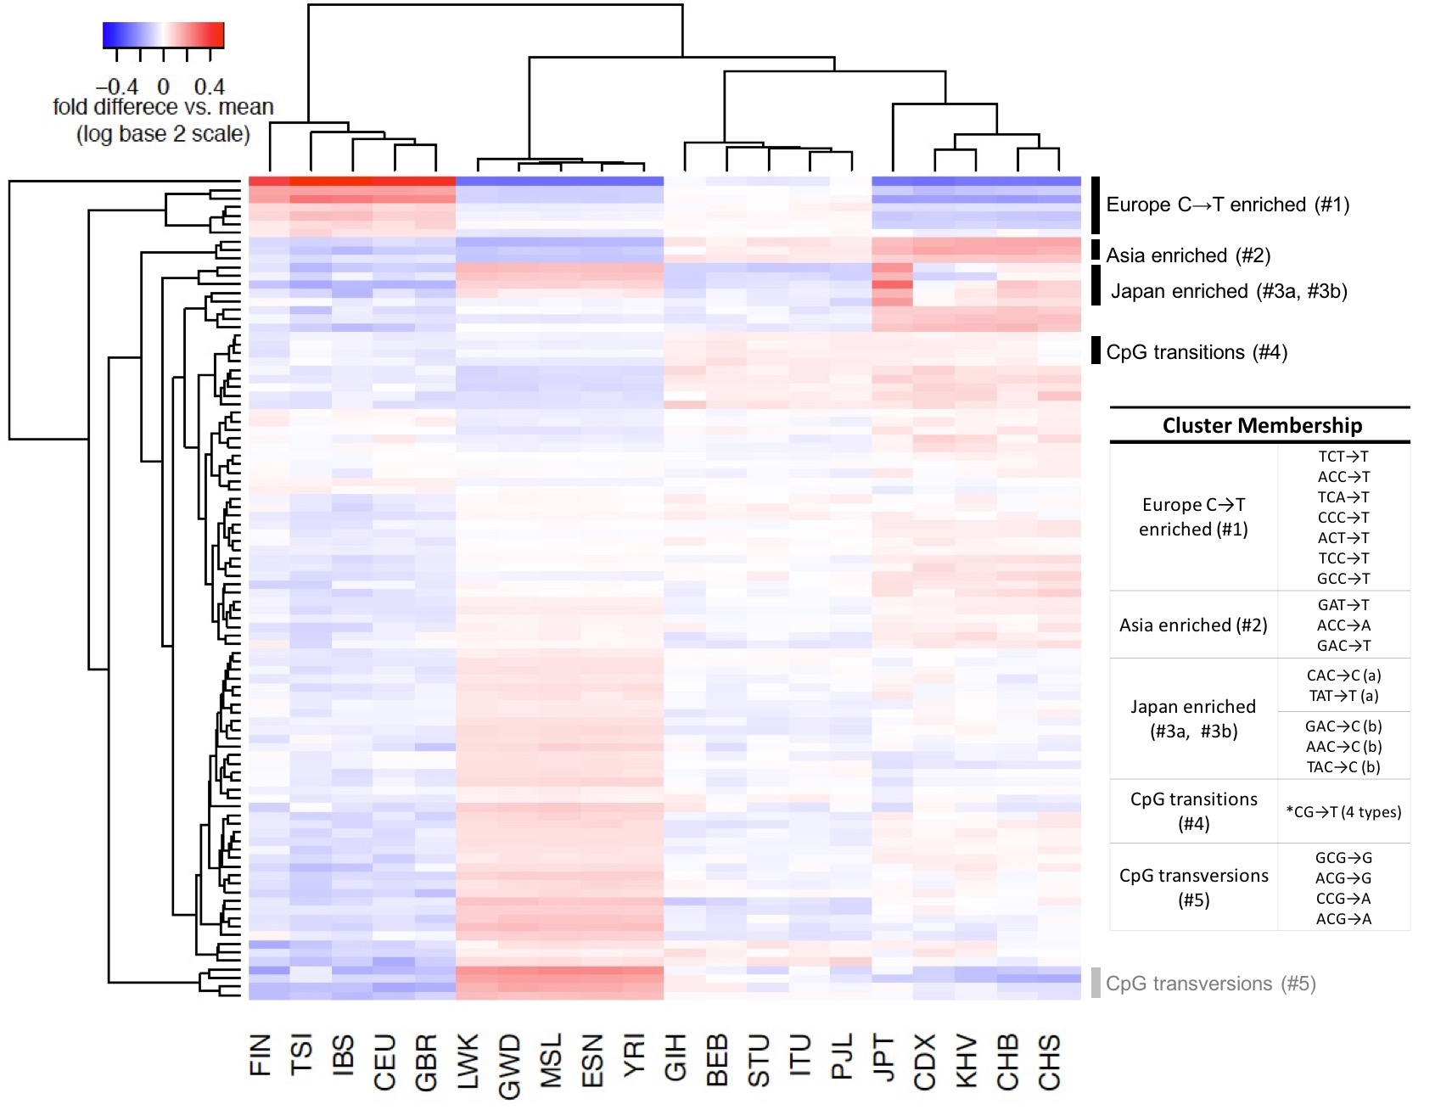

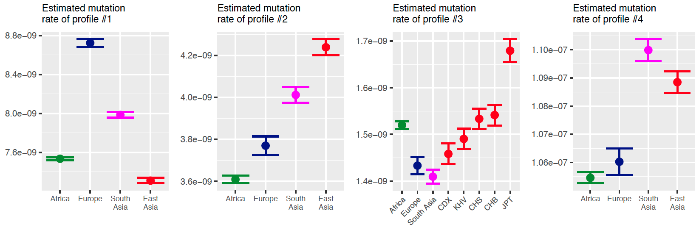

**Figure 2: Mutational signatures driven at the 3-mer level.**

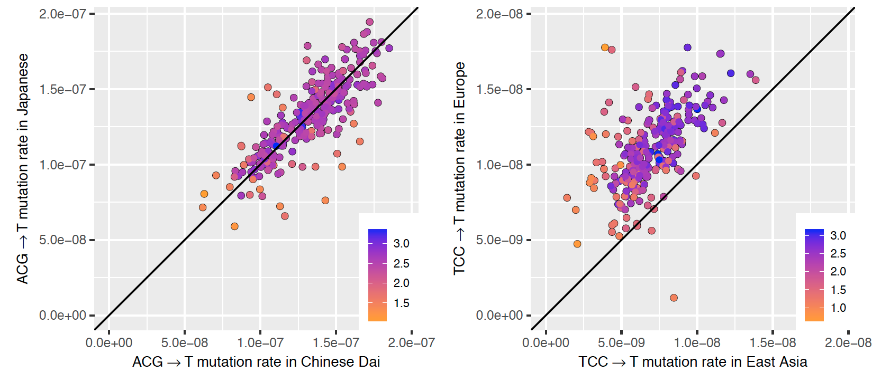

**Figure 3: Highly variable 7-mers within profile 4 in East Asia.**

|  |  |  |  |  |  |
| --- | --- | --- | --- | --- | --- |
| 7-mer | Fold  enrichment  in Japan* | FDR-adjusted P  (enrichment in Japan) | Expected  polymorphic  sites on X | Observed polymorphic sites on X | P  (X enrichment) |
| TTTATTT→T | 2.14 | 6.4×10-22 | 48 | 65 | **0.009** |
| CAAACCC→C | 5.28 | 1.3×10-12 | 6.2 | 27 | **6.7×10-10** |
| AGTACAG→C | 16.3 | 1.3×10-7 | 3.0 | 4 | - |
| TCAACAG→C | 5.64 | 9×10-4 | 2.2 | 7 | **0.009** |
| ATAACAG→C | 4.37 | 0.001 | 3.3 | 7 | 0.4 |
| ATGACAG→C | 4.62 | 0.001 | 2.4 | 4 | - |
| CCCACAG→C | 2.61 | 0.001 | 4.6 | 25 | **3.3×10-11** |
| ACCACCA→C | 3.29 | 0.03 | 2.7 | 3 | - |
| AAGACAG→C | 3.20 | 0.03 | 3.1 | 4 | - |
| AATACAG→C | 3.20 | 0.03 | 2.8 | 1 | - |
| ACAACAG→C | 4.62 | 0.03 | 2.3 | 3 | - |
| ATCACAG→C | 2.80 | 0.03 | 3.1 | 4 | - |
| GTGACAG→C | 5.86 | 0.03 | 1.2 | 1 | - |
| TTTATTA→T | 1.63 | 0.04 | 13.1 | 15 | 0.3 |

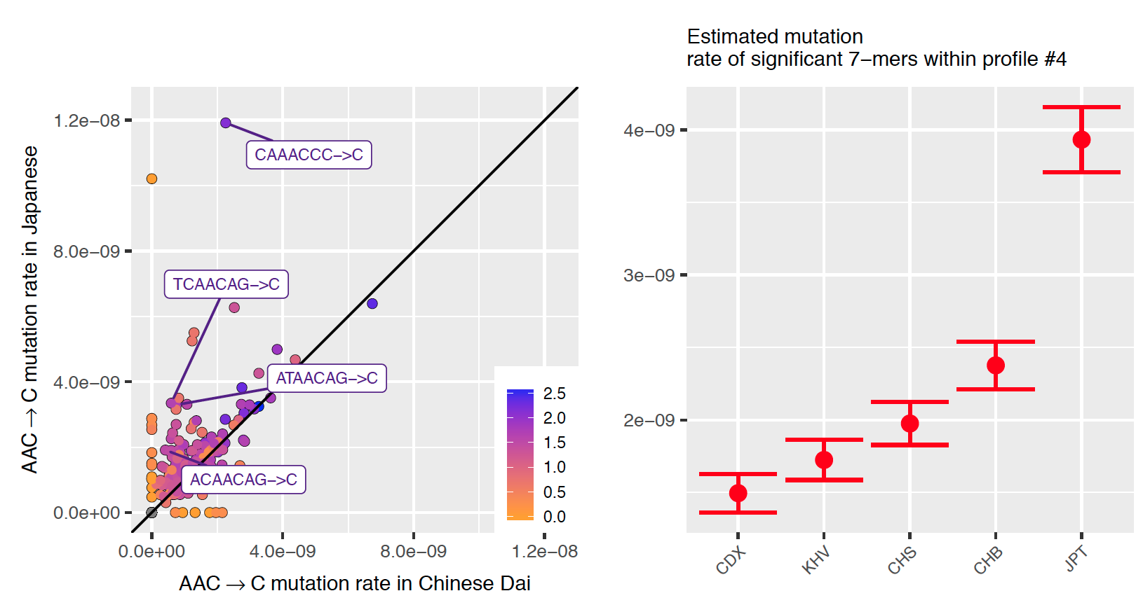

**Figure 4: Signatures of mutation rate variation detected at the 7-mer context.**

|  |  |  |  |  |  |
| --- | --- | --- | --- | --- | --- |
| 7-mer | Africa  rate* | Europe rate* | South Asia rate* | East Asia rate* | P |
| CAAACCC→C | 1 | 0.94 | 0.34 | **3.62** | 3×10-39 |
| TTTATTT→T | 1 | 0.84 | **0.61** | 1.04 | 2×10-25 |
| TTTAAAA→T | 1 | 0.89 | **0.84** | **0.88** | 1×10-21 |
| ATTAAAA→T | 1 | 0.71 | **0.76** | **0.82** | 2×10-21 |
| AAACAAA→A | 1 | 0.78 | **0.66** | 0.88 | 2×10-21 |

