I followed this video:- <https://www.youtube.com/watch?v=JnFYQpzxj7U>

1. Install GitBash
2. Open Intellij and click on VCS tab and enable VCS then select GIT and click on okay.

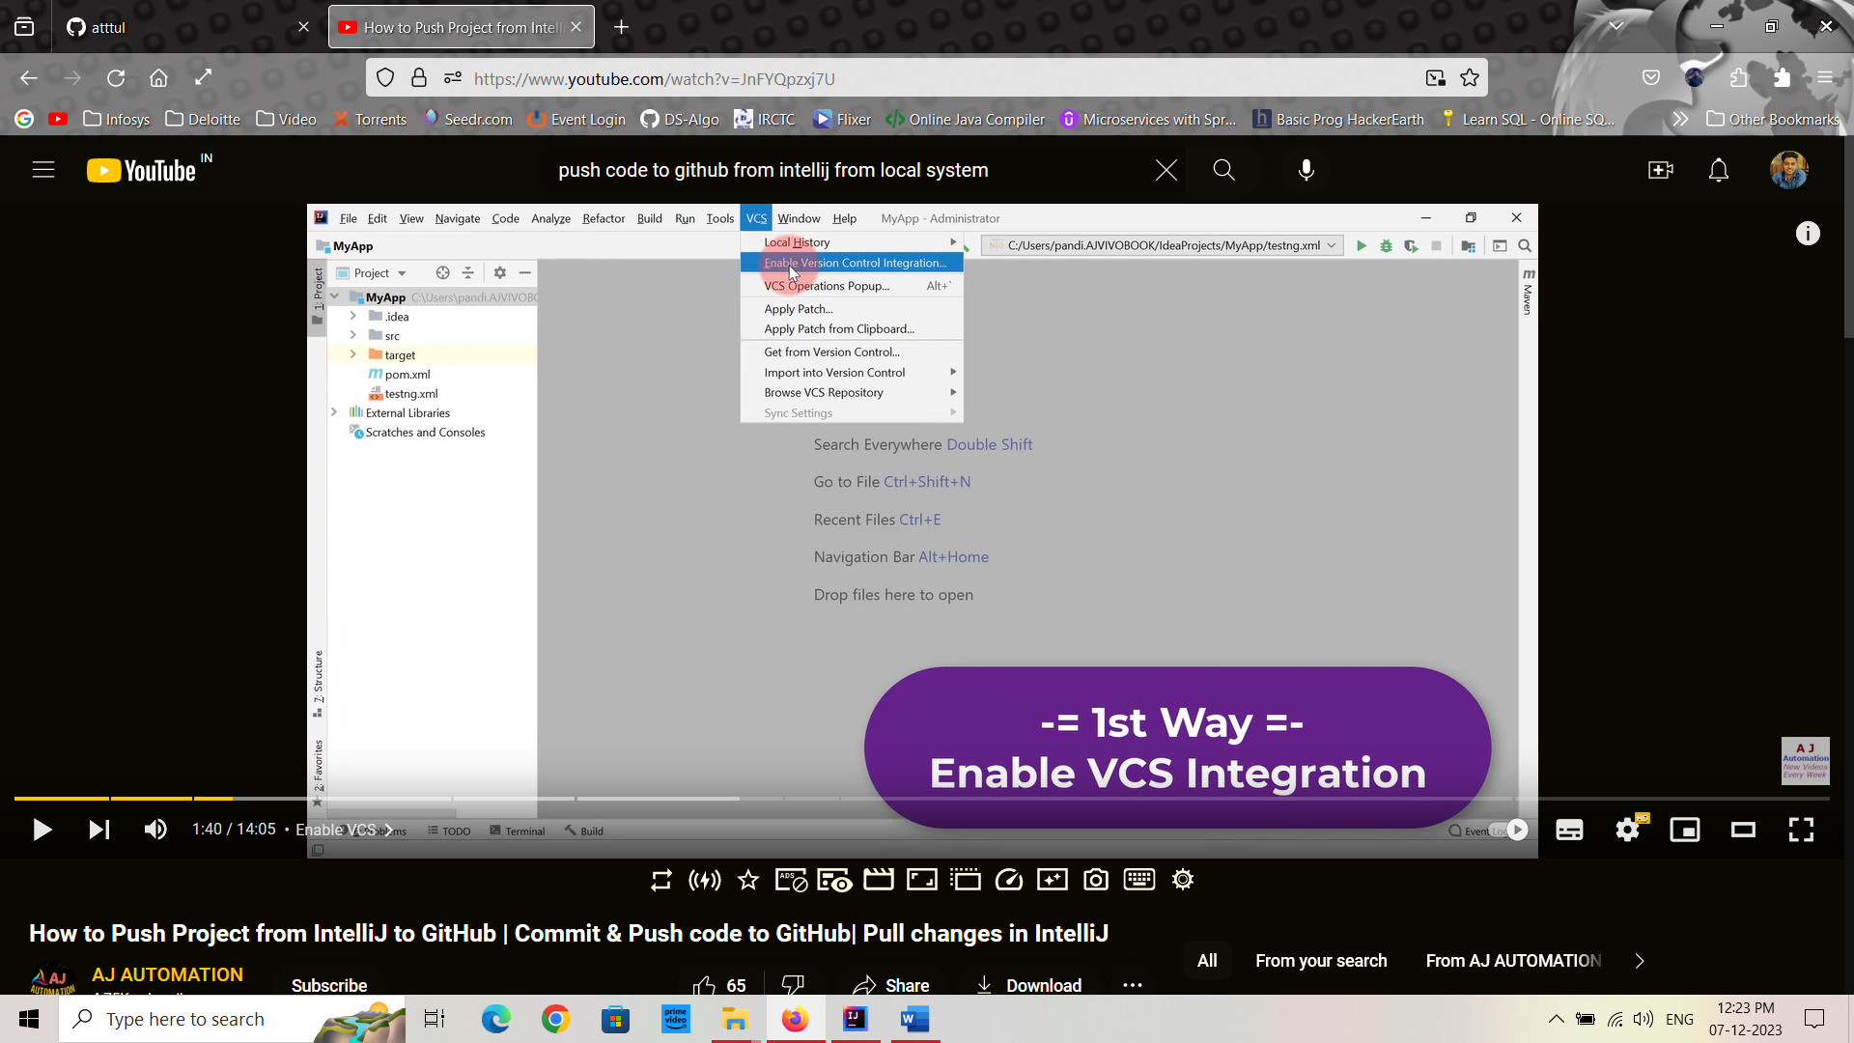

1. Create a new Git Repository on GitHub for the project

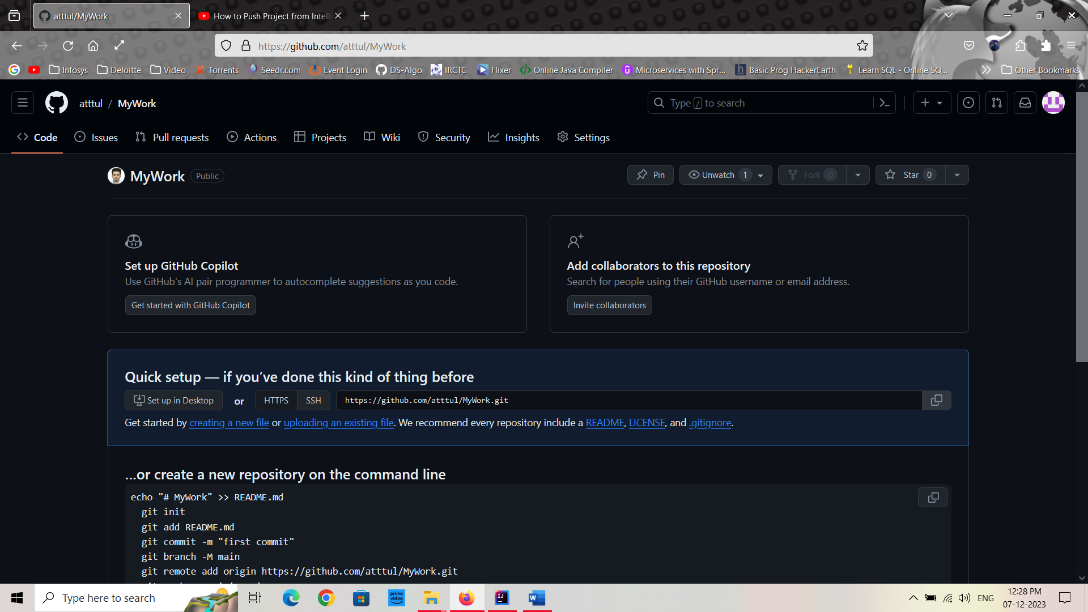

1. Copy the repository URL. <https://github.com/atttul/MyWork.git>
2. From top tabs, Go to VCS->Git->remotes, click on manages remotes

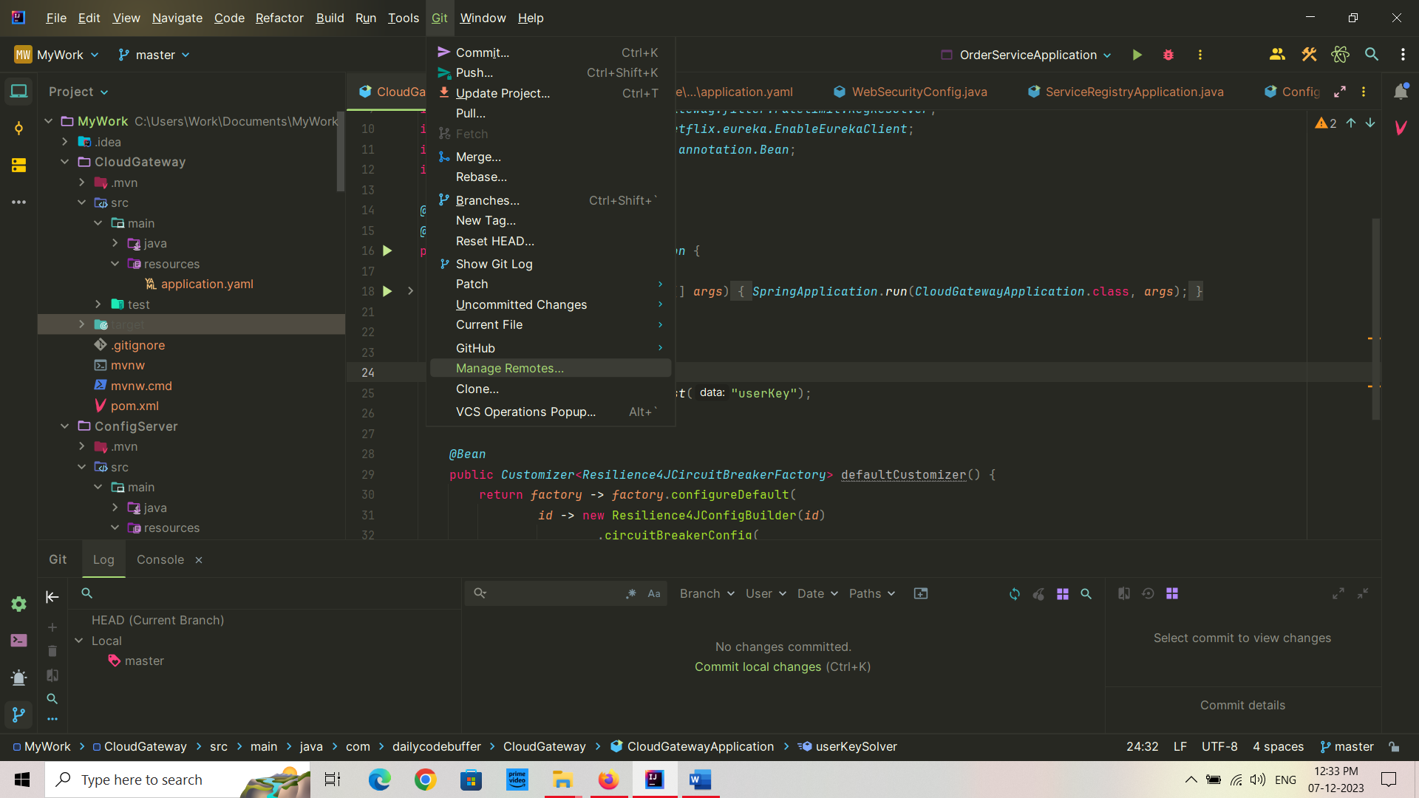

1. Click on add remotes

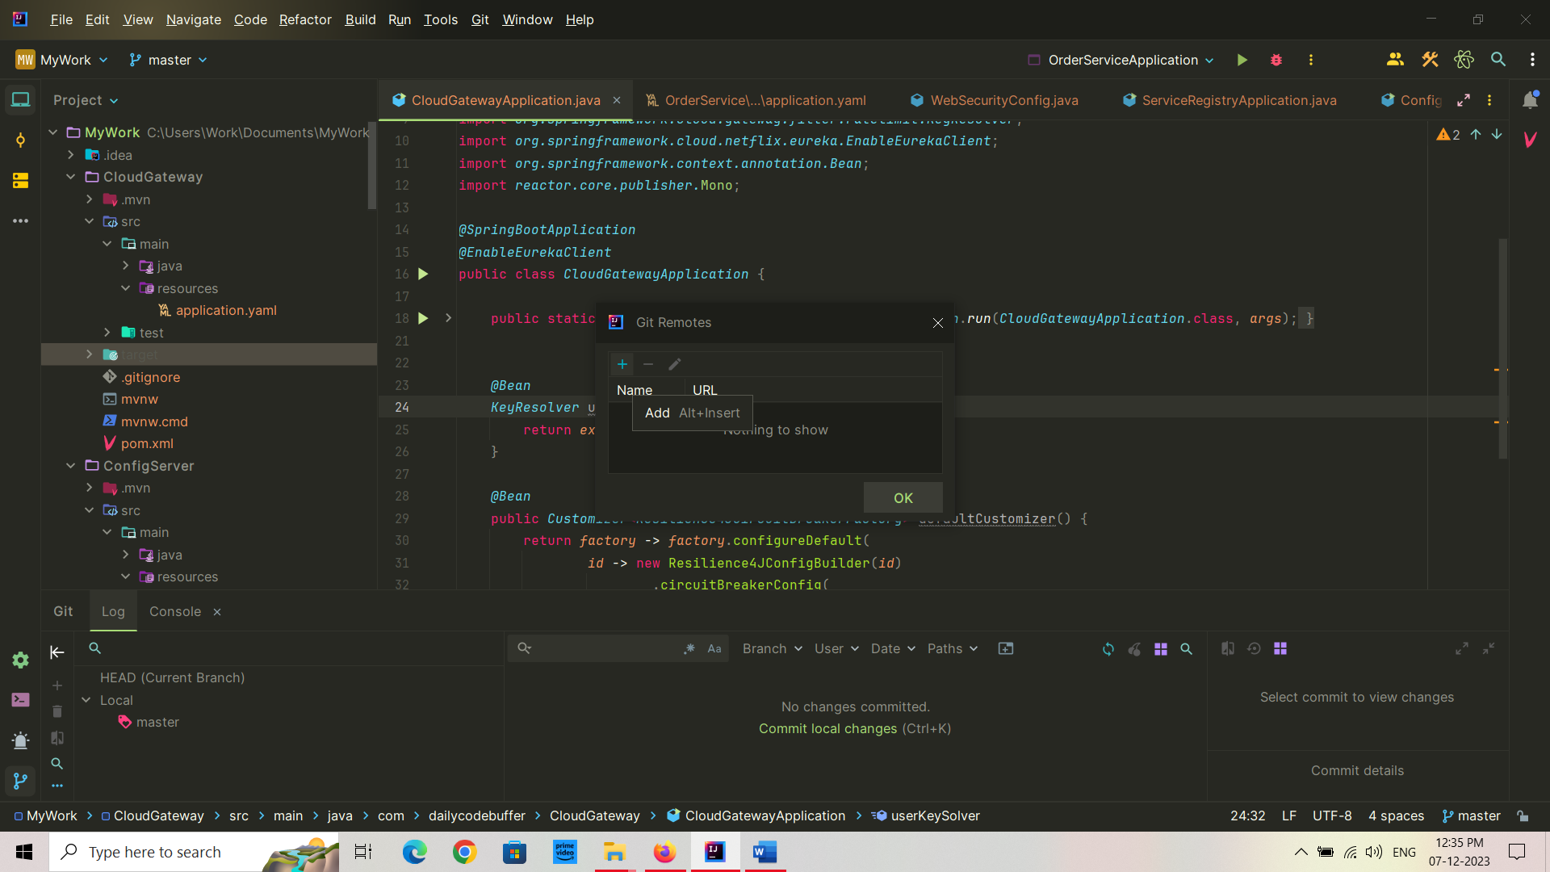

1. Copy paste your new GitHub repository then click on Ok->Ok
2. Then on LHS click on commit, we can see unsaved files:

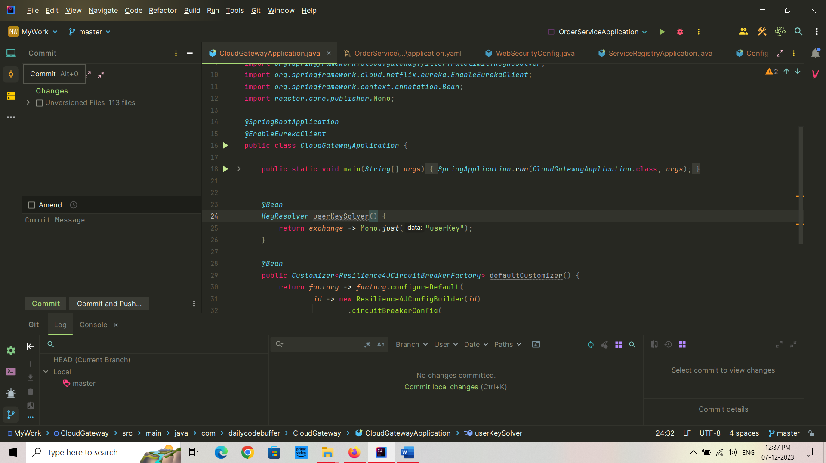

1. Then select these files, means all files:

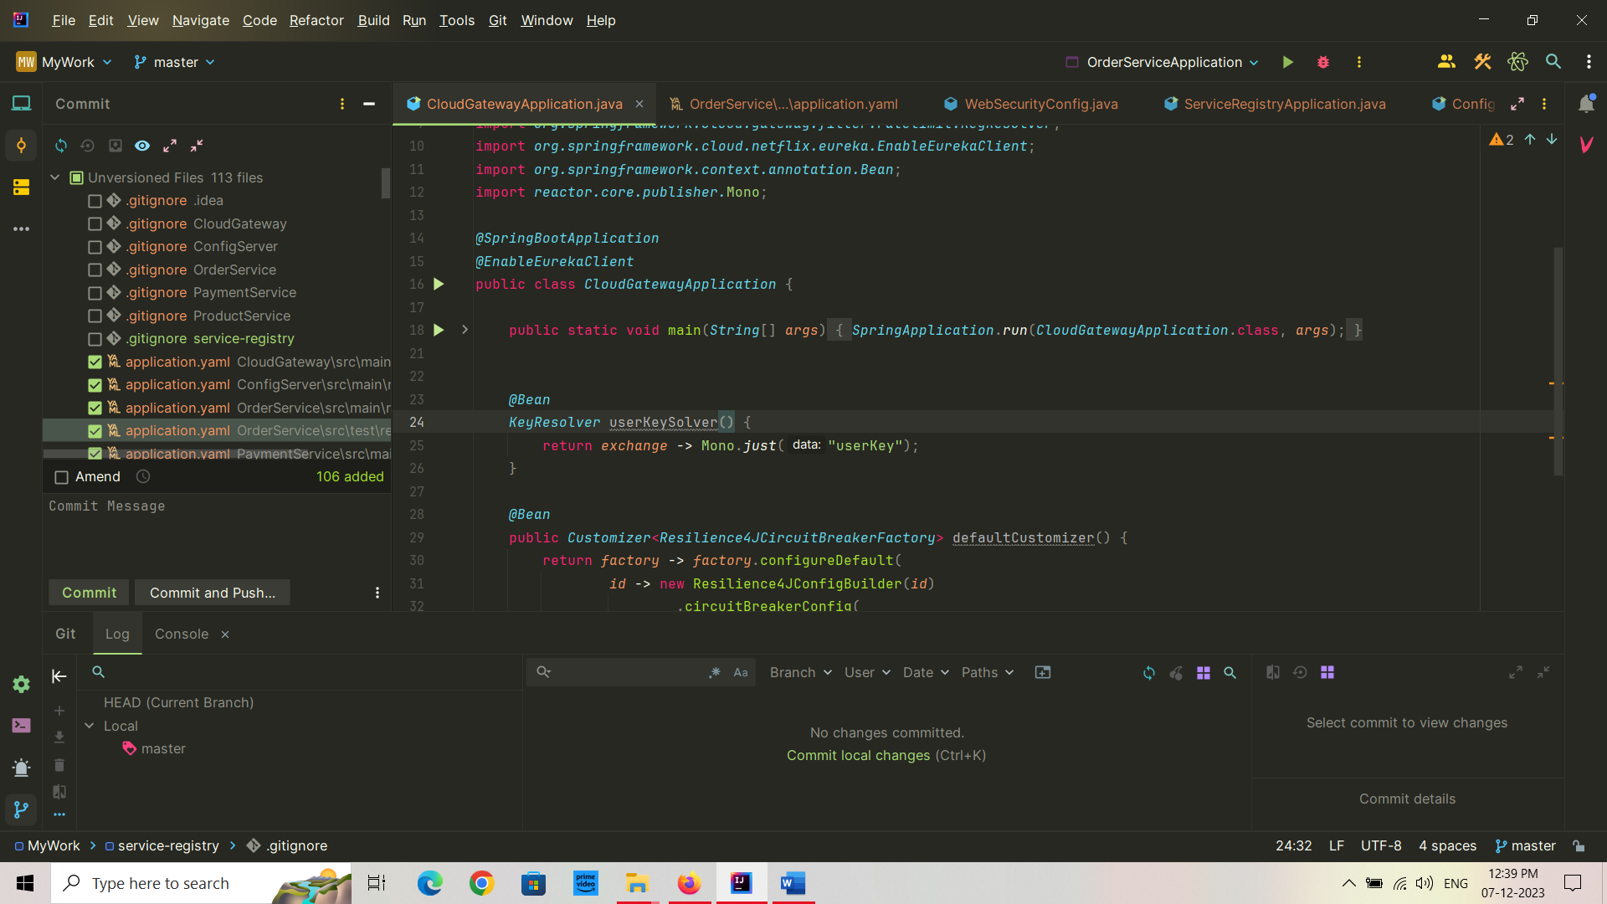

1. Give a commit message then “commit and Push”.
2. Then it will show some warnings and ask for commit anyway and push. Click on this option.
3. Then again ask for push. Click on it.
4. Then ask for log in to GitHub. Do this. First ask for authorization, give that also.
5. Then the code will be pushed.

