Lab 01

Waves

Andrea Tuggle

Physics 1112L

Dr. Nathan Harrison

PART 1

1. OBJECTIVE:

The objective of this lab was to understand waves and wave motion using Sage Math. We were to use the original equation given in the lab manual and then adapt that to our own to see how velocity affects the overall equation. We are expected to make three different graphs with different speeds.

1. THEORY:

The theory of this lab is to figure out how changing a variable of an equation will affect the overall wave and wave motion.

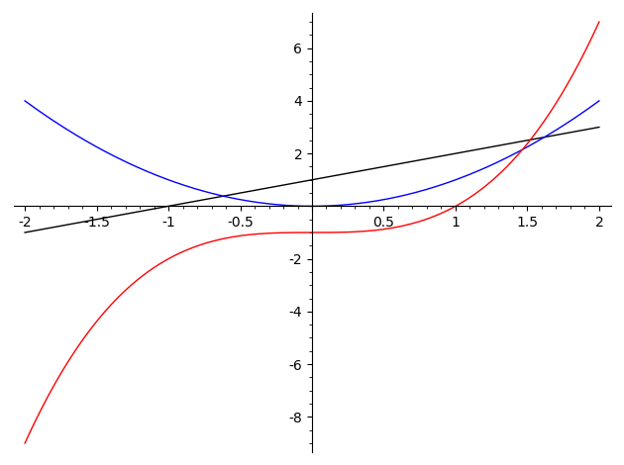

Original Sage Code used:

y1, y2, y3, x = var("y1, y2, y3, x")

y1 = x + 1

y2 = x^2

y3 = x^3 - 1

p1 = plot(y1, (x, -2, 2), color="black")

p2 = plot(y2, (x, -2, 2), color="blue")

p3 = plot(y3, (x, -2, 2), color="red")

g = Graphics()

g += p1

g += p2

g += p3

g.show()

Altered Sage Code used:

y1, y2, y3, x = var("y1, y2, y3, x")

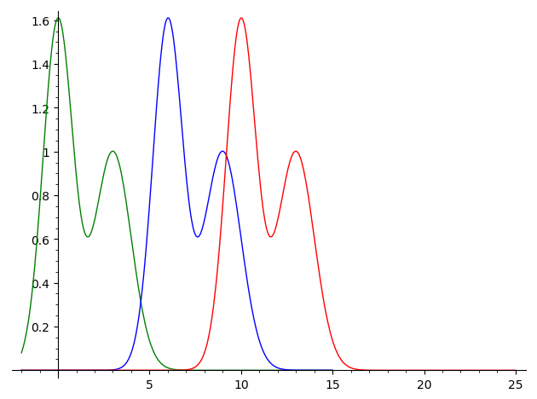y1 = 1.6*exp(-0.75*(x^2)) + exp(-0.5*(x-3)^2)

y2 = 1.6*exp(-0.75*((x-6)^2)) + exp(-0.5*((x-6)-3)^2)

y3 = 1.6*exp(-0.75*((x-10)^2))+exp(-0.5*((x-10)-3)^2)

p1 = plot(y1, (x, -2, 15), color="green")

p2 = plot(y2, (x, -2, 15), color="blue")

p3 = plot(y3, (x, -2, 25), color="red")

g = Graphics()

g += p1

g += p2

g += p3

g.show()

1. PROCEDURE

* I first placed the original equation into the Sage Cell to see the original output
* I next chose variables (except 5 as instructed) and used those three numbers to create three different graphs
* Altering the numbers I saw how it affected the overall structure and movement of the wave.

PART 2

Original animated code:

traveling_wave = [plot(exp(-(x - t)^2), (-1, 4), ymin=0, ymax=2) for t in sxrange(0, 5, 0.1)] animation = animate(traveling_wave) animation.show(delay=10)

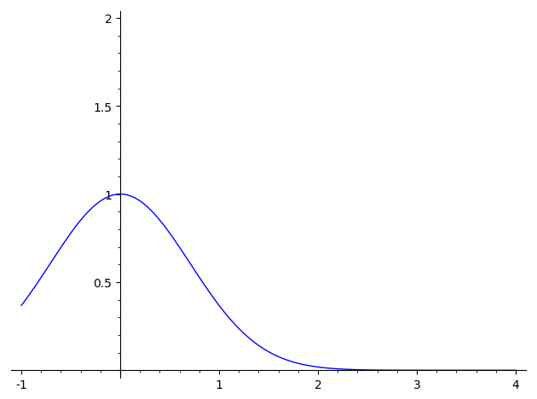

(beginning image of moving wave)

Altered animated code (1):

traveling_wave = [plot(( 0.6*exp(-0.6*((x-t)+4)^2))+ exp(-((x+t)-4)^2), (-10, 10), ymin=0, ymax=2) for t in sxrange(0, 10, 0.5)]

animation = animate(traveling_wave)

animation.show(delay=10)

Link:

<https://sagecell.sagemath.org/?z=eJxVjkEKwjAQRfeeYpYzpilpUXc5SVEJGGsgTUo62PT2pnEhrubx-PCGk3lb78J4XwuAhmH2kRFBtZejzTPKHRCzZBInuvVEAqovTjDJ6hpA2akGOlVwm1zQar8m657gGRMwuABLTiaMFuuwKYUzXQ8muMmwi6G0v2yR_56i36ZdXnHFh_Vm06X1AVHVOTE=&lang=sage&interacts=eJyLjgUAARUAuQ>==



(beginning image of altered code(1))

Altered animated code (2):

traveling_wave = [plot(( 0.6*exp(-0.6*((x-t)+7)^2))+ exp(-((x+t)-7)^2), (-10, 10), ymin=0, ymax=2) for t in sxrange(0, 10, 0.5)]

animation = animate(traveling_wave)

animation.show(delay=10)

Link: <https://sagecell.sagemath.org/?z=eJxVjkEKwjAQRfeeYpYzpilpQV3lJEUlYKyBNCnpYNPbm8aFuJrH48MbTuZtvQvjfS0AGobZR0YE1Z6PNs8od0DMkklc6NYTCai-OMEkq2sAZaca6FTBbXJBq_2arHuCZ0zA4AIsOZkwWqzDphROdD2Y4CbDLobS_rJF_nuKfpt2ecUVH9abTZfWB1T5OTc=&lang=sage&interacts=eJyLjgUAARUAuQ>==



(beginning image of altered code (2))

6) RESULTS:

My results for this lab was two waves that moved away from another left to right

7) ANALYSIS:

In this lab I was able to see how using different numbers for the variables will affect the overall flow of the waves.

8) COMMENTS:

I learned a lot on how to use Sage today and grew appreciative of what it can do. I still have lots more to learn but will hopefully understand it better for future labs.