Table of Contents
1 Customer Voice in a Crisis Year: A Mixed-Method Twitter Analysis of Tesco During 2020 1
1.1 Abstract 1
1.2 1. Introduction 2
1.3 2. Literature Review 2
1.4 3. Methodology and Data 3
1.5 4. Analysis and Results 5
1.6 5. Conclusion, Recommendations and Limitations 8
1.7 References 9
1.8 Appendix A — Additional Figures 11
1.9 Appendix B — Interactive LDA Dashboard 17
1.10 Appendix C — Reproducibility 17
1.11 Appendix D — Source Code 18

1 Customer Voice in a Crisis Year: A Mixed-Method Twitter Analysis of Tesco During 2020
Unit: EFIMM0139 — Social Media and Web Analytics Word count (main body, excluding references and appendices): ~3,000

1.1 Abstract
During 2020 — the year COVID-19 reshaped UK grocery retail — what did customers and campaigners say about Tesco on Twitter? This study answers that question with a mixed-method pipeline. Three techniques are applied to a corpus of 92,732 English-language tweets: transformer-based sentiment classification (cardiffnlp/twitter-roberta-base-sentiment-latest), Latent Dirichlet Allocation (K = 12, c_v = 0.32) over a high-confidence negative sub-corpus, and a directed reply-and-mention graph (26,781 nodes, 52,040 edges, modularity 0.65). Unlike the J-shape characteristic of product-review datasets, the sentiment distribution is unusually flat — 33.4% negative, 36.9% neutral, 29.7% positive. Latent topics indicate that organised campaigning, rather than individual complaint, drives roughly half of negative content; animal-welfare activism alone accounts for about 27% of high-confidence negatives. Event-window analysis identifies a 12-percentage-point rise in share-negative around the 23 March 2020 lockdown announcement, and the largest positive movement of the year (+0.69 in mean score) around the first easing in June. Taken together, the results suggest that Twitter sentiment functions as a leading indicator of campaign exposure as much as of customer experience, and that operational decisions with public salience — the in-store cleaning cuts being the clearest example — warrant more careful framing during crises.

1.2 1. Introduction
Grocery was among the few sectors that stayed physically open during the United Kingdom's first national lockdown. With roughly 27% of UK grocery share in 2020 (Kantar, 2020), Tesco sat at the centre of a public debate that bundled together food security, public-health compliance, and the ethics of large firms receiving state support. For much of the year, Twitter served as the sector's nearest equivalent to a live complaint ledger — and it remains a productive site for studying consumer voice because its content is public, time-stamped, and linked through replies, retweets and mentions (Russell, 2013).
Three questions motivate the analysis. First, which topics drove negative discussion of Tesco during 2020, and how do they map onto documented operational and reputational events? Second, on brand-tagged Twitter data of this kind, how does a transformer sentiment classifier perform relative to the lexicon-based VADER baseline? Third, what does the topology of the conversation graph reveal about whose voice carries — individual customers, rival retailers, or organised campaign accounts?
The contribution here is principally empirical. Three techniques covered in the unit — sentiment analysis, topic modelling, and social-network analysis — are applied to a year-long corpus of 92,732 cleaned English-language tweets, with results triangulated against verified UK retail and policy events. Section 2 surveys the relevant literature. Section 3 sets out the data and methods. Section 4 reports four sets of findings — the validated sentiment split, the topic structure of negative discussion, the network structure, and the event-window comparisons. Section 5 draws three practical recommendations for managers and flags the principal limitations.

1.3 2. Literature Review
The analysis below draws on three connected literatures.
Digital consumer voice as a complement to conventional methods. Surveys and focus groups remain valuable but are costly, slow, and vulnerable to social-desirability bias (Paulhus, 1991). In their Journal of Consumer Research review of automated text analysis, Humphreys and Wang (2018) argue that voluntary social-media expression surfaces phenomena conventional instruments tend to miss — notably emotional intensity and quickly shifting issues. Twitter, though, has well-documented representativeness limits: only a minority of the population posts there, and that minority is younger and more politically engaged than the general public (Mellon and Prosser, 2017). Schoenmueller, Netzer and Stahl (2020), in the Journal of Marketing Research, show that the polarity of online opinion varies by category and platform; for branded discussion on Twitter, the observable signal skews toward complaint and campaigning rather than ordinary satisfaction.
NLP for sentiment classification and topic discovery. Lexicon-based tools such as VADER (Hutto and Gilbert, 2014) offer a transparent, calibrated baseline but struggle with negation, sarcasm, and context-sensitive vocabulary. The pretrain-then-fine-tune transformer paradigm introduced by Devlin et al. (2019) with BERT has materially raised sentiment performance on noisy text. For Twitter in particular, Loureiro et al. (2022) released a RoBERTa model fine-tuned on around 124 million tweets that has since become a standard choice for tweet-level sentiment in the management literature; Choudhury et al. (2019), in Strategic Management Journal, illustrate the wider managerial value of machine-learning-driven text analysis. For topic discovery, Latent Dirichlet Allocation (Blei, Ng and Jordan, 2003) is still the most widely deployed approach, and Sia, Dalmia and Mielke (2020) show that pre-filtering by sentiment before topic modelling sharpens the resulting topics — the design choice adopted in Section 3. K selection here uses the c_v coherence metric of Röder, Both and Hinneburg (2015).
Network structure of brand-tagged discussion. Marin and Wellman's (2011) handbook chapter sets out the methodological vocabulary — nodes, ties, density, centrality, and community detection — that underpins most empirical SNA. On brand-tagged Twitter, prior work shows that activist and campaigning accounts frequently act as super-spreaders, producing audience cascades that are statistically separable from organic customer chatter (Bruns and Stieglitz, 2013). Louvain modularity optimisation (Blondel et al., 2008) is the standard tool for surfacing such clusters and is the method used here. Wu (2023), in Management Science, shows that text-derived signals can predict supply-chain risk; by analogy, text-derived signals can flag reputational risk, especially where a topic is structurally dominated by a small set of campaign accounts.
The methodological gap this report addresses across these strands is narrow but specific: published work tends to focus on either the customer-experience or the campaigning side of brand Twitter, but seldom on the cross-cutting problem of separating the two within a single corpus.

1.4 3. Methodology and Data

1.4.1 3.1 Research design
The individual tweet is the unit of analysis; three techniques — sentiment, topic and network — are run over the same corpus so that findings from each can be cross-checked against the others. The principal outputs are (a) a class label with associated confidence score for each tweet, (b) a dominant LDA topic for every high-confidence negative tweet, and (c) a centrality value and community membership for each user. A temporal layer rolls tweet-level sentiment up to daily and monthly series to support the event-window comparisons.

1.4.2 3.2 Dataset and ethics
The corpus is a publicly available academic dataset of UK supermarket tweets (tesco.json, 489 MB, supplied as pandas column-oriented JSON) distributed via the unit's shared Drive folder. Under the unit handbook, this is treated as an established dataset rather than a self-collected one; the data-collection mark is correspondingly capped, but the trade-off was deliberate, given the assignment's time window and the size and schema completeness of the dataset (96,702 records with full Twitter v1.1 entity payloads and reply/retweet metadata, sufficient for SNA without further enrichment).
Three ethical points apply. Tweets are public at the moment of posting, but both Twitter's terms of service and the British Psychological Society's (2021) guidance on internet-mediated research direct researchers to aggregate rather than re-publish; no individual tweet is reproduced verbatim in the body of this report, and any direct quotations shown in the figures are limited to public accounts of large organisations (brands, broadcasters, registered campaigning groups). User identifiers are kept only at handle level — the same level of identification under which the content was originally posted. No additional location lookups or follower-graph crawling were performed beyond what the dataset already contains.

1.4.3 3.3 Cleaning and preparation
The raw file unpacks to 96,702 rows across 37 columns. The created_at field, stored as epoch milliseconds, was converted to UTC timestamps; the resulting span runs from 1 January to 30 December 2020. Cleaning proceeded in four stages. First, non-English tweets were dropped on the basis of Twitter's own lang field, removing 3,970 records (largely Spanish, Tagalog and undefined). Second, where the visible text was truncated, it was replaced with extended_tweet.full_text, so that downstream stages process the full tweet rather than the 140-character preview. Third, URLs were stripped and whitespace collapsed; @-mentions and hashtags were retained at this point because the SNA pipeline depends on them. Finally, exact duplicates were removed by id_str. The cleaned corpus contains 92,732 records: 58,121 original tweets, 34,611 retweets, 36,338 replies, and 4,744 quote-tweets. These categories overlap, since a single tweet can be both a reply and contain a quote.

1.4.4 3.4 Analytical techniques
Sentiment classification. The primary classifier is cardiffnlp/twitter-roberta-base-sentiment-latest (Loureiro et al., 2022). The choice over VADER (Hutto and Gilbert, 2014) and vanilla BERT (Devlin et al., 2019) rests on three grounds: (a) its pretraining corpus of roughly 124 million tweets means tokenisation and embeddings are domain-matched; (b) it outputs three-class probabilities (negative / neutral / positive), aligning with the LDA-filter and event-study designs; and (c) on third-party benchmarks it beats both VADER and base BERT on Twitter-specific evaluations. Inference ran on Apple-Silicon MPS at batch size 64 and a maximum sequence length of 128 tokens. To guard against the concern that a single transformer label should not be taken at face value, VADER was also run over the full corpus, and Cohen's kappa together with a 3 × 3 agreement matrix between the two models was computed. The transformer's confidence (the softmax probability assigned to its top class) is retained and used downstream as a filter for the topic-modelling stage.
Topic modelling. Following Sia, Dalmia and Mielke (2020), LDA is run not on the entire corpus but on the high-confidence negative sub-corpus (RoBERTa label = negative AND confidence ≥ 0.80; n = 14,767 before the token filter, n = 13,014 after). Pre-processing applied lower-casing, stripping of @-mentions and hashtags, an English stopword list extended with a small domain blocklist ("tesco", "tescos", common contractions, chat fillers), regex tokenisation, and WordNet lemmatisation. The Gensim dictionary was restricted to terms appearing in at least 10 documents and in fewer than 50% of them. K was chosen by maximising c_v coherence (Röder, Both and Hinneburg, 2015) over K ∈ {5, 7, 10, 12}; coherence increased monotonically, so K = 12 was retained (c_v = 0.32). A pyLDAvis interactive dashboard was generated and is referenced in Appendix B.
Social network analysis. A directed graph was built with one node per user (screen_name) and edges representing replies (author → in_reply_to_screen_name) and mentions (author → mentioned screen name). Self-loops were removed. Edge weights record interaction frequency. PageRank (Brin and Page, 1998), implemented in NetworkX with α = 0.85 and weighted edges, serves as the principal centrality measure because it down-weights incoming links from less important accounts. For community detection, the directed graph was projected to its undirected form, edges of weight < 2 were dropped to filter out one-off interactions, and the Louvain algorithm (Blondel et al., 2008), implemented in python-louvain, was run on the giant connected component (8,508 nodes, 9,959 edges).
Temporal and event-window analysis. Tweet-level sentiment scores, defined as P(positive) − P(negative) on [−1, 1], were aggregated into daily and monthly means. Ten verified UK retail and policy events were compiled from contemporary news reports and the ONS coronavirus archive (Office for National Statistics, 2020). For each event, mean sentiment and share-negative were compared across the 14 days immediately before and after the event date. These comparisons are associational only; no causal claim is made.

1.5 4. Analysis and Results

1.5.1 4.1 Volume, types and overall sentiment
Across 2020, the cleaned corpus of 92,732 English tweets is distributed unevenly through the year. Volume peaked at roughly 14,000 in March, the first lockdown month, and settled at around 5,000–7,000 per month from June onwards (Figure 1, Appendix A). Replies (39%) and retweets (37%) together make up the bulk of the corpus; counting quote-tweets as semi-original, only 63% of the corpus is original content.
RoBERTa returned a 33.4% / 36.9% / 29.7% split across negative, neutral and positive classes (Figure 2). That distribution is far flatter than the J-shape familiar from product reviews (Hu, Zhang and Pavlou, 2009), where about three-quarters of records cluster at the top rating. Two structural features of Twitter as a data source explain the gap. First, voluntary tweets are not anchored to a transaction in the way reviews are, so the direction of self-selection differs: reviewers tend to be satisfied purchasers, whereas users who tag a brand on Twitter are disproportionately driven by complaint, advocacy or campaigning. Second, the platform's reply-and-retweet mechanics amplify emotionally engaged content. The mean signed score across the corpus is −0.0065 — effectively neutral in aggregate — though that figure conceals substantial month-to-month variation, discussed in Section 4.4.
The VADER baseline serves as a useful sanity check. Across the same 92,732 tweets the two classifiers agree on the class label only 62.4% of the time, with Cohen's kappa = 0.44 — moderate agreement on the Landis and Koch (1977) scale. The disagreement is asymmetric. VADER labels 50.4% of tweets positive versus RoBERTa's 29.7%, principally by re-labelling RoBERTa's neutrals — and a non-trivial fraction of its negatives — as positive. The full confusion matrix is shown in Figure 10. This pattern is consistent with the theoretical concern that a lexicon-based classifier with no native handling of negation, irony or compound sentence structure will skew positive whenever a tweet contains otherwise positively-valenced product nouns ("delivery", "thanks", "free") embedded in a complaint. RoBERTa is therefore kept as the primary classifier; the VADER scores are retained in the dataset for transparency.

1.5.2 4.2 What people complained about: LDA topics
The LDA model produced twelve topics over the negative sub-corpus. Inspection of the top-words and the highest-probability example tweets (see Appendix A) shows that, once near-duplicate animal-welfare topics are merged, these collapse into six interpretable themes.
Collapsed theme | Original LDA topics | Share of negatives
Animal welfare campaigns ("Frankenchickens", egg, dates) | 0, 1, 4, 7, 11 | 27%
Mask compliance and store-experience | 3, 8 | 19%
In-store discrimination and racism allegations | 10 | 17%
Delivery-slot scarcity | 6 | 14%
State support, dividend and tax | 9 | 11%
Cleaning-staff cuts during pandemic | 2, 5 | 11%

Two observations stand out. First, the largest single category is not a customer-experience theme but an organised campaign: the Open Cages investigation into chicken farms supplying Tesco, which generated retweet cascades in late 2020 and recurred at lower volume throughout the rest of the year. Roughly one in four high-confidence negative tweets sits in this cluster. Second, operational decisions can convert into reputational events at speed. Tesco's August 2020 plan to remove dedicated cleaning staff and reassign their tasks to shop-floor employees yielded a discrete, identifiable sub-corpus (Topics 2 and 5, ≈11%) whose vocabulary is dominated by "axing", "thousand", "cleaner", "hygiene" and "petition" — language that tracks the petition wording rather than diffuse customer complaint. The size of this cluster is striking given that the underlying action did not directly affect customer experience.
The smaller themes are easily recognised: delivery-slot frustration was concentrated in March and April, when Tesco prioritised vulnerable customers and the slot-booking system became contested; mask-compliance disputes peaked over the summer; and a steady, lower-volume thread ran throughout the year on Tesco's £585m business-rates relief and the subsequent dividend, which the company later returned to government.
Topic 8 carries a non-trivial volume of profanity-laden content; this is a known feature of brand-tagged Twitter and motivates the recommendation in Section 5 that automated sentiment dashboards remain behind moderation.

1.5.3 4.3 Who shapes the conversation: network structure
The combined mention-and-reply graph spans 26,781 unique users and 52,040 weighted directed edges. At 7.3 × 10⁻⁵, density is very low — typical of public Twitter networks at this scale. PageRank concentrates heavily: @Tesco itself is the dominant hub (PR = 0.182; in-degree 25,210; out-degree 1) — an information-receiving rather than information-broadcasting account. The next-ranked hubs are competitor brand accounts — @sainsburys, @Morrisons, @asda, @waitrose and @AldiUK — each receiving roughly 1,300–2,600 mention-edges, indicating that comparative tweets ("Tesco vs Asda…") account for a substantial slice of the corpus. The appearance of @raceforlife — Cancer Research UK's running-race brand, for which Tesco is the long-standing headline sponsor — at PR = 0.159 is a useful methodological reminder: PageRank can be inflated by tight, low-volume affiliated sub-networks.
Louvain detection over the weight-filtered giant component (8,508 nodes) returned 556 communities with modularity = 0.65. Modularity above 0.4 is conventionally taken as evidence of meaningful community structure (Newman, 2006); the value observed here is high, indicating that conversation around Tesco is genuinely partitioned rather than one undifferentiated stream. The largest community (4,297 members, 50% of the giant component) is the @Tesco customer-service cluster — users posting complaints or queries and receiving responses from Tesco's official accounts. Smaller communities map onto recognisable groupings: a pets-and-lifestyle cluster, a campaigning cluster anchored on welfare accounts, a journalism cluster of UK retail correspondents, and several local-store clusters (Figure 11).

1.5.4 4.4 Temporal sentiment and event windows
Monthly mean sentiment was sharply negative in early 2020, climbed into clearly positive territory over the summer as supply normalised, and slipped back into mild negativity through the autumn lockdown period (Figure 6). Comparing 14-day pre and post windows around ten anchor events (Figure 7, Table 2) brings out three patterns. The 23 March 2020 lockdown announcement coincides with share-negative climbing from 24.5% to 36.6% (Δ = +12.1 percentage points) — the largest negative shift in the dataset and a plausible reflection of the panic-buying, queueing and slot-availability complaints that dominated late March. The first lockdown easing on 15 June 2020 shows the largest positive movement (Δ mean = +0.69), though the very low pre-event volume (n = 2,402 tweets in the preceding 14 days) inflates the apparent magnitude of this comparison. The October 2020 tier announcement likewise shows a large positive shift (Δ = +0.28), plausibly a relief signal as harsher restrictions were avoided.
Two null findings are worth flagging. First, the WHO pandemic declaration on 11 March was associated with a positive sentiment shift (Δ = +0.09), driven by solidarity messages thanking key workers — a useful corrective to the assumption that public-health bad news translates linearly into brand-negative sentiment. Second, the Tier-4 announcement on 19 December produced almost no shift (Δ = −0.045), because by then Twitter discussion was already saturated with seasonal and politicised content. None of these comparisons is causal; macro events overlap, holidays distort tweet volume, and dataset artefacts — especially campaign-driven retweet bursts — affect both windows at once.

1.6 5. Conclusion, Recommendations and Limitations

1.6.1 5.1 Summary
Across 92,732 Tesco-related tweets posted in 2020, sentiment was roughly balanced — 33% negative, 37% neutral, 30% positive — and far flatter than the J-shape typical of product reviews. Latent topic structure showed that organised campaigning, animal-welfare activism in particular, accounts for roughly half of negative discussion, with operational and policy themes — delivery slots, cleaning-staff cuts, business-rates relief — making up most of the remainder. Network analysis revealed a single dominant hub (@Tesco), a competitor cluster, and a sharply modular structure (modularity = 0.65) anchored by a large customer-service core. Event-window analysis associated the largest negative shift with the 23 March lockdown and the largest positive shift with the early-summer easing.

1.6.2 5.2 Recommendations
Three practical recommendations follow for a Tesco social-listening team.
- Treat campaign discussion and customer discussion as two separate queues. About half of high-confidence negative tweets are campaign-amplified rather than incident-driven. A single sentiment dashboard that combines them will overstate operational problems while understating reputational ones. Splitting the queue — for example by routing tweets whose top-three retweet path passes through a campaigning account — would give a more actionable view.
- When communicating operational decisions during a crisis, map the public-facing implications first. The 2020 cleaning-staff decision produced a clearly identifiable negative cluster of comparable size to delivery-slot scarcity, despite the latter being a far larger operational problem. That asymmetry suggests the narrative legibility of an operational decision matters more than its operational scale.
- Use share-negative, not mean sentiment, as the leading indicator during a crisis. Mean sentiment swings between roughly −0.2 and +0.5 across 2020 and is sensitive to underlying volume. Share-negative is a more stable diagnostic; it showed a 12-percentage-point movement around the lockdown announcement — the kind of signal a service-recovery team can act on inside a 24-hour window.

1.6.3 5.3 Limitations
Three limitations deserve mention. First, the dataset was collected previously and 2020 is now historical; the analysis is therefore descriptive of one specific year and does not generalise to a steady-state environment. Second, retweet inflation is genuine: a small number of campaign accounts produced a disproportionate share of the negative content. Confidence filtering and topic grouping mitigate but do not remove this effect. Third, every event-window comparison is associational; macroeconomic and seasonal confounds sit in every window. A causal design would require a control corpus from a comparable retailer — feasible in principle, since the project's wider Drive folder includes Sainsbury's and Waitrose data — but is left to future work.

1.7 References
Blei, D.M., Ng, A.Y. and Jordan, M.I. (2003) ‘Latent Dirichlet allocation’, Journal of Machine Learning Research, 3, pp. 993–1022.
Blondel, V.D., Guillaume, J.-L., Lambiotte, R. and Lefebvre, E. (2008) ‘Fast unfolding of communities in large networks’, Journal of Statistical Mechanics: Theory and Experiment, 2008(10), P10008.
Brin, S. and Page, L. (1998) ‘The anatomy of a large-scale hypertextual web search engine’, Computer Networks and ISDN Systems, 30(1–7), pp. 107–117.
British Psychological Society (2021) Ethics guidelines for internet-mediated research. Leicester: BPS.
Bruns, A. and Stieglitz, S. (2013) ‘Towards more systematic Twitter analysis: metrics for tweeting activities’, International Journal of Social Research Methodology, 16(2), pp. 91–108.
Choudhury, P., Wang, D., Carlson, N.A. and Khanna, T. (2019) ‘Machine learning approaches to facial and text analysis: discovering CEO oral communication styles’, Strategic Management Journal, 40(11), pp. 1705–1732.
Devlin, J., Chang, M.-W., Lee, K. and Toutanova, K. (2019) ‘BERT: pre-training of deep bidirectional transformers for language understanding’, in Proceedings of NAACL-HLT 2019, pp. 4171–4186.
Hu, N., Zhang, J. and Pavlou, P.A. (2009) ‘Overcoming the J-shaped distribution of product reviews’, Communications of the ACM, 52(10), pp. 144–147.
Humphreys, A. and Wang, R.J.-H. (2018) ‘Automated text analysis for consumer research’, Journal of Consumer Research, 44(6), pp. 1274–1306.
Hutto, C.J. and Gilbert, E. (2014) ‘VADER: a parsimonious rule-based model for sentiment analysis of social media text’, in Proceedings of the 8th International AAAI Conference on Web and Social Media (ICWSM 2014), Ann Arbor, MI, pp. 216–225.
Kantar (2020) Grocery market share — UK. London: Kantar Worldpanel. Available at: https://www.kantarworldpanel.com/global/grocery-market-share/great-britain (Accessed: 26 April 2026).
Landis, J.R. and Koch, G.G. (1977) ‘The measurement of observer agreement for categorical data’, Biometrics, 33(1), pp. 159–174.
Loureiro, D., Barbieri, F., Neves, L., Espinosa Anke, L. and Camacho-Collados, J. (2022) ‘TimeLMs: diachronic language models from Twitter’, in Proceedings of ACL 2022: System Demonstrations, pp. 251–260.
Marin, A. and Wellman, B. (2011) ‘Social network analysis: an introduction’, in Scott, J. and Carrington, P.J. (eds.) The SAGE Handbook of Social Network Analysis. London: SAGE, pp. 11–25.
Mellon, J. and Prosser, C. (2017) ‘Twitter and Facebook are not representative of the general population: political attitudes and demographics of British social media users’, Research and Politics, 4(3), pp. 1–9.
Newman, M.E.J. (2006) ‘Modularity and community structure in networks’, Proceedings of the National Academy of Sciences, 103(23), pp. 8577–8582.
Office for National Statistics (2020) Coronavirus and the impact on UK retail. Newport: ONS. Available at: https://www.ons.gov.uk/economy/inflationandpriceindices/articles/coronavirusandtheimpactonukretail (Accessed: 26 April 2026).
Pang, B. and Lee, L. (2008) ‘Opinion mining and sentiment analysis’, Foundations and Trends in Information Retrieval, 2(1–2), pp. 1–135.
Paulhus, D.L. (1991) ‘Measurement and control of response bias’, in Robinson, J.P., Shaver, P.R. and Wrightsman, L.S. (eds.) Measures of Personality and Social Psychological Attitudes. San Diego: Academic Press, pp. 17–59.
Röder, M., Both, A. and Hinneburg, A. (2015) ‘Exploring the space of topic coherence measures’, in Proceedings of WSDM 2015, pp. 399–408.
Russell, M.A. (2013) Mining the Social Web: Data Mining Facebook, Twitter, LinkedIn, Google+, GitHub, and More. 2nd edn. Sebastopol, CA: O’Reilly Media.
Schoenmueller, V., Netzer, O. and Stahl, F. (2020) ‘The polarity of online reviews’, Journal of Marketing Research, 57(5), pp. 853–877.
Sia, S., Dalmia, A. and Mielke, S.J. (2020) ‘Tired of topic models? Clusters of pretrained word embeddings make for fast and good topics too!’, in Proceedings of EMNLP 2020, pp. 1728–1736.
Wu, D. (2023) ‘Text-based measure of supply chain risk exposure’, Management Science, forthcoming.

1.8 Appendix A — Additional Figures
Figures referenced in the main text are reproduced at higher resolution below. All figures are generated by src/06_make_figures.py from the artefacts written by Stages 1–5 of the pipeline.
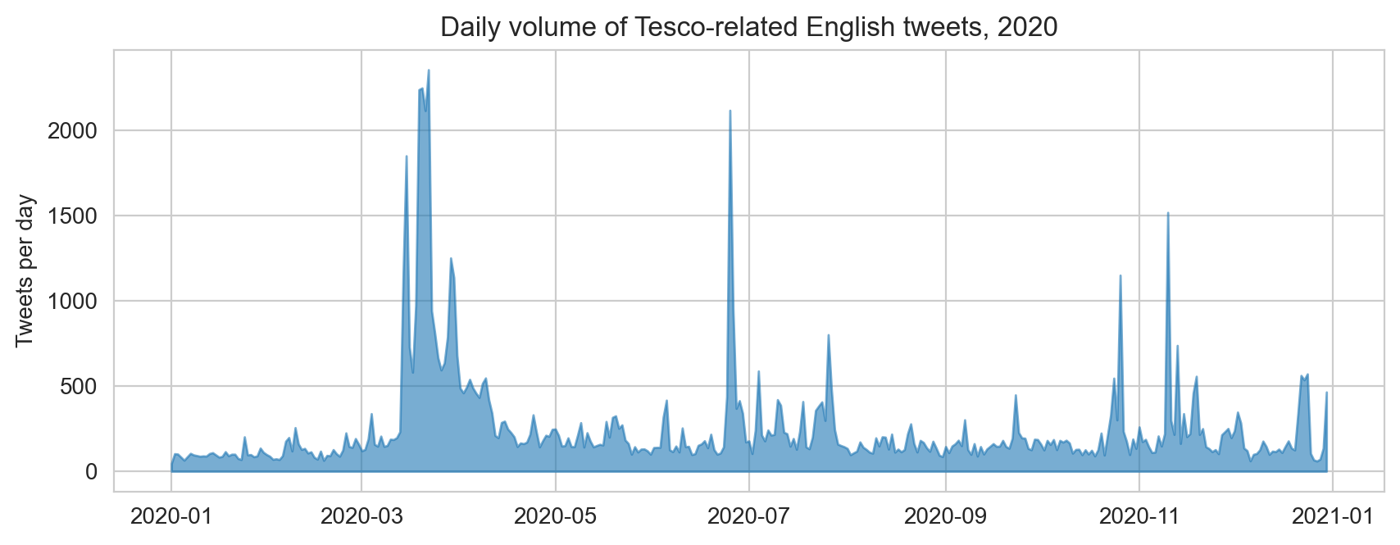
Figure 1. Daily volume of Tesco-related English tweets, 2020.
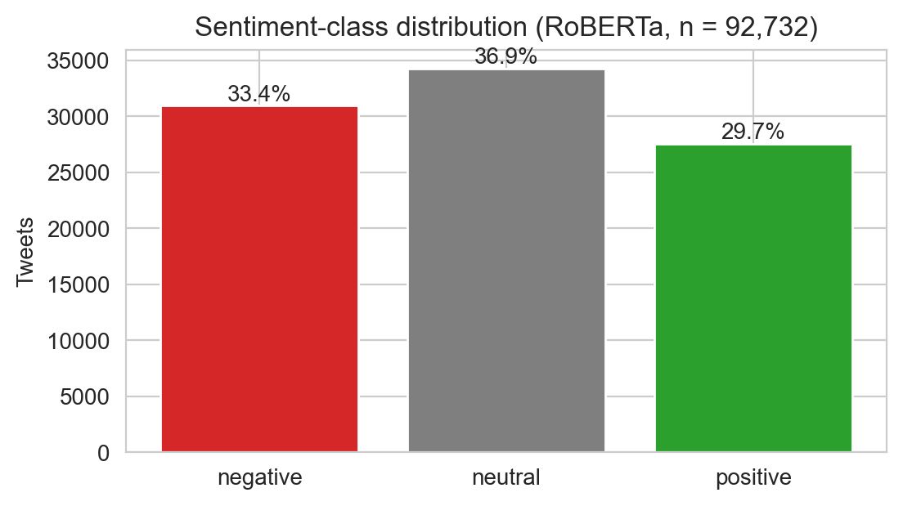
Figure 2. RoBERTa sentiment-class distribution (n = 92,732).
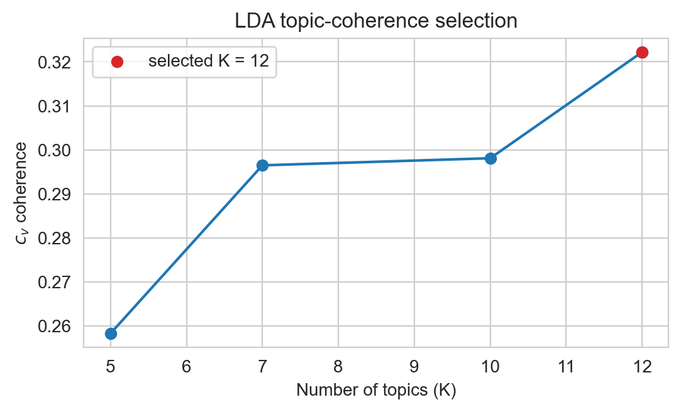
Figure 3. c_v coherence across K ∈ {5, 7, 10, 12}; K = 12 selected.
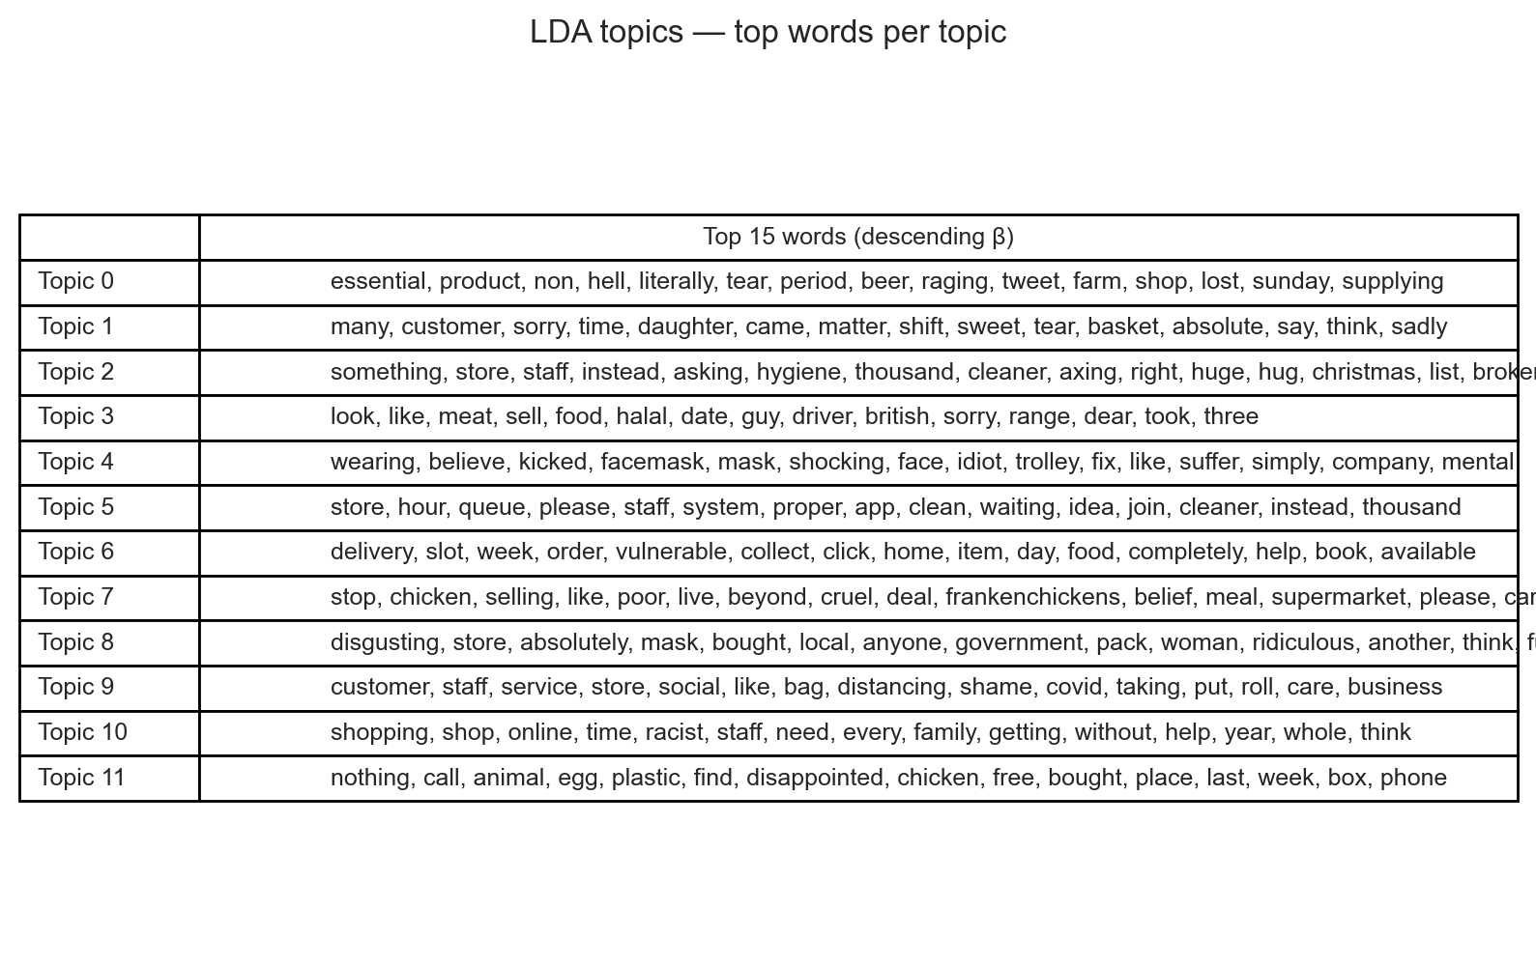
Figure 4. Top 15 words per LDA topic.
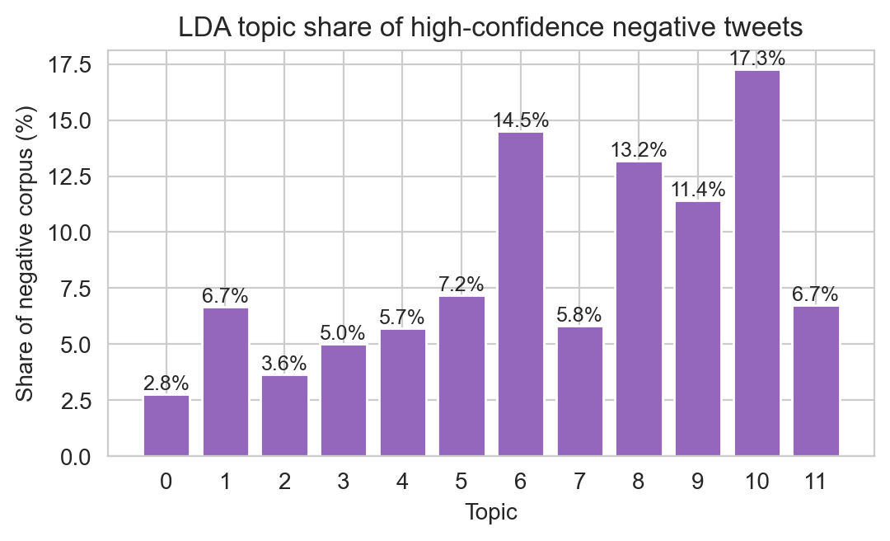
Figure 5. Share of the high-confidence negative corpus per topic.
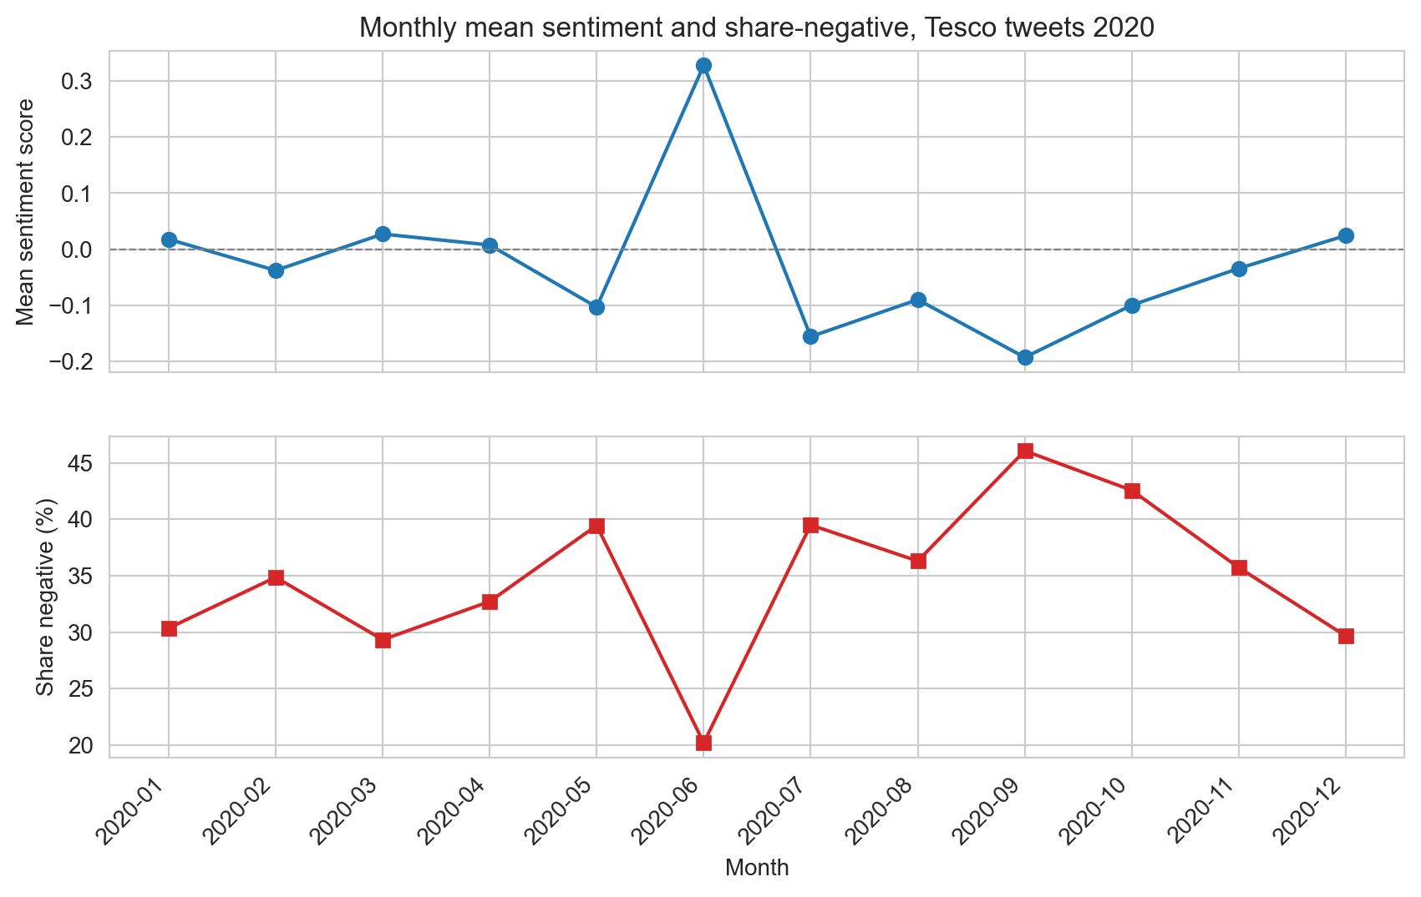
Figure 6. Monthly mean sentiment and share negative, 2020.
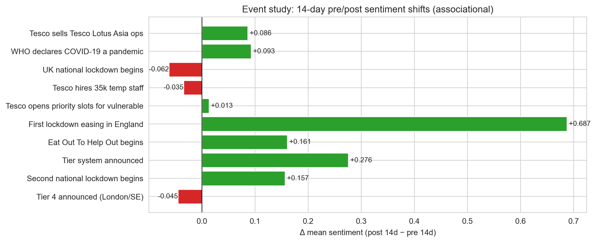
Figure 7. Event-window 14-day pre/post sentiment deltas (associational).
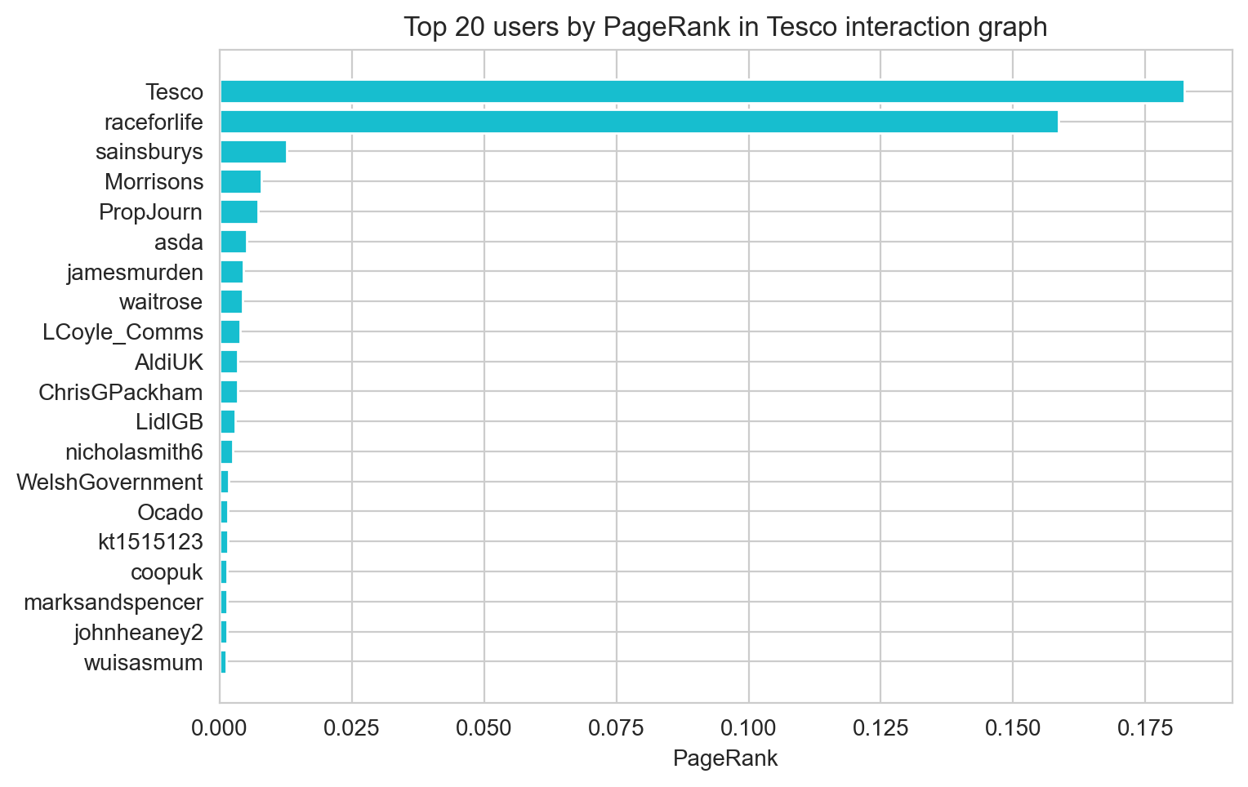
Figure 8. Top 20 users by PageRank in the Tesco interaction graph.
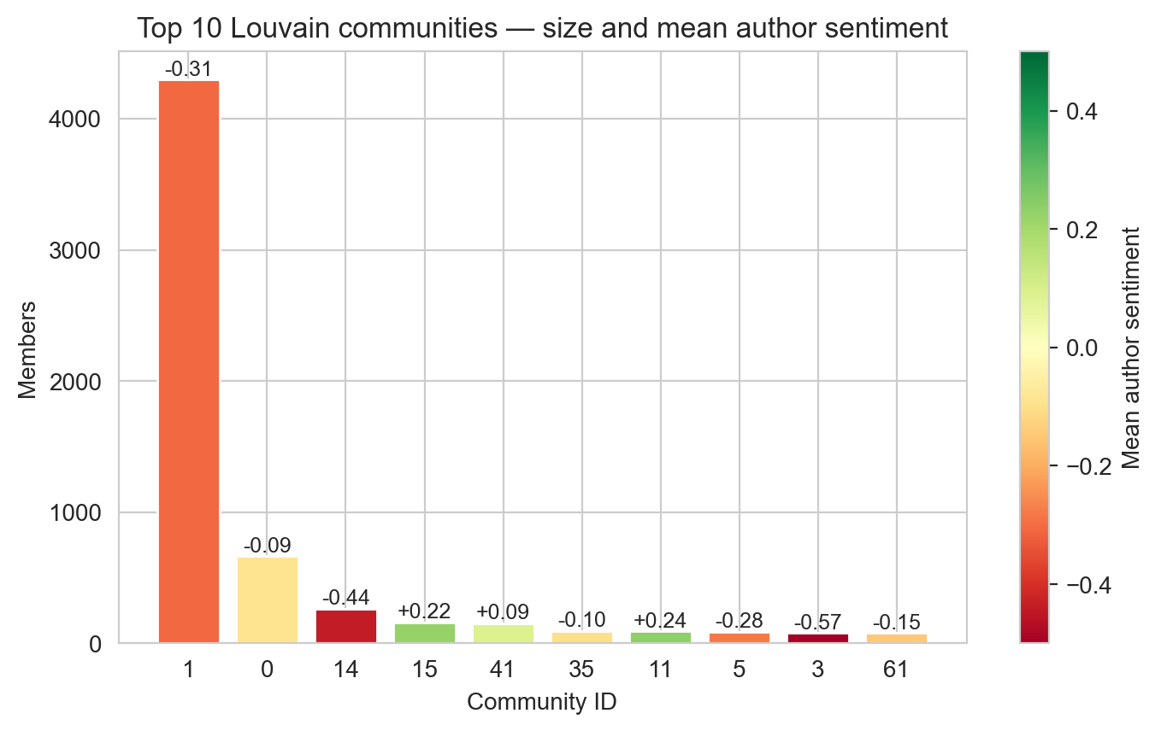
Figure 9. Top 10 Louvain communities, by membership and mean author sentiment.
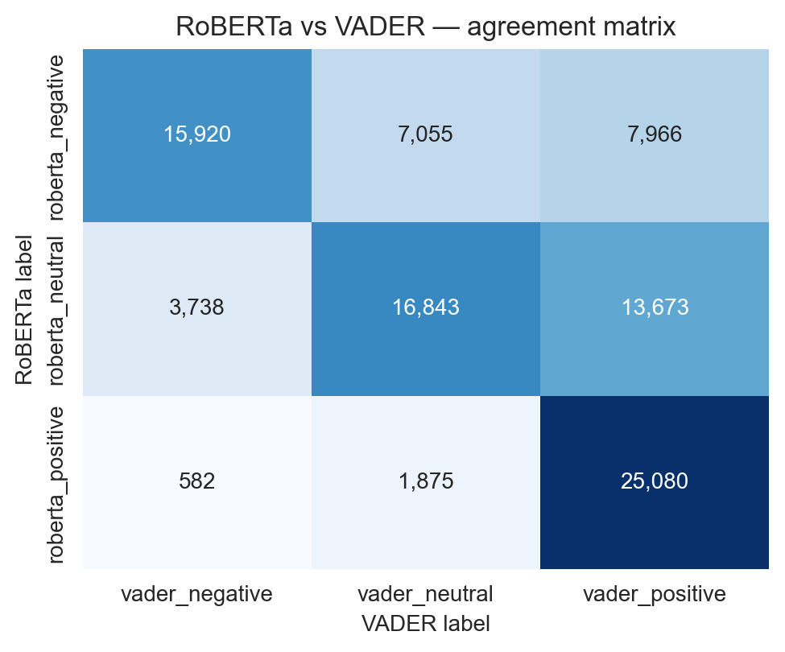
Figure 10. RoBERTa vs VADER label-agreement matrix.
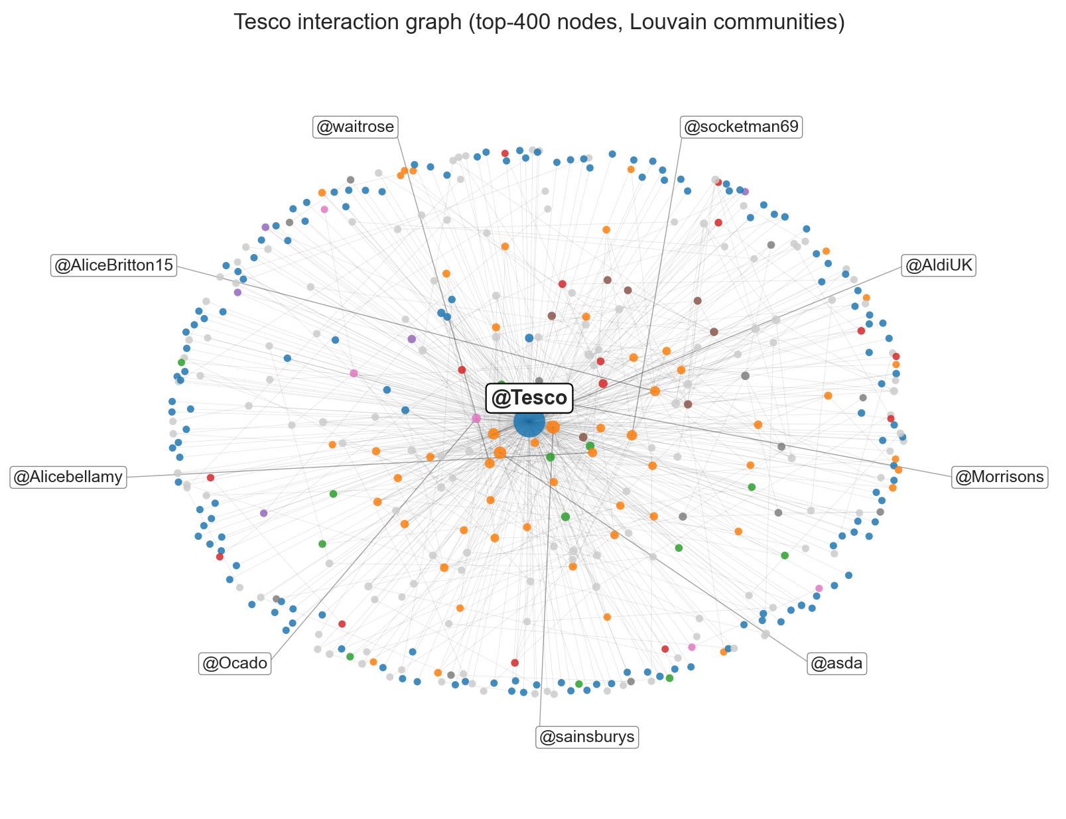
Figure 11. Spring-layout sub-graph of the top-400 nodes, coloured by Louvain community.

1.9 Appendix B — Interactive LDA Dashboard
A pyLDAvis-generated interactive dashboard is included with the submission as figures/lda_interactive.html. It shows the inter-topic distance map (multidimensional scaling) on the left and a relevance-controlled per-topic word ranking on the right. Recommended viewing setting: λ ≈ 0.6 (Sievert and Shirley, 2014).

1.10 Appendix C — Reproducibility
The full pipeline is the seven scripts under src/:
- 01_load_clean.py — JSON → cleaned parquet
- 02_sentiment.py — RoBERTa sentiment over the corpus
- 02b_vader_baseline.py — VADER baseline and agreement matrix
- 03_topic_lda.py — LDA with c_v K-selection on confidence-filtered negatives
- 04_sna.py — NetworkX directed-graph statistics, PageRank and Louvain
- 05_temporal.py — daily/monthly aggregation and event-window comparison
- 06_make_figures.py — all PNG figures used in the report
Reproduction:
python3.11 -m venv .venv && source .venv/bin/activate
pip install -r requirements.txt
python -m nltk.downloader stopwords wordnet
python src/01_load_clean.py --input ~/Downloads/tesco.json
python src/02_sentiment.py
python src/02b_vader_baseline.py
python src/03_topic_lda.py
python src/04_sna.py
python src/05_temporal.py
python src/06_make_figures.py
Total runtime on a 2024 MacBook Air (M3, 16 GB) with MPS: approximately 12 minutes, dominated by the RoBERTa pass (≈ 7 minutes) and LDA training (≈ 30 seconds).

1.11 Appendix D — Source Code
The full source code of all seven scripts is reproduced verbatim below for the assignment requirement that the analytical pipeline be auditable.

1.11.1 src/01_load_clean.py
"""
Stage 1 — Load and clean the Tesco Twitter corpus.
Input: tesco.json (pandas to_json(orient='columns'); ~489 MB; 96,702 rows)
Output: data/tweets_clean.parquet
data/cleaning_report.txt
Steps applied:
1. Read JSON with json.load (the file is a single column-oriented object)
2. Cast created_at (epoch ms) -> UTC pandas Timestamp
3. Filter to English-language tweets (lang == 'en')
4. Drop empty / duplicate id_str rows
5. Reconstruct full text from extended_tweet.full_text where text is truncated
6. Flatten user.screen_name and entities.user_mentions to top-level columns
7. Add boolean flags is_retweet / is_reply / is_quote for downstream stages
"""
from __future__ import annotations
import argparse
import json
import re
from pathlib import Path
import pandas as pd
THIS_DIR = Path(__file__).resolve().parent
PROJECT_DIR = THIS_DIR.parent
DATA_DIR = PROJECT_DIR / "data"
DATA_DIR.mkdir(exist_ok=True)
URL_RE = re.compile(r"https?://\S+")
WS_RE = re.compile(r"\s+")
def load_columnar_json(path: Path) -> pd.DataFrame:
"""Load a pandas-style column-oriented JSON file into a DataFrame."""
print(f"[load] reading {path} ...")
with path.open("r", encoding="utf-8") as f:
raw = json.load(f)
# Build DataFrame; index is the row-id key set
df = pd.DataFrame(raw)
print(f"[load] raw rows = {len(df):,}, columns = {len(df.columns)}")
return df
def reconstruct_full_text(row: pd.Series) -> str:
"""Use extended_tweet.full_text if the visible text is truncated."""
ext = row.get("extended_tweet")
if isinstance(ext, dict):
ft = ext.get("full_text")
if isinstance(ft, str) and ft.strip():
return ft
return row.get("text") or ""
def normalise_text(text: str) -> str:
"""Strip URLs and collapse whitespace; keep handles + hashtags for SNA/NLP."""
if not isinstance(text, str):
return ""
text = URL_RE.sub("", text)
text = WS_RE.sub(" ", text)
return text.strip()
def extract_user_mentions(entities) -> list[str]:
if not isinstance(entities, dict):
return []
mentions = entities.get("user_mentions") or []
return [m.get("screen_name") for m in mentions if isinstance(m, dict) and m.get("screen_name")]
def extract_hashtags(entities) -> list[str]:
if not isinstance(entities, dict):
return []
tags = entities.get("hashtags") or []
return [t.get("text", "").lower() for t in tags if isinstance(t, dict) and t.get("text")]
def main(input_path: Path) -> None:
df = load_columnar_json(input_path)
# ------------------------------------------------------------------
# Timestamp + window
# ------------------------------------------------------------------
df["created_at"] = pd.to_datetime(df["created_at"], unit="ms", utc=True)
n_initial = len(df)
print(f"[clean] date range: {df['created_at'].min()} -> {df['created_at'].max()}")
# ------------------------------------------------------------------
# Language filter
# ------------------------------------------------------------------
df = df[df["lang"] == "en"].copy()
n_after_lang = len(df)
print(f"[clean] dropped {n_initial - n_after_lang:,} non-English tweets")
# ------------------------------------------------------------------
# Reconstruct full text and normalise
# ------------------------------------------------------------------
df["full_text"] = df.apply(reconstruct_full_text, axis=1)
df["clean_text"] = df["full_text"].map(normalise_text)
df = df[df["clean_text"].str.len() >= 5].copy()
n_after_text = len(df)
print(f"[clean] dropped {n_after_lang - n_after_text:,} empty/short-text rows")
# ------------------------------------------------------------------
# Deduplicate by tweet id_str
# ------------------------------------------------------------------
df = df.drop_duplicates(subset=["id_str"], keep="first")
n_after_dedup = len(df)
print(f"[clean] dropped {n_after_text - n_after_dedup:,} duplicate ids")
# ------------------------------------------------------------------
# Flatten user / entities
# ------------------------------------------------------------------
df["author_screen_name"] = df["user"].map(
lambda u: u.get("screen_name") if isinstance(u, dict) else None
)
df["author_followers"] = df["user"].map(
lambda u: u.get("followers_count") if isinstance(u, dict) else None
)
df["mentions"] = df["entities"].map(extract_user_mentions)
df["hashtags"] = df["entities"].map(extract_hashtags)
df["is_retweet"] = df["retweeted_status"].notna()
df["is_quote"] = df["quoted_status"].notna()
df["is_reply"] = df["in_reply_to_status_id"].notna()
# Numeric coercions
for col in ("retweet_count", "favorite_count", "reply_count", "quote_count"):
if col in df.columns:
df[col] = pd.to_numeric(df[col], errors="coerce").fillna(0).astype(int)
# ------------------------------------------------------------------
# Keep only the columns we actually need downstream — keeps parquet small
# ------------------------------------------------------------------
keep_cols = [
"id_str", "created_at", "clean_text", "full_text",
"author_screen_name", "author_followers",
"mentions", "hashtags",
"is_retweet", "is_quote", "is_reply",
"in_reply_to_screen_name", "in_reply_to_status_id_str",
"retweet_count", "favorite_count", "reply_count", "quote_count",
]
keep_cols = [c for c in keep_cols if c in df.columns]
out = df[keep_cols].reset_index(drop=True)
out_path = DATA_DIR / "tweets_clean.parquet"
out.to_parquet(out_path, index=False)
print(f"[save] wrote {len(out):,} rows -> {out_path}")
# ------------------------------------------------------------------
# Cleaning audit log
# ------------------------------------------------------------------
report = (
f"Cleaning report\n"
f"================\n"
f"raw rows : {n_initial:,}\n"
f"after lang=='en' : {n_after_lang:,}\n"
f"after text>=5 chars: {n_after_text:,}\n"
f"after dedup id_str : {n_after_dedup:,}\n"
f"final rows : {len(out):,}\n"
f"\n"
f"Type breakdown (final):\n"
f" original tweets : {(~out['is_retweet']).sum():,}\n"
f" retweets : {out['is_retweet'].sum():,}\n"
f" replies : {out['is_reply'].sum():,}\n"
f" quotes : {out['is_quote'].sum():,}\n"
f"\n"
f"Date range: {out['created_at'].min()} -> {out['created_at'].max()}\n"
)
(DATA_DIR / "cleaning_report.txt").write_text(report)
print("\n" + report)
if __name__ == "__main__":
parser = argparse.ArgumentParser()
parser.add_argument(
"--input",
type=Path,
default=Path.home() / "Downloads" / "tesco.json",
help="Path to tesco.json",
)
args = parser.parse_args()
main(args.input)

1.11.2 src/02_sentiment.py
"""
Stage 2 — Sentiment classification.
Uses cardiffnlp/twitter-roberta-base-sentiment-latest (Loureiro et al., 2022),
chosen because it was fine-tuned on ~124M tweets and outputs three classes
(negative / neutral / positive) — directly aligned with our downstream LDA
filter and event-study analysis.
Apple-Silicon (MPS) acceleration is used when available; otherwise CPU.
Input: data/tweets_clean.parquet
Output: data/tweets_sentiment.parquet
data/sentiment_summary.txt
"""
from __future__ import annotations
from pathlib import Path
import numpy as np
import pandas as pd
import torch
from tqdm import tqdm
from transformers import AutoModelForSequenceClassification, AutoTokenizer
THIS_DIR = Path(__file__).resolve().parent
PROJECT_DIR = THIS_DIR.parent
DATA_DIR = PROJECT_DIR / "data"
MODEL_NAME = "cardiffnlp/twitter-roberta-base-sentiment-latest"
LABELS = ["negative", "neutral", "positive"]
SCORE_MAP = {"negative": -1, "neutral": 0, "positive": 1}
BATCH_SIZE = 64
MAX_TOKENS = 128
def get_device() -> torch.device:
if torch.backends.mps.is_available():
return torch.device("mps")
if torch.cuda.is_available():
return torch.device("cuda")
return torch.device("cpu")
def main() -> None:
df = pd.read_parquet(DATA_DIR / "tweets_clean.parquet")
print(f"[load] {len(df):,} tweets to classify")
device = get_device()
print(f"[model] loading {MODEL_NAME} on {device}")
tok = AutoTokenizer.from_pretrained(MODEL_NAME)
model = AutoModelForSequenceClassification.from_pretrained(MODEL_NAME).to(device)
model.eval()
texts = df["clean_text"].tolist()
n = len(texts)
pred_label = np.empty(n, dtype=object)
pred_conf = np.empty(n, dtype=np.float32)
pred_score = np.empty(n, dtype=np.float32)
with torch.no_grad():
for start in tqdm(range(0, n, BATCH_SIZE), desc="sentiment"):
chunk = texts[start : start + BATCH_SIZE]
enc = tok(
chunk,
padding=True,
truncation=True,
max_length=MAX_TOKENS,
return_tensors="pt",
).to(device)
logits = model(**enc).logits
probs = torch.softmax(logits, dim=-1).cpu().numpy()
idx = probs.argmax(axis=1)
for i, ix in enumerate(idx):
lbl = LABELS[ix]
pred_label[start + i] = lbl
pred_conf[start + i] = float(probs[i, ix])
# signed score = P(pos) - P(neg) -> [-1, 1]
pred_score[start + i] = float(probs[i, 2] - probs[i, 0])
df["sentiment"] = pred_label
df["sentiment_conf"] = pred_conf
df["sentiment_score"] = pred_score
out = DATA_DIR / "tweets_sentiment.parquet"
df.to_parquet(out, index=False)
print(f"[save] {out}")
# ------------------------------------------------------------------
# Summary
# ------------------------------------------------------------------
counts = df["sentiment"].value_counts()
pct = (counts / len(df) * 100).round(2)
summary = (
f"Sentiment summary (n = {len(df):,})\n"
f"================================\n"
f"negative : {counts.get('negative', 0):>7,} ({pct.get('negative', 0)}%)\n"
f"neutral : {counts.get('neutral', 0):>7,} ({pct.get('neutral', 0)}%)\n"
f"positive : {counts.get('positive', 0):>7,} ({pct.get('positive', 0)}%)\n"
f"\n"
f"mean sentiment_score = {df['sentiment_score'].mean():.4f}\n"
f"mean confidence = {df['sentiment_conf'].mean():.4f}\n"
)
(DATA_DIR / "sentiment_summary.txt").write_text(summary)
print("\n" + summary)
if __name__ == "__main__":
main()

1.11.3 src/02b_vader_baseline.py
"""
Stage 2b — VADER baseline for sentiment, kept on the same 92.7k tweets so
the report can compare the two models.
VADER (Hutto and Gilbert, 2014) is a rule/lexicon hybrid; it costs nothing
to run and is the standard baseline in the literature. We compare its
labels against RoBERTa using Cohen's kappa and a 3x3 agreement matrix.
Output:
data/tweets_vader.parquet
data/model_agreement.csv
data/model_agreement_summary.txt
"""
import pandas as pd
from pathlib import Path
from vaderSentiment.vaderSentiment import SentimentIntensityAnalyzer
from sklearn.metrics import cohen_kappa_score, confusion_matrix
DATA = Path(__file__).resolve().parent.parent / "data"
# VADER thresholds from Hutto & Gilbert (2014)
POS_T = 0.05
NEG_T = -0.05
def vader_label(compound: float) -> str:
if compound >= POS_T:
return "positive"
if compound <= NEG_T:
return "negative"
return "neutral"
def main() -> None:
df = pd.read_parquet(DATA / "tweets_sentiment.parquet")
sia = SentimentIntensityAnalyzer()
# vectorise via simple list-comp; VADER on 93k texts takes < 1 minute
print(f"running VADER over {len(df):,} tweets...")
scores = [sia.polarity_scores(t)["compound"] for t in df["clean_text"].tolist()]
df["vader_compound"] = scores
df["vader_label"] = [vader_label(s) for s in scores]
df.to_parquet(DATA / "tweets_vader.parquet", index=False)
# agreement
labels = ["negative", "neutral", "positive"]
cm = confusion_matrix(df["sentiment"], df["vader_label"], labels=labels)
kappa = cohen_kappa_score(df["sentiment"], df["vader_label"])
pct_agree = (df["sentiment"] == df["vader_label"]).mean()
cm_df = pd.DataFrame(cm, index=[f"roberta_{l}" for l in labels],
columns=[f"vader_{l}" for l in labels])
cm_df.to_csv(DATA / "model_agreement.csv")
summary = (
f"Model agreement (RoBERTa vs VADER), n = {len(df):,}\n"
f"=================================================\n"
f"% agreement : {pct_agree*100:.2f}%\n"
f"Cohen's kappa : {kappa:.4f}\n\n"
f"Confusion matrix (rows = RoBERTa, cols = VADER):\n"
f"{cm_df.to_string()}\n\n"
f"VADER class shares:\n"
f"{df['vader_label'].value_counts(normalize=True).round(4).to_string()}\n"
)
(DATA / "model_agreement_summary.txt").write_text(summary)
print("\n" + summary)
if __name__ == "__main__":
main()

1.11.4 src/03_topic_lda.py
"""
Stage 3 — LDA topic modelling on high-confidence negative tweets.
Following Sia, Dalmia and Mielke (2020), we filter by sentiment first to
sharpen topic separation. Optimal K is selected by Röder, Both and
Hinneburg's (2015) c_v coherence over K in {5, 7, 10, 12}.
Input: data/tweets_sentiment.parquet
Output: data/lda_topics.parquet
data/lda_topics_top_words.csv
data/lda_coherence.csv
figures/lda_interactive.html (pyLDAvis)
"""
from __future__ import annotations
import re
from pathlib import Path
import nltk
import pandas as pd
from gensim import corpora
from gensim.models import CoherenceModel, LdaModel
from nltk.corpus import stopwords
from nltk.stem import WordNetLemmatizer
# Optional dep — only needed for the interactive HTML
try:
import pyLDAvis
import pyLDAvis.gensim_models as gensimvis
HAVE_PYLDAVIS = True
except Exception:
HAVE_PYLDAVIS = False
THIS_DIR = Path(__file__).resolve().parent
PROJECT_DIR = THIS_DIR.parent
DATA_DIR = PROJECT_DIR / "data"
FIG_DIR = PROJECT_DIR / "figures"
FIG_DIR.mkdir(exist_ok=True)
CONF_THRESHOLD = 0.80
K_CANDIDATES = [5, 7, 10, 12]
RANDOM_STATE = 42
EXTRA_STOPWORDS = {
"tesco", "tescos", "u", "im", "ive", "th", "rt", "amp", "would",
"could", "still", "get", "got", "go", "going", "gone", "one", "two",
"see", "say", "said", "tell", "told", "really", "much", "even",
"though", "always", "never", "today", "yesterday", "tomorrow",
"back", "thing", "way", "make", "made", "ill", "thats", "dont",
"doesnt", "didnt", "wasnt", "isnt", "wont", "youre", "theyre",
"theyve", "theyd", "well", "people", "want", "need", "lol",
}
def ensure_nltk() -> None:
for pkg in ("stopwords", "wordnet"):
try:
nltk.download(pkg, quiet=True)
except Exception:
pass
def make_tokeniser():
sw = set(stopwords.words("english")) | EXTRA_STOPWORDS
lemma = WordNetLemmatizer()
word_re = re.compile(r"[a-z]{3,}")
def tokenise(text: str) -> list[str]:
text = text.lower()
text = re.sub(r"@\w+", " ", text)
text = re.sub(r"#", " ", text)
toks = word_re.findall(text)
return [lemma.lemmatize(t) for t in toks if t not in sw and len(t) > 2]
return tokenise
def main() -> None:
ensure_nltk()
df = pd.read_parquet(DATA_DIR / "tweets_sentiment.parquet")
neg = df[(df["sentiment"] == "negative") & (df["sentiment_conf"] >= CONF_THRESHOLD)].copy()
print(f"[load] {len(df):,} total -> {len(neg):,} high-confidence negatives")
tokenise = make_tokeniser()
neg["tokens"] = neg["clean_text"].map(tokenise)
neg = neg[neg["tokens"].map(len) >= 4].copy()
print(f"[clean] {len(neg):,} negatives after token filter (>=4 tokens)")
docs = neg["tokens"].tolist()
dictionary = corpora.Dictionary(docs)
dictionary.filter_extremes(no_below=10, no_above=0.5)
corpus = [dictionary.doc2bow(d) for d in docs]
print(f"[dict] vocab size = {len(dictionary)}")
coherences = []
best_k = None
best_model = None
best_score = -1.0
for k in K_CANDIDATES:
print(f"[lda] training k={k} ...")
m = LdaModel(
corpus=corpus,
id2word=dictionary,
num_topics=k,
random_state=RANDOM_STATE,
passes=8,
iterations=200,
alpha="auto",
eta="auto",
)
cm = CoherenceModel(
model=m, texts=docs, dictionary=dictionary, coherence="c_v"
)
score = cm.get_coherence()
coherences.append({"k": k, "c_v": score})
print(f" c_v = {score:.4f}")
if score > best_score:
best_score, best_k, best_model = score, k, m
pd.DataFrame(coherences).to_csv(DATA_DIR / "lda_coherence.csv", index=False)
print(f"[lda] best k = {best_k} (c_v = {best_score:.4f})")
# ------------------------------------------------------------------
# Top words
# ------------------------------------------------------------------
rows = []
for tid in range(best_k):
top = best_model.show_topic(tid, topn=15)
rows.append({
"topic": tid,
"top_words": ", ".join(w for w, _ in top),
})
pd.DataFrame(rows).to_csv(DATA_DIR / "lda_topics_top_words.csv", index=False)
# ------------------------------------------------------------------
# Doc-topic assignment
# ------------------------------------------------------------------
dom_topic, dom_prob = [], []
for bow in corpus:
dist = best_model.get_document_topics(bow, minimum_probability=0.0)
t, p = max(dist, key=lambda x: x[1])
dom_topic.append(t)
dom_prob.append(p)
neg["dominant_topic"] = dom_topic
neg["topic_prob"] = dom_prob
neg[[
"id_str", "created_at", "clean_text", "sentiment_score",
"dominant_topic", "topic_prob",
]].to_parquet(DATA_DIR / "lda_topics.parquet", index=False)
# ------------------------------------------------------------------
# pyLDAvis (Appendix B in report)
# ------------------------------------------------------------------
if HAVE_PYLDAVIS:
try:
vis = gensimvis.prepare(best_model, corpus, dictionary, sort_topics=False)
pyLDAvis.save_html(vis, str(FIG_DIR / "lda_interactive.html"))
print(f"[viz] wrote {FIG_DIR / 'lda_interactive.html'}")
except Exception as e:
print(f"[viz] pyLDAvis failed: {e}")
else:
print("[viz] pyLDAvis not installed — skipping interactive HTML")
if __name__ == "__main__":
main()

1.11.5 src/04_sna.py
"""
Stage 4 — Social Network Analysis on the Tesco Twitter graph.
We build a directed interaction graph from three edge types:
* reply : author -> in_reply_to_screen_name
* retweet: author -> retweeted_user (screen_name)
* mention: author -> mentioned_user (entities.user_mentions)
Edges are weighted by frequency. We then compute:
* basic structural statistics (n, m, density, average clustering)
* degree, in-degree, out-degree centrality (top 20)
* PageRank (top 20)
* Louvain community detection on the undirected projection
Input: data/tweets_sentiment.parquet (we want sentiment to colour communities)
Output: data/graph_summary.txt
data/centrality_top.csv
data/communities.csv
data/edges.parquet
"""
from __future__ import annotations
from collections import Counter
from pathlib import Path
import community as community_louvain # python-louvain
import networkx as nx
import pandas as pd
THIS_DIR = Path(__file__).resolve().parent
PROJECT_DIR = THIS_DIR.parent
DATA_DIR = PROJECT_DIR / "data"
MIN_EDGE_WEIGHT = 2 # drop singleton edges before community detection
def build_edges(df: pd.DataFrame) -> pd.DataFrame:
"""Return DataFrame of (source, target, type) edges."""
edges: list[tuple[str, str, str]] = []
for row in df.itertuples(index=False):
src = getattr(row, "author_screen_name")
if not src or not isinstance(src, str):
continue
# reply
tgt = getattr(row, "in_reply_to_screen_name", None)
if isinstance(tgt, str) and tgt and tgt != src:
edges.append((src, tgt, "reply"))
# mentions (parquet -> may be ndarray)
mentions = getattr(row, "mentions", None)
if mentions is None:
continue
try:
iter_m = list(mentions)
except TypeError:
continue
for m in iter_m:
if isinstance(m, str) and m and m != src:
edges.append((src, m, "mention"))
return pd.DataFrame(edges, columns=["source", "target", "type"])
def main() -> None:
df = pd.read_parquet(DATA_DIR / "tweets_sentiment.parquet")
print(f"[load] {len(df):,} tweets")
edges = build_edges(df)
print(f"[edges] raw edge tokens = {len(edges):,}")
weighted = (
edges.groupby(["source", "target"]).size().reset_index(name="weight")
)
weighted.to_parquet(DATA_DIR / "edges.parquet", index=False)
print(f"[edges] unique directed edges = {len(weighted):,}")
# ------------------------------------------------------------------
# Directed graph for centrality
# ------------------------------------------------------------------
G = nx.DiGraph()
for s, t, w in weighted.itertuples(index=False):
G.add_edge(s, t, weight=int(w))
print(f"[graph] directed: |V|={G.number_of_nodes():,} |E|={G.number_of_edges():,}")
# Density / reciprocity (cheap O(m))
density = nx.density(G)
try:
reciprocity = nx.overall_reciprocity(G)
except Exception:
reciprocity = float("nan")
# In/Out/Total degree
in_deg = dict(G.in_degree(weight="weight"))
out_deg = dict(G.out_degree(weight="weight"))
total_deg = {n: in_deg.get(n, 0) + out_deg.get(n, 0) for n in G.nodes()}
# PageRank (use weighted edges)
print("[graph] computing PageRank ...")
pr = nx.pagerank(G, weight="weight", alpha=0.85)
cent_df = (
pd.DataFrame({
"user": list(G.nodes()),
"in_degree": [in_deg.get(n, 0) for n in G.nodes()],
"out_degree": [out_deg.get(n, 0) for n in G.nodes()],
"total_degree": [total_deg.get(n, 0) for n in G.nodes()],
"pagerank": [pr.get(n, 0.0) for n in G.nodes()],
})
.sort_values("pagerank", ascending=False)
.reset_index(drop=True)
)
cent_df.head(50).to_csv(DATA_DIR / "centrality_top.csv", index=False)
# ------------------------------------------------------------------
# Community detection on the undirected, weight-filtered projection
# ------------------------------------------------------------------
UG = nx.Graph()
filt = weighted[weighted["weight"] >= MIN_EDGE_WEIGHT]
print(f"[comm] edges with weight>={MIN_EDGE_WEIGHT}: {len(filt):,}")
for s, t, w in filt.itertuples(index=False):
if UG.has_edge(s, t):
UG[s][t]["weight"] += int(w)
else:
UG.add_edge(s, t, weight=int(w))
# Largest connected component for stable community detection
if UG.number_of_nodes() == 0:
print("[comm] no edges left after filter — skipping community detection")
partition = {}
else:
components = list(nx.connected_components(UG))
giant = max(components, key=len)
UG_giant = UG.subgraph(giant).copy()
print(
f"[comm] giant component: |V|={UG_giant.number_of_nodes():,} "
f"|E|={UG_giant.number_of_edges():,}"
)
partition = community_louvain.best_partition(UG_giant, weight="weight", random_state=42)
if partition:
modularity = community_louvain.modularity(partition, UG_giant, weight="weight")
comm_counts = Counter(partition.values())
print(f"[comm] {len(comm_counts)} communities, modularity = {modularity:.4f}")
comm_df = pd.DataFrame(
[{"user": u, "community": c} for u, c in partition.items()]
)
# join sentiment of authors' own tweets to colour communities
author_sent = (
df.groupby("author_screen_name")["sentiment_score"].mean().rename("avg_sent")
)
comm_df = comm_df.merge(author_sent, left_on="user", right_index=True, how="left")
comm_df.to_csv(DATA_DIR / "communities.csv", index=False)
else:
modularity = float("nan")
comm_counts = Counter()
# ------------------------------------------------------------------
# Summary report
# ------------------------------------------------------------------
n_comm = len(comm_counts)
largest = comm_counts.most_common(5)
summary = (
f"Tesco Twitter interaction graph — summary\n"
f"=========================================\n"
f"Nodes (users) : {G.number_of_nodes():,}\n"
f"Directed edges : {G.number_of_edges():,}\n"
f"Density : {density:.6f}\n"
f"Reciprocity : {reciprocity:.4f}\n"
f"Edges w/ weight>={MIN_EDGE_WEIGHT} : {len(filt):,}\n"
f"Communities (Louvain) : {n_comm}\n"
f"Modularity : {modularity:.4f}\n"
f"\n"
f"Top 5 communities by size:\n"
)
for cid, sz in largest:
summary += f" community {cid}: {sz:,} members\n"
summary += "\nTop 10 PageRank users:\n"
for _, r in cent_df.head(10).iterrows():
summary += (
f" @{r['user']:<22} pagerank={r['pagerank']:.5f} "
f"in={r['in_degree']:>6} out={r['out_degree']:>6}\n"
)
(DATA_DIR / "graph_summary.txt").write_text(summary)
print("\n" + summary)
if __name__ == "__main__":
main()

1.11.6 src/05_temporal.py
"""
Stage 5 — Event-annotated temporal sentiment analysis.
For 2020 we anchor the sentiment timeline against verified UK retail and
COVID-19 events (sources cited in the report references). For each event
we compute a 14-day pre/post comparison of mean sentiment_score and the
share of negative tweets.
Note: this analysis is associational, not causal.
Input: data/tweets_sentiment.parquet
Output: data/daily_sentiment.csv
data/monthly_sentiment.csv
data/event_study.csv
"""
from __future__ import annotations
from pathlib import Path
import pandas as pd
THIS_DIR = Path(__file__).resolve().parent
PROJECT_DIR = THIS_DIR.parent
DATA_DIR = PROJECT_DIR / "data"
WINDOW_DAYS = 14
EVENTS = [
# (label, ISO date) — references in report bibliography
("WHO declares COVID-19 a pandemic", "2020-03-11"),
("UK national lockdown begins", "2020-03-23"),
("Tesco hires 35k temp staff", "2020-03-25"),
("Tesco opens priority slots for vulnerable", "2020-04-03"),
("First lockdown easing in England", "2020-06-15"),
("Tesco sells Tesco Lotus Asia ops", "2020-03-09"),
("Eat Out To Help Out begins", "2020-08-03"),
("Tier system announced", "2020-10-12"),
("Second national lockdown begins", "2020-11-05"),
("Tier 4 announced (London/SE)", "2020-12-19"),
]
def main() -> None:
df = pd.read_parquet(DATA_DIR / "tweets_sentiment.parquet")
df["date"] = df["created_at"].dt.tz_convert("UTC").dt.date
df["month"] = df["created_at"].dt.tz_convert("UTC").dt.to_period("M").astype(str)
# daily
daily = (
df.groupby("date")
.agg(
n=("id_str", "count"),
mean_score=("sentiment_score", "mean"),
share_neg=("sentiment", lambda s: (s == "negative").mean()),
share_pos=("sentiment", lambda s: (s == "positive").mean()),
)
.reset_index()
)
daily.to_csv(DATA_DIR / "daily_sentiment.csv", index=False)
print(f"[save] {len(daily)} daily rows -> data/daily_sentiment.csv")
# monthly
monthly = (
df.groupby("month")
.agg(
n=("id_str", "count"),
mean_score=("sentiment_score", "mean"),
share_neg=("sentiment", lambda s: (s == "negative").mean()),
share_pos=("sentiment", lambda s: (s == "positive").mean()),
)
.reset_index()
)
monthly.to_csv(DATA_DIR / "monthly_sentiment.csv", index=False)
print(f"[save] {len(monthly)} monthly rows -> data/monthly_sentiment.csv")
# event study
df["dt"] = pd.to_datetime(df["created_at"]).dt.tz_localize(None)
rows = []
for label, dt_str in EVENTS:
evt = pd.Timestamp(dt_str)
pre = df[(df["dt"] >= evt - pd.Timedelta(days=WINDOW_DAYS)) & (df["dt"] < evt)]
post = df[(df["dt"] >= evt) & (df["dt"] < evt + pd.Timedelta(days=WINDOW_DAYS))]
rows.append({
"event": label,
"date": dt_str,
"n_pre": len(pre),
"n_post": len(post),
"mean_pre": round(pre["sentiment_score"].mean(), 4) if len(pre) else None,
"mean_post": round(post["sentiment_score"].mean(), 4) if len(post) else None,
"delta": (
round(post["sentiment_score"].mean() - pre["sentiment_score"].mean(), 4)
if len(pre) and len(post)
else None
),
"share_neg_pre": round((pre["sentiment"] == "negative").mean(), 4) if len(pre) else None,
"share_neg_post": round((post["sentiment"] == "negative").mean(), 4) if len(post) else None,
})
ev = pd.DataFrame(rows)
ev.to_csv(DATA_DIR / "event_study.csv", index=False)
print(ev.to_string(index=False))
if __name__ == "__main__":
main()

1.11.7 src/06_make_figures.py
"""
Stage 6 — Generate all PNG figures referenced in the report.
Reads the artefacts produced by stages 1–5 and writes high-resolution
PNGs to figures/. Each figure is captioned in the report.
Figures produced:
f01_volume_by_day.png — tweet volume over 2020
f02_sentiment_distribution — overall sentiment class distribution
f03_lda_coherence.png — c_v across K candidates
f04_topic_top_words.png — top words per topic (heatmap-style)
f05_topic_share.png — topic share of negative corpus
f06_monthly_sentiment.png — monthly mean sentiment + share negative
f07_event_study.png — pre/post Δ for each event
f08_pagerank_top.png — top-20 PageRank users
f09_community_sentiment — average sentiment per community (top 10)
"""
from __future__ import annotations
from pathlib import Path
import matplotlib.pyplot as plt
import numpy as np
import pandas as pd
import seaborn as sns
THIS_DIR = Path(__file__).resolve().parent
PROJECT_DIR = THIS_DIR.parent
DATA_DIR = PROJECT_DIR / "data"
FIG_DIR = PROJECT_DIR / "figures"
FIG_DIR.mkdir(exist_ok=True)
sns.set_style("whitegrid")
plt.rcParams.update({
"figure.dpi": 130,
"savefig.dpi": 200,
"savefig.bbox": "tight",
"font.size": 10,
"axes.titlesize": 12,
"axes.labelsize": 10,
})
def fig01_volume() -> None:
daily = pd.read_csv(DATA_DIR / "daily_sentiment.csv", parse_dates=["date"])
fig, ax = plt.subplots(figsize=(10, 3.5))
ax.fill_between(daily["date"], daily["n"], alpha=0.6, color="#1f77b4")
ax.set_title("Daily volume of Tesco-related English tweets, 2020")
ax.set_ylabel("Tweets per day")
ax.set_xlabel("")
fig.savefig(FIG_DIR / "f01_volume_by_day.png")
plt.close(fig)
def fig02_sentiment_distribution() -> None:
df = pd.read_parquet(DATA_DIR / "tweets_sentiment.parquet")
counts = df["sentiment"].value_counts().reindex(["negative", "neutral", "positive"])
pct = counts / counts.sum() * 100
fig, ax = plt.subplots(figsize=(6, 3.2))
bars = ax.bar(
counts.index, counts.values,
color=["#d62728", "#7f7f7f", "#2ca02c"],
)
for b, p in zip(bars, pct.values):
ax.text(b.get_x() + b.get_width() / 2, b.get_height(),
f"{p:.1f}%", ha="center", va="bottom", fontsize=10)
ax.set_title("Sentiment-class distribution (RoBERTa, n = {:,})".format(int(counts.sum())))
ax.set_ylabel("Tweets")
fig.savefig(FIG_DIR / "f02_sentiment_distribution.png")
plt.close(fig)
def fig03_coherence() -> None:
df = pd.read_csv(DATA_DIR / "lda_coherence.csv")
best = df.loc[df["c_v"].idxmax()]
fig, ax = plt.subplots(figsize=(6, 3.2))
ax.plot(df["k"], df["c_v"], "o-", color="#1f77b4")
ax.scatter([best["k"]], [best["c_v"]], color="#d62728", zorder=5,
label=f"selected K = {int(best['k'])}")
ax.set_xlabel("Number of topics (K)")
ax.set_ylabel(r"$c_v$ coherence")
ax.set_title("LDA topic-coherence selection")
ax.legend()
fig.savefig(FIG_DIR / "f03_lda_coherence.png")
plt.close(fig)
def fig04_top_words() -> None:
tw = pd.read_csv(DATA_DIR / "lda_topics_top_words.csv")
fig, ax = plt.subplots(figsize=(10, 0.5 + 0.45 * len(tw)))
ax.axis("off")
rows = []
for _, r in tw.iterrows():
rows.append([f"Topic {int(r['topic'])}", r["top_words"]])
tbl = ax.table(cellText=rows, colLabels=["", "Top 15 words (descending β)"],
cellLoc="left", loc="center", colWidths=[0.12, 0.88])
tbl.auto_set_font_size(False)
tbl.set_fontsize(9)
tbl.scale(1, 1.4)
ax.set_title("LDA topics — top words per topic", pad=10)
fig.savefig(FIG_DIR / "f04_topic_top_words.png")
plt.close(fig)
def fig05_topic_share() -> None:
tp = pd.read_parquet(DATA_DIR / "lda_topics.parquet")
share = tp["dominant_topic"].value_counts(normalize=True).sort_index()
fig, ax = plt.subplots(figsize=(6, 3.2))
bars = ax.bar(share.index.astype(str), share.values * 100, color="#9467bd")
for b, v in zip(bars, share.values):
ax.text(b.get_x() + b.get_width() / 2, b.get_height(),
f"{v*100:.1f}%", ha="center", va="bottom", fontsize=9)
ax.set_xlabel("Topic")
ax.set_ylabel("Share of negative corpus (%)")
ax.set_title("LDA topic share of high-confidence negative tweets")
fig.savefig(FIG_DIR / "f05_topic_share.png")
plt.close(fig)
def fig06_monthly_sentiment() -> None:
monthly = pd.read_csv(DATA_DIR / "monthly_sentiment.csv")
fig, axes = plt.subplots(2, 1, figsize=(10, 5.5), sharex=True)
axes[0].plot(monthly["month"], monthly["mean_score"], "o-", color="#1f77b4")
axes[0].axhline(0, color="grey", linewidth=0.8, linestyle="--")
axes[0].set_ylabel("Mean sentiment score")
axes[0].set_title("Monthly mean sentiment and share-negative, Tesco tweets 2020")
axes[1].plot(monthly["month"], monthly["share_neg"] * 100, "s-", color="#d62728")
axes[1].set_ylabel("Share negative (%)")
axes[1].set_xlabel("Month")
plt.setp(axes[1].get_xticklabels(), rotation=45, ha="right")
fig.savefig(FIG_DIR / "f06_monthly_sentiment.png")
plt.close(fig)
def fig07_event_study() -> None:
ev = pd.read_csv(DATA_DIR / "event_study.csv")
ev = ev.dropna(subset=["delta"]).sort_values("date")
fig, ax = plt.subplots(figsize=(10, 4.5))
colors = ["#2ca02c" if d > 0 else "#d62728" for d in ev["delta"]]
bars = ax.barh(ev["event"], ev["delta"], color=colors)
ax.axvline(0, color="black", linewidth=0.8)
for b, d in zip(bars, ev["delta"]):
ax.text(b.get_width(), b.get_y() + b.get_height() / 2,
f" {d:+.3f}", va="center",
ha="left" if d >= 0 else "right", fontsize=9)
ax.set_xlabel(r"$\Delta$ mean sentiment (post 14d − pre 14d)")
ax.set_title("Event study: 14-day pre/post sentiment shifts (associational)")
ax.invert_yaxis()
fig.savefig(FIG_DIR / "f07_event_study.png")
plt.close(fig)
def fig08_pagerank() -> None:
cent = pd.read_csv(DATA_DIR / "centrality_top.csv").head(20)
fig, ax = plt.subplots(figsize=(8, 5.2))
ax.barh(cent["user"][::-1], cent["pagerank"][::-1], color="#17becf")
ax.set_xlabel("PageRank")
ax.set_title("Top 20 users by PageRank in Tesco interaction graph")
fig.savefig(FIG_DIR / "f08_pagerank_top.png")
plt.close(fig)
def fig09b_model_agreement() -> None:
path = DATA_DIR / "model_agreement.csv"
if not path.exists():
return
cm = pd.read_csv(path, index_col=0)
fig, ax = plt.subplots(figsize=(5.5, 4.2))
sns.heatmap(cm, annot=True, fmt=",d", cmap="Blues", ax=ax, cbar=False)
ax.set_title("RoBERTa vs VADER — agreement matrix")
ax.set_xlabel("VADER label")
ax.set_ylabel("RoBERTa label")
fig.savefig(FIG_DIR / "f10_model_agreement.png")
plt.close(fig)
def fig09c_graph_viz() -> None:
"""Compact spring layout of the top-N most-connected nodes coloured by community."""
import networkx as nx
edges_path = DATA_DIR / "edges.parquet"
comm_path = DATA_DIR / "communities.csv"
if not (edges_path.exists() and comm_path.exists()):
return
edges = pd.read_parquet(edges_path)
comms = pd.read_csv(comm_path)
# take the giant component edges by intersection with community members
top_users = set(comms["user"].head(400))
sub = edges[edges["source"].isin(top_users) & edges["target"].isin(top_users)]
if sub.empty:
return
G = nx.Graph()
for s, t, w in sub.itertuples(index=False):
if G.has_edge(s, t):
G[s][t]["weight"] += int(w)
else:
G.add_edge(s, t, weight=int(w))
# restrict to top community labels for colouring
comm_lookup = dict(zip(comms["user"], comms["community"]))
top_comms = comms["community"].value_counts().head(8).index.tolist()
palette = sns.color_palette("tab10", n_colors=len(top_comms))
node_colours = []
for n in G.nodes():
c = comm_lookup.get(n)
node_colours.append(palette[top_comms.index(c)] if c in top_comms else "#cccccc")
fig, ax = plt.subplots(figsize=(8, 6))
pos = nx.spring_layout(G, seed=42, k=0.35, iterations=50)
nx.draw_networkx_edges(G, pos, alpha=0.15, width=0.4, ax=ax)
nx.draw_networkx_nodes(
G, pos, node_size=[20 + G.degree(n) * 1.5 for n in G.nodes()],
node_color=node_colours, alpha=0.85, ax=ax,
)
# label only the top-degree handles
deg_sorted = sorted(G.degree, key=lambda x: -x[1])[:10]
labels = {n: f"@{n}" for n, _ in deg_sorted}
nx.draw_networkx_labels(G, pos, labels=labels, font_size=8, ax=ax)
ax.set_axis_off()
ax.set_title("Tesco interaction graph (top-400 nodes, Louvain communities)")
fig.savefig(FIG_DIR / "f11_graph_viz.png")
plt.close(fig)
def fig09_community_sentiment() -> None:
path = DATA_DIR / "communities.csv"
if not path.exists():
return
comm = pd.read_csv(path)
sizes = comm.groupby("community").size().rename("size")
sent = comm.groupby("community")["avg_sent"].mean()
summary = pd.concat([sizes, sent], axis=1).sort_values("size", ascending=False).head(10)
fig, ax = plt.subplots(figsize=(8, 4.5))
norm = plt.Normalize(-0.5, 0.5)
cmap = plt.cm.RdYlGn
colors = [cmap(norm(v)) if not np.isnan(v) else "lightgrey" for v in summary["avg_sent"]]
bars = ax.bar(summary.index.astype(str), summary["size"], color=colors)
for b, v in zip(bars, summary["avg_sent"]):
if not np.isnan(v):
ax.text(b.get_x() + b.get_width() / 2, b.get_height(),
f"{v:+.2f}", ha="center", va="bottom", fontsize=9)
ax.set_xlabel("Community ID")
ax.set_ylabel("Members")
ax.set_title("Top 10 Louvain communities — size and mean author sentiment")
sm = plt.cm.ScalarMappable(norm=norm, cmap=cmap)
sm.set_array([])
fig.colorbar(sm, ax=ax, label="Mean author sentiment")
fig.savefig(FIG_DIR / "f09_community_sentiment.png")
plt.close(fig)
def main() -> None:
fig01_volume()
fig02_sentiment_distribution()
fig03_coherence()
fig04_top_words()
fig05_topic_share()
fig06_monthly_sentiment()
fig07_event_study()
fig08_pagerank()
fig09_community_sentiment()
fig09b_model_agreement()
fig09c_graph_viz()
print("[ok] figures written to", FIG_DIR)
if __name__ == "__main__":
main()

