MAKERERE  P.O. Box 7062, Kampala, Uganda  https://mak.ac.ug |  | UNIVERSITY  Telephone: +256-414-534560/1-9  E-mail: cs@cis.mak.ac.ug
COLLEGE OF COMPUTING AND INFORMATION SCIENCES
School of Computing and Informatics Technology
Department of Computer Science

Business Case and Feasibility Study
BabyHealth Guard
Digital Maternal and Newborn Health Monitoring System
GROUP 2
PROJECT TEAM
No. | Name | Registration No. | Phone No. | Email
1 | Keith Paul Kato | 24/U/26593/EVE | 0759021371 | keithpaulkato@gmail.com
2 | Elizabeth Ageno | 24/U/25850/PS | 0778501066 | eageno075@gmail.com
3 | Joanita Kewoda | 24/U/05727/EVE | 0748149321 | Kewodajoanita02@gmail.com
4 | Mathias Atugonza | 24/U/0273 | 076253273 | Atumathias20@gmail.com
Course unit: ENTREPRENEURSHIP PRINCIPLES
Course code: C0E2105
Lecturer: Dr. Margaret Nagovuma
Partner organisation or health facility: To be selected
November 2026

Document control
Table 1 Document identification
Item | Record
Document ID and version | BHG-BCF-001 | Version 1.0 | 11 November 2026
Purpose | Academic review and prospective funding discussion
Prepared by | Makerere University Computer Science student team, Group 2
Review status | Proposed; partner facility, business sponsor and external reviewers not yet appointed

Executive decision
Recommendation. Proceed with bounded discovery and technical remediation, then reassess pilot readiness. Defer live clinical operation until a facility partner, lawful operating arrangements, clinical governance and tested safeguards are in place.
BabyHealth Guard already has a Spring Boot API, a partially connected web dashboard and a Flutter interface prototype. The SRS sets out a substantially broader service. Security, data integrity, truthful save states and mobile persistence remain material gaps; current interface demonstrations are not evidence of an operational health service [1], [2].
Proposed funding envelope. Use a provisional cash ceiling of UGX 4,320,000 for a 12-week discovery and prototype-readiness exercise. This comprises UGX 3,600,000 in unquoted planning allowances and UGX 720,000 contingency. Initially release no more than UGX 864,000, subject to a sponsor accepting the scope and controls. Student effort is an additional non-cash resource, not included in that cash request.
Decision boundary. No organisation or health facility has been selected. No customer, financing, gateway or clinical-approval commitment is established by this study. The proposed amounts, schedule and pricing scenarios require validation before they become an approved delivery baseline.

1 Purpose and evidence boundaries
This study explains the business need, compares investment options, tests feasibility and defines the evidence required for a further funding decision. It accompanies the SRS rather than replacing its requirements. The approach draws on WHO costed digital-health implementation planning and ISO 21502 project-management guidance; this is a tailored assessment, with no certification claim [3], [4].
Repository observations are grounded in source snapshot 951c4fe and SRS version 1.1 as reviewed on 11 November 2026. National statistics describe Uganda at their stated reference dates. Budget rates, option scores, task targets, user volumes and prices below are explicitly proposed assumptions. Interviews, vendor quotations, facility workflow measurements and willingness-to-pay evidence have not been supplied for this assessment.
Table 2 Evidence and decision status
Evidence class | What can be used now | What must be established
Repository facts | Code, dependencies, screens and the SRS baseline [1], [2]. | Repeatable acceptance and security evidence.
External context | Dated WHO, UBOS and UCC publications. | Relevance to a selected facility and user cohort.
Planning assumptions | Transparent arithmetic and provisional option scores. | Written quotations, available student hours and sponsor approval.
Unresolved decisions | Facility, sponsor, jurisdiction, data roles and clinical owner remain open. | Named accountable parties and recorded decisions.

2 Problem and strategic case

2.1 National context and local validation
Uganda is the initial planning context identified in the project documentation, rather than a confirmed deployment jurisdiction. UBOS reports 2022 UDHS antenatal-care indicators of 37 percent for first-trimester initiation and 68 percent for four or more visits. These dated national indicators establish context; they do not establish a facility baseline, a current local market size or the visit protocol that this product should implement [5].
UCC identifies affordability, digital skills and relevant local content as barriers to meaningful use of connectivity. This supports testing both smartphone and assisted or basic-phone access; it does not establish that the proposed USSD code is allocated or that access is free [6].
The business hypothesis is that fragmented records and follow-up lists create avoidable coordination work for mothers and healthcare workers. Discovery must test that hypothesis through consented interviews and observation, including whether a facility already has an effective solution. WHO guidance places digital interventions within functioning health systems: software alone cannot supply staff, transport, medicines or emergency care [7].

2.2 Value proposition and consequences of inaction
For a participating facility, the proposed value is one authorized view of maternal records, visit status and follow-up tasks. For mothers, it is clearer access to their own approved care information and contact routes. For a sponsoring institution, value would be evidenced by usable workflows, accountable service costs and measurable operational improvements.
Without change, any validated local coordination problems would remain. Their cost must first be measured: staff time per task, incomplete records, unresolved follow-ups and avoidable repeat entry. This study assigns no monetary value to deaths prevented, hospitalizations avoided or clinical outcomes; no causal impact has been demonstrated for BabyHealth Guard.

3 Proposed scope and benefits
The funded stage should deliver one secure, testable maternal workflow from registration through observation recording, appointment status and follow-up visibility. It should include clear pending and failed states, selected offline recovery tests and a provider sandbox proof where access is available. Production USSD allocation, nationwide deployment, autonomous diagnosis, AI screening and emergency dispatch remain outside this stage [1].
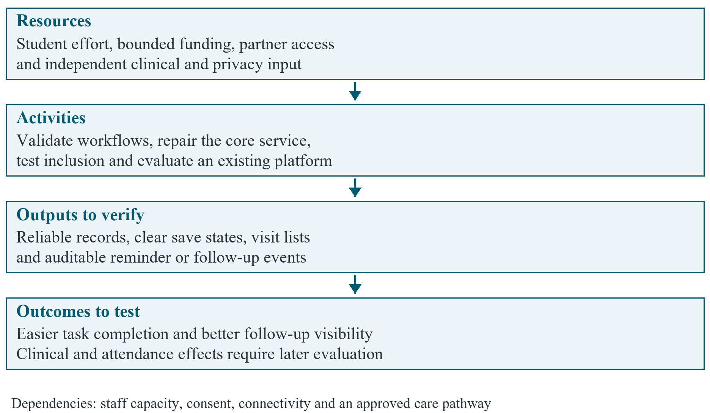
Figure 1 Proposed benefits pathway with dependencies and outcomes to be tested
The first benefits to test are operational: successful task completion, record completeness, reliable save acknowledgements and traceable follow-up actions. Better attendance or clinical outcomes would require an appropriately designed later evaluation. A twelve-person exploratory usability exercise can expose problems; it cannot establish population-level effectiveness.
Table 3 Scope outcomes and SRS traceability
Outcome | Relevant SRS requirements | Evidence expected
Authorized maternal record | FR-001 to FR-014; NFR-006, NFR-020 | Role, facility and ownership tests; stable identifiers.
Reliable visit workflow | FR-015 to FR-021; FR-035 | Persisted appointment lifecycle and follow-up states.
Truthful offline behaviour | FR-027 to FR-029; NFR-013 | Restart, retry, duplicate and conflict demonstrations.
Safe contact and messaging | FR-019, FR-030 to FR-034 | Approved wording, explicit failures and provider receipts where available.

4 Options and investment choice
Option A. Retain existing arrangements with minimal process improvement. This avoids a new software build, but any actual facility process and its cost are still unknown.
Option B. Configure an existing platform. DHIS2 Tracker supports individual longitudinal records and follow-up, while OpenMRS provides an open-source medical-record platform. Both warrant a structured fit assessment; configuration, hosting, training, integration and support still require resources [8], [9].
Option C. Extend BabyHealth Guard in stages. Reuse the current code and interface work for an academic feasibility demonstration, while repairing safeguards and validating one workflow. This is the provisional preferred option, conditional on partner fit and the comparison with Option B.
Option D. Build the entire proposed multi-channel service immediately. This would address the widest scope but carries the largest unvalidated delivery and operating burden for the student team.
Table 4 uses proposed team planning judgments on a scale of 1 to 5, where 5 is more favourable. The weighted result is the sum of each weight multiplied by its score and divided by 5. The scores are not measured platform benchmarks or agreed sponsor preferences. Safety, privacy and legal gates remain mandatory and cannot be traded away for a higher total.
Table 4 Provisional weighted option assessment
Criterion | Weight | A | B | C | D
Workflow fit | 25% | 2 | 4 | 4 | 5
Cash affordability | 20% | 5 | 3 | 4 | 1
Bounded delivery | 15% | 5 | 3 | 4 | 1
Inclusion potential | 15% | 2 | 3 | 4 | 4
Assurance maturity | 15% | 2 | 4 | 2 | 1
Team ownership and learning | 10% | 4 | 3 | 5 | 4
Weighted score out of 100 | 100% | 65 | 68 | 76 | 55

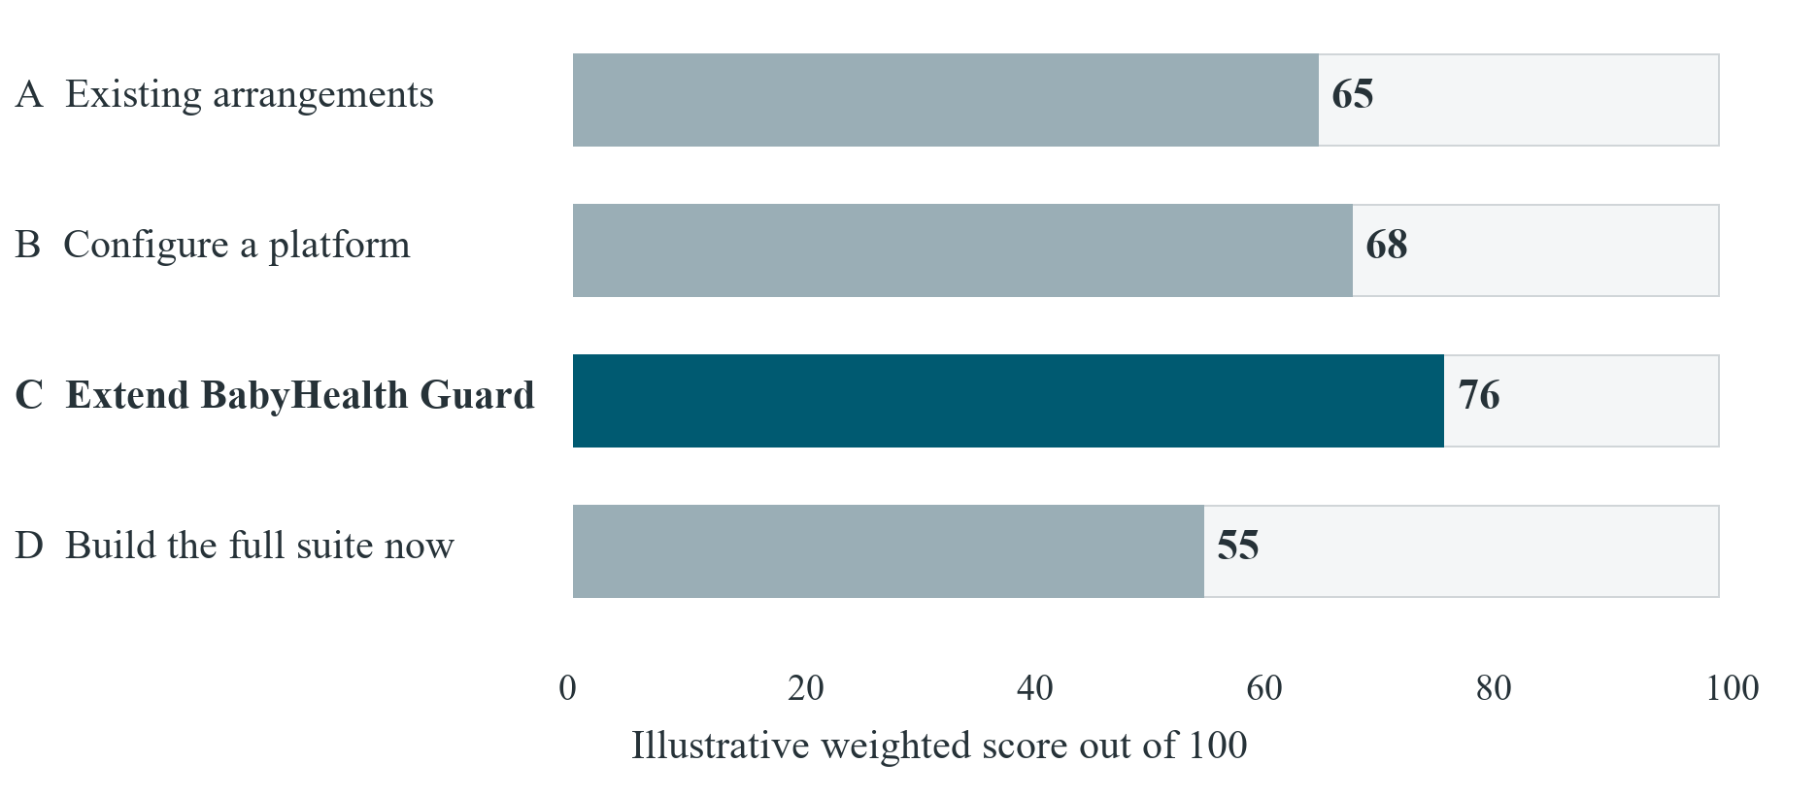
Figure 2 Illustrative option scores with independent safety and privacy gates
Option C leads this illustrative assessment because of reuse and academic ownership, while its assurance score remains low. At Gate 1, compare the critical workflow in a configured platform and the current prototype using the same task script and total-cost boundary. Select Option B if it better meets the partner need within the approved cost and support model. Stop or rescope if neither option clears the mandatory gates.
The preference is sensitive to priorities. If assurance maturity receives 35 percent, workflow fit 25 percent, and each remaining criterion 10 percent, Option B scores 72 and Option C scores 68. This reverses the ranking. Those alternative weights are also hypothetical, but they show why a facility and sponsor must agree the criteria before relying on the recommendation. No score establishes clinical safety or compliance.

5 Technical feasibility and readiness
The Java, Flutter and PostgreSQL foundation makes a bounded prototype technically plausible. The source inspection does not establish production readiness. The following findings create release conditions rather than an implementation task list for this document [1], [2].
Table 5 Observed technical gaps and required evidence
Area | Observed baseline | Required before further release
Access control | Registration accepts privileged roles; APIs lack facility and ownership enforcement. | Controlled provisioning and negative authorization tests.
Session security | JWT validation does not enforce expiry; development secrets and accounts remain configured. | Expiry and disabled-account tests; managed configuration; demo seeds restricted.
Record integrity | Appointment reconstruction changes IDs; validation and relationships are weak. | Stable-ID round trips, lifecycle tests and database constraints.
Web persistence | Demo values and successful-looking messages can mask failed or absent writes. | Server-confirmed writes and distinct failure states.
Mobile and offline | Flutter state is local; no persistent queue or backend connection is present. | Durable encrypted storage and repeatable sync/recovery tests.
External services | No operational reminder or SMS/USSD gateway is evidenced. | Provider agreement and sandbox callbacks; no unsupported live-service claims.

Keep the modular monolith initially. Separate infrastructure through configuration and adapters, add migration discipline and automate critical checks before considering service decomposition. A small system with reliable authorization, recovery and observability is the appropriate technical test. Student familiarity with each language, toolchain and hosting environment must be confirmed rather than inferred from the repository.

6 Operational and commercial feasibility
The operating model requires a participating facility to own patient identity verification, staff permissions, clinical interpretation and follow-up. The student team can develop and demonstrate software; clinical service ownership and ongoing support need separate accountable arrangements. Manual care processes must remain available during outages and evaluation.
Table 6 Stakeholders and validation questions
Stakeholder | Expected value or role | Question to resolve
Mother or caregiver | Access to approved information and contact actions. | Phone access, language, shared-device privacy and usability.
Nurse or midwife | Record capture and follow-up visibility. | Does the workflow reduce duplicate work and fit staffing?
Facility manager | Potential operating owner or buyer. | Who controls data, pays and approves change?
Institutional sponsor | Possible grant, sponsored deployment or service funding. | What evidence and procurement conditions are required?
Clinical and privacy reviewers | Independent review of content and processing. | Who can accept residual risks and oversee incidents?
Gateway and hosting providers | Contracted technical dependencies. | What are the actual fees, support terms and service limits?

Institutional subscriptions or sponsored facility access are hypotheses, not verified demand. No beneficiary should be assumed able or willing to pay. During discovery, interview a small, consented mix of prospective users and decision-makers; record current tools, purchasing authority, budget cycles and objections. Seek a written statement of workflow-review interest before describing any facility as a partner. Market sizing and sales forecasts should follow that evidence in the later business plan.

7 Legal clinical and ethical feasibility
Before collecting real health data, establish the deployment jurisdiction, responsible legal or institutional entity, controller and processor roles, lawful processing basis, newborn representation, retention, access rights and hosting arrangements. Uganda's Data Protection and Privacy Act addresses personal data, including health information, and PDPO provides registration requirements and guidance for organisations processing personal data. Obtain competent local review of the actual arrangement and applicable obligations [10], [11].
Development and demonstrations should use synthetic health records. Interviews and usability work still require appropriate consent, minimal collection and review of applicable university or research-ethics procedures. Academic status is not a substitute for those decisions. This study does not establish that registration, ethical review or institutional permission has been obtained.
A qualified clinical owner must approve education, alert thresholds, escalation wording and local contacts before activation. Contact actions must report what the device or provider actually confirms. The software must not imply diagnosis, guaranteed safety, free service or emergency dispatch. Intended-use and regulatory applicability must be reviewed before a live pilot; this assessment makes no medical-device classification.
The name, logo and student affiliation identify the academic team. They do not establish Makerere University sponsorship, endorsement, intellectual-property ownership or a service contract. The team should document ownership and licence obligations before accepting investment or committing the software to an institution.

8 Financial feasibility

8.1 Proposed stage cash requirement
All values are in Uganda shillings (UGX). Table 7 is an illustrative planning envelope, not supplier quotations, an approved budget or evidence of committed funding. Obtain written tax-inclusive quotations and revise the baseline before procurement. Paid production USSD allocation, production clinical operation, purchased handsets, full-time salaries and a commercial rollout are excluded.
Table 7 Illustrative 12-week cash budget
Cost item | Assumed basis | UGX
Local discovery travel | 6 visits x 100,000 | 600,000
Team connectivity | 4 people x 50,000 x 3 months | 600,000
Sandbox hosting | 3 months x 100,000 | 300,000
Messaging sandbox allowance | 1 lot x 250,000 | 250,000
Usability transport reimbursement | 12 people x 25,000 | 300,000
Independent reviews | 3 reviews x 300,000 | 900,000
Training and printing materials | 1 lot x 200,000 | 200,000
Test-device access | 2 access allowances x 150,000 | 300,000
Access and administration allowance | 1 lot x 150,000 | 150,000
Base cash total | Sum of planning allowances | 3,600,000
Contingency | 20% of base cash total | 720,000
Proposed cash ceiling | Subject to sponsor approval | 4,320,000

The three independent-review allowances are placeholders for clinical, privacy and technical-security input. Reviewer availability and fees are unconfirmed. The messaging allowance covers limited sandbox or test activity only; it does not purchase a dedicated production short code. If permissions, tax or provider costs exceed the ceiling, reduce scope or seek a revised decision instead of using undeclared resources.

8.2 Effort and cost uncertainty
The capacity assumption is four students contributing eight hours each per week for twelve weeks: 384 hours. At an illustrative opportunity-cost rate of UGX 15,000 per hour, the non-cash contribution is UGX 5,760,000. Adding the cash ceiling gives a resource envelope of UGX 10,080,000. The shadow rate is not a wage commitment or a market salary quotation, and team availability remains to be confirmed.
Table 8 Cash-cost sensitivity against the proposed ceiling
Base-cost movement | Resulting cash need | Position against UGX 4,320,000
No increase | 3,600,000 | 720,000 contingency remains
25% increase | 4,500,000 | 180,000 additional approval required
50% increase | 5,400,000 | 1,080,000 additional approval required

The contingency covers a 20 percent increase in the stated base allowances, not unlimited scope expansion. Schedule delays can also consume non-cash effort. A sponsor should receive a short cost and effort variance report at every gate, with unused funds and forecast completion cost stated explicitly.

8.3 Illustrative operating sustainability
For a later operating scenario, assume 100 active mothers per facility, four SMS messages per mother per month and a hypothetical SMS rate of UGX 60. Assume monthly fixed software-service costs of UGX 700,000: hosting and backup 300,000, part-time maintenance and support 300,000, and coordination 100,000. A hypothetical facility fee of UGX 300,000 is used solely to test the arithmetic. Neither that fee nor willingness to pay is validated.
Table 9 Unvalidated monthly operating scenarios in UGX
Scenario | Facilities | Fee per facility | Fixed cost | SMS cost | Balance
Base | 3 | 300,000 | 700,000 | 72,000 | 128,000
Stress | 3 | 200,000 | 700,000 | 144,000 | -244,000
Expansion | 6 | 300,000 | 1,100,000 | 144,000 | 556,000

In the base scenario, monthly revenue is UGX 900,000 and modelled cost is UGX 772,000, leaving UGX 128,000 before omitted costs. Variable SMS cost is UGX 240 per active mother. Contribution per facility is 300,000 - (100 x 4 x 60) = UGX 276,000; the break-even count is the ceiling of 700,000 / 276,000, or three facilities. The stress case needs five facilities at its assumed rates. The expansion case increases fixed costs to acknowledge additional support needs.
These balances are not profit forecasts. The model excludes recovery of development costs, full-time professional staff, taxes, depreciation, a dedicated production USSD service and clinical-service costs. At the base volume, modelled software cost is approximately UGX 2,573 per active mother per month. Validate the cost boundary, support workload, inclusive access and buyer demand before using this scenario to set prices or claim sustainability. NPV, payback and monetized clinical returns are deferred until cash-flow and outcome assumptions are supportable.

9 Delivery governance and scalability
The twelve-week schedule is a proposed capacity test for a narrow workflow, not a delivery promise. The project team should nominate a delivery lead and finance custodian, maintain a shared backlog and decision log, and agree academic review dates with the lecturer. A prospective sponsor must appoint the person able to approve each funding release. Clinical and privacy responsibilities require qualified external owners [4].
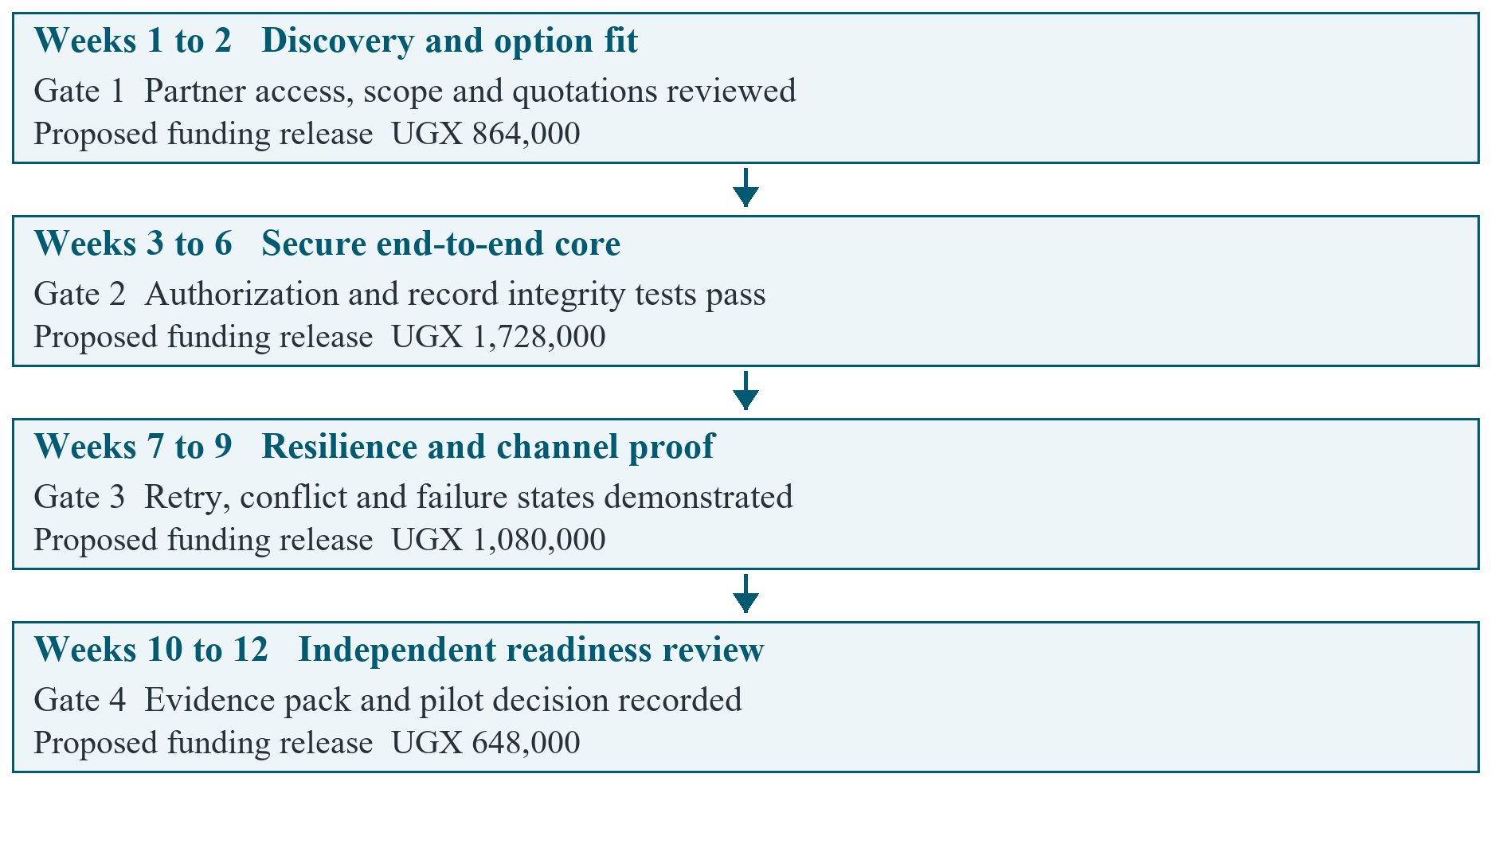
Figure 3 Proposed 12-week stage gates and conditional funding releases
Table 10 Gate evidence and decisions
Gate | Minimum evidence | Decision and funding condition
1 | End of week 2 | Partner workflow-review interest; platform fit comparison; quotations; confirmed student capacity. | Choose B or C and approve scope; otherwise pause or agree an academic-only rescope.
2 | End of week 6 | Authenticated end-to-end synthetic workflow; authorization, expiry, validation and stable-ID tests. | Release resilience work only after critical failures are resolved.
3 | End of week 9 | Offline restart/retry/conflict results; truthful error states; provider sandbox proof or documented deferral. | Approve the bounded assurance package; rebaseline any excluded channel.
4 | End of week 12 | Independent findings, usability results, recovery evidence, actual costs and named operating owners. | Approve, defer, pivot or stop a separately costed pilot. No automatic clinical launch.

The proposed releases are UGX 864,000, 1,728,000, 1,080,000 and 648,000 respectively. Each is a conditional maximum within the cash ceiling, not a payment already authorized. The last release supports the final assurance work after Gate 3; Gate 4 records whether a new pilot proposal is justified.
Scalability should be demonstrated in stages: one approved workflow, one facility evaluation, then a separately governed multi-facility cohort. Keep facility boundaries testable, measure database growth, queue age, provider failure rates, support effort and cost per active mother. The SRS targets for 100 concurrent users and 10,000 active profiles remain proposed acceptance targets, not achieved capacity [1]. Expand only after load, recovery and access-isolation evidence supports the next scale and an operator can sustain it.

10 Principal risks and controls
Ratings are initial planning judgments, not quantified failure probabilities. The named roles below are proposed responsibilities and require appointment. A serious safety or privacy concern can stop progression regardless of budget or option score.
Table 11 Initial feasibility risk register
ID and rating | Risk | Control and stop trigger | Proposed owner
R1 | High | Unauthorized access or wrong-patient data. | Synthetic data until isolation, identity and integrity tests pass; critical failure stops release. | Technical lead and independent reviewer
R2 | High | Misleading clinical reassurance or contact claims. | Clinical owner approves messages; remove unsupported success and free-service claims. | Clinical owner to be appointed
R3 | High | No willing facility or authorized buyer. | Secure workflow-review interest and validate purchasing authority; pause at Gate 1 if unavailable. | Delivery lead and prospective sponsor
R4 | High | Gateway cost, allocation or delivery constraints. | Obtain written provider terms; use receipts and failure states; defer unsupported live channels. | Integration lead to be nominated
R5 | High | Insufficient student time or unquoted costs. | Confirm hours, track actuals and forecast spend; rescope before the ceiling is breached. | Delivery lead and finance custodian
R6 | High | Unlawful processing or inadequate incident ownership. | Confirm data roles, permissions, retention and hosting before real-data work. | Privacy owner to be appointed
R7 | Medium | Low literacy, shared phones, weak power or connectivity. | Test local-language and assisted workflows; retain non-digital care access. | Facility representative and UX lead
R8 | Medium | Support and infrastructure fail to scale. | Measure cohort costs, restore tests and support queues before expansion. | Operating owner to be appointed

11 Validation and funding decision

11.1 Evidence required from the next stage
Benefits need baselines, denominators and accountable reviewers. Table 12 proposes a small initial evaluation; its targets require agreement with a partner. No benefit in this table is represented as already achieved.
Table 12 Proposed validation measures
Measure | Method and proposed target | Interpretation
Critical task completion | At least 90% of eligible role-specific tasks completed without assistance in exploratory testing. | Small-sample usability evidence, not population effectiveness.
Record completeness | At least 95% of required fields complete in the agreed synthetic task set. | Validate required fields with the clinical owner first.
Access and record integrity | All agreed negative-access and ID/lifecycle test cases pass. | Any critical failure blocks progression.
Offline recovery | All accepted records in a 50-entry synthetic retry set survive restart and sync once; conflicts remain visible. | Demonstrates the specified test set only.
Operational effort | Measure staff task time and follow-up visibility against the observed current process. | Set improvement targets after a local baseline exists.
Cost and commercial fit | Tax-inclusive quotations, actual effort and buyer feedback recorded against the ceiling and scenarios. | No revenue or savings claim without supporting evidence.

Attendance, newborn outcomes and maternal outcomes are later evaluation questions. A subsequent pilot plan must define its design, comparator where appropriate, sample, approvals and limits. Do not extrapolate national indicators or a short usability exercise into claims that the product reduces mortality.

11.2 Investment decision rule
Approve discovery only when the academic team confirms capacity, a sponsor accepts the bounded budget and appropriate participant-data handling is arranged. Progress to implementation only after Gate 1 validates a genuine workflow need and records the build-versus-configure decision. A live pilot needs a separate approval, qualified clinical and privacy ownership, lawful processing arrangements and passing release evidence.
Pivot to an existing platform where fit and total cost are better. Pause if no facility is available, key assumptions remain unsupported, critical defects persist or forecast cash exceeds the ceiling without approval. Stop real-data activity if lawful or safe operation cannot be established. This preserves the academic learning value while keeping a prospective funder's exposure bounded.

11.3 Priority assumption register
Table 13 Assumptions that must be validated
ID | Current planning assumption | Required validation and timing
A1 | Four students can supply 384 hours over twelve weeks. | Each member confirms availability before schedule approval.
A2 | Stage cash fits within UGX 4,320,000. | Tax-inclusive written quotations and access costs at Gate 1.
A3 | A facility has a need and will review the workflow. | Consented discovery and written interest at Gate 1.
A4 | Monthly facility fee of UGX 300,000 is viable. | Buyer authority and willingness-to-pay evidence before pricing.
A5 | Four SMS messages at UGX 60 each are an adequate cost basis. | Approved reminder design and provider terms before a pilot budget.
A6 | Fixed monthly software costs begin at UGX 700,000. | Hosting, support-hour and tax estimates before commercial use.
A7 | Clinical, privacy and operating owners can be appointed. | Named reviewers and responsibilities before real-data or live-care work.

12 References
[1] BabyHealth Guard project team, Software Requirements Specification, BHG-SRS-001, ver. 1.1, Makerere University student project, Nov. 11, 2026. Repository file: documentation/SRS.docx.
[2] BabyHealth Guard project team, "BabyHealth-Guard source code," repository snapshot, Git commit 951c4fe, Nov. 11, 2026. Inspected paths include backend/src, frontend/index.html and mobile/lib.
[3] World Health Organization, Digital Implementation Investment Guide Integrating Digital Interventions into Health Programmes, Geneva, Switzerland: WHO, 2020. Accessed: Nov. 11, 2026. [Online]. Available:
https:/​/​www.who.int/​publications/​i/​item/​9789240010567
[4] Project, programme and portfolio management - Guidance on project management, ISO 21502:2020, Dec. 2020.
[5] Uganda Bureau of Statistics, National Priority Gender Equality Indicators Illuminating the Path Towards Gender Equality in Uganda, 3rd ed., Kampala, Uganda: UBOS, 2025, sec. 6.13, fig. 6.13. Accessed: Nov. 11, 2026. [Online]. Available:
https:/​/​www.ubos.org/​wp-​content/​uploads/​publications/​03_​2026the_​national_​priority_​gender_​equality_​indicators_​third_​edition_​2025_​1.pdf
[6] Uganda Communications Commission, "New communications sector report highlights efforts to bridge access and usage gaps," Dec. 15, 2025. Accessed: Nov. 11, 2026. [Online]. Available:
https:/​/​www.ucc.co.ug/​new-​communications-​sector-​report-​highlights-​efforts-​to-​bridge-​access-​and-​usage-​gaps/​
[7] World Health Organization, WHO Guideline Recommendations on Digital Interventions for Health System Strengthening, Geneva, Switzerland: WHO, 2019. Accessed: Nov. 11, 2026. [Online]. Available:
https:/​/​www.who.int/​publications/​i/​item/​9789241550505
[8] DHIS2, "Individual data records with Tracker and Event programs." Accessed: Nov. 11, 2026. [Online]. Available:
https:/​/​dhis2.org/​tracker/​
[9] OpenMRS, "OpenMRS product." Accessed: Nov. 11, 2026. [Online]. Available:
https:/​/​openmrs.org/​product/​
[10] Republic of Uganda, Data Protection and Privacy Act, Cap. 97, originally Act No. 9 of 2019, consolidated Dec. 31, 2023. Accessed: Nov. 11, 2026. [Online]. Available:
https:/​/​ulii.org/​en/​akn/​ug/​act/​2019/​9/​eng%402023-​12-​31
[11] Personal Data Protection Office, "Registration classification and guidance notes," Knowledge Center, 2026. Accessed: Nov. 11, 2026. [Online]. Available:
https:/​/​pdpo.go.ug/​knowledge-​center

