MAKERERE  P.O. Box 7062, Kampala, Uganda  https://mak.ac.ug |  | UNIVERSITY  Telephone: +256-414-534560/1-9  E-mail: cs@cis.mak.ac.ug
COLLEGE OF COMPUTING AND INFORMATION SCIENCES
School of Computing and Informatics Technology
Department of Computer Science

Business and Sustainability Plan
BabyHealth Guard
Digital Maternal and Newborn Health Monitoring System
GROUP 2
PROJECT TEAM
No. | Name | Registration No. | Phone No. | Email
1 | Keith Paul Kato | 24/U/26593/EVE | 0759021371 | keithpaulkato@gmail.com
2 | Elizabeth Ageno | 24/U/25850/PS | 0778501066 | eageno075@gmail.com
3 | Joanita Kewoda | 24/U/05727/EVE | 0748149321 | Kewodajoanita02@gmail.com
4 | Mathias Atugonza | 24/U/0273 | 076253273 | Atumathias20@gmail.com
Course unit: ENTREPRENEURSHIP PRINCIPLES
Course code: C0E2105
Lecturer: Dr. Margaret Nagovuma
Partner organisation or health facility: To be selected
November 2026

Document control
Table 1 Document identification
Item | Record
Document ID and version | BHG-BSP-001 | Version 1.0 | 11 November 2026
Prepared by | Makerere University Computer Science students, Group 2
Intended readers | Course lecturer, prospective facility reviewers and potential funders
Status | Proposed plan; facility, commercial operator and sponsor remain to be selected

Executive plan
We propose to develop BabyHealth Guard as a supported maternal and newborn health software service for a selected health facility, with possible institutional sponsorship. Our immediate objective is to validate one useful workflow and a credible payer before committing to commercial operation. The SRS defines the intended system; the Business Case and Feasibility Study identifies readiness gaps and makes further investment conditional on evidence [1], [2].
Proposed offer. Help authorized facility staff manage maternal records, appointment status and follow-up visibility, while mothers access approved information and contact routes. The initial service would cover a narrow workflow with clear save and failure states. Offline recovery and messaging must be demonstrated before they are sold as working capabilities.
Funding position. Retain the feasibility study's proposed UGX 4,320,000 cash ceiling for the first twelve weeks. A separate, conditional operating illustration requires UGX 3,616,000 to cover its peak collection deficit and a protected reserve. The combined UGX 7,936,000 is a planning envelope, not a single immediate funding request or evidence that any money has been pledged.
At a hypothetical monthly fee of UGX 300,000 per facility, the first-year operating illustration produces UGX 7,500,000 in invoices but only UGX 6,000,000 in collections because of a one-month delay. Its limited software costs are UGX 7,400,000. It therefore does not establish commercial self-sufficiency. Prices, support effort, tax treatment and all material operating costs must be validated before a service contract is offered.

1 Venture status and planning basis
We are an academic team of four Makerere University Computer Science students taking ENTREPRENEURSHIP PRINCIPLES, C0E2105. No health facility has been specified. This plan does not assert incorporation, a business bank account, ownership of all intellectual property, confirmed interviews, paying customers, supplier quotations or clinical approval. University affiliation identifies the team; it does not establish university endorsement, funding or a service guarantee.
The planning approach combines WHO guidance on needs-based, costed digital health implementation with conventional business-plan coverage of customers, delivery, funding and financial assumptions. The SBA source is used as general planning guidance; its United States business forms and financing programmes are not presented as Ugandan requirements or available funding [3], [4]. The document is tailored to the project and makes no certification claim.
Verified project facts come from the SRS and feasibility study. Proposed actions use future or conditional language. Every price, facility count, collection period, support allowance and growth path in this plan is an unvalidated planning assumption. Months are relative to approval of the plan, rather than promised calendar dates. External guidance was checked on 11 November 2026.

2 Customer need and proposed service

2.1 Customer and beneficiary distinction
Our initial customer hypothesis is a facility or health programme with a demonstrable problem coordinating maternal records, visits and follow-up. The person using a screen, the person benefiting from care and the person approving expenditure may be different. A facility manager or institutional sponsor could be the buyer; nurses and midwives would be operational users; mothers and caregivers would be beneficiaries and users of selected functions. Discovery must identify the actual authority to buy and the budget available.
The problem to test is avoidable coordination work caused by fragmented records and unclear follow-up status. We must observe the current process before claiming that software improves it. A facility already using an effective electronic system may need configuration or integration rather than another product. National health need alone does not prove a market for this particular service.

2.2 Initial service boundary
The first offer should include only an agreed, tested maternal workflow, named user roles, training, limited support and verifiable service reporting. Future newborn modules, additional channels or wider deployment should follow validated needs. Production USSD allocation, autonomous diagnosis, guaranteed emergency response and nationwide operation are outside the initial commercial offer. The current prototype is not yet a production clinical service [1], [2].
The hypothesized value for staff is less duplicate work and clearer follow-up lists; for mothers, more understandable access to approved information; for a buyer, accountable service costs and operational evidence. We will test task completion and record completeness before making stronger claims. No reduction in mortality, hospitalization or missed visits is claimed as an achieved project result.
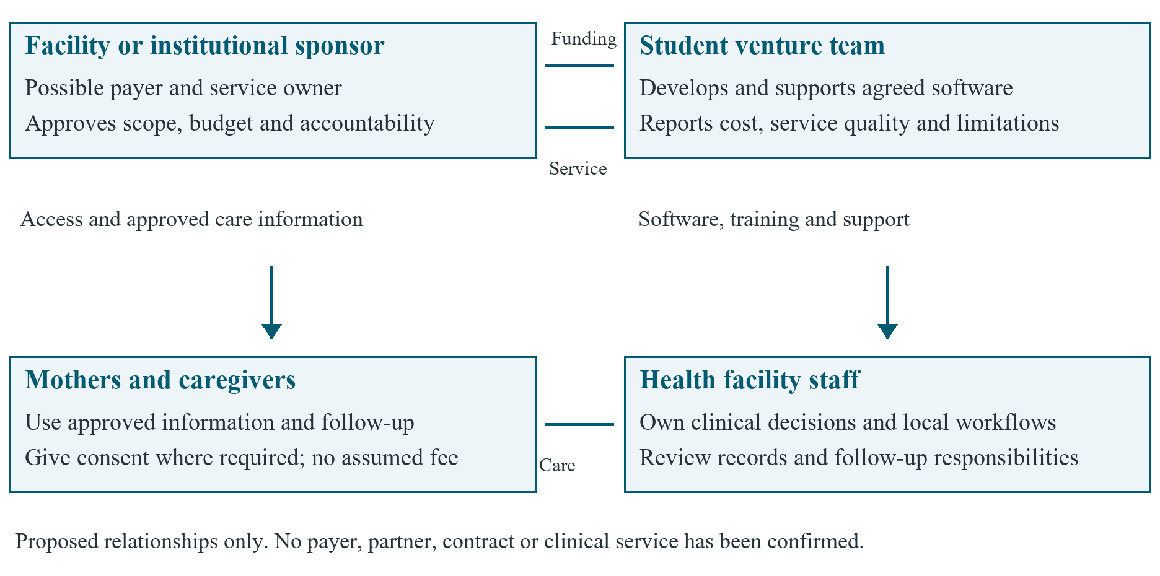
Figure 1 Proposed value and funding relationships

3 Business model and value capture
The proposed model combines grant-supported validation with a later institutional service fee or sponsored facility contract. A sponsor could pay for a defined facility cohort when facilities cannot fund the service directly. The same covered service must not be billed to both parties. Mothers are not assumed willing or able to pay, and selling identifiable health data or advertising against patient profiles is excluded from the proposed model.
Table 2 adapts the nine areas of the Business Model Canvas into decisions for this project. It is a working model, not evidence of customer acceptance or an established company [5].
Table 2 Business model decisions requiring validation
Area | Proposed position
Customer segments | Begin with one suitable facility; distinguish its buyer from clinical users and beneficiaries.
Value proposition | Make one maternal record and follow-up workflow easier to use and verify.
Channels | Permission-based introductions, a synthetic-data demonstration and a written evaluation proposal.
Customer relationships | Named facility champion, training, an agreed support channel and periodic service reviews.
Revenue streams | A facility subscription or a sponsor contract after validation; grants for defined development work.
Key resources | Student time, tested software, secure infrastructure and qualified external review.
Key activities | Workflow research, safe delivery, onboarding, maintenance and evidence reporting.
Key partners | Prospective facility, clinical and privacy reviewers, hosting and messaging providers. None appointed.
Cost structure | Development, hosting, support, messaging, onboarding, governance and eventual professional staffing.

A service agreement should identify the paid scope, active facilities, message allowance, support hours, exclusions, renewal date and exit arrangements. Additional messaging or integration work should require a written price and scope change. Initial grants should buy documented learning and readiness evidence; recurring service income should cover agreed operating obligations. These funding streams must be recorded separately.

4 Market evidence and alternatives

4.1 Initial market selection and sizing
Uganda is the initial planning context. No district, ownership category or facility size has been selected. We should first identify a reachable facility with relevant maternal services, an accountable clinical lead, a manager willing to review the workflow and realistic access conditions. A discovery list is not a customer pipeline until permission and eligibility are confirmed.
We cannot yet state a defensible total addressable market, serviceable market or market share. Build these estimates from a dated official facility register, the selected geography, verified service eligibility and current tools. The serviceable market must exclude facilities without fit, buying authority or support coverage. The obtainable market must also respect team capacity. Five year-end facilities in the financial illustration is an assumption, not a measured market opportunity.
Table 3 Proposed discovery evidence
Question | Method and initial target | Decision use
Is the problem real? | Observe one consented workflow and interview a small mix of users and managers. | Record existing task time, duplication and follow-up gaps.
Who can buy? | Speak to at least two people with actual budget or procurement responsibilities. | Identify approval steps, budget cycle and contracting entity.
Does the offer fit? | Run a common synthetic task script with at least six staff or managers. | Compare current practice, a configured platform and our prototype.
Can beneficiaries use it? | Include at least six mothers or caregivers in approved exploratory work. | Test language, shared-phone privacy and assisted access.
What will it cost? | Obtain written hosting, messaging and review quotations. | Replace allowances and define tax and service limits.
Will someone pay? | Present a written scope and price range to an authorized buyer. | Seek a conditional written evaluation agreement; distinguish interest from purchase.

These small targets are proposed discovery activities, not completed research or statistically representative samples. Participant recruitment and data collection need appropriate consent and institutional review. Record refusals and objections as well as positive feedback. If no facility or payer validates the need, revise the scope before further development expenditure.

4.2 Competitive position
DHIS2 Tracker supports individual, longitudinal data and follow-up. OpenMRS is an open-source electronic medical-record platform with configurable facility workflows. Both deserve a fair fit and total-cost comparison; public product descriptions do not demonstrate that either is already suitable for our prospective partner [6], [7].
Table 4 Alternatives and evidence needed
Alternative | Potential advantage | Test before choosing
Improve current processes | Avoids a new system and reduces transition work. | Can simpler changes resolve the actual coordination problem?
Configure an existing platform | Reuses a maintained platform and wider ecosystem. | Compare task fit, hosting, training, integration and ongoing support.
Extend BabyHealth Guard | Reuses student work and permits a narrow local workflow. | Demonstrate safety controls, persistence, usability and affordable support.
Develop a broad custom suite | Offers extensive customization in principle. | Establish a funded team, validated demand and full lifecycle costs first.

Our proposed differentiation is attentive implementation of a validated local workflow, including clear failure states and practical support. It is not an established technical advantage. Reuse or configure an existing platform if it offers better fit and sustainable cost. A configuration or integration service could remain a viable business direction even if a standalone product is not justified.

5 Customer acquisition and retention
We should start with permission-based introductions to facility managers and health-programme staff, including appropriate academic referral routes. Outreach should offer a short workflow discussion and a synthetic-data demonstration. It should not promise clinical benefits or imply university or government endorsement. No outreach, partnership negotiation or external message has been carried out as part of preparing this document.
The proposed acquisition sequence is to screen fit, confirm a champion and buyer, demonstrate the agreed task, scope a time-limited evaluation, then negotiate paid terms only after readiness evidence passes. For an initial learning cycle, use a capacity target of ten eligible prospects, four discovery meetings, two demonstrations and one possible evaluation. These are workload assumptions; conversion to a paid agreement may be zero.
An evaluation agreement should state the responsible parties, duration, approved data, success measures, support limits, costs and exit decision. Interest letters and unpaid evaluations are not recurring revenue. Count a contracted facility separately from an invoiced or paid facility. The hypothetical five-facility year-end path requires repeated validated acquisition cycles and cannot be inferred from one demonstration.
Retention should depend on reliable service and measured value. Train a facility champion and a backup, review unresolved support issues, verify invoice collection and discuss renewal before the agreed end date. Track paid renewals, voluntary departures and reasons for non-renewal. Additional sales should pause when the team cannot meet its current support commitments.

6 Operations and accountability

6.1 Team structure and governance
The four named students remain the project team shown on the cover. Roles below are proposed responsibilities to allocate by agreement, rather than claims about members' qualifications or appointments. The lecturer provides academic oversight as part of the course; this does not make the lecturer a commercial sponsor, clinical owner or investment approver.
Table 5 Proposed operational responsibilities
Role | Accountability | Evidence before operation
Business and delivery lead | Coordinate scope, buyer discussions and the delivery backlog. | Named lead, documented decisions and available time.
Engineering and assurance lead | Coordinate security, integrity, recovery and release evidence. | Independent review of critical controls; no self-certification.
Finance and administration custodian | Maintain quotations, receipts, invoices and cash forecasts. | Separate review of expenditure and reconciled records.
User research and support lead | Manage consented research, training and support records. | Approved research method and agreed service hours.
External clinical and privacy owners | Approve clinical content, data roles and response duties. | Qualified named owners and written arrangements.

Before contracting, document ownership of code and other assets, contributor permissions, third-party licences, university obligations and the entity authorized to receive funds. Incorporation or a fiscal-host arrangement should follow competent local advice and the intended contract. No founder equity split, valuation or investor return is assumed in this plan.

6.2 Service delivery and data stewardship
A facility onboarding checklist should cover role permissions, data separation, approved clinical wording, staff training, recovery tests and a handover rehearsal. Demonstrations should use synthetic health records. Any later real-data use needs a defined lawful basis, retention policy, access arrangements and allocation of controller and processor responsibilities. PDPO provides registration and compliance guidance; the responsible parties must check and meet the obligations applying to the actual arrangement [8].
Commercial support must have agreed hours, escalation contacts and response priorities. The students should not sell 24-hour support or clinical emergency response without a funded service capable of providing it. Facility staff retain responsibility for care decisions and non-digital fallback arrangements. Technical incidents affecting privacy or record integrity should suspend the affected function until an accountable owner approves recovery.
The operating budget must eventually include monitored hosting, backups, restoration exercises, patching, access review, provider failures and support time. The current illustrative allowances do not prove that all of these can be delivered at the proposed price. Keep service credentials and operational ownership with an accountable entity so that a graduating student is not the sole point of continuity.

7 Pricing and financial sustainability

7.1 Model boundaries and inputs
All values are in Uganda shillings (UGX). The feasibility stage retains the earlier UGX 3,600,000 base and UGX 720,000 contingency. Its 384 student hours cover twelve weeks and have an illustrative non-cash value of UGX 5,760,000 [2]. Later support requires a separate staffing commitment. The operating scenario begins only if readiness and institutional permissions permit it. Month 4 is a modelling assumption, not a release commitment.
Table 6 Unvalidated operating assumptions
Driver | Assumed value or treatment
Monthly facility fee | UGX 300,000; buyer willingness and tax treatment unconfirmed.
Usage per facility | 100 active mothers and four SMS messages per mother per month.
SMS price | UGX 60 per message; no provider quotation supplied.
Monthly fixed software costs | UGX 700,000: hosting and backup 300,000; limited support 300,000; coordination 100,000.
Onboarding cash cost | UGX 100,000 per new facility, added to the feasibility study's recurring model.
Collection timing | Full payment one month after invoicing; no bad debt in the base illustration.
Year 1 facility path | Months 4 to 12: 1, 1, 2, 2, 3, 3, 4, 4 and 5; zero facilities in Months 1 to 3.
Protected operating reserve | UGX 1,400,000, equal to two assumed months of fixed software costs.

The proposed fee is a hypothesis to test through a written offer. The assumed SMS allowance costs UGX 24,000 per facility per month, leaving UGX 276,000 toward fixed costs before onboarding and omitted expenses. The earlier three-facility break-even result applies only to its limited recurring software model. It is not a commercial break-even claim for a fully staffed health service.

7.2 First year invoices and cash collection
One facility-month means one facility receiving the defined service for one month. The nine-month path contains 25 facility-months and five onboarding events. Table 7 shows the timing effect before operating funding. Operating cash cost includes the fixed allowance, SMS and onboarding. Parentheses indicate a cumulative cash deficit.
Table 7 Conditional operating cash illustration in UGX
Month | Facilities | Invoiced | Collected | Cash cost | Cumulative
4 | 1 | 300,000 | 0 | 824,000 | (824,000)
5 | 1 | 300,000 | 300,000 | 724,000 | (1,248,000)
6 | 2 | 600,000 | 300,000 | 848,000 | (1,796,000)
7 | 2 | 600,000 | 600,000 | 748,000 | (1,944,000)
8 | 3 | 900,000 | 600,000 | 872,000 | (2,216,000)
9 | 3 | 900,000 | 900,000 | 772,000 | (2,088,000)
10 | 4 | 1,200,000 | 900,000 | 896,000 | (2,084,000)
11 | 4 | 1,200,000 | 1,200,000 | 796,000 | (1,680,000)
12 | 5 | 1,500,000 | 1,200,000 | 920,000 | (1,400,000)
Total | 25 facility-months | 7,500,000 | 6,000,000 | 7,400,000 | (1,400,000)

The operating illustration generates an invoiced balance of UGX 100,000 before omitted costs, but a cash deficit of UGX 1,400,000 by Month 12. Its outstanding final invoice is UGX 1,500,000. The deepest cumulative deficit is UGX 2,216,000 in Month 8. Funding only the year-end deficit would therefore leave an earlier cash shortfall.
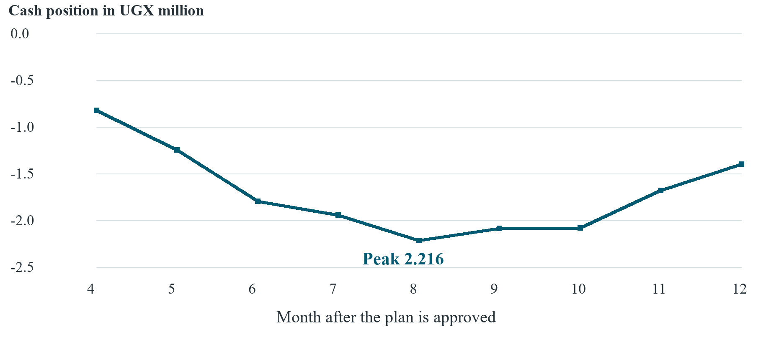
Figure 2 Cumulative operating cash deficit before bridge funding
A conditional operating bridge of UGX 3,616,000 comprises that peak deficit plus the protected UGX 1,400,000 reserve. Keep the feasibility contingency separate. If the full stage and bridge amounts were funded before the relevant outflows, and all modelled collections occurred, year-end cash would be UGX 2,936,000. This includes UGX 720,000 unspent stage contingency, UGX 1,400,000 reserve and UGX 816,000 unused bridge capacity. These are conditional balances, not earned profit or available dividends.

7.3 Growth and cost sensitivities
Table 8 tests arithmetic over three years without assigning a probability to growth. Year 2 assumes 96 facility-months, ten facilities at year end and five new onboardings; Year 3 assumes 144 facility-months, fourteen at year end and four new onboardings. The monthly fee and SMS usage stay unchanged. Fixed software allowances rise to UGX 1,100,000 and UGX 1,700,000 respectively. Capacity, demand and these cost levels are unverified.
Table 8 Conditional three year illustration in UGX
Measure | Year 1 | Year 2 | Year 3
Facility-months | 25 | 96 | 144
Invoices issued | 7,500,000 | 28,800,000 | 43,200,000
Cash collected with one-month lag | 6,000,000 | 27,300,000 | 42,000,000
Limited software operating cash costs | 7,400,000 | 16,004,000 | 24,256,000
Invoiced operating balance | 100,000 | 12,796,000 | 18,944,000
Feasibility base cash cost | 3,600,000 | 0 | 0
Modelled balance after stage base cost | (3,500,000) | 12,796,000 | 18,944,000

The three-year balances omit full professional staffing, clinical-service payroll, taxes, bad debt, depreciation, financing costs, dedicated production USSD allocation and recovery of student development effort. They are neither audited accounts nor profit forecasts. A statutory balance sheet, valuation or discounted investment return would imply precision that the available evidence does not support.
Under a stress case with the same facility path, a fee of UGX 200,000 and SMS at UGX 120, Year 1 invoices fall to UGX 5,000,000 and operating cash costs rise to UGX 8,000,000. The invoiced operating loss is UGX 3,000,000 before the feasibility stage and other omitted costs. With the same collection delay, receipts are UGX 4,000,000 and the operating cash gap is UGX 4,000,000. The base bridge must be recalculated if these conditions become credible.
A separate staffing sensitivity adds UGX 3,000,000 per month for professional capacity in Year 2. It changes the illustrative UGX 12,796,000 operating balance to a UGX 23,204,000 deficit. At eight average facilities, fixed software and that added staff allowance alone imply a monthly floor of UGX 536,500 per facility including SMS, before onboarding and other omitted costs. Sustainable paid operation therefore requires a validated price, a funded staffing model or demonstrably greater support capacity; a small positive software balance is insufficient.
Payment in advance could reduce the collection gap, but it requires a buyer willing and able to agree. Longer payment terms, churn or unpaid invoices increase funding exposure. Review actual cash weekly during evaluation, reforecast monthly and do not use ring-fenced funds to conceal a recurring operating loss.

8 Funding strategy and financial controls
We propose milestone-based non-dilutive support for initial validation, followed by a separately approved operating bridge only if a partner and service model are credible. Possible sources include an academic innovation grant, a health-programme sponsor or an institution purchasing a defined evaluation. These are categories to research, not identified open calls, eligibility findings or promises of funding. Debt or equity terms are not proposed before ownership, contracting authority and repayment or return evidence exist.
Table 9 Staged funding and release conditions
Purpose | Proposed ceiling | Release evidence
Feasibility stage base | UGX 3,600,000 | Discovery, quotations, controls and stage evidence specified in the feasibility study.
Stage contingency | UGX 720,000 | Documented eligible variance; prior sponsor approval and separate tracking.
Operating cash gap cover | UGX 2,216,000 | Readiness approval, signed payer terms and a revised monthly cash forecast.
Protected operating reserve | UGX 1,400,000 | Funded before service commitments; replenishment and access rules agreed.
Combined conditional envelope | UGX 7,936,000 | Not an immediate single request; reconcile actual need before each release.

The feasibility stage remains subject to its earlier four proposed releases of UGX 864,000, 1,728,000, 1,080,000 and 648,000; the base and contingency rows above show their funding purpose, not a second request [2]. The later operating amounts are new conditional planning needs. They must not be represented as approved pilot funding or as covering all costs of clinical operation.
For each funding application, attach the current scope, budget basis, evidence of buyer interest, ownership position, risk disclosures and named reporting responsibilities. Specify whether the funder buys development, evaluation or service delivery. Record restrictions, reporting dates, assets bought and treatment of unspent funds. Grant income should not be counted as customer revenue when assessing recurring sustainability.
Keep a transaction record with date, purpose, approved budget line, supporting receipt and reviewer. The finance custodian should prepare monthly reconciliations, cash forecasts and variance reports for a second team reviewer and the authorized sponsor. Report conflicts of interest and related-party purchases. No member should promise expenditure or contracts beyond delegated authority.

9 Sustainability and responsible exit
Financial sustainability means that collected service income or explicitly committed sponsorship can support the complete agreed cost boundary. Before renewal, include actual support hours, compliance, replacement equipment, provider charges and professional staffing. Separate subsidized evaluation from a service that can support itself. If a sponsor remains necessary, specify its duration and a credible renewal or exit decision.
Operational sustainability requires documented onboarding, repeatable releases, recoverable data, a second maintainer and a named facility champion. Graduation and examination periods are predictable capacity constraints. Assign handover duties and secure administrative access before a student leaves. Expansion should follow measured support capacity and restore tests, with the SRS capacity targets treated as unproven until tested [1].
Inclusion is part of the service design. Test language, literacy, disability access, shared-phone privacy, power and connectivity with intended users. A basic-phone or assisted option should be offered only when its delivery, cost and privacy are verified. Preserve access to the facility's ordinary care process when a person declines digital participation or when the software is unavailable.
A planned exit should identify who informs users, maintains care continuity, exports permitted records, revokes credentials and completes retention or deletion obligations. Define an agreed export format and test it before relying on portability as a sales promise. The responsible institution should confirm receipt and ownership of any operational handover. If no accountable operator can sustain the service, stop new enrolments and arrange a controlled transition rather than leaving an unsupported system running.

10 Business milestones and decision gates
Figure 3 shows a conditional twelve-month path. Months 1 to 3 contain the existing feasibility stage; the later periods illustrate what might follow after approval. No partner recruitment, paid conversion or clinical activation date is committed. Rebaseline the plan when the academic calendar, partner review or supplier terms change.
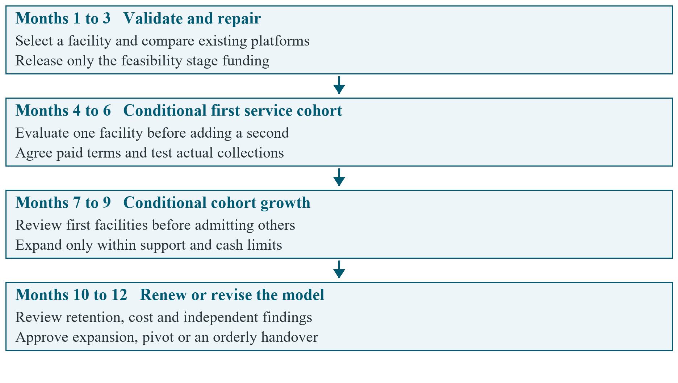
Figure 3 Conditional business milestones for the first twelve months
At the end of the feasibility stage, decide whether to continue with BabyHealth Guard, configure an existing platform, narrow the project to academic work or stop the venture. A pilot needs its own costed scope and permissions. Paid expansion needs an authorized buyer, a fully costed service agreement, a funded reserve and passing assurance evidence. Forecast facility counts alone must never trigger expansion.

11 Business risks and evidence for renewal
Table 10 Principal business risks
Risk | Control and decision trigger | Proposed owner
No validated buyer or budget | Stop expansion spending if discovery cannot identify authority and credible funding. | Business lead
Clinical or privacy harm | Use synthetic data initially; suspend affected live functions after a serious concern. | Clinical and privacy owners
Support cost exceeds price | Record hours and full costs; revise price, subsidy or scope before renewal. | Delivery and finance leads
Late or failed collection | Track aged invoices and forecast cash; pause new commitments before the reserve is threatened. | Finance custodian
Dependence on one student or supplier | Maintain a backup owner, documented handover and tested recovery route. | Engineering lead
Duplicate tools or poor workflow fit | Compare configuration alternatives using the same tasks and total-cost boundary. | Facility champion and business lead

Table 11 defines an initial review scorecard. Targets are proposals to agree with a partner, not results already achieved. Use aggregate or appropriately de-identified reporting for business review; identifiable health records should not be copied into funding reports.
Table 11 Proposed commercial and sustainability scorecard
Measure | Definition and initial decision use
Buyer validation | A named authorized buyer, documented budget route and written conditional terms before paid commitments.
Usability and integrity | Use the feasibility study's agreed synthetic task and critical-control measures; any critical failure blocks release.
Collection performance | Separate invoices from receipts; investigate any invoice overdue beyond the agreed terms.
Support effort | Record hours per facility and compare actual cost with the service allowance every month.
Cash protection | Reforecast weekly cash; approve no new commitment that would use the protected reserve without a recovery decision.
Retention | Report paid renewals divided by facilities eligible to renew, with departures and reasons disclosed.
Continuity and inclusion | Demonstrate restore and handover tests; record access barriers and unresolved user exclusions.

Renew only when the buyer accepts the measured service value, responsible owners remain available and the complete forward cost is funded. Revise the business model if price or subsidy cannot cover justified costs. Pause if a facility, permissions or essential evidence remain unavailable. This plan should be revised after discovery, before any live evaluation and whenever actual costs or contract terms invalidate its assumptions.

12 References
[1] BabyHealth Guard project team, Software Requirements Specification, BHG-SRS-001, ver. 1.1, Makerere University student project, Nov. 11, 2026. Repository file: documentation/SRS.docx.
[2] BabyHealth Guard project team, Business Case and Feasibility Study, BHG-BCF-001, ver. 1.0, Nov. 11, 2026. Repository file: documentation/Business_Case_and_Feasibility_Study.docx.
[3] World Health Organization, Digital Implementation Investment Guide Integrating Digital Interventions into Health Programmes, Geneva, Switzerland: WHO, 2020. Accessed: Nov. 11, 2026. [Online]. Available:
https:/​/​www.who.int/​publications/​i/​item/​9789240010567
[4] U.S. Small Business Administration, "Plan your business." Accessed: Nov. 11, 2026. [Online]. Available:
https:/​/​www.sba.gov/​counseling/​plan-​your-​business/​
[5] Strategyzer, "The Business Model Canvas." Accessed: Nov. 11, 2026. [Online]. Available:
https:/​/​www.strategyzer.com/​library/​the-​business-​model-​canvas
[6] DHIS2, "Tracker overview." Accessed: Nov. 11, 2026. [Online]. Available:
https:/​/​dhis2.org/​tracker/​
[7] OpenMRS, "Product." Accessed: Nov. 11, 2026. [Online]. Available:
https:/​/​openmrs.org/​product/​
[8] Personal Data Protection Office, "Knowledge Center," registration and compliance guidance. Accessed: Nov. 11, 2026. [Online]. Available:
https:/​/​pdpo.go.ug/​knowledge-​center

