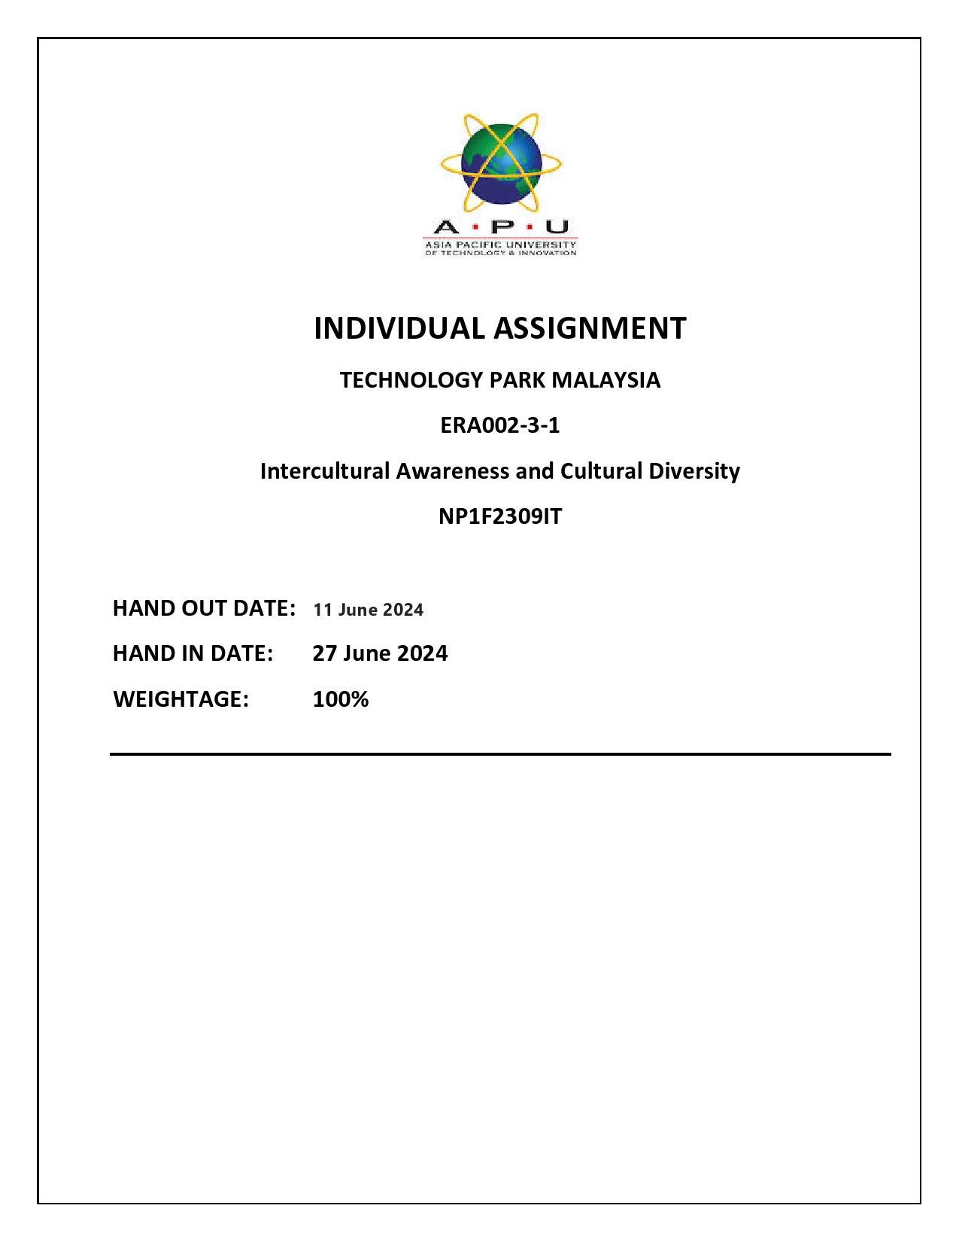

Table of Contents

Acknowledgement 3

Introduction to Dhulikhel 4

Origins and History Dhulikhel 4

Lifestyle in Dhulikhel 4

Customs and Practices in Dhulikhel 5

Conclusion 5

References 6

Script of the 3- minute video 7

# Acknowledgement

I would like to thank Asia Pacific University for giving me the life-changing opportunity to romote Dhulikhel culture as part of the IACD cultural exchange program. I am quite grateful to the university's program directors, coordinators, especially Safal Karki sir.  
  
My heartfelt gratitude to LBEF College and all of the faculty members who inspired me to visit Dhulikhen and write a digital essay on the Dhulikhel. I am extremely grateful to Mr. SAFAL KARKI, my renowned faculty adviser for the IACD, who took a personal interest in providing the necessary academic mentoring. Your suggestions also helped me finish my digital story.   
  
Finally, I am really delighted to be mentored by this accomplished instructor who is shaping tomorrow's global citizens. His passion motivates kids like me to be inquisitive, lifelong learners. Thank you again from the bottom of my heart!

Yours’ Sincerely

Atul Dhital

# Introduction to Dhulikhel

Dhulikhel, a city of over 40 cultures and a city of nature, where we discovered culture, business, traditions, and technology at a manageable level, where they are accepting new technologies while preserving their own culture and traditions.

Dhulikhel is one of Nepal's oldest cities and a major tourist destination in the country. It is located in the district of Kavrepalanchowk, near the eastern end of Kathmandu Valley. Dhulikhel is an important historical trading town on the main trade route between Nepal and Tibet, with a rich cultural heritage, spectacular views of Mount Everest, and a vibrant diversity. Dhulikhel is currently connected to two highways: the B.P. Highway and the Araniko Highway, which link Kodari, a Tibetan border town, to Kathmandu, Nepal's capital.   
Dhulikhel, like the rest of the globe, understands the appeal of the tourism business. Recognizing its economic benefits, tourism acts as a conduit for the transfer of resources from industrialized to poor countries. This company is a significant source of

# Origins and History Dhulikhel

Dhulikhel was located on the eastern boundary of the old Nepal Mandala and belonged to the Bhaktapur Empire. Dhulikhel was one of the final places annexed to Gorkha, which was expanding under Prithvi Narayan Shah. Visitors from Tibit come to Kathmandu in the 16th century to follow the tatopani NAKA; at the time, they enjoy the dhulikehl environment. And they begin performing research on the Dhulikhel culture and tradition.

# Lifestyle in Dhulikhel

Dhulikhel is a popular getaway destination for Kathmandu residents. It is around 26 kilometers from Kathmandu. It is surrounded by beautiful hills, and the views of the Himalayan Mountains are breathtaking. It is definitely worth a visit if you want peace and quiet. The city center is quite noisy and dirty, but as you travel to the outskirts, you will be surrounded by forests. You can hike to Namobuddha (a Buddhist monastery) or Balthali (my recommendation). The views of the Himalayas from those locations are spectacular.

# Customs and Practices in Dhulikhel

In the Dhulikhel, people lay a higher focus on customs and traditions while utilizing modern technology. This means they prioritized tradition and technology. The city area is primarily populated by Neawar and Bharmin cultures. They primarily follow the following culture.   
They celebrate more than six Jatras per year. This includes:

1. Bagbhairab Jatra.
2. The goddess of war.
3. The source of energy for Lord Shiva.
4. Manifestations of Parvati, Shiva's might in Tantric traditions.
5. Kali Devi Jatra

# Conclusion

The small but culturally rich Dhulikhel coexist with the mountains they inhabit. Their culture is a unique combination of ethnic roots and modern influences. Nepal's cultural heritage includes arts, music, attire, Jatras, and traditions that have been proudly passed down through generations. Living in a Gurung village is an enriching experience for any outsider. This fascinating look at their lifestyle, customs, and musical traditions has provided significant cultural exposure.

# References

Elalliance. (2023). *Gurung*. Retrieved from Elaliance: https://www.elalliance.org/languages/gurung

MarvelAdventure. (2024). *Gurung people and their culture*. Retrieved from Marvel Adventure: https://www.marveladventure.com/gurung-people-and-their-culture

Omniglot. (2024, Januarey 31). *Gurung (तमु क्यी / ཏམུ་​ཀི / Tamu Kyi)*. Retrieved from Omniglot.

# Script of the 3- minute video