An Operating System (OS) is a software that acts as an interface between computer hardware components and the user. Every computer system must have at least one operating system to run other programs. Applications like Browsers, MS Office, Notepad Games, etc., need some environment to run and perform its tasks.

The OS helps you to communicate with the computer without knowing how to speak the computer's language. It is not possible for the user to use any computer or mobile device without having an operating system.

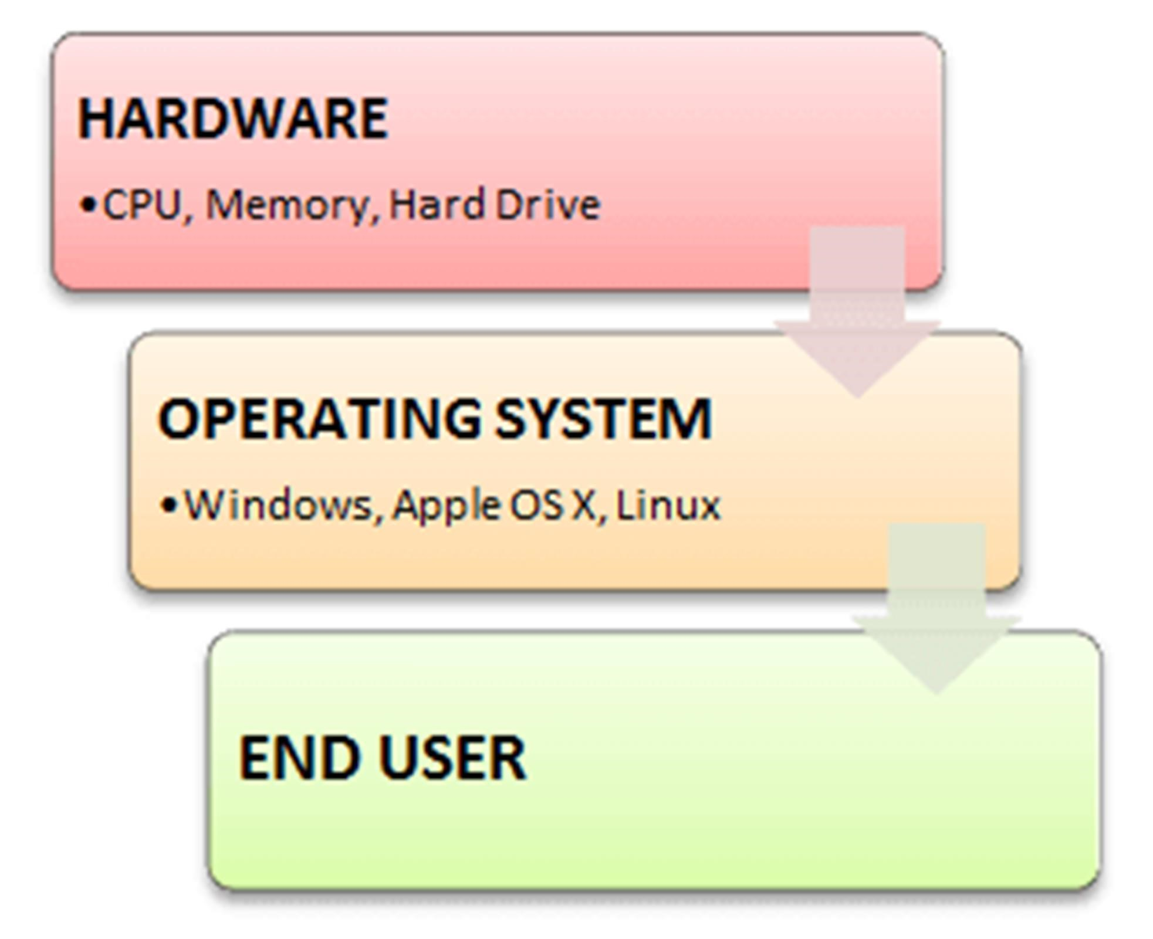Introduction to Operating System

operating system (OS)

An operating system (OS) is the program that, after being initially loaded into the computer by a boot program, manages all of the other application programs in a computer. The application programs make use of the operating system by making requests for services through a defined application program interface (API). In addition, users can interact directly with the operating system through a user interface, such as a command-line interface (CLI) or a graphical UI (GUI).

Why use an operating system?

An operating system brings powerful benefits to computer software and software development. Without an operating system, every application would need to include its own UI, as well as the comprehensive code needed to handle all low-level functionality of the underlying computer, such as disk storage, network interfaces and so on. Considering the vast array of underlying hardware available, this would vastly bloat the size of every application and make software development impractical.

Instead, many common tasks, such as sending a network packet or displaying text on a standard output device, such as a display, can be offloaded to system software that serves as an intermediary between the applications and the hardware. The system software provides a consistent and repeatable way for applications to interact with the hardware without the applications needing to know any details about the hardware.

**Types of operating system**  
  
Following are the popular types of Operating System:

* Batch Operating System
* Multitasking/Time Sharing OS
* Multiprocessing OS
* Real Time OS
* Distributed OS
* Network OS
* Mobile OS

# Batch Operating System

Some computer processes are very lengthy and time-consuming. To speed the same process, a job with a similar type of needs are batched together and run as a group.

The user of a batch operating system never directly interacts with the computer. In this type of OS, every user prepares his or her job on an offline device like a punch card and submit it to the computer operator.

# Multi-Tasking/Time-sharing Operating systems

Time-sharing operating system enables people located at a different terminal(shell) to use a single computer system at the same time. The processor time (CPU) which is shared among multiple users is termed as time sharing.

# Real time OS

A real time operating system time interval to process and respond to inputs is very small.

Examples: Military Software Systems, Space Software Systems are the Real time OS example.

# Distributed Operating System

Distributed systems use many processors located in different machines to provide very fast computation to its users.

# Network Operating System

Network Operating System runs on a server. It provides the capability to serve to manage data, user, groups, security, application, and other networking functions.

# Mobile OS

Mobile operating systems are those OS which is especially that are designed to power smartphones, tablets, and wearables devices.

Some most famous mobile operating systems are Android and iOS, but others include BlackBerry, Web, and watchOS.

Below are the main functions of Operating System:

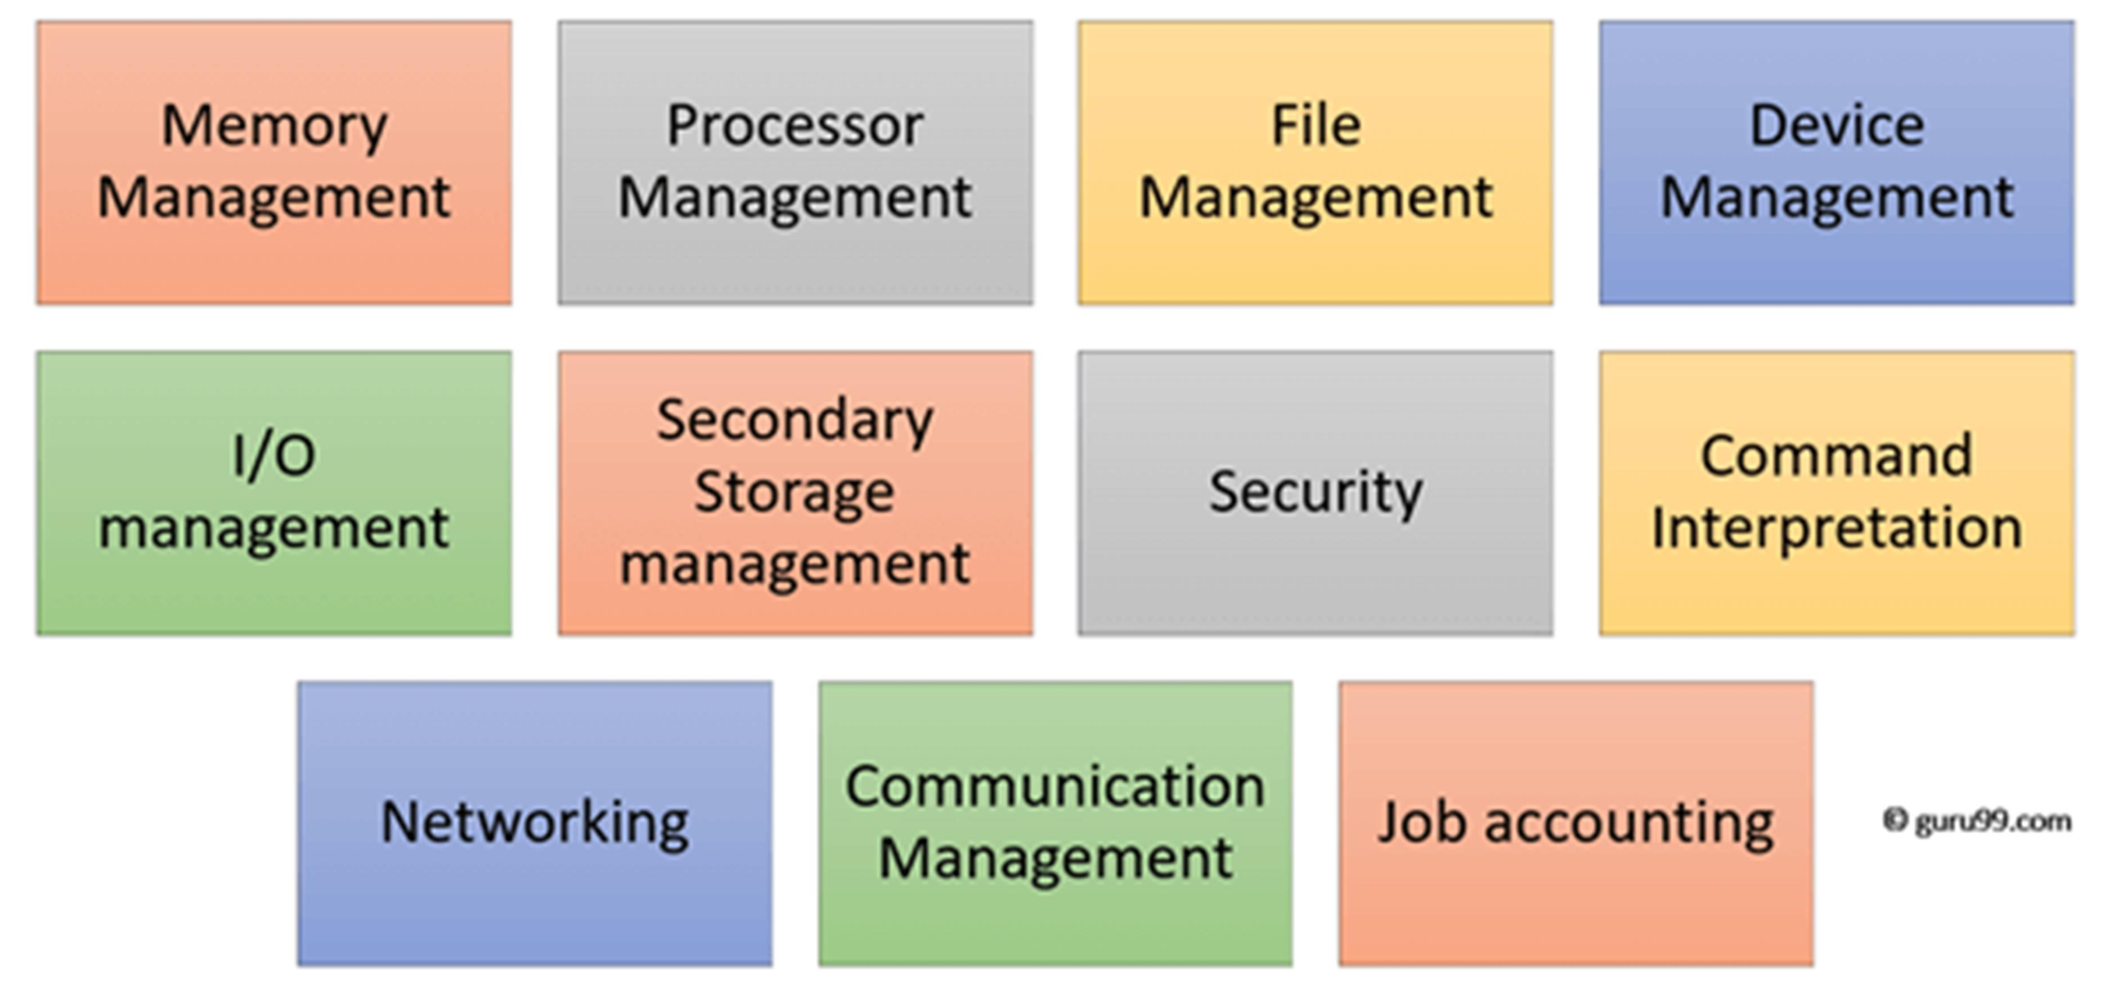

Functions of Operating System

In an operating system software performs each of the function:

1. Process management
2. Memory management.
3. File management
4. Device
5. I/O System
6. Secondary-Storage
7. Security
8. Command interpretation
9. Networking
10. Job accounting
11. Communication management

Here is a list important features of OS:

* Protected and supervisor mode
* Allows disk access and file systems Device drivers Networking Security
* Program Execution
* Memory management Virtual Memory Multitasking
* Handling I/O operations
* Manipulation of the file system
* Error Detection and handling
* Resource allocation

Every system needs operating system to create interface between user and hardware.

We are designing the Alienware PC gaming PC. We utilize the Windows operating system since it is capable of handling various tasks connected to the current trend of digital systems. For example:

* + Gamming
  + Security
  + Performance
  + Productivity
  + Accessibility
  + Multitasking
  + AI assistance

Windows 11 is the latest upgrade to Microsoft Windows that has replaced Windows 10.

The biggest change is the new design and interface but there are many other enhancements with Windows 11:

* New Design
* Changed Taskbar
* Redesigned Settings App
* Overhauled Start Menu
* New Window Snap Layouts
* Virtual Desktops