

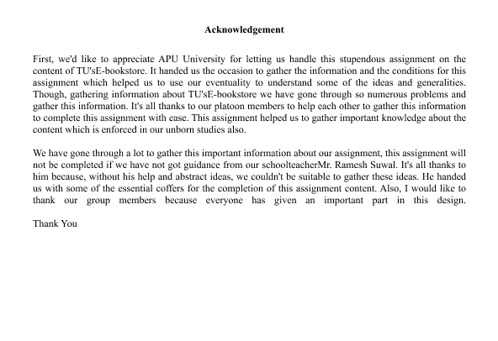’

Contents

Introduction 3

Database: 4

Database Management System (DBMS): 4

**Functions of DBMS:** 4

**Advantage of database management system:** 4

File based system: 5

ER-Diagram 5

Business rules for TU’s e-bookstore 7

Normalization process 8

Unnormalized from 8

**First Normal form** 8

**Second normal** 9

**Third normal form** 9

**Data dictionary** 10

# Introduction

Developing an online platform, the Tribhuban University (TU) E-Bookstore System overcome the unauthorized access of books within TU. The aim of the project is to develop a comprehensive database system that can manage feedback, customer registration, inventory control, and book orders. In addition to managing book availability and streamlining purchase procedures, the system provide TU's increment in student body which is a productive online shopping experience and ensure a vibrant learning environment.

# Database:

A database is an organized collection of structured information, or data, that is usually saved electronically in a computer system. A database is usually controlled by a database management system. Together, the data and the DBMS, along with the applications that are associated with them, are referred to as a database system, often shortened to just database (oracle.com, n.d.).

# Database Management System (DBMS):

A database typically requires a comprehensive database software program known as a database management system. A DBMS serves as an interface between the database and its end users or programs, allowing users to retrieve, update, and manage how the information is organized and optimized. A DBMS also facilitates oversight and control of databases, enabling a variety of administrative operations such as performance monitoring, tuning, and backup and recovery (oracle.com, n.d.).

## **Functions of DBMS:**

The database metadata repository in which DBMS stores data information.

Databases support the query-based data retrieval and analysis.

DBMS implements preset constraints and rules to guarantee data integrity.

Proper coordination and transaction execution assure by DBMS.

Data access is controlled by DBMS that allowed viewing and updating.

Multiple users' concurrent access to databases is maintained by DBMS.

For execution plans, DBMS evaluates and improves query performance.

## **Advantage of database management system:**

Changes in database structure independence are rendered easy using DBMS.

DBMS reduces the quantity for redundant info within the system.

For accuracy and consistency, DBMSs apply integrity specifications.

Data security is enhanced with DBMS to approved access.

Recovery procedures monitor the fix of data during faults.

Decrease in overall effort because of changes without impacting applications.

Data sharing in initiatives is offered by centralized databases.

Big amounts of data are managed easily for DBMS.

# File based system:

A file-based data management system, commonly known as a file system, is a form of software that allows users to access and organize small groupings of data. It is usually integrated into a computer’s operating system and is responsible for storing and retrieving files from a storage medium, such as a hard disk or flash drive (webopedia.com, n.d.).

**Disadvantages of File-based system**

In file based system the data security is kind of insecure because the data may be allocated in multiple file and several location which might get lost. Due to the data is stored in multiple location (coursehero, 2023).

Redundancy and larger demand for storage were the outcome of data duplication.

A significant challenge is moving data among departments.

File-based remedies tend to make tougher for programs to exchange data.

The chance that data destruction or invalidity doubles in a greater number of users.

Adjustments in the scheme involve considerable development and maintenance consumption.

# ER-Diagram

Entity Relationship Diagram can be referred as the Er-Diagram. A fault diagram is a visual representation of a database which assists with comprehending the database's logical architecture. An Er-diagram can be summarized up in three basic concepts. (Peterson, 2021):

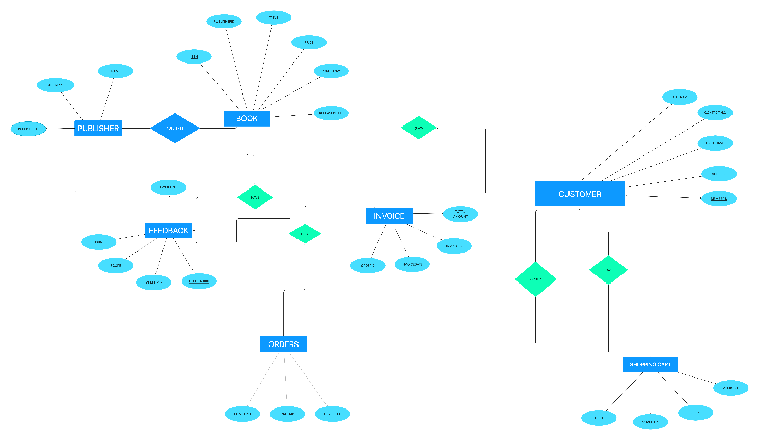

# Business rules for TU’s e-bookstore

Following are the business rules for TU’s E-Bookstore that can fulfill the requirement.

* A person must provide valid identification and contact information to register as a library member**.**
* Each member is assigned a unique library card number upon registration.
* A member must present a valid library card to borrow books.
* A member can borrow a maximum of five books at a time.
* The borrowing period is two weeks, with the option to renew for an additional two weeks if there are no holds on the book.
* Books must be returned by the due date to avoid late fees.
* A member with overdue books cannot borrow additional items until the overdue items are returned.
* Members can reserve a book that is currently checked out by another member.
* Reserved books must be picked up within three days of notification; otherwise, the reservation is canceled.
* Each book is uniquely identified by an ISBN number.
* The catalog includes information such as title, author, genre, and availability status.
* Late fees accrue for each overdue day at a fixed rate.
* Members are responsible for the safe return of borrowed books.
* In case of lost or damaged books, the member is charged the current replacement cost of the item.
* The library system may organize events such as book readings, workshops, or seminars.
* Members receive notifications about upcoming events, and they can register to attend.
* Access to the library database is restricted to authorized personnel.
* Regular backups of the database are performed to prevent data loss.
* Members may request books from other libraries through interlibrary loan services.
* Interlibrary loan requests are subject to approval and may have associated fees.
* Member information, including borrowing history, is confidential and should not be disclosed without the member's explicit consent.

# Normalization process

The procedure of normalizing the database serves minimize irregularities in updates and data dependence. It evaluates the data set applying the candidate key or primary key and other functional relationships that are present in the data structure (geeksforgeeks, 2022).

# Unnormalized from

In the design of databases, normalization is a method of organizing data to get remove unwanted linkages and repetitions. It seems to indicate that there are a few book names in one cell of the "book name" column in your case, which might end up in mutual & partial dependencies that are functional. This could give rise to redundant records and hinder handling of data.

|  |  |  |  |  |
| --- | --- | --- | --- | --- |
| Customer Name | Customer  Address | Department | Author Name | Bookname |
| Atul Sharma | Banasthali | BSC.CSIT | Philip ball | The history of computer science |
| Yash Raj | Panga | BBA | Plato | The theory of economy |

## **First Normal form**

A unique value key, occasionally referred to as an index key, is needed to recognize tables in relational databases with the goal to address the complicated problem of duplicates that occurs while trying to find data. The value of this key is then employed to identify information to perform query or other change (techopedia, 2011).

|  |  |  |  |  |
| --- | --- | --- | --- | --- |
| Customer Name | Customer  Address | Department | Author Name | Bookname |
| Atul Sharma | Banasthali | BSC.CSIT | Philip Ball | The history of computer science |
| Ashmita | Thankot | BBM | James Bond | Project Management |

## **Second normal**

Only once a 1NF relation is needed is a 2NF table constructed. Each non-key property in this normalization is entirely dependent on its primary key that acts like a unique defining key. Another usual version gets away with depend on the primary key. (Diwan, 2020).

|  |  |  |  |
| --- | --- | --- | --- |
| Customer ID | Customer Name | Customer  Address | Department |
| C01 | Atul Sharma | Banasthali | BSC.CSIT |
| C02 | Yash Raj | Panga | BBA |

|  |  |
| --- | --- |
| Customer ID | Book ID |
| C01 | B01 |
| C02 | B02 |

## **Third normal form**

3NF refers to the third normalization step. Only after a table is in 2NF and without a recursive functional connection is it regarded as being in 3NF. (Diwan, 2020).

|  |  |  |  |
| --- | --- | --- | --- |
| Customer ID | Customer Name | Customer  Address | DepartmentID |
| C01 | Atul Sharma | Banasthali | D01 |
| C02 | Yash Raj | panga | D02 |

|  |  |
| --- | --- |
| Author Name | Author Id |
| Philip Ball | A01 |
| James bond | A02 |
|  |  |

**Database Diagram**

The data contained in a database is expressed visually in database layouts. The link between a foreign key and primary key is depicted in a database diagram. Using a database feature in the database we've created, we can create a database diagram (jetbrains, 2020).

**Finalized Database Diagram**

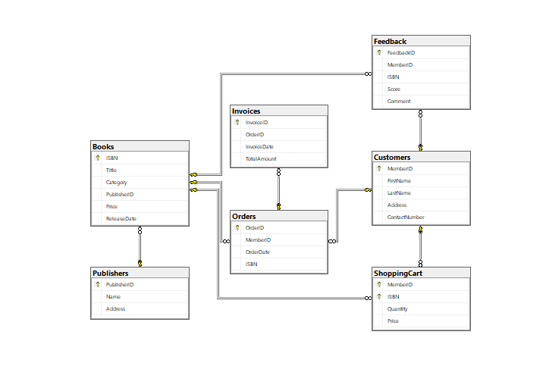

## **Data dictionary**

The metadata is handled on a data dictionary, which is a meta-data Repository (MDR). Metadata can be defined as data relating to content. The table names, their details, and the unique identification number of the attributes needed are all contained in the data dictionary part. The database management system provides the capacity to automatically update the data stored within (tutorialspoint, 2020).

**References**

(2020, June 20). Retrieved from tutorialspoint: https://www.tutorialspoint.com/What-is-Data-Dictionary

coursehero. (2023, 02 27). *Unanticipated queries in a file based system handling*. Retrieved from coursehero: https://www.coursehero.com/file/p7t8d8g/Unanticipated-Queries-In-a-file-based-system-handling-suddenad-hoc-queries-can/

*Database Business Rules Importance*. (2023, 02 27). Retrieved from relationaldbdesign: https://www.relationaldbdesign.com/database-design/module4/business-rules-importance.php

Diwan, A. (2020, June 15). *Second Normal Form (2NF)*. Retrieved from tutorialspoint: https://www.tutorialspoint.com/Second-Normal-Form-2NF

geeksforgeeks. (2022, 09 13). *Normalization Process in DBMS*. Retrieved from geeksforgeeks: https://www.geeksforgeeks.org/normalization-process-in-dbms/

jetbrains. (2020, December 20). *Database diagrams*. Retrieved from jetbrains: https://www.jetbrains.com/help/phpstorm/creating-diagrams.html#:~:text=Database%20diagrams%20graphically%20show%20the,using%20primary%20and%20foreign%20keys.

myreadingroom. (2023, 2 20). *What is DBMS? Advantages and Disadvantages of Database Management System(DBMS)*. Retrieved from myreadingroom: http://www.myreadingroom.co.in/notes-and-studymaterial/65-dbms/462-advantages-and-disadvantages-of-dbms.html

Peterson, R. (2021). *guru99*. Retrieved from https://www.guru99.com/er-diagram-tutorial-dbms.html#:~:text=ER%20Diagram%20is%20a%20visual,Ellipses%20%3A%20Symbol%20represent%20attributes

techopedia. (2011, 12 08). *What Does First Normal Form (1NF) Mean?* Retrieved from techopedia: https://www.techopedia.com/definition/25955/first-normal-form-1nf