

Database Schema

The database schema represents the logical picture of the whole database. The database system and primary key should be represented in the Schema Diagram. The scheme diagram includes the names of the relations and attributes. In the schema diagram, the arrow key represents the foreign key, whereas the primary key is underlined. Other limitations are not explicitly displayed in schema diagrams.

# Individual part

## **Atul Dhital**

**1.1 To create table**

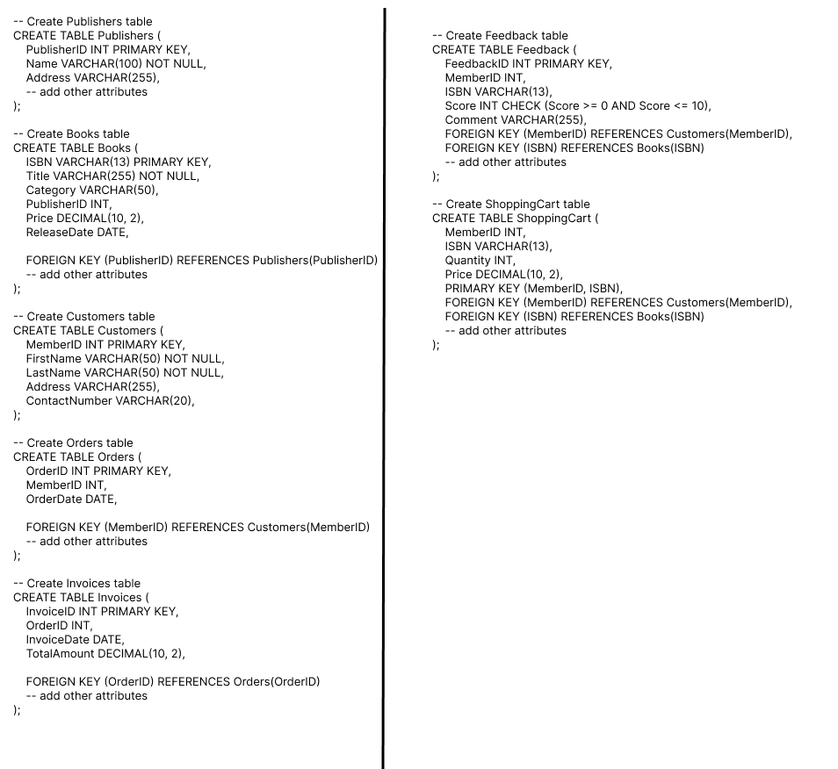

* 1. **Insert value into Table (DML)**

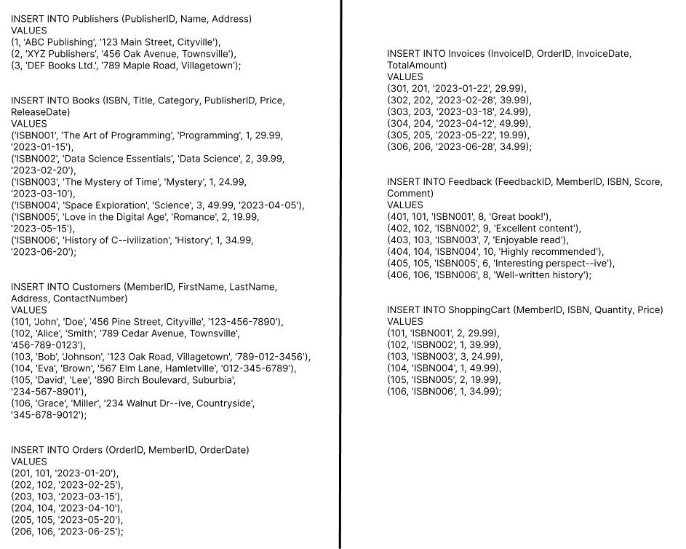

1. **A list of books ordered by store manager from various publishers based on monthly basis.**

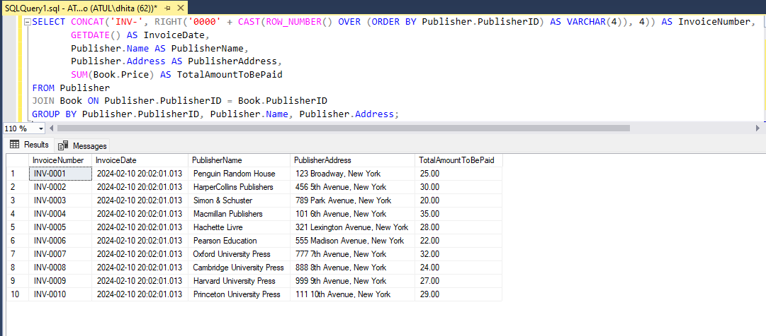

**3. Produce a record of invoices for various publishers. The invoice consists of invoice number, invoice date, publisher’s names & addresses and total amount to be paid.  
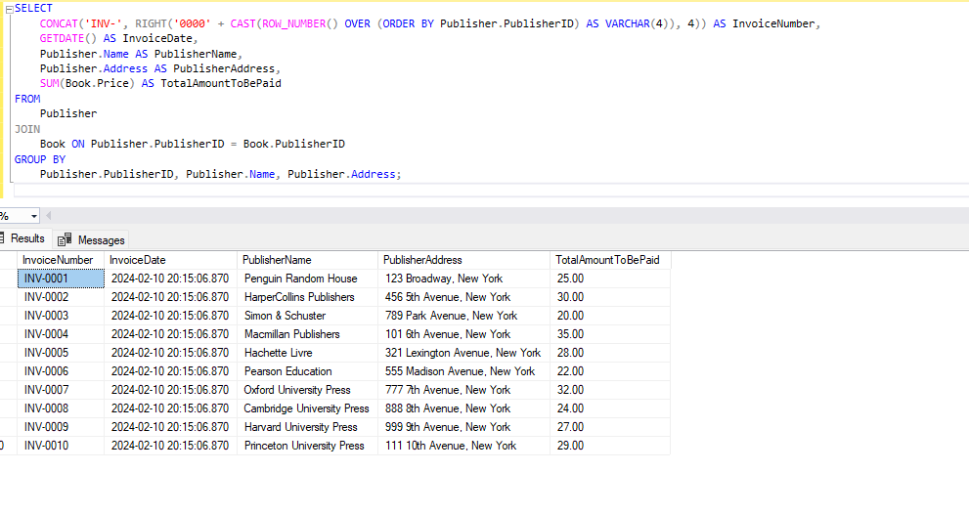**

**4.** **A list of all customers records who registered members in TU E-Bookstore are. The record of each member should show member identification number, first name and last name, address and contact number.   
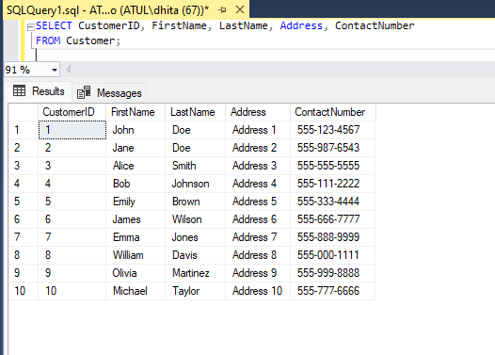**

**5. A list of purchased books that have been delivered to members. The list should show member identification number, first name and last name, address, contact number, book serial 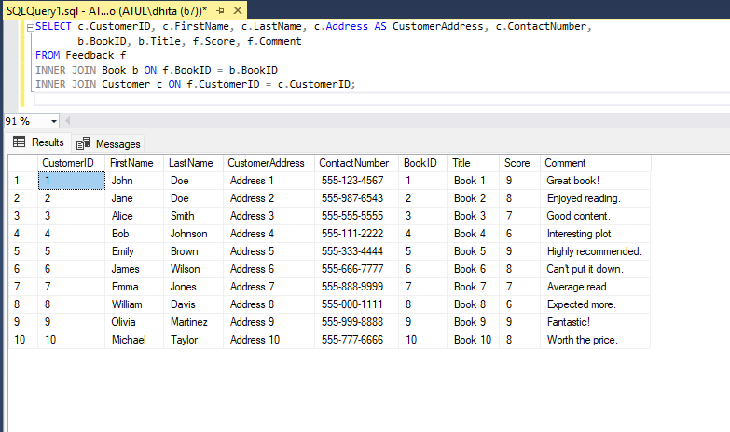number, book title, quantity, date and status of delivery.**

**6. List of books based on specific categories (e.g. Science Fiction, Romantic, History, Horror, etc.). The list should show type of book category, book serial number, book title and quantity.**   
  
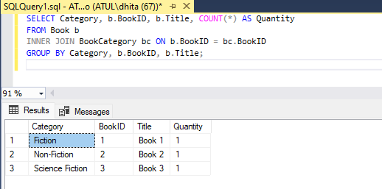

**7. Produce list of total number of books for each category of books.**

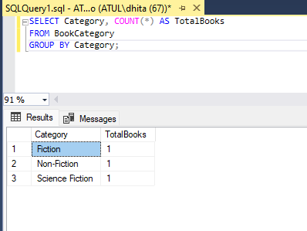

**8. A list of total books and its total price as added by members in shopping cart.**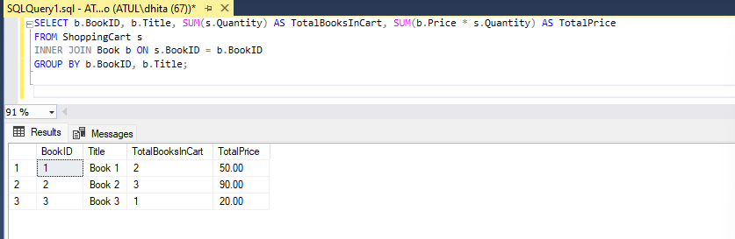

**9. Produce a list of book with the number of various feedbacks for books based on scores (1-10 which is 0= terrible, 10= masterpiece) rated by members.  
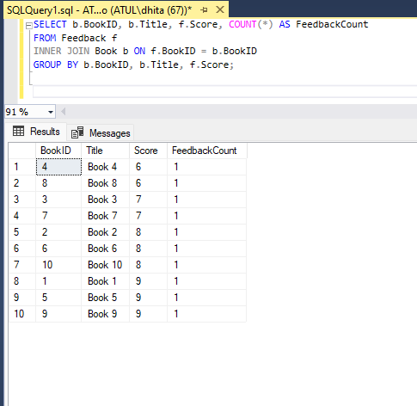**

1. **Ashmita rawal**
2. **Yeaharth Basya**

# Conclusion