# System Analysis

## Requirement gathering

1. **One-on-One Interviews:**

It is one of the most used ways of gathering information which is quite handy on this platform. It is generally done while sitting with the clients and asking whether there’s a fault in the current system or what’s the thing that’s bothering them this would change the system or something that might be essential. It’s a simple but effective way coz people easily reveal or always have something that says it lacks this or that so this might be the best way of gathering the information. (LISBDNETWORK, 2022)

1. **Group Interviews:**

It is kind of similar way like one-on-one, but it is done among a bunch of people usually more than one person. It’s easier to reveal and gather the information in a group because it doesn’t require more amount of time than the first one above. The more it’s easier to work so the group can gather the information ease within a very short time and also the people in the certain group can help us to gather the information while they are discussing the matter and finds a fault in each other’s statement and then we can get the information regarding something missing and something wrong in the system. (LISBDNETWORK, 2022)

1. **Joint Application Development:**

It’s like a group of people gathering the requirements that are needed in the improvement of the system by making documentation of the series of problems referring to the system’s backwardness. (LISBDNETWORK, 2022)

1. **Questionnaires:**

These are the casual ways of gathering the information by asking the people in the company about some of the minor faults in the system. It is a commonly used term in big companies or organizations. It is the gathering of information among many people of large amount like more than six or seven. (LISBDNETWORK, 2022)

# Design a Diagram

## Context diagram

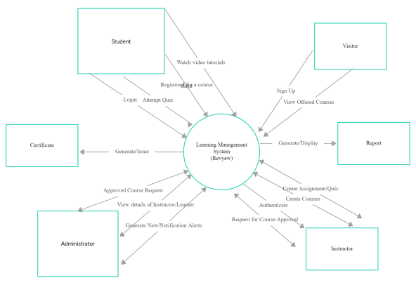

## Level - 0 DFD

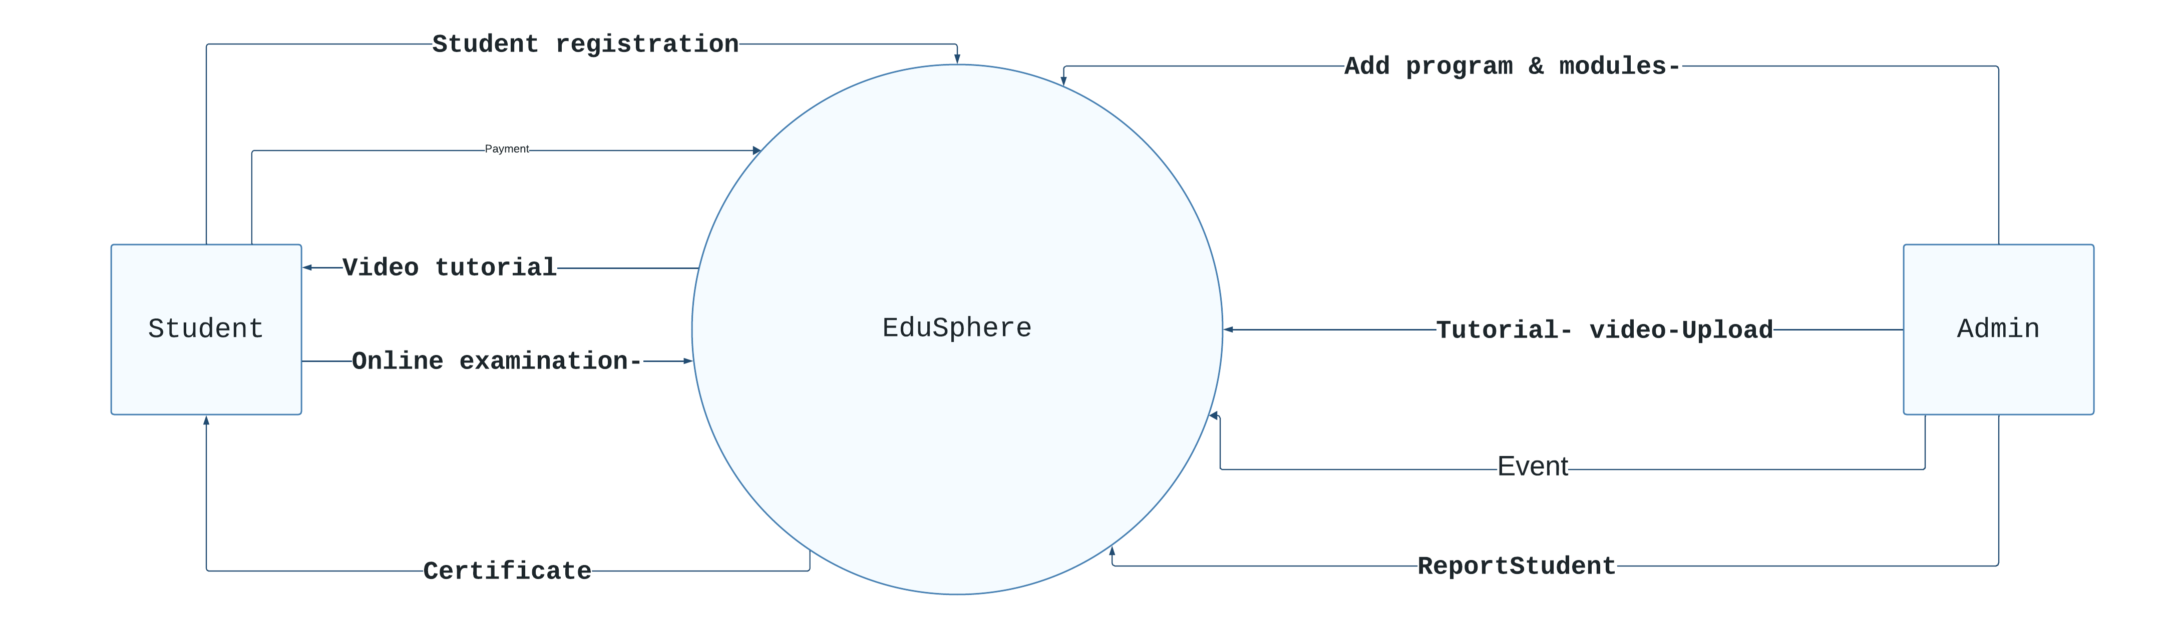

Fig: DFD level 0 diagram

## ERD

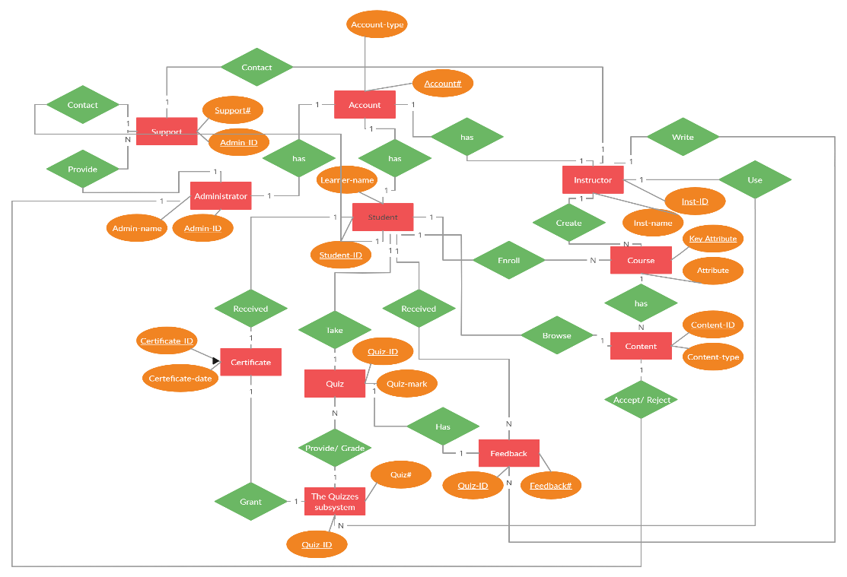

# Requirement Gathering

## Document review

Document review means reviewing or investing, analyzing the whole document again and again to gather the information from it and test whether there is any mistake or not. Basically, document review is important everywhere in small businesses, and schools, creating ideas and it also works in our platform eLearning.

So, document review helps us understand what to add and what to not add to our company " EduSphere" or what is the mistake in a document and how can we make this a better document? In a simple way document review means just reviewing the previous document and editing that document and taking the earlier ideas from that document. So, in our company’s eLearning project, it works the same it covers the mistake, edit it, and gathers the required important data from the previous document. Talking about the document review it demands a close checking of the document in a document review to know if they are all working as the measurement of the content properly or not. In this process, every document is properly or detailly covered. To assist decision-making or to adhere to legal or regulatory standards, it is important to make sure that all pertinent information is identified and presented in a clear and structured manner.

Advantages:

1. It will make our document more error-free because it will help to find the error in our previous document and will improve the development of the quality of the document.

2. It will save a lot of time because it will review the document and find the problems in the document early and save from the problems that are going to happen later.

3. It will help to understand the document and find the missing points in the document and

allows adding them.

Disadvantages:

* 1. So, one of the disadvantages is that the person or anybody reviewing the document will only have a limited idea and may not understand what is the purpose or use of that document which will lead to mistakes or errors in that document.

2. Document review will be a time-consuming task as reviewing the document again and again will slow down the process of document reviewing.

3. In the document review process the cost will be high because of the expertise we need for the document review as it needs a high level of skills and knowledge to implement it.

# References

bartleby. (2023, 03 19). *Effects Of Lack Of Resource Materials For Students*. Retrieved from bartleby: https://www.bartleby.com/essay/Effects-Of-Lack-Of-Resource-Materials-For-PKVCHVEBHEF

bcisnotes. (2020, Feb 20). *PIECES Framework || The Context of System Analysis and Design || Bcis Notes*. Retrieved from bcisnotes: https://bcisnotes.com/thirdsemester/system-analysis-and-design/pieces-framework/

DeFranzo, S. E. (2023, March 19). *Advantages and Disadvantages of Surveys*. Retrieved from snapsurveys: https://www.snapsurveys.com/blog/advantages-disadvantages-surveys/

elearningindustry. (2023, 03 19). *Lack Of eLearning Materials In Secondary Schools*. Retrieved from elearningindustry: https://elearningindustry.com/lack-of-elearning-materials-secondary-schools#:~:text=Inadequate%20technology%20infrastructure.,Consideration%20of%20eLearning%20policies

LISBDNETWORK. (2022, February 11). *Information Gathering*. Retrieved from lisedunetwork: https://www.lisedunetwork.com/information-gathering/

open. (2023, 03 19). *Purpose of teaching and learning materials*. Retrieved from open: https://www.open.edu/openlearncreate/mod/page/view.php?id=168509#:~:text=Learning%20materials%20can%20significantly%20increase,new%20skill%20gained%20in%20class

Simplilearn. (2023, 2 3). *Feasibility Study and Its Importance in Project Management*. Retrieved from Simplilearn: https://www.simplilearn.com/feasibility-study-article